|  |
| --- |
| **Allanton Primary Newsletter**  **October 2020** |

Dear Parent/Carer,

I cannot quite believe that it is October already! The last few weeks have allowed staff and pupils the time to settle back into the new rhythm of school life.

Since the children have returned in August, our focus has been on Literacy, Numeracy and Health and Wellbeing.

**Literacy**

This area covers reading, writing, talking and listening including spelling, grammar and handwriting. Teachers are skilled at assessing the children’s learning through what they do, say, make or write to identify their starting points in learning.

**Numeracy and Mathematics**

This area covers all aspects of number work including place value, addition, subtraction, multiplication and division as well as teaching concepts such as time, shape, position and movement. The children are also taught how to solve number problems mentally using the Number Talks strategies to increase their mental agility.

**Health and Wellbeing**

Children receive 2 hours PE per week outdoors. Class teachers have also spent time with the children to reconnect with school life and re-engage with learning. Children are following new routines extremely well.

**Health and Safety**

The flu vaccine will help protect your child against flu this winter. The flu vaccine for children is a single dose of nasal spray squirted up each nostril. It is quick and painless. Its brand name is [Fluenz Tetra](http://www.medicines.org.uk/emc/medicine/29109).

NHS Team will be administrating this vaccine on **Tuesday 27th October** to all children who have returned their forms or informed NHS by telephone.

***Your child will not receive the vaccine without Parental permission.***

***If your child or anyone in your household displays any of the following symptoms***

*• A high temperature or fever*

*• A new continuous cough*

*• A loss of, or change in sense of smell or taste*

*• Note; A new continuous cough means coughing for longer than an hour, or three or more*

*coughing episodes in 24 hours. If you usually have a cough, it may be worse than usual.*

*• Your entire household should isolate until a test can be carried out.*

*• You should inform the school as soon as possible.*

*• If you have more than one child (even if they attend different schools/nurseries) you should keep them all off until the results of your test are known.*

**

**Digital Learning**

Over the next few weeks, we will be looking at digital solutions to allow us to share and celebrate your child’s learning with you. Unfortunately, we will be unable to have our usual contact with parents through assemblies, open hours and sharing jotter work etc. We will be looking at ways to do this through our use of Twitter, Glow and the School Blog. All children will be issued with their Glow username and password and we will set home - learning task grids on the School Blog.

[www.blog.glowscotland.org.uk/nl/allantonblog](http://www.blog.glowscotland.org.uk/nl/allantonblog)

www.twitter.com/allantonprimary



**Parent Appointments**

Parent consultation will take the form of a telephone conversation. On Wednesday 7th or Thursday 8th October, you will receive a call from your child’s class teacher. You have been issued with a time slot. Please be available at your allocated time.

If your time does not suit please contact, the school and we will organise another time for you.



**Halloween**

Our usual Halloween disco will not be happening this year. Children can dress up on Friday 30th October and we will organise Halloween activities in their own classroom and outdoors.



**Maths Week**

Mrs McAllister has organised many fun maths activities for all classes to take part in the Scottish Maths Week Event. Activities and challenges include quizzes, magic maths, maths trails, cryptography challenges and natural art.

**‘Fun’ October Class Competitions**

As we are unable to have assemblies, we have decided to run some class competitions this month. This month’s class competitions will be:

* Witches Hat Challenge
* Sprint to the Finish
* Maths Quiz

**Collecting Children at the School Gate**

If your child is confident in entering the school playground without you, could you now please leave them at the school gate? If you feel, you still need to support your child with this then please stay in the allocated area and respect the 2m distancing rule from both children and adults.

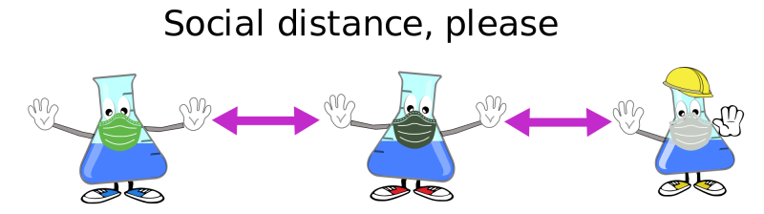

If you have any questions, please do not hesitate to contact us at school.

[ht@allanton.n-lanark.sch.uk](mailto:ht@allanton.n-lanark.sch.uk)

Telephone 01501 8267.

Isobel Cook

Head Teacher

MC900288988[1]

**Dates for your diary**

October break: Monday 12 October to Friday 16 October

In-service day: Monday 16 November

Christmas and New Year Holidays: Wednesday 23 December to Tuesday 5 January

Mid-term break: Monday 8 February and Tuesday 9 February

In-service Day: Wednesday 10 February

Spring Break Friday 2 April to Friday 16 April

May Day holiday: Monday 3 May

In-service day: Thursday 6 May 2021

May weekend holiday: Friday 28 May 2021 and Monday 31 May 2021

School closes: Thursday 24 June 2021