We would like to say a huge thank you to all of the amazing children in the nursery who have embraced this new way of learning we are so proud of the way you have all adapted to the ever changing restrictions we have.

Snack donation
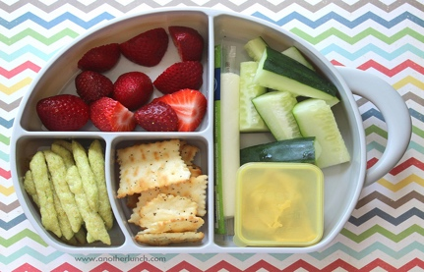
This Photo by Unknown Author is licensed under CC BY-SA
As the children are now being collected outdoors by a member of staff, would it be possible to pop your snack donations into an envelope or moneybag for your child to place in the bank? Your generous donations are greatly appreciated and we have provided some delicious healthy snacks for your children.

Learning and Teaching
The children have been learning about taking part in conversations, listening to one another's ideas and sharing thoughts and feelings within a small group. Experiences include creating a fairy garden outdoors, making models from junk and making some delicious pizza from playdough. We have also been learning about our numbers through number songs and games at together time.

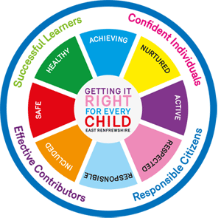
Personal plan meetings 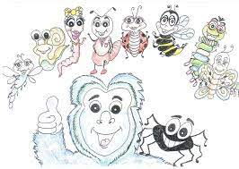
Personal plan telephone consultations were a huge success. We will now begin to work towards the children achieving their goals that will be documented in their individual learning journeys
Learning Journeys
Learning journeys for all children will now be documented online with access through a unique link and password, which we are aiming to have with you in the near future.

Dates for your Diary
Friday 30th – Halloween celebration (children can come in their costumes)
Monday 12th – Friday 16th – October break

Thank you
The nursery team

