Welcome To
Allanton Primary

A Parent Guide To Starting School

In Scotland, Curriculum for Excellence aims to achieve a coherent, enriched curriculum from 3 to 18 years and our children are entitled to experience a broad general education. All schools therefore, follow the principles of “Curriculum for Excellence” which allows our children to become:-

- successful learners
- confident individuals
- effective contributors
- responsible citizens

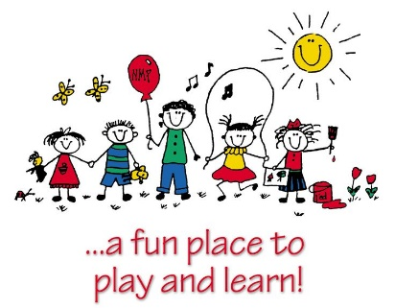

The Curriculum for Excellence is presented through experiences and outcomes in eight curricular areas.

- Literacy
- Maths
- Health and wellbeing
- Religious and moral education
- Expressive arts
- Sciences
- Social studies
- Technologies

This booklet will discuss areas of the curriculum and show how you can help your child get ready for school in a variety of different ways.
Getting Ready for School

It is nearly time to start school! Here are some things you can practise at home to help you get ready for school.
Speaking and Listening
- I can talk about my ideas, needs and feelings
- I can ask a grown-up for help
- I can follow simple instructions

Self Care and Independence
• I can wash and dry my hands.
• I can wipe my nose.
• I can put on/fasten my coat and shoes. • I can use the toilet.
• I am learning to dress/undress – this will help me change for PE.
• I am happy to be away from my parents or carers. I know they will be back soon.

.

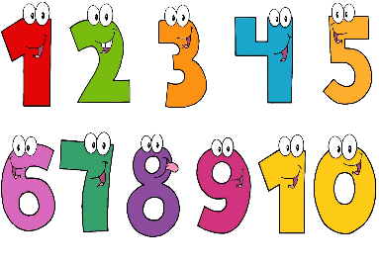
Reading and Writing
• I can recognise/read my name.
• I can hold a pencil to draw.
• I am learning to write my name.
• I enjoy listening to stories and rhymes.
Maths and numeracy
• I can count a small number of items.
• I like singing number rhymes or songs.
• I am learning to say numbers to ten.
• I can recognise some numbers.
Playing With Others
- I can join in games and activities with other people.
- I can share and take turns.
Eating and Drinking
- I can use a spoon, knife and fork.
- I can open my lunch box as well as wrappers and packaging.
- I can drink from a water bottle, carton or cup.
The period before a child starts school for the first time can be an anxious time for parents. We have put together the following information as a simple guide to how you can best prepare your child for this exciting time in their lives!

Developing Numeracy
Numeracy in school is more than just number work. We explore lots of different topics to encourage children to have a well-rounded experience of all areas of numeracy. Below are some topics covered in Primary One and ways in which you can help your child to develop these further:

Sorting and Matching Activities

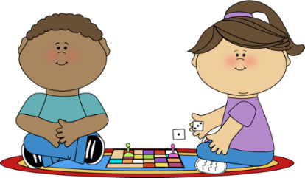

- Sort different items using categories e.g. sort toys by size, shape, colour
- Order items e.g. order toys from smallest to the largest
- Spot the difference pictures
- Help your child carry out small questionnaires such as ‘What is your favourite colour?’ then discuss the results – What colour got the most votes? Least votes?
- Identify similarities and differences between different things.
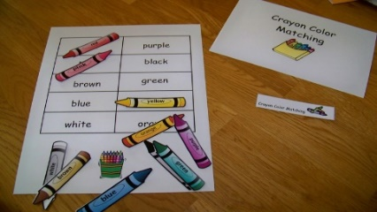

Numbers

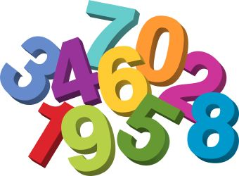

Numbers are everywhere. Point them out to your child – on doors, on buses and telephones. At home your child could count:
- Stairs
- Sweets
- Cars
- Lego or toys

Addition and Subtraction

- Write out the number stories using rainbow colours, in sand etc.
- Use cubes or other counting materials to add and subtract
- Roll two dice and add the numbers together to find a total
- Roll two dice and subtract the smaller number from the bigger number
- Find different ways to make a given number e.g. 1 red car + 2 blue cars = 3 cars/3 blue cars + 0 red cars = 3 cars
- Find the difference between e.g. I have 1 coin, you have 3 coins so how many more coins do you have?
Shapes
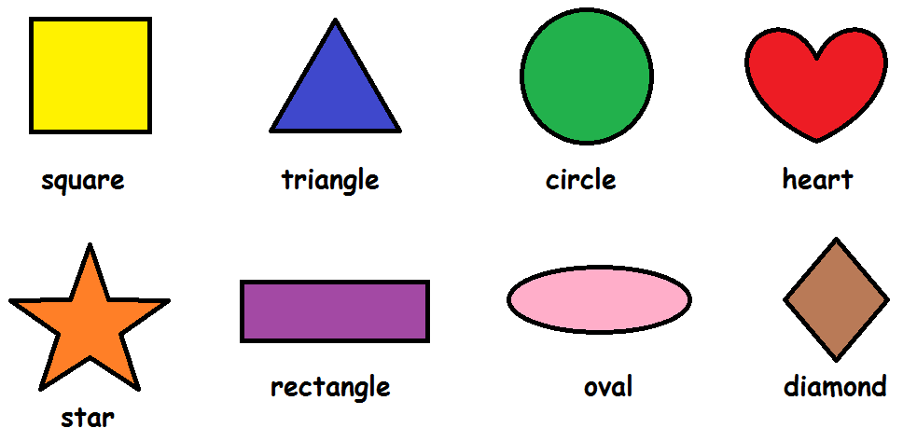

At school children play and build with both flat shapes and solid shapes to become familiar with them. Shapes are everywhere so point them out.

- Find 2D and 3D objects around you e.g. a ball is a sphere
- Use 2D shapes to make simple patterns
- Use 2D shapes and 3D objects to make pictures or models
- Sort shapes using different criteria – Which shapes have 3 corners? Which shapes can roll?
- Spot different 2D shapes within 3D objects e.g. square faces on a cube
- Describe a shape and ask your child to guess which one you are talking about

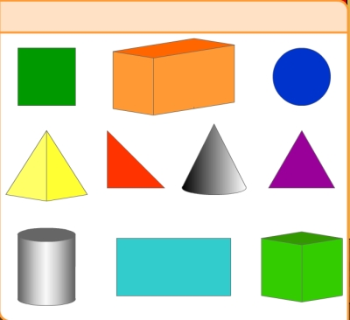
Weight/Length/Capacity

In school children are involved in practical activities
in order to investigate all types of measurement.
At home this can be done in everyday situations and you could talk about:

cans of juice - full/empty
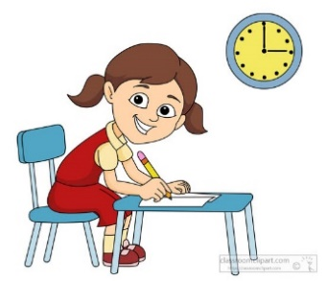
steps – long/short
shopping bags – heavy/light
watching TV – today/tomorrow
going to bed – day/night
Which is the biggest, smallest, tallest etc ?
Which is bigger ?
Can you see a smaller one than this ?

Position and Movement
- Help your child to learn their left from right (Left makes a L shape)
- Do some orienteering with your child e.g. go forward 2 steps, turn right etc.
- Do treasure hunts with your child and help them find things by giving instructions
- Use different positional language – beside, under, over etc.
- Play games with your child and let them give you the instructions on where to go.
Active Literacy
This involves children being introduced to sounds each week and using magnetic boards to recognise and identify the letters of the alphabet. The Teacher introduces each sound in a context i.e. a story and then demonstrates the letter formation and word building through the use of a magnetic board and letters. The children are provided with a magnetic board to allow them to mirror the taught lesson and work independently or with a partner throughout the week.
Children are taught to work with a partner to consolidate the taught lesson. This is called reciprocal teaching. They take turns to guide each other through the word building reading and writing process. This involves using the diagram below.
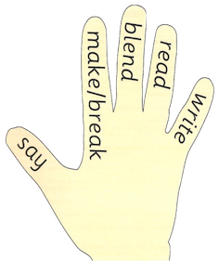

- First, say the word.
- Make it with the letters.
- Break it up, leaving a space between each sound.
- Blend the sounds from left to right.
- Read the word.
- Write the word on the line.
Spelling

Each week, three common words will be introduced
to your child. They will be taught strategies to recognise these tricky words.
Spelling Strategies

The strategies the children are taught are:

- Using Phoneme Knowledge (sounding out)
- Syllabification – breaking words down into syllables. The children can clap out words to identify syllables e.g. go-ing/An-drew
- Word Shape – Look at letter shape, size, ascending and descending letters.
- Tricky Letters – Looking at the position of tricky letters as an aid to spelling.
- Compound Words – Breaking the compound word into simple words e.g. into makes in and to.
- Mnemonic – using an aide memoire e.g. because – Big Elephants Can Add Up Sums Easily
- Using Analogy – If you know how to spell one word you can spell similar words e.g. if you can spell hill, you can spell mill, will, fill etc.

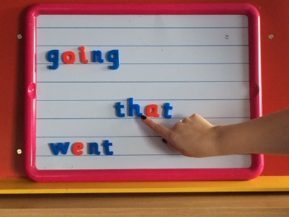

Reading

Reading books will be introduced in class and sent home each night. It is essential that the books are returned each day as the pupils will be completing tasks linked to their reading book.

Children are taught to read through the process of guided reading using a variety of quality short texts, from a range of publishers. They are no longer following what is considered to be the traditional model of a ‘reading scheme’. The books are organised into levels. This is known as ‘banding’. Each band is represented by a different colour. Within each band there will be a variety of fiction and non-fiction texts that allow the children to experience many styles of writing. The basic guide within the banding is that most children start at the pink level and will progress to lime by the end of Primary two or in Primary three.

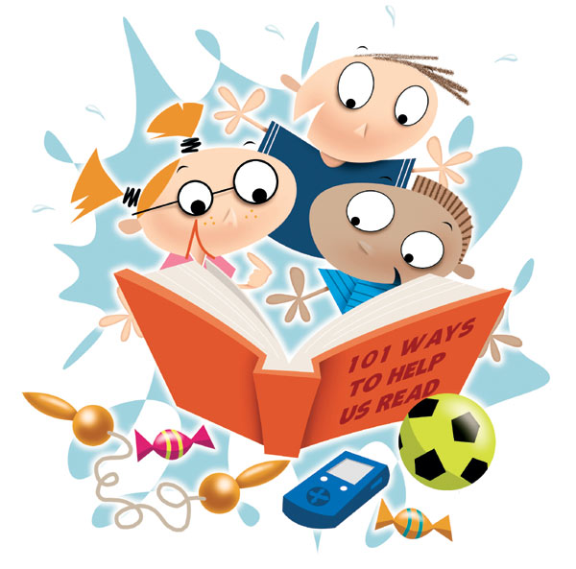

Children are taught to read using the Guided Reading approach. The teacher provides an overview of the text. This is known as a ‘walkthrough’. At the start of the lesson, the teacher is the only person with the copy of a book. The teacher has read the book prior to teaching and has identified the vocabulary (common words) to be introduced. The teacher helps the children to read the topic words in the book by drawing their attention to the picture clues. Time is taken to teach the children various comprehension strategies to help them gain a better understanding of the text. They also learn word attack strategies to enable them to decode words that they find difficult. After the initial walkthrough, the children have opportunities to read aloud. This happens in a group setting/with a partner. The teacher circulates to listen and provide feedback.

Word Attack Strategies

- Look at the first letter
- Sound out the first few letters
- Break the word into syllables
- Look at the last letters
- Read the sentence again
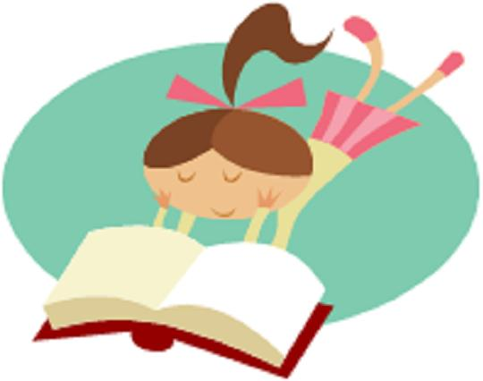
- Look at the picture
- Look at the shape of the word

Writing

Initially, children will be introduced to the writing process by over-writing and then move on to under –writing. Please do not worry too much about children not being able to form letters of the alphabet properly as this will be taught in school.

Our writing programme consists of daily writing activities which are completed in their daily writing jotter. Writing across the curriculum and a weekly taught writing lesson.

To prepare your child for starting school a pack will be provided and will include a variety of activities to encourage your child to learn, be excited and enthusiastic about coming to school after the summer holidays.

Parents as Partners

Allanton Primary School enjoys very good, supportive relationships with our parents and operates an open door policy. However, in the current climate the school operates an appointment only consultation. We have an active Parent Council and parent committee group called “Friends” who provide a vital role in helping and assisting our school to provide worthwhile experiences for our pupils.
It is our aim that all pupils in our care are given the opportunity to reach their full potential as learners and responsible citizens. When staff, pupils and parents co-operate in a climate of mutual trust and respect we can all benefit from this and therefore, learn and achieve together.
Please do not hesitate to contact the school at any time if you have concerns and someone will be available to speak to you.
e-mail us at ht@allanton.n-lanark.sch
Telephone number: 01501 826703
Follow us on Twitter @allantonprimary

