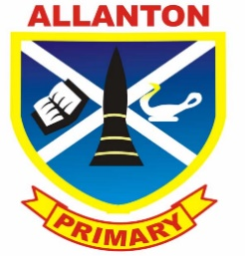
Allanton Primary School Parent Council
Agenda
Tuesday 8th November 2016

- Welcome

- A71 safety update

- Head teacher update

- AOB

