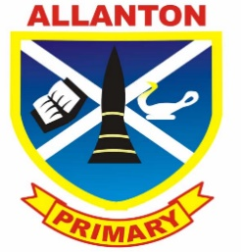
Allanton Primary School Parent Council
Agenda
Tuesday 17th January 2017

- Welcome

- Head teacher update

- A71 Safety Update

- First Class

- AOB

