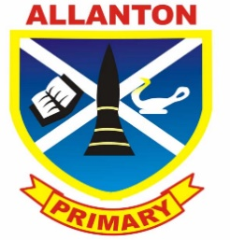
Allanton Primary School
Parent Council AGM
Tuesday 13th September 2016

- Welcome and Introduction

- Review minutes AGM 2015

- Annual report 2015 / 2016

- Election of office bearers & committee members

- Head teacher update

- Parent council moving forward

- Diary dates

- AOB

