Alexander Peden Primary School & Nursery Class
Living our Values Statement

Rationale
“Developing good relationships and positive behaviour in the classroom, playground and wider community is essential for creating the right environment for effective learning and teaching. Where children and young people feel included, respected, safe and secure and when their achievements and contributions are valued and celebrated, they are more likely to develop self-confidence, resilience and positive views about themselves.”
Scottish Government, 2013

The Rights of the Child (Article 28):
"Every child has the right to an education... Discipline in schools must respect children’s dignity... "

At Alexander Peden Primary School & Nursery Class we strive to be a nurturing and mindful community, working in partnership with our families, local community and other agencies to ensure our children access the highest quality learning and teaching and a wide range of opportunities and experiences that will support and challenge them to aim high and be the best that they can be.

Our Aims
A nurturing approach is fully embedded in our whole school community and is at the heart of pupils learning experiences.

To support our vision of creating a nurturing, supportive environment for all learners, we have developed a positive behaviour strategy that embodies our nurturing ethos. ‘Living our Values’ encourages pupils to fully embrace our school values in class and around our school community. The following guidelines highlight our expectations for all pupils. These are modelled daily by our staff team.

Respect: Pupils demonstrate mutual respect between themselves and the adults in our school community. Pupils treat each other, the class and school property with kindness. Pupils openly share their views and take time to listen to adults and each other.

Kindness: Pupils always use kind hands, feet and words. They give encouragement and praise to each other. They willingly put others before themselves and are generous and considerate in their actions. Pupils show awareness of how their behaviour can affect others.

Friendship: Pupils look out for each other and show kindness and respect. They celebrate the diversity of our school and awareness of the feelings of others. They listen when someone has something to say.

Teamwork: Pupils work collaboratively supporting each other to successfully demonstrate our school values and achieve our school vision. They show respect, kindness and friendship to ensure that everyone is included.

Honesty: Pupils always tell the truth irrespective of the situation or who they are speaking to. They strive to show that they are trustworthy and genuine in how they conduct themselves within the class and school community.
Safety: Pupils ensure that their behaviours are not putting themselves or others at risk. Currently, this includes supporting each other to fully embrace all COVID safety measures, demonstrating all our school values.

Achieving Our Aims

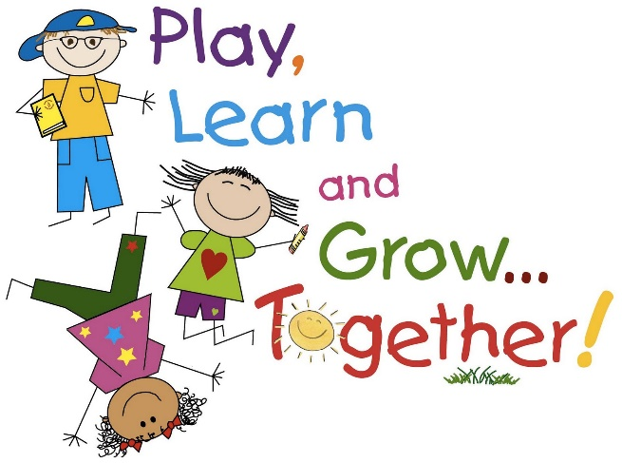
‘Living our Values’ is presented in each class in the form of a colour (rainbow) chart, where each pupil aims to reach the sun by the end of each week. Pupils will move up the colour chart as they demonstrate our school values through their engagement with learning and the life of the school. Success in reaching the sun will be celebrated at assembly with each pupil having their name proudly displayed on the ‘Living our Values’ chart.

Parents/Carers will also receive a text message celebrating their child’s achievement.

Individuals that are struggling to demonstrate our values should be highlighted through our Pastoral Note system. Where there are on-going concerns, teachers should, in partnership with the individual child and parents/carers develop an ‘Individual Nurture Protocol’. (See Appendix 1)

Updated: August 2021 (S Campbell – HT)
Review Date: August 2022

