Alexander Peden Primary School & Nursery Class
Health and Wellbeing Curriculum Statement

Rationale
The Scottish Governments ‘Mental Health Strategy 2017 – 2027’ notably states its vision for young people in Scotland:

“Along with literacy and numeracy, health and wellbeing is one of the three core areas that are the responsibility of all staff in the school. All adults who work in Scotland's schools have a responsibility to support and develop the mental, emotional, social and physical wellbeing of pupils, as part of what is referred to as 'Responsibility of All'.”
Scottish Government, 2017
At Alexander Peden Primary School & Nursery Class we strive to be a nurturing and mindful community, working in partnership with our families, local community and other agencies to ensure our children access the highest quality learning and teaching and a wide range of opportunities and experiences that will support and challenge them to aim high and be the best that they can be.
‘Our School Vision’

Our Aims
We are committed to supporting and developing our pupil’s mental, emotional, social and physical wellbeing, and strive to provide pupils with tools to support and nurture their own wellbeing.

Learning in health and wellbeing ensures that children and young people develop the knowledge and understanding, skills, capabilities and attributes which they need for mental, emotional, social and physical wellbeing now and in the future. Learning through health and wellbeing enables children and young people to:

- Make informed decisions in order to improve their mental, emotional, social and physical wellbeing.  - Experience challenge and enjoyment.  - Experience positive aspects of healthy living and activity for themselves.  - Apply their mental, emotional, social and physical skills to pursue a healthy lifestyle.  - Make a successful move to the next stage of education or work.  - Establish a pattern of health and wellbeing which will be sustained into adult life, and which will help to promote the health and wellbeing of the next generation of Scottish children. It also enables some to perform at high levels in sport or prepare for careers within the health and leisure industries. | 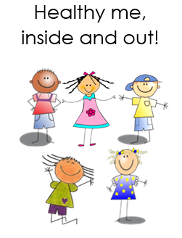
Achieving Our Aims
At Alexander Peden Primary School and Nursery, we take a holistic approach to promoting HWB throughout the school and across the curriculum. Working with partners, our approach takes account of the stage of growth, development and maturity to develop successful learners, confident individuals, responsible citizens and effective contributors.

Our Health and Wellbeing programmes are underpinned by the principles of Curriculum for Excellence (CfE), the Well-being indicators (SHANARRI) and Getting it Right for Every Child (GIRFEC). At Alexander Peden, we utilise the Healthy Schools SHANARRI framework to support our pupils across all stages of their development. | 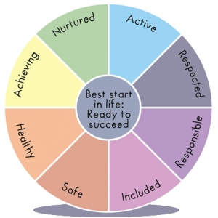
Health and Wellbeing is the responsibility or everyone at Alexander Peden Primary School and Nursery, whatever their contact with our children and young people. Everyone shares a clear vision in ensuring that we create a safe, positive ethos and a climate of respect and trust which allows us to support and nurture all of the learners within our school community.

Learning & Teaching
Core Health and Wellbeing Lesson Expectations

- Core Health and Wellbeing lessons should be taught once over a double block, or during two single slots of teaching and learning each week.

- The Healthy Schools Planner should be used to structure lessons and should be differentiated according to the needs of the pupils in your class.

- It is essential that we foster an environment where pupils feel comfortable discussing their wellbeing, therefore each Health and Wellbeing lesson should begin with a ‘Wellbeing Check-In’, allowing the pupils to reflect upon their own wellbeing and share experiences, targets or worries.

- Prior learning should be reflected upon after the check-in, using the floor book to share previous lessons and activities.

- Date and Learning Intention should be displayed in the class floor book and should be shared with pupils at the beginning of the lesson.

- Success Criteria must be shared at the beginning of the lesson, as it is essential for pupils to understand how they will achieve the intended learning. Success Criteria can be used to shape the structure of the lesson or can be linked to a specific task.
- A wide range of pedagogical approaches should be used during the Health and Wellbeing lesson. Pupils should be given opportunities to share their views and opinions, work collaboratively with others and develop critical thinking. Links to other curricular areas can be explored during the lesson to enhance learning and provide opportunities for pupils to transfer their skills.

- A wide range of AiFL strategies should be employed to assess pupil understanding and should be used throughout or at the end of the learning experience.

- Pupil work must be recorded in the class floor book. Floor books should contain pupil voice, evidence of completed work, photographs, drawings or post-its. This can be completed with pupils during the lesson or prior to the next Health and Wellbeing lesson.

- Floor books must be kept up to date and should be available for pupils to observe and reflect upon their learning.

Wellbeing Webs
- Wellbeing Webs must be completed at the beginning of each term and given to the Health and Wellbeing Curriculum Lead to collate.  - Health and Wellbeing Curriculum Lead will provide suggested learning experiences and advice on how to support pupil wellbeing in class.  - It is the responsibility of all staff to know their class Wellbeing data and provide universal support where needed.  - Responsive planning should be used to support pupils or target a specific indicator if necessary.  - Wellbeing Webs must be shared with parents during Learning Conversations and targets should be set to support any areas of concern. | 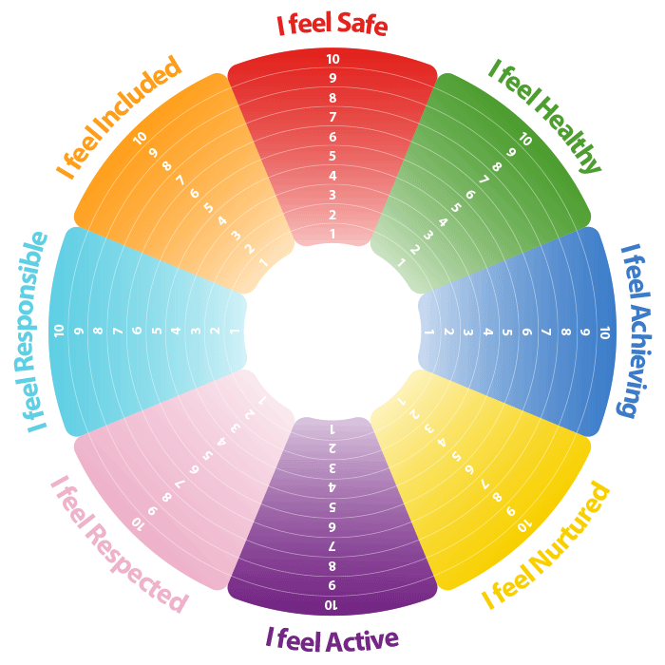

Mindfulness
At Alexander Peden Primary School & Nursery we endeavour to provide our children with opportunities to discuss and reflect on their feelings and emotions in a safe and nurturing environment. The approaches and resources we use to facilitate this are:
- All staff trained in DoBeMindful Explorers and/or participated in their online CPD session
- Daily and weekly circle time / check ins
- Use of emotions mat to allow pupils to identify and discuss how they are feeling
- Use of mindfulness area which provides pupils with a range of resources they can use to self calm, practice breathing techniques or discuss feelings and emotions
- Emotions bear is accessible for pupils who struggle to self regulate
- Emotions books can be used to support individuals, groups or whole classes if there is an area of concern
- Safe spaces are located in each class and resources should be made available for targeted pupils
- All staff have access to ‘Calm’ and should use this during mindfulness sessions where appropriate
- All staff have access to a range of online resources such as Cosmic Kids and GoNoodle
- All staff are encouraged to use ‘Mindfulness’ music to create a calm and mindful classroom environment
- All staff are expected to use appropriate language and tone which promotes and models a mindful approach
- The Sunshine Room provides children with a calm, multi-sensory experience and should be used to support individual pupils or targeted groups
- Classes can also use the Sunshine Room for additional guided meditations

Expectations and Communication
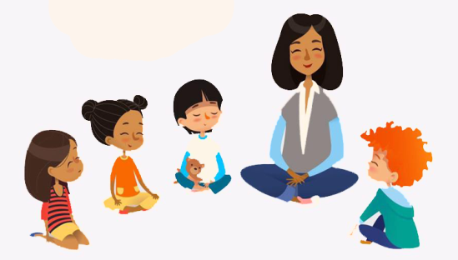 | - All staff at Alexander Peden Primary School are expected to teach and model good posture and practice during guided meditations  - All staff are expected to promote a mindful community  - Staff and Pupils should respect others in their learning environment during guided meditations  - Staff and Pupils should not enter or leave the base during guided meditation unless it is absolutely necessary  - Mindfulness activities should promoted as part of family learning opportunities  - All new staff are encouraged to participate in Mindfulness CLPL opportunities  - All staff are encouraged to speak to a member of the HWB Team about pupils or groups of children they feel would benefit from extra support or further mindfulness sessions

Updated: August 2021 (H Easton Acting PEF PT – HWB)
Review Date: August 2022

