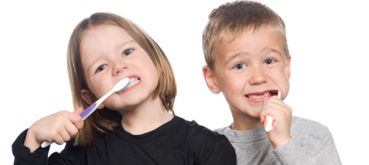
THE IMPORTANCE OF TOOTHBRUSHING AT HOME

Dear Parent/Carer,
Now that the children are returning to nursery and school, this brings some challenges, new routines and new ways of working for everyone to get used to.
We want to reassure you that we will do as much as we can to make sure children can look after their teeth.
We will continue to deliver Homecare packs (Toothbrush and Toothpaste) to establishments for the children for their use at home.
Thank you for your continued support at this difficult time.

Help your child look after their teeth:
- Encourage your child/children to brush at home
- Brush teeth twice a day for at least two minutes using fluoride toothpaste, every morning after breakfast & before bed
- Spit out excess toothpaste & don’t rinse after brushing - this gives toothpaste time to work and protects the teeth
- Keep sugary snacks & drinks to mealtimes only
- Remember plain water & plain milk are the only drinks safe for teeth

If you have any concerns about your child’s mouth please contact your child’s registered dentist. If your child is not registered with a dentist then please phone us on 01236 707711 and we will support you to find a dentist.

Regards,

Childsmile Prevention Team
NHS Lanarkshire Public Dental Service

