Welcome Back

It was lovely to see the children return last week, looking smart in their school uniform. They have all enjoyed meeting their teacher(s), seeing their friends and getting to know their new class bases. The children are all settling in well to their new classes and are working hard to impress their new teachers!

Parking

Please remember that the car park is for staff only. The only exceptions are after care drop off and pick up or parents/ carers with a permit.

Please respect the yellow lines and no parking signs (from 8am to 4pm) in Lincoln Avenue. Parking on these lines makes it difficult for children to see their parents/ carers as they exit school; is dangerous as cars are driving where children are walking; and makes access for buses or emergency vehicles difficult.

The yellow lines mean that you are not allowed to park there (even if you are in the car) at the times shown on the sign.

Please also be respectful of our neighbours and do not park across driveways or in private bays.

We understand that it is busy and would encourage you to walk with your child to school or even park and stride (where you drive part the way then park and walk then last section). Thank you in advance for your co-operation.

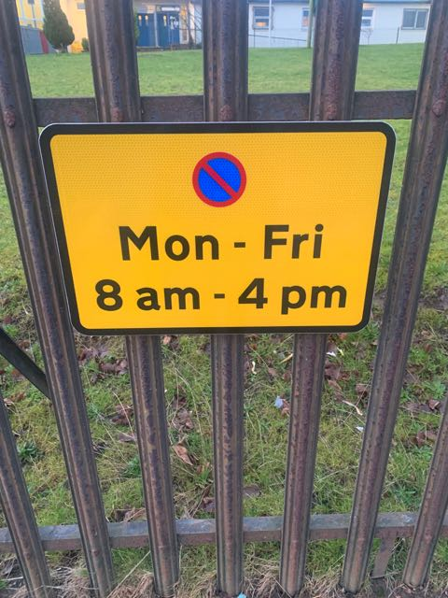

Staffing

Miss Lalmy is unfortunately still absent however we would like to welcome Miss McCartney to the school on a temporary basis.

P1 – Mrs Hall/ Mrs Lowe

P2 – Miss Quinn

P3 – Mrs Brown/ Ms Gillies

P4 – Ms Whiston

P5 – Miss Stevenson

P6 – Miss Carlin

P7 – Mrs White

NCCT – Miss McCartney

Literacy support – Mrs Devine

Principal Teacher – Mrs McGregor

Head Teacher – Miss Sommerville

Office – Mrs Kupsky/ Mrs Quinn

ASNA – Mrs Hanna

Janitor – Mrs McGown

Entering and Exiting School

The school day starts at 8.55am.

The entrance door (senior/junior door) will be open **from 8.40am**, children should enter the school building on their arrival and head to their designated class base. They should be in their class ready to start their day at 8.55am.

**Children should not be in the playground before 8.40am as there is no supervision.**

Please avoid overcrowding at the gate areas. Please do not stay once you have dropped off/ collected your child.

Remember adults are not allowed in the playground.

Breakfast Club/ School Lunches

There is a daily breakfast club available for all children from 8.15am to 8,45am. The main office door will be opened at 8.15am and children can enter anytime between then and 8.45am. Children have the choice of toast, cereal, a piece of fruit, milk or fruit juice. They may have one of everything or just select the items they would like. As it is a breakfast club, children will be encouraged to take something to eat or drink.

Breakfast Club is free for all P1-5 children and any children in receipt of free school meals. Breakfast is £1 to other pupils per day.

Lunch time is still be from 12.30pm to 1.20pm. The most recent primary school menu can be accessed on <https://www.northlanarkshire.gov.uk/index.aspx?articleid=5594>

If a child is going home for lunch they should be collected from the front gate at 12.30pm.

Uniform

Remember our school colours are red and grey, not black.

Children will be outside at playtime and lunch times please ensure they have a waterproof jacket with them. You may wish to put a change of clothes in their bag in case they fall including a spare pair of socks in case their feet get wet.

Nut Free Zone



Anything that could contain nuts or nut traces should not be brought into school. Please check labels of pre-packed snacks carefully to ensure they do not contain nuts. Please remind your child not to share their snacks/ lunch with others as some children have allergies so it is important children only eat the food they brought with them.

X (Twitter)

Please follow us! X (Twitter) is used as another form of communication. It lets you see the learning happening in your child’s class. The feed can also be seen on the school blog if you log on using a computer. Our handle is @AitkenheadS

Email

If your email address has changed, please inform the school.

PE Days

P1 – Monday and **Friday**

P2 – **Tuesday** and Friday

P3 – **Monday** and Wednesday

P4 – **Wednesday** and Thursday

P5 – Wednesday and **Thursday**

P6 – **Tuesday** and Thursday

P7 – Tuesday and **Friday**

The day in bold text is the children’s outdoor PE session. They should bring appropriate clothing for being outside (warm jumper, waterproof jacket, outdoor shoes)

They should have indoor shoes for their indoor session.

Please remember that children are not allowed to wear jewellery or false nails to PE for Health and Safety reasons. To keep property safe it would be better to keep jewellery at home on PE days.

Parent Council

Twitter: @APSparents

Email: apcparentcouncil@gmail.com

PC Chair: Mrs Fiona Aitken

**Next Meeting: Thursday 7th September**

Meetings are held in the Primary 7 class base. All parents/ carers are welcome as part of the wider parent forum.

**Please come along if**

**you can.**



Easy Fundraising

Have you registered with easyfundraising?

Help raise school funds at no extra cost for yourself.

Sign up here

<https://www.easyfundraising.org.uk/causes/aitkenheadprimaryschoolparentcouncil/?utm_campaign=raise-more&utm_content=s-e2>

Then use the website or app straightaway when you shop online. Over 4000 retailers are involved.

