Revised Standard Grade Technological Studies

Introduction to Systems
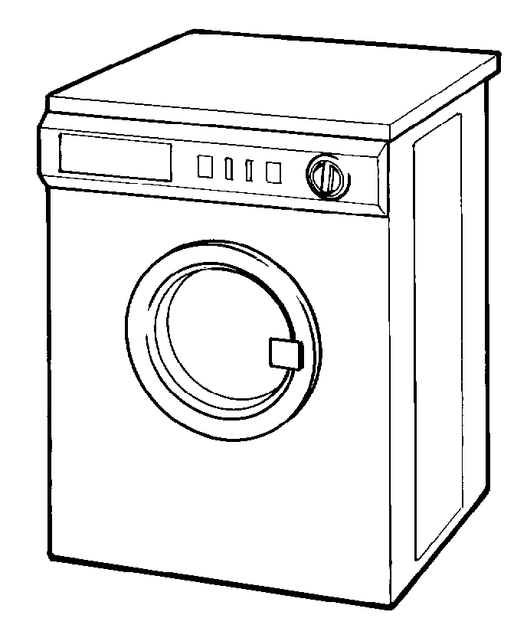

Contents

Guide for Teachers | 1
Introduction | 2
Systems Approach | 3
Sub-systems | 5
Control Systems | 7
Open-loop Control | 9
Closed-loop Control | 11
Negative and Positive Feedback | 13
Control Diagrams | 14
Error Detector | 15
Positional Control | 18
Sequential Control Systems | 19
End-of-Topic Assessment | 20

Guide for Teachers

The systems approach is used widely in industry as a tool for analysis of complex and sophisticated design problems.

Since the analysis of any problem must precede the designing – and subsequent manufacture – of solutions, it follows that the Introduction to Systems should be taught as the first unit of the Standard Grade Technological Studies course.

The systems approach will then be applied in other component units of the course and, indeed, continues through Higher and Advanced Higher Technological Studies.

The material in this unit should be presented sequentially, but it should be noted that whilst additional notes or textbooks are not required, the unit notes should not be offered as an open learning pack.

Opportunities for class discussion and debate arise at many points through the unit – these will form an important part of the teaching/learning process for sound knowledge and understanding of the systems approach.

Resources

No resources will be required for delivery of this unit.

Introduction

Technology influences all our lives so much that there is hardly a thing that is not affected by it. We take the term ‘technology’ to mean the things or products made by our society.

In our modern world there are so many new products being created that it is impossible for us to keep up and know everything about these developments. As technologists we need some help to use and understand all this technology. The strategy we use is called the top-down approach.
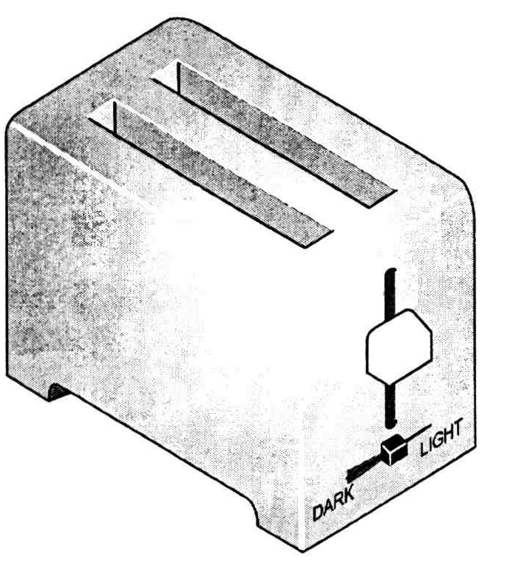

Here we limit the study of technology to what we need to know. For example, to use a toaster all we need to know is that if we plug it in, set the temperature, switch it on and insert a slice of bread then, after a few minutes, we will get toast. However, an engineer designing a new toaster will need to know a lot more and will have an understanding of all the parts that go to make up the toaster and how they relate to one another.

In order to simplify the difficulties of dealing with complex devices and machines, a method of analysis called the systems approach has been developed. It is based on the concept that any technological design or device can be described as a system and that this system can be split into smaller parts or sub-systems. Each sub-system deals with the function of a particular part of the design or device.

For example, the system diagram below describes a sound-mixing system used in the music department of a secondary school.

Rhythm

Even people with no training in the systems approach can look at a system diagram and gain an understanding of the function of the various elements of a system.

Systems Approach

We use system diagrams to show the top-down approach as we break down or analyse technology. All systems can be analysed in terms of input, process and output. A diagram called the universal system diagram consists of these three basic elements.
process
input
output
Universal system diagram

The output is the specified function performed by the system, (for example, the output of a kettle is ‘hot water’).

The system itself produces the output as a result of an input being supplied to it. (The input to a kettle is ‘cold water’.)

The system changes the input in some way to produce a different output. This change is called the process (heating the water).

All systems can be analysed in terms of input, process and output.

So when analysing or breaking a product down to help understand it, we first try to find the inputs and the outputs and show these on a system diagram. Take, for example, the toaster.

toaster
Plug in
Add bread
Set temperature
Switch on

Toast Heat

System diagram

To help find the inputs to and outputs from a system we usually ask:
- (input) what have I to do in order to make it work?
- (output) what does it do?

Assignment 1
Draw a system diagram showing the inputs to and the outputs from each of the following.

(a) torch (b) vacuum cleaner (c) kettle

(d) personal stereo (e) mobile phone (f) washing machine

Assignment 2
Complete the following system diagrams.

Assignment 3
Draw a system diagram based on the universal system, for each of the following.

kettle | television
exercise bicycle | garden hose
dishwasher | tumble dryer
radio | coal fire

Sub-systems

We have seen that the top-down approach is used when studying technology. This deals with technology on a need-to-know basis. For most people, knowing what they have to do to make the technology work (input) and what it does (output) is enough. However, we will be using technology to solve problems and so we need to break it down or analyse it in greater depth. To do this, we use a sub-system diagram as shown below.

input sub-system

process (control) sub-system

output sub-system
Output
Input
System boundary

The sub-system diagram shows the internal detail of the system. Each box, called a sub-system, can be thought of as a system within a system and has its own input and output. The dashed line around the sub-system is called a system boundary and this marks the area of interest to us. The ‘real world’ input and output are shown as arrows entering and leaving the sub-system diagram.

Consider a fairly complicated system, a washing machine. Most systems cannot operate entirely independently of other systems around them. A washing machine has a control system, which is electronic. It also has a water system using valves and pumps, which is a different system to the control system. However, for the washing machine to work, the control system and the water system must overlap each other. This can lead to confusion when drawing system diagrams. In order to isolate the system being considered, a system boundary is sometimes drawn. The system boundary is drawn as a dashed line right around the part of the system being considered, thus defining the limits of the system, as shown in the example below.
We would first complete a system diagram showing the inputs and outputs:
System diagram
washing machine
Plug in
Add clothes
Set washing cycle
Switch on
Add powder
Cold water
Hot dirty water
Clean clothes

As we require more detail about the system, it must now be broken down into its sub-systems. This is shown on the simplified sub-system diagram below.

Assignment 4
- Draw a sub-system diagram for the each of the following.

(a) torch (b) vacuum cleaner
(c) kettle (d) toaster

- Draw a sub-system diagram for a house alarm with a door sensor, panic button, keypad arm, control unit, siren and strobe-light alarm.

Control Systems

For any system to be effective, it must be adequately controlled.

Imagine the problems that might arise in your school if there was no-one:
- in charge
- taking responsibility for day-to-day activities
- ensuring that teachers were present and teaching their classes
- checking that pupils actually went to classes.

Such a scenario could hardly be called a system, much less an education system.

All types of system require some form of control to make the system work properly. A system may be based mainly around people (as in an education system) and is then known as a soft system. Systems based on manufactured components (as in a central heating system) are called hard systems. The emphasis of the Technological Studies course is on hard systems.

In many cases people do the controlling, especially in soft systems. However, hard systems are usually controlled automatically. Automatic control has become more and more common over recent years as technology has progressed. This type of control releases people from many of the boring and mundane jobs of watching machines operate, with only occasional adjustments to settings being necessary.

Control is absolutely central to the effective functioning of our society, from the streetlight that switches on automatically at night, through the air-conditioning in shops and offices and the autopilot in aeroplanes, to international electronic banking and the world wide web.

For this reason, control is also at the heart of the Standard Grade Technological Studies course and permeates every aspect of it.

Most hard systems have within them an element that is dedicated to the control of the main part of the system. This control element may be small in relation to the whole system or it may be the main part of the system.

In many cases, the control element of a system is important enough to be regarded as a system in its own right and it is then called a control system. Control systems can be split into two distinct types, either of which may be controlled manually or automatically.

- Manual control is performed by the actions of humans.
- Automatic control is performed by technological devices (often electronic).

As part of the systems analysis we also normally consider the type of control the system provides. There are two types of control:
- open-loop control
- closed-loop control.

Illustration of control – filling bath water for an elderly person
An elderly person can be forgetful. Take the example of an elderly man who each morning, when filling a bath, goes through the same routine. He turns on the tap, and then watches television whilst the bath is filling, frequently forgetting that the tap is still on.

This is an example of manual open-loop control. The bath continues to fill, and will eventually overflow, because nobody is there to turn off the tap.

Water
tap
handle
tap
valve
bath
level
flood
Person

Because the bath has flooded several times recently, the elderly man’s son decides to visit each morning and fill the bath. He turns on the tap, stands and watches until the bath is full enough and then turns off the tap.

This is an example of manual closed-loop control.

Water
tap
handle
tap
valve
bath
level
bath ready

hand

eyes
son’s brain
(control)

However, the son is a very busy man and cannot afford the time taken to fill the bath.

The elderly man’s granddaughter studies Standard Grade Technological Studies and designs an automatic closed-loop control system for filling the bath. She replaces the hand-operated tap with an electrically operated valve, makes a control unit and fits a level sensor at the depth Grandad likes.

water
valve
bath
level

Water

level sensor
control
unit
fill switch
Press

Grandad just has to press the ‘fill’ switch, and everything is done automatically. When the level sensor is activated by the water reaching the correct level, it feeds back a signal to the control unit, which switches off the water supply.

Clearly this illustration is extreme but it does show open- and closed-loop control in operation.
Open-loop Control

At the simplest level a control system can process an input condition to produce a specified output.

This is the simplest acceptable level of control. It is also the most common form of control system, used widely in domestic and industrial systems because it is cheap to install and simple to operate.

In open-loop control the input action causes a resulting output.

Domestic lighting systems usually have open-loop control. The input is the action of pressing the light switch and the output is light from the filament of the bulb.

A system diagram for the light is shown below.

light
switch
lamp
filament
glass
bulb
Action light

This is called an open-loop control system diagram. Here, it describes a manual open-loop control system.

Another good example of this type of control is a hairdryer.

In the hairdryer the heating element and fan motor are switched on when the appropriate switches are held down. This is shown on the sub-systems diagram below.

heat control sub-system

heating
element

Heater only on when switched on

motor

fan

on/off control sub-system

Cold air

Sound energy

Hot air
Switch on

Electrical energy

Set temperature level

Here the input signal from the on/off and temperature switch is processed to produce the output. The output air is not monitored or adjusted in any way and it is just blown out at whatever temperature the heater warms it to.

An open-loop control system is the simplest and cheapest form of control. However, although open-loop control has many uses, its basic weakness lies in its inability to adjust the output to suit the requirements.

Closed-loop Control

This is the most sophisticated form of control.

In closed-loop control the value of the output is constantly monitored as the system operates and this value is compared with the set (or reference) value. If there is any difference between the actual value and the set value (an error), then the input to the system is varied in order to reduce the output error to zero.

Closed-loop control is a more accurate system of control and at the same time more expensive. It employs self-monitoring, where a sensor is used to read the condition being controlled and adjust the output if necessary. This monitoring takes place through a feedback loop. Here an input sensor checks the output and adjusts it when it does not meet the requirements.

Closed-loop control systems are therefore capable of making decisions and adjusting their performance to suit changing output conditions. An example is a thermostatically controlled fan heater.
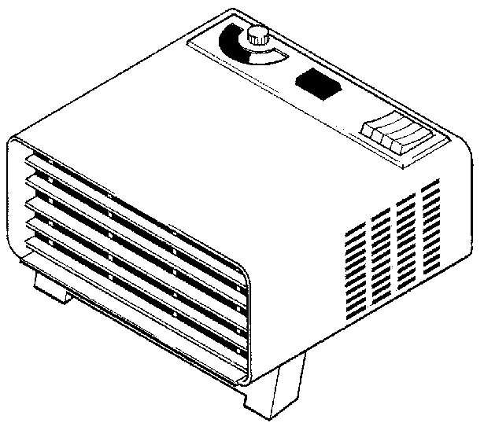

The sub-systems diagram for the heater is shown below.

on/off control

motor

fan

heater

thermostat
Switch on

Electrical energy
Hot air at required temperature
Set temperature
In this example a thermostat monitors the output temperature and switches the heater on when it is too cold and off when the temperature is at the required or set level.

All closed-loop control systems include a sensing sub-system that feedbacks information to the control sub-system. The control sub-system will process this feedback signal and make a ‘decision’ on whether to alter the output.

Note that in closed loop systems the feedback loop is not necessarily a physical link between the sensor and the output. Instead the sensor monitors the environment that the output is controlling.

In the system diagram you should note that the diagram now forms a continuous loop that can be followed round repeatedly as the system operates.

This is why the system is called closed-loop and the comparison with open-loop becomes much clearer.

The line representing data flow from the output back to the input is called the feedback loop and the signal from the output back to the control sub-system is sometimes called the feedback signal.

A closed-loop system can always be identified by the presence of a feedback loop.

An open-loop system never has a feedback loop.

Assignment 5
Draw a sub-systems diagram for a fridge with a thermostat, control unit, coolant pump, door switch and light.

Assignment 6
- State three examples of manual open-loop control. Draw a system diagram for each one and show the system boundary.
- State three examples of manual closed-loop control. Draw a system diagram and show the system boundary.
- State three examples of automatic closed-loop control. Draw a system diagram and show the system boundary.

Negative and Positive Feedback

The purpose of closed-loop control is to ensure that the output is maintained at, or as closely as possible to, the desired level. In the case of a central heating system, a graph of the temperature in a room might appear as below:

As can be seen from the graph, the control system is constantly trying to pull the temperature of the room back towards the set temperature level by reducing the error. This type of control uses negative feedback to reduce the error.

Reinforcing or increasing the error can create the opposite effect, for example in a public address system when the microphone is held too close to the speakers. A sound is picked up by the microphone, amplified and then output through the speaker. The amplified sound is then picked up, re-amplified and so on. The net result is a high-pitched sound caused by the feedback and this can be represented by the graph below:

This is an example of positive feedback where the error is increased. Although positive feedback does have some useful applications, negative feedback is far more widely used in control systems.

Control Diagrams

Example 1: temperature control in a gas oven
The specification of the control system is given below.

The required temperature is set on a dial on the control panel of the cooker (the set or reference value). A temperature sensor constantly monitors the output (oven temperature) and produces a signal representing the actual temperature.

The actual signal is fed back to a control element, which compares it with the set signal. Any difference between set and actual signals produces an error signal, which causes the control element to either decrease or increase the input (gas flow) in order to reduce the temperature error to zero. In automatic control systems, the signals are usually voltage signals.

inlet valve
burner
oven
Gas
control unit
temperature
sensor

Set value

actual value

The control unit shown in the system diagram above performs two functions.

- The set and actual values are compared.
- Any resulting error is used to vary the input sub-system as required.

A more detailed diagram, sometimes called a control diagram, may be drawn. This shows the control unit in more detail.

The control diagram includes an error detector. It compares the actual value to the set value.
Error Detector

The error detector symbol, shown below, is included in control diagrams.

Inside the error detector the actual value is subtracted from the set value and the resultant value is the error signal. The error signal changes the state of the input device in a way that tends to reduce the error.

The operating conditions of the error detector are summarised below.

actual value |  | set value | error signal | input change
V_{a} | = | V_{s} | nil | none
V_{a} | < | V_{s} | +ve | increase
V_{a} | > | V_{s} | -ve | decrease

All closed-loop control systems include an error-detection function. In manual closed-loop control systems the brain is the error detector.

In automatic closed-loop control systems the error detection is usually performed electronically by a device called an operational amplifier.

Example 2
A sub-systems diagram for an automatic heater is shown below.

Room heated automatically

Set switch on temperature

control
sub-system

output driver

heater
temperature sensor
Switch on

cold

Set level

Electrical energy

When working with control systems instead of using a sub-systems diagram a control diagram may be drawn. The control diagram for the automatic heater is shown below.

Darkness sensor

control
sub-system

Room heated automatically

output driver

temperature sensor

heater
+
Switch on

cold

Set level
Electrical energy

The control diagram breaks the ‘control’ sub-system into more specific blocks. If there is closed-loop control then the diagram will include an error-detection symbol. The symbol shows how the two signals, the set level signal and the feedback signal, will be compared.

The error detection symbol is also used to indicate that the control involves two signals. The feedback signal is connected to the negative symbol to indicate the use of negative feedback.

Assignment 7
Explain the following terms when applied to control systems:
- open loop
- closed loop
- negative feedback
- positive feedback
- error detector.

Assignment 8
- Draw a control diagram showing the manual closed-loop control system for a cyclist steering a bicycle.

Draw a control diagram showing the automatic closed-loop control system for the cruise-control in a car.

In each case show the system boundary and identify the feedback loop.

Positional Control

A good example of positional control is the model servo-motor commonly found in radio-control cars and aeroplanes.
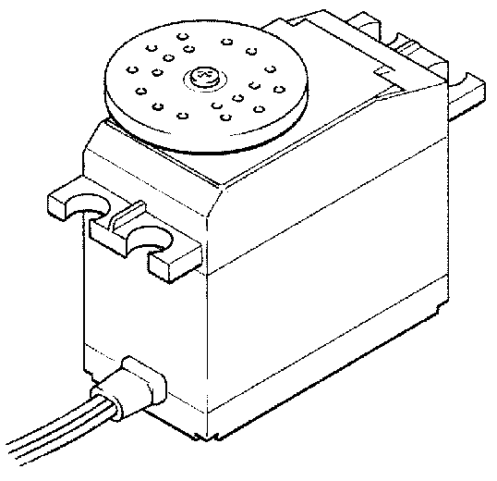
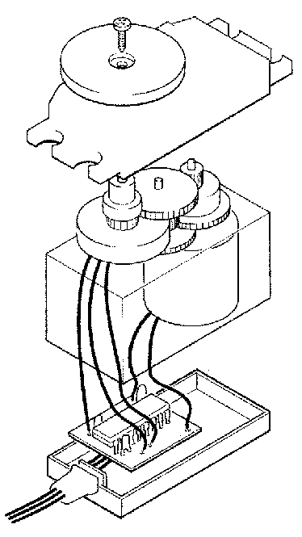

Servo-motor

The servo contains a motor, gearbox, feedback potentiometer and electronic control circuit on a small printed circuit board.

The feedback potentiometer is directly connected to the output shaft. Therefore, when the motor spins, the output shaft is turned slowly by the gearbox, which in turn moves the potentiometer. The movement of the output shaft is restricted to 180º as the potentiometer cannot spin continuously.

The control diagram for the servo system is shown below.

Darkness sensor

control
sub-system

Constant position

output driver

potentiometer (feedback)

motor
+

Set position

Electrical energy

Note how the feedback signal from the potentiometer is fed into the negative symbol of the control diagram, indicating negative feedback.

Sequential Control Systems

Sequential control is used where the outputs are required to follow a fixed cycle of events; that is to switch on or off in a particular sequence.

An interesting example of sequential control was that used in music boxes. Pins sticking out on the drum are arranged to produce notes; as the drum rotates the notes are played in the correct sequence to produce a tune.

A more modern example of sequential control is a robot arm used to weld cars together on a large production line.

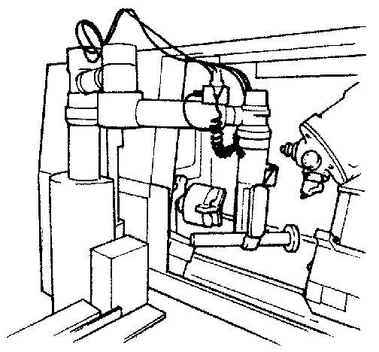

Most modern sequential control systems use electronics or microcontrollers. For example, microcontroller chips are used to control traffic light sequences and for the timing of clocks and defrosting programmes.

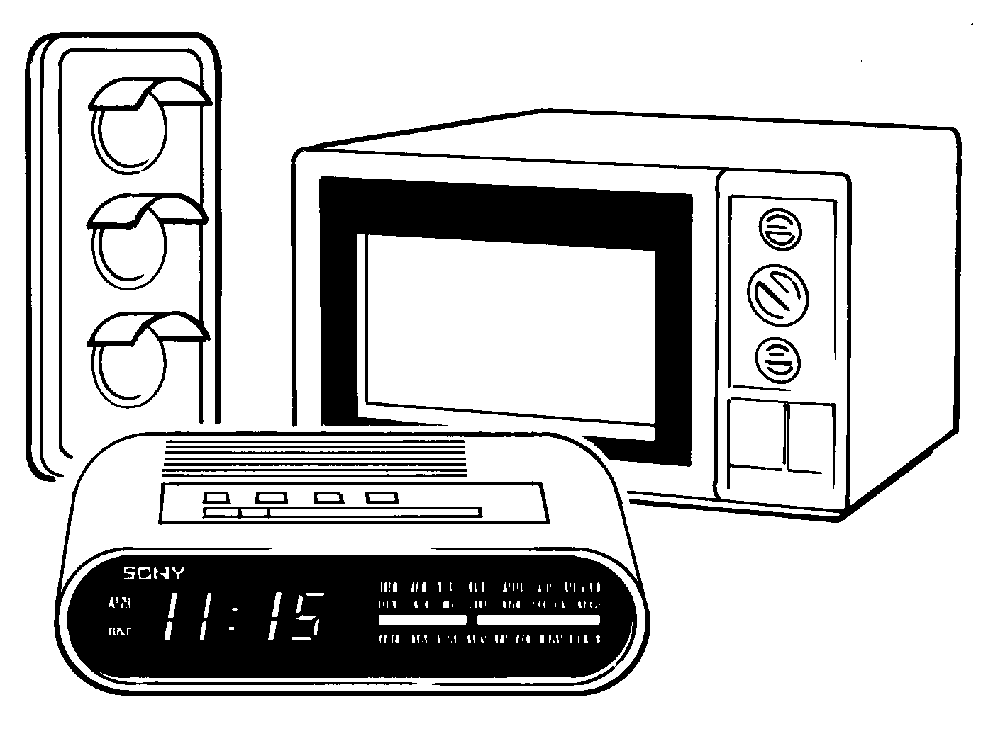

End-of-Topic Assessment

1. A control diagram for a car’s cruise control is shown below.
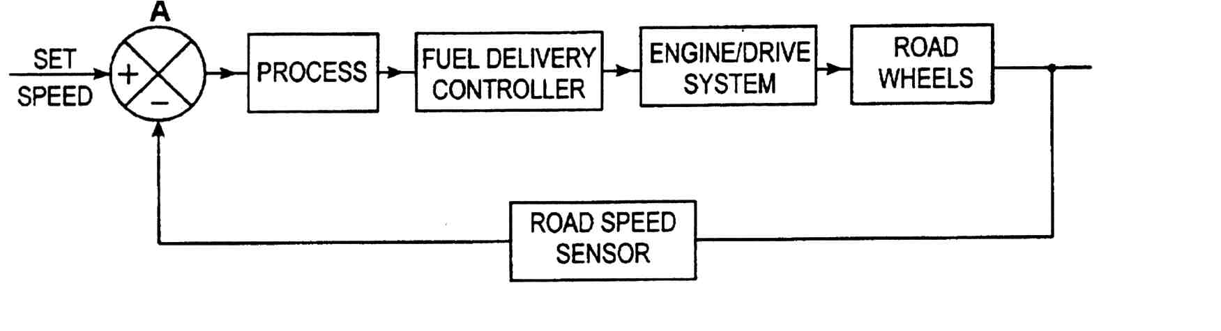

(a) What type of control is used in this system? (1)

(b) Name component A and describe its function and operation in this system. (4)

(c) Describe how the complete speed control system operates. (6)

2. A vacuum cleaner and electric iron are shown below.
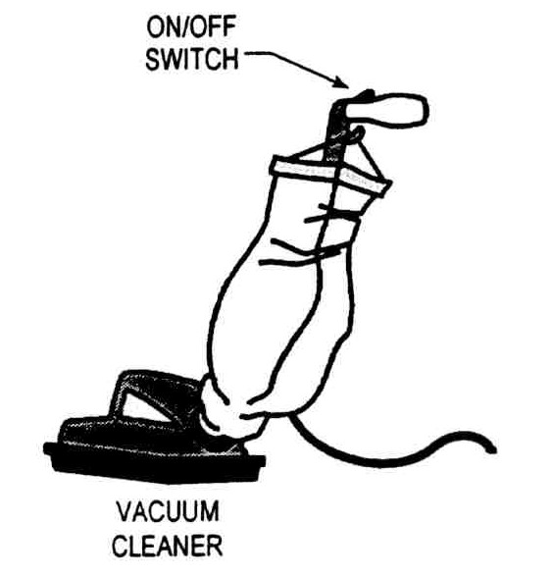
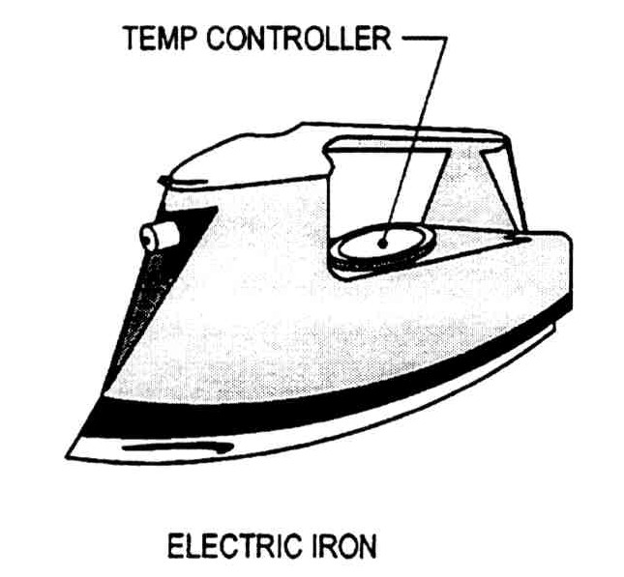

(a) Draw a control diagram for the vacuum cleaner. (3)

(b) Draw a control diagram for the iron. (4)

(c) Name the type of control used in each of these items. (2)

