Logic in Electronics
Contents

Switching logic | 121
Making decisions | 121
Logic gates | 121
Integrated circuits | 122
The NAND logic gates | 123
The NOR logic gate | 124
Boolean expressions | 125
Logic in simple component circuits | 126
NAND gate technology | 128
Binary numbers | 130
The decimal system | 130
The binary system | 130
Combinational logic | 132
Truth tables for combinational logic systems | 133
Dealing with NAND and NOR gates in combinational logic | 137
Creating logic diagrams from truth tables | 139
Creating logic systems from written specifications | 141
Logic gate integrated circuits (ICs) | 145
Logic ICs in prototype board circuits | 146
Pin-out diagrams | 147
Pin-out diagrams for common TTL logic Ics | 147
Practical tasks | 150

Switching Logic

Making decisions

Although it may not always seem like it, electronics and electronic systems are very logical in the way that they work. In the simplest form, if you want a light to come on, then you press a switch. Of course, it gets more complicated than that. Most technological systems involve making more complicated decisions: for example, sorting out bottles into different sizes, deciding whether a room has a burglar in it or not, or knowing when to turn a central heating system on or off.

Logic gates

Logic gates are very useful in dealing with and processing a combination of different inputs. This switching logic can be applied to electrical switches and sensors, pneumatic valves or hydraulic systems. Switching logic uses logic gates to perform decisions. In previous work you have already seen NOT, AND and OR logic gates.
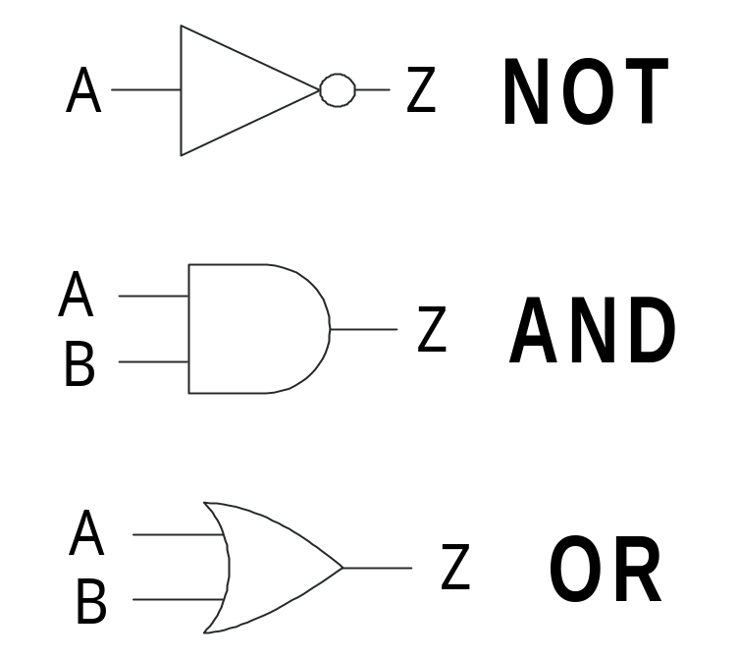

It is worth remembering that logic gates are part of digital systems and, as such, respond to either logic 1 or logic 0 signals only.

Integrated circuits

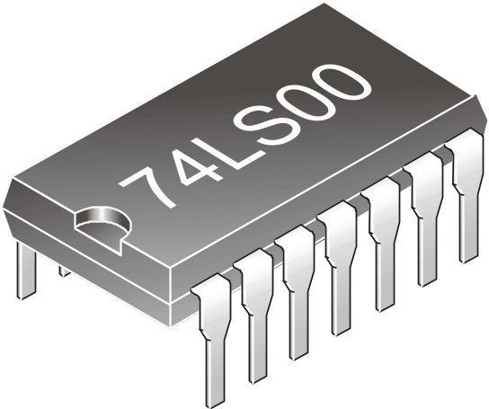
Although logic gates have electronic symbols, they are not discrete components: they are contained in integrated circuits. A typical example is the TTL7400 IC shown below. (The LS part gives more information about the chip for users.)

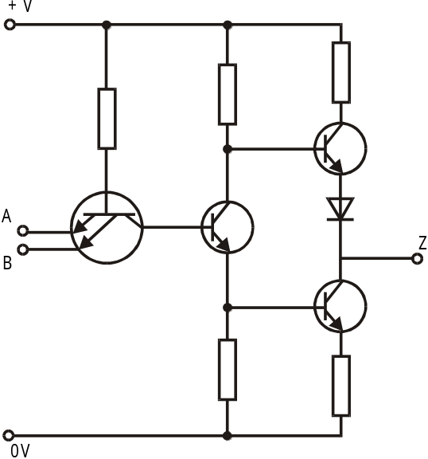Integrated circuits (ICs) are silicon-based components containing complex circuits. The simplest 14-pin IC that you will deal with is the TTL 7400 shown above. TTL stands for transistor−transistor logic. The 7400 chip effectively contains four NAND logic gates. Each NAND gate has the following transistor circuit.
From this circuit diagram, it is easy to see why the term transistor − transistor logic is used.

NAND logic gates are a combination of NOT and AND logic gates − see the following page.

The NAND logic gate

The NAND gate is effectively an inverted AND gate. In other words, the results obtained from the output are the opposite to those of the AND gate. This gate is often referred to as ‘NOT AND’.

When drawing up the truth table for the NAND gate it can be difficult to ‘picture’ or imagine the results. The best way to do this is to pretend that it is an AND gate and then invert (reverse) the results, thus giving you the outputs for the NAND gate.

A | B | AND | Z
0 | 0
0 | 1
1 | 0
1 | 1

Truth table
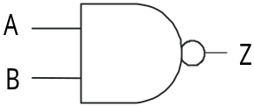
Symbol for NAND Gate

Practical task
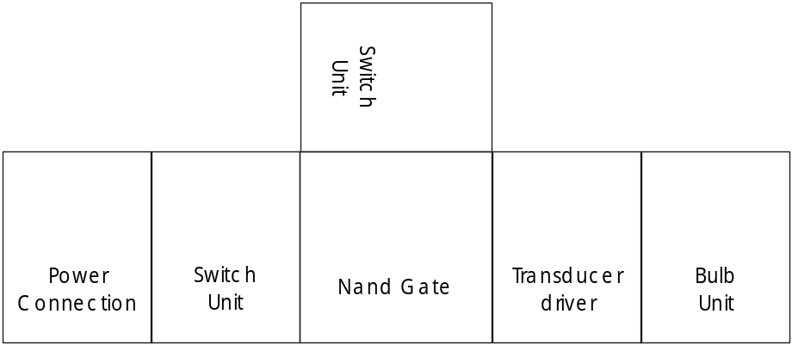Copy out the NAND gate symbol, the truth table and the block diagram.

Set up the E&L modular board electronic system and complete the table using the system to confirm the outputs at Z.

Note: This task can be completed using a circuit simulation software package such as Crocodile Clips.

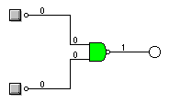

The NOR logic gate

The NOR gate is effectively an inverted OR gate. In other words, the results obtained from the output are the opposite to that of the OR gate. This gate is often referred to as ‘NOT OR’.

As with the NAND gate, when drawing up the truth table for the NOR gate it can be difficult to ‘picture’ or imagine the results. The best way to do this is to pretend that it is an OR gate and then invert (reverse) the results, thus giving you the outputs for the NOR gate.

A | B | OR | Z
0 | 0
0 | 1
1 | 0
1 | 1

Truth table
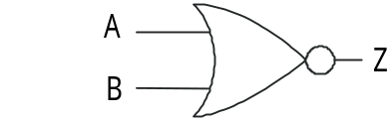

Symbol for NOR gate

Practical task
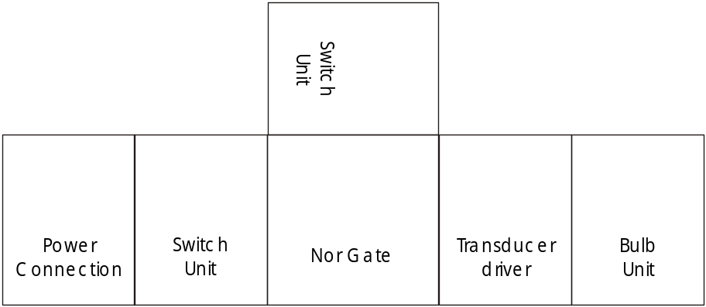Copy out the NOR gate symbol, the truth table and the block diagram.

Set up the E&L modular board electronic system and complete the table using the system to confirm the outputs at Z.

Note: this task can be completed using a circuit simulation software package such as Crocodile Clips.
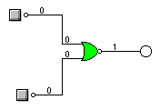

Boolean expressions

Each logic gate has a corresponding Boolean mathematical formula or expression. The use of these expressions saves us having to draw symbol diagrams over and over again.

The name Boolean is taken from an English mathematician, George Boole, who founded symbolic logic in the nineteenth century.
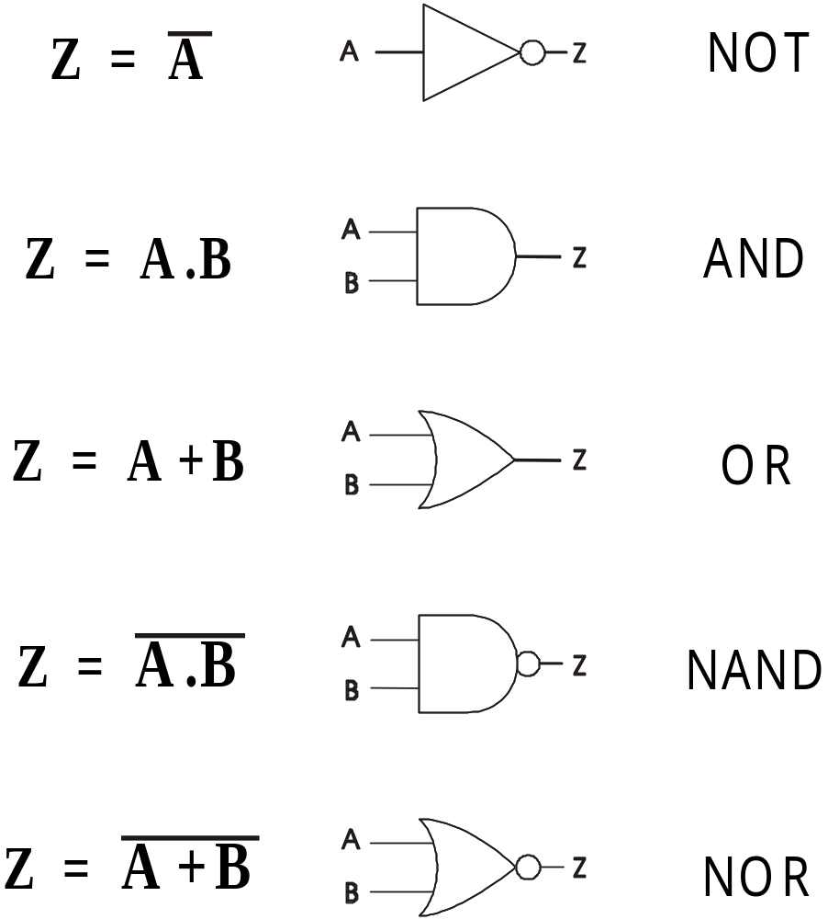

Logic in simple component circuits

Boolean logic can also be seen in simple component circuits as well as in pneumatic, hydraulic and other systems.

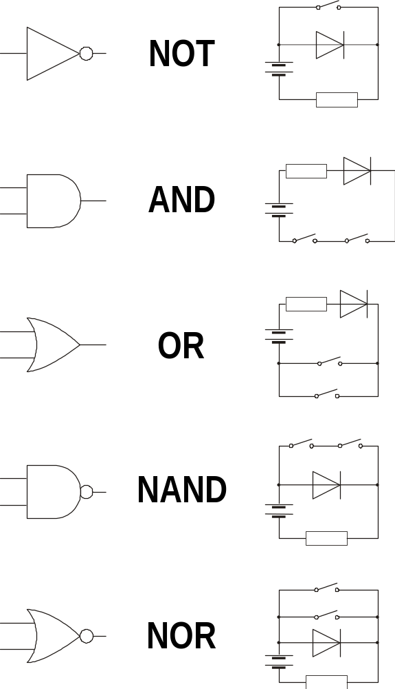The circuits below show the five main types of logic.

Logic gate exercises
For each of the following examples, state whether the output Z is at logic 0 or logic 1.

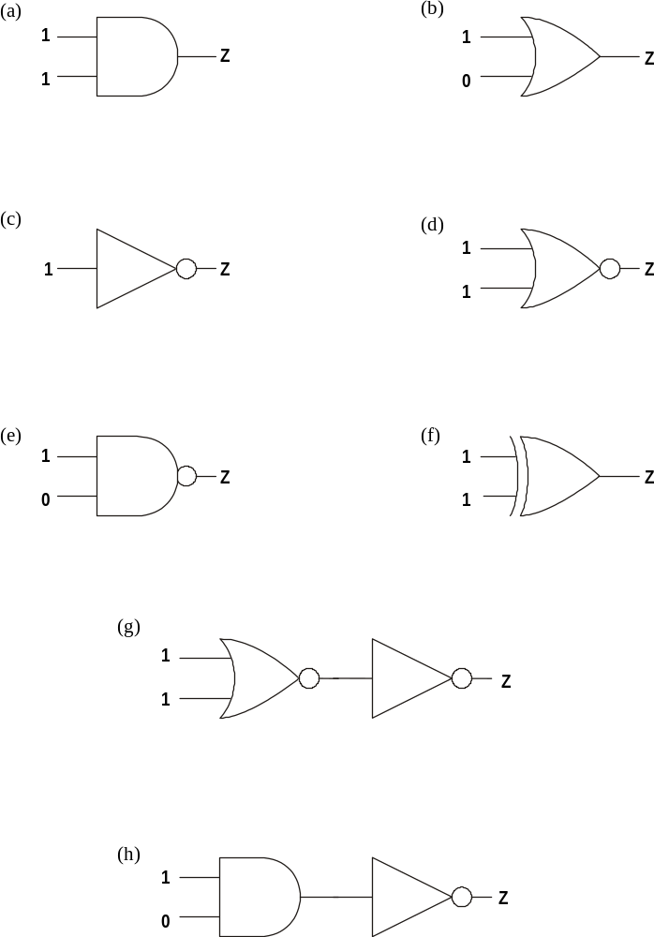

NAND gate technology

NAND gate technology can be used to build other logic gates using NAND gates only. (The same thing can be achieved using NOR gates, but NAND gate chips are more common.)
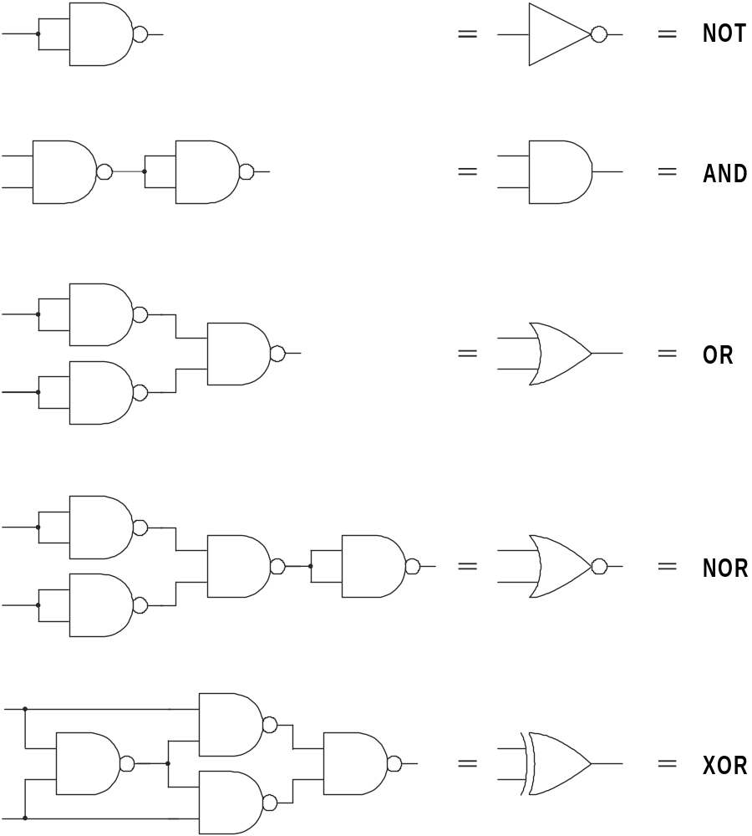

Many manufacturers use only one type of gate (normally NAND) in the manufacture of their products. This has several advantages.

- You only have to stock one type of chip instead of a large range.
- People only have to be familiar with the characteristics of this one chip.
- Very often significant simplification of complex circuits is possible, thus reducing the number of chips required.

NAND gate problems
Redraw the following logic systems replacing the logic gates with combinations of NAND logic gates. Use the equivalents shown on the previous page.

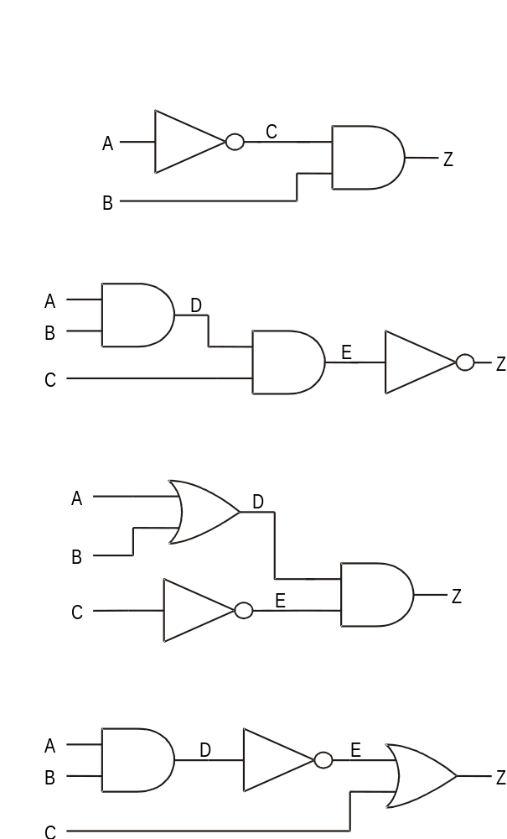

Binary numbers

The number system that we use is the decimal system; that is, we use a scale of ten. This decimal system uses 10 different digits: 0, 1, 2, 3, 4, 5, 6, 7, 8, and 9. You should have noticed that truth tables use only two digits, 0 and 1. This is called a binary system and it uses combinations of the digits 0 and 1 to form binary numbers.

The decimal system

The table below shows the decimal system of counting. The values of the columns (of the left-hand table) working from right to left are 1, 10, 100 and 1000. These can be written as powers of ten: 10⁰, 10¹, 10², and 10³. As indicated above, this type of counting is called decimal and uses a base of 10.

Decimal |  |  |  |  | Binary
10³ | 10² | 10¹ | 10⁰ |  | 2⁴ | 2³ | 2² | 2¹ | 2⁰
1000 | 100 | 10 | 1 |  | 16 | 8 | 4 | 2 | 1
 |  |  | 0 |  |  |  |  |  | 0
 |  |  | 1 |  |  |  |  |  | 1
 |  |  | 2 |  |  |  |  | 1 | 0
 |  |  | 3 |  |  |  |  | 1 | 1
 |  |  | 4 |  |  |  | 1 | 0 | 0
 |  |  | 5 |  |  |  | 1 | 0 | 1
 |  |  | 6 |  |  |  | 1 | 1 | 0
 |  |  | 7 |  |  |  | 1 | 1 | 1
 |  |  | 8 |  |  | 1 | 0 | 0 | 0
 |  |  | 9 |  |  | 1 | 0 | 0 | 1
 |  | 1 | 0 |  |  | 1 | 0 | 1 | 0
 |  | 1 | 1 |  |  | 1 | 0 | 1 | 1
 |  | 1 | 2 |  |  | 1 | 1 | 0 | 0
 |  | 1 | 3 |  |  | 1 | 1 | 0 | 1
 |  | 1 | 4 |  |  | 1 | 1 | 1 | 0
 |  | 1 | 5 |  |  | 1 | 1 | 1 | 1
 |  | 1 | 6 |  | 1 | 0 | 0 | 0 | 0

The binary system

As stated above, the binary system uses only two digits, 1 and 0. This system is suited to digital systems in electronics, where 1 represents ON or HIGH and 0 represents OFF or LOW.

The right-hand table shows the binary equivalents of the decimal numbers in the table on the left. The values of the columns working from right to left are 1, 2, 4, 8, and 16. These can be written in powers of 2: 2⁰, 2¹, 2², 2³ and 2⁴.

Examples
The number 7 in decimal is 111 in binary: (one 4) + (one 2) + (one 1) = 7.
The number 13 in decimal is 1101 in binary: (one 8) + (one 4) + (no 2) + (one 1) = 13.

Binary number problems
- Change the following decimal numbers to binary numbers.

 | Decimal | Binary
(a) | 23
(b) | 41
(c) | 39
(d) | 57
(e) | 50
(f) | 67
(g) | 74
(h) | 93
(i) | 114
(j) | 85

- Change the following binary numbers to decimal.

 | Binary | Decimal
(a) | 11
(b) | 1001
(c) | 1100
(d) | 1101
(e) | 101
(f) | 110
(g) | 1111
(h) | 10000
(i) | 10001
(j) | 11011

Combinational logic

So far in this unit of work we have only looked at simple logic systems on their own. In reality, most logic systems use a combination of different types of logic gates in one system. This type of logic control is known as combinational logic.

For example, if you study the simple block diagram of the electronic system below, you will notice it has an AND gate, an OR gate and an inverter (NOT gate) in it.
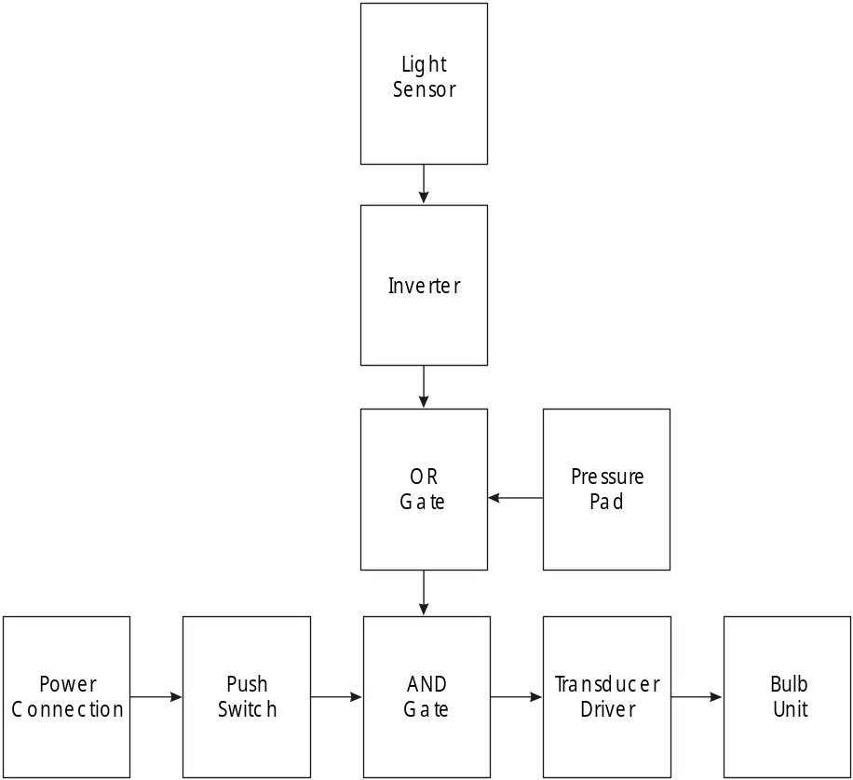

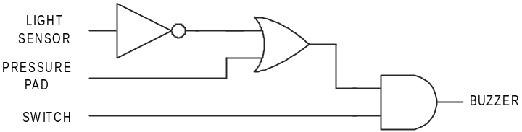We can draw a logic diagram of this system, as shown below. There is more than one logic gate in this diagram and so it is known as a combinational logic diagram.

Questions
1. What is this system designed for?
2. What is the purpose of the AND gate?
3. Why is the inverter (NOT gate) included?

