Revised Standard Grade Technological Studies

Programmable Control
Contents

Students’ Notes | 1
Section 1: Electronic Control Systems | 3
Section 2: The Stamp Controller | 11
Section 3: Inside a Microcontroller | 27
Section 4: Using Inputs | 44
Section 5: Number Systems | 55
Section 6: Stepper Motors | 58
Section 7: Analogue Sensors | 62
Section 8: Project Assignments | 69
Teacher’s Notes | 73
Introduction | 75
General Notes on Using the Stamp Controller | 76
Serial Port Information for PC Users | 78
Standard Programming Format | 80
PBASIC Commands | 81
Equipment List | 82
Software and Minimum Computer Specifications | 86
Contact Addresses | 87
Answers to Assignments | 88
Programming with PBASIC | 137
Programming with PBASIC | 139
Switching outputs on and off | 139
Detecting inputs | 140
Using symbols | 141
‘For … next’ loops | 142
Sub-procedures | 143
Data sheets | 144
Input module | 144
Two digital inputs and two analogue sensors | 146
Output Driver module | 148

Students’ Notes

Contents

Section 1: Electronic Control Systems | 3
Introduction | 3
System diagrams | 4
Case study – an electronic toy | 5
What is a microcontroller? | 9
Section 2: The Stamp Controller | 11
Summary – programming procedure | 12
Downloading a sample program | 13
Windows software instructions | 14
Flowcharts | 15
Continuous loops | 16
Converting a flowchart into a control program | 19
Continuous loops | 21
Using symbols | 23
Section 3: Inside a Microcontroller | 27
Memory (ROM and RAM) | 28
Arithmetic/logic unit (ALU) and clock | 28
Buses | 28
Connecting output transducers to the stamp controller | 29
The motor driver | 31
Noise suppression capacitors | 31
Controlling motors | 32
Speed control of d.c. motors | 34
For … next loops | 37
Sub-procedures | 42
Section 4: Using Inputs | 44
Digital sensors | 44
The input module | 45
Section 5: Number Systems | 55
Notation | 56
Bits and bytes | 56
Converting decimal to binary | 57
Section 6: Stepper Motors | 58
Section 7: Analogue Sensors | 62
Light-dependent resistor (LDR) | 63
Thermistor | 64
Variable resistor (potentiometer) | 64
The input module | 65
Section 8: Project Assignments | 69
Project briefs | 69
PBASIC commands | 71

Section 1: Electronic Control Systems

Introduction

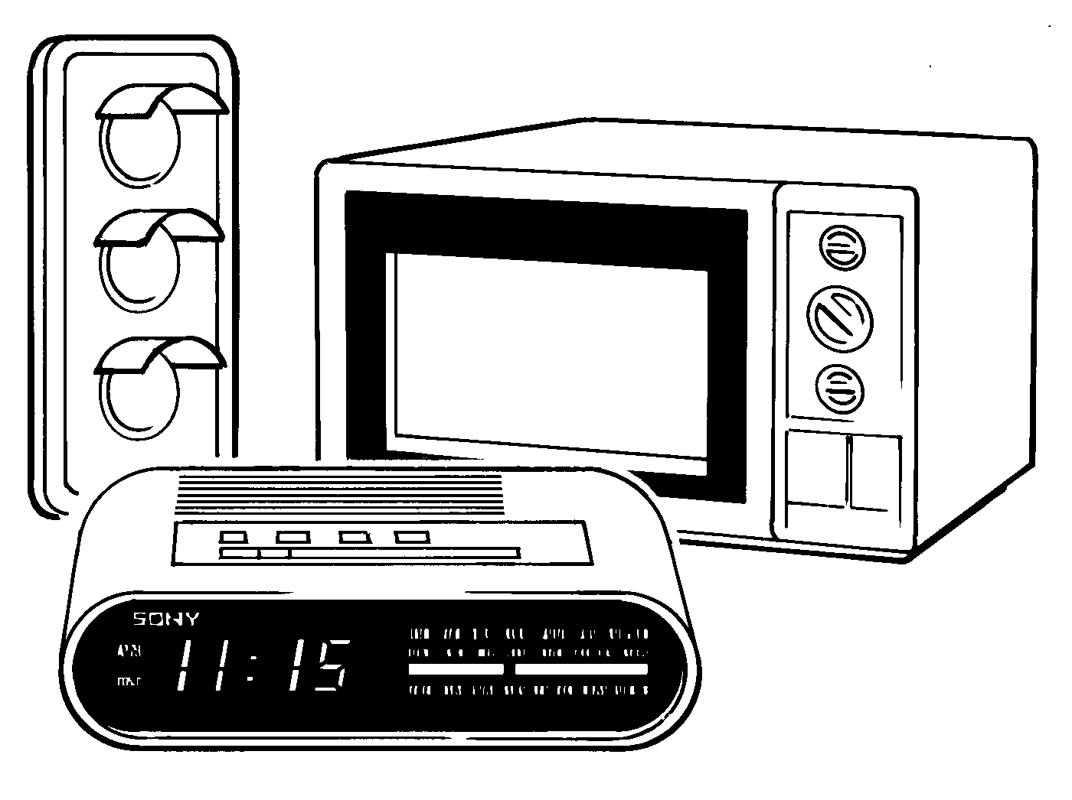

Many electronic devices have been developed to make life easier (for example a microwave), to make life safer (for example traffic lights), to help with work (for example a computer) and for entertainment purposes (for example computer games consoles).

Some of these devices are purely electronic devices (for example a digital watch). However, many of these devices also control mechanisms (for example the eject mechanism in a video recorder) and so can be described as mechatronic devices.

However, both electronic and mechatronic devices all have one thing in common – an electronic control system.

Any electronic control system can be broken down into three distinct parts. This can be shown as a block diagram containing INPUT – PROCESS – OUTPUT blocks.

Assignment 1.1
- List three electronic devices.

List three mechatronic devices. Explain the ‘mechanism’ in each of the three mechatronic devices listed.

System diagrams

A system diagram is a more detailed block diagram that also shows the real-world input signals (for example light or heat) and the real-world output signals (for example movement or sound).

Therefore, the system diagram for a warning device for a freezer in a restaurant would be drawn as below. The buzzer would sound if the temperature in the freezer passed a certain level.

Case study – an electronic toy



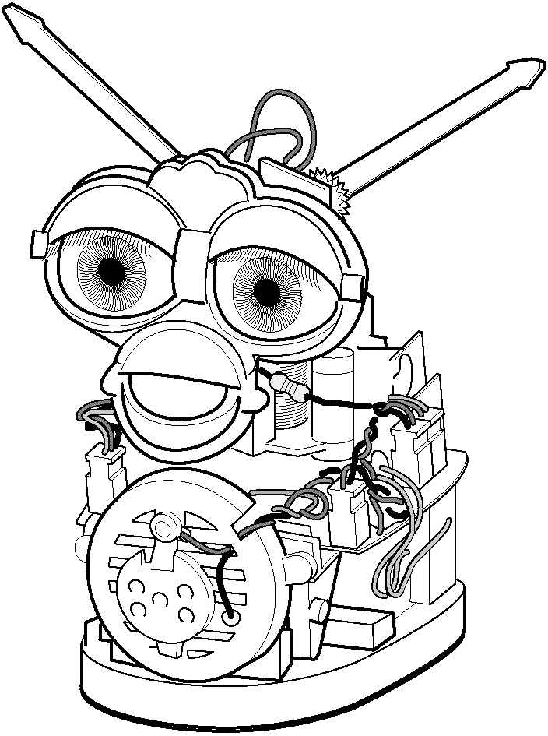

A popular electronic toy is shown above. This is a good example of a mechatronic system, as it uses an electronic circuit to control a number of mechanisms. It also contains a number of sensors so that it can react to changes when it is moved (for example being put in a dark place or being turned upside down).

Input transducers are electronic devices that detect changes in the ‘real world’ and send signals into the process block of the electronic system. Some of the input transducers for the electronic toy are:
- push switches on the front and back to detect when the toy is being ‘stroked’, and a switch in the mouth to detect when the toy is being ‘fed’
- a light-dependent resistor (LDR) between the eyes to detect if it is light or dark
- a microphone to detect noises and speech
- a tilt switch to detect when the toy is being turned upside down
- an infrared detector to detect infrared signals from other toys.

Output transducers are electronic devices that can be switched on and off by the process block of the electronic system. Some of the output transducers of the electronic toy are:
- a d.c. motor to make the eyes and mouth move
- a speaker to produce sounds
- an infrared LED (light-emitting diode) to send signals to other toys.

Assignment 1.2
Draw a systems diagram for the electronic toy described above.

Assignment 1.3
List the input and output transducers for the following devices.

(a) Washing machine
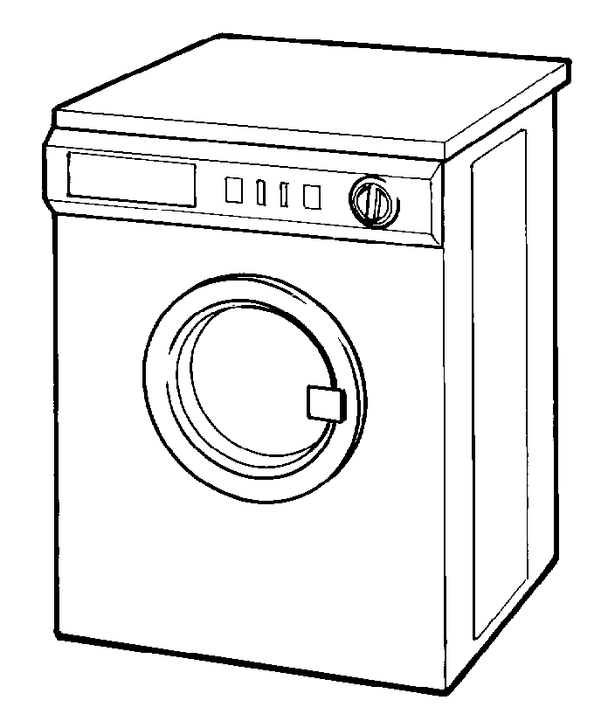
(b) Personal stereo
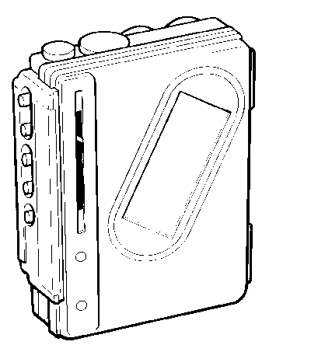
(c) Vending machine

(d) Hairdryer

What is a microcontroller?

A microcontroller is often described as a ‘computer-on-a-chip’. Microcontrollers have a controller and memory all built into a single chip. As they are small and inexpensive they can easily be built into other devices to make these products more intelligent and easier to use.

Microcontrollers are usually programmed for a specific electronic product − for instance, a microwave oven may use a single microcontroller to process information from the keypads, display user information on the seven-segment display or control the output devices (turntable motor, light, bell and magnetron).
Microcontrollers are single-chip ‘computers’ designed to control specific processes or products. The microcontroller is programmed with a program to complete the desired task. By altering this program, the same ‘brand’ of microcontroller can be used to complete different tasks. The same microcontroller device can therefore be used in a range of different products by simply programming it with a different program.

One microcontroller can often replace a number of separate parts, or even a complete electronic circuit. Some of the advantages of using microcontrollers in a product design are:
- increased reliability and reduced quantity of stock (as one microcontroller replaces several parts)
- simplified product assembly and smaller end products
- greater product flexibility and adaptability since features are programmed into the microcontroller and not built into the electronic hardware
- rapid product changes or development by changing the program and not the electronic hardware.

Applications that use microcontrollers include household appliances (for example a microwave), alarm systems (for example a fire alarm), medical equipment (for example an incubator for premature babies) and electronic equipment (for example a computer mouse).

Assignment 1.4
List the advantages of using a microcontroller within a product design.

Assignment 1.5
List three devices that may contain a microcontroller. Explain why you think it would be useful to have a microcontroller in these devices.

Section 2: The Stamp Controller

The stamp controller system consists of three main components.

The ‘Basic Stamp’ software
This software runs on a computer and allows you to use the computer keyboard to type in programs.

The serial cable
This is the cable that connects the computer to the stamp controller. The cable needs to be connected only when downloading programs. It does not have to be connected when the stamp controller is running because the program is stored on the stamp controller board – even when the power supply is removed!

The stamp controller
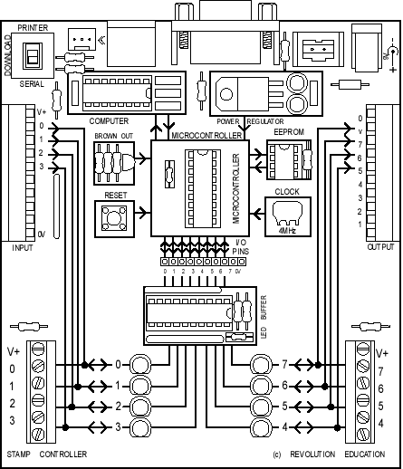
The stamp controller ‘runs’ programs that have been downloaded to it. It has indicator LEDs to show which outputs and inputs are on or off, and has connectors for the input and output modules.

The ‘brain’ of the stamp controller board is the 18-pin microcontroller chip in the centre of the board. The program is stored in the 8-pin EEPROM (Electronically Erasable Programmable Read Only Memory) chip. This type of memory can be reprogrammed when desired, but it also keeps the program when the power supply is removed. This means the stamp controller will start to run the program currently in the memory whenever the power supply is connected.

When the power supply is connected to the stamp controller board, the microcontroller ‘reads’ the program from the EEPROM memory chip. It then carries out the program as instructed. The program can contain instructions (‘commands’) to switch outputs on and off, to react to inputs or to pause for time delays. The stamp controller is extremely fast – it can process over 1000 instructions in a second!

Summary − programming procedure

- Draw a flowchart for the control task.
- Write the program on the computer using the Stamp software.
- Connect the download cable from the computer to the stamp controller.
- Connect the power supply to the stamp controller.
- Use the Stamp software to download the program. The download cable can then be removed after the download.

The program will start running on the stamp controller automatically. However, the program can also be restarted at any time by pressing the reset switch.

Downloading a sample program

The following PBASIC program switches pin 7 on and off every second. When you download this program, the red LED 7 on the stamp controller should flash on and off every second.

main:
high 7
pause 1000
low 7
pause 1000
goto main

This program uses the ‘high’ and ‘low’ commands to control pin 7, and uses the ‘pause’ command to make a delay.

The last ‘goto main’ command makes the program ‘jump’ back to the label ‘main’ − at the start of the program. This means the program loops forever. Note that the first time the label is used it must be followed by the colon (:) symbol. This tells the computer that the word is a new label.

Activity 2.a
Start up the Stamp software and key in the program above. Save the program and then download it to the stamp controller by clicking ‘Run’. See the instruction sheets on the next two pages, which explain how to do this for both the Windows and Acorn Stamp software.

If you have the stamp controller connected correctly, after a few seconds you should see a ‘download successful’ message on the computer screen, and the red LED 7 on the stamp controller should start flashing.

If you get an error message check that you have not made a spelling mistake in the program, and that the stamp controller is connected to both the power supply and the computer.

Important note: if the computer gives an error message on the line containing ‘switch’ you may have the software in the wrong mode. Check that the software is in ‘PBASIC’ mode.

Windows software instructions

Toolbar short cuts

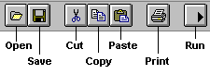

To download/run a program:
- check that the download cable is connected to the stamp controller and the computer’s serial port
- check that the power supply/battery is connected to the stamp controller
- click ‘Run’ (or the toolbar icon).

To save a program:
- click ‘File’ − ‘Save As’… (or the toolbar icon)
- type in a filename (up to eight letters, no spaces or punctuation)
- click <OK>.

To open a saved program:
- click ‘File’ − ‘Open’ … (or the toolbar icon)
- select a filename from the list by clicking on it
- click <OK>.

To start a new program:
- click ‘File’ – ‘New’.

To print a program:
- click ‘File’ – ‘Print’ … (or the toolbar icon)
- if you want each program line printed to have a number, make sure the ‘Print Line Numbers’ box is selected
- click <OK>.

Flowcharts

Flowcharts are commonly used to explain how a program works. As flowcharts are drawn graphically they often make programs easier to understand. A flowchart should be drawn for each program you develop.

A simple flowchart is shown below.

The flowchart shown uses three different symbols.

Start/stop symbol
The ‘Start’ or ‘Stop’ symbol shape is a rectangle with rounded ends. Each flowchart must contain only one ‘Start’ symbol and, usually, only one ‘Stop’ symbol.

Wait symbol
The ‘Wait’ symbol is a rectangle. The text inside the symbol explains how long the time delay is.

Outputs symbol
The ‘Outputs’ symbol is a parallelogram. The text inside the symbol explains which output pins are switched on or off at any time.

Continuous loops

Sometimes it is necessary to create programs that loop ‘forever’, as is the case in this flowchart. There is no ‘Stop’ symbol because the program never ends!
Assignment 2.3
A set of temporary traffic lights is required for a system of roadworks.

red | 10 s
red and amber | 2 s
green | 10 s
amber | 2 s

Draw a flowchart for the lights sequence shown by one set of traffic lights. Use the times shown in the table for each stage.

Assignment 2.4

A microwave oven operates with the following sequence. Draw a flowchart for this sequence.

- Light on
- Turntable on
- Magnetron on
- Wait 30 seconds
- Magnetron off
- Wait 10 seconds
- Turntable off
- Buzzer on
- Wait 0.5 second
- Buzzer off
- Light off

Assignment 2.5
The flowchart for the movement of a robot buggy is shown below.

Draw the path you would expect the robot buggy to take. For how long is the robot buggy moving?

Converting a flowchart into a control program

Once a flowchart has been drawn it is necessary to convert it into the stamp controller programming language, which is called PBASIC.

A PBASIC program for the flowchart shown on the previous page is:

main:
high 7 ' switch pin 7 on
pause 2000 ' wait for 2 seconds
high 6 ' switch pin 6 on
pause 1000 ' wait for 1 second
high 5 ' switch pin 5 on
high 4 ' switch pin 4 on
pause 3000 ' wait for 3 seconds
low 7 ' switch pin 7 off
low 6 ' switch pin 6 off
low 5 ' switch pin 5 off
low 4 ' switch pin 4 off
end ' end the program

Note that some flowchart symbols require more than one line of PBASIC code. Also remember that comments (an explanation after the apostrophe (') symbol) make each line of a PBASIC program much easier to understand. These comments are ignored by the computer when it downloads a program to the stamp controller.

A label (for example ‘main:’ in the program above) can be any word (apart from keywords such as ‘high’), but it must begin with a letter. When the label is first defined it must end with a colon (:). The colon ‘tells’ the computer that the word is a new label.

Activity 2.c
Key in the program listed above, and then download it to the stamp controller.

The LED indicator on pin 7 should light first, followed by the LED on pin 6 and then the LEDs on pins 4 and 5. The program will then stop. To rerun the program, simply press the ‘reset’ switch on the stamp controller.

Read through the program carefully and make sure you understand exactly what each program line achieves.

Note the ‘comments’ at the end of each line. A comment starts after an apostrophe (') and continues to the end of the line. Although the comments are not needed to make the program work, they are an essential part of the program as they explain in ‘plain language’ what the program is doing. You should always add a comment to every line of your program, particularly if the program is to be studied by someone else at a later date.

Continuous loops

A PBASIC program that would achieve this control operation is listed below.

main:
high 7 ' switch pin 7 on
pause 2000 ' wait for 2 seconds
high 6 ' switch pin 6 on
pause 1000 ' wait for 1 second
high 5 ' switch pin 5 on
high 4 ' switch pin 4 on
pause 3000 ' wait for 3 seconds
low 7 ' switch pin 7 off
low 6 ' switch pin 6 off
low 5 ' switch pin 5 off
low 4 ' switch pin 4 off
pause 1000 ' wait for 1 second
goto main ' jump back to start

Activity 2.d
Key in, download and run the program listed above.

At the start of this program is a label called ‘main’. Note that all address labels must end with a colon (:) when they are first used in a program.

The last line ‘goto main’ causes the program to ‘jump back’ to the first line labelled ‘main’. This means that this program will loop ‘forever’. Note that when ‘main’ is typed after a ‘goto’ command it does not need a colon.

This program again uses the ‘pause’ command. This creates a short time delay (measured in milliseconds − thousandths of a second) ‘pause’ can be followed by a number between 1 and 65535.

It is also a good programming technique to use tabs (or spaces) at the start of lines without labels so that all the commands are neatly aligned. The term ‘white-space’ is used by programmers to define tabs, spaces and blank lines, and the correct use of white-space can make the program listing much easier to read and understand.

Note: some early BASIC languages used ‘line numbers’ rather than labels for ‘goto’ commands. Unfortunately, this line number system can be inconvenient to use, because if you modify your program by later adding, or removing, lines of code you then have to modify all the line numbers within the ‘goto’ commands accordingly. The label system, as used in most modern BASIC languages, overcomes this problem automatically.
Using symbols

Sometimes it can be hard to remember which pins are connected to which devices. The ‘symbol’ command can then be used at the start of a program to rename the inputs and outputs.

symbol red = 7 ' rename 7 ‘red’
symbol green = 5 ' rename 5 ‘green’

main: ' make a label called ‘main’
high red ' red LED on
low green ' green LED off
pause 1000 ' wait 1 second
low red ' red LED off
high green ' green LED on
pause 1000 ' wait 1 second
goto main ' jump back to the start

Activity 2.e
Key in the program listed above, and then download it to the stamp controller.

The red and green LEDs should flash alternately.

Read through the program carefully, and make sure you understand exactly what each program line achieves.

Assignment 2.6
A set of temporary traffic lights is required for a system of road works.

red | 10 s
red and amber | 2 s
green | 10 s
amber | 2 s

Draw a flowchart for the lights sequence shown by one set of the traffic lights. Use the times shown in the table for each stage.

Write a PBASIC program, using ‘high’ and ‘low’ commands, to achieve this operation. Use the following pin configuration − red (7), amber (6) and green (5).

Assignment 2.7
What is meant by the term ‘white-space’? Why is it important to use white-space and comments when writing programs? Why is it important to add comments to programs?

Assignment 2.8
A fountain in a garden centre is to be used to attract visitors to a new range of plastic ponds. The garden centre owner wishes to develop a microcontroller-based system that can be programmed to switch the fountain pump and an external lighting system on and off at regular intervals.

The following PBASIC program will switch the pump on and off every 60 seconds. The lights turn on 10 seconds after the pump has started and turn off 10 seconds before the pump is stopped.

Draw a flowchart for the control sequence and add the missing comments to the program listing.

main: high 7 ' switch the pump on
pause 10000 ' wait 10 seconds
high 6 ' switch the lights on
pause 40000 ' …
low 6 ' …
pause 10000 ' …
low 7 ' …
pause 60000 ' …
goto main ' …

Assignment 2.9
A toy shop has a train set in the window. The train set has an electric train, a set of red/green signals and a set of moving track points that allow the train to move around two different loops of track.

Input connection | Pin | Output connection
 | 7 | train motor
 | 6 | points
 | 5 | green signal
 | 4 | red signal
 | 3
 | 2
 | 1
 | 0

The toy-shop owner wants to develop a program that will carry out the following sequence.

- Switch the green signal on
- Switch the train on for 30 seconds
- Stop the train
- Switch the green signal off and the red signal on
- Switch the points on
- Switch the train on for 30 seconds
- Stop the train
- Switch the points off
- Switch the red signal off and the green signal on
- Jump back to step 1

Draw a flowchart for the control sequence and then use the flowchart to write a PBASIC program.

Section 3: Inside a Microcontroller

The ‘brain’ of the stamp controller system is the 18-pin microcontroller in the centre of the board. Although microcontrollers are relatively cheap (some microcontrollers cost less than £1), they are very complex devices containing many thousands of transistors, resistors and other electronic components. The microcontroller on the stamp controller has been programmed to read the commands from the EEPROM memory chip and then carry these commands out.

The main features of the microcontroller are shown in the block diagram.

Microcontrollers contain all of these features within a single package, as opposed to microprocessor systems (for example as used in desktop computers), where each block in the diagram above is normally a separate integrated circuit. In general the only component that needs to be added to a microcontroller is a clock resonator, which sets the operating speed of the microcontroller.

Memory (ROM and RAM)

Microcontrollers contain both ROM (permanent memory) and RAM (temporary memory).

The ROM (Read Only Memory) contains the operating instructions (that is, the ‘program’) for the microcontroller. The ROM is ‘programmed’ before the microcontroller is installed in the target system, and the memory retains the information even when the power is removed. The stamp controller board contains a microcontroller whose ROM has been programmed to read the external EEPROM chip and then carry out the instructions it reads.

The RAM (Random Access Memory) is ‘temporary’ memory used for storing information whilst the program is running. This is normally used to store answers to mathematical ‘sums’ the microcontroller carries out as it is working. This memory is ‘volatile’, which means that as soon as the power is disconnected the contents of the memory are lost.

Arithmetic/logic unit (ALU) and clock

The processing unit (full name arithmetic and logic unit (ALU)) is the ‘control centre’ of the microcontroller. It operates by reading instructions from the ROM and then carrying out the mathematical operations for each instruction. The speed at which these operations occur is controlled by the clock circuit.

The clock circuit within the microcontroller ‘synchronises’ all the internal blocks (ALU, ROM, RAM, etc.) so that the whole system works correctly.

Buses

Information is carried between the various blocks of the microcontroller along ‘groups’ of wires called buses. The ‘data bus’ carries data between the ALU and RAM, and the ‘program bus’ carries the program instructions from the ROM to the ALU.

Assignment 3.1
Explain the following microcontroller terms: ALU, bus, clock.

Assignment 3.2
Explain the differences between the following types of memory:
RAM, ROM, EEPROM.

Connecting output transducers to the stamp controller

The stamp controller can only drive low-power devices, such as LEDs, directly. It cannot drive devices such as lamps, buzzers, solenoids or motors directly because these devices require a higher current to operate.

A common way to drive these devices is with a transistor, as shown in the diagram above. In this case the lamp is controlled by the transistor switching on and off.

The Output Driver

The output driver module provides four transistor outputs, as in the circuit shown above. Instead of using four separate transistors, the output driver uses an integrated circuit called the ULN2803A, which contains all the transistors in one 18-pin ‘chip’.

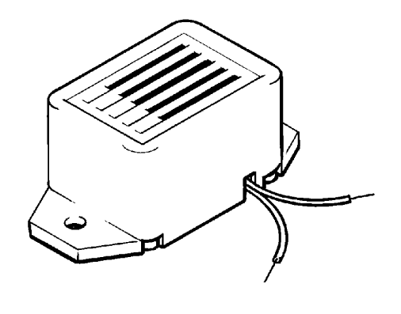

To use the transistor outputs, the output device should be connected between the screw-terminal numbered output (4–7) and a V+ connection. The positive (red) wire on polarised devices (for example a buzzer) should be connected to the V+ connection.

The white 6-pin header beside the screw terminals allows a ‘stepper motor’ or control model to be connected easily to all four of the outputs.

The motor driver

The output driver module also contains a second integrated circuit called the L293D push−pull driver. This chip allows forward and reverse control of two d.c. motors. Each motor output uses two of the stamp controller output pins to control the direction of rotation of the motor.

Pin 4 | Pin 5 | Motor A |  | Pin 6 | Pin 7 | Motor B
off | off | halt |  | off | off | halt
off | on | forwards |  | off | on | forwards
on | off | backwards |  | on | off | backwards
on | on | halt |  | on | on | halt

To use the push−pull motor output, the motor should be connected between the screw terminals labelled A or B. If the motor turns in the opposite direction to that expected, the two motor wires should be swapped over.

Noise-suppression capacitors

Some d.c. motors create electrical noise as they rotate. This problem only occurs with some d.c. motors − it is not normally a problem with d.c. solar motors. This electrical noise can affect the stamp controller, sometimes causing it to reset and act erratically. Fortunately this problem is very easily solved by connecting a 220 μF polyester capacitor directly across the motor terminals. The capacitor smoothes out the electrical noise before it can affect the stamp controller.

Controlling motors

Connect a buggy to the output driver module as shown in the diagram.

The ‘high’ and ‘low’ commands can be used to switch the output pins and control the motors forward, backward and halt.

main: ' make a label called ‘main’
high 5 ' motor A forward
high 7 ' motor B forward
pause 1000 ' wait 1 second
low 5 ' motor A halt
low 7 ' motor B halt
pause 1000 ' wait 1 second
high 4 ' motor A backward
high 6 ' motor B backward
pause 1000 ' wait 1 second
low 4 ' motor A halt
low 6 ' motor B halt
goto main ' jump back to the start

Activity 3.a
Key-in the program listed above, and then download it to the stamp controller. The buggy should rock backwards and forwards. If the buggy spins, swap the motor wires over where they connect to the output driver module.

Assignment 3.3

Connect a buggy to the output driver module as shown in the diagram.

Write a program to control the movement of the buggy as shown in the flowchart above.

Assignment 3.4
Build a maze on the table out of books. Write a PBASIC program to steer the buggy through the maze. Add comments to each line in your program to explain how it works.

Speed control of d.c. motors

There are two ways to control the speed of a d.c. motor. The simplest is to vary the voltage applied to the motor. If, for instance, 3 V is applied to a small d.c. motor it will rotate at a lower speed than if 5 V were applied. Unfortunately the ‘turning power’ (torque) of the motor will also drop, which means the whole motor system will be less powerful.

The second way to control the motor is to always apply the full voltage (for example
5 V) across the motor, but then to switch the power supply on and off rapidly. As the power supply is off some of the time, the motor does not receive as much power and so the motor turns more slowly. The advantage of this system is that the torque remains quite high.

This system is called pulse-width modulation (PWM). The time that the power supply is switched on is called the mark time, and the time that the motor is switched off is called the space time. By varying the on (mark)-to-off (space) ratio, the speed of the motor can be varied.

Activity 3.b

Connect a d.c. solar motor across the ‘V+’ and ‘7’ terminals on the output driver module. This will provide an interfacing circuit as shown above.

Connect a propeller to the output shaft of the d.c. solar motor to make the rotational speed easier to see.

Key in, download and run the program listed below. This program drives the motor at approximately half speed, as the space (off time) is twice the length of the mark (on time). Note that you must use pause delays, as the power supply must switch on and off very quickly (wait delays would be too long).

main: high 7 ' output high
pause 5 ' pause for 5 ms
low 7 ' output low
pause 10 ' pause for 10 ms
goto main ' loop

Try out different speeds (by experiment) by altering the length of the pause delays.

Assignment 3.5
Explain the terms ‘mark’ and ‘space’ in relation to PWM speed control of a d.c. motor.

Assignment 3.6
Describe the advantages and disadvantages of using PWM speed control.

Assignment 3.7

Connect the washing machine model to the output driver module. The motor on the washing machine is controlled by outputs 6 and 7 (motor B). Switching output 6 on will make the motor turn one way; switching output 7 on will make the motor turn the other way.

- Write a PBASIC program that will make the motor rotate at full speed in each direction for five seconds.
- Write a second PBASIC program that will make the motor rotate at half speed in each direction for five seconds. Use PWM speed control for the motor.

‘For … next’ loops

START
SET COUNTER = 5
SWITCH PIN 7
HIGH
WAIT 1 s
SWITCH PIN 7
LOW
HAVE WE
LOOPED 5
TIMES?
STOP
WAIT 1 s
Y
N

It is often useful to repeat the same part of a program a number of times, for instance when flashing an LED. In these cases a ‘for … next’ loop can be used.

In this flowchart the LED connected to output pin 7 is flashed on and off five times. The number of times the code has been repeated is stored − that is, stored in the RAM memory of the stamp controller. There are 10 available variables, labelled b0 to b9, which can be used in this way. These variables can also be renamed using the symbol command to make them easier to remember.

Activity 3.c
Key in, download and run the following program.

symbol counter = b0 ' define the variable ‘counter’
symbol red = 7 ' define pin 7 with the name ‘red’

main: for counter = 1 to 5 ' start a for … next loop
high red ' switch pin 7 high
pause 1000 ' wait for 1 second
low red ' switch pin 7 low
pause 1000 ' wait for 1 second
next counter ' end of for … next loop

end ' end program

Note again how white-space (extra spaces) has been used to clearly show all the commands that are contained between the ‘for’ and ‘next’ commands.

Assignment 3.8

Connect a buggy to the output driver module, as shown in the diagram.

The buggy should follow the path shown in the diagram above, moving in each direction for three seconds.

Draw a flowchart for the movement of the buggy, making use of a ‘for … next’ command structure.

Write a high-level program in PBASIC to control the movement of the buggy as shown by your flowchart. (It will be necessary to experiment with time delays to establish how quickly your buggy turns 90 degrees to the left.)

Assignment 3.9

The following PBASIC program will carry out the instructions shown in the flowchart above. Copy and then complete the program listing by adding the missing comments.

symbol counter = b0 ' define the variable ‘counter’

main: high 7 ' …
high 6 ' …
high 5 ' …
high 4 ' …
pause 5000 ' …

for counter = 1 to 10 ' …
low 7 ' …
low 6 ' …
low 5 ' …
low 4 ' …
pause 500 ' …
high 7 ' …
high 6 ' …
high 5 ' …
high 4 ' …
pause 500 ' …
next counter ' …

low 7 ' …
low 6 ' …
low 5 ' …
low 4 ' …
end ' stop the program
Sub-procedures

A sub-procedure is a separate ‘mini-program’ that can be called from the main program. Once the sub-procedure has been carried out, the main program continues.

Sub-procedures are often used to separate the program into small sections to make it easier to understand. Sub-procedures that complete common tasks can also be copied from program to program to save time.

The following program uses two sub-procedures to separate the two main sections of the program (‘flash’ and ‘noise’).

symbol red = 7 ' rename pin 7 ‘red’
symbol buzzer = 6 ' rename pin 6 ‘buzzer’
symbol counter = b0 ' define a counter using variable b0

main: ' make a label called ‘main’
gosub flash ' call the sub-procedure flash
gosub noise ' call the sub-procedure noise
goto main ' loop back

end ' end of the main program

flash: ' make a sub-procedure called ‘flash’
for counter = 1 to 25 ' start a for … next loop
high red ' red LED on
pause 50 ' wait 0.05 second
low red ' red LED off
pause 50 ' wait 0.05 second
next counter ' next loop
return ' return from the sub-procedure

noise:
high buzzer ' buzzer on
pause 2000 ' wait 2 seconds
low buzzer ' buzzer off
return ' return from the sub-procedure

Activity 3.d
Key in, download and run the above program.

The main program is very simple as it simply calls the two sub-procedures through the ‘gosub’ command. At the end of each sub-procedure a ‘return’ command is used to return the program flow back to the main program loop.

Note that at the end of the main program (but before the sub-procedures) an ‘end’ command has been added. This is a good idea as it stops the main program accidentally ‘falling’ into a sub-procedure at the end of the main program.

Assignment 3.10
A washing machine has both wash and spin cycles. Add the missing comments to this PBASIC program, which will control the washing machine.

symbol motor = 7 ' rename pin 7 ‘motor’
symbol counter = b0 ' name a counter variable

main: ' make a label called ‘main’
gosub wash ' …
gosub spin ' …
gosub wash ' …
gosub spin ' …
gosub wash ' …
gosub spin ' …

end ' …

wash: ' …
for counter = 1 to 250 ' …
high motor ' …
pause 10 ' …
low motor ' …
pause 5 ' …
next counter ' …
return ' …

spin:
high motor ' …
pause 5000 ' …
low motor ' …
return ' …

Section 4: Using Inputs

Digital sensors

A digital sensor is a simple ‘switch’ type sensor that can only be ‘on’ or ‘off’.

Common examples of a digital sensor are:
- microswitches
- push-and-rocker switches
- reed switches.

The simplest type of switch is represented by the symbol shown below.

The Input Module

The input module provides the interfacing circuits required to connect switches and sensors to the stamp controller.

When the slide switch on the input module is ‘up’ the input module provides four digital (on/off) switch connections. These can be used to connect input switches (for example a microswitch) to the stamp controller. The switches can be connected through the screw-terminal blocks or through the white push-on headers.

Input pins 0 and 1 have ‘on-board’ test switches. These allow programs to be tested without the need to connect external switches.

Assignment 4.1
List four different kinds of switch. Give an example of where each type of switch may be used.

Activity 4.a
Key in, download and run the program listed below. This program makes output pin 7 flash every time the push-switch on input pin 0 is pushed.

main: ' make a label called ‘main’
if pin0 =1 then flash ' jump if the input is on
goto main ' else loop back around

flash: ' make a label called ‘flash’
high 7 ' switch output 7 on
pause 2000 ' wait 2 seconds
low 7 ' switch output 7 off
goto main ' jump back to start

In this program the first three lines make up a continuous loop. If the input is off the program just loops around time and time again.

If the switch is then pushed, the program jumps to the label called ‘flash’. The program then switches pin 7 on for two seconds before returning to the main loop.

Note carefully the spelling in the ‘if … then’ line – ‘pin0’ is all one word (without a space). Note also that only the label is placed after the command ‘then’ – no other words apart from a label are allowed.

Assignment 4.2
A burglar alarm must sound a buzzer and light a warning signal for 20 seconds when any of the four windows in a house are opened. Each window contains a reed switch that is connected to the alarm.

Draw a flowchart and write a PBASIC program that will operate the burglar alarm correctly. Use the following input and output connections.

Input connection | Pin | Output connection
 | 7 | red light
 | 6 | buzzer
 | 5
 | 4
switch 3 | 3
switch 2 | 2
switch 1 | 1
switch 0 | 0

Assignment 4.3
As part of a Christmas decoration in a shop, a lighting sequence is to be controlled by a microcontroller. The output connections are shown below.

Input connection | Pin | Output connection
 | 7 | red light
 | 6 | yellow light
 | 5 | green light
 | 4
 | 3
 | 2
 | 1
pressure mat | 0

When a visitor treads on a pressure mat under the carpet, the lights should flash on and off in sequence three times.

The following PBASIC program will carry out the instructions shown in the table above.

Copy and then complete the program listing by adding the missing comments.

symbol counter = b0 ' …
symbol red = 7 ' …
symbol yellow = 6 ' …
symbol green = 5 ' …

main: if pin0 = 1 then flash ' …
goto main ' …

flash: for counter = 1 to 3 ' …
high red ' …
low green ' …
pause 500 ' …
high yellow ' …
low red ' …
pause 500 ' …
high green ' …
low yellow ' …
pause 500 ' …
next counter ' …

low green ' …
goto main ' …

Assignment 4.4

Connect a buggy to the output driver module (or MFA movement module), as shown in the diagram. Connect the microswitch ‘bumpers’ to pins 0 and 1 on the input module.

The buggy should continue going forwards until either of the two microswitch bumpers is activated. At this point the buggy should reverse for three seconds, rotate 90 degrees clockwise and then continue forwards.

Draw a flowchart and write a PBASIC program to control the movement of the buggy as described above.

Assignment 4.5

Develop a PBASIC program that will carry out the instructions shown in the flowchart above. Use the following pin configuration.

Input connection | Pin | Output connection
 | 7 | red light
 | 6 | amber light
 | 5 | green light
 | 4
 | 3
 | 2
 | 1
start switch | 0
Assignment 4.6

Connect the washing machine model to the input module and output drivers module. The washing machine model has the following connections.

Input connection | Pin | Output connection
 | 7 | motor reverse
 | 6 | motor forward
 | 5 | solenoid bolt
 | 4 | LED
 | 3
 | 2
door microswitch | 1
start switch | 0

The washing machine operates as follows.

- Wait until the start switch is on.
- Wait until the door switch is on.
- Switch on the LED.
- Switch on the solenoid bolt.
- Wash cycle: repeated 20 times – motor forwards for five seconds, motor backwards for five seconds.
- Spin cycle: repeated 10 times – motor forwards for two seconds, motor backwards for two seconds.
- Switch off the solenoid bolt.
- Switch off the LED.

Draw a flowchart and write a PBASIC program to control the movement of the washing machine as described above.

Assignment 4.7

Connect the bank safe model to the input module and output drivers module. The bank safe model has the following connections.

Input connection | Pin | Output connection
 | 7 | buzzer
 | 6
 | 5 | solenoid/red LED
 | 4 | green LED
code switch 3 | 3
code switch 2 | 2
code switch 1 | 1
door microswitch | 0

The bank safe operates as follows.

- Switch on the red LED.
- Switch on the solenoid bolt.
- Wait until code switch 1 is pushed.
- Wait until code switch 2 is pushed.
- Wait until code switch 3 is pushed.
- Switch off the solenoid bolt.
- Switch off the red LED.
- Wait until the door is opened (microswitch off).
- Switch on the green LED.
- Wait 10 seconds.
- Switch off the green LED.
- Switch on the buzzer.
- Wait until the door is closed (microswitch on).
- Switch off the buzzer.
- Loop back to step 1.

Draw a flowchart and write a PBASIC program to control the movement of the washing machine as described above.

Section 5: Number Systems

A microcontroller operates by performing a large number of commands in a very short space of time. This is possible because each command can be expressed as a series of electronic signals. These electronic signals are recognised as being in one of two states, described as high and low (or ‘on’ and ‘off’).

The counting system used in everyday activities is the decimal system. This number system uses the ten familiar digits 0 to 9 to explain how big or small the number is.

However, as the microcontroller only recognises the two electronic states high and low, it uses the binary number system. This number system uses just two digits, 0 and 1. An electronic signal that is low is represented by ‘logic 0’, and a signal that is high is represented by ‘logic 1’.

The first sixteen numbers in the decimal and binary systems are shown in the table below.

 | Decimal | Binary
 | 0 | 0000
 | 1 | 0001
 | 2 | 0010
 | 3 | 0011
 | 4 | 0100
 | 5 | 0101
 | 6 | 0110
 | 7 | 0111
 | 8 | 1000
 | 9 | 1001
 | 10 | 1010
 | 11 | 1011
 | 12 | 1100
 | 13 | 1101
 | 14 | 1110
 | 15 | 1111

A single binary digit is referred to as a bit (binary digit). Different systems carry out calculations using different numbers of bits, and so systems are often referred to as 8-bit, 16-bit or 32-bit systems. The most common microcontrollers use the 8-bit system, although 32-bit microcontrollers are also now becoming more readily available.

Notation

When using a number of different counting systems it is important to distinguish which counting system you are using. For instance, the number ‘10’ has different values in the decimal and binary counting systems!

Therefore the following notations are used with stamp controller programs.

Decimal values are written as usual: 10 (= 10 in decimal)
Binary values are indicated by a % symbol: %10 (= 2 in decimal)

Bits and bytes

Eight bits grouped together are described as a byte. The decimal value of a byte is calculated by adding together the corresponding decimal value of each of the individual bits. The eight bits in a byte are labelled bits 0 to 7, from right to left. The rightmost bit is called the least significant bit (LSB) and the leftmost bit is called the most significant bit (MSB). The decimal value of each bit is given in the table below.

bit number | 7 | 6 | 5 | 4 | 3 | 2 | 1 | 0
decimal value | 128 | 64 | 32 | 16 | 8 | 4 | 2 | 1

The binary number %10010111 when converted into decimal would be:

1 | x | 128 | = | 128
0 | x | 64 | = | 0
0 | x | 32 | = | 0
1 | x | 16 | = | 16
0 | x | 8 | = | 0
1 | x | 4 | = | 4
1 | x | 2 | = | 2
1 | x | 1 | = | 1
 |  |  | Total: | 151

Note that when writing binary numbers it is quite common to write all eight bits, even if the first bits are equal to zero (unlike the decimal system, where leading zeros are not normally written).

Assignment 5.1
Convert each of the following binary numbers into decimal.
- %11110000
- %11000011
- %01010101
- %10101010

Converting decimal to binary

To convert any decimal number into binary, repeatedly divide the decimal number by two and record the remainder after each division. The binary number is then found by reading up the remainder column. The decimal number 29 is used as an example.

29 | ÷ | 2 | = | 14 | rem. 1
14 | ÷ | 2 | = | 7 | rem. 0
7 | ÷ | 2 | = | 3 | rem. 1
3 | ÷ | 2 | = | 1 | rem. 1
1 | ÷ | 2 | = | 0 | rem. 1

Therefore the decimal number 29 equals the binary number %00011101

Assignment 5.2
Convert each of these decimal numbers into binary.
- 17
- 23
- 11
- 38
- 33

Section 6: Stepper Motors

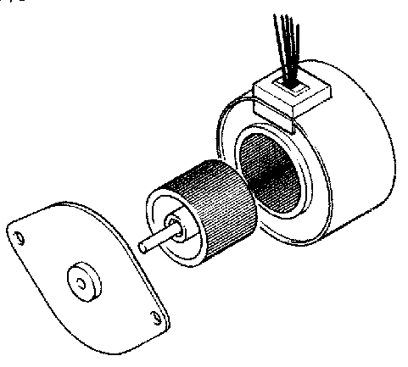

Stepper motors are very accurate motors that are commonly used in computer disc- drives, printers, X–Y plotters and clocks. Unlike d.c. motors, which spin round freely when power is applied, stepper motors require that their power supply is continuously ‘pulsed’ in four different patterns. For each pulse, the stepper motor moves around one ‘step’, typically 7.5 degrees (giving 48 steps in a full revolution).

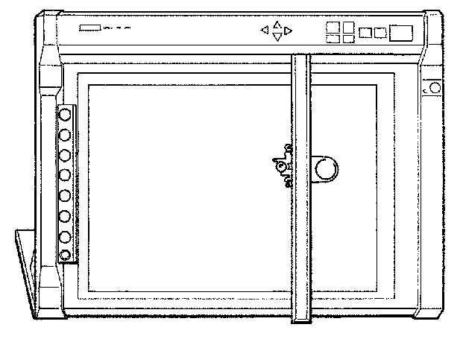

Stepper motors do have some limitations. First, the power consumption is greatest when the stepper motor is stopped (as all coils are still energised). The speed of revolution is also limited to around 100 steps per second, which provides a rotational speed of 2 revolutions per second or 120 revolutions per minute.

The stepper motor contains magnets that are fixed to the central armature. Four electronic coils are located around the casing. When a current is passed through these coils they generate a magnetic field, which attracts/repels the permanent magnets on the armature, and so the armature spins one ‘step’ until the magnetic fields align. The coils are then energised in a different pattern to create a different magnetic field, and the armature spins another step.

To make the armature rotate continuously, the four coils inside the stepper motor must be switched on and off in a certain step order. The ULN2803A driver chip on the output driver module provides the method of interfacing these four coils.

The table below shows the four different steps required to make the motor turn.

Step | Coil 4  (output 7) | Coil 3  (output 6) | Coil 2  (output 5) | Coil 1  (output 4)
1 | 1 | 0 | 1 | 0
2 | 1 | 0 | 0 | 1
3 | 0 | 1 | 0 | 1
4 | 0 | 1 | 1 | 0
1 | 1 | 0 | 1 | 0

To make the motor spin the other way, the steps are reversed (i.e. 4-3-2-1-4, etc. rather than 1-2-3-4-1, etc.).

Note
The wiring configuration of stepper motors varies between different manufacturers. Therefore, it may be necessary to rearrange the coil connections for the above sequence to operate correctly. An incorrect coil arrangement will result in the stepper motor vibrating back and forth rather than rotating.

The sequence of wires for the Middlesex Stepper Motor is, from the top:
white, white, blue, yellow, brown, red and you may have to change the wires on these stepper motors to get this sequence.

Activity 6.a

Build the circuit as shown.

Key in, download and run the program listed below. The program demonstrates how to spin the stepper motor continuously. Try changing the speed by altering the value of delay.

symbol delay = b0 ' define the variable

let delay = 100 ' set delay to 0.1s

high 7 ' set up first step
low 6
high 5
low 4

main: low 5 ' next step
high 4
pause delay ' pause for delay time
low 7
high 6
pause delay ' pause for delay time
low 4 ' next step
high 5
pause delay ' pause for delay time
low 6 ' next step
high 7
pause delay ' pause for delay time
goto main ' loop forever

Activity 6.b
A shorter way to create the same program would be to use a binary number that switches all of the output lines on and off at the same time. This means each step would then only be one program line long. The binary output number for each step is shown in the table below.

Step | Binary output
1 | %10100000
2 | %10010000
3 | %01010000
4 | %01100000
1 | %10100000

Key in, download and run the program listed below. The ‘let pins =’ command moves the binary number on to all of the output pins in one single command. Try changing the speed by altering the value of delay.

symbol delay = b0 ' define the variable

let delay = 100 ' set delay to 0.1s

main: let pins = %10100000 ' first step
pause delay ' pause for delay
let pins = %10010000 ' next step
pause delay ' pause for delay
let pins = %01010000 ' next step
pause delay ' pause for delay
let pins = %01100000 ' next step
pause delay ' pause for delay
goto main ' loop forever

Assignment 6.1
Explain the main differences between d.c. motors and stepper motors.

Assignment 6.2
Describe three products that may contain stepper motors. Describe how the motor is used in each case.

Section 7: Analogue Sensors

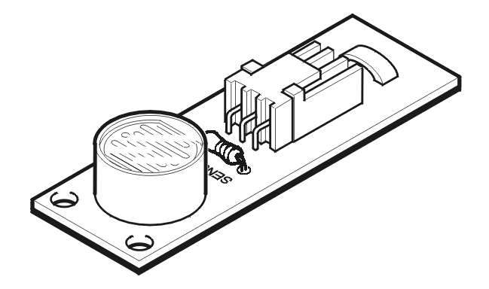

An analogue sensor measures a continuous property such as light, temperature or position. The analogue sensor provides a varying voltage signal. This voltage signal can be represented by a number in the range 1 to 240 (for example very dark = 1, bright light = 240).

Common examples of a digital sensor are:
- LDR (light-dependent resistor)
- Thermistor
- Variable resistor (potentiometer).

Light-dependent resistor (LDR)

The LDR is a component whose resistance depends on the amount of light falling on it. Its resistance changes with light level. In bright light the LDR’s resistance is low (typically around 1 kΩ). In darkness its resistance is high (typically around 1 MΩ).

The circuit symbol and a graph showing the resistance at various light levels are shown below.

The analogue sensors are connected to the input module in a potential divider arrangement.

Thermistor

The thermistor is a component whose resistance depends on its temperature.

The circuit symbol and a graph showing the resistance at various temperatures.

Variable resistor (potentiometer)

A variable resistor is used to measure position.

The Input Module: Analogue Sensors

The input module provides the interfacing circuits required to connect switches and sensors to the stamp controller.

When the slide switch is ‘down’ the input module provides two digital (on/off) and two analogue sensor connections.

The two analogue sensor connections allow the connection of analogue sensors (for example an LDR light sensor or a thermistor temperature sensor). The analogue sensors provide a reading in the range of 1–240 with a change in value (of, for example, the light level or temperature).

Activity 7.a
Key in, download and run the program listed below. This program makes a red or green LED light depending on the light level falling on an LDR sensor. Before running this program make sure you have connected a light sensor to the input module and that the slide switch is in the ‘down’ position.

main: ' make a label called ‘main’
if sensorA > 50 then red ' jump if the value > 50
goto green ' value is < 50 so jump

red: ' make a label called ‘red’
high 4 ' switch output 4 on
low 5 ' switch output 5 off
goto main ' jump back to start

green: ' make a label called ‘green’
high 5 ' switch output 5 on
low 4 ' switch output 4 off
goto main ' jump back to start

In this program the second line checks the value of sensor A. If the value is bigger than 50 the program jumps to label red.

If the value is not bigger than 50 the next ‘goto green’ line is carried out instead.

Note that only the label is placed after the command ‘then’ in the ‘if … then’ – no other words apart from a label are allowed.

Activity 7.b
Key in, download and run the program listed below. This program gives the variable b0 the value of the temperature sensor (sensor A). The debug command then sends this value to the computer screen so that the temperature level can be seen.

Before running this program make sure you have connected a temperature sensor to the input module (sensor A) and that the slide switch is in the ‘down’ position and you have selected ‘Extended PBASIC’ from the options menu.

main: ' make a label called ‘main’
let b0 = sensorA ' give b0 the value of the sensor
debug b0 ' show the value on the computer
pause 10 ' wait 0.01 second
goto main ' jump back to start

Note that the debug command is not examinable.
Assignment 7.1

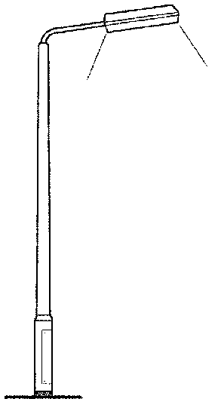

A street lamp must turn on when the light level is below the level ‘100’ and turn off when the level is above ‘100’. The lamp is connected to output 7 and the LDR light sensor is connected to sensor A.

Draw a flowchart and write a PBASIC program that will make the street lamp work correctly.

Assignment 7.2
State whether each of the input transducers below is an analogue or digital sensor.

(a) LDR
(b) reed switch
(c) microswitch
(d) thermistor
(e) variable resistor
(f) tilt switch
(g) push switch
(h) rocker switch

Assignment 7.3
For each of the input transducers stated in assignment 7.2 give an example of an electronic product that may use that transducer. Explain how the transducer would be used within the product.

Section 8: Project Assignments

For the following practical project assignments students are expected to:
- identify the control task to be achieved
- select suitable input and output transducers, explaining the reason a particular transducer was selected
- build a model of the system, correctly connecting the transducers through the input and output driver modules
- develop a flowchart of the control sequence
- use the flowchart to develop and test a PBASIC program for the control sequence.

Project briefs

- A woman has a very valuable jewellery collection. Design and build an alarm system that will detect when a light is shone on to the jewellery box.
- Your car is nearly as long as your garage. Design and build a system that sounds a buzzer for a short time when the bumper of the car is close to the back wall of the garage.
- Design and build an automatic door system to help reduce heat loss from a large department store.
- A family with several small children finds that the fridge door is constantly left open. They require a system to warn them when the door of the fridge has been left open, but not when it is simply opened to take something out.
- A large greenhouse needs a temperature monitoring system that includes a warning light to tell the owner when the temperature gets too high. The operator must lower the temperature and cancel the warning light within a short time or an alarm will sound.
- Design and build a single-sweep windscreen wiper. The system should start when the operating switch is pushed, and stop again when it returns to the parked position.
- Design and build a device to alert a cricket umpire when light is bad enough to stop play.
- An advanced satellite television system must rotate the dish to a number of different positions. Design and build a system using a stepper motor that will move to four preset positions.
- A system is required that sounds an alarm when someone breaks a beam of light or a fire breaks out in a house. The alarm must continue to sound until a reset switch is activated.
- A rotary table for an automatic drilling process has to revolve clockwise for six seconds, stop for two seconds and then revolve anticlockwise for six seconds. It carries on going through this cycle indefinitely. Design and build this system.
- Design and build a rotary table that will revolve once and then trigger a switch that will make the table revolve in the opposite direction until it triggers the switch again. The cycle should repeat indefinitely.
- Design and build a machine that will revolve to face a moving light source.
- A venetian blind is required to tilt automatically when the light falling on it drops below a predetermined level.
- Design and build a model of a goods lift for a hospital. For safety reasons the lift should not operate if safety doors on any level remain open.
- Design and build a model of an automatic railway level crossing.
- Design and build an automatic curtain control that operates at dawn and dusk. There should also be provision for a manual override switch.
- A small engineering company decides to automate its works. A system is required that will pick up a metal disc using an electromagnet. It will then transport this disc along a line until it hits a switch, release it and return for another disc, thus completing the cycle. Design and build a model of this system.
- In a busy production process a small vehicle is required to run along a track between two limit switches. The switches stop the motor for ten seconds, then reverse its direction, sending the vehicle back along the track. Design and build a model of this system.
- A bus driver wants to know when people are getting on to the bus. Design a system that will sound a buzzer each time someone gets on.
- A family occasionally leave their home unoccupied when they take a weekend holiday in a hotel. A system is required that will deter burglars by making their home appear occupied whilst they are away.
- Design and build a warning light for shipping that will come on automatically at sunset and remain on until dawn. The light must flash on and off and turn through 270°.
- Design and build a lift suitable for a two-storey warehouse. The lift will run unmanned but must not be able to operate unless a safety grill has been closed first. It should be possible to control the lift from both floors.
- A heavy-duty industrial tumble dryer is required by a local cleaning contractor. The system should also include a fan to circulate hot air and a method to ensure that the door has been closed before the machine starts. The drum should also rotate in both directions during the process.
- Design and build an audible levelling device suitable for indicating when a caravan is level.
- Car theft has become a major problem. After careful consideration, design and build a possible burglar alarm for cars left unattended.

PBASIC commands

Input/output
low Switch an output pin off (low).
high Switch an output pin on (high).
sensor Reads the analogue input (A or B) and gives scaled value 1–240.

Time
pause Pause for 1 to 65535 milliseconds.

Looping
for … next Create a FOR … NEXT loop.

Program flow
if … then Test an input and jump to label.
goto Jump to address label.

Subroutines
gosub Jump to sub-procedure.
return Return from sub-procedure.

Miscellaneous
end End the main program.
debug Send variables to computer for viewing (not examinable).
symbol Allocate a symbol for a variable or value.

Note that the software must be configured to ‘Extended PBASIC’ mode when using the ‘sensor’ command.

