National 4/5
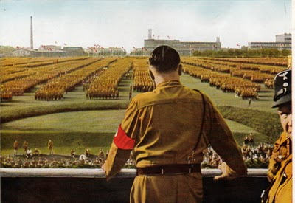
Hitler and Nazi Germany 1918-1939
Hitler and Nazi Germany, 1919-1939
This topic is a study of the attempts to establish democracy in Weimar Germany, the reasons for its collapse and the nature of the Nazi state.

Issue 1: Weimar Germany, 1919–1933
The effects on Germany of the end of the First World War and the Peace Settlement; opposition to the Treaty of Versailles; the formation and characteristics of the Weimar Republic. Attempts to overthrow the Weimar Republic, as seen in the Spartacist Revolt, 1919, and Beer Hall Putsch, 1923; economic problems of the Weimar Republic, 1919–33.

Issue 2: Nazi rise to power
Discontent against the Weimar Republic, appeal of Hitler and the Nazis, and the coming to power of the National Socialists in 1933–34; the Reichstag fire 1933; Nazi consolidation of power.

Issue 3: Nazi control of Germany
Formation and characteristics of the National Socialist Government; National Socialism in power: intimidation; treatment of Jews and other minority groups; opposition to National Socialism by socialists, communists, and the churches.

Issue 4: Nazi social and economic policies
Nazi economic policies; militarism; youth movements and education; role of women; Nuremberg rallies.

RESOURCES
There are a huge number of resources you can use to help you with this topic, some are listed below. With any website you use, please consider if it is reliable. If you are ever unsure or need help ask your teacher!
https://www.bbc.com/education/topics/znk9q6f/resources/1
http://spartacus-educational.com/
https://www.historylearningsite.co.uk/
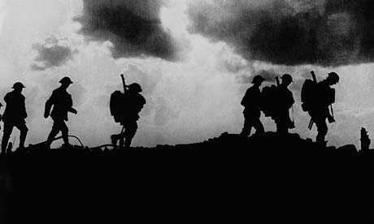

The End of the Great War
Armistice began at 11am on 11th November 1918, 2 two days after the Kaiser’s abdication, bringing to an end one of the most destructive wars in modern history. Nearly ten million soldiers died as a result of the conflict and, according to one estimate, it cost 260 billion dollars.
No official agencies kept careful accounting of civilian losses during the war years, but scholars suggest that as many as thirteen million non-combatants died as a direct or indirect result of the war. The conflict uprooted or displaced millions of persons from their homes in Europe and Asia. Property and industry losses were catastrophic, especially in France, Belgium, Poland, and Serbia, where fighting had been heaviest.
Germany at the end of the war
By August 1918, and with the USA joining the allied forces in 1917, many Germans saw defeat as inevitable. Many German soldiers chose to desert the army and return home with news of defeat in the ‘spring offensive.’ Morale was low and many ordinary Germans wanted an end to the war. Germany suffered the loss of 1.7 million young men, with another 4.3 million men wounded. The total casualties amounted to over 7 million, though this includes some men who were prisoners or listed as missing. The German, however, were led to believe they were winning.
German people were suffering. By 1918, Germany was producing only 50% of the milk it had done before the war. Germany was not a self-sufficient country and the British navy was stopping food and other essential supplies getting to Germany by blockading Germany’s northern ports. This had a huge impact on daily life in Germany. Riots had broken out due to food shortages. There were shortages of fertiliser, food, fuel, soap, medicines and lamp oil. Food shortages were so severe that they led to the “Turnip Winter” and an adult’s calorie intake was half what it should have been. Throughout the war approximately 750,000 Germans died from starvation and malnutrition. 150,000 had died from the effects of the ‘Spanish flu’ due to their weakened immune systems.
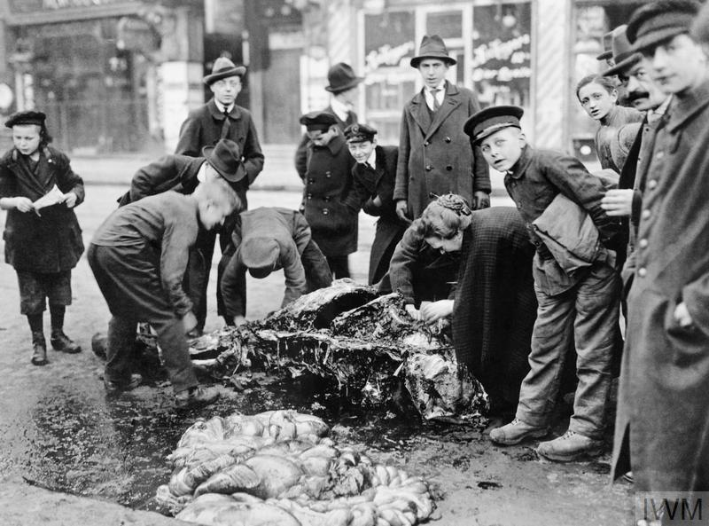
Economically Germany was also struggling. Machinery was, at the end of the war, obsolete in many cases, run by ill-trained people. The workforce was not physically fit enough to work as hard as required as food shortages had been so bad. Estimates suggest that up to 35% of all trade was organised illegally on the Black market. The economy also suffered from shortages of raw materials such as coal and rubber. From 1915 until the end of the war, Germans were forbidden to drive a car. The German government started to lose control of events as the country slid towards chaos.
A horse shot during fighting between German Government and revolutionaries is cut apart by civilians desperate for food.
Protests, demonstrations and riots spread throughout Germany. The threat of revolution quickly spread; this was encouraged by the events in Russia in 1917.

Task 1:
- Describe the problems faced by German Civilians in 1918 (5)

The Kiel Mutiny and Abdication
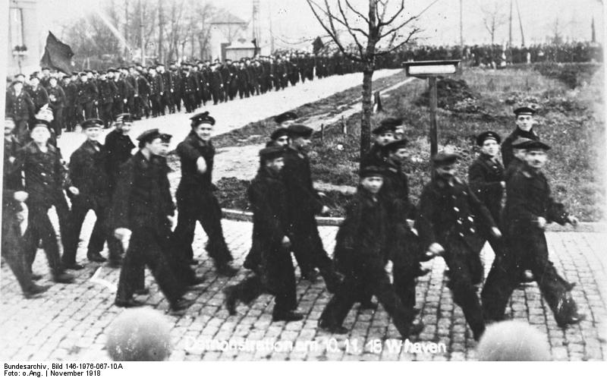
on 28th October 1918, Germany's naval command at Kiel planned an attack on the British Naval blockade. British submarines patrolled off the north German coast and such a mission would have been all but suicidal for the 80,000 soldiers.
The sailors of Kiel mutinied rather than go on such a mission. During the mutiny officers were killed and naval boats were taken over. The navy had been the Kaiser's and Germany's pride and joy and here were the sailors rebelling against authority.
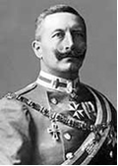
The army was not sent to crush the mutiny as the Kaiser could not trust that they would not join the sailors. Soldiers had joined the protests and many cities had been taken over by workers' and soldiers' councils. This was very similar to what had happened in Russia during the communist take-over of 1917.
On 9th November, 1918, Kaiser Wilhelm II (left) abdicated and fled to Holland.
The Chancellor, Max von Baden, handed power over to Friedrich Ebert, the leader of the German Social Democrat Party and the largest party in the Reichstag. It was also hoped that a new civilian government would obtain favourable peace terms with the allies. The Social Democrats announced that Germany was now a republic (A country lead by a government and not by a monarch).

Task 2:
- Summarise the events leading up to the abdication of the Kaiser in 1918.

Practise your skills:
- Explain why the Kaiser was so unpopular by late 1918. (5 marks)
Source A is from the memories of Sebastian Haffner published in 2002.
Although November 1918 meant the end of the war, I recall no sense of joy. There was only confusion as men returned from the Front. On Saturday the papers announced the Kaiser’s abdication. On Sunday, I heard shots fired in the streets of Berlin. During the whole war I hadn’t heard a single shot, yet now the war was over they began shooting. I felt uneasy. On November 11th, I saw the newspaper headline “Armistice Signed”. I turned to stone. I felt my whole world had collapsed.
Source B describes the effects of the end of the First World War on Germany.
In November 1918, when the Kaiser fled to Holland, German soldiers retreated in disarray. They were in a state of shock. The streets were full of lorries with sailors, soldiers and workers brandishing red flags. There was fighting and gunfire in the streets around my home. Families kept close together, often afraid to venture out in fear of stray bullets.

- Compare the views of Sources A and B about the effects of the end of the First World War on Germany? (Compare the sources overall and/or in detail.) (4 marks)
- Describe the Kiel Mutiny of 1918. (4)
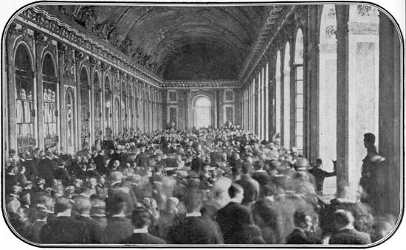
The Treaty of Versailles – signed 28th June 1919
The Treaty of Versailles was the peace treaty which put an official end to the Great War. Like many other treaties, it is named for the place of its signing: the Hall of Mirrors in the Palace of Versailles, just outside of Paris.
The Versailles Palace was considered the most appropriate venue simply because of its size - many hundreds of people were involved in the process and the final signing ceremony in the Hall of Mirrors could accommodate hundreds of dignitaries.
The treaty was signed after 6 months of negotiations. The Peace talks were dominated by the Big 3. The Big Three were the most important politicians there: David Lloyd George, Georges Clemenceau and Woodrow Wilson. The victors from World War One were in no mood to be charitable to the defeated nations and Germany in particular.

The Big Three – What did they want?

Britain: Prime Minister David Lloyd George
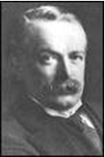
The British public was after revenge. "Hang the Kaiser" and "Make Germany Pay" were two very common calls at the end of the war and David Lloyd George (British PM), looking for public support, echoed these views.
In private Lloyd George was concerned with a greater threat - the spread of communism to Western Europe. He felt that Germany should be treated in such a way that left her as a barrier to resist the expected spread of communism from Russia. In addition he worried that a harsh treaty may cause problems in the future when the Germans may want revenge.

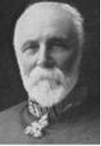
France: Prime Minister Georges Clemenceau (“The Tiger”)
Held one very simple belief - Germany should be brought to its knees so that she could never start a war again. France had now been to war twice with Germany since 1870. France had seen the bulk of the fighting on her lands and the north-east corner of France was destroyed. They wanted financial compensation known as reparations. The security of France was the main priority. "The Tiger" did not have to adapt his policies to suit the French public - the French leader and the French public both thought alike.
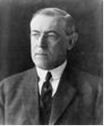
USA: President Woodrow Wilson
Wilson could not understand how an advanced civilisation could have reduced itself so that it had created so much devastation.
America was not as bitter towards Germany, as, entering the war in 1917, she had not been as badly affected. Wilson believed that Germany should be punished but in a way that would lead to European peace.
He believed the peace should be based on 14 points. The main points were:
- No more secret treaties between nations.
- Countries must seek to reduce their weapons and their armed forces;
- National self-determination. People of the same nationality to govern themselves and one nationality should not have the power to govern another
- All countries should belong to the League of Nations that would prevent future wars.
However, in America, there was a growing desire for the government to adopt a policy of isolation and leave Europe to its own devices.
TASK 3:
- Read the information above and take part in the Versailles game.
- Summarise what each nation wanted from the Versailles Treaty.
- How would you describe the negotiations held at Versailles in 1919.
The Terms of the Treaty of Versailles
The Peace Treaty had been a compromise. Some historians have argued that it was the best outcome given the circumstances.
Blame: Article 231 – Germany was to accept WAR GUILT. By accepting this clause Germany would be admitting to causing the war, the deaths and all the destruction. Accepting war guilt meant that Germany would have to pay the allies compensation. This is known as Reparations.
Reparations: Article 232 – Germany to pay £6,600 million (figure decided in1921). This was to be paid in cash, land and goods e.g. coal and would be paid over a 50 year period.
Armed Forces: The Military Terms. Germany would have to disarm. This meant:
- Army – maximum 100 000 men.
- No conscription. No Airforce.
- No tanks. No Artillery.
- Small navy, e.g. 6 battleships. No submarines.
- Armament factories destroyed.
- No German troops in the Rhineland. Allied troops in part of Rhineland for
15 years.

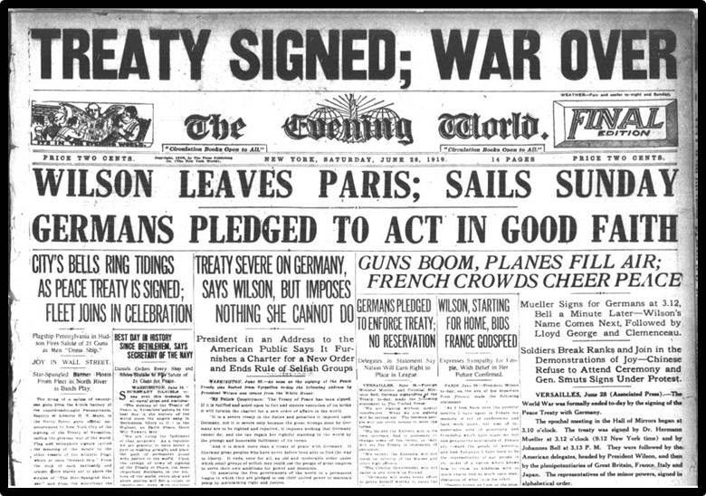
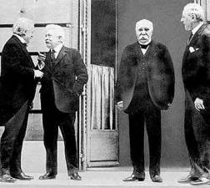

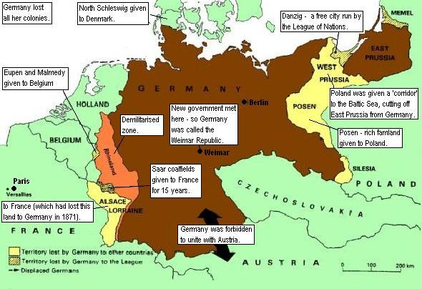
Territory Terms:

Task 4
- Create a spider diagram outlining the main terms of the Treaty of Versailles.
- Can you suggest possible reactions to the treaty? By France? By Germany?
- Can you suggest any potential future problems caused by this Treaty?

Views on the Treaty of Versailles
Understanding cartoon sources can cause us difficulty for many reasons. To help us understand them we need to
- Identify who or what is in the cartoon.
- What that means to us.
- What the cartoonist was trying to say about the issue.
Source B: Cartoon in a British Newspaper by Cartoonist David Low.
Source A: Cartoon created in 1920.

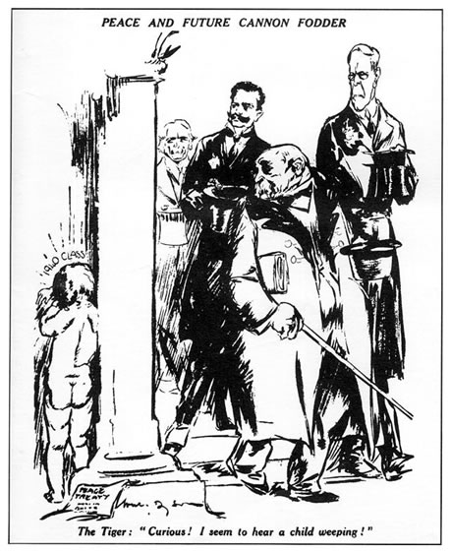
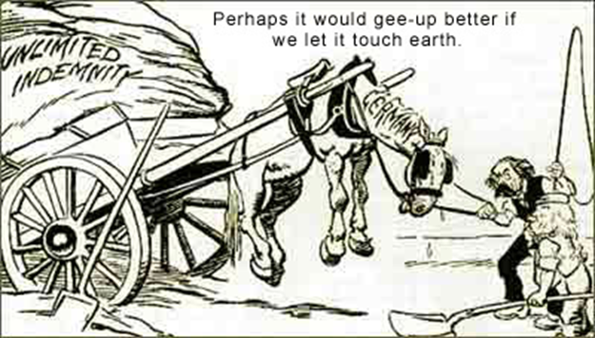

Task 5: In pairs, note down the opinion conveyed in Source A and Source B

German View on the Treaty
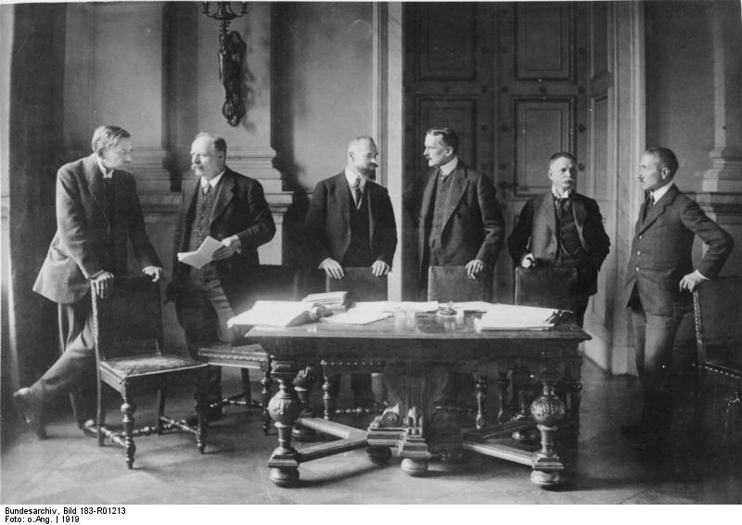
On 7 May, the victors presented their Treaty to the small German delegation that had not been allowed to negotiate. Count Brockdorff-Rantzau angered the Big Three by giving a long speech criticising the Treaty; then the delegation left.

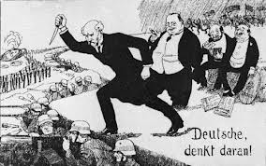
‘The stabbed in the back myth’
Although the Treaty was deeply humiliating for Germans, the new democratic government had no choice but to sign it. They could not afford a continuation of the fighting.
However many Germans were angry and demanded revenge for the humiliation. The Army said it could have won the war if only the weak-willed politicians had not given into the Allies. Although this was not true, the politicians were nicknamed the November Criminals and were accused of stabbing the army in the back. From the very beginning the Weimar government was blamed for accepting defeat in war and signing the dreaded peace treaty
Why did they dislike the Treaty?

- The Treaty had been an imposed ‘diktat’ (dictated peace). They were given no input.

- They felt that the Allies should have a new attitude as the Kaiser was gone. The new Weimar Republic should not be punished for the actions of the old Government.
‘May the hand wither that signs this treaty.’
Chancellor Scheidemann June 1919

- They were angry to be treated as a defeated country. Many Germans did not believe they had lost the war - their country was not invaded, their armies marched home with flags flying. Many Germans felt all nations had agreed to put an end to the bloodshed.
- They accepted that Germany was involved in causing war, but were angry that they were given all the blame in clause 231.
- The reparations bill was huge and would keep their country in ruin for years.
- The armed forces - this was just a way to keep Germany weak.
- The loss of territory. Germany lost a tenth of its land - they claimed that the treaty was simply an attempt to destroy their economy. Other nations were given self-determination – but the Treaty forced Germans to live in other countries. Germans were also angry that they could not unite with the Austrian Germans.
Task 6
- Summarise each bullet point.
- Then add a one word description of this point.

Practise your skills
Source C: Dr. Hans A Schmitt, 1989.

We must understand the fundamental reason for Germany's reaction... What hit Germans the hardest was the surprise of defeat. On November 11, 1918, no foreign armies threatened Germany with invasion. Nothing shook the German's belief that their armies returned undefeated from the field of battle. Everything following the armistice (The Treaty of Versailles) was so out of tune. The public did not see that Germany was entirely to blame for the Great War. The lack of consultation in negotiations was a further insult.

- How fully does Source C explain why the German people reacted so badly to the Treaty of Versailles? (5)
- To what extent were economic problems to blame for suffering of Germany in the aftermath of the First World War? (9)

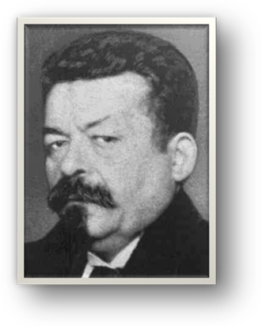
WEIMAR DEMOCRACY
The leading party in Germany's Reichstag (Parliament) was the Social Democrat Party led by Friedrich Ebert. It had been hoped that a new civilian government would obtain favourable peace terms with the allies. The Social Democrats announced that Germany was now a republic (A country lead by a government and not by a monarch).
Berlin became too dangerous for the democratic government to hold meetings in the Reichstag. As a result, the democratic government relocated to the small and peaceful town of Weimar, Germany in 1919. It is referred to as the Weimar Government.

Task 7
- Imagine that you are creating a new government. How would you want your country to be run? Write a list of at least 5 bullet points.

The new German Constitution

The National Assembly was elected to create a constitution (a set of laws that establish how a state should be ruled). Germany would have fair elections with universal suffrage and would be governed by a Parliament (Reichstag), Chancellor and a President.
The Weimar Constitution
Every German had the right to:
Free Speech.
Freedom of Religion.
Form parties, hold meetings and rallies.
Join a trade union
The government could not:
Arrest people without cause.
Open private letters
Search homes without good reason

The constitution set out that the electoral system should be one of Proportional Representation (PR), which caused problems as it allowed many different parties into the Reichstag.
It included Article 48, a law that gave the President power to rule, without permission of the Reichstag, in an emergency situation. The Constitution also included basic civil rights to every German citizen.

Source A: German Newspaper in 1920
The new Constitution is to be welcomed. The ordinary people have a political voice that really counts. They have guarantees of their freedom, freedom to vote, to have opinions... The Reichstag is an expression of what the people want. Laws will be fair to everyone and all opinions will be represented in the Reichstag.
Source B: Statement made by an opponent of the new democracy
The new constitution has serious weaknesses. The new Reichstag will achieve little if anything. Extreme groups enter it intending to destroy it. The people have but a small voice with each opinion being cancelled by an opposing one. No clear decisions are made since no single party has the power to put its policies into action.
Task 8
- Describe the ways that the Weimar Constitution was democratic? (4)
- Compare the views of source A and B on the Weimar constitution. (4)

Political Parties in Germany
The terms "left" and "right" are thought to have appeared during the French Revolution of 1789 when members of the National Assembly divided into supporters of the king to the president's right and supporters of the revolution to his left.

One problem facing the Weimar Government, partially caused by the PR electoral system, was the vast number of parties elected to the Parliament. Coalition governments of 2 or more parties were common and this made making decisions difficult.
Inside the German Reichstag there were many different types of parties with different ideologies (ideas on how the country should be run). The ideologies of political parties are often referred to as left wing, centre or right wing.
Group Task 9 – (groups of 3)

- Each member of the group will be assigned a different political ideology to become an expert on. Use the hand out given to you by your teacher.
- You will need to teach your ideology to the other members of your group so try to think of the easiest way to summarise the main points from the handout.
- Pupils will then be randomly selected to stand and deliver an ideology they were not an expert in so be prepared to deliver to the class.
- Make notes on a spectrum (left to right)
The Conservatives and Nationalists (right wing) were in a minority. In the years after 1919, they played an increasing part in the violence and murders, which dominated the early years of the Weimar Government.
German society, like any society had many levels and classes, all of whom wanted different things out of the government. This led to the formation of many different political parties.
- Workers want improved working conditions, pay and benefits for workers
- Farmers want fair food prices for their products
- Business owners want high profits and control over workers
- Ex-soldiers want the rebuilding of the army and military jobs
- Middle class Want society to remain consistent, with no major changes
- The Wealthy Want society to remain consistent, with no radical changes, more importantly, they want protection of their wealth.

The Socialists in Germany:
The largest group in the Reichstag. Although the Socialists wanted to give everybody the vote and improve working and living conditions for the workers, they could not agree about the best way to go about it. As a result, the Socialist group consisted of three parties.

- The Social Democratic Party (SPD)
Led by Friedrich Ebert, the Social Democrats were the largest party and wanted to achieve their aims peacefully. They wanted the Reichstag to pass laws which would slowly improve living conditions for the German people. They got their support from the majority of the working classes and trade unions. Most of the German Chancellors in the Weimar Republic came from this party.

- The Independent Socialists (USPD)
They wanted to force the government to change the laws quickly. The USPD agreed to support the SPD in forming a new government.

- The Spartacists (KPD)
Communists led by Karl Liebnecht and Rosa Luxembourg. They wanted to overthrow the government by revolution.

Other political parties in Germany at this time:

- The German Democratic Party (DDP)
Made up of mainly middle class and well educated Germans. It supported the government and wanted improvements in living and working conditions.
- The Centre Party (ZENTRUM)
Obtained support from Catholics from all social classes. They did not like the Socialist threats to their private property or the reform policies of the Social Democrats. Although not in favour of the Republic at first, they later came to support most of its policies.

- The National People’s Party (DNVP)
Composed of right wing Nationalists who had supported the Kaiser and his government. They hated the new Republic and wanted to bring back the monarchy. The DNVP included many different types of people including rich and powerful landowners and industrialists. They wanted to keep the traditions of ‘old Germany’ and did not like the new democratic ideas which brought the middle and working classes to power.
- The German People’s Party (DVP)
This party was mainly supported by business people. They wanted to make Germany a powerful trading nation again. Many industrialists belonged to this party. They were not as extreme as they DNVP.

- The National Socialist German Workers’ Party (NSDAP or NAZIS)
An extreme right wing party of Conservatives and Nationalists who hated democracy and the Weimar Republic. They wanted to destroy the Versailles Treaty and blamed the Jews and Weimar politicians for Germany’s defeat. They were led by Adolf Hitler.

Task 10:
- Copy and complete the following table.
Party Name | Who supported them e.g. workers | What did they want to achieve?
(you will have 8 rows)

- Explain why it would be difficult to rule Germany after the war.

Extension: Create a diagram to show the political spectrum and the position of the main parties in Weimar Germany.

Revolution in Germany
While communists and fascists have different ideals they are both undemocratic and want change faster; they are prepared to use violence to achieve their aims. There were two attempts to overthrow the Weimar Government. The Spartacists’ (communists) tried in January 1919 and the National Socialist German Workers’ Party (NAZIS, fascists) attempted a Putsch in November 1923.
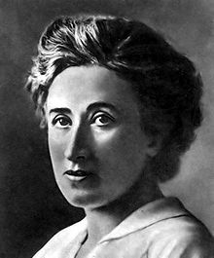
This next section will examine the two attempted revolutions.
1. The Spartacist Uprising
The Spartacist's were communists who split from the SPD (Independent Socialists) in frustration at the SPD's role within Government.
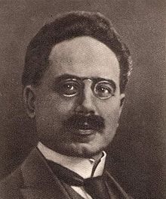
The leaders of the Communist party were Rosa Luxemburg and Karl Liebnecht. (Right) who founded the Party in December 1918. On January 1st, 1919, members of the Spartacist movement rose in an attempted revolution.
They wanted the Germany to be ruled by the workers not the upper classes that dominated the Reichstag, but initially this move was opposed by both Liebnecht and Luxemburg.
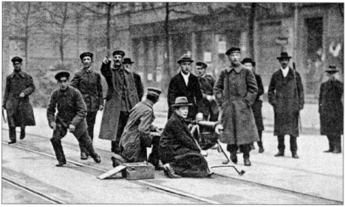
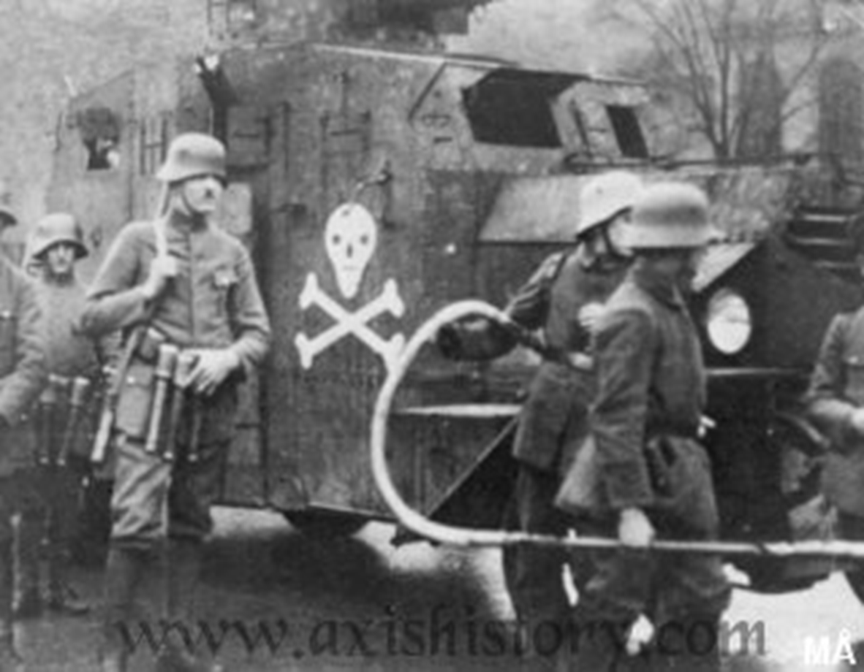
Spartacist supporters took over the centre of Berlin, but with no organised plan for revolution, and their leaders spending hours deciding what to do, many supporters abandoned the streets. The newly formed Weimar Government were prepared for the revolt and reacted promptly, and brutally.
Ebert struck a deal with General Groener on 10th November 1918, agreeing that Ebert would not interfere with the army if the army would crush the revolution and protect his government.

The army was deployed to bring the revolution to an end, and these were aided by 250,000 Freikorps, a paramilitary group consisting of former servicemen. Order had been restored to the streets of Berlin by the 13th of January. Both Rosa Luxemburg and Karl Liebnecht were killed whilst in police custody.

Task 11
1. Create a spider diagram on the Spartacist Revolt.
- Include arms for: Date, the leaders, beliefs, events of the day, the results. Use images as well!

Source A: adapted from the chronicle of the 20th Century
The Spartacists have been defeated in their attempt to take over Berlin. Troops loyal to the government along with the Freikorps soldiers combined to defeat the revolt. There was much confused fighting in the streets. The revolt collapsed when 3000 Freikorps men marched into the city yesterday and the Spartacists, whose call for support from German workers had been mostly ignored.
- How fully does source A describe the main events of the Spartacist rising in 1919? (6)
Extension: Read the following case study and create 10 questions on the information. The questions should become increasingly more challenging.

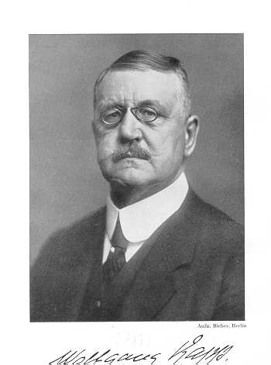
Case Study: The Kapp Putsch, 1920
Wolfgang Kapp was a right wing extremist. After the Sparticist revolt the government attempted to disband some Freikorps units. In response up to 5000 Friekorps led by Kapp marched on Berlin and captured the city. The government asked the army to intervene, but they refused. To end the putsch, the government called a ‘General Strike’. The workers responded in support of the government and the country came to a halt, Kapp soon realised that he could not run Germany without the support of the working class. The ordinary workers had saved the Republic. Kapp left Germany but very few supporters were punished. The government had learned that they could not rely on the army for support.
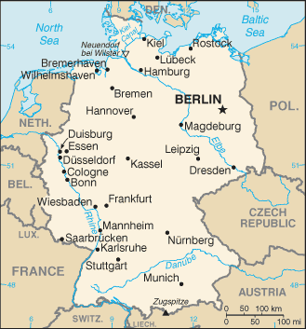
2. The Munich Beer Hall Putsch
On 8th November, 1923, the Bavarian government held a meeting of about 3,000 officials in a Munich Beer Hall.
Hitler and armed stormtroopers entered the building, announcing that the Munich Putsch (a revolution) had begun. Hitler’s aim was to overthrow the National government who had ‘stabbed Germany in the back.’ He would take over the German state of Barvaria and then march to Berlin.
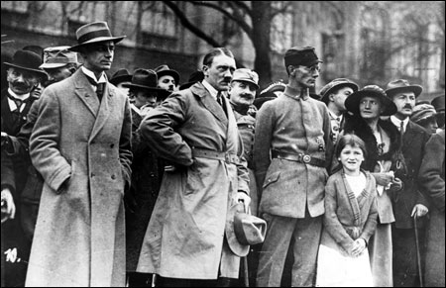
Hitler took Gustav von Kahr, Otto von Lossow, the commander of the Bavarian Army and Hans von Seisser, the commandant of the Bavarian State Police into an adjoining room. Hitler told the men that he was to be the new leader of Germany and offered them posts in his new government.
The three men were initially reluctant to agree to this offer, but they had little choice. Ludendorff arrived (leader of the German Army at the end of the First World War). He was a strong supporter of the Nazi Party and agreed to become head of the new German Army.
The next day Hitler, Ludendorff, Goering and 3,000 armed supporters of the Nazi Party marched through Munich before heading for Berlin. By this point the Von Khar, Lossowand Seisser had been freed from the Beer hall and had informed the Government of Hitler’s plans. At Odensplatz they found the road blocked by the Munich police. As they refused to stop, the police fired into the ground in front of the marchers. The stormtroopers returned the fire and during the next few minutes 21 people were killed and another hundred were wounded.Hitler was arrested and put on trial.

Significance of the Beer Hall Putsch
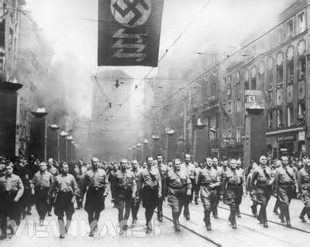
The Beer Hall putsch was important because:
- It showed that the Weimar Republic was still very unpopular.
- It showed that extremist groups were still trying to overthrow the Republic.
- It made Hitler realise that he could not overthrow the Government by violence.
- It allowed Hitler to use his trial as a propaganda weapon to win the attention and sympathy of the German people.

Task 12
- Create a spider diagram on the Munich Putsch.
Include arms with: Date, the leaders, beliefs, events of the day, the results. Use images as well.
- Using the information above and your spider diagrams compare the two ‘revolts.’ (6)
What was similar about the two events? What was different about them?

The French Occupation of the Ruhr
Germany was struggling in the early 1920s and only just about managed to pay its first reparations instalment.
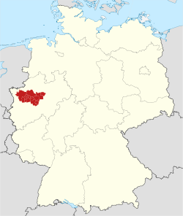
In 1922, the Weimar Government simply could not manage to pay another instalment. The Allies did not believe this, especially France, where anger towards Germany still ran deep and the German government was accused of trying to get out of her reparations responsibilities.
When Germany defaulted on a timber instalment, France took action. On 11th January 1923, breaking the rules of the League of Nations, French and Belgian troops entered and occupied the Ruhr. The Ruhr was Germany’s Industrial heart. The Ruhr produced 80% of Germany’s steel and 71% of its coal. The aim of the French and Belgians was simple: Take control of the coal mines, steel works such as Krupps, and factories. Force Germany to pay up.
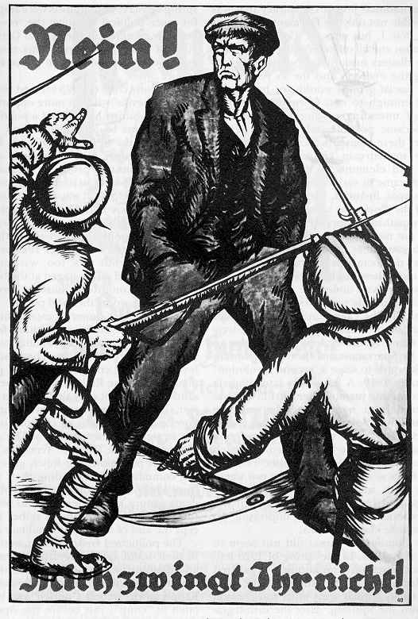
Passive Resistance
Germany was not in a position to fight the French and Belgians. Instead Chancellor Cuno and Industrialists such as Fritz Thyssen backed a policy of Passive Resistance. Passive resistance meant that the workers in the Ruhr simply refused to work.
The French responded by bringing in their own workers to operate the mines and began arresting leaders of the resistance movement. The French occupation ended in August 1925. However the French gained little from it.
Task 13
Source A German poster from 1923 reads: “No, you can’t make me”
- Describe the French occupation of the Ruhr (4)

HYPERINFLATION
Key word: HYPERINFLATION- a rapid rise in the level of prices of goods and services (usually daily and sometimes even hourly)

Germany was struggling in the 1920s. During World War I, Germany had spent much of its wealth trying to win the war. When Germany lost the war, the Government had to pay back everything they had borrowed as well as the reparations payments agreed by the Treaty of Versailles. The Treaty had also taken much of Germany’s industrial territory, making it very difficult to create the wealth necessary to repay the Allies. It was calculated that it would take sixty six years to pay the full amount.
The Weimar Government faced a problem she had little money and people needed to be paid. The government now had to fund a passive resistance campaign. This made Germany’s economic situation even worse. The government’s solution to this problem was to print more money. Unfortunately, this did not help matters as it caused Germany to suffer from Hyperinflation.

What is Hyperinflation?
Every country has industry and makes money; this is how much the country is worth. A country should only print notes to the value of what she is worth. This means that the face value of the notes in your pocket has the same value in gold in the central bank.
In 1923 Germany prints more money than she is actually worth. This means the value of each note becomes less. As the value of the money decreases, businesses decide to increase the prices of goods. A vicious cycle of hyperinflation is created as, to deal with the rise in the price of goods, the government prints yet more money making the problem worse.
Source A: The price of some goods (marks)
Item | 1913 | Summer 1923 | November 1923
1 egg | 0.08 | 5,000 | 80,000,000,000
1 kg butter | 2.70 | 26,000 | 6,000,000,000,000
1 kg beef | 1.75 | 18,800 | 5,600,000,000,000
Pair shoes | 12.00 | 1,000,000 | 32,000,000,000,000
Bread | 0.5 | 69,000 | 201,000,000,000

Task 14
- Explain why Germany was likely to suffer from inflation. (4)
- In your own words and using Source A examples, explain the term Hyperinflation. (3)

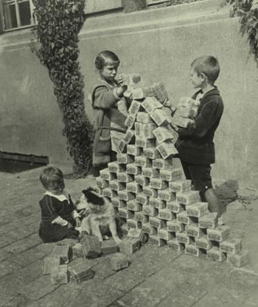
The Effects of HyperInflation
Hyperinflation caused the people to suffer further, although the middle classes were affected more than any other group as hard earned savings disappeared overnight. People were paid by the hour and rushed to pass money to loved ones so that it could be spent before its value meant it was worthless. Pensioners on fixed incomes suffered as pensions became worthless.
Bartering became common - exchanging something for something else but not accepting money for it. People sold furniture, clothing, jewellery and works of art to buy food. Little shops became crowded with such merchandise.
People had to shop with wheel barrows full of money; others found other uses for their money – burning it for fuel or creating children’s toys. The poor became even poorer and the winter of 1923 meant that many lived in freezing conditions burning furniture to get some heat.
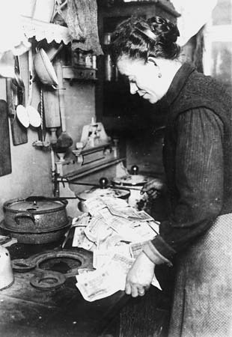
Business could not keep up and many started to close down and unemployment suddenly soared. Farmers refused to bring produce into the city in return for worthless paper. Food riots broke out. Parties of workers marched into the countryside to dig up vegetables and to loot the farms.
The very rich suffered least because they had sufficient contacts to get food etc. Most of the very rich were land owners and could produce food on their own estates. With many people unhappy with the situation, and at Weimar’s failure to solve the situation, support for extremist parties grew. Communism or the Nazis offered hope.
However, some people did gain by the economic crisis – Anyone with a loan before Hyperinflation could pay it off easily.

Task 15
- Choose 1 group of people in Weimar Germany. Read the Profile and note only how they would be affected by Hyperinflation. Then swap with a partner – can you guess the group affected.

Practise your skills

In Source A Konrad Heiden remembers the hyperinflation in Germany.
On Friday afternoons, workers desperately rushed to the nearest store, where a queue had already formed. It was soul destroying. When you arrived a pound of sugar cost two million marks but, by the time your turn came, you could only afford a half pound. In the chaos, people pushed prams loaded with money. Life became nightmarish. We were devastated as life savings became worthless. Of course, there were those who were used to having no money but it was hard for those of us who once had money and suddenly had nothing.

Source B describes some of the effects of hyperinflation in Germany in 1923.
By 1923 an economic crisis had developed in Germany. In little more than a year, hyperinflation had done appalling damage. It reduced to nothing money saved over decades of hard work. People paid for meals in restaurants before they ate because the price would have gone up before they had drunk their coffee. Others carried their savings to the bakers in wheelbarrows. Many Germans blamed the Weimar government. Fear and despair became the daily experience not only for those who already knew the effects of poverty but also of many accustomed to prosperity. In the end America came to the rescue.

- Compare the views of Sources A and B about the effects of hyperinflation in Germany in 1923? (4)

Source D: Egon Larsen, a German journalist, remembering in 1976
Bartering became more and more widespread . . . A haircut cost a couple of eggs. A student I knew had sold his gallery ticket at the State Opera for one dollar to an American; he could live on that money quite well for a whole week. The most dramatic changes in Berlin's outward appearance were the masses of beggars in the streets. In the summer of that inflation year a grandmother found herself unable to cope. So she asked one of her sons to sell her house. The old woman decided to keep the money under her mattress and buy food with it as the need arose - with the result that nothing was left except a pile of worthless paper when she died a few months later.
- How fully does Source D explain the effects of Hyperinflation? (5)

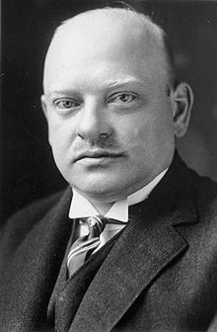
The ‘Golden Age’ of Weimar

The years 1924-9 is often called the ‘Golden Age of Weimar.’ They are also known as the ‘Stresemann Years,’ after the most important politician, and Chancellor of Germany at the time – Gustav Stresemann.

Why would this be called the ‘Golden Age’?
The first issue Stresemann had to deal with was the economic crisis. He had to end the Hyperinflation. He brought hyperinflation under control by scrapping the existing currency and replacing it with a new one called the Retenmark. Loans from America in 1924 called the Dawes Plan, also aided economic stability in Germany. With further US investment Germany began to recover. Another of Stresemann’s achievements in the negotiation of the Dawes Plan was to negotiate smaller reparation payments with a longer payment period. When the French and Belgians left the Ruhr, Germany’s industry got going again. Employment levels, foreign investment, and wealth in Germany began to rise.

Stresemann was a former foreign minister and he worked hard to regain international respect for Germany. He signed the Treaty of Locarno in 1925. In this act Germany accepted the terms of the Treaty of Versailles as it affected Western Europe. Stresemann also managed to get Germany accepted into the League of Nations.
During this ‘Golden Age,’ there was little support for the extremist parties. However in 1929 disaster struck. Gustav Stresemann died and the USA economy collapsed. Again Germany is plunged into economic depression.

Task 16
- Define the term ‘Golden Age.’
- From the above information what evidence is there that the Weimar government did experience a ‘Golden Age.’ (5)

The Wall Street Crash

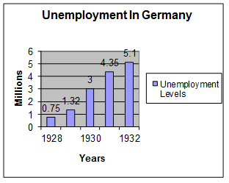
In October 1929, the American economy suffered when many American companies went bankrupt during the Wall Street Crash. American banks quickly demanded the immediate repayment of the loans that Germany had been given.
Source A
Trade between nations collapsed as countries could not afford to buy each others’ goods. In Germany, unemployment and industrial depression soon followed. Factories closed down and both middle class owners and working class employees suffered. As food prices started to rise, it seemed like 1923 all over again. The misery of unemployment was felt throughout the country.

Although it was not the Weimar government’s fault, it was again blamed for everything that had gone wrong. The Government appeared powerless. They could not do anything to improve the situation. The political parties in the Reichstag failed to agree on any one policy. When Bruning became Chancellor in 1930, Article 48 had to be used to issue emergency laws.

How did the Wall Street Crash Affect Germany
• The Germany government cut wages in an attempt to save money. Workers were paid less yet had to pay higher taxes.
• Unemployment benefit was cut.
• The government was unable to solve the increasing unemployment problem.
• In despair, more and more people turned to the Communists or Nazis for help. They hoped that they would do a better job than the weak Weimar Government.
• Article 48 was used to run Germany as the coalition governments could not agree. This made democracy appear weak.

The economic crisis gave Hitler and the Nazis the chance they needed to seize power.
The Weimar government had never been very popular during the years of prosperity. In 1923 and again in 1929, inflation and unemployment had caused chaos in Germany. The working and middle classes who usually supported the government were ruined. They lost faith in the democratically elected Weimar Government, allowing others to come to power.

Task 17
- Describe the impact of the Wall Street Crash on Germany (4)

- To what extent was the Weimar Government successful in the period 1918-29? (9)

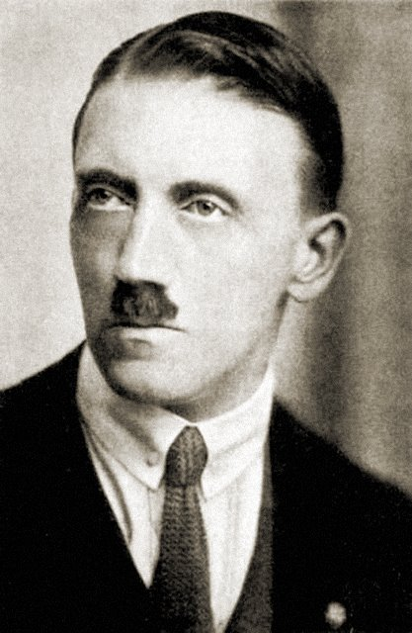
The Nazis
The Nazi Party did not exist in 1920, instead there was a small right-wing party called the German Worker's Party (GPW) in Munich. Hitler discovered that the party's political ideas were similar to his own and, although sent in as a spy, Hitler often made points and speeches at meetings.
Hitler's abilities as an orator impressed the party leaders who invited him to join the party. This gave Hitler tremendous power within the organisation as they knew they could not afford to lose him. During the 1920s Hitler had many referendums and elections that he could practise his speech. His charisma was appealing to the voters.
In April 1920, the party changed its name to the National Socialist German Workers Party (NSDAP). Hitler had always been hostile to socialist ideas, especially those that involved racial or sexual equality. However, socialism was a popular political ideology in Germany and reflected in the growth in the German Social Democrat Party (SDP). Hitler hoped to attract as many votes as possible with the change of name.
What did the Nazis believe?
While in Lansberg Prison for the failed Putsch, Hitler wrote Mein Kampf (My Struggle) where he outlined his main objectives and beliefs on Germany’s future. On 27th February 1925 the party re-launched.
Nazis believed in Anti-Semitism; the hatred of Jews. While this was not an uncommon belief across Europe at the time, the Nazis used the Jews as a scapegoat for all of Germany’s problems. This and other policies were liked by many Germans. The Nazis also believed in Nationalism and wanted to ensure a strong Germany for the master race. After the humiliation at Versailles this was supported by many, especially former soldiers. As a Fascist party the Nazis were therefore anti-communist, but they did believe in strong state control of the economy.

Main Nazi policies were:
- To destroy the Treaty of Versailles.
- To have complete power in Germany.
- To make Germany great again for the ‘master race.’
- Expand Germany’s borders to include all German speakers in other countries.
- Militarise Germany

Task 18

- Create a Nazi Party campaign leaflet.
It has to appeal to a wide range of people. It must follow the Nazi beliefs and outline what the Nazis want to achieve in power.

Practise your skills
- Describe the popular appeal of the Nazi Party in late 1920s
- Explain why the Nazis were successful in the 1920s.

The Nazi Rise to Power

The appeal of the Nazi Party policies and the failure of the Weimar Government to deal with the economic depression successfully resulted in the Nazi’s becoming more successful at the polls.

Source B
In 1932, Hitler was leader of the largest political party in the Reichstag, but did not have a majority. However, President Hindenburg who disliked Hitler appointed Franz Von Papen as Chancellor.
However, Von Papen had enemies and was replaced as Chancellor by Kurt Von Schleicher in December 1932. Von Papen, naturally unhappy with this, planned to oust Schleicher and began negotiations with Hitler. Schleicher’s Government soon began to collapse and Von Papen was able to convince President Hindenburg to appoint Hitler as Chancellor of Germany.
Although Hitler was now the Chancellor of Germany, he still had three main problems:
- President Hindenburg could still remove Hitler from power and he also had the support of the army.
- The Nazis still did not have a majority in the Reichstag.
- The Nazis still had to follow the Weimar Constitution and rule through the Reichstag.

Task 19

- Explain why Hitler should have been made Chancellor in 1932.
- Describe Hitler’s appointment to Chancellor January 1933? (5)
- Explain why Hitler did not have complete control of Germany at this point in January 1933?

Extension:

- Create a timeline of the Nazi Party from 1920-1933.
- Highlight the time periods when the Nazis were doing well
- Look at the periods when the Nazis were not popular. Explain why the Nazis were not popular in this period.

Creating Nazi Germany: Consolidation of Power
By 1933, Hitler was one large step closer to his goal of having complete control of Germany. Before the March elections of that year he had been made Chancellor - the second most powerful political job in Germany. Using the powers that the job gave him, he looked to increase his power even more by calling another election for March. Hitler aimed to gain a larger share of the vote and therefore more power.

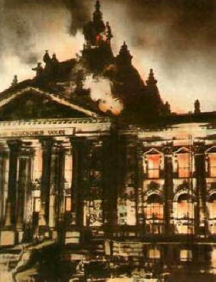
The Events
At 10pm on 27th February 1933, the Berlin Fire Department received a call that the Reichstag building was on fire. A number of small fires had been started around the building, but most failed to take hold, except the fire started in the great chamber.
A young communist Marinus van der Lubbe was discovered on the premises in just trousers and shoes. Van der Lubbe and four other communists, Ernst Torgler, Georgi Dimitrov, Blagoi Popov, and Vassil Tanev were arrested and charged with arson and attempting to overthrow the government.
Although van der Lubbe confessed to the crime, many people believed that the real culprits were the Nazi Party, probably members of the SA (Brown shirts)

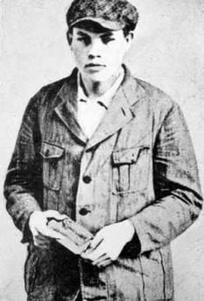
The Outcome of the Trial
In July 1933 Marinus van der Lubbe and the 4 other conspirators were charged with arson and attempting to overthrow the government. Van der Lubbe, who confessed to the crime, was found guilty, but the others were acquitted as there wasn’t enough evidence against them. Van der Lubbe was beheaded on 10th January 1934.

The impact of the Reichstag Fire
Hitler was able to use the event to his advantage. Germany, Hitler claimed, was on the verge of revolution. Around 4000 communists were arrested and many citizens’ rights were taken away. For example censorship was introduced and many newspapers that were hostile to the Nazis were closed.
Task 20
Write a short newspaper article reporting the Reichstag Fire. Remember you cannot mention any details that could not be reported the next day!

Chancellor to Dictator

The Enabling Law

At the March elections, the Nazi party was the largest single political party. However, he still only had 288 seats – 43.9% and not a majority. Hitler made a deal with the Catholic Centre Party, used the emergency laws to prevent Communists from taking their seats in the Reichstag and used the SA to intimidate other deputies. Hitler needed a two-thirds majority to pass the Enabling Act –it passed.
This meant Hitler now had the power to issue new laws without consulting parliament.
- He made the Nazis the only legal political organisation in the country. The other parties were banned or dissolved themselves.
- No-one could now challenge the Nazis legally, which made opposition very dangerous. Opponents of the Nazis had to work in secret, and some fled abroad.

Crushing all opponents

Hitler continued to crush any potential opposition to his power. In April 1933, the parliaments of the German states (Lander) were replaced by Nazi governors who could appoint and dismiss officials and judges. Anti-Nazis or Jews were removed from the civil service and by May 1933, trade unions were banned and replaced by the Labour Front.

The Night of the Long Knives – 30th June 1934
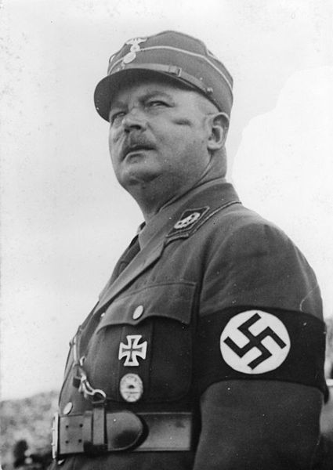
Only Hindenburg and the army stood in Hitler’s path to complete power. The army were unhappy with the size of the SA which numbered 3 million by 1934. Army officers feared that Ernst Rohm would break up the regular army and put them all under his leadership. Hitler feared that this could lead to revolution. Hitler also feared that Rohm was planning to challenge him for leadership of the Nazis.
Hitler found out about a letter written by Rohm in January 1934. It stated, “Hitler can’t walk over me as he might have done a year ago; I’ve seen to that. If Hitler is reasonable I shall settle the matter quietly; if he isn’t I must be prepared to use force.”
On the 30th June 1934 Hitler used the SS to murder around 400 of his enemies including Rohm and von Schleicher and von Kahr. By killing his own men, Hitler won the loyalty and approval of the army.

The Death of Hindenburg and the Oath of Loyalty
President Hindenburg died of old age on the 2nd of August 1934. Immediately Hitler merged the roles of Chancellor and President to create Fuhrer (supreme leader)
Hitler also ensured that every member of the army took an oath of loyalty directly to him ensuring their allegiance.
Germany was now a totalitarian state and the Third Reich had begun.

Task 21
- Create a timeline outlining the main events leading to Hitler’s appointment as Chancellor. Some years will have more than one event highlighted.

Practise your skills
- Describe the methods used by Hitler to pass the Enabling Act in 1933? (4)
- Explain why the Enabling Act was so important to Hitler in consolidating power? One reason, but focus on fully explaining the point.
- What actions did Hitler take to ensure that he became Fuhrer in 1934?

Source A is from an account by a National Socialist of the reactions of Germans to the Night of the Long Knives
The Weimar constitution tried very hard to protect people’s rights. With the failure of the Munich Putsch of 1923, most people believed that Hitler and the Nazis were finished. Hitler’s courage in taking decisive action has made him a hero in the eyes of many Germans. He has won strong approval and sympathy for the steps he took. People think his action is proof that he wants order and decency in Germany. Reports from different parts of the country are unanimous that people are expressing satisfaction that Hitler has acted so decisively against the serious threat opposed by Rohm and the SA to Germany and her people.

Source B is from “Hitler’s Domestic Policy” by Andrew Boxer.
On the morning of 30th June 1934, Rohm and other SA leaders were arrested and eventually shot. Hitler’s personal popularity soared as a result of the Night of the Long Knives, as this event became known. Most Germans disliked the corruption and arrogance of the SA and welcomed the decisive action against it. President Hindenburg’s telegram to Hitler seemed to sum up the relief felt by most Germans: “By your determined action and gallant personal intervention, you have saved the German nation from serious danger. For this, I express to you my most grateful thanks and that of the German people.”

- Compare Sources A and B about the attitudes of Germans to the Night of the Long Knives? (4)

- To what extent was the Nazi rise to power in January 1933 due to discontent with the Weimar Republic? (9)

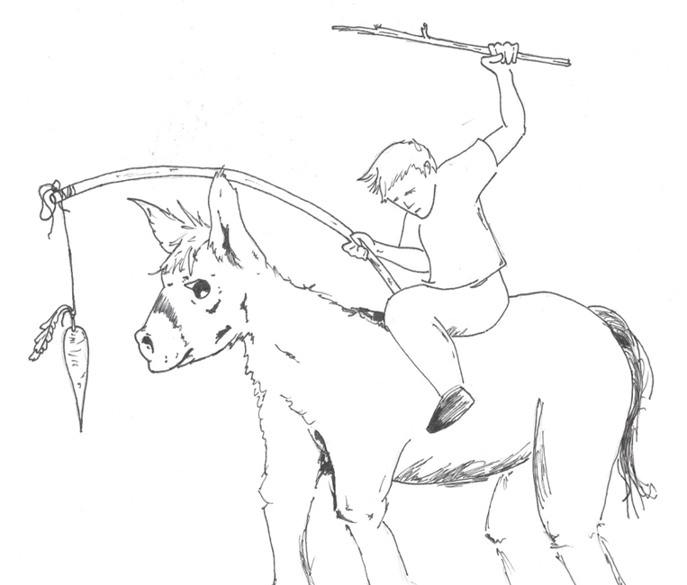
Nazi Control of Germany:
The Carrot and the Stick

The Nazis controlled the German people with an approach of reward (Carrot) and Fear and intimidation (stick).

Fear and Intimidation
Hitler used a number of organisations to keep and extend his control of Germany.

- The SS Formed in 1925 to act as Hitler’s personal bodyguard, they increased in power drastically after the Night of the Long Knives when they murdered key members of the SA. By 1933 they numbered 52,000. Led by Heinrich Himmler they were fanatically loyal to Hitler. The SS were perfect Ayrans, easily spotted by their black uniforms. Hitler used them as his execution squad to eliminate his opponents. They were also controlled the concentration camps.

- The SD (Security Service) and Gestapo (Secret State Police).

The SD had an army of informants and hunted down, and also often murdered, opponents.

The Gestapo formed in 1933 and led by Hermann Goering. It included up to 45,000 members. They wore ordinary clothes and spied on German citizens. They paid up to 160,000 informers to spy on friends and neighbours. The Gestapo, although possibly not as large as the people thought, were greatly feared in Germany. People would disappear after receiving a visit from the Gestapo.

- The Police force and law courts. Heinrich Himmler, the head of the SS, was also in charge of the police. This meant no-one investigated the crimes committed by the Nazis. Special 'people's courts' made sure that opponents of the Nazis charged with treason were found guilty, even if there was little or no evidence.

- Concentration camps. Established in 1933. Opponents of the Nazis and “undesirable” members of the population, such as Jews, Communists and gypsies, were sent to the camps without trial. Prisoners wore colour-coded bands to identify the reason for imprisonment, for example, pink for homosexuals and green for criminals. The SS, Hitler's most loyal organisation, ran the camps.
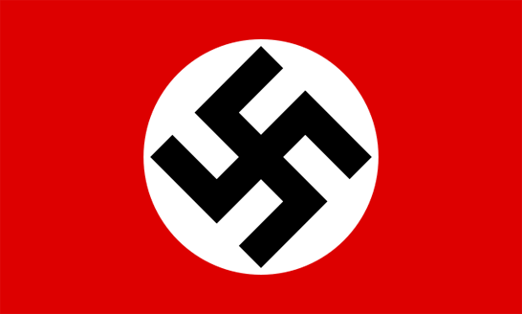
The visible evidence of control, seen in flags, symbols and uniforms on the streets, together with the use of informants, made people very cautious. However, the system was not as efficient as it appeared, with security forces often reporting "grumbling" among workers, but unable to do much about it and opposition still existing.

Task 22
Create a spider on the groups implementing terror in Germany. You can include any information, but ensure you include: the groups name, who led the organisation, what they did.

Persecution in Nazi Germany
The Nazi Police state persecuted many within society and many groups who targeted by Hitler's policies, but none more so than the Jews.

Who did the Nazis persecute?
The Nazis believed that only Germans could be citizens and that non-Germans did not have any right to the rights of citizenship.
The Nazis racial philosophy taught that some races were untermenschen (sub-humans). Many scientists at this time believed that people with disabilities or social problems were degenerates, whose genes needed to be eliminated from the human bloodline.
The Nazis, therefore:
- Tried to eliminate the Jews.
- Killed 85 per cent of Germany's gypsies.
- Sterilised black people.
- Killed mentally disabled babies.
- Killed mentally ill patients.
- Sterilised physically disabled people and people with hereditary diseases.
- Sterilised deaf people.
- Put homosexuals, prostitutes, Jehovah's Witnesses, alcoholics, pacifists, beggars, hooligans and criminals - who they regarded as anti-social - into concentration camps.

Task 23
Write a summary of who the Nazis persecuted. Make sure that it is written in your own way.

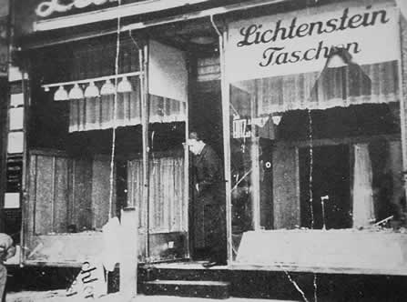
How the Nazis persecuted the Jews: key dates
1933
- Boycott of Jewish businesses.
- Jewish civil servants, lawyers and teachers sacked.
- Race Science lessons to teach that Jews are untermensch.
A shop damaged during Kristallnacht

1935
- In May, Jews were forbidden from joining the army.
- 'Jews not wanted here' signs put up at swimming pools, restaurants etc. banning Jews.
- Nuremberg Laws (15 September) Jews could not be citizens. They were not allowed to vote or to marry a German.

Source A: A translation of Law for the Protection of German Blood and German Honour (Nuremberg Laws). Passed by the Reichstag 15th September 1935

The Nuremberg Laws
- Marriages between Jews and people of German blood are forbidden.
- Jews must not employ in their household female people of German blood who are under 45 years old.
- Jews are forbidden to fly the Reich and National flag and to display the Reich colours.
- Jews can no longer be citizens of Germany
- Jews must carry special identity papers with a large J for Jude (German for Jew) printed over their personal details.

1937
- Jews were no longer allowed to own their own business

1938
- Jews could not be doctors.
- Jewish children forbidden to go to school.
- Kristallnacht (9 November) - attacks on Jewish homes, businesses and synagogues.
1939
- Jews were forbidden to own a business, or own a radio.
- September – Polish Jews were forced to live in a ghetto.
- All Jews were forced to wear a yellow star of David.

1941
- Army Einsatzgruppen squads in Russia started mass-shootings of Jews.

1942
- Wannsee Conference (20 January) decided on the Final Solution, which was to gas all Europe's Jews. The main death camps were at Auschwitz, Treblinka and Sobibor

Task 24
  - Explain why the Nazi persecution of the Jews could not be stopped?
  - In pairs examine the Nuremberg Laws and decide which rule was the worst for Jews? You must have good reasons to support your answer.
  - Write a summary in your jotter of the events of Kristallnacht.

Practise your Skills
- Describe the ways in which the Nazis persecuted the Jews. Use the dates above to write an extended answer. (4)
- Evaluate the usefulness of Source A as evidence of Nazis persecution of the Jewish people? (6) (source is on previous page)

Opposition to the Nazis

Those who spoke out against Hitler and his policies faced intimidation and threats from the Gestapo or imprisonment, and in some cases execution. However, brave individuals and groups openly opposed the Nazis - a few survived, but many were killed.
It was difficult - and dangerous - to oppose Hitler. However, some brave people did try. The main opposition to National Socialism came from the Socialists, the Communists and the Churches.

The Socialists and the Communists
Despite their parties being banned and their leaders arrested the Socialists and Communists continued to resist Nazi rule. Some went underground and organised resistance secretly among the working class factory workers. Others tried to print illegal newspapers or pamphlets.
Resistance was made more difficult as the Socialists and Communists refused to work together after the Socialists had brutally crushed the Spartacist rising. This weakened their resistance attempts.

The Churches
Initially the Churches welcomed Hitler because they thought he would resist the Communists who were against any type of religion. However, it did not take the Churches very long to realise that they too were under attack from the Nazis.
It was important for Hitler to eliminate other beliefs like Christianity because they might challenge the right wing, extremist views of the Nazis. The problem was there were so many Christians in Germany. One third of all Germans were Roman Catholics and two thirds were Protestants.

The Catholic Church
In July 1933, Hitler signed a concordat (an agreement) with the Pope, agreeing that the Catholic Church could continue to worship feely, as long as it did not interfere with the Nazi government. However, Hitler soon ignored it; priests were put in concentration camps and Catholic schools closed. Although Hitler did attack the Catholic Church, he could not attempt to destroy it completely because of its status as a worldwide Church.

Examples of opposition:
- The Catholic Archbishop of Munster, von Galen, led a successful campaign to end euthanasia of mentally-disabled people.
- Some Catholic priests opposed Hitler. In 1937, the Pope's message 'With Burning Concern' attacked Hitler as 'a mad prophet with repulsive arrogance' and was read in every Catholic Church.

The Protestants
The German Protestant Church were not a united group and did not have as many links abroad as the Catholics. Hitler wanted to make the Protestant Churches into a Reich Church so that they would come under Nazi control. Ludwig Muller, a Protestant Minister was appointed as Reich Bishop. In these churches, the Bible was replaced by copies of Hitler’s autobiography Mein Kampf and pagan festivals replaced Christian services.
Many Protestant ministers, led by Martin Niemöller, formed the Confessional Church in opposition to Hitler's Reich Church. Niemöller was held in a concentration camp during the period 1937-1945. Another Protestant pastor, Dietrich Bonhöffer, took part in the 1944 bomb plot and was executed. Although the Nazis attacked the Churches they never managed to outlaw them completely.

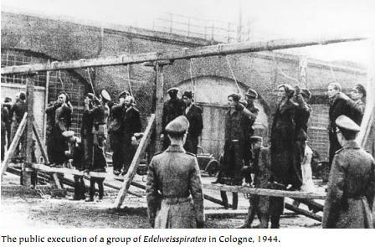
Other Resistance
The Edelweiss Pirates
This was a youth resistance group which mostly comprised of working class girls and boys between the ages of 14-18. They refused to take part in the Nazi youth groups and instead formed anti-Nazi gangs. There were about a dozen members in each gang and they attacked Hitler Youth patrols and sheltered army deserters and concentration camp escapees. They painted anti-Nazi slogans, hid deserters and beat up Nazi officials. In 1944, the Cologne Pirates (the Edelweiss Pirates based in Cologne) killed the Gestapo chief, so the Nazis publicly hanged 12 of them.

The Meuten
These groups aimed to destroy Nazi control and tended to occur in areas of where Communist support had been strong. The Gestapo believed that there were approximately 1500 Meuten members in Leipzig between 1937-1939.
The Swing Kids
Heavily influenced by American culture, the Swing Kids loved to listen to jazz and wear the latest American fashion. Hitler hated this as he considered jazz to be ‘black music’ and the American fashion to be immodest and not in keeping with the Nazi view of women. The swing kids also allowed Jewish members. They openly went against what the Nazis believed.

White Rose
Hans and Sophie Scholl were members of the White Rose Group in Munich who distributed anti-Nazi leaflets. In 1943 both Han and Sophie were arrested and charged with preparing and distributing anti Nazi leaflets. Both were sentenced to death.
Inge Scholl describes the difficulties of resistance in Students Against Tyranny, written in 1952
The fear of the people in the face of the constant threat of Gestapo intervention and the thoroughness of the surveillance system were the strongest obstacles. On the other hand, it still seemed possible, by means of anonymous leaflets and fly posters, to create the impression that the Nazis did not have solid support and that there was general discontent.
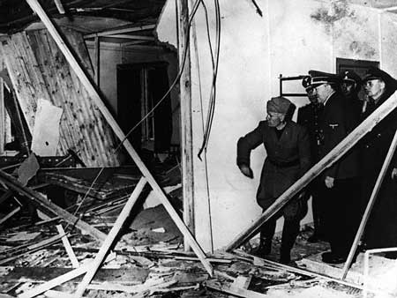
The Army – this was unusual in Nazi Germany. In 1944, a group of army officers and intellectuals called the Kreisau Circle tried to bomb Hitler. The bomb was planted by Colonel Claus von Stauffenberg. It exploded, but Hitler survived. In retaliation, 5,000 people were executed.

Task 25
- Create Summary notes for opposition to the Nazis. Your notes should have: the heading of the group, who they were and have examples of their actions.
Hitler surveys the damage from the bomb planted by the Kreisau Circle

- Describe the opposition faced by the NASDP to their hold on power (4)
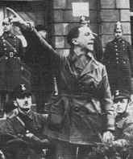
Nazi Social and Economic Policy: Propaganda
Propaganda within Nazi Germany was taken to a new level. Hitler was very aware of the value of good propaganda and he appointed Dr Joseph Goebbels as its head. Goebbels became the Minister of Propaganda and National Enlightenment
Propaganda is the art of persuasion - persuading others that your view is correct. Propaganda might take the form of persuading others that your military might is too great to be challenged; that your political might within a nation is too great or popular to challenge etc.

The Propaganda Ministry worked hard to ensure that people were persuaded to follow the Nazi point of view. They used a number of methods:

- Nuremberg Rallies. Every year in September mass rallies at Nuremberg. This was another form of propaganda used successfully by the Nazis. Used to excite and entertain with mock battles, military parades and music. These rallies helped to promote militarism – respect for the armed forces.

Source A: Frau Solmitz attended a Nuremberg rally

It was 10pm by the time the first torchlight came and then 20,000 Brownshirts followed one another like waves in the sea. Their faces shone with enthusiasm in the light of the torches. It was a magnificent picture, the snow white, scarlet, green and black colours, the fantastic berets, boots and gauntlets in the dancing light of the torches, the swords, the flags. We were drunk with enthusiasm.
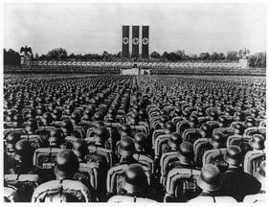

Military might was shown during the Nuremberg Rallies (Left)

- Censorship - Newspapers were censored and any material that gave a different view point from the Nazis was banned and destroyed. Goebbels organised a book burning in May 1933.
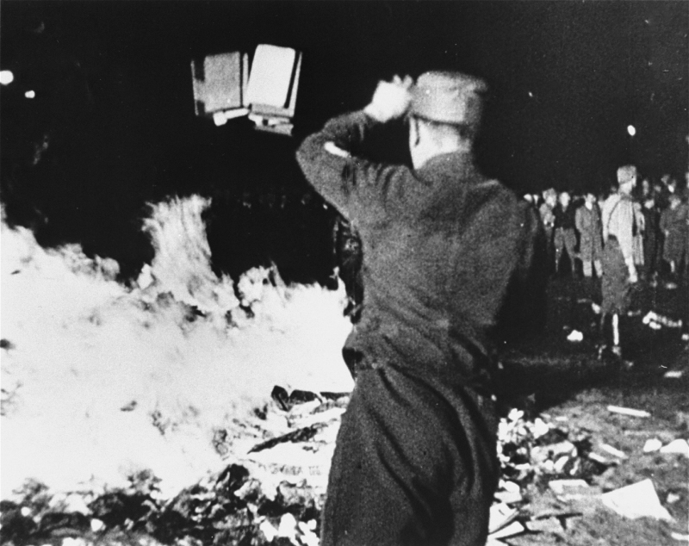

Book Burning in May 1933.

- New Media utilised. By 1939 over 70% of German homes had a radio as so called ‘People's radios’ were massed produced. They were sold very cheaply, but broadcasts controlled as they had a limited range and could only receive Nazi approved channels. Certainly no foreign radio stations. When talking about the impact the radio had on the German population Albert Speer stated, “Through technical devices like the radio 80 million people were deprived of independent thought. It was thereby possible to subject them to the will of one man.” Loudspeakers were used in public places blared out Nazi propaganda.
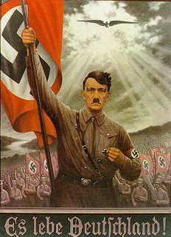
- Films were made that glorified war, or emphasised the God like nature of Hitler (Triumph of the Will) and attacked the Jews (The Eternal Jew). With millions attending the cinema each week this was particularly effective at delivering the message that the Nazis wanted people to hear.

- Cult of personality - Hitler's picture was everywhere, and he was shown to be Germany's saviour as in the poster to the right.

Task 26

- Create a mind map about the different types of Propaganda within Nazi Germany. Remember use only: pictures, abbreviates, symbols, numbers, single words.

Practise your Skills

- Explain the role of propaganda within Nazi Germany (6)

Nazi Economic Policy – An economic Miracle?
There was two aims of Nazi economic policy: Full employment and Autarky. Autarky was the need for Germany to be self-sufficient. Official unemployment figures dropped from 6 million unemployed in January 1933 to literally nothing by 1939. This appears impressive, but statistics do not always tell the whole truth! For Instance:
- Women were not included in unemployment figures as Hitler believed women belonged at home as wife and mother.
- From 1935 Jews were no longer included in unemployment statistics as following the Nuremburg laws they were no longer ‘German’.

What did the Nazis do?
The German Labour Front (DAF)
The German Labour Front was established by the Nazis to replace Trade Unions. It entitled members to an extra day holiday and provided protection from on the spot dismissal by employers. However, workers had no opportunity to campaign for increased pay or improved working conditions. Furthermore, workers could not leave their current employment without permission from the government. Each employee was issued with a workbook which contained a record of their attendance and behaviour. They could not be employed without this workbook.
Weekly working hours increased on average from 60 to 72 hours per week with no increase in pay. However, employed Germans were earning on average ten times more than unemployed Germans on benefits.

The German Labour Service (RAD)
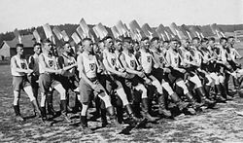
Established in 1935 the German Labour Service was a compulsory scheme which required all men between the ages of 19-25 to work for the government for six months. Women were subsequently included in this also. Although the intention was for women not to work, the demands of the economy, especially on outbreak of war meant that the Nazis needed them to work. This shows an example of contradictory policy.
Workers wore military style uniforms and tasked with building public works such as the autobahn (motorway) and hospitals. Although wages were very low the majority of workers were grateful as they felt that the government was doing all it could to help them by creating employment opportunities. Public works schemes such as building schools, hospitals and roads created jobs.
It is also important to point out that there may have been little choice, failure to comply could result in being sent to a concentration camp for ‘re-education.’
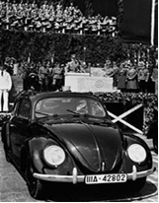
Strength Through Joy (Kraft durch Freude) KdF
Nazi party attracted support by offering cheap holidays to workers. An example of this being in 1938 over 180,000 people went on state subsidised cruises. On a smaller scale weekly activities were also organised for workers including theatre shows and hiking trips.
Hitler opening a new Volkswagen factory.

Hitler even went as far as to promise every worker an affordable family car, the Volkswagen. Many workers paid the agreed 5 marks a week, however this money was filtered into war preparation and no cars were produced for the public.
Autarky This meant that the Nazis wanted to ensure that Germany was self-sufficient. There was an unsuccessful attempt at making Germany self-sufficient. The Nazis did subsidise farmers, which made food slightly cheaper. Imports from abroad was also reduced, however food was still cheaper imported. For most German people there were few luxuries.

Nazi Foreign Policy helped them appear strong economically. For example:
- Many men were conscripted into the armed forces and so removed from unemployment statistics.
- Military preparation created jobs as more workers were needs in factories to produce ammunition, weapons etc
- Anschluss and future territorial gains allowed them to gain extra resources of that country.
Task 27
- Create a table like the one below:
Economic Policy | Detail | Evidence of Success | Evidence of Weakness
The German Labour Front
The German Labour Service (RAD)
Strength through Joy (KdF)
Autarky

- How successful were the Nazi economic policies in improving the lives of the workers? (9)
- How successful were Nazi economic policies in Germany between 1933-1939? (9)

Nazi Social Policy: The Youth

Nazi Policy affecting the young in Germany concentrated on both education and in their youth groups.

Education
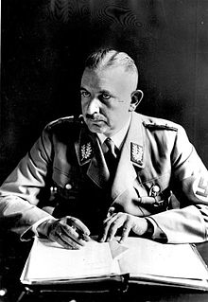
Education played a very important part in Nazi Germany in trying to create a loyal following for Hitler and the Nazis. Education was under the control of Bernhard Rust.
Enforcing a Nazi curriculum on schools depended on the teachers delivering it. Any teacher considered disloyal was sacked and therefore it is no surprise that 97% of all teachers joined the Nazi Teachers' Association. All teachers had to be careful about what they said as children were encouraged to inform the authorities if a teacher said something that did not fit in with the curriculum.
Many students attended classes during school holidays in which the Nazi curriculum was spelled out. Classrooms were covered with pictures of Hitler, swastikas and insulting pictures of Jews. German children were being indoctrinated (brainwashed).

Curriculum Changes
Subjects underwent a major change in schools. Some of the most affected were History and Biology.
- History was based on the glory of Germany. The German defeat in 1918 was explained as the work of Jewish and Marxist spies, who had weakened the system from within. The Treaty of Versailles was the work of nations jealous of Germany's might and power. The hyperinflation of 1923 was the work of Jewish saboteurs.
- Biology became a study of the different races to 'prove' that the Nazi belief in racial superiority was a sound belief. "Racial Instruction" started as the age of 6.
- Geography taught pupils about the land Germany – land removed in 1919 and the need for Germany to have living space - lebensraum.
- Science had a military slant to it. The curriculum required that the principles of shooting be studied; military aviation science; bridge building and the impact of poison gas
- PE became a very important part of the curriculum. Hitler had stated that he wanted boys who could suffer pain. PE took up 15% of a school's weekly timetable. Boxing became compulsory for boys. Those who failed fitness tests could be expelled from their schools - and face humiliation from those who had passed.

Education for Boys and Girls

Girls had a different curriculum in some ways as they studied subjects like home economics - to prepare young girls to be the perfect mother and wife.
At every opportunity, teachers were expected to attack the life style of the Jews. Exam questions even contained anti- Semitic ideas.

"A bomber aircraft on take-off carries 12 dozen bombs, each weighing 10 kilos. The aircraft takes off for Warsaw the international centre for Jewry. It bombs the town. On take-off with all bombs on board and a fuel tank containing 100 kilos of fuel, the aircraft weighed about 8 tons. When it returns from the crusade, there are still 230 kilos left. What is the weight of the aircraft when empty?"

Other questions would also include areas the government wanted taught by teachers in the nation's search for a master race:

"To keep a mentally ill person costs approximately 4 marks a day. There are 300,000 mentally ill people in care. How much do these people cost to keep in total? How many marriage loans of 1000 marks could be granted with this money?"

Task 28

Explain how the Nazis used education in an attempt to make perfect German citizens. Creating a table may help:

Nazi Actions | Why did they take this action?

Youth Movements
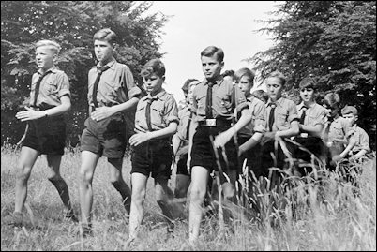
The Hitler Youth Movement formed in 1926 and by 1933, it had 100,000 members. After the Nazi consolidation of power, it had risen to 2 million. By 1939, it became compulsory to join the Hitler Youth and it was claimed there was 7.3 million members.
The Hitler Youth was seen as being as important to a child as school was and therefore needed to be controlled. In the early years of the Nazi government, Hitler had made it clear as to what he expected German children to be like:
"The weak must be chiselled away. I want young men and women who can suffer pain. A young German must be as swift as a greyhound, as tough as leather, and as hard as Krupp's steel."

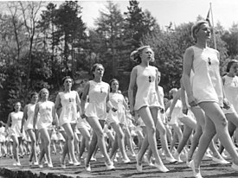
The young were organised into different groups according to their age and sex.

Boys
6-10 years | Pimpfen (Little fellows) – Took part in activities to ensure fitness such as hiking, camping and physical exercise.
10-14 years | German Young People- oath of loyalty to Hitler and training in military discipline.
14-18 years | Hitler Youth – More advanced military training

Girls
10-14 years | Young Girls – Physical exercise
14-17 years | League of German Maidens - training for motherhood

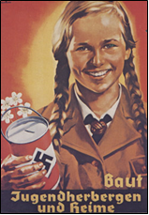
To the outside world, the Hitler Youth seemed to sum up German discipline. In fact, this image was far from accurate. Teachers complained that boys and girls were so tired from attending evening meetings of the Hitler Youth, that they could barely stay awake the next day at school. Also by 1938, attendance at Hitler Youth meetings was so poor - barely 25% - that the authorities decided to tighten up attendance with the 1939 law making attendance compulsory
Activities of the Youth Groups
Boys were trained to obey and carry out orders. Girls were taught how to be good mothers so that the future German race would be well looked after.
Training was tough and brutal in order to make the young people strong. The youth movements took part in the great Nazi Party Rallies. Dressed in uniform, carrying banners and playing the drums they were made to look like little soldiers.
For many, the youth groups were entertaining and offered the opportunity to spend time with friends. For many poor German children they also offered the chance for camping holidays.
Task: Create a graffiti board about the Hitler youth. You can use pictures and words.
- Give statistics
- Try to organise it – girls and boys.
- Outline activities.

Practise your exam skills
Source A describes the experiences of a former member of the Hitler Youth.

On 30th January 1933 Hitler became Chancellor of Germany. If other people rave about their time in the Hitler Youth, I cannot share their enthusiasm. My memories are that it was very oppressive. In our troop, activities consisted almost entirely of military drill. Even at sport or shooting practice we had to do drill first. Every day was the same monotonous routine. Then there was the endless marching. It was more punishment than fun. The slightest sign of weakness meant more drill! But, there was method in this madness: from childhood onwards we were drilled in toughness and obedience.

Source B is about life in the Hitler Youth.

I was full of enthusiasm when I joined the Hitler Youth at the age of 10. What boy isn’t fired up with the ideals of comradeship, honour and loyalty? Then the trips! Is there anything nicer than enjoying the splendour of the homeland in the company of one’s comrades? There was always something different to do. We often went on marches on a Sunday. What joy we felt to be able to go on these trips. Playing handball or football on the meadows or bathing in a lake far away from the noisy city was a means of relaxation as well as building us up physically.

2. Compare the views of Sources A and B about the activities of the Hitler Youth? (4 marks)

Source C:
When I arrived, the school yard was crowded with girls. They looked serious as old women. Most of them were jumping, running, marching to the tunes of Nazi songs, to make their bodies strong for motherhood.
A whistle shrilled and the girls gathered about an elevated platform. For fifteen minutes the girls received minute instructions until each knew exactly what to do and when to do it. There was no whining, no complaining. Everybody seemed eager and happy to follow orders.

How fully does source C show typical features of the Hitler Youth organisations? (6)

Source D was written by historians J.F. Corkery and R.C.F. Stone, in “Weimar Germany and the Third Reich”, published in 1980.
The Munich or Beer Hall Putsch was an attempt by the Nazis to seize power. Opposition to Nazi rule within Germany was difficult. Government organisation of the workers gave opportunity for brainwashing them. In 1935 the Labour Service was established. This meant that every male between the ages of 18 and 25 had to do six months in public work camps. Camp discipline was semi-military. Camp leaders were given ranks. Men drilled with spades instead of rifles. The Labour Service was an opportunity to spread Nazi propaganda, building upon that already provided by the schools and Hitler Youth. Workers were urged to regard themselves as ‘soldiers of work’.

1. Evaluate the usefulness of Source D as evidence about militarism in Nazi Germany? (5)

Nazi Social Policy: Women

The Nazis had clear ideas of what they wanted from women.

Women were expected to stay at home and look after the family. Girls were trained at school to be housewives and discouraging them from going on to higher education. The introduction of the Law for the Reduction of Unemployment in 1933, gave women financial incentives to stay at home

Women doctors, teachers and civil servants were forced to give up their careers. Even at the end of the war, women were never asked to serve in the armed forces.

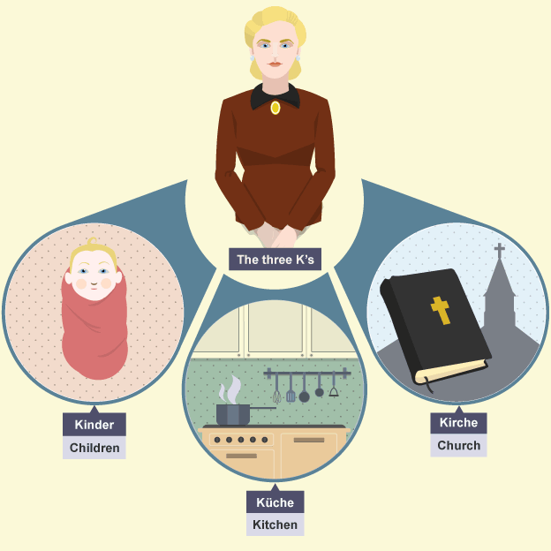
Their job was to keep the home nice for their husband and family - their life should revolve round the three 'Ks':

- church
- children
- cooking

Goebbels said: "The mission of women is to be beautiful and to bring children into the world."

Hitler wanted a high birth rate, so the German population would grow. The Nazis even considered making it law that families should have at least four children. Girls did keep fit in the BDM to make themselves healthy for childbirth, but they were discouraged from staying slim, because it was thought that thin women had trouble giving birth.

The Law for the Encouragement of Marriage in 1933 gave newly- wed couples a loan of 1,000 marks, and allowed them to keep 250 marks for each child they had. Mothers who had more than eight children were given a gold medal. Unmarried women could volunteer to have a baby for an Aryan member of the SS.

Women were supposed to emulate traditional German peasant fashions - plain peasant costumes, hair in plaits or buns and flat shoes. They were not expected to wear make-up or trousers, dye their hair or smoke in public.

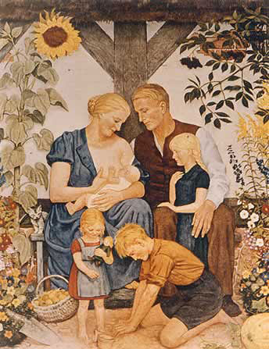

Task 29

- Look at the image above – in what ways does the artist represent the Nazi ideals of women?
- Describe the Nazi views of women.
- Describe the Laws passed by the Nazis towards women.
Task 30

- Create a bullet point list of reasons for Nazi popularity in the period 1933-1939.

- To what extent was the use of propaganda the main reason for Hitler’s popularity within Germany? (8)

