NATIONAL 4/5 HISTORY

[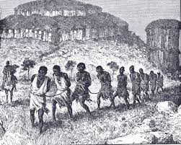](http://www.google.co.uk/url?sa=i&rct=j&q=&esrc=s&frm=1&source=images&cd=&cad=rja&uact=8&ved=&url=http://individuality1977.blogspot.com/2007/03/200th-anniversary-of-british-abolition.html&ei=KMBgVKr2DcXbsASoo4KYBg&bvm=bv.79189006,d.cWc&psig=AFQjCNG6pAi2uN1OaYBLrfY1eKWP19AgPA&ust=1415713192778556)

**The Atlantic Slave Trade,**

**1770–1807**

**The Atlantic Slave Trade, 1770-1807**

Our British Topic is the Atlantic Slave Trade 1770-1807. This is an issue that Britain had great involvement and prospered from. Thousands of Africans were enslaved in this period, taken from their homes to the Americas. We will study 4 main themes: The Triangular Trade; Britain’s role and the Caribbean; The captives experience and the abolitionist campaigns.

The Triangular Trade The organisation and nature of the slave trade: its effects on British ports, eg Liverpool, Bristol; its effects on African societies, eg Ashanti, and on West Indian plantations. Slave ‘factories’ on the African coast; the economics and conditions of the ‘Middle Passage’.

Britain and the Caribbean The importance of tropical crops such as sugar; the influence of the British in the Caribbean and the impact of the Caribbean trade on the British economy; the negative impact of the slave trade on the development of the Caribbean islands.

The captive’s experience and resistance Living and working conditions on the plantations; discipline; other forms of slave labour on the Caribbean islands; resistance on the plantations; fear of revolt.

The abolitionist campaigns Origins of the abolitionist movement and its increased support outside and within Parliament. Role of Wilberforce. Arguments of the abolitionists: Christian, humanitarian, economic. Decision to concentrate on the slave trade.

Methods of the abolitionists: meetings, evidence, eg Clarkson; first-hand accounts by slavers, eg Newton; publicity, eg Wedgwood. Attitudes and evidence of slaves and former slaves, eg Equiano. Resistance to the trade by slaves.

Defenders of the trade: planters, MPs, cities; effect of the French Revolution; reasons for the delay in the abolition of the trade.

The debate over reasons for the eventual success of the abolition campaign: public opinion, Parliamentary debate...

There are a number of websites that will help you revise this topic, some include:

* <http://www.liverpoolmuseums.org.uk/ism/slavery/>
* <http://abolition.e2bn.org/index.php>
* <http://www.nationalarchives.gov.uk/pathways/blackhistory/africa_caribbean/africa_trade.htm>
* <http://spartacus-educational.com/USASafrica.htm>
* <http://www.bbc.co.uk/education/topics/zqyfr82>

**What is Slavery?**

Slavery refers to a condition in which individuals are owned by others, who control where they live and at what they work. Slavery had existed throughout history, in many times and most places. The ancient Greeks, Romans, Incas and Aztecs (both South America) all had slaves.

A chattel slave is an enslaved person who is owned forever and whose children and children's children are automatically enslaved. Chattel slaves are individuals treated as complete property, to be bought and sold. Even their children can be traded in this way.

Chattel slavery was supported and made legal by European governments and monarchs. This type of enslavement was practised in many European colonies, from the sixteenth century onwards. Our unit focuses on Britain’s involvement in buying and selling of enslaved Africans to the West Indies in the Caribbean in what is known as the Atlantic Slave Trade.

**Task 1: ‘What is Slavery?’**

1. Below are four sentences. Copy the correct sentences into your jotter. Change the incorrect sentences so that they give an accurate point.

* Slavery in 1770 was a new phenomenon.
* Slavery was legal and supported by many European powers.
* Chattel Slaves were owned only for a short period of time.
* The Atlantic Slave Trade involves Britain in enslaving people from Africa to the Americas.

1. Add the term Slavery and Chattel Slave to your glossary.

**How did Slavery Start?**

[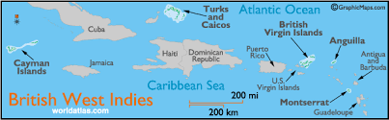](http://www.google.co.uk/imgres?imgurl=http://www.worldatlas.com/webimage/countrys/namerica/caribb/bwi.gif&imgrefurl=http://www.worldatlas.com/webimage/countrys/namerica/caribb/bwi.htm&h=189&w=609&tbnid=gYZrhzDP7vM1PM:&zoom=1&docid=IrWBbhJhQSPxmM&ei=04u5VJ6EGcfbaJuXgbgI&tbm=isch&ved=0CGEQMygiMCI)In 1492 Columbus discovered the New World; this included the series of islands in the Caribbean that became known as the West Indies. The European powers raced to add these islands to their colonies and establish trade.

Therefore settlers from across Europe – Spain, Portugal, France and Britain arrived to set up ***Plantations*** in these islands. A plantation was essentially a farm for growing a new crop, for example there are tobacco and cotton plantations. However in Britain the sought after good was sugar and this grew especially well in the West Indies. As demand for more sugar increased in Europe more workers were needed to work on the sugar plantations, but producing sugar was difficult and expensive - it takes 50 tons of sugar cane to produce just one ton of sugar.

Above are the Islands colonised by Britain. Other European powers owned other islands.

Yet enslaving Africans did not start immediately. At first Europeans used the Native Arawak of the West Indies to work the crop. However they were not used to farming. European criminals were made slaves on the plantations too, but on finishing their sentences they had to be freed. Disease such as malaria, yellow fever and leprosy also had an impact on reducing worker numbers.

**Task 2: ‘Why did Slavery Start’**

1. Describe the effects of the discovery of the West Indies in the 15th century. **(3)**

***Source A:*** *A historian writing in 1987 describes explains why Africans were needed on the West Indies*

*At first* ***bondservants*** *were brought over from Europe to work on the Sugar plantations. A bondservants agreed to work for five years. After this time they were given a farm of their own. But the work of sugar plantations was very hard. The climate was too hot and growing sugar was disliked by many Europeans. More cheap workers were needed as the demand for sugar grew. These workers came from the shores of Africa. The number of black slaves from West Africa to the West Indies steadily grew.*

1. Evaluate the usefulness of Source A in explaining why enslaved Africans were needed in the West Indies. **(5)**
2. Explain the difference between a Bondservant and Chattel Slave?

**Captured in Africa**

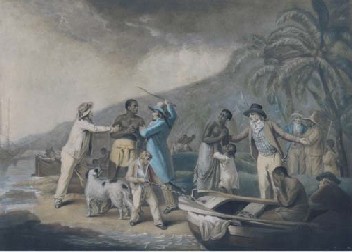

In the beginning the slave traders (men who would sell the slaves in the West Indies) would simply land on the coast and kidnap any African that was near. (Source A)

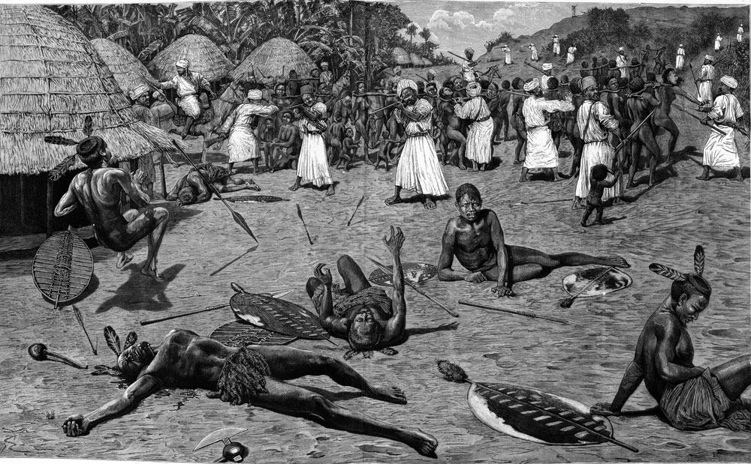However as more slaves were needed they found that it was easier to work with local chiefs or middle men who acquired the slaves for them. African chiefs such as the King of Dahomey would sell their people to the Europeans too. Sometimes these people were criminals and sold into slavery as punishment. At other times African chiefs would wage war on neighbouring tribes with the purpose of marching those captured to the coast and selling them (source B). Sometimes it was simply to cover a debt. While some chiefs happily enslaved their own people for benefits such as profit, not all African chiefs participated in the trade.

Source A: (above) Painting by George Morland

Source B: (below) shows an attack on a village.

T The Asante Empire on the west coast of Africa (modern day Ghana) had strong ties with the Slave Traders. They enslaved people who broke tribal laws and those taken prisoner while building their Empire

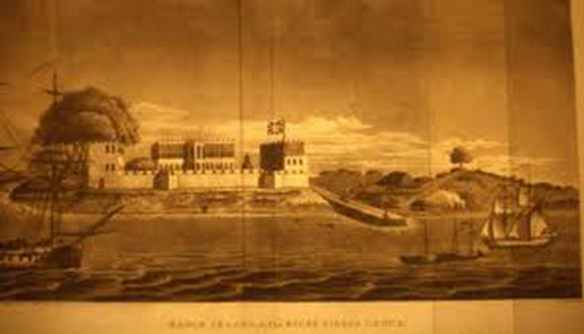The Slave Factories

Once captured these enslaved people would be marched, sometimes for weeks, to the coast.

The captives would have their hands and feet found and the whole group would be collared together by the neck using a goree–a wooden stick that looked like a two-sided “Y”.

Many died on this route. Those who survived were sold to **factors,** men who would then supply the slave ships, and they would be placed in forts where they could be kept for months awaiting the arrival of the slave ships. Conditions in these forts were very bad and many of the enslaved died before the arrival of the ships. It is estimated that in the 1770s 45% died in these forts. When the ships did arrive, they embarked on the ‘Middle Passage.’



**Task 3 : ‘Captured in Africa’**

1. Compare Sources A and B about the capture of slaves in Africa. **(4)**

**Source A** is from the autobiography of Olaudah Equiano, an ex-slave.

We walked for many weeks in chains. Then we saw a great river with no bank at the far side. On it lay a strange ship. We were taken to a large fort. There our African owners washed us and shaved us and rubbed our skins with palm oil to make it shine. White men came in and looked at us. After a few days the black and white traders did a deal. We were kept in the fort for several more weeks, chained and fed boiled beans till another ship arrived.

1. Evaluate the Usefulness of Source A as evidence about the enslavement of people in Africa. **(5)**
2. Turn to page 22 of the J Teale Textbook. In pairs complete Activity 6.
3. Add the term Middleman and slave fort to your glossary.
4. In your jotter create your own summary of the chapter ‘Captured in Africa.’

**The Organisation of the Trade**

By the 1700s a trade route had grown up between Britain, Africa and the West Indies. People called it the Triangular Trade because it had three sides.

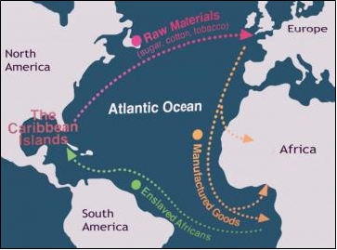**Stage One** - Ships from **BRITAIN** loaded up with a cargo that was in high demand in Africa – cloth, iron bars, gunpowder, salt and trinkets such as beads. The ship sailed from British ports such as Liverpool and Bristol to the west coast of Africa. Once in Africa these manufactured goods were traded for African men, women and children. They could wait between 4-8months for the ship to be filled.

**Stage Two** - The notorious ‘**middle passage’**. This is the name given to the journey across the Atlantic Ocean. Loaded ships sailed from Africa to the ‘AMERICAS’ which took between 8-11 weeks. Captains would aim to arrive during peak harvesting seasons, when the demand from planters for slaves, and prices were highest. Here the Slaves would be sold at auction

**Stage 3** – **‘The Homeward passage’** where the ship was filled with luxury goods such as Sugar, Tobacco or Rum and sailed to Britain to be sold for high profits. Sometimes the captain and crew were sacked and left to make their own way home. The owners then rehired the ship to West Indian merchants who used it solely to take their goods to Britain.

**Task 4: ‘The Triangular Trade’**

1. Create your own diagram of the ‘Triangular Trade.’ You must:

* Draw the triangle
* Give each leg of journey its name and state what cargo was carried at each stage.
* Label the countries and give your diagram a name.

1. Use the diagram and information on this page to create your own fill in the blanks task about the Triangular trade. You must:

* Have at least 10 sentences with **key words** missing.
* One sentence must define the triangular trade
* Cover **all aspects** of the triangular trade: parts of journey, goods etc.
* You must **include statistics**
* Create a word bank at the bottom of your paragraph.

**Source B** is from the log (diary) of a slave ship called the ***African***. The ship sailed on the Triangular Trade in the 1750s.

*The ‘African’ left Liverpool and took 43 days to reach Africa, where she spent 258 days trading. The Middle Passage took 36 days and then 39 days were spent in the West Indies. The home passage to Britain took 49 days.*

1. Using Statistics in your answer: In essays and in descriptions it is important to give details to strengthen your argument. This involves giving examples by using facts, mentioning people involved or using statistics. Answer the following about the ‘*Ship African*.’

* How long did this ship take on the Middle Passage?
* How long was the journey for the Ship’s Captain?
* What does this tell us about the Triangular Trade? Use the statistic to support your answer.

Source C is a set of orders sent to the captain of the Save Ship Enterprise in July 1816

You are to board immediately and sail to the Slave Coast of West Africa. You will trade the goods on board for slaves, palm oil and ivory. Carry only male slaves if you can because you will be sailing for the Spanish colonies, and females are difficult to sell there. Be careful when you choose your slaves; only take healthy strong ones.

Take good care of your slaves when they are on board and do not let any of your crew abuse them. Take care of any who are sick, crew or cargo. Once you have a full load of slaves, stock up with fresh food and water, and proceed as quickly for Barbados.

1. Note down any 4 instructions given to the captain of the ship Enterprise.
2. Why do you think he wanted the slaves well cared for?
3. Evaluate the usefulness of Source C as evidence of the triangular trade. **(5)**

**The Middle Passage**

The crossing from Africa to the West Indies was called the ‘**Middle Passage’**. The crossing was perhaps the worst part of the slave experience. Crossing the Atlantic Ocean took between six and eleven weeks. Captains crammed as many slaves as possible into the hold. They were separated from members of their own tribe; the language barrier made attempts at resistance difficult, but slaves did find ways to communicate with each other. It is important to remember that some ships were better than others.

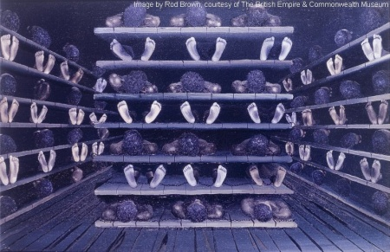

**How the slaves were "packed":**

There are two ways for the captains to load their boats with slaves. One system is called **loose packing** to deliver slaves. Under that system, captains transported fewer slaves than their ships could carry in order to reduce the disease and deaths among them. The other system is the cruellest one and is called **tight packing**. This system was based on the fact that the more slaves, the more profit they could make. They carried as many slaves as their ship could carry, and often more. In the ship's hold, the slaves were chained ankle to wrist, with barely any place to move.



**Sanitary/hygiene:**

In the worse case, the captains did not provide any kinds of hygiene. In other boats, the captains placed buckets for the slaves' excrements, but there was never one bucket per slave. Slaves who were close to the buckets used it but those who were farther away often tumbled and fell on others while trying to reach it. Severely hindered by the shackles that were tightly secured around their ankles, most slaves preferred to ease themselves where they were rather than to bruise themselves in the process of trying to reach it. Sometimes sailors would be ordered to go below deck to wash the slaves briefly. When weather conditions were bad, the conditions of the quarters dramatically worsened. The slaves' holding quarters were so hot and humid that the floor of their rooms was covered with layers of filth during most of the voyage. The smell would be unbearable.

**Death**

Suicide attempts occurred in painfully cruel ways. Slaves tried jumping overboard and even asked others to strangle them. Starvation suicide attempts became so common that a device was introduced to forcefully open the mouths of slaves who refused to eat. Slaves believed that their death would return them to their homeland and to their friends and relatives. To prevent slaves from killing themselves, sailors began chopping the heads off of corpses, implying that when they died, they would return to their homes headless. Even with precautions to avoid suicide attempts like drowning and starvation, many healthy and well-fed slaves died from what was known as "fixed melancholy." They had simply lost the will to live.

**Food and water**

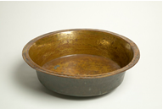Food was a very big problem for the slaves and the captains. The captains often thought that food was too expensive, and tried to buy as little food as they could. Some captains chose to take a sufficient amount of food, believing that healthy slaves would be worth the cost of the food. Many captains simply decided to buy as less food as possible, even if much of their "cargo" died of starvation. The feeding of the slaves was on deck. The slaves were taken out cautiously, with sailors to feed them and many to guard them with loaded guns in order to prevent a slave rebellion. On other boats, the slaves were fed in the hold, by sailors. The amount and quality of food depended on the captain. The English fed the slaves twice a day and gave the slaves’ meals in small fat tubes.

**Disease**

Diseases were very common in boats, they were transmitted easily because of the poor hygiene and the way slaves were packed together. Deaths numbers could very important, as in a Portuguese ship, a hundred out of five hundred slaves died during the night because of an unrecorded disease. The flux, smallpox, yellow fever and scurvy were the most spread diseases on the boats. To prevent both despondency and scurvy, sailors forced the slaves to be more active and participate in what they called a dance. In this ritual, sailors snapped large whips at the naked bodies of the slaves who jumped screamed from the pain. The shackles were left on during the whippings and often tore away at their bruised flesh.

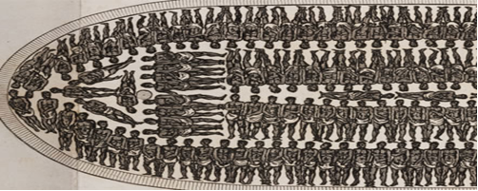

Although the crew avoided the slaves, they often would call a woman on deck to satisfy their desires.

**Task 5: ‘The Middle Passage’**

1. Imagine you are an enslaved African on the Middle Passage in week 3 of the journey. Use all the sources given to complete the “What would they hear, see, feel and smell?” worksheet
2. List any reason you can find to explain why suicide rates were so high.

Source A is an account from the ex-slave Olaudah Equiano.

In the ship’s hold we hardly had any room to turn over. The smell almost suffocated us. Many slaves died of sickness. Things were worse because the chains rubbed hard on our skin. The smell from the lavatory buckets was awful. Children often fell into these buckets. One day I saw two slaves who were chained together jump into the sea. For them death was better than life on the slave ship.

1. How fully does source A describe conditions on the middle passage? **(6)**
2. “Loose packing was better for the enslaved Africans” How valid is this view? Give a balanced answer.

* Is there any evidence that this statement is correct?
* Is there any evidence that this statement is exaggerated?
* Give an overall answer to the question.

**Task 6: ‘Resistance and Rebellion during the Middle Passage’**

During the Middle Passage some slaves attempted to offer **resistance**. Resistance was the refusal to do what they were told and included not eating. There are also several reports of **rebellion** when enslaved Africans tried taking control of ships; attempting to sail them back to Africa. Rebellion was very difficult for the slaves.

1. Add the words Resistance and Rebellion to your glossary.
2. Copy and complete the table below:

**Why Rebellion was so difficult**

|  |  |  |
| --- | --- | --- |
| **Point** | **Detail** | **Explanation** |
| Punishment |  |  |
| Language barrier |  |  |
| Restraints |  |  |
| Only allowed on deck after a few weeks |  |  |
| Kept below deck. |  |  |
| Crew better equipped with weapons |  |  |

1. To what extent was the language barrier between slaves the main reason for the failure of enslaved Africans to offer resistance on the Middle Passage? **(8)**

* The language barrier was important – you must look at this reason.
* However we know that there were many reasons why it was difficult for slaves to resist – punishments, kept below deck etc. – these must also be examined.
* Once all factors are examined we can come to a conclusion as to what extent (Just how much) the language barrier was the reason for the lack of resistance on the Middle Passage.
* You could mention that there were cases of rebellion.
* Start your answer with a short introduction sentence.

**Extension: Practice your Source Skills**

**Source A:** Artistillustration of the march to the Gold Coast.

**Source B:** Extracts from John Clarkson’s diary 1787. Clarkson was against the slave trade.

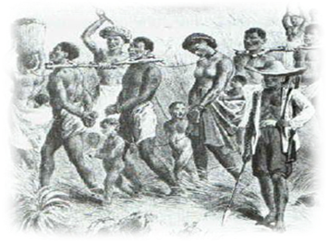

African slave dealers capture men, women and children and march them to the coast where they are traded for goods. The prisoners are forced to march hundreds of miles, with their hands tied behind their backs. The prisoners are connected by chains and wooden neck yokes. Their journey to the coast can take months and sometimes nearly half can die on the journey.

1. Compare Sources A and B about the movement of slaves to the coast. **(4)**
2. Evaluate the usefulness of source B as evidence of the treatment of enslaved Africans. **(6)**
3. Describe the experience of slaves during the Middle Passage. **(6)**

.

**The Impact of the Slave Trade on Africa**

People in the 18th century had little knowledge about Africa. Only a few explorers travelled to Africa and returned with interesting tales. From these stories grew certain ideas about what Africa and the African people were like.

David Hume, a Scottish philosopher

I...suspect the Negroes...to be naturally inferior to the whites. There never was a civilised nation of any other complexion than white...no ingenious manufacturers amongst them, no arts, no sciences.’

[They] are totally incapable of refinement, arts or sciences. They are idle and lazy. The only way to civilise them is to work.’

An English Journalist also claimed.

Were these views on Africa and Africans before the slave trade correct? Lets Discover...

**Task 7: ‘Africa before the Slave Trade.’**

1. Use the J Teale textbook page 11 and 12 to complete Activity 2 on page 19.
2. Put the sub-heading ‘The impact of the Slave Trade on Africa.’ Read the information on pages 16-18 in the J Teale textbook.

* Use this information to create a word search.
* Your word search must have at least 10 words related to the impact of the slave trade on Africa.
* You must create a clue to help someone search for the word.
* You must remember to make the questions challenging and remember the task is about the impact of the slave trade.

1. Swap your word search with a partner and complete. Next to the clue note the answer as well as in the search box
2. Describe the impact the slave trade had on the development of Africa. **(6)**

**The Impact of the Slave Trade on Britain**

Many British ports benefited from involvement in the triangular trade, but the bulk of the slave trade was done in just three British Ports: Bristol, London and Liverpool. Merchants (A person who makes a living by buying and selling goods) in these cities became extremely rich.

**Source A:** Figures on slave ships and number of slaves transported in 1771

**Port Number of ships Number of Slaves**

**Liverpool 107 29,250**

**London 58 8,136**

**Bristol 23 8,810**

**Lancaster 4 950**

**Task 8: ‘The Impact of the Slave Trade on Britain.’**

1. Create 3 of the following tables in your jotter. Write the city at the top of the table!

|  |  |  |
| --- | --- | --- |
| What figures show this city played an important role in the slave trade?  Why was this City able to be successful? | In what ways did this city benefit from taking part in the trade? Any negatives? Explain. | Use this column to draw images to help you remember the information. |
|  |  |  |

* Your teacher will give a city to examine. Using pages 25-29 of the textbook and complete one of your tables for this city.
* **Give a speech** to the rest of your group about why your city benefited the most from the trade.
* The other members of your group will do the same. As you listen to them make notes in each of your other tables.
* Which city does your group believe benefited the most? Give reasons for your answer.

1. Explain the reasons for the success of British ports involved in Atlantic slavery. **(6)**

**The Impact of the Slave Trade: Scotland**

We have mainly talked about English cities’ involvement in the Slave Trade, but what was Scotland’s involvement? Was Scotland guilty of involvement in the Slave Trade?

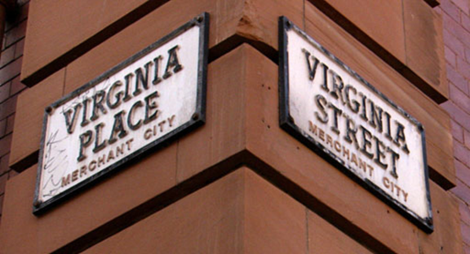Some argue that Scottish merchants became wealthy through the Tobacco trade and not the slave Trade. The Tobacco Trade weakened in 1775 due to the US wars of Independence and became less important. However others argue that the tobacco that was traded by Scottish merchants was still produced by slaves.

Also low number of slave voyages left from Scotland. There were only 30 voyages from Scottish ports such as Port Glasgow and Greenock and the number of slaves was roughly 5,000 compared to the millions from the rest of Britain, the Scottish role was limited.

Places and buildings in Glasgow show clear links with the slave trade.

Others point to the Scottish enlightenment. Writers such as David Hume were famous for writing about civilisation and freedom. During this period Scotland was ahead of the world in terms of human rights. How could Scots become involved in Slavery? The Court of Session (an important court in Scotland) stated that Slavery was not recognised by the Scottish laws. It therefore did not exist, and if it does not exist then how could the Scots be involved?

**Task 9: ‘The Impact of the Slave Trade: Scotland.’**

1. Read the above information. Complete the following table, but leave space to add further points.

|  |  |
| --- | --- |
| **Not Guilty** | **Guilty** |
| Scottish merchants dealt in Tobacco and not slaves.  There were only ____ voyages that left from Scotland. This was only ______ slaves.  Scotland’s Court of Session stated that slavery was not recognised. | Scotland is still guilty because....  Although there were fewer voyages Scotland is still guilty because.... |

**Source A:** is written by Historian Professor Geoff Palmer in 2007

Tate and Lyle are dominant names in our sugar industry. Tate was English but Lyle was Scottish. Both made their fortune from the activities of Slavery. There are many more examples of Scots making their fortune in the sugar trade. Many Caribbean people are descended from the British...they are blood relatives...if you look at the Jamaican telephone directory, 60% of the names are Scottish.

**Source B**

By the late 1700s, one third of the Jamaican plantations were owned by Scots. In 1790, the combined worth of exports and imports between the West Indies and Scotland totalled at least £50 million in today’s currency.

1. Read Sources A and B and add to your table.
2. Evaluate the usefulness of Source A as evidence of Scotland’s involvement in the slave trade. **(5)**

**Case Study: Thomas Leyland and the Enterprise**

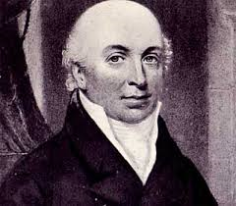

Thomas Leyland was Liverpool’s richest man. From poorer beginnings, he soon became a wealthy man. The profit on one voyage made by Leyland's slave ship 'Lottery' in 1798 was more than £12,000 (more than £900,000 today). In 1802, Leyland purchased the estate of Walton Hall north of Liverpool and built a second home outside of the city. (below) In 1803 he and partners invested in a slave venture – the Enterprise. In total he was involved in 70 voyages, transporting 25,000 Africans into slavery. Once the slave trade ended Leyland established a bank called Leyland and Bullin’s Bank in Liverpool. At the time of his death he was worth over £736,000 (70 million in today’s value)

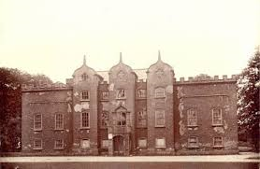

1. Study the information about Leyland and the voyage of the Enterprise in 1803 in the Teale textbook page 36-38.
2. Complete Activity one on page 39 of the textbook.
3. Write a summary paragraph of the impact the slave trade had on Britain.

**Practice your Skills**

1. Explain the reasons why some British people supported the Slave Trade. **(5)**
2. Describe the ways that British ports benefited from the Slave Trade. **(6)**
3. Look at your answers for questions one and two. Do you notice anything about the points.

**Source A:** Letter written by a Liverpool merchant in 1816

Do not buy any above 24 years of age as it may happen that you will have to go to Jamaica where any exceeding that age would be liable to a duty of £10 per head. While the slaves are on board the ship allow them every indulgence consistent with your safety, and do not suffer any of your officers or crew to abuse or insult them in any way. Keep the vessel clean.

**Source B:** Written by a modern historian

Merchants usually gave written instructions to their ship’s captains. These often included guidance on what kind of slaves to buy. Merchants wanted young slaves as they could be sold at the highest price. Captains were expected to keep their ships as clean as possible throughout the voyage. They were often urged to look after the slaves well in order that as many as possible would survive the crossing.

1. Compare the views of Sources A and B about merchants’ attitudes to slaves **(4)**
2. Extension:

* ***Evaluate the usefulness of Source B as evidence of the attitude of merchants to the slaves.***
* Use the grid given to write a marking scheme for the question.

**Remember**

* Use specimen papers for revision. You will soon notice that questions may be worded in a slightly different way.
* It may be a source question, describe or explain one.
* However the information needed is similar, you just use it in a different way.

**Collect the marking scheme and check your answer.**

**The Slave Auctions**

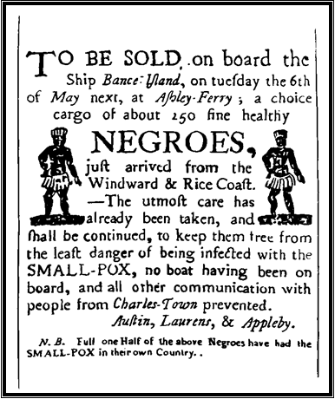

On arrival in the West Indies the slaves were prepared to be sold. If they looked fit and healthy they would be worth more. The crew shaved the male slaves and all slaves were washed. Then they rubbed their skin with oil to make it shine as shiny skin makes the muscles look bigger.

**Sold to the Highest Bidder**

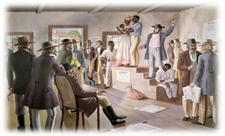The slaves would be brought from the pen, in turn, to stand on a raised platform so that they could be seen by the buyers. Before the bidding began, those that wished to could come up onto the platform to inspect the slaves closely. The slaves had to endure being poked, prodded and forced to open their mouths for the buyers.

The auctioneer would decide a price to start the bidding. This would be higher for fit, young slaves and lower for older, very young or sickly slaves. Potential buyers would then bid against each other. The person who bid the most would then own that slave. The picture below shows a slave being auctioned to the highest bidder.

**Source A** is a drawing of a slave auction. The auctioneer (with the rolled paper in his hand) will sell each slave to the highest bidder. The picture was drawn in the late 18th century.

**Grab and Go Auction**

On the day of the auction buyers would pay the trader an agreed amount of money. The trader would then give them a ticket for each slave that they had bought. At the sound of a drum roll, the door to the slave pen would be opened and the buyers would rush in and grab the slave or slaves that they wanted. The buyers then checked their slaves out by returning their ticket or tickets to the slave trader. For the slaves this was often a very frightening experience because they did not understand the language and had no idea what was happening.

Source B: Olaudah Equiano an ex-slave describes a grab and go auction in 1789.

On a signal given the buyers rushed into the yard where the slaves were kept, and chose the ones they liked the best. The noise and the clamour and the eagerness shown on the faces of the buyers increased the fear of the terrified Africans. In this way relations and friends were separated, most of them never to see each other again.

**Refuse Slaves**

Slaves who were not taken in a scramble were called ‘refuse’. They were sold in lots to anyone who would take them. Those who were too weak or sick to be sold were sometimes left to die. Sometimes doctors bought them up, since their price was low, hoping to cure them and sell them for more; sometimes plantation owners bought them cheaply with a view to working them to death quickly.

**Task 11: ‘The Slave Auctions.’**

1. Choose one of the tasks below

* Draw 2 pictures. One should show the Highest Bidder Auction and one the Scramble Auction.
* Label these drawings so it is clear what is happening.

**Or**

* Create a spider diagram for each type of auction describing what happened.

1. Why would the Grab and Go Auction be so upsetting for the slaves?
2. Why would being bought by a doctor be the best that a ‘refuse’ slave could hope for? **(2)**

**Life on the Caribbean Plantations**

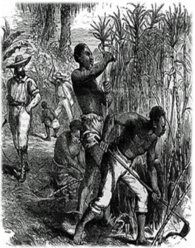

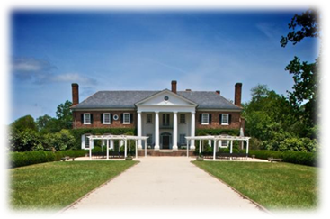Growing sugar is hard, heavy work. The ground has to be dug, hoed, weeded and planted in the hot sun of the West Indies. Gangs of slaves, men, women and children, worked to the orders of a white overseer, and often to the sound of his whip. They worked from dawn till dusk. The busiest time was when they harvested the sugar crop where they could work for 18 hours a day. Slaves cut the sugar cane and loaded it on to carts to take it to the mill where they crushed and boiled it to extract the brown sticky juice. They left it in barrels till the brown syrup called molasses was drawn off, to make into rum. The clearer sugar was left behind, for shipment to Europe.

Slaves who worked in the ‘Big House’ as servants, maids and drivers had slightly better conditions and were treated slightly better.

**Source A is a description of slaves at work by a Swiss traveller in 1785.**

There were about a hundred men and women digging ditches in a sugar cane field. Most of them were covered in rags. The sun shone down with full force on their heads. Sweat poured from all parts of their bodies. Their limbs were weak with trying to dig the soil which had been baked hard by the sun. They were all exhausted but finishing time had not yet come. Several overseers with large whips lashed those who tried to take a rest.

**Source B: A slave talks about her old Master**

My old Master was a good man, he treated all his slaves kind, and took care of them. He even let us look after his children. But not all white folks were as good to their slaves. I saw poor slaves almost torn up by dogs, and whipped unmercifully, when they didn’t do what white folks said. But thank God I had good white folks.

**Task 12: ‘Plantation Life.’**

1. Watch the History File episode ‘Everyday Life’ and answer the following questions.
2. What caused the lives of slaves to vary?
3. What happened to the slaves when they were too old to work in the first gang?
4. What were the two main problems of working in the fields?
5. What was the danger of working in the sugar boiling houses?
6. How could slaves make money?
7. What could they then do with their money?
8. What happened if slaves stepped out of line?
9. What punishments were there for running away? (try to state 3)
10. What punishment was used that was **not** physical?
11. How did slaves cope with plantation life?
12. What free time did they have?
13. Choose one of Thistlewood’s slaves to write a tribute for (textbook page 57). What was the person was like? What they did during their life? How they were treated on Thistlewood’s plantation?

**Source C** was written Bryan Edwards in 1801. He was a plantation owner in the West Indies.

A bell summons the first gang of field workers just before sunrise. Absentees are noted and they go off to work in the fields till half past eight. Then they sit down to breakfast. This is usually boiled vegetables, such as yams, seasoned with salt and cayenne pepper. In truth it is very tasty and wholesome. By this time most of the absentees arrive, and are punished sometimes by a few stripes of the driver’s whip. They get half an hour for breakfast, and then go back to the fields till noon. They get two hours to eat and rest, and many of them sleep. At two o’clock the bell rings to get them back to the fields until sunset. Sometimes they get rum if the day has been wet or the work very hard.

1. Evaluate the usefulness of Source **C** as evidence of the working conditions of slaves in the West Indies. **(5)**

**Resistance on the Plantations**

Slaves could resist in a number of ways. The easiest way was to work slowly and poorly, but punishments for this were harsh. See some of the punishments. They would also often runaway hoping to escape and sometimes they tried to organise uprisings.

Slaves worked long hours in the fields which made planning and organising a resistance difficult. As well as this they were closely monitored to ensure that there were no rebellions being planned – the overseer was in the field and the slaves’ homes were often near the plantation. Planning and organising was also difficult for slaves because many were generally poorly educated. They also had to be careful as other slaves may report planned resistance in order to gain favour with the slave owners.

The slaves would also find rebellion difficult because the white slave owners were better armed. With few weapons it was difficult for slaves to stage a successful uprising.

[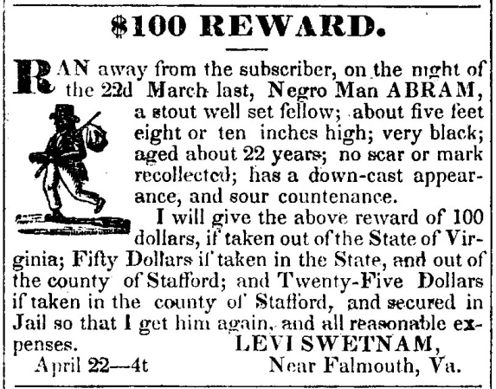](http://www.google.co.uk/url?sa=i&rct=j&q=&esrc=s&frm=1&source=images&cd=&cad=rja&uact=8&docid=cl-FdFy_Fyu9vM&tbnid=SEv_1-9DpCn99M:&ved=0CAUQjRw&url=http://www.balchfriends.org/Slaves/pages/1837-05-06AbramRunawaySlaveFromFalmouth.htm&ei=9y6MU4-fNMmk0QWWiIHICQ&bvm=bv.67720277,d.ZWU&psig=AFQjCNFtcpP8FWml37GH_G4v_G5HsojWXQ&ust=1401782385030634)Fear of being punished was also a deterrent to resisting on the plantations. The physical punishments such as whipping and execution were feared, but slaves were also afraid of being separated from family and friends. Many slaves, especially those born into slavery, were brainwashed and accepted their slavery.

There were also laws in the West Indies that made resistance difficult for slaves – they had no rights and would be hunted down and returned to their owners. There were rewards for anyone (black or white) who returned a runaway slave. Should a rebellion be successful, many of the islands were small that there was nowhere for them to go.

On larger islands like Jamaica slaves could hide in the dense forest for years. In Jamaica captured runaways were kept in the local workhouse till their owners collected them. In 1794 there were 1,094 slaves waiting to be collected.

**Source C:** Rewards were given for returning runaway slaves

**Source D** shows examples of laws passed in the West Indies.

Any white person or slave capturing an escaped slave alive must get a reward of 500 pounds of sugar from the owner.

A slave who is violent to a white person is to be severely whipped. If it

happens again his nose will be slit and his face branded with a hot iron. If it happens a third time the punishment will be worse.

**Source E** was written by Olaudah Equiano, an ex-slave. He describes how slaves were punished for little ‘crimes’.

It was very common for the slaves to be branded with the first letter of the master’s name. Then a heavy iron collar was hung around their necks. This was done for even the smallest thing. They were loaded with chains and often instruments of torture were added. An iron muzzle was put around the mouth. Thumbscrews were used. I have seen a Negro beaten till some of his bones were broken for letting a pot of porridge boil over. It is not surprising that treatment like this should make them to want to die.

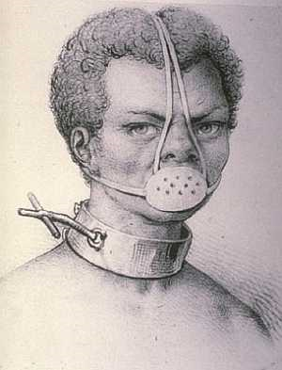

**Successful Resistance**

Slave traders were shocked when four years after the French revolution in 1793 the slaves of the French colony Saint. Domingue rose up against their rulers. Under the leadership of Toussaint L’ouverture set up an independent country called Haiti.

However, we will see later that it resulted in the slave trade lasting longer.

**Task 13: ‘Resistance on the Plantations’**

1. Work in pairs to bullet point all the reasons why resistance was difficult. This should be a simple list. E.g. Punishments,...
2. Create a spider diagram on the punishments slaves faced.
3. Explain why resistance on plantations was difficult for slaves. **(5)**

Choose any 5 from your list and explain them.

1. Can you find evidence that suggests there were still some successful resistance on the plantations?
2. To what extent was the fear of punishment the main reason for little slave resistance to their owners in the West Indies? **(8)**

* Punishment was important – you must look at this reason.
* However there were many reasons why it was difficult for slaves to resist - these must also be examined.
* Once all factors are examined we can come to a conclusion as to what extent (Just how much) fear of punishment was the reason for the lack of resistance.
* Start your answer with a short introduction sentence.

**Impact of the Slave Trade on the Caribbean**

The arrival of Europeans in the Americas had brought diseases that devastated local populations. The local Arawaks were wiped out and replaced by Africans.

The economy of these islands was completely dependent on sugar. This reliance continued for some islands such as Jamaica until the turn of the 20th century and meant that any drop in the price of sugar resulted in unemployment.

In many of these islands, including Jamaica, there is a sense of injustice and a need for redemption which remains to this day.

While nothing could reduce the horrors of the Slave Trade and slavery, one positive impact could also be seen in the creative way in which, gradually, the black communities developed new identities. What can be now in the West Indies is a combination of their African tradition, European culture, and their experiences in the West Indies.

**Task 14: ‘Impact of Slavery on West Indies.’**

1. Create 5 questions on the impact of the slave trade on the West Indies. Use the above information.

Ensure the questions are challenging – remember the focus is on the impacts.

1. Note the answer next to the question.

**Practice your skills**

Source A describes the hardships faced by slaves on a plantation in the West Indies.

The enslaved people on the West Indian plantations were forced to work long hours, especially when the cane was being harvested and processed. Some tried to escape but plantation owners kept detailed descriptions of their slaves which would be publicised if one escaped making eventual capture almost inevitable. Slave owners would provide an occasional barrel of salt fish but slaves relied heavily on food which they grew for themselves. If the weather was bad their crops could fail and they would face starvation.

1. How fully does source A describe the hardships faced by enslaved people on the plantations? **(6)**

**The Case of the Slave Ship Zong**

The Zong slave ship was owned by a wealthy merchant from Liverpool William Gregson. Gregson employed Captain Luke Collingwood to manage the voyage to Jamaica. Before the voyage the ship was insured for £8,000 from Liverpool firm Gilbert & Co.

On the 6th September the Zong left West Africa with 442 enslaved Africans on board. At some point in the journey the ship went off course. This meant that the journey was going to take longer than expected and the crew were worried about their water supply. Also by this point many of the slaves had become ill and were dying. Collingwood was worried that they would not make a profit when they reached Jamaica. He called a meeting with his crew and announced:

If *the slaves were thrown alive into the sea to save the crew it would be the loss of the insurers*

The Ships first mate however argued that:

There is no present lack of water to justify such a measure.

The crew believed the Captain and from 29th November to the 1st December 132 sick slaves were thrown overboard to die. Some of the enslaved threw themselves overboard to avoid the brutality. When the Zong arrived in Jamaica on the 22nd December 200 slaves were sold.

Collingwood died before the slave ship returned to Britain. The owner of the Zong ship, Gregson, demanded that the insurers pay £30 for each enslaved African or ‘slave’ thrown overboard as compensation. The insurance company sensed that something was not quite right with the Zong case and refused to pay, so the case was taken to court. The insurers had also discovered that when the ship had arrived in Jamaica there were 420 gallons (1,110 litres) of water spare. The Ship’s log had also mysteriously disappeared.

The case went to court in March 1783 and the case went against the insurers. No officer or crew member was prosecuted as this was a case of insurance fraud rather than murder. After all the enslaved people was simply cargo.

*Blacks are simply goods and property, it is madness to accuse these well-serving honourable men of murder. They acted out of necessity and in the most appropriate manner…The case is the same as if horses had been thrown overboard.*

One influential lawyer at the time stated:

This court case was widely reported and shocked many in Britain. It fuelled the many abolitionists who were calling for an end to the slave trade, including abolitionist Granville Sharp, who by that time had a track record of supporting enslaved Africans in court cases.

This case was a turning point that saw an increased number of people vocally challenging the Slave trade. In 1787 the Society for the Abolition of the Slave Trade was formed in London. It was led by Quakers, a religious group that had long been pointing out the cruelties of the trade, but included others such as Thomas Clarkson and Granville Sharp.

[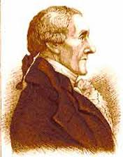](http://www.google.co.uk/url?sa=i&rct=j&q=&esrc=s&source=images&cd=&cad=rja&uact=8&ved=0CAcQjRw&url=http://www.rejesus.co.uk/site/module/william_wilberforce/P4/&ei=2KbGVISSE8LSaNzmgkg&bvm=bv.84349003,d.d2s&psig=AFQjCNHk9x8vj-JCJp-mMH9qAMN4_9INKw&ust=1422391333847847)

**Granville Sharp** was a Civil Servant (he worked for the government) who, unsuccessfully, wanted the crew of the Zong charged with murder.

He did have some success. He was involved in a case to free an enslaved man James Somerset who had escaped his master in Britain. As a result of this case the courts stated that slaves could not be taken out of Britain against their will.

In 1786 he meets fellow abolitionist Thomas Clarkson (below).

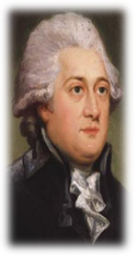

**Thomas Clarkson** came from a wealthy family and had studied at Cambridge. He was interested in the slave trade and was shocked at what he discovered. He was soon active in campaigning for an end to the slave trade by touring Britain giving speeches and showing shackles and other methods of punishing slaves.

**Task 15: ‘The Zong Case.’**

1. In pairs decide on the 6 most important details of the case of the Zong.
2. Explain why the Zong Case was so important to the ending of the slave trade. **(3)**
3. Should the crew of the Zong been tried for murder? Write a balanced answer.

* You must present all the evidence that suggests they should.
* Then present the evidence that suggests they should not be.
* Come to a conclusion based on this evidence and give a reason for your answer.

**Abolitionist Methods**

The Abolitionists started with baby steps. They decided to target the Slave Trade, believing that once this had ended so too would slavery. What were the methods used by the Abolitionists to encourage the end of the trade?

**[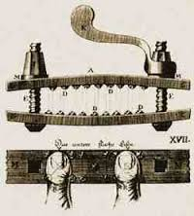](http://www.google.co.uk/url?sa=i&rct=j&q=&esrc=s&source=images&cd=&cad=rja&uact=8&ved=0CAcQjRw&url=http://usslave.blogspot.com/2011/08/thumbscrew-torture-device.html&ei=p_bHVK2-PIjqaOr-gsAE&bvm=bv.84349003,d.ZGU&psig=AFQjCNEIKky7a1uDppzYrFTweDXae44iFg&ust=1422477329125536)Education**

The first tool was education. Teaching people and letting them see the true cruelty of the trade. Thomas Clarkson had spent time studying the slave ships and had interviewed the crew. Afterwards he toured the country with examples of the thumbscrews, whips, mouth openers, shackles and chains. He also had with him examples of goods that Africans could produce and trade with – there was no need for slavery. Hearing his **speeches** and seeing the evidence he had gathered meant people could not deny the cruelty.

By the 1780s a number of Africans had managed to escape slavery and formed the **‘Sons of Africa.** Two famous members were Olaudah Equiano and Ottabah Cugoano. These men were able to write about their experiences and toured the country to promote their books. Thousands of people were able to hear and read about their first-hand account of the slave trade.

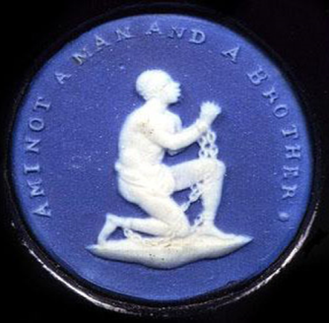**Abolitionist Images**

**Images** became important in getting the message across to much of the British population as only half of the British public at the time could read. Thomas Clarkson asked pottery maker Josiah Wedgewood to **distribute leaflets**. He joined the campaign and asked one of his workers to design a seal for the pamphlet envelopes. What was created was an image of a slave in chains with the words, “Am I not a man and a Brother.’ This came to symbolise the campaign and appeared on pottery and jewellery. Abolition campaign became popular. Other **books** of illustrations were published showing some of the cruelties of the trade.

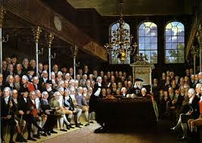**Parliament**

As well as in the streets the Abolitionists took their campaign to Parliament. Many **Bills** (a proposed law) were put forward to end the trade, but as only rich men could vote at this time it made it difficult. Many of these men owned or made their money through the trade. William Wilberforce proposed Bills to end the slave trade each year from 1790-1806.

ilberforce also made great speeches in parliament to persuade his colleagues.

**Petitions**

After the first Abolition Bill was rejected in 1791 new petitions flooded Parliament.

|  |  |  |
| --- | --- | --- |
| Year | Number of Petitions | Number of Signatures |
| 1783 | 1 | 273 (mainly from Quakers) |
| 1787-1788 | 100 | 60,000 |
| 1792 | 519 | 390,000 |

As well as petitions members of the public began to **Lobby** their Mps (speaking to MPs to persuade them). In the 1770s Quakers were one of the first groups to do this and in 1788 Equiano led a group to parliament to support a bill that would improve conditions on slave ships and reduce the number of people they could carry.

**Women’s Involvement**

[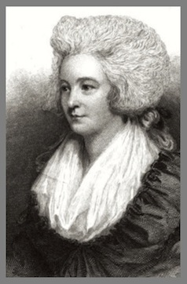](http://www.google.co.uk/url?sa=i&rct=j&q=&esrc=s&frm=1&source=images&cd=&cad=rja&uact=8&ved=0CAcQjRw&url=http://www.hieropraxis.com/2013/05/william-wilberforce-hannah-more/&ei=62bLVOzXJ6XU7AbbzID4CQ&bvm=bv.84607526,d.ZGU&psig=AFQjCNEkaezpqkjvblRFFYNwr9Yclp8tKg&ust=1422702690069269)The campaign to abolish the slave trade was one of the first campaigns that highlight the role of women in politics. There were women of all statuses involved in the abolition movement including Georgiana, Duchess of Devonshire.

Women were involved in producing leaflets, pamphlets and letters. Hannah More, an evangelical and a close friend of John Newton and William Wilberforce, was an influential figure who wrote many poems and plays against the trade.

It was women that played an important role in the **Sugar Boycotts** a campaign to hit the profits of slave-produced sugar. By 1792 they had convinced many grocers to stop selling the sugar and families to stop eating it; about 400,000 people were boycotting the sugar resulting in sugar sales dropping by one-third.

Poet and playwright Hannah More

**Task 16: ‘The Abolitionist Methods.’**

1. In pairs study the abolitionist methods above and write a **list** of the methods used.
2. Use this to create a mind map on **Abolitionist Methods** – include at least 6 methods.
3. Add at least 2 piece of detail about each one.

**Reasons for Keeping the Trade**

**Pro-Slavery Lobby**

Just as strong were the groups campaigning to maintain the Atlantic Slave Trade. Those who made fortunes from West Indies plantations began making speeches to argue that the slave trade was necessary. They argued that the slave would mean the end of a successful British economy and insisted that slaves were treated well. This was offered in evidence to parliamentary inquiries.

**MPs in Parliament**

Many members of Parliament were objected to the slave trade, being plantation owners. They made many speeches in Parliament in support of the trade and used every delaying tactic to ensure that the trade was not abolished. On the 2nd April 1792 Henry Dundas (a member of the government proposed a gradual abolition of the trade.

What argument is being made here?

**Source A:** Temple Luttrell, speech in Parliament, 23 May 1777

Some gentlemen may, indeed, object to the slave trade as inhuman and evil; but let us consider that, if our colonies are to be cultivated, which can only be done by African negroes, it is surely better to supply ourselves with those labourers in British ships, than buy them from French, Dutch or Danish traders.

Many campaigns were held in the important Slave ports such as Liverpool. Influential men such as Thomas Leyland lobbied MPs arguing that the end of the trade would have disastrous effects on British cities such as Liverpool. Another argument was that if the Slave Trade ended then this would encourage the slaves in the West Indies to offer up more resistance like what had been seen against the French in Haiti.

**Task 17: ‘Reasons for Keeping the Trade.’**

1. Collect the ‘Who Said it’ resource sheet from your teacher. Match the Statement with the person who said it.

* Get the answer checked before you glue it into your jotter.

1. Write a summary of this section under the heading ‘Reasons for Keeping the Trade.’
2. Extension: Get thinking! Imagine you are an abolitionist. Can you think of counter arguments you could make to the pro slavery campaigners.

**Reasons for Ending the Trade Arguments made by the abolitionists**

Many of the reasons for ending the slave trade were religious, moral and humanitarian reasons. Christian groups became increasingly important in arguing the case to stop the slave trade, but some Christians were involved in the trade. The Church of England for example owned plantations in the West Indies. Many Christians of these Christians argued that Slavery was mentioned and accepted in the Bible, therefore it is approved of by God.

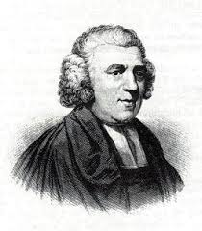However in the 17th and 18th centuries there was a growing **Evangelical Movement** in the Church of England. They believed in doing what Jesus had taught them. John Newton had been a slave ship captain. He applied to become a priest after nearly dying on one of his voyages. He admitted to flogging slaves and using thumbscrews. His book: ‘*Thoughts upon the African Slave Trade.’* (1787) was important as it was from a white captain who witnessed the events. His book highlighted the horrific treatment of slaves on the ships which was similar to the accounts of the poor treatment on the plantations.

This movement along with other Christians argued it was immoral and used the Bible to argue slavery was wrong. They pointed to Luke 16:13: *"No man can serve two masters".*

Morally, it was argued, slavery was wrong and it did not matter if other countries chose to continue with it. The African people were not inferior to Europeans and so should be treated as equals.

They also argued that the Atlantic Slave Trade was completely different from any that had existed in Africa as the enslaved in Africa were slaves as punishment and that they were able to keep their own identity. They also pointed out that the slavery was not extended to the future generations. The Atlantic Slave Trade damaged Africa, their slavery did not.

Abolitionists argued on humanitarian grounds that the Africans suffered greatly from being removed from their homeland and that there was appallingly low life expectancy of slaves on the plantations (7-9 years on some large plantations). In the West Indies they could be separated from their families at any point which was traumatic.

**Task 18: ‘Reasons for Ending the Trade.’**

1. Explain what the Evangelical Movement was?
2. List the arguments made by the abolitionists.

**Source A**

Disease, hunger and over work mean that life expectancy was terrible. 26% of the Africans who arrive to work on the plantations die in the first year. More than half the workers in the sugar cane fields are women. Pregnant women are expected to work until six weeks before they gave birth. They return to work after just three weeks. Twelve lashes of the whip could be given for bad work. Slaves who ran away could be given over a hundred lashes.

1. How fully does source A explain the reasons why the slave trade should be abolished? **(6)**

The Effects of the French Revolution

[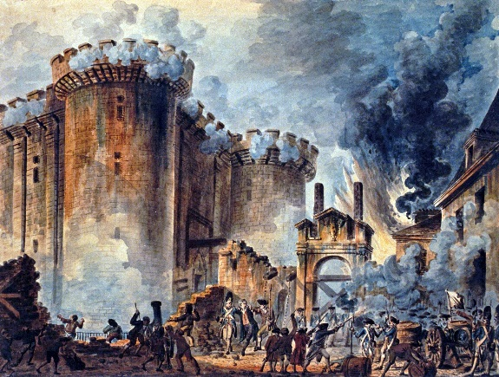](https://www.google.co.uk/url?sa=i&rct=j&q=&esrc=s&source=images&cd=&cad=rja&uact=8&ved=2ahUKEwiHj9XuuMvbAhWE1RQKHX72AZsQjRx6BAgBEAU&url=https://en.wikipedia.org/wiki/Storming_of_the_Bastille&psig=AOvVaw3DTNoHOsd_aPjHUmHBnitH&ust=1528800781742790)The French Revolution brought new ideas such as the ideas of liberty and equality. These ideas became linked with the arguments of the abolitionists. This meant that many in power did not want to associate with these ‘revolutionary’ abolitionists. Alarmed the British government then clamped down on the issue of abolition. For example they made it difficult for the abolitionists to hold meetings.

The storming of the Bastille, 14th July 1789

The French Revolution also created the circumstances for a slave revolt on the French colony of Saint Domingue. Toussant L’ouverture had led freed slaves and set up an independent nation called Haiti. This example had frightened the British government who thought steps towards abolition of the trade would encourage more slave rebellions in the West Indies.

The wealth the Slave Trade generated was enough on its own as an argument to maintain the trade. However, in 1793 Britain became involved in the French Revolutionary Wars. Britain needed money to pay for the war so the slave trade was seen as important for this purpose. As well as this to oppose the slave trade during a major war seemed unpatriotic to many and the abolitionists lost support.

For the war with France, Britain needed a strong Navy. The slave trade was seen as important as a ‘nursery of seamen’ as it provided training for sailors joining the Royal Navy. A strong Navy was important to Britain already as it had made Britain the superpower of the time. This therefore was an important reason in reluctance to end the trade.

The idea of the poor overthrowing the wealthy was a worry to Britain, where people were very poor with little democratic rights. Many were scared that revolution like the one in France could happen in Britain.



**Task 19:** **The Effects of the French Revolution**

1. Read the information above
2. Create a spider diagram on the effects of the French Revolution. Include the arms: New Ideas, British War with France, British Navy, Revolution in the West Indies and Poor overthrowing the rich.
3. Explain why the abolition of the slave trade took so long to achieve (6)

**Practice your Skills**

Source B

News of the Revolution in France made many British people fearful of sudden change, which harmed the abolitionist campaign. Events on the island of Haiti, where slaves killed hundreds of British soldiers, added to these fears. All this time the mayors and town councils of the ports which benefited most from the trade kept up pressure to stop abolition in its tracks

1. How fully does source B explain the problems faced by the abolitionist campaign **(5)**
2. Explain the reasons why people opposed abolition. **(5)**

Source C

The abolitionist campaign was supported by freed slaves such as Ottabah Cugoano who attended meetings and spoke about their experiences. Undoubtedly, public meetings played an important part in the campaign to end the slave trade. Thomas Clarkson toured the nation describing the plight of enslaved Africans to shocked audiences. Numerous petitions were sent to Parliament from cities all over the UK. The pressure on Britain’s leaders became intense.

1. How fully does Source C identify the methods used by the abolitionists to promote their cause? **(5)**
2. Describe the impact of the abolitionist campaign on people in Britain **(6)**

**Why did the Slave Trade End?**

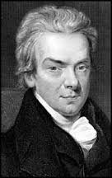

The slave trade ended in Britain by a law passed in parliament in 1807. There are many reasons why the slave trade ended. One reason was the tireless 20 year campaign by William Wilberforce in parliament. This was important as MPs in parliament had to be persuaded. Without him the slave trade may have lasted much longer than it did.

Yet all Wilberforce’s attempts to have slavery abolished failed. A new government in 1806 was important in bringing about abolition; they had been persuaded that the time was right. The action of other abolitionists such as Granville Sharp and Thomas Clarkson was important in turning public opinion against the trade. MPs were now afraid of losing their seat if they did not end the trade.

William Wilberforce

Religion played a role in bringing about the end of the slave trade as more Christian groups voiced their objection to the trade.

There were also economic reasons too with many now arguing that sugar produced by slaves was becoming more expensive and that cheaper sugar could be produced cheaper elsewhere in countries such as India. As well as this the slave trade was a risky business for merchants. Many were happier investing in the relatively safe opportunities created by the industrial revolution.

Slave Rebellions were becoming increasingly common in the West Indies after the success in Haiti.

**Task 20: ‘Why did the slave trade end?’**

1. Complete activity 2 on page 94 of the J Teale textbook.
2. To what extent was the role of William Wilberforce important in bringing the end of the slave trade in Britain in 1807? **(8)**

* The role of Wilberforce was important – you must look at this reason.
* However we know that there were many reasons to explain why the slave trade ended –these must also be examined.
* Once all factors are examined we can come to a conclusion as to what extent (Just how much) the role of Wilberforce was the most important reason for bringing the end of the slave trade in Britain.
* Start your answer with a short introduction sentence.