Plastics and Materials – National 4
N4 By the end of this section I should be able to:

- Explain why plastics are known as polymers.

- State where plastics come from.

- Give examples of natural and synthetic polymers.

- State the advantages and disadvantages of natural and synthetic polymers.

- Name the polymer from the name of its monomer.

- Explain the difference between thermoplastic and thermosetting polymers.

- Describe the properties of some plastics and relate their use to their property.

- Explain how the disposal of plastics can cause problems to the environment.

- Explain why burning plastics can be harmful to the environment.

- Describe what is meant by a biodegradable plastic.

- Describe the issues that can arise with using non-biodegradable plastics.

- Research and present information on biodegradable and non-biodegradable plastics and recycling of plastics.

- Research and present information about novel materials and investigate some of their properties and uses - ceramics.

Plastics and Materials - National 5

By the end of this section I should be able to:

- Give examples of natural and synthetic polymers.

- Describe how addition polymers are made.

- Use structural formulae to show how an addition polymer is made from its monomer.

- Identify the repeating unit and the monomer when give a portion of the addition polymer.

- Describe how condensation polymers are made.

- Explain what a condensation reaction is.

- Identify the ester link in a polyester chain.

- Use structural formulae to show how a condensation polymer is made from its monomer.

- Identify the repeating unit and the monomer when give a portion of the condensation polymer.

- Identify whether a polymer is an addition or condensation polymer when given the structure of the polymer

- Research and present information about novel polymers and investigate some of their properties.

Plastics
Materials can be classified as _____________ or ______________.

Natural materials include: silk, wool, leather and cotton

Plastics are synthetic (man-made). They are obtained from crude oil which is non-renewable.
There are 2 types of plastic

- Thermoplastic – ___________________________________________
________________________________________________________

- Thermosetting ____________________________________________
________________________________________________________.

Thermoplastic | Use | Thermosetting | Use
Polythene |  | Bakelite
Polystyrene |  | Melamine | Picnic plates
Nylon |  | Polyacrylamide  (P.A.M.) | Soft contact lenses

Advantages and Disadvantages of Plastics
Some of the advantages of plastic include:
- Durability
- Flexibility
- Lightweight
- Cheap.

Some disadvantages of plastics
- Produce poisonous gases when they burn.
- They are from a non-renewable source
- They do not breakdown naturally – they are non-biodegradable.

Plastic being burned | Name of poisonous gas
Polyvinylchloride (P.V.C.)
All hydrocarbon polymers
Polyurethane foam

Polymerisation
Polymers are made when small molecules join together to form much larger molecules.
The small molecules are called MONOMERS.
The large molecules formed when the monomers join together are called POLYMERS.
POLYMERISATION is the name of the process where the monomers join together to make a polymer.

There are 2 types of polymer: ________________ and _______________.

- Addition Polymerisation
Addition polymers are made when small unsaturated monomers join together to give much larger molecules.
Unsaturated monomers like ethene have carbon to carbon double bonds which open to allow the monomers to join together.
This process is called addition polymerisation and the polymer is an addition polymer.
Making Polyethene
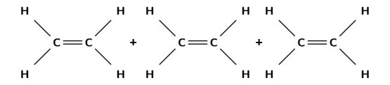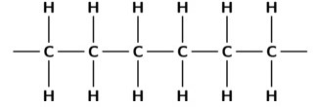 | monomer
 | polymer

The repeating unit for polyethene is shown below:

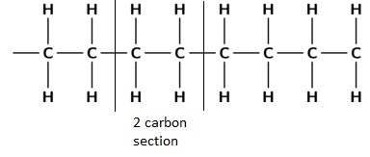
Repeating unit

Monomer | Polymer
Ethene | Polyethene (polythene)
Propene | Polypropene
Butane
Styrene
Vinyl chloride
The name of a polymer can be worked out from the name of the monomer as shown below.

Examples
- Draw the addition polymerisation reaction of chloroethene

- Draw the addition polymerisation reaction of propene

2.Condensation Polymerisation (National 5)
Condensation polymers are formed when monomers join together and usually produce water.

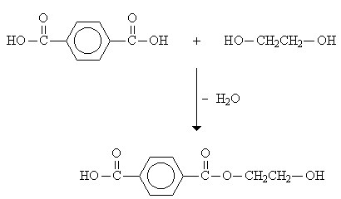
di-acid monomer

diol monomer

ester link

When many of these acid and alcohol monomer join it forms a _____________.

The ester link in the back bone identifies it as a condensation polymer.

New ‘Novel’ Materials

New materials with very specific properties are constantly being developed.

Name | Use | Property
Kevlar |  | Lightweight
Biopol |  | biodegradable plastic
Polyethenol |  | Soluble plastic
Ceramic |  | Hard (wear resistant)  Resistant to corrosion and high temperatures.
Shape Memory Alloys (SMAs) |  | Metal mixtures that remember their original shape.
Poly(ethyne) |  | Hydrocarbon that conducts electricity.

“Novel Materials” are materials that have been recently developed.

Nuclear Chemistry
By the end of this section I should be able to:

- Describe how certain heavy elements are formed. (N4)

- Explain why some atoms are radioactive. (N4/5)

- Describe the term background radiation. (N4)

- Name the different types of radiation and state their mass, charge and penetrating power. (N5)

- Write nuclear equations to represent radioactive decay. (N5)

- Explain what is meant by the term ‘half-life’. (N5)

- Carry out calculations involving half-life. (N5)

- Name some uses of radioisotopes in industry and medicine. (N5)

Structure of the Atom (UNIT 1 REVISION)

Name of particle | Electrical Charge | Mass | Position

Formation of Elements

All of the elements which can be naturally found on Earth originated in the ______________ and were formed in nuclear fusion reactions.

Atoms of hydrogen in the centre of stars began to fuse (join) together to form new, larger nuclei.

Helium was produced when two hydrogen atoms were fused together.
2 3 4 1
H + H He + n
1 1 2 0

The nuclei of helium could then undergo more fusion to produce other elements. Heavier elements such as carbon and oxygen were made by the fusion (joining together) of lighter elements in the stars.

Radiation
During our lifetime we are continually exposed to some degree of background radiation.
Most of this radiation is naturally occurring and has been around since the Earth was formed.
This has been added to over the past century or so from artificial sources.

Natural background radiation comes from 3 main sources:

Artificial background radiation

The radiation emitted from artificial sources is much less than natural sources however.
Levels of radiation can be measured using equipment called _______________

Radioactivity (National 5)
Some elements have isotopes which are unstable. This causes them to spontaneously decay or breakdown into more stable isotopes by releasing energy in the form of radiation. This is called radioactivity.

During this process the _____________ of the element is changed.

This is different from normal chemical reactions when only the electrons in the outer shells are affected.

There are three main types of radiation:

Experiment 1:
Radioactive source
positive
negative

Experiment 2:

paper
aluminium
Lead or concrete

1.Alpha particles
An alpha particle is identical to a helium nucleus. It consists of two protons and two neutrons. It can be written as α or ⁴ He.
²
2.Beta particles
Beta particles are high energy electrons emitted from the nucleus. A beta particle can be written as β or ⁰ e.

⁻¹
It is created in the nucleus when a neutron splits into two particles, a proton and an electron.

3.Gamma radiation
Gamma radiation is an electromagnetic wave, not a particle. This means that gamma radiation has no mass or charge. Gamma radiation is given the symbol γ.

Summary

Type of Radiation | Symbol | Stopped by
Alpha | α or ⁴ He  ² | A thin sheet of paper.
Beta | β or ⁰ e  ⁻¹ | A thin piece of aluminium.
Gamma | ⁰γ  0 | Thick piece of lead or thick concrete.

Half-life (National 5)
When a radioactive isotope (radioisotope) decays it causes a decrease in the mass and activity of the isotope.

The half-life (t _{1/2}) of a radioisotope is the time taken for the mass or activity to decrease by half.

Every radioisotope has a half-life and these can vary from seconds to millions of years.
1st half-life 3rd half-life
1 ½ ¼ 1/8 1/16
2nd half-life 4th half-life
The half-life of radioisotopes is constant. No matter what mass of radioisotope is present the half-life will be the same. For example 1g or 10g of an identical radioisotope with have the same half-life.

The graph below shows how the activity and mass of a radioisotope decays and how half-life can be found.
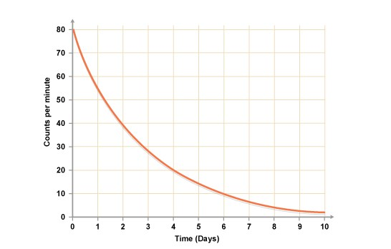

t

1
/
2

=

The half-life of an isotope can be used to determine how old something is. For example all living things on Earth contain carbon isotopes. S

cientist can measure the radioactivity of ancient fossils or relics to determine how many half-lives the carbons have undergone.

In this way they can work out how old the object is. This is sometimes known as carbon dating.

Half-Life Calculations (National 5)

- A radioisotope of phosphorus has a half-life of 14 days. A sample of the radioisotope has a mass of 80 g.
Calculate the remaining mass of the sample of the radioisotope after 56 days.

- The initial radioactivity of a sample of a radioisotope was 100 counts/minute.
If the activity fell to 25 counts/minute in 24 days, what is the half-life of the

3. A radioisotope has a half-life of 7 s.
How long will it take for 48 g of the radioisotope to decay to leave 6g?

Nuclear Reactions (National 5)
There are two main families of nuclear reaction. There is nuclear fission and nuclear fusion.

During nuclear fission heavy nuclei break up into lighter nuclei. I

n nuclear fusion, the opposite happens. Light nuclei join up to form heavier nuclei.

³He → ¹H + ²H Nuclear Fission
2 1 1
¹²C + ⁴He → ¹⁶O Nuclear Fusion
6 2 8

Nuclear Equations (National 5)
1. Alpha (α) emission
For example when Uranium – 238 undergoes alpha radiation it loses an alpha particle. This can be seen in the equation:

²³⁸U →

- Beta (β) emission
In the following example Thorium-212 is undergoing beta radiation and emitting a beta particle.

- Gamma emission
This is electromagnetic energy and not a particle. The gamma decay of Cobalt-60 is shown below.

⁶⁰Co → ⁶⁰Co + ⁰γ
27 27 0
No change in mass number or atomic number occurs when γ radiation is emitted.
Remember:
Total mass number on reactant side = total mass number on product side
Total atomic number on reactant side = total atomic number on product side

Uses of Radioisotopes (National 5)

Radioisotopes are used in medicine and also increasingly used in industry.

Radioisotope | Use
⁹⁹Tc (Technetium - 99)

⁶⁰Co (Cobalt -60)

⁹⁰Sr (Strontium-90)

²⁴¹Am (Americium 241)

