Name ___________________________________ Class _____________



CfE Higher Chemistry
Unit 2 -Nature’s Chemistry

Introduction Page
(1) Systematic carbon chemistry 1-2
(2) Alcohols, carboxylic acids and oxidation 3 - 16

Key Areas
(3) Esters, Fats and Oils 17 – 26
(4) Soaps, detergents and emulsions 30 - 31
(5) Proteins 32 - 37
(6) Chemistry of cooking 38 - 42
(7) Oxidation of food 43 - 44
(8) Fragrances 45 - 48
(9) Skin care 49 - 53

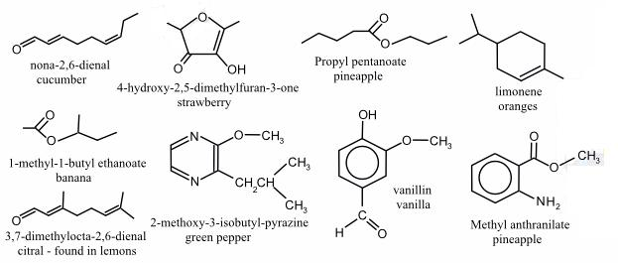

(1) Revision of Hydrocarbon Structures
(Alkanes, alkenes, alkynes, cycloalkanes, cycloalkenes)

(2) Revision of Systematic naming, Isomers, Addition reactions.

(3) Alcohols, carboxylic acids and oxidation of alcohols

Alcohols are a large group of organic molecules all of which contain at least one hydroxyl (OH) group as the functional group. A functional group allows organic molecules to react. Ethanol is an example of an alcohol and is the second member of its homologous series based on the corresponding alkanes.

Complete the table below for straight-chain alcohols with the functional group at the end of the molecule:

Number of Carbon Atoms | Name of  Alcohol | Formula | Full Structural Formula | Shortened Structural  Formula

The General Formula for the Alcohols is ____________

Naming alcohols

Always draw the full structural formula before naming any organic molecule. The oxygen atom from the hydroxyl group must be joined to a carbon atom as per valency rules then apply systematic naming. Note that branching can occur but the hydroxyl group has priority over branches. From propanol onwards, isomerism can occur because the position of the hydroxyl group can be changed. The rules are:

- Select longest hydrocarbon chain containing hydroxyl group and name it

- Number the carbon atoms from the end nearest the OH group

- Name the branches and indicate their positions as shown below

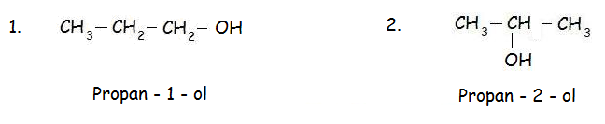

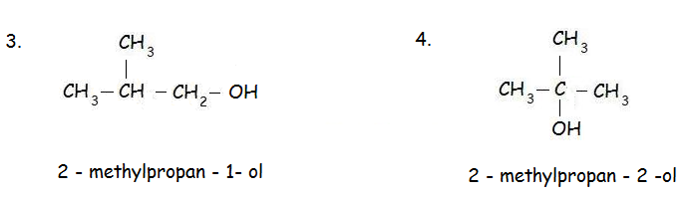

No. 2 can also be represented as CH₃CH(OH)CH₃

No. 4 can also be represented as CH₃C(CH₃)(OH)CH₃

Some alcohols have more than one hydroxyl group:

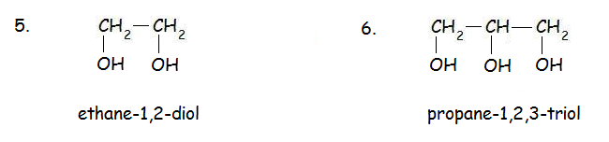
(ethylene glycol, found in antifreeze) (glycerol)

Primary, Secondary and Tertiary Alcohols

There are different types of alcohol: primary, secondary and tertiary alcohols. This is determined by the position of the OH group on the carbon backbone.

A primary alcohol has 2 (or 3) hydrogen atoms attached to the same carbon atom as the hydroxyl group:
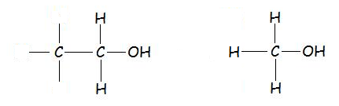

A secondary alcohol has only 1 hydrogen atom attached to the same carbon atom as the hydroxyl group:

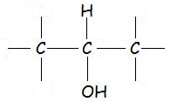

A tertiary alcohol does not have any hydrogen atoms attached to the same carbon atom as the hydroxyl group:
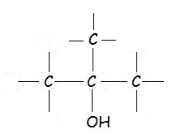

Examples:

Ethanol Propan – 2 – ol 2-Methylbutan – 2 – ol

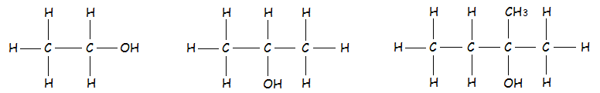

primary secondary tertiary

Reactions of Alcohols
All alcohols can be burned (oxidised) in a good supply of oxygen to produce _______________ ________________ and __________. We usually call this a _______________________ reaction. Combustion is an extreme form of oxidation.

Write the balanced formula equations for the complete combustion of 1. methanol, 2. ethanol and 3. propanol below:

1. ____________________________________________________________________

2. ____________________________________________________________________

3. ____________________________________________________________________

Some alcohols undergo mild oxidation which does not produce carbon dioxide and water, but produces new organic molecules instead. The new products depend on the type of alcohol used.

A mild oxidising agent is used to oxidise the alcohol while the oxidising agent is reduced:

- Acidified potassium dichromate
- Acidified potassium permanganate
- Benedict’s solution
- Hot copper (II) oxide

When hot copper (II) oxide is used, the alcohol vapour is passed over the oxidising agent.

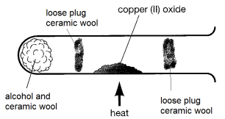

As the alcohol is oxidised, the copper (II) ions are reduced to copper atoms as shown in the ion electron equation below:

Copper: ________________________________________________
Cu²⁺ = ___________________ agent
Repeat this for the reduction of acidified dichromate ions below using your data book:

Dichromate: ________________________________________________
Cr₂O₇²⁻ = ___________________ agent
Which Type of Alcohols Undergo Mild Oxidation?

Acidified potassium dichromate solution can be used to find out which alcohols can undergo mild oxidation. If the alcohol is oxidised, the acidified potassium dichromate will be reduced as follows:

Cr₂O₇²⁻(aq) + 14H⁺(aq) + 6e⁻ → 2Cr³⁺(aq) + 7H₂O
Dichromate Chromium (III)
Ion

Orange → Blue/green

Why is this a reduction reaction? __________________________________________

What happens to the potassium ions in the potassium dichromate solution? _________________________________________________________________________

Oxidising Alcohols

Aim
To find out which type of alcohol undergoes oxidation.

Method
1. A 2cm depth of each type of alcohol to separate labelled test tubes.

2. About 0.5 – 1cm³ of acidified potassium dichromate solution was slowly to each test tube.

3. The mixture was heated in a water bath.

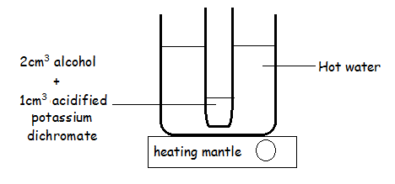

Results
A colour change occurs with ____________________________________________________

Conclusion
___________________ and ______________________ alcohols can be oxidised using a mild oxidising agent but ______________________ alcohols cannot.
Products of Mild Oxidation
Only primary and secondary alcohols can undergo mild oxidation. These reactions produce new families of organic chemicals:

Primary alcohol → Aldehyde/Alkanal
ethanol → ethanol

Secondary alcohol → Ketone/Alkanone
propan – 2 – ol → propanone

Tertiary alcohol → no reaction

Aldehydes/alkanals

The functional group in aldehydes and ketones is called the carbonyl group:

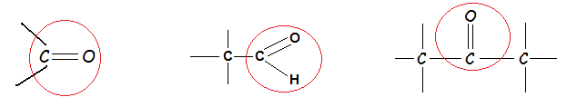

The position of the carbonyl group is different in aldehydes and ketones:

Aldehydes/alkanals – the carbonyl group is at the end of the molecule.

Ketones/alkanones – the carbonyl group is within the molecule linked to 2 other carbon atoms:

Aldehydes and ketones are further examples of homologous series. Their names are derived from the corresponding alkanes:
- Propane → propanal
- Propane → propanone

- Pentane → pentanal
- Pentane → pentanone

Use this information to complete the 2 tables on the following pages for alkanals and alkanones:

Number of Carbon Atoms | Name of  Alkanal | Full Structural Formula | Shortened Structural  Formula

Number of Carbon Atoms | Name of  Alkanone | Full Structural Formula | Shortened Structural  Formula

The General Formula for the aldehydes/alkanals is __________________
The General Formula for the ketones/alkanones is ________________
Since Aldehydes and Ketones have the same general formula, they must be _______________.
Systematic Naming and Isomers

Aldehydes and ketones are named systematically as before. In aldehydes the carbonyl functional group is always at the end of the molecule so isomerism can only occur when the position of any branches is altered. Draw 2–methylpentanal and 3–methylpentanal below to illustrate this:

In ketones the position of the carbonyl functional group is never at the end of the molecule but can be anywhere within the molecule. This leads to isomerism from _________________ onwards.

Draw butanone, pentan–2–one and pentan–3-one to illustrate this:

Further isomerism occurs when the position of branches is altered. Draw 2,2-dimethylpentan-3-one and 2,4-dimethylpentan-3-one below to illustrate this:

Summary of Oxidation so far

Primary alcohol → Aldehyde (Alkanal)
ethanol → ethanal

Secondary alcohol → Ketone (Alkanone)
propan – 2 – ol → propanone

Tertiary alcohol → no reaction

Further oxidation?

When primary alcohols are oxidised to alkanals, the hydrogen atom of the hydroxyl group is removed along with one of the hydrogen atoms on the shared carbon atom.

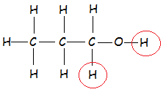

When secondary alcohols are oxidised to alkanones, the hydrogen atom of the hydroxyl group is removed along with the only hydrogen atom on the shared carbon atom.
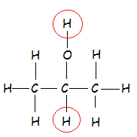

Look at structures of aldehyde and ketones. Could any of them be further oxidised?

Oxidation of Alcohols Experiment

Aim
To use the mild oxidising agents, acidified potassium dichromate solution, Benedict's solution and Tollens' reagent, to distinguish between an aldehyde and a ketone.

Hypothesis
I think that ______________________ can be oxidised further because _________________________________________________________________________
Hazards - Read all hazards associated with the chemicals you will use.

- Carbonyl compounds are highly flammable, vapours irritate eyes, skin and lungs!! They are poisonous so do not ingest!!
- 0.1 mol l⁻¹ potassium dichromate is toxic if swallowed. It is carcinogenic and very toxic by inhalation. It is also a skin sensitiser and is very toxic to the aquatic environment.
- 1 mol l⁻¹ sulphuric acid irritates the eyes.
- Benedict's solution contains copper salts and so is harmful if swallowed.
- Tollens' reagent contains diluted sodium hydroxide which irritates the skin and eyes.

Care
- Wear eye protection and immediately wash off any chemical spillages on the skin.
- When working with Tollens' reagent and carbonyl compounds wear gloves.

Disposal
Dispose of all organic waste in the organic waste beaker provided.

Set up all of the reactions at the same time – label all test tubes.

Method 1
- A hot water bath was set up.
- 1 cm³ (1cm depth) of potassium dichromate, 0.1 moll⁻¹ was added to 2 test tubes
- 2 cm³ (2cm depth) of sulfuric acid, 1 moll⁻¹, was added to acidify the potassium dichromate solution.
- 5 drops of the aldehyde was added to one test tube and 5 drops of the ketone to the other.
- Both test tubes were placed in the water bath and any changes observed and recorded.

Method 2
- Benedict's solution was added to two test tubes to a depth of about 3 cm.
- 5 drops of the aldehyde was added to one test tube and 5 drops of the ketone to the other.
- Both test tubes were placed in the water bath and any changes observed and recorded.

Method 3
Repeat method 2 but use Tollens' reagent and two very clean test tubes instead of benedict’s solution.

Results

Test | Observations with Aldehyde | Observations with Ketone
Acidified potassium dichromate
Fehling’s solution
Tollens reagent

Conclusion
_______________ can be further oxidised but __________________ cannot because _________________________________________________________________________

Summary so far
Oxidation can be thought of as the gaining of oxygen atoms or the loss of hydrogen atoms resulting in an increase in the oxygen : hydrogen ratio.

Reduction can be thought of as the losing of oxygen atoms or the gain of hydrogen atoms resulting in a decrease in the oxygen : hydrogen ratio.

Name | Formula | oxygen:hydrogen ratio | Answer
 | C₂H₅OH |  | 0.17
 | CH₃CHO
 | CH₃COOH

Oxidation of ethanol → ethanal and oxidation of ethanal → ethanoic acid increases the O:H ratio.
Complete Summary of Oxidation Reactions

Primary Alcohol → →

Secondary Alcohol → →

Tertiary Alcohol → →

Reminder
Now that you understand the mechanism of oxidation of organic molecules, is there any new information you can add to your Research Notes e.g. changes in O:H ratio for the oxidation of vitamin C??

Carboxylic Acids
_______________ but not _______________ can be further oxidised to form carboxylic acids using a variety of mild oxidising agents. Alkanoic acids are another homologous series based on the corresponding alkane.

They are the oxidation product of aldehydes so the functional group must be at the end of the molecule. The functional group is the carboxyl group:

Number of Carbon Atoms | Name of  Acid | Full Structural Formula | Shortened Structural  Formula
Branched carboxylic acids.
Branched chain carboxylic acids with no more than 8 carbon atoms in their longest chain should be named from structural formulae. Given the name of a branched chain carboxylic acid structural formulae should be drawn and molecular formula written.
Your teacher will give you some examples to try.

Reduction Reactions
Carboxylic acids can be reduced in stages back to the original parent aldehyde and alcohol:
→ → Primary Alcohol

Alkanones can be reduced back to the parent secondary alcohol:

→ Secondary Alcohol

What is the effect on the oxygen : hydrogen ratio? _______________________________

- Esters, Fats and Oils

An ester is the product of the reaction between the functional groups in a carboxylic acid and an alcohol. Water is also produced. This is called a __________________ reaction and is also known as an ________________________. The hydroxyl group of the acid reacts with the hydrogen atom of the hydroxyl group in the alcohol to form water. animations - Welcome to the NQ Higher Sciences website

Carboxylic acid functional group: Alcohols functional group: ______

The name of an ester is found by replacing the –ol ending of the alcohol with the ending -yl (ethanol → ethyl) and replacing the –oic ending of the acid with –oate (methanoic → methanoate)

Example: Ethanoic acid + propan – 1 – ol → propyl ethanoate

Example: Propan – 2 – ol + methanoic acid (you would not be expected to name this unless PS)

Esters contain an ester link as the functional group as shown in the diagrams below:
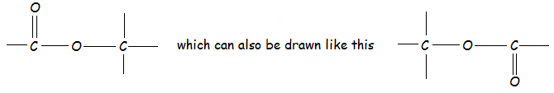

Draw a dotted line through the diagrams to show which part is from the alcohol and the acid.

The ester link can also be shown like this:
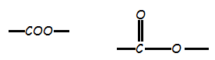

More ways to represent the reaction between an alcohol and an alkanoic acid:
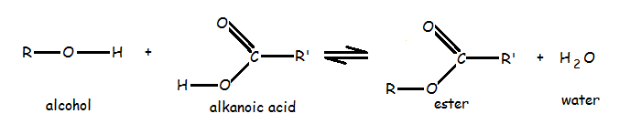
The double headed arrow is used to show that these reactions are reversible. The R and R’ represent different alkyl groups.
Esters can also be represented as shortened structural formulae:

CH₃COOC₂H₅ or C₂H₅OOCCH₃

Draw a dotted line through the above formulae to show which part is derived from the alcohol and the acid. You may find it easier to draw the full structure first!
You should be able to name an ester from the names of the parent alcohol and alkanoic acid or from full or shortened structural formulae.
Your teacher will give you more examples to try.

Making an Ester Experiment

Aim: to make an ester and investigate their properties:

Method:
1. Set up a hot water bath.
2. Choose an alkanoic acid and alcohol from the results table on the next page to make an ester.
3. Add 1 cm depth alkanoic acid (or a spatula if solid) to 1cm depth alcohol in a boiling tube.
4. Carefully add 5 drops of concentrated sulfuric acid (dangerous stuff which contains H⁺ ions as the catalyst)
5. Wrap a paper towel condenser around the top of the boiling tube and insert a loose cotton wool ‘plug’. This will prevent escape of reactant/products when they evaporate.
6. Heat in the water bath for about 20 minutes or longer then put in to a test tube rack to cool down before the next step.
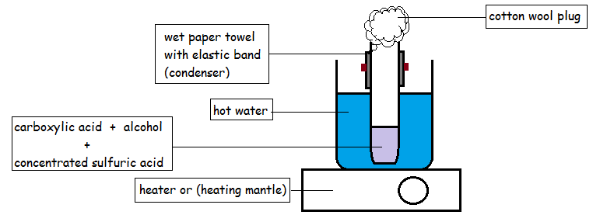
7. Add about 20cm³ of 1 mol l⁻¹ sodium hydrogencarbonate solution to a small beaker.
8. Slowly pour the reaction mixture into the sodium hydrogencarbonate solution. This neutralises the sulfuric acid and any remaining carboxylic acid and removes the smell of the carboxylic acid.
9. Gently swirl the contents of the beaker until it stops bubbling.ee if there is any sign of the ester separating from the aqueous mixture.
10. Check for immiscibility (an oily layer on top of the aqueous layer) and carefully smell the ester.

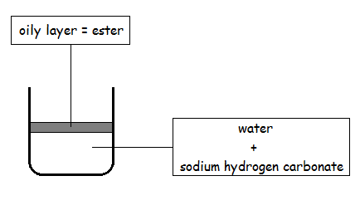

Results

Carboxylic acid | Alcohol | Ester | Smell of ester
ethanoic acid | C₅H₁₁OH
 |  | CH₃COOC₂H₅
methanoic acid | ethanol
 |  | propyl methanoate
salicylic acid | methanol | methyl salicylate

Problems with Ester Production
Ester formation is slow at room temperature and the yield of ester is low because it is a reversible reaction. The rate can be increased in 2 ways:
- increase the temperature of the reaction
- use concentrated sulfuric acid as a catalyst to lower the _____________________
- use concentrated sulfuric acid to remove water from the products to encourage the forward reaction

These issues will be addressed in more detail in the next unit so it is important to learn and understand the reaction and its problems now!
Uses of Esters
Esters are oily liquids which usually have pleasant fruity smells. They have a range of uses: food flavourings, perfumes (characteristic smells) and solvents.

Twig - Oil Products: Esters and Perfumes- Learn Chemistry

Food flavourings: pear drops, strawberry ‘flavoured’ yoghurt, raspberry ‘flavoured’ ice lolly.
Perfumes: jasmine, rose, citrus.
Solvents: nail varnish remover (ethyl ethanoate or acetone), paints, glues

FYI
Ethyl ethanoate is a solvent used to extract caffeine from coffee and tea. Labels on packaging claim that the tea or coffee has been "naturally decaffeinated" because ethyl ethanoate is a chemical found naturally in many fruits. Caffeine (C₈H₁₀N₄O₂) is an alkaloid and is produced by plants. The name alkaloid means “alkali-like”.

Natural fruit flavours contain subtle blends of some of the esters in the following table:

Name | Shortened Structural Formula | Odour/Flavour
 | CH₃COO(CH₂)₄CH₃ | Banana
 | CH₃COO(CH₂)₄CH₃ | Orange
Methyl Butanoate |  | Pineapple
3-Methylbutyl Butanoate | CH₃(CH₂)₂COO(CH₂)₂CH(CH₃)₂ | Apple
 | CH₃COOC₃H₇ | Pear
Methyl-1-butyl ethanoate | CH₃COOCH(CH₃)C₄H₉ | Banana
2-Methylpropyl methanoate |  | Raspberry
 | C₃H₇COOC₅H₁₁ | Apricot, Strawberry
Benzyl ethanoate | CH₃COOCH₂C₆H₅ | Peach, flowers
Ethyl methanoate
Methyl 2-aminobenzoate | C₆H₄(NH₂)COOCH₃ | Grapes
Benzyl butanoate | C₃H₇COOCH₂C₆H₅ | Cherry

Points to Note
Making an ester is a reversible reaction. The forward reaction makes an ester using concentrated sulfuric acid as a catalyst. Concentrated sulfuric acid also slows down the reverse reaction.

The reverse reaction converts the ester back in to an alcohol and alkanoic acid. This is an hydrolysis reaction. Dilute alkali e.g. sodium hydroxide or potassium hydroxide is used.

Hydrolysis of Esters

Esters can be hydrolysed (the reverse reaction) to produce the parent _______________ and the parent _____________________ by replacing the water which was lost in the forward reaction (esterification/condensation reaction).
Ester + Water ⇌ Alcohol + Alkanoic Acid
A dilute alkali is used to catalyse the reaction and the mixture heated under reflux:
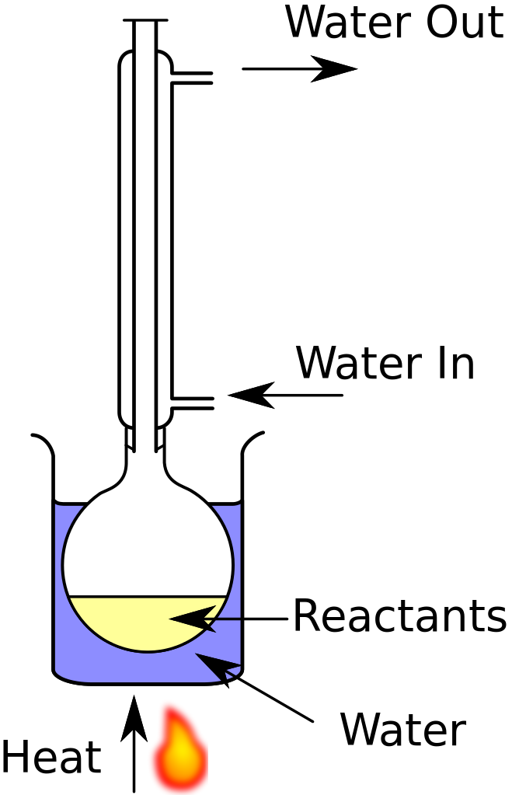
Look at this diagram carefully; it is exactly the same as the apparatus you used to make an ester. Look back now. The esterification diagram is on page ___ of this booklet.
The sodium salt of the alkanoic acid is produced if dilute sodium hydroxide is used. The potassium salt of the alkanoic acid is produced if dilute potassium hydroxide is used:
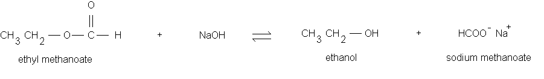
An inorganic acid like HCl (aq) is then used to displace the organic acid from the salt:
HCOO⁻ Na⁺ + HCl → HCOOH + NaCl
methanoic acid

Your teacher will give you some examples to try.

Edible Fats and Oils
Fats and oils are natural esters. Complete the table to show the sources of some fats and oils.

Name of fat or oil | Animal, vegetable or marine
Sunflower oil
Linseed oil
Suet
Cod liver oil
Lard
Castor oil
Palm oil
Rape seed oil

Natural oils have vegetable and marine (fish) origins while natural fats have ______________ origins. Also, solids fats are mainly from ____________; liquid oils are mainly from _________________. Fats and oils are an essential part of the diet providing us with energy. Fats and oils are a more concentrated source of energy than ___________________. They are essential for the transport and storage of fatsoluble vitamins in the body

Fats and oils are natural esters from the reaction between long chain carboxylic acids and the alcohol glycerol. Glycerol has the systematic name propan 1,2,3 triol. Draw the full structural formula for glycerol below:

Glycerol is a trihydric alcohol because it contains three alcohol groups. Each molecule of glycerol reacts with ___ molecules of fatty acids. Each fat/oil molecule produced contains ___ ester linkages.
The long chain carboxylic acids are known as fatty acids. They can be saturated or unsaturated:
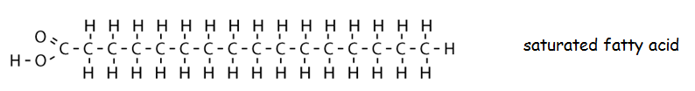

This structures can be represented in a different way:
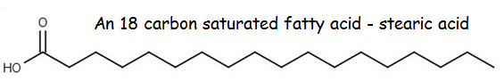
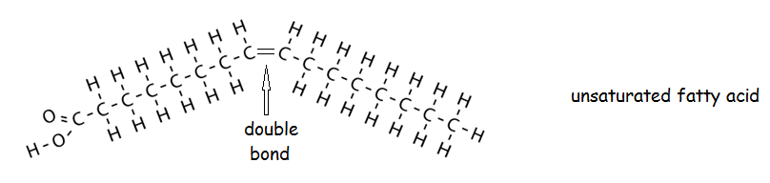
This structures can be represented a different way:
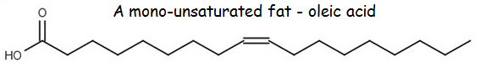
More examples:
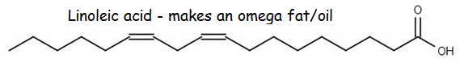
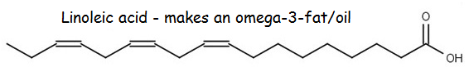
Fatty acid structures are shortened to make them easier to draw:
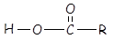
If the carbon chains attached to the carboxyl group are different they may be represented as shown below:
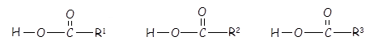
The 3 fatty acids which react with glycerol may all be the same or any combination of different carboxylic acids.
To follow the mechanism of the reaction, glycerol is drawn ‘north to south’ as shown below:

Complete the reaction mechanism of a molecule of glycerol reacting with 3 molecules of C₁₇H₃₅COOH:
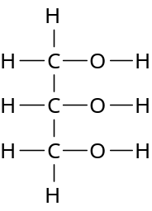

_______________
Now show the mechanism when a molecule of glycerol reacts with 3 different fatty acids:

Is C₁₇H₃₅COOH a saturated or an unsaturated fatty acid?
Melting points of Fats and Oils
Fats and oils are also known as triglycerides (an ester made from glycerol and three fatty acids). Most fats and oils in nature are mixtures of triglycerides in which the fatty acid molecules may or may not be identical. The properties of a fat or an oil depend on the fatty acids which are combined with the glycerol in each triglyceride. Fats are ____________ at room temperature while oils are ______________.

Fatty acids are saturated or unsaturated straight chain carboxylic acids which range in size from C₄ to C₂₄ carbon atoms, but mainly C₁₆ and C₁₈.

Fatty acid | Formula | Saturated or unsaturated
palmitic acid
stearic acid
linoleic acid
oleic acid
The Structure of Fats and Oils
The structure below represents a fat molecule containing 3 saturated fatty acids:
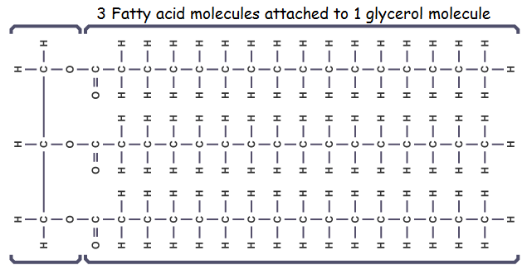
This structure can be simplified to a ‘tuning fork’ structure to show how molecules pack closely together in a fat. Molecules which can pack closely together have stronger Van der Waals forces between molecules so are solid at room temperature. Fats have higher melting points than oils.
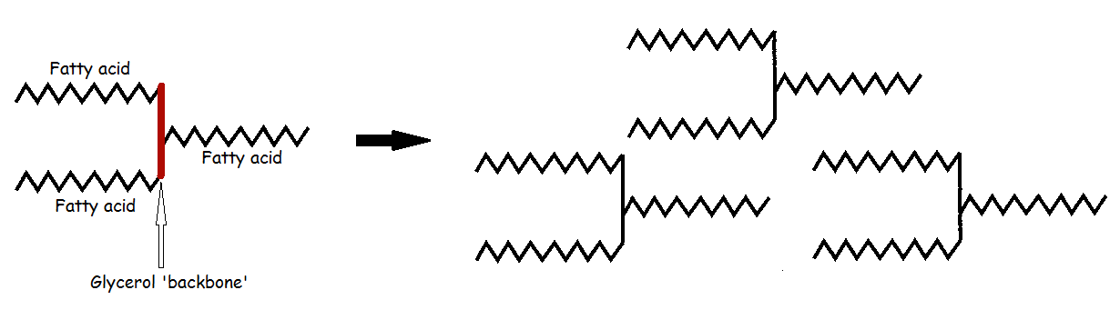

Just one carbon to carbon double bond in a fatty acid causes a distortion in the tuning fork shape. Molecules cannot pack closely together due to their irregular structure have weaker Van der Waals forces between the molecules and thus lower melting points. Oils have lower melting points than fats so are liquid at room temperature:

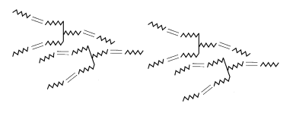
Marine animals living in cold oceans mostly contain body oils rather than fats because solid fats cannot be transported round the body.

Margarine
Margarine is just an oil which has been ‘hardened’. The oil is reacted with hydrogen to remove/reduce the number of carbon to carbon double bonds. This is an ______________ reaction which converts unsaturated compounds into (more) saturated ones. A nickel catalyst is used to ______________________________________.
The degree of hydrogenation, use of additives and blending can produce margarines with different properties such as improved taste and appearance. Additives include:
- Flavouring to make margarine taste like butter
- Vitamin A and D to make margarine as healthy as butter*
- Colouring to make margarine look like butter
*Vitamin A, known as retinol, has many important functions; efficient immune system, good eyesight (so you do need to eat carrots and take cod liver oil!!!)
*Vitamin D, known as cholecalciferol, is needed for intestinal absorption of calcium (to prevent rickets), iron, magnesium, phosphate and zinc. Very few foods contain vitamin D (mainly oily fish) unless the food is fortified (like margarine). Most Vitamin D is synthesised in the skin from cholesterol – UVB radiation from the sun is needed for this process. (See UVB radiation later!)
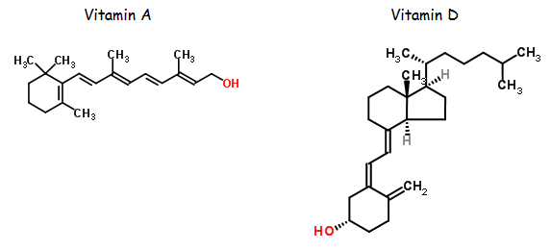
Examine the structure of these vitamins – are they water soluble or fat soluble? Why?
___________________________________________________________________________________________________________________________________________________________________________________________________________________________

Emulsifiers (mechanism later)
Margarine is a water/oil emulsion – a mixture of water and oil which would separate into layers without an emulsifier e.g. lecithin.
Comparison of unsaturation in fats and oils
The degree of saturation in a fat or oil can be determined by the Iodine Number (bromine can also be used). The iodine (or bromine) reacts with the C=C bonds, so the greater the iodine number, the greater the number of double bonds.
Method
- Using a plastic pipette, add five drops of olive oil to 5 cm³ of hexane in a conical flask.
2. Use a burette filled with a dilute solution of bromine water (0.02 moll⁻¹). Read the burette.
3. Run the bromine water slowly into the oil solution while shaking vigorously - the yellow colour of bromine disappears as bromine reacts with the oil.
4. Continue adding bromine water until yellow colour remains – all carbon to carbon double bonds have now been saturated so bromine now unreacted.
5. Obtain titre volume and repeat until concordant results achieved.
6. Repeat the experiment with different oils e.g. soya bean oil (vegetable), lard ‘oil’ (animal).
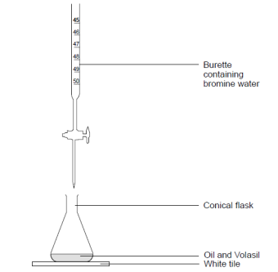

Results
Fat or Oil | Average Iodine No.
Butter | 40
Beef fat | 45
Lard (pig fat) | 50
Olive oil | 80
Peanut oil | 100
Soya bean oil | 180

Conclusion
Animal fats have lower iodine numbers because they are more saturated (fewer C=C bonds) than oils. Vegetable fats (oils) have higher iodine numbers because they are more unsaturated (more C=C bonds) than fats.
Fats and oils are just mixtures of saturated and unsaturated esters. Each fat or oil will have a different degree of saturation/unsaturation:

FAT saturated |  | unsaturated
OIL saturated | unsaturated

Hydrolysis of Fats and Oils
Like simple esters, fats and oils, which are esters, can be hydrolysed (split using ‘water’) to produce glycerol and the 3 fatty acid(s).

Hydrolysis of a simple ester methyl propanoate (revision):

Hydrolysis of fat or oil. You do not need to know what the molecule is called:

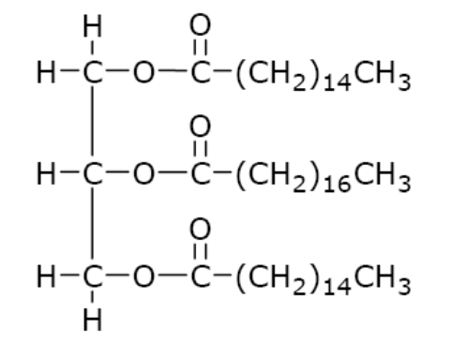

Label the ester links in the above diagram then draw the structure of the 3 fatty acids present in the molecule.

1. 2. 3.

Now draw the fat/oil molecule above using the symbol R instead of the carbon chain.

Hydrolysis can be done simply by treatment with superheated steam. In school labs hydrolysis is carried out using aqueous or alkali. You have already seen this when simple esters were hydrolysed. Look back in your booklet to find this.
(5) Soaps, Detergents and Emulsions
Fats and oils are esters. Fats and oils can be hydrolysed to make soaps using an alkali. The products of the reaction are a water-soluble ionic salt of the carboxylic acid and glycerol. The fatty acid salts are ‘salted out’ of the reaction mixture by adding a great excess of sodium or potassium chloride and the soap is then filtered off.

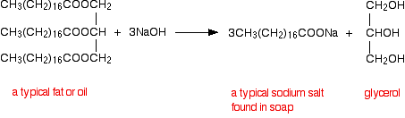

Soaps the sodium or potassium salts of fatty acids:

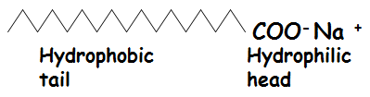

Detergents
Detergents are produced by the petrochemical industry. They are used in hard water areas because, unlike soaps, they do not produce a scum on the surface of the water.
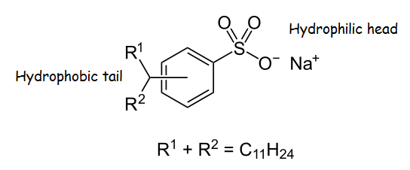
The Cleaning Action of Soaps and Detergents
Oils and grease is insoluble in water. Soaps and detergents are ‘emulsifying reagents’ which make oil and water form an emulsion (a suspension of fat in water - remember margarine?). Soaps and detergents have different solubility properties because of different polarities in their structures:

The non-polar hydrophobic ‘tail’ attracts non-polar fat/oil molecules whilst the hydrophilic polar heads are attracted to polar water molecules. Large fatty ‘lumps’ are broken up into smaller ball-like structures called ‘micelles’ resulting in a suspension of fatty material in water. The following set of diagrams show how this works.
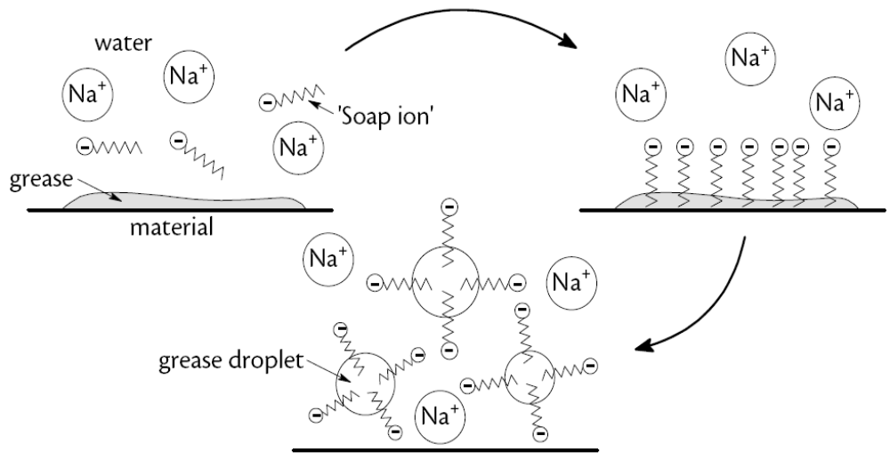

The dirt or grease is held inside the ball and suspended in the water. Repulsion between the negative charges results in a stable suspension (emulsion).

Emulsifiers in Food
Many foods, like margarine and mayonnaise, are mixtures of oil and water which could easily separate into layers. Emulsifying (re)agents, which work in exactly the same way as soaps and detergents, are added to food to maintain even suspensions of the mixture. Lecithin is used in margarine. Egg yolks or a synthetic emulsifier (xanthan gum) is used in mayonnaise. Even dried pasta contains an emulsifier to prevent pasta pieces sticking to each other during cooking.

Emulsifiers are usually made by reacting edible oils with glycerol to form molecules in which either one or two fatty acid groups are linked to a glycerol backbone rather than the three normally found in edible oils. The hydroxyl group(s) in these molecules are hydrophilic whilst the fatty acid chains are hydrophobic:

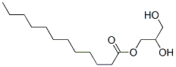
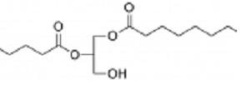

Emulsifiers have E-numbers which are shown on food packaging. E471 is one of the most common.

You might carry out an investigation into which foods make a good emulsifier.

(6) Proteins
Proteins are molecules which make up the major structural materials of animal tissue such as muscle fibres, hair, nails and skin. We need protein in our diet for ___________ and ____________. Meat and fish are rich in protein. Proteins contain the elements carbon, hydrogen and oxygen and nitrogen.

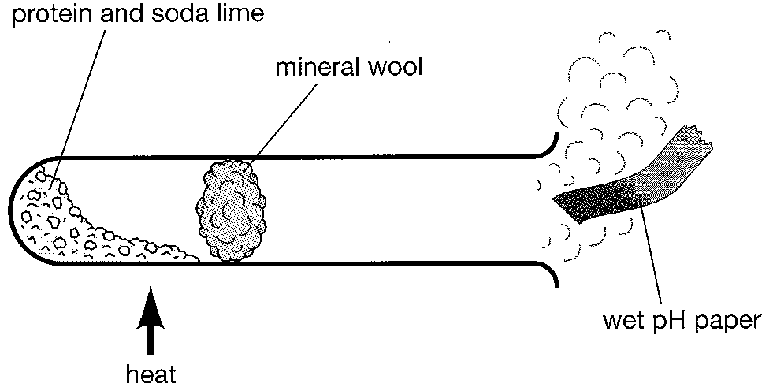
A simple test to confirm the presence of nitrogen is shown in the diagram. The gases produced (amines or ammonia) turn moist pH paper blue so nitrogen must be present.

Proteins are also involved in the maintenance and regulation of life processes as haemoglobin, immunoglobulins and enzymes (biological catalysts).

Proteins are natural polymers made up of monomers called amino acids. Amino acids contain the amine functional group (-NH₂) and the carboxyl functional group (–COOH). Each amino acid contains both functional groups therefore can react as acids and/or as bases. Natural amino acids have the two groups bonded to the same carbon atom and are called alpha amino acids (α-amino acids):
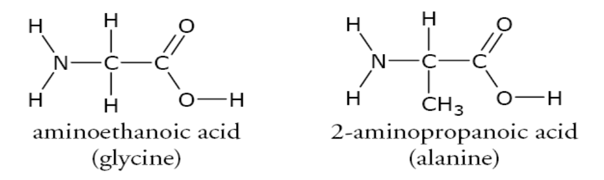

Label the acid group and the amine group in the molecules above.

20 amino acids are needed to synthesise body proteins. Since proteins can contain thousands of amino acids this means there is an enormous number of different proteins. 12* amino acids can be made in our body when we digest proteins. The remaining 8* must be obtained in our diet (ingested) so are known as essential amino acids. One essential amino acid missing from our diet can cause serious deficiencies; this could prevent the formation of an enzyme such as insulin, which controls blood sugar levels, resulting in lifelong diabetes!

* depends which text book or website you read!!
Condensation Polymerisation
An amide link or peptide link (CONH) is formed when the amino group of one molecule reacts with the carboxyl group of an adjacent molecule. Water is eliminated. This is condensation polymerisation. The following amino acids react to form a tripeptide:

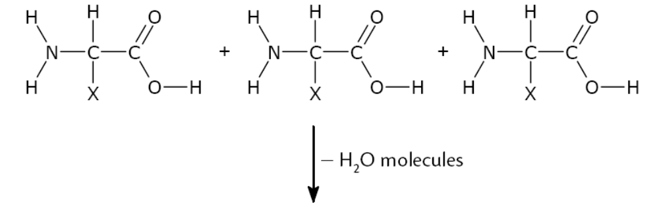

X (or R) can be a Hydrogen atom, an alkyl group, or groups containing any arrangement of atoms. For example, cysteine has the structure:

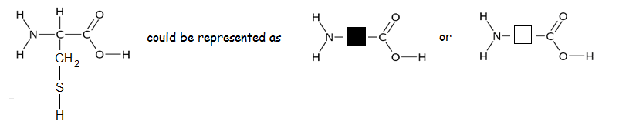

Classification of Proteins
Chain of amino acids are known as a polypeptides. Amide (peptide links) between amino acids are polar. Hydrogen bonds can occur at these links (H atoms attracted to NOF atoms). Show this in the diagram below:
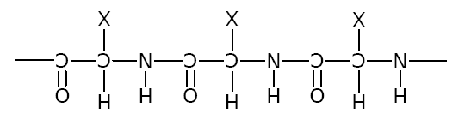

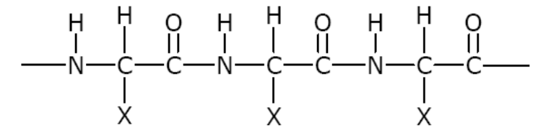
Structure of Protein
The structure of a protein depends on the amino acids present and bonding which might occur WITHIN (intramolecular) a single polypeptide or BETWEEN (intermolecular) polypeptides.

Hydrogen bonding can occur within a peptide chain or between 2 peptides:

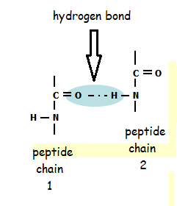

Classification of Proteins
Proteins can be classified as fibrous or globular. If the H bonds occur in the same linear protein molecule, a helix structure is produced. If H bonds occur between different chains a β - pleated sheet is formed. These helices or sheets can then be folded to give fibrous or globular proteins:
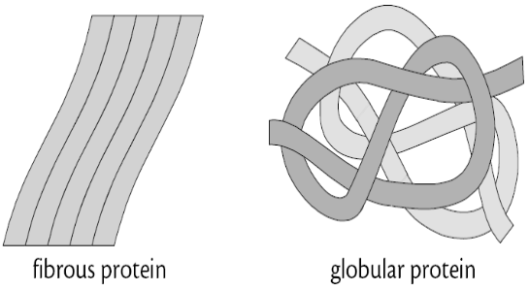

Fibrous proteins are long and thin and are the major structural materials of animal tissue. For example: skin, muscle, hair, nails.

Globular proteins are involved in the maintenance and regulation of life processes and include enzymes, hormones such as insulin and haemoglobin for the transport of oxygen in the blood.

Enzymes
Enzymes are natural catalysts which lower the activation energy of biological reactions so they can take place at body temperature.

Enzymes are specific; amylase only catalyses the break-down of starch molecules but not the breakdown of proteins. Lipase catalyses the breakdown of fats into ____________ __________ and ________________ in the small intestine.

The specificity of enzymes is due to their molecular shapes. The 3D shapes of the molecules are the result of intramolecular and intermolecular bonds.

Enzymes are thought to work by the ‘lock and key’ mechanism:
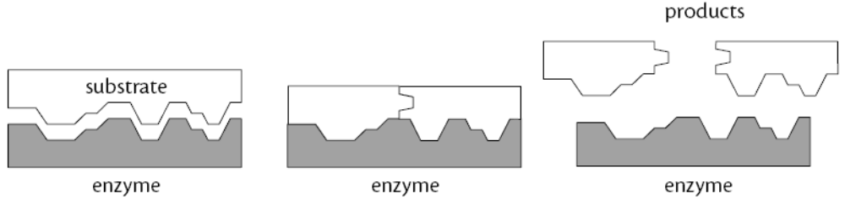

Enzymes are temperature and pH sensitive: high temperature and changes in pH can irreversibly alter the 3D structure of the enzyme. The enzyme is said to be ____________________. All proteins, not just enzymes, can be denatured by temperature and pH.
Some chemical processes involve a sequence of reactions with each stage requiring a different enzyme eg. the production of ethanol from starch in fermentation:
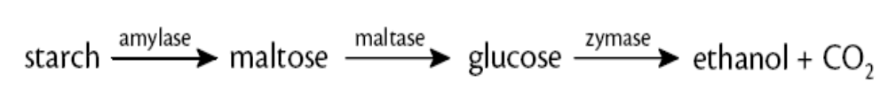
Hydrolysis (digestion) of Proteins

This takes place naturally in the acid pH of the stomach with the enzyme pepsin. Large protein molecules are hydrolysed to smaller polypeptides. Further enzymes continue this hydrolysis in the gut to finally produce the constituent amino acids which can pass through the gut wall into the blood stream.
In the lab proteins can be broken down to their amino acids by hydrolysis (break down using water). This can be done by ‘refluxing’ the protein with fairly concentrated hydrochloric acid using the apparatus below: Hydrolysis of the peptide bond

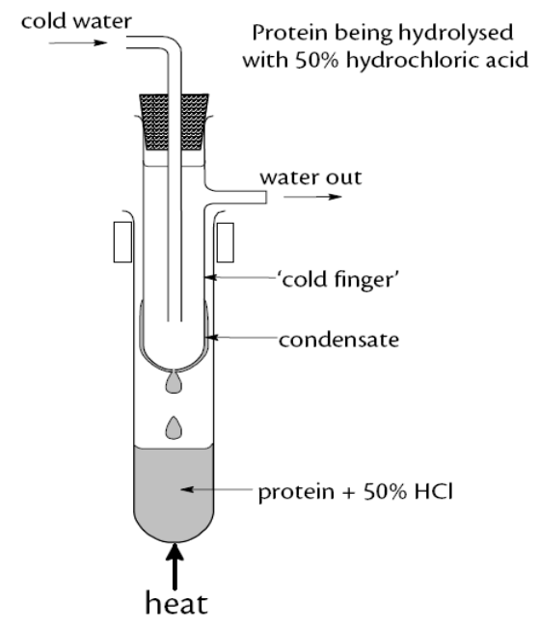

Record the results of the hydrolysis of the following tri-peptide

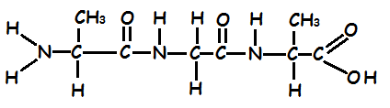

___________________________________________________________________________________
Chromatography
Following hydrolysis, constituent amino acids can be identified using the technique of chromatography in which the hydrolysed protein (hydrolysate) is run alongside standard amino acids (known amino acids). The individual amino acids are treated with the chemical ninhydrin to make them visible on the chromatogram:

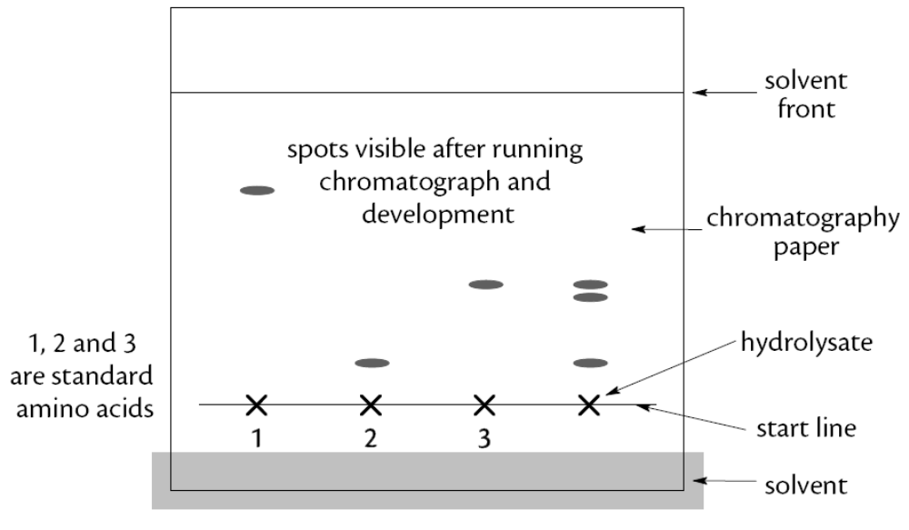

Chromatography will be examined further in Unit 3 Chemistry in Society: Chemical Analysis

(7) Chemistry of Cooking

Proteins are complex molecules made from long, branched amino acid chains (peptides). Intramolecular and intermolecular bonding produces spirals, sheets, or helices resulting in 3D proteins such as the fibrous or globular structures described earlier:

When proteins are heated (‘cooked’) these intermolecular and intramolecular bonds are broken allowing the proteins to change shape (denature). These changes alter the texture of foods.

Egg whites contain globular albumen. Cooking causes protein chains in the albumen to unwind. Intermolecular bonds form between separated chains resulting in a 3D network - the solid egg white.

Meats contains connective tissue to hold muscle fibres together. In meat this is mainly the protein collagen:
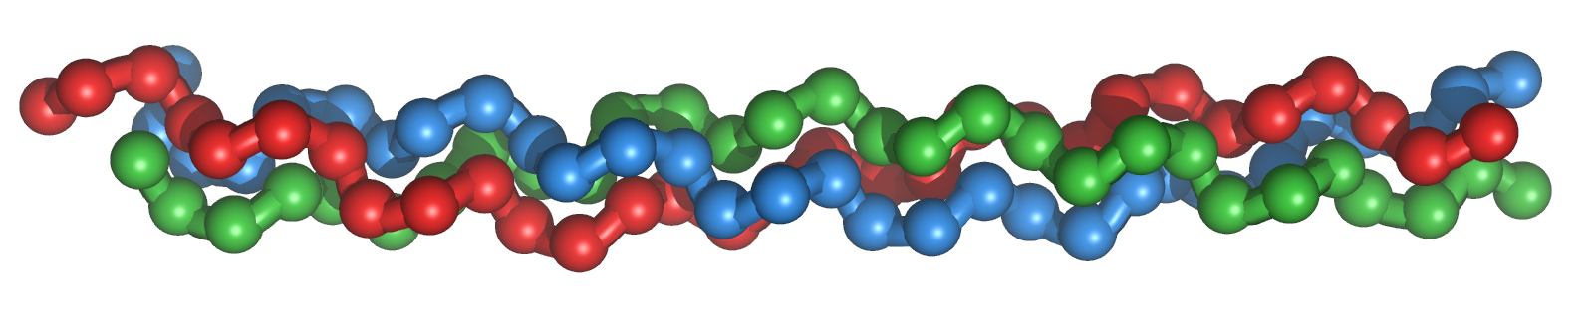
Different cuts of meat contain different quantities of collagen so different temperatures are needed for cooking:

Roasting joints contain a lot of connective tissue become tender if cooked at over 60ºC as the collagen denatures.

Fillet steaks have less connective tissue so need to be cooked at a lower temperature otherwise collagen molecules bunch together so the meat becomes tough.

Flavour in Food
We taste food using our sense of smell AND taste. Try chewing flavoured food without looking at it, while pinching your nose!
Cooking causes chemical reactions which leads to new flavours: toasted bread tastes different from untoasted bread because there is a reaction between a carbonyl group (>C=O) in the carbohydrate and an amino group (-NH₂) in bread protein.
Many flavour and aroma molecules are aldehydes (alkanals) and ketones (alkanones). Both contain the carbonyl functional group. You learned about these families at the beginning of this booklet. Revise them now!

Boiling points of Aldehydes and Ketones
Aldehydes and ketones are classed as VOCs (volatile organic compounds).

Volatility is a measure of _________________________________________

Small non-polar molecules have very low bps so evaporate very easily. Larger, non-polar molecules have more LDFs so have higher bps therefore are harder to evaporate.

The carbonyl group in aldehydes and ketones is polar: 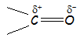

Draw 3 molecules of propanal in the shape above (bp 49ºC) to show intermolecular bonding:

The type of intermolecular bonding is _____________________________________________.

Repeat this for propanone (bp 56ºC):

Why is the bp higher for propanone?

Draw diagrams to show bonding between 3 molecules of propan-1-ol (bp 97ºC) then 3 molecules of propan-2-ol (bp 82⁰C):

What kind of bonding occurs between alcohol molecules? ______________________________

Why is the bp of propan-1-ol higher than the bp of propan-2-ol? _________________________
_________________________________________________________________________
Why is the bp of the alcohol higher than that of the equivalent aldehyde or ketone? __________
_________________________________________________________________________

Which Cooking Method?

The method and time of cooking is very important so that flavour molecules are not lost in the cooking process.

When vegetables are boiled, water in cells evaporates and ruptures cell membranes and cell walls. This releases flavour molecules. Volatile flavour molecules enter the air if they have low bps. If they can form hydrogen bonds with water they dissolve in the cooking liquid and may be thrown away when vegetables are drained.

Structures of flavour molecules and type of intermolecular bonding are very important in determining whether they are water-soluble or oil/fat-soluble. A long hydrocarbon chain (which is non-polar) with a single polar group would be fat/oil-soluble because it would only form one hydrogen bond with a water molecule. Hydrogen bonding between flavour molecules reduces their volatility.

- oil/fat-soluble – cook in water e.g. green beans and broccoli.
- water soluble - cook in oil/fat e.g. asparagus.

The table below shows the impact of structure on solubility in water vs oil:

‘Functional’ group | Structure | Hydrogen bonding? | Water/oil-soluble?
Alkane | C-C | No | oil-soluble
Alkene | C=C | No | oil-soluble
Alkyne | C=C | No | oil-soluble
Hydroxyl | -O-H | Yes | water-soluble
Carbonyl | >C=O or | Yes | water-soluble
Carboxylic acid | -COOH or | Yes | water-soluble
Aldehyde | -CHO or | Yes | water-soluble
Amino | -NH₂ or | Yes | water-soluble
Phenyl | C₆H₅- or | No | oil-soluble
Amide | -CONH- or | Yes | water-soluble
Ester | -COO- | Yes | water-soluble

Remember to also consider the length of the carbon backbone not just the functional group.

The molecular structures below represent the formulae of some common flavours. Examine them and try to decide if they are likely to be water- or oil soluble.

(8) Oxidation of Food

Foods contain a large variety of organic molecules like aldehydes, ketones, carboxylic acids, fats, oils and alcohols. Some of these can be oxidised by oxygen in the air around them. You learned about primary, secondary and tertiary alcohols and their oxidation reactions at the beginning of this booklet. Revise them now!

Oxidation increases the oxygen : hydrogen ratio in the molecules. Show this below in the oxidation of ethanol to ethanal to ethanoic acid:

Oxidation of organic molecules makes food ‘go off’. Butter (a saturated fat) releases volatile, unpleasant smelling butanoic acid and other fatty acids which taste and smell rancid when oxidised.

Oils are also easily oxidised. Reaction occur at the C=C double bonds of unsaturated fatty acids in the oil releasing small volatile molecules such as aldehydes and ketones also with a rancid smell.

Oxidation of food is prevented/reduced by adding antioxidants which prolong their shelf-life. Antioxidants are reducing agents. By undergoing oxidation, the antioxidant provides electrons to prevent the oxidation of fats/oils in food.

In organic chemistry oxidation can be:

- gain of oxygen atoms → an increase in the oxygen : hydrogen ratio
- loss of hydrogen atoms → an increase in the oxygen : hydrogen ratio
- loss of electrons

In organic chemistry reduction can be:

- loss of oxygen atoms → decrease in the oxygen : hydrogen ratio
- gain of hydrogen atoms → decrease in the oxygen : hydrogen ratio
- gain of electrons

Vitamin C (aka Ascorbic Acid), tocopherols and citric acid are commonly used antioxidants. Apples go brown when they are cut and oxidise in the air. A few drops of lemon juice (contains Vitamin C) prevents oxidation. Oxidation occurs at the OH groups in the ‘ring’ structure as shown:
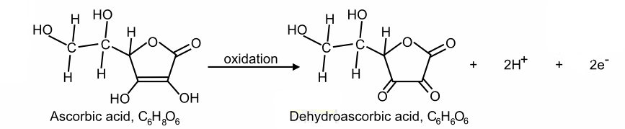

O : H ratio ___________ → ___________

What other feature of the reaction indicates that this is an oxidation reaction? _____________
Is the resulting structure an aldehyde or a ketone? _____________________

In crisp manufacture, potatoes are typically fried under an atmosphere of steam and packaged under nitrogen to help reduce oxidation.

Redox Titration

The concentration of vitamin C in foods can be measured by a variety of means. You may carry out investigative work to measure the quantity of vitamin C in fruit juice or vegetables. This simple method could be used to investigate the effect that cooking food has on antioxidant levels. See Unit 3.

(9) Fragrances
If you ‘google’ the word fragrance, you will probably find lots of sites selling perfumes. Fragrance is the old-fashioned word for perfume. Most perfumes and other ‘smellies’ contain essential oils derived from plant The term ‘essential’ does not refer to the ‘importance’ of the oil but the essence (flavour/smell/aroma). Essential oils are used in perfumes, cosmetics, soaps, candles, food and household cleaning products. So the smells are fruity, floral or spicy depending on the source.

Essential oils are mixtures of volatile (low bp) hydrophobic liquid aroma compounds that evaporate easily in air giving distinctive fragrances. The oils have the aroma of the plant from which they are extracted e.g. lavender, peppermint, orange, lemon, and eucalyptus oils. The difficulty is obtaining the liquid before it evaporates.

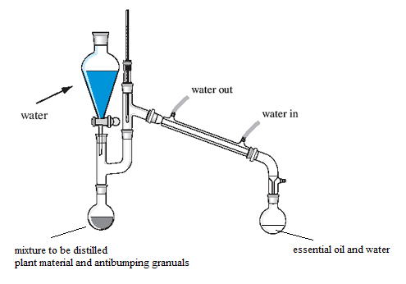
Steam Distillation
In this process the volatility of the oil is important so it is carried by the steam.
More water can be added from the funnel.

The essential oil collects as a mixture of
oil and water, but as the two do not mix,
they are easily separated.

In the laboratory extraction can be achieved with the apparatus shown.

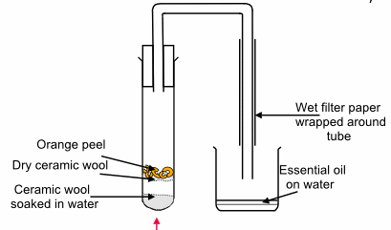
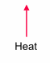

Every essential oil contains mixtures of organic compounds rather than just one pure compound, but it is often the aromatic molecules based on benzene C₆H₆ – no longer in the course) that provide the distinct fragrances.

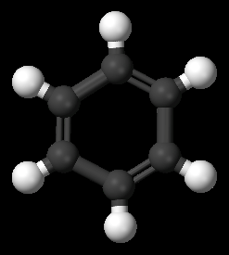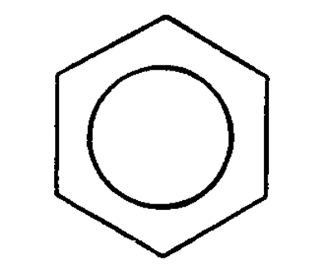

Terpenes
Terpenes are key components in most essential oils.

Terpenes are unsaturated compounds formed by joining together isoprene units.

The systematic name for isoprene is (2-methylbutan-1,3-diene). LEARN THIS!!
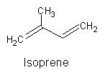

Isoprene units link together to form terpenes with the basic molecular formulae (C₅H₈)_{n} where n is the number of linked isoprene units. This is called the isoprene rule.

Isoprene units may link together "head to tail" to form linear chains or join to form rings. Isoprene units can be thought of as one of nature's common building blocks.

Terpenes can be oxidised within plants to produce some of the compounds responsible for the distinctive aroma of spices. These derivatives, such as alcohols, aldehydes ketones etc. may still be referred to as terpenes or terpenoids. The names of the molecules usually indicate the predominant functional group. Some examples of terpenes and derivatives are show on the table on the next page.

Complete the tasks below by studying the molecules in the table:

- Highlight and count the number of isoprene units in the carbon structures.
- Identify any functional groups.
- Comment on their solubility.

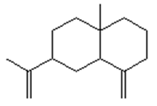  Selinene  (celery) | 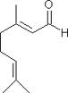  Citral  (lemon grass) | 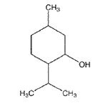  Menthol  (peppermint)
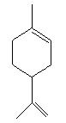  Limonene  (oranges/lemons) | 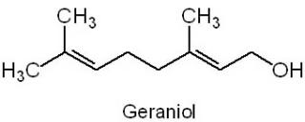 (rose oil) | 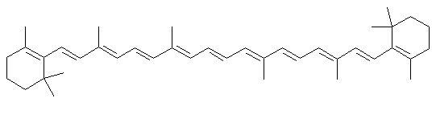
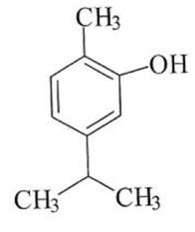  Carvacrol  (oregano/thyme) | 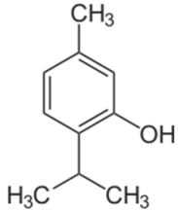  Thymol  (thyme plant) | β Carotene  (carrots)

Solvent extraction
Limonene can be extracted from oranges using ethyl ethanoate as a solvent. This process separates organic chemicals from water soluble substances. Some substances are more soluble in the organic solvent than in aqueous solvents.
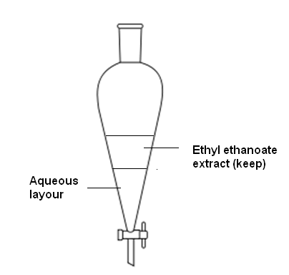

Non-polar terpenes dissolve well in ethyl ethanoate and dissolve poorly in water. If an impure terpene in an aqueous extract is shaken with ethyl ethanoate, most of the terpene will ‘move’ into the ethyl ethanoate layer (see diagram) and very little will remain in the lower aqueous layer.

Water soluble impurities move into the water layer which is removed using a separating funnel then further purified by another shake with ethyl ethanoate to dissolve more of the terpene. All the terpene/ethyl ethanoate fractions can be added together and distilled to separate the 2 components.

(9) Skin Care

Huge sums of money are spent on cosmetics every year (men and women!!) to prevent wrinkles or to protect against sun damage. In the seventies, cheap package holidays became readily available and many tourists used a variety of oils to promote sun tans. Many of these people have, at best, prematurely ‘aged’ their skin or, at worst, developed skin cancer (malignant melanoma). About 11000 new cases are diagnosed here every year.
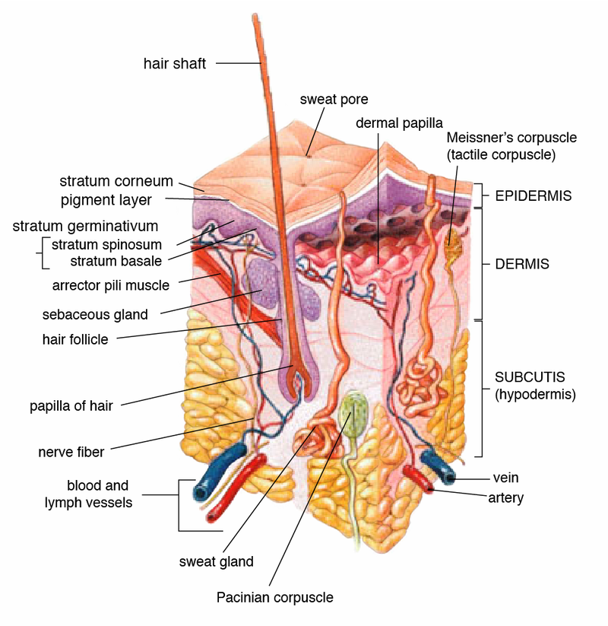
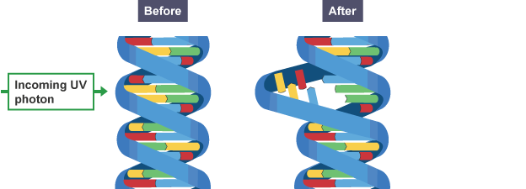
Both "photo-aging" and skin cancer are caused by harmful, high energy ultraviolet (UV) radiation. UV radiations are found beyond the visible part of the electromagnetic spectrum. There are 3 main types of UV radiation:

- UVA: most penetrating → damages collagen in the dermis → loss of elasticity → wrinkles

- UVB: high energy breaks bonds in DNA of epidermal cells → sun burn and/or skin cancer

- UVC: higher energy than UVA and UVC – way beyond visible - very little reaches Earth

Continued exposure to UV radiation results in the production of melanin from cells in the dermis. Melanin protects the skin but makes it appear tanned. So, although tans look healthy, they are not!

Sunblocks
Currently 2 types of sunblock exist - ZnO and TiO₂ sunblocks reflects UV away from the skin
- chemical sunblocks absorbs UV radiation

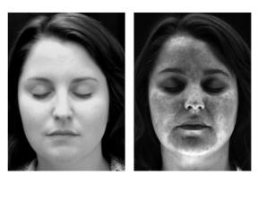
UV Photography reveals the effects of or aging of skin caused by UV radiation light.

Some skin-care products claim to contain chemicals which prevent wrinkling. Manufacturers claim that these products are ‘anti-aging’. You
need to examine adverts for anti-aging products carefully to verify the scientific basis of the claims.
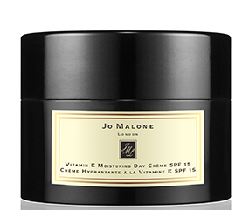

Free Radical Reactions
UV light provides enough energy to break bonds in molecules in the skin. This photochemical reaction produces free radicals.

Free radicals are ___________________________________________________________ this makes them extremely reactive with the potential to harm cells.

Free radicals are formed naturally in the body and are important in many normal cellular processes but, at high concentrations, can be very dangerous. Free radicals can damage major cell components e.g. DNA, cell proteins and cell membranes. Damage to DNA may result in skin cancer.

The chemistry is complicated so simple examples of free radical formation and chain reactions are given here.

Free radical chain reactions include the following steps: initiation, propagation and termination. For example in the explosive reaction between hydrogen and chlorine the overall reaction is:

The presence of acidic HCl(g) in the product can be shown using moist pH paper.

H₂(g) + Cl₂(g) → 2HCl(g)

1. Initiation
U.V. light provides the energy for the homolytic fission of the halogen into free radicals with an unpaired electron:

Cl₂(g) → Cl (g) + Cl(g)  
- Propagation
Free radicals collide with other molecules to produce stable atoms/molecules as well as more free radicals to continue the chain reaction:
H₂(g) + Cl → H (g) + HCl(g)
H (g) + Cl₂(g) → HCl(g) + Cl (g)

- Termination
Free radicals are used up by collision with each other.
H (g) + Cl(g) → HCl(g)
H (g) + H(g) → H₂(g)
Cl (g) + Cl(g) → Cl₂(g)

The following reaction is very useful in chemistry to produce substituted alkanes from unreactive parent molecules.

Substitution Reactions
Alkanes are unreactive because they contain only single carbon to carbon covalent bonds. Hydrogen atoms in an alkane can be substituted for a halogen atom in the presence of UV light. This reaction is slow and the bromine solution is slowly decolourised. The overall reaction is:
The presence of acidic HBr(g) in the product can be shown using moist pH paper.

CH₄(g) + Br₂(g) → CH₃Br(g) + HBr(g)

- Initiation
U.V. light provides the energy for the homolytic fission of the halogen into free radicals:
Br₂(g) → Br (g) + Br(g)
- Propagation
Free radicals collide with alkane molecules to produce stable molecules as well as more free radicals to continue the chain reaction:

CH₃-H(g) + Br → CH₃ (g) + HBr(g)
CH₃ (g) + Br₂(g) → CH₃ - Br(g) + Br (g)

- Termination
In this stage, free radicals are used up by collision with each other.
Br (g) + Br(g) → Br₂(g)
CH₃ (g) + Br(g) → CH₃ - Br(g)
CH₃ (g) + CH₃(g) → CH₃ - CH₃(g)

The product of the last equation is ethane. However, to minimise the range of possible products, an excess of the original alkane is used and the products separated from the excess alkane by distillation. Further substitution can occur with hydrogen atoms progressively replaced by halogen atoms.

Free Radical Scavengers

Antioxidants are chemicals which react with and remove free radicals. Antioxidants are also known as free radical scavengers. Many cosmetic products contain free radical scavengers.

Free Radical Scavengers are molecules which _______________________________________

_________________________________________________________________________

Most of the antioxidants which protect us from free radicals are ingested in our food including beta-carotene, lycopene and vitamins A, C and E. Melatonin, a hormone, is also a free radical scavenger:

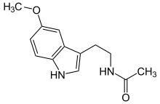
Melatonin

Free radical scavengers are added to food products and to plastics e.g. food wrapping to prevent both degradation of the food and the wrapper itself.

