Name ___________________________________ Class _____________



CfE HIGHER CHEMISTRY

Chemistry in Society

- Getting the most from reactants: designing an industrial process p1

- Revision – the mole, calculations from equations p 2 – 7

- Percentage Yield, Excess and Atom Economy p 8- 13

- Controlling the Rate p 14 -31

- Molar Volume and Relative Volumes p 32 - 37

- Enthalpy and Hess’s Law p 38 - 48

(7) Equilibrium p 48 - 58
(8) Chromatography p 60 – 65

(9) Volumetric Analysis p 66

(10) Researching Chemistry p 67

- Getting the most from reactants: designing an industrial process

Industrial processes are designed to maximise ________ and minimise the impact on the ___________________.

Factors influencing process design include:

- Availability, sustainability and cost of feedstock(s);
- Opportunities for recycling;
- Energy requirements;
- Marketability of by-products;
- Product yield.

Environmental considerations include: minimising waste; avoiding the use or production of toxic substances; designing products which will biodegrade if appropriate.

To achieve all of the above it is essential to understand and manipulate the chemistry behind the chemical industry; the need to use readily available raw materials

A raw material is ______________________________________________________

Some examples include

Chemists must also understand the competing demands between feedstocks, fuels and other chemicals, to fully appreciate the complicated world of the chemical industry.

A feedstock is _______________________________________________________

First we will make sure we understand the importance of equations to the chemical industry and how we can use the information in balanced chemical equations in many different ways.

Stages of the Chemical Industry

There are several key stages involved in the development of new chemicals. These stages include research, pilot production, modification and mass production:

Research and development = any systematic laboratory-based investigation to establish new facts, or discover and develop of methods and systems for the advancement of knowledge or to produce new chemicals.
Pilot production = application of research making up to about 1000kg of the new chemical and to further investigate its properties and efficacy before modification.

Mass production = scaling up of pilot production for the global markets although modifications may still take place following further research.

The flow diagram below illustrates the processes involved in the manufacture of almost every new chemical:
RAW MATERIALS

FEEDSTOCK PREPARATION

REACTOR

RECYCLE
UNREACTED
FEEDSTOCK

SEPARATOR

PRODUCTS

First we will make sure we understand the importance of equations to the chemical industry and how we can use the information in balanced chemical equations in many ways.

- Revision – The Mole

One mole of any substance is defined as the gram formula mass (gfm):

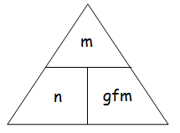
m =

n =

gfm =

Examples

1 mole sodium, Na = 23g

23

1 mole water, H₂O = 18g

2 + 16

Mass of 2 mole water = n x gfm
2 x 18
36g

How many mol in 10g calcium carbonate?

1 mol calcium carbonate, CaCO₃ = 100g

40 + 12 + 48

From the triangle n = m
gfm

= 10
100

= 0.1 mol

Concentration
The concentration of an aqueous solution is the mass of solute dissolved in a known volume of water. This is usually expressed as moles per litre, ie moll⁻¹ (mol dm⁻³) but can also be expressed in grams per litre:

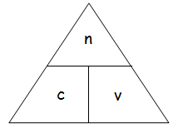
Number of moles

Concentration

Volume in litres

Examples

How many moles are there in 100 cm³ of sodium hydroxide solution, 0.4 moll⁻¹?

n = c x v
= 0.4 x 100
1000

= 0.04 mol

What is the concentration of hydrochloric acid solution containing 0.1 mol of HCl in 50 cm³?
50 cm³ = 0.05 litres.

c = n
v

= 0.1
0.05

= 2 moll⁻¹

What volume of a sodium carbonate solution, concentration 2 moll⁻¹, contains 0.5 mol?

v = n
c

= 0.5
2

= 0.25 litres

= 250 cm³

The two triangles can be combined for further problems:

Examples

What mass of hydrogen chloride is needed to make 200 cm³ of hydrochloric acid, concentration 2moll⁻¹?

Calculate the number of moles of HCl first:

n = c x v
= 2 x 0.2
= 0.4 mol

Now calculate the gfm of 1 mol HCl:

1 mole sodium, HCl

1 + 35.5 = 36.5g

Finally calculate the mass of HCl needed:

m = n x gfm
= 0.4 x 36.5
= 14.6g

What is the concentration of a solution which contains 5.85g of sodium chloride in 500cm³ of solution?

Calculate the gfm of 1 mol NaCl first number of moles of NaCl first:

1 mole NaCl

23 + 35.5 = 58.5g

Now calculate the number of moles for 5.85g NaCl.

n = m
gfm

= 5.85
58.5

= 0.1 mol

Finally calculate the concentration of NaCl.

c = n
v

= 0.1
0.5

= 0.2 moll⁻¹

Your teacher may give you examples to try.

Calculations based on Balanced Chemical Equations

It is unlikely that you need practice at balancing chemical equations at this stage but here are 2 examples just to make sure.

Examples

1. Calculate the mass of water produced on burning 1g of methane:

Balanced equation:

Mole ratio:

2. Calculate the mass of lead (II) carbonate required to produce 2.2g carbon dioxide on
heating.

Balanced equation

Mole ratio

Note that these examples assume 100% efficiency.
- Percentage Yield, Atom Economy and Excess

We always assume that we will obtain 100% products from reactions, for example, a simple neutralisation reaction:

NaOH(aq) + HCl(aq) → NaCl(aq) + H₂O(l)

At the end of this reaction no reactants will remain but there will be 100% products. However, many important industrial reactants are reversible so we never achieve 100% products. Using balanced chemical equations along with data from industrial processes it is possible to determine how efficient a reaction is by calculating the percentage yield of a required product. Industrial chemists must calculate percentage yields before mass production of products to ensure that it is an economically viable process.

We do this by calculating the quantity of product we should produce - the theoretical yield. Then we can calculate either the actual mass or percentage yield obtained.

Esterification reactions are reversible. In these organic calculations we assume:

1 mole of alcohol + 1 mole of alkanoic acid 1 mole of ester

Example 1
5g methanol reacts with ethanoic acid to produce 9.6g of methyl ethanoate. Calculate the percentage yield.

Equation:

Mole Ratio:

GFMs:

Theoretical Yield:

Actual Yield: 9.6g

Percentage Yield =

Example 2
Under test conditions, 10kg of nitrogen reacts with excess hydrogen to produce 1kg ammonia. Calculate the percentage yield.

Equation:

Mole Ratio:

GFMs:

Theoretical Yield:

Actual Yield: 1kg

Percentage Yield =

Try some more yield calculations now.

Excess (Unreacted Chemical) Calculations

To ensure the highest yield possible from a chemical reaction, industrial chemists often add too much (excess) of one of the reactants. This means that at the end of a reaction some reactants will be left over. It is easy to calculate the quantity (number of moles/mass/volume) of the excess reactant by following the same procedures as before.

Examples
- 8g methane is sparked in 16g oxygen. Is 16g oxygen enough or too much? Is 16g methane enough or too much? Write a balanced equation then calculate how much oxygen is needed to react with methane in theory. Then decide which reactant is in excess and which one controls the reaction.

_________________ is in excess therefore all of the _______________ will be used up.
So the mass of products will depend on the number of moles/mass of _____________ present.

Now calculate the mass of carbon dioxide produced.

- 0.4g magnesium is added to 50cm³ of dilute sulphuric acid, concentration 0.5 moll⁻¹. Which reactant is in excess? Which reactant controls the reaction?

_________________ is in excess therefore all of the ________________ will be used up.

So the mass of products will depend on the number of moles/mass of _____________ present.

Now calculate the mass of hydrogen produced.

No. of moles of excess sulphuric acid is ___________________

Your teacher will give you more examples to try now.
Atom Economy

Adding excess reactants to ensure a higher yield of conversion of reactants into products could be considered wasteful but excess reactants can be recycled if unreacted. For any industrial reaction to be cost effective it is important to produce as much of the desired product as possible rather than unwanted by-products. Consideration of the atom economy allows us to calculate the proportion of reactants converted into the desired product.

Atom economy = Mass of desired product(s) x 100
Total mass of reactants

Example 1
Calculate the atom economy for the production of sodium chloride assuming that all the
reactants are converted into products i.e. 100% yield.

NaOH + KCl → NaCl + KOH
1 mol 1 mol 1 mol 1 mol
40g 74.6g 58.5g 56.1g

Atom economy = Mass of desired product(s) x 100
Total mass of reactants

= 58.5g x 100
114.6g

= 51.05%

Reactions like this have a high percentage yield (because they are not reversible) but have a low atom economy value if large quantities of unwanted by-products are formed; in this reaction approximately 49% of an unwanted product.

Example 2
Calculate the atom economy for the production of the ester ethyl propanoate, assuming that all reactants are converted into products.

A high percentage atom economy exists because the only by-product is water; water is not poisonous to the environment and can easily be disposed of or put to other uses.
In order to ensure that costly reactant(s) are converted into product, an excess of less expensive reactant(s) can be used. By considering a balanced equation, the limiting reactant and the reactant(s) in excess can be identified. Whilst the use of excess reactants may help to increase percentage yields, this will be at the expense of the atom economy so an economic/environmental balance must be achieved.

Your teacher will give you more examples to try now.

- Controlling the Rate

In industry new products, such as medicines, ammonia, paint and soap powder must be produced in large or small quantities quickly and cheaply. Chemical engineers must determine the ideal reaction conditions before mass production begins. If reaction rates are too low (too slow) profit margins will be too small; if too high production may be unsafe leading to the risk of a thermal explosion. Extractor fans remove flour dust from the air in large bakeries to prevent the risk of thermal explosion. In N5 you learned 4 factors which affect the rate of a reaction:

1. _______________ 2. ________________ 3. ______________ 4. ________________

All of these factors can be explained by Collision Theory. This theory states that before a reaction can take place, the particles must collide with each other.

We are surrounded by air containing 78% Nitrogen and 21% Oxygen gas molecules which are colliding all the time, yet we are not poisoned by dangerous brown nitrogen dioxide gas!!

Draw electron cloud diagrams of oxygen and nitrogen below:

Oxygen molecule Nitrogen molecule

When these molecules move towards each other, it is their electron clouds which first collide. Think about this!!!

Electron clouds contain only negative charges so as they collide they must _________ each other. The molecules do not move fast enough to overcome this repulsion. These collisions are not successful. Energy, eg. lightning, needs to be supplied.

The minimum quantity of energy needed to start a reaction is called the Activation Energy (E_{A}). The units are kilojoules per mole (kJmol⁻¹). Oxygen and nitrogen do not react quickly at room temperature (RT) so the activation energy for this reaction must be __________.

The reaction between hydrogen and oxygen does not take place at RT even though it is an explosive reaction. This reaction also has a _______ activation energy. Energy, in the form of a burning splint is used to test for the hydrogen ‘pop’.

Neutralisation reactions take place very quickly at RT, so they must have very _______ activation energy:
H⁺(aq) + OH⁻(aq) → H₂O(l)
In photography light provides the activation energy for silver salts on photographic film to be reduced to silver atoms:
Ag⁺ + e⁻ → Ag(s)

Ultra violet light provides the activation energy for the reaction between hydrogen and chlorine to produce hydrogen chloride gas:

H₂ + Cl₂ → 2HCl

We will now examine how factors make collisions successful and increase reaction rates.

Collision Theory and Concentration
Concentration is a measure of the number of particles of reactants in a known volume. As concentration increases the number of collisions ________________ so the rate of the reaction __________________.

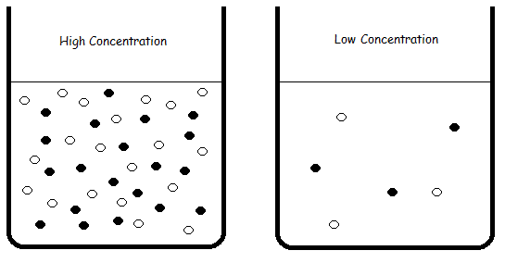

Collision Theory and Particle Size (Surface Area)
As particle size ______________ the number of collisions ________________ so the rate of the reaction __________________.
OR
As surface area ______________ the number of collisions ________________ so the rate of the reaction __________________.

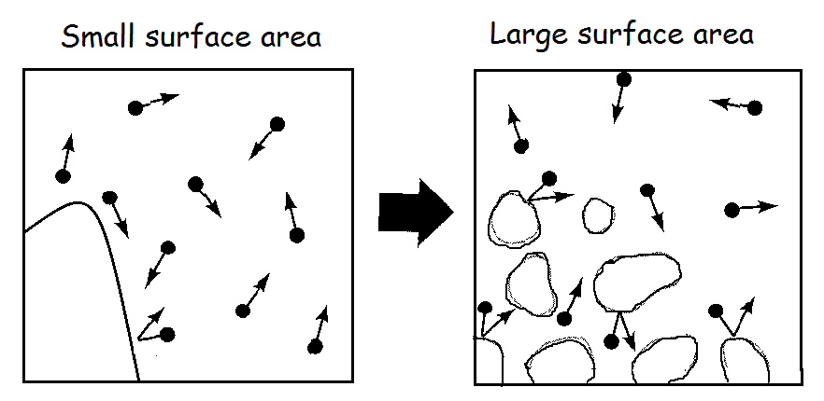

Collision Theory and Temperature
The temperature of a substance is a measure of the average kinetic energy (KE) of all of its particles. At any given temperature all the particles in a substance move at different speeds; some are speeding up and some are slowing down.

At 20⁰C particles all the particles in a substance move at different speeds so there is a distribution of KE; some particles lose energy (slow down) some particles are gain energy (move faster). So the overall pattern always stay the same!! This is shown in the graph below:
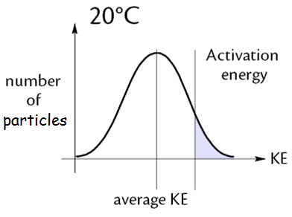

The graph shows that a very small number of particles have very low KE and a very small number of particles have very high KE. The majority of particles have an _______________ KE because they are either losing or gaining energy.

The activation energy (E_{A}) is the ________________ quantity of energy needed by particles to collide successfully and react. The shaded area represents the number of particles which have KE equal to, or greater than, the activation energy (E_{A}).

If the temperature is increased from T1 to T2 (20⁰C to 30⁰C) all the particles move faster (have greater KE) so more particles have the minimum quantity of energy (E_{A}) to collide and react. The whole distribution curve shifts to the right:
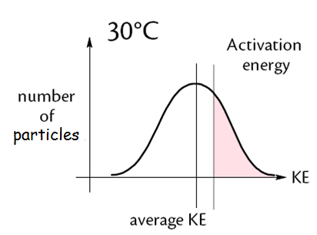
The 2 graphs can be superimposed to show the effect of increasing the temperature:

The graph now has a larger shaded area which represents the increased number of particles with energy equal to, or greater than, the activation energy.

Effect of Temperature on Reaction Rate
As temperature increases, particles move ____________ and collide with more ___________, so the rate of ___________________ collisions increases therefore reaction rate ___________________.

A small rise in temperature can result in a large number of particles having energy equal to, or greater than, the activation energy. This is why reaction rate approximately doubles with every 10⁰C increase in temperature. This is shown in the graph below:

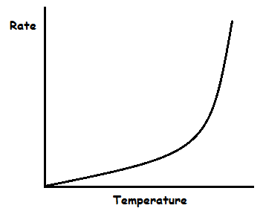

Most chemical reactions can be represented by this graph but there are other possibilities which you are already familiar with, for example, explosions and enzyme reactions.

Catalysts and Activation Energy
In N5 we learned that catalysts speed up chemical reactions without getting used up in the reaction. In fact, catalysts increase reaction rate by lowering the Activation Energy for the reaction.

Draw an energy distribution graph below to show this:

Using a catalyst lowers the Activation Energy so __________ particles have Kinetic Energy equal to, or greater than, the Activation Energy.

This results in an __________________ in the number of __________________ collisions so reaction rate ______________.

Collision Geometry
Particles must also have the correct orientation with each other so that they can react.

Consider the reaction:

CO(g) + NO₂(g) → CO₂(g) + NO(g)

correct collision geometry successful collision

repulsion unsuccessful collision

So there are 2 conditions which must be met for a successful collision to occur:

- Correct collision geometry
- Minimum kinetic energy

Effect of Pressure on Reaction Rate – ONLY APPLIES TO GASES!!
We will study pressure in more detail in unit 3 but in the meantime, this is very similar to the effect of increasing the concentration of particles.

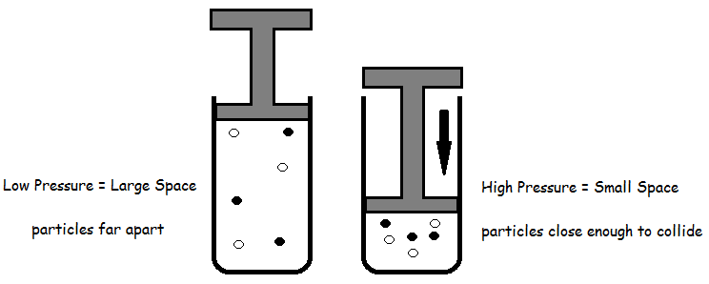

An increase in pressure of a mixture of gases increases the number of collisions and if particles are have energy equal to, or greater than, the Activation Energy, AND the correct collision geometry, the rate of the reaction will increase.

Methods of Monitoring Reaction Rate

(Revision – N5 Average rate Examples and Rate Graphs Sheet)

There are many methods of monitoring the course of a chemical reaction such as measuring:
- Temperature
- Volume of a gas produced
- pH
- Colour
- Concentration

It is very difficult to monitor the course of a chemical reaction by measuring the change in concentration of a reactant or product over a period of time. However, reactions can be monitored by measuring another property which is related to concentration.

At the beginning of a reaction there is a __________ concentration of reactants and a ___________ concentration of products.

As the reaction proceeds the concentration of reactants ______________________ while the concentration of products ______________________.

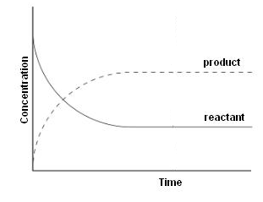
Relative rate of Reaction (You may carry out a practice Outcome 1 if time allows)
This just means we will compare reactions carried out at different concentrations or temperatures etc. to find out how this affects the reaction rate. We will measure the time (t) it takes to produce the same quantity of product in each reaction. Since the same quantity of product is always produced we can say the quantity is 1.

quantity of product = 1

time is in seconds = t

Relative Rate = 1
t (s)

The unit of relative rate is ________.
Effect of Concentration on Relative Rate (Outcome 1)
It is important to try to understand the chemistry of the reaction first. We start with a balanced chemical equation:

H₂O₂(aq) + 2H⁺(aq) + 2I⁻(aq) → 2H₂O(l) + I₂(aq)

This equation tells us that: hydrogen peroxide (H₂O₂) reacts with potassium iodide to form water and iodine in acidic conditions – how do we know that conditions are acidic?

Iodide ions (I⁻) are supplied using a potassium iodide solution. Potassium ions (K⁺) are not in the equation. Why not?

Aim: To investigate the effect of changing the concentration of potassium iodide solution on the rate of reaction with hydrogen peroxide solution.

If we are given one bottle of potassium iodide solution with a concentration of 0.1moll⁻¹, how do we change the concentration and keep this a fair test?

Volume of KI (aq) (cm³) | Volume of Water (cm³)
25 | 0

How do we know the reaction is finished?

H₂O₂(aq) + 2H⁺(aq) + 2I⁻(aq) → 2H₂O(l) + I₂(aq)

We need a 2nd chemical reaction and an indicator to ‘see’ when the reaction is complete.

Thiosulfate ions in sodium thiosulfate react with the iodine molecules as soon as they are produced so the solution will be remain colourless.

2S₂O₃²⁻(aq) + I₂(aq) → S₄O₆²⁻(aq) + 2I⁻(aq)

We will add the same quantity of thiosulfate ions to every experiment until they are all used up. This quantity is 1. The time, in seconds (s), for all the thiosulfate to be used up is t. So the rate of the reaction is 1/t (s⁻¹). Changing the concentration of KI (aq) will affect the rate of the reaction.

When the thiosulfate ions have been used up, iodine molecules, which are still being produced, can be detected with starch which acts as an indicator. We will see the colour change:

_______________ → _________________
- See experiment workcard (PPA 1) for instructions.

- Read all instructions and safety before you start.

- Ask your teacher if you have to write up Outcome 1.

Conclusion
As the concentration of a reactant increases, the reaction rate ____________________, ie. rate is proportional to concentration.

Insert the graph you obtained below as a reminder of the investigation.

Effect of Temperature on Relative Rate
Aim: To investigate if increasing the temperature increases the rate of reaction

Oxalic Acid reacts with an acidified solution of potassium permanganate:

5(COOH)₂(aq) + 6H⁺(aq) + 2MnO₄(aq)→ 2Mn²⁺(aq) + 10CO₂(g) + H₂O(l)

The course of the reaction can be followed by measuring the time it takes for the reaction mixture to turn colourless. No indicator is required as this is a SELF INDICATING REACTION.

Experiment - See experiment work card (PPA 2) for instructions and read all instructions and safety before you start.

Method:

Conclusion
As the temperature of a reaction increases, the reaction rate ____________________, ie. rate is proportional to concentration.

What temperature rise is needed to double the reaction rate? _____________.

A _______ increase in temperature → _________ change in reaction rate.

Insert the graph you obtained below as a reminder of the investigation

Reaction profiles

Exothermic Reactions

Most chemical reactions are exothermic releasing energy, usually in the form of heat, to the surroundings (container, air etc) so there is a temperature rise.

Experiment Demo: Very Exothermic Reactions!

The Pathway of an Exothermic Chemical Reaction
When reactant particles collide successfully bonds in the reactant particles are broken. Energy is needed to break these bonds. This is the Activation Energy (E_{A}).

Energy is released when bonds are made in the new products. The overall energy change depends on the quantities of energy involved in the bond breaking and bond making steps.

If the energy needed to break the bonds in the reactants is _________ than the energy released when the bonds in the products are made then the reaction is exothermic.

We can show this is in an energy profile diagram:

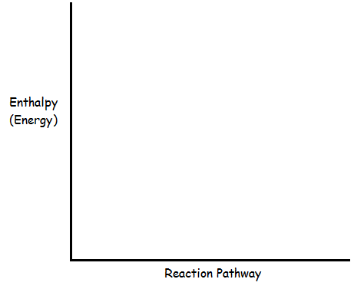

In an exothermic reaction the products have less energy than the reactants so heat energy is gained by the surroundings – there is a temperature rise. All neutralisation reactions are exothermic.

Endothermic Reactions
Reactions in which energy is absorbed from the surroundings are called endothermic reaction eg. the reaction between barium hydroxide pentahydrate and ammonium thiocynate..

1. Add 3 heaped spatula of powdered barium hydroxide to a boiling tube.
2. Measure and note the temperature of this solid.
3. Add 3 heaped spatula of ammonium thiocynate to the barium hydroxide and use the thermometer to mix the solids.
4. Measure and record the lowest temperature reached. Touch the boiling tube as well.
Results
Temperature of barium hydroxide _______ ºC
Temperature of reaction mixture _______ ºC

Temperature decrease ________ ºC

This is an ________________________ reaction.

The Pathway of an Endothermic Chemical Reaction

Complete the energy profile diagram below.

The energy contained in the products is _________ than the energy in the reactants. Energy in the form of ________ must have been _________ by the surroundings.

Enthalpy Change
The net energy change in a chemical reaction is normally referred to as the Enthalpy Change for the reaction and is given the symbol _______.

The enthalpy change is calculated using the equation: ΔH = H_{P} - H_{R}

ΔH = _________________________
H_{P} = __________________________
H_{R} = __________________________

It is impossible to measure the absolute enthalpy of a chemical however it is fairly easy to carry out a chemical reaction and measure the resulting enthalpy changes.

The enthalpy change for an exothermic reaction will have a ___________________ sign which must be shown eg. ΔH = -550kJ mol⁻¹

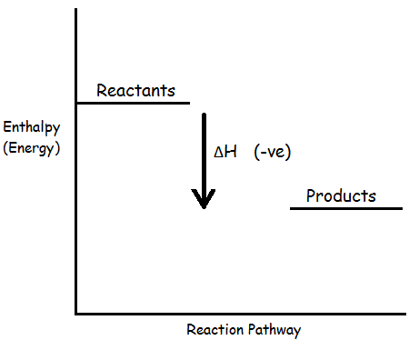

The enthalpy change for an endothermic reaction will have a _______________ sign eg.
ΔH = +230kJ mol⁻¹

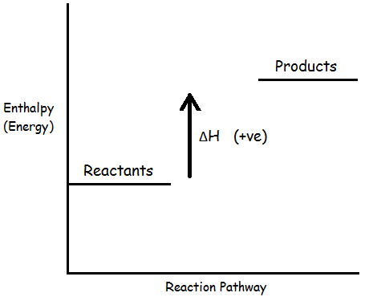

Activation energy barriers
In all chemical reactions, the Activation Energy (E_{A}) is the minimum kinetic energy required by colliding particles before a reaction will occur. Sometimes this energy can be supplied in the form of heat eg. when using a Bunsen burner.

The unit of Activation Energy is _______________.

This information can be added to the diagrams you completed earlier:

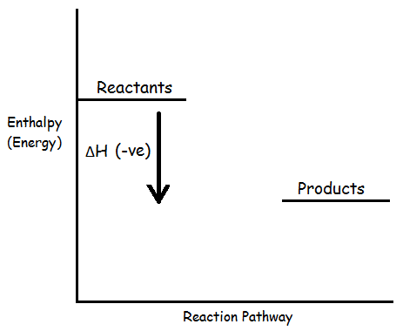

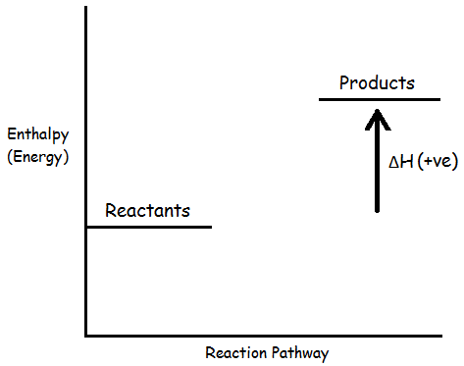
Catalysts and Activation Energy
Catalysts _____________ the rate of a chemical reaction by providing an alternative reaction pathway with a _____________ activation energy.

Add this information to the diagrams below:

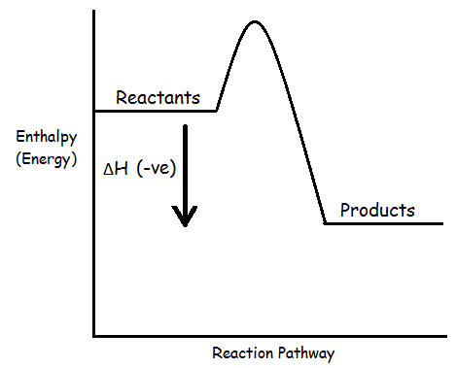

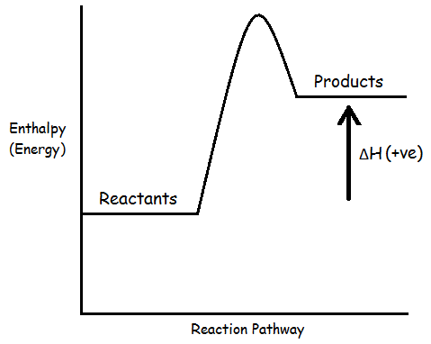
From both diagrams it is clear that using a catalyst ___________________________ on the overall enthalpy change.

Work through Potential Energy Examples
How Catalysts Work
This experiment below confirms that a catalyst can ‘take part’ in a reactions without being used up. Cobalt ions are used to catalyse the reaction between potassium sodium tartrate solution and hydrogen peroxide solution (a homogeneous catalyst). Cobalt ions will be regenerated.

Rochelle Salt Experiment
1. Add about 2cm³ potassium sodium tartrate solution to a boiling tube.
2. Add a few drops of cobalt (II) chloride solution until the mixture is a distinct pink colour.
3. Gently warm the mixture in a Bunsen flame – do not boil!!
4. Add a few drops of hydrogen peroxide to the heated mixture and note all colour changes.
5. Add a few more drops of hydrogen peroxide and note any further changes.
6. Draw diagrams here.

Co²⁺(aq) → Co³⁺(aq) → Co²⁺ (aq)

Catalysts can be briefly chemically changed during the reaction and regenerated at the end of the reaction ie. it is not used up:

Catalyst Mechanism

A catalyst provides an alternative pathway, with a _______________activation energy, for a chemical reaction. So less energy is needed to start the reaction.
Many catalysts are solid (heterogeneous) and simply provide a surface upon which the chemical reaction takes place at active sites. Add labels to the diagram below:

Heterogenous Catalysts
- Add 2cm³ hydrogen peroxide to a test tube and test for the production of oxygen.
- Add a pinch of Manganese(IV) Oxide powder.
- Note the difference in reaction rate and test for oxygen production.

Activated Complex

For successful collisions reactant particles must collide with energy ________, or greater than the activation energy of the reaction. In the example below the diatomic molecule XY decomposes into its elements as follows:

2XY(g) X₂ + Y₂

As the molecules collide, the X – Y bonds are weakened and partial bonds are set up between the X atoms and between the Y atoms – this is the activated complex.

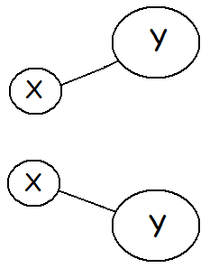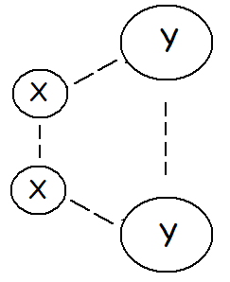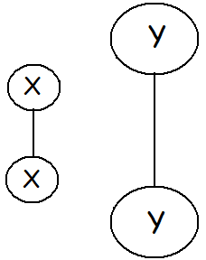
Reactants ‘Activated Complex’ Products

The activated complex is a very unstable arrangement of atoms at an intermediate stage between reactants and the products. This occurs at the top of the activation energy barrier and has a very high potential energy:

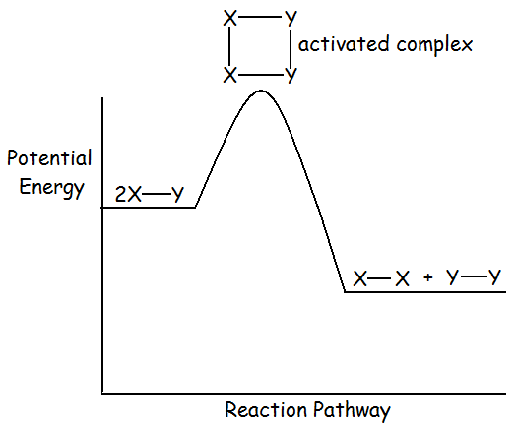

The activated complex has a fleeting existence; there is an equal chance that the complex could lose energy to reform the reactants or retain enough energy to become new products. An example of this is shown below in the reaction between ethene and bromine:

ENZYMES are BIOLOGICAL CATALYSTS. These are mentioned more in Unit 2.

- Molar Volume

When reactants and products are gaseous it is not always possible to measure masses of gases; they are too difficult to weigh. It is much easier to deal with volumes of gases. We still have to relate gas volumes to numbers of moles. So what is the volume of a mole of gas and does it depend on which gas?

We can answer this question by experiment or using information from the data book. First we will determine the volume of carbon dioxide by experiment.

Demo

1. Create a partial vacuum in a container, eg. a round bottom flask, using a vacuum pump.
2. Weigh the flask and note the mass. _______ g
3. Fill a gas syringe with 100cm³ of dry carbon dioxide gas from a cylinder.
4. Connect the container to the gas syringe as shown in the diagram.
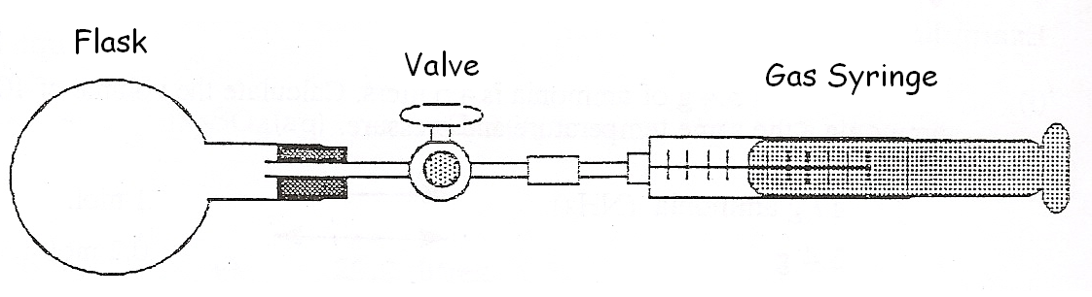

5. Open the valve of the container to allow CO₂ to pass from the gas syringe into the flask.
6. Assuming the delivery tube has a volume of 10 ml, a source of error in the experiment,
what volume of CO₂ moved into the flask? __________
7. Reweigh the flask and note the mass of the container plus CO₂.
8. What is the mass of CO₂ in the flask? ________
9. Now calculate the molar volume ie the volume of 1 mole of CO₂:

_____ g → ______ml

44 g → __________ ml (____ l)

So the molar volume of CO₂ = _________ l mol⁻¹.

Your teacher will give you more examples to try now.

Volume Calculations using Density Values
Molar volume can also be calculated from the density values given in your data book. Use your data book to put the letters d, m, and v in the triangle below. This information applies to gases at STP, ie. standard temperature and pressure (25^{O}C and 1 atm).

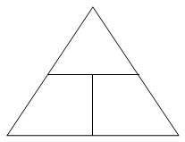

d = density (_________)

m = mass (____)

v = volume (_____)

Using the information in the triangle, write down the formula for each of the following calculations:

d = m = v =

Now, complete the table below and calculate the molar volume using the appropriate formula. Be careful with all of the units!!!!!!

Gas | Formula | Mass of 1 mol (g) | Density (gcm⁻³) | Molar volume (l mol⁻¹)
Hydrogen
Helium
Nitrogen
Oxygen
Chlorine

Complete the table below and calculate the molar volume using the appropriate formula. Be careful with all of the units!!!!!!

What conclusion can be reached regarding the molar volume of gases?

_____________________________________________________________________
_____________________________________________________________________
_____________________________________________________________________

What two variables must be kept constant when comparing the Molar Volumes of gases?

________________________ and _______________________.

Calculations involving Reacting Volumes Examples
1. Calculate the volume of hydrogen produced when 0.2g of zinc reacts with excess dilute sulphuric acid. Take the molar volume of hydrogen to be 22.2 l mol⁻¹.

Balanced Equation: Zn(s) + 2HCl(aq) → ZnCl₂(aq) + H₂(g)

Mol ratios: 1 mol 2 mol → 1 mol 1 mol

65.4g → 22.2 l

0.2g → x

Working:

Volume of H₂ = __________ l

= ________ cm³ (if less than 1 litre convert to cm³)

2. Calculate the volume of CO₂ produced by the complete combustion of 7g ethene. Take the molar volume of CO₂ to be 22.0 lmol⁻¹.

Balanced Equation:

Mol ratios:

_____g C₂H₄ → _____ l CO₂

____g → _____ l

Working:

Volume of CO₂ = __________ l

= ________
The examples above represent theoretical calculations: these can be verified experimentally by measuring the volume of CO₂ produced in a chemical reaction to determine the accuracy of the procedure.
Activity (1.21) Teacher Demonstration.

1. Accurately weigh out approximately 0.25g powdered CaCO₃. Mass = _________g
2. Add the CaCO₃ to a flask as shown in the diagram below.
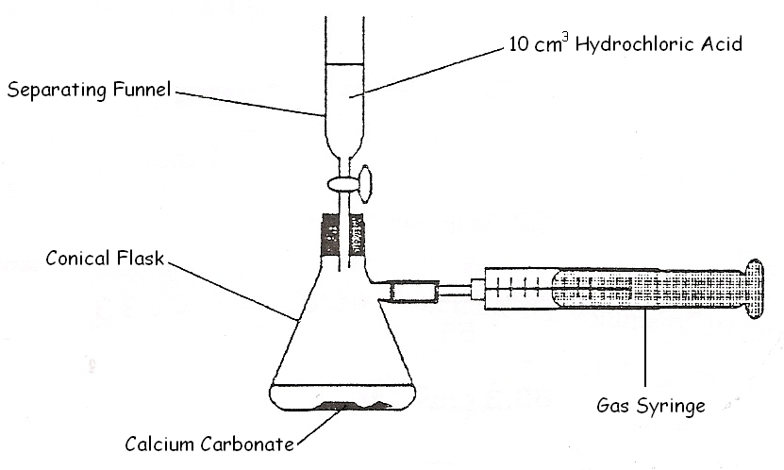
3. Open the tap to release 10cm³ of HCl 1 moll⁻¹ to the CaCO₃. The acid is in excess to
ensure that ________________________________________________________.
4. Note the volume of CO₂ collected in the syringe after deducting 10cm³ (equivalent to the
volume of HCl). Volume of CO₂ = ________ .

Now calculate the theoretical volume of CO₂ gas which should be produced from the balanced chemical reaction taking the molar volume of CO₂ to be 23.6 l:

Balanced Equation:

Mol ratios:

g CaCO₃ → 23.6 l CO₂

g → x l

Volume of CO₂ = __________ l

= ________

Your teacher may give you more examples to try now.
Calculations involving simple volumes of Gases
These are the easiest calculations you will ever do in Higher Chemistry but you must remember to ignore all solids and liquids in all calculations.

Also remember to read information in the question about the temperature of the reaction; if the temperature of the reaction is 100ºC or above, liquid water will become a gas so its volume must be included in your answer.

1 mole of any gas occupies the same volume same volume at STP eg if molar volume = 24l mol⁻¹:

1 mol of Ar = 24 litres Ar

1 mol of CO₂ = 24 litres CO₂

Balanced chemical equations give us the relative number of moles and/or volumes of reactant and product gases.

Example 1 N₂(g) + 3H₂(g) → 2NH₃(g)

1 mol 3 mol → 2 mol

1 vol 3 vol → 2 vol

24 l 72 l → 48 l

So 1 litre 3 litres → 2 litres

or 10 cm³ 30 cm³ → 20 cm³

or 1 cm³ 3 cm³ → 2 cm³

In the above reaction the volume of the product is half the volume of the reactants.

Example 2 C(s) + O₂(g) → CO₂(g)

1 mol 1 mol → 1 mol

1 mol 1 vol → 1 vol

So ignore 1 litre → 1 litre

or 10 cm³ → 10 cm³

or 1 cm³ → 1 cm³

In the above reaction the volume of the product is equal to the volume of the reactants.
Example 3
30 cm³ of methane is completely burned in 100 cm³ of oxygen. What is the volume and composition of the gas at the end of the experiment? (All volumes are measured at atmospheric pressure and room temperature)

Balanced Equation: CH₄(g) + 2O₂(g) → CO₂(g) + 2H₂O(l)

So 1 mol 2 mol → 1 mol ignore

or 1 vol 2 vol → 1 vol

30 cm³ 60 cm³ → 30 cm³
(100 cm³)*

*From 100 cm³ available O₂ only 60 cm³ are required therefore O₂ is in excess.

Since O₂ is in excess, all of the methane will be used up therefore the volume of the product(s) will depend on the volume of methane.

Volume and composition of gases at the end of the reaction:

30 cm³ CO₂ (produced)
40 cm³ O₂ (unreacted)
70 cm³ total

Your teacher may give you more examples to try now.

(6)Enthalpy and Hess’s Law

For industrial processes it is essential that chemists can predict the quantity of heat energy taken in or given out by chemical reactions. If reactions are endothermic, costs will be incurred in supplying heat energy in order to maintain the reaction rate. If reactions are exothermic, the heat released to the surroundings may need to be removed to stop the temperature rising.

Reactions in which energy is absorbed from the surroundings are called endothermic reaction. For example, citric acid C₆H₈O₇ and sodium bicarbonate, NaHCO_{3.}

Activity
1. Add 1 heaped spatula of ammonium nitrate, to a boiling tube.
2. Measure and note the temperature of this solid.
3. Add 1 heaped spatula of potassium hydroxide and use the thermometer to mix the solids.
4. Add 2cm³ water.
5. Measure and record the lowest temperature reached. Touch the boiling tube as well.

Draw diagrams to show the reaction pathways of an endothermic reaction then an exothermic reaction.

Your teacher will give you some revision questions to try now.
Enthalpy of Combustion (revision of N5) (Activity 1.12)
Chemical energy is also known as enthalpy. The enthalpy of combustion is the energy released when 1 mole of a substance is burned completely in _______________. This can be calculated from experimental results using specific heat capacity, mass and temperature using the formula E_{H} = c m ΔT.

E_{H} = c m ΔT

Specific heat capacity Mass of Temperature
of water water change of water
4.18kJ kg^{-1 O}C⁻¹ kg ^{O}C

We never actually burn 1 mole of any substance – we burn a small mass and scale up for ΔH at the end of the calculation.

The unit for enthalpy (ΔH) = kJ mol⁻¹

Is the enthalpy of combustion of an alcohol endo- or exothermic??

Enthalpy of Combustion Experiment

Aim:To calculate the enthalpy of combustion of given alcohols

Method:
1. Weigh a spirit burner containing an alcohol and note the mass.
2. Measure 100cm³ water and pour into a metal beaker.
3. Measure the temperature of the water and note this.
4. Heat up the water by about 10ºC using the spirit burner and note the final temperature.
5. Reweigh the spirit burner and note the final mass.
6. Calculate the Enthalpy of Combustion below.

Diagram:

Comparing Enthalpies of Combustion
Complete the table below for some fuels using your data booklet:

Alcohol | Formula | ΔHcomb/kJmol⁻¹
Methanol
Ethanol
Propan – 1 - ol
Butan - 1 - ol |  | -2673

There is a fairly constant difference between the values for any two successive members of the series because _______________________________________________________

What are the sources of error in your combustion experiment which would make the result differ from data book values?

Your teacher will give you some revision questions to try now.

Hess’s Law
It is not always possible to carry out experimental work and gather data to carry out calculations; for example, we cannot produce methane gas directly from its elements – this takes millions of years in nature.

Consider the reaction: A → B

This reaction could proceed directly from A to B. However, direct routes are often impractical or impossible, like the formation of methane mentioned above. Sometimes it is still possible to achieve the required products by an indirect route as show in the flow diagram below:
Route 1
A
B
ΔH1

Route 2
ΔH2
ΔH3
C
D
E
Route 3
ΔH4
ΔH5
ΔH6

The energy change for a chemical reaction is represented by the symbol ΔH:

where Δ = change
H = energy

The enthalpy change for Route 1 = ___________________________
The enthalpy change for Route 2 = ___________________________
The enthalpy change for Route 3 = ___________________________

The Law of Conservation of Energy states that “Energy can be neither created nor destroyed but is changed from one form into another”.

So the total enthalpy change for Routes 1, 2 and 3 will be ________________________ ie.

ΔH1 = ________________ = __________________

This application of the conservation of energy law to chemical reactions is known as Hess’s Law. It states that

“the enthalpy change in converting reactants into products is the same regardless of the route by which the reaction takes place.”
Hess’s Law – Experimental Proof
The procedures below should confirm Hess’s Law.

Solid potassium hydroxide can be converted into potassium chloride solution by two different routes:

Route 1 is the direct route in which solid potassium hydroxide is added directly to hydrochloric acid. Take the enthalpy change to be ΔH1.

KOH(s) + HCl(aq) → KCl(aq) + H2O(l) ΔH1

Method
1. Measure 25 cm³ of 1 mol l⁻¹ hydrochloric acid into a polystyrene cup and put in a beaker.
2. Measure and record the temperature of the acid.
3. Weigh out accurately about 1.2 g of potassium hydroxide into a polystyrene cup and record the exact mass. Make sure the mass of potassium hydroxide does not exceed 1.4 g.
4. Add the acid to the solid potassium hydroxide. Slowly and continuously stir the reaction mixture with the thermometer until all the solid reacts.
5. Measure and record the highest temperature reached by the reaction mixture.

Calculate ΔH1 starting with E_{H} = c m ΔT

Route 2 is the indirect route and involves two steps:

In Step 1 solid potassium hydroxide is dissolved in water. Take the enthalpy change to be ΔH2a.

KOH(s) + H₂O(l) → KOH(aq) ΔH2a

In Step 2 the potassium hydroxide solution is then added to hydrochloric acid to form potassium chloride solution:

KOH(aq) + HCl(aq) → KCl(aq) + H₂O(l) ΔH2b

Method - Part A
1. Measure 25 cm³ of water into a polystyrene cup.
2. Measure and record the temperature of the water.
3. Weigh out accurately about 1.2 g of potassium hydroxide into a polystyrene cup and record the exact mass. Make sure the mass of potassium hydroxide does not exceed 1.4 g.
4. Add the water to the potassium hydroxide. Slowly and continuously stir the reaction mixture with the thermometer until all the solid dissolves.
5. Measure and record the highest temperature reached by the solution.
6. Keep the solution you have just prepared but allow it to cool down for some time before proceeding to part B.

Method - Part B
1. Measure 25 cm³ of 1 mol l⁻¹ hydrochloric acid into a polystyrene cup.
2. Measure and record the temperature of the acid.
3. Measure and record the temperature of the potassium hydroxide solution you prepared in step A. Remember to calculate the average starting temperature.
4. Add the acid to the potassium hydroxide solution and stir the reaction mixture slowly and continuously with the thermometer.
5. Measure and record the highest temperature reached by the reaction mixture.

Now calculate ΔH2a then ΔH2b

According to Hess's Law the overall enthalpy change involved in converting solid potassium hydroxide into potassium chloride solution will be the same no matter whether the direct or indirect route is taken. Is this true within the limits of experimental error?

If so, then ΔH1 = ______ + ______

Calculation to prove Hess’s Law:

Applications of Hess’s Law
Hess’s Law can be used to calculate enthalpy changes which cannot be determined by experiment. For example, the formation of 1 mole of ethane from its elements:

Target Equation C(s) + H₂(g) → C₂H₆(g)
1 mole

This reaction takes millions of years so cannot be recreated in the lab. Instead, data book values for combustion and/or formation can be used to calculate the Enthalpy of Formation of 1 mole of ethane. The equation above is the target equation.

Step 1 Balance the target equation below:

C(s) + H₂(g) → C₂H₆(g)

Step 2 Write balanced equations for the enthalpy of combustion of carbon, hydrogen and ethane. Record data book enthalpy values for each:

C(s) + O₂(g) → CO₂(g) ΔHa =

H₂(g) + O₂(g) → H ₂O(l) ΔHb =

C₂H₆(g) + O₂(g) → CO₂(g) + H ₂O(l) ΔHc =

Step 3 Rewrite and/or reverse each equations, so that the elements carbon and hydrogen are on the left of the arrow and ethane is on the right of the arrow as they are in the target equation.
Reverse the sign of the ΔH value if an equation is reversed.
Multiply one or more of the equations to achieve the same number of moles as the target equation.

Step 4 Circle the correct number of moles of reactants and products which are the same as in the target equation.
Score through the remaining substances which should be the same on both sides of the arrows.

Step 5 Add the ΔH values to find the enthalpy of formation of 1 mole of ethane:

Hess’s Law calculations from diagrams.
Multiply components of the flow diagram to get the correct number of moles.
Add together equations for arrows pointing towards the correct product and subtract enthalpy values going the ‘wrong way’.
2C(s) + 3H₂(g)
2CO₂(g) + 3H₂O(l)
C₂H₆(g)

Route 1

+1.5O₂(g) 2CO₂(g)
Route 2
3ΔHb

2ΔHa
Route 2
+O₂(g) +O₂(g) ΔHa
Route 2
-ΔHc
-3.5O₂
Route 2

So the enthalpy change, ΔH, for the Route 1 reaction: 2C(s) + 3H₂ → C₂H₆(g)

ΔH = 2ΔHa + 3ΔHb - ΔHc

= 2(-394) + 3(-286) - (-1560)

= -788 - 858 + 1560

= -86 kJ mol⁻¹

ΔH = -86 kJ mol⁻¹

Your teacher will give you more examples to try now.

Bond Enthalpies
For a chemical reaction to occur bonds in reactants must be broken – this requires an energy input. When products are made energy is released. The energy required to break bonds is found in the data book. If these bonds are being made the sign is reversed. Calculations from data book values will determine whether a chemical reaction is endothermic or exothermic.

Example
Calculate the enthalpy change, using bond enthalpies, for the following reaction:

2HCl(g) → H₂(g) + Cl₂(g)

Bonds broken = 2 x HCl = 2 x 432 = 864kJ

Bonds made = 1 x H-H = 1 x (-436) = -436kJ
= 1 x Cl-Cl = 1 x (-243) = -243kJ

Enthalpy change = all bonds broken + all bonds made

ΔH = 864 – 436 – 243
= 185 kJmol⁻¹

Your teacher will give you more examples to try now.

- EQUILIBRIUM

Some chemical reactions are not reversible producing 100% products, for example in a neutralisation reaction a salt and water are produced with all of the acid and alkali used up:

NaOH(aq) + HCl(aq) → NaCl(aq) + H₂O(l)

In the chemical industry many of the profitable chemical reactions are reversible so reaction conditions have to be carefully manipulated to encourage the forward reaction to ensure maximum production.

Dehydration of hydrated cobalt chloride
Hydrated cobalt chloride is pink. Hydrated cobalt chloride is composed of crystals of cobalt chloride which contain water molecules of crystallisation - CoCl₂.6H₂O. Anhydrous cobalt chloride (no water molecules) is blue. This can be shown in the following simple experiment:

1. Add a spatula of hydrated cobalt chloride to a boiling tube.
2. Gently heat the crystals until the water molecules of crystallisation are driven off. Note the colour change.
3. Let the anhydrous cobalt cool for a few minutes then add a few drops of water. Note the colour change.

The conversion of hydrated cobalt chloride into anhydrous copper chloride is an example of reversible reaction. Write the equation for the dehydration of cobalt chloride (include the names of each of the substances and colour changes) below:

Thermal Decomposition of Ammonium Chloride
Another example of a reversible reaction is the thermal decomposition of ammonium chloride. This is not a particularly good example. Carry out the experiment to find out why not?

1. Add 1 cm depth ammonium chloride to a boiling tube.
2. Heat the solid gently and observe what is seen at the mouth of the boiling tube.

Ammonium chloride decomposes to form ammonia gas and hydrogen chloride gas. On cooling, the ammonia gas and hydrogen chloride gas react to reform ammonium chloride.

Write the equation for this reaction below (include the names of each of the substances and observed changes):

Although the thermal decomposition of ammonium chloride is another example of a reversible reaction, it is not a particularly good one; why not?

Dynamic Equilibrium
During reversible reactions the forward and reverse reactions occur at the same time during which the reaction mixture contains both reactants and products.

Consider the reversible reaction:
A + B
C + D

A + B are mixed together in a reaction vessel. The rate of the forward reaction will be relatively ________________.

As the reaction proceeds the concentrations of A and B will _________________ and so the rate of the _________________ reaction will decrease.

Also at the start, the products C + D will not be present in the reaction vessel so the rate of the ________________ reaction will be zero.

As the forward reaction proceeds ____ and ____ will be formed and their concentrations will gradually ________________. The rate of the _________________ reaction will therefore __________________.

If the conditions are not altered a balance point will be reached and the reaction will appear to have stopped. We say that the reaction at this point has reached dynamic equilibrium.

At equilibrium the rates of the forward and backward reactions are equal as shown in the diagram below:

Although the rate of the forward and reverse reactions are equal, the concentration of reactants and products is unlikely to be equal but they will remain constant!

If the concentrations of A and B are less than the concentrations of C and D, the equilibrium position lies to the right, ie on the product side:

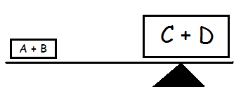

If the concentrations of A and B are greater than the concentrations of C and D, then we say the equilibrium position lies to the ____________, ie on the _______________ side:

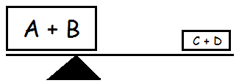

A dynamic equilibrium can be demonstrated simply using just water and basins.

Shifting the Position of Equilibrium
In industry, chemists and other scientists must maximise profits by ensuring that large scale chemical reactions result in the highest yield of products possible. In some cases yields are very small but the product is essential to our everyday lives. So chemists have devised methods to increase yields by shifting the position of the equilibrium by:

- Changing concentration
- Changing temperature
- Changing pressure

The effect of any change is summarised in Le Chatelier’s Principle: If a system at equilibrium is subject to any change, the system readjusts itself to counteract the applied change. In very simple terms:

If the concentration of reactants is increased, the equilibrium shifts to the right to reduce this concentration, so more products will be made.

If the concentration of products is reduced, the equilibrium shifts to the right to replace the products which have been removed.

If reactants are removed, the equilibrium shifts to the left to replace the reactants.

If products are added, the equilibrium shifts to the left to remove the products.

Changing Concentration
Set up the equilibrium shown in which all 3 ions are present together in the solution:
Fe³⁺(aq) + SCN⁻ (aq) FeSCN²⁺(aq)
Yellow Colourless Blood-red

As you do each step look at the equation above and think about what you expect to happen and try to explain this using the terms “concentration of reactants” and “concentration of products”.

Method
- Put 10cm³ water into a test tube then add iron (lll) chloride solution drop by drop until the solution becomes pale yellow.
2. Add potassium thiocyanate solution drop by drop to the iron (lll) chloride solution until a pale orange-brown solution is formed.
3. Divide this orange-brown solution into 4 equal volumes and keep one as a control to compare all results against.
4. To the 1st test tube add iron (lll) chloride solution drop by drop and compare the colour with the control then explain.
___________________________________________________________________

5. To the 2nd test tube add potassium thiocyanate solution drop by drop and compare the colour with the control then explain.
___________________________________________________________________

6. Add a spatulaful of ammonium chloride to the 3rd test tube and shake the mixture (ammonium chloride removes Fe³⁺ from the equilibrium mixture forming a complex with them). Now compare the colour with the control then explain.
___________________________________________________________________

Now complete the table which summarises everything you have just found out:

Change | Observations | Equilibrium Shift
Increased concentration of
Fe³⁺ ions (reactants)

Increased concentration of
SCN⁻ ions (___________)

Decreased concentration of
Fe³⁺ ions (_____________)

Explanation

Fe³⁺ (aq) + SCN⁻ (aq) FeSCN²⁺(aq)
Yellow Colourless Blood-red

Increasing the concentration of Fe³⁺ (aq) ions increases the rate of the forward reaction compared to the reverse reaction. The equilibrium shifts to the right. At this new equilibrium, the concentration of products is higher.

Decreasing the concentration of SCN⁻ (aq) ions decreases the rate of the forward reaction compared to the reverse reaction. The equilibrium shifts to the left. At this new equilibrium, the concentration of reactants is higher.

Further Example
Bromine molecules exist in equilibrium with bromide ions and bromate ions (BrO⁻):
Br₂ (l) + H₂O (l) 2H⁺ (aq) + Br⁻ (aq) + BrO⁻ (aq)
yellow colourless

Effect of adding NaOH(aq) -
-
-
- bleaching effect ____________

Effect of adding HCl(aq) -
-
-
- bleaching effect ____________

Changing Temperature
When copper is added to concentrated nitric acid a brown gas is produced. This gas is an equilibrium mixture of 2 gases: dinitrogen tetroxide, N₂O₄ (pale yellow) and nitrogen dioxide, NO₂ (brown). The equilibrium colour is a light brown colour which can be altered by changing temperature.
Endothermic
N₂O₄ (g) 2NO₂ (g)
Pale yellow Exothermic Brown

The forward reaction is endothermic, so ______ _____________ is needed to break the internal bonds of N₂O₄ to produce 2 molecules of NO₂.

The reverse reaction is exothermic, so the mixture must be ________________ __________ so that bonds are reformed to make N₂O₄ from 2 molecules of NO₂.

Predict the colour of the equilibrium mixture when heated _________________.
Predict the colour of the equilibrium mixture when cooled _________________.
Experiment to find out the effect of temperature on the equilibrium mixture:

Method
- Put 3 test tubes of the N₂O₄/NO₂ mixture in a test tube rack.
- At the same time, put one test tube in hot water, one in iced water and leave one in the rack.
- Compare the hot and cool test tubes with the room temperature mixture and note any colour differences.
Results
When heated the colour changes from ____________ to ____________ because the equilibrium shifts to the ___________.

When cooled the colour changes from ____________ to ____________ because the equilibrium shifts to the ___________.

Explanation
Since dinitrogen tetroxide (pale yellow) exists as single intact N₂O₄ molecules, _______________ bonds must be broken to break one molecule into 2 separate molecules of NO₂ – this requires an input of energy and is therefore an _________________ reaction.

Conversely 2 molecules of NO₂ (dark brown) must recombine to produce 1 molecule of N₂O₄, ie new bonds are made - this ________________ energy and is therefore an _________________ reaction.

Note
Increasing the temperature increases the rate of both forward and reverse reactions but the reaction which needs heat will be favoured ie the endothermic reaction.
The converse is true when the temperature is decreased.
Changing Pressure
A change in pressure can only affect an equilibrium in which gases are present.

The pressure exerted by a gas is caused by moving gas particles colliding with the walls of the containing vessel. An increase in the number of particles in the vessel will cause an increase in pressure ie more ‘hits’; similarly a decrease in the number of particles causes a decrease in pressure, the size of the container is the same.

Remember that 1 mol of a gas occupies a volume (space) of ______ litres.
2 mol of a gas occupies a volume (space) of ______ litres.

Air on the outside of the vessel also exerts a pressure. What happens if we increase the pressure on the container?

Consider the Equilibrium:
N₂O₄ (g) 2NO₂ (g)
pale yellow brown

Mole Ratio:
Volume Ratio:
Which side of the equilibrium needs occupies a larger volume? _____________
To achieve this, should the pressure be increased or decreased? _______________

Pressure Demonstration

1. What happens to the colour of the gas immediately the plunger is pushed in?
_____________________________________________________________________

2. What happens to the colour after about 10 seconds?
_____________________________________________________________________

3. What happens to the colour of the gas immediately the plunger is released?
_____________________________________________________________________

4. What happens to the colour after about 10 seconds?
_____________________________________________________________________

Explanation
Pushing the plunger in causes an _______________ in pressure. This reduces the _____________ inside the syringe so the equilibrium will shift to reduce the volume of the gases in the syringe ie. shift to the ____________.

Releasing the plunger causes a _______________ in pressure. This ________________ the volume inside the syringe so the equilibrium will shift to increase the volume of gases in the syringe ie. shift to the ____________.

A reaction involving gas(es) can only reach equilibrium if it is carried out in a closed container.

Think about a bottle of coke or lemonade which has had the cap removed. Discuss in a group and report your findings to your teacher.

Summary of Equilibrium Changes

 | Change Applied | Effect on Equilibrium Position
Concentration | (a) Addition of a reactant  or  Removal of a product  (b) Addition of a product  or  Removal of a reactant | Shifts to the __________  Shifts to the __________
Temperature | (a) Increase  (b) Decrease | Favours the ____________ reaction  Favours the ____________ reaction
Pressure | (a) Increase  (b) Decrease | Favours the side with the __________ no. of mols or volume or no. of particles  Favours the side with the __________ no. of mols or volume or no. of particles

What about the effect of a catalyst on the position of an equilibrium?

The Effect of a Catalyst
A catalyst _______________ the Activation Energy E_{A} of a chemical reaction so __________ the rate of the reaction.

In a reversible reaction a catalyst lowers the Activation Energy of both the forward and reverse reactions and therefore also increases the rate of both the forward and reverse reactions as shown below:
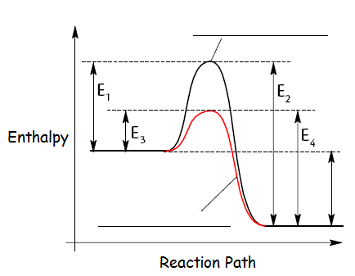

Label the 2 lines in the Enthalpy diagram then complete the table below:

Reaction | Activation Energy
Forward – with catalyst
Forward – without catalyst
Backward - with catalyst
Backward - without catalyst

What does the unlabelled double-headed arrow represent? _______________________

Add a line to the graph to show the effect of an inhibitor. An inhibitor ________________ the Activation Energy.

Note
Catalysts lower the Activation Energy of the forward and reverse reactions by the same energy value so reaction rates of the forward and reverse reactions increase to the same extent.

Therefore, a catalyst does not alter the position of equilibrium but does speed up the rate of attainment of equilibrium.
Equilibrium in Industry
One of the most important chemicals in our everyday lives is Ammonia. This is produce by the Haber Process. Write a balanced chemical equation for its production below:

___________________________________________________ ΔH = -91kJmol⁻¹

Conditions for maximum production of ammonia with minimum costs are carefully considered by chemical engineers. The Haber process is never allowed to reach equilibrium:

Concentration
- Ammonia gas is condensed and piped away reducing the concentration of __________
- The rate of the forward reaction _____________
- Equilibrium shifts to the ___________
- Unreacted N₂ and H₂ are recycled increasing the concentration of _____________
- Equilibrium shifts to the ___________
- The rate of the forward reaction _____________

Temperature
- The Haber process is an ___________________ reaction
- An increase in temperature favours the _____________ reaction compared to the _________________ reaction
- Equilibrium shifts to the _____________
- In industry a moderate temperature of 400ºC is used

Pressure
- In the Haber process there are _____ vols of reactants and ______ vols of products
- An increase in pressure favours the _____________ reaction compared to the _________________ reaction to _______________ the volume
- Equilibrium shifts to the ___________
- In industry a moderate pressure of 200 atmospheres is used since the equipment needed to maintain ultra-high pressures would be ________________

Catalyst
- An ___________ catalyst is used in the Haber process
- The catalyst is in the form of hollow cylinders which increases the _____________ __________ making a more effective catalyst
- The catalyst ______________ the Activation Energy of both the Forward and Reverse reactions which then _________________ the rate of both the Forward and Reverse reactions
- This allows the Haber process to be carried out at a ___________ temperature

As a result of all of these considerations and compromises the production of ammonia becomes more _________________.

- Chromatography

Many analytical techniques are used in chemistry and other science disciplines to identify, quantify or check the purity of chemicals. Analytical techniques are commonly used for quality control in many industrial processes such as the pharmaceutical industry and in the world of sports (blood and urine samples of athletes are frequently analysed to ensure that competitors are not using banned substances to improve their performance)

You have already carried out many of these techniques already such as: volumetric and redox titrations and paper chromatography. There are many other types of chromatography.

Chromatography

Chromatography separates compounds according to their relative affinity for the mobile phase and the stationary phase. In simple paper chromatography, the mobile phase is water (or another solvent such as alcohol or propanone) and the stationary phase is the paper. Separation of components usually depends on the size of molecules and their polarity; this may affect how soluble they are in the mobile phase.

Different colours of water soluble ink will move at different rates carried by water.

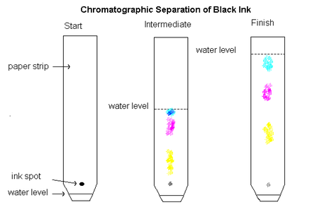

In the above example, the blue ink has least affinity for the paper and most affinity for the solvent and has also the smallest mass. We can also deduce that the blue molecules must be the most polar since water is polar. If a non-polar solvent such as hexane had been used, an order of polarity could be deduced: blue is most non-polar and yellow the least.

Depending on the type of chromatography used, the identity of a component can be indicated either by the distance it has travelled or by the time it has taken to travel through the apparatus (retention time).

Results can sometimes be presented graphically showing an indication of the quantity of substance present on the y-axis and retention time on the x-axis.
Gas Liquid Chromatography
In modern labs, chromatography is usually carried out using more sophisticated apparatus. Techniques such as gas-liquid chromatography (GLC) and high performance liquid chromatography (HPLC)
Both techniques use the same principal as paper chromatography as the mobile phase is a gas such as helium and the stationary phase is a high boiling point liquid adsorbed onto a solid.
How fast a particular compound travels through the machine will depend on how much of its time is spent moving with the gas as opposed to being attached to the liquid in some way.
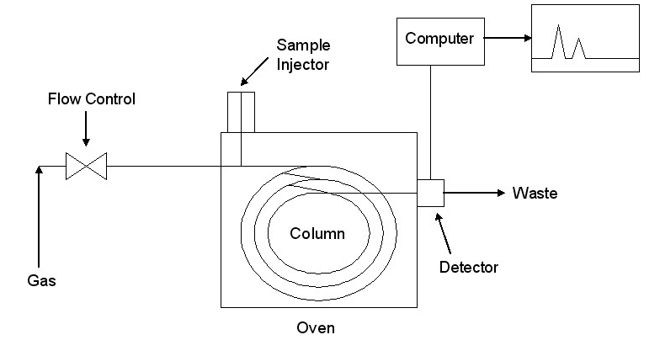

Results of GLC Analyses

Example 1
The injected sample contained a mixture of propane, pentane and heptane, all non-polar molecules:
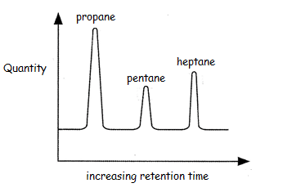
- None of the molecules are p______ so retention time is totally dependent on the m_____ of each molecule

- The heavier the molecule the _______ the retention time so heptane takes longer to travel through the column.

- The highest peak occurs with _______ so this is the most a________ molecule in the mixture.

Example 2

The injected sample contained a mixture of 2 substances, one ethanol and another of a similar molecular mass.
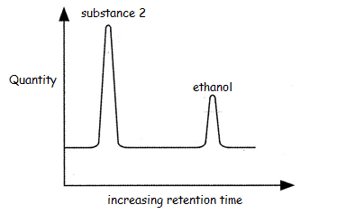

- Both molecules have a similar m_______ so the different retention times are due to the p_________ of the molecules.

- Substance 2 is more a__________ – it has the highest peak

- Substance 2 is the non-polar hydrocarbon ____________

Example 3

The injected sample in Graph X contained a mixture of 3 known substances A, B and C. The sample in Graph Y was compared to the standard substances for identification.

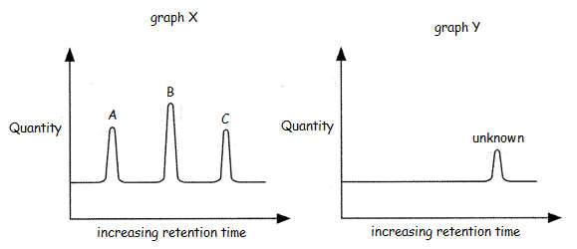

- The retention time for the unknown is the same as sample ___

- Comparing peak heights the quantity of the unknown appears to be half of that in the standard preparation

Retention Factor
Substances can also be identified by calculation of the Retention Factor (R_{f}) where:

R_{f} = distance travelled by the spot/sample
distance travelled by the solvent

Since the distances are measured in the same units, they will cancel to give an answer as a simple ratio.

The bigger the R_{f} value, the further the spot/sample has moved.

(9)Volumetric Analysis
Volumetric Analysis is a technique to calculate the quantity or concentration of a reacting compound.

A solution of an accurately known concentration is known a _____________ solution.
Note down the steps required to make a standard solution below.

Redox Titrations

Volumetric Analysis can also be applied to a redox reaction. For example, the concentration of a reducing agent can be determined using a solution of a suitable oxidising agent of known concentration.

Example 1

MnO₄⁻ + 8H⁺ + 5e- Mn²⁺ + 4H₂O
Fe²⁺ Fe³⁺ + e-

Redox: _________________________________________________

18cm³ of 0.0005molL-1 acidified potassium permanganate was added to a 10cm³
iron (II) sulphate solution.

Using the redox equation you have made, calculate the concentration of the iron (ii) sulphate solution.

Your teacher will provide you with more examples
(10)Researching Chemistry

Examine the practical techniques used in Higher Chemistry and the methods used to analyse results from experiments.

Separating Techniques:

Name:
Used to separate:
Name:
Used to separate:
Name:
Used to separate:

Methods of collecting a gas:

Analysis of data

You should be familiar with calculating averages, eliminating rogue data (usually from titrations), drawing graphs and interpreting graphs as it important that the data we use is meaningful and correct.

Your teacher may give you examples to work through

