Name ___________________________________ Class _____________



CfE Higher Chemistry

Unit 1 - Chemical Changes and Structures

Key Area page

(1) Structure and Bonding in the first 20 elements 1 - 8

(2) Trends in the Periodic Table 9 - 13

(3) Bonding in compounds 14 - 37

(4) Oxidising and Reducing Agents 38 - 45

- Structure and Bonding in the first 20 elements

The Modern Periodic Table
The Russian chemist, Dimitri Mendeleev (1839 – 1907), arranged elements in order of increasing atomic __________. He also produced columns of elements with similar _______________ properties. Mendeleev left gaps for elements yet to be ______________. He made predictions about undiscovered elements; he correctly predicted the properties of __________________, an element he called eka-silicon. He predicted this would fill the gap between ________________ and ______________ in the Periodic Table.

The current Periodic Table is based on the one drawn by Mendeleev. Each element in a period has an atomic _______________ which increases by one across the period. This is due to the difference in the number of ________________ in the nucleus of successive elements.

Elements in the same group have the same number of _______________ in the outer energy level (shell): alkali metals have ____ electron in the outer energy level; halogens have ____ electrons in the outer energy level. ______________ gases are a group of unreactive gases. Their lack of reactivity is due to these elements all have _________ outer energy levels.

Structure of the first 20 elements (you must learn this)
Elements with atomic numbers 1 – 20 in the Periodic Table can be grouped according to their bonding and structure:
- Metallic Bonding

Metals consist of a giant lattice of positively charged ‘ions’ and delocalised outer electrons. Delocalised electrons allow metals to _____________ __________________. The attraction of ‘ions’ and outer electrons is called metallic bonding. Metallic bonds are very strong: 80 – 600kJmol⁻¹. This means that up to 600kJ of energy is needed to break 1 mol of metallic bonds. The greater the number of delocalised electrons, the greater the charge on the metal ‘ions’, the greater the strength of the metallic bonds.

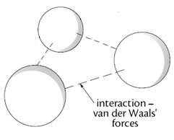
D. Monatomic Gases

Monatomic gases exist as separate or discrete atoms.

Noble gases can be cooled down to the liquid or solid state.
___________________________hold atoms together when cooled down.

All atoms or molecules are held together by weak interatomic or intermolecular forces called van der Waals forces.

There are several categories of van der Waals forces which we will find out about in this section of work.

C (i) Covalent Molecular Gases

The simplest of are the diatomic elements eg. hydrogen, nitrogen, oxygen and the halogens:

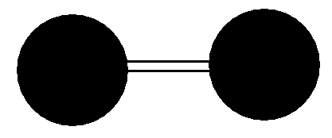

Each molecule contains 2 atoms held together by very strong covalent bonds. Covalent bonds are approximately as strong as either metallic or ionic bonds.
Hydrogen, nitrogen, oxygen, fluorine and chlorine are all gases. These gases can be cooled to form liquids and solids.
Melting and boiling point information in the data book confirm that bromine is a liquid and iodine a solid.

What holds all of these diatomic molecules together in the liquid and solid states naturally or when cooled? _______________________

C (ii) Covalent Molecular Solids
Phosphorus is made up of discrete molecules although it is a solid. Each molecule consists of 4 phosphorus atoms held together by covalent bonds. All of the P₄ molecules are held together by weak van der Waals forces of attraction.

Sulfur is made up of discrete molecules even though it is a solid. Each molecule consists of 8 sulfur atoms held together by covalent bonds.

All of the S₈ molecules are held together by weak van der Waals forces of attraction.

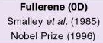
Buckminster fullerenes, known as fullerenes, were discovered in 1985.

Fullerenes are discrete molecules containing 60 or more atoms held together by covalent bonds.

Molecules are held together by weak van der Waals forces of attraction.

C₆₀ molecules have a spherical shape
(almost identical to a football). Other shapes such as nanotubes
can also be made.
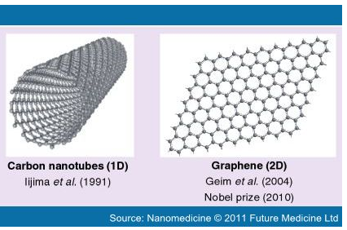
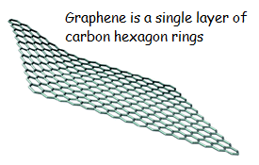

Fullerenes have higher melting points than sulfur or phosphorus. Explain this:
_____________________________________________________________________
_____________________________________________________________________
____________________________________________________________________

Which has a higher melting point sulfur or phosphorus? __________________
_____________________________________________________________________
_____________________________________________________________________
_____________________________________________________________________

B Covalent Network Solids
B₁₂ molecular units interlock to form a 3 dimensional covalent network structure. All bonds are covalent.

Although the word molecule appears in this description you must learn that this is not the same as the discrete molecular solids on the previous page.
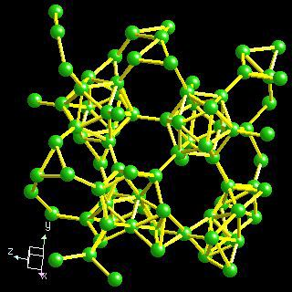

Carbon exists naturally in two forms, diamond and graphite, both are covalent networks:
In diamond, each carbon atom is at the centre of a regular tetrahedron and is surrounded by four other carbon atoms at the corners of the tetrahedron.
All bonds are covalent; therefore diamond has very ________ mp and bp.
Diamond is the hardest substance known.

In graphite, each carbon atom forms covalent bonds with only 3 neighbouring carbon atoms to form layers (like graphene).
The layers are held together by weak van der Waals forces of attraction.
Every time we use a pencil, layers of graphite slide on to the paper.
Graphite is also use as a lubricant between moving metal parts.

Silicon has a 3-dimensional covalent network lattice structure similar to diamond so also has a very ______ mp.

There are 3 polymorphs (different forms) of carbon. They are:

______________________ and __________________________(covalent networks)

______________________ (discrete molecules)

Summary:

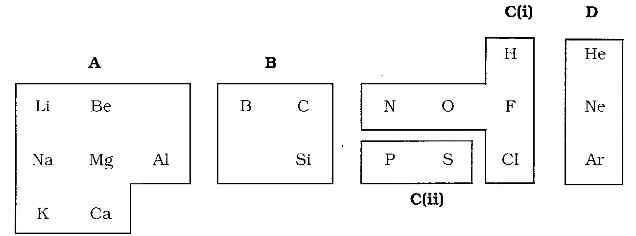

Complete the following summary table using the appropriate type of bonding and structure.

A
B
C(i)
C(ii)
D

Explain why covalent network elements have high melting and boiling points.

_____________________________________________________________________
_____________________________________________________________________
_____________________________________________________________________

Explain why discrete monatomic elements and discrete molecules have low melting and boiling points.

_____________________________________________________________________
_____________________________________________________________________
_____________________________________________________________________

Explain why graphite conducts electricity and why diamond does not.

_____________________________________________________________________
_____________________________________________________________________
_____________________________________________________________________

Explain why diamond is hard and why graphite is not.

_____________________________________________________________________
_____________________________________________________________________
_____________________________________________________________________

How does the structure of diamond and graphite differ from fullerenes?

_____________________________________________________________________
_____________________________________________________________________
_____________________________________________________________________

- Trends in the Periodic Table

Data book information shows that there are trends in the periodic table across a period and down a group. We will examine:

Covalent Radius (used as a measure of atomic size)
Electronegativity
Ionisation energy

Covalent Radius
The covalent radius is about half the distance between the two nuclei of covalently bonded atoms of an element.
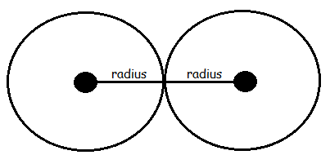

Trend
Across a period covalent radius ___________________.
Down a group covalent radius _____________________.

Explanations
Across a period the number of protons ________________ which increases _______________ charge. Increased nuclear charge attracts electrons closer to the nucleus so covalent radius ___________________.

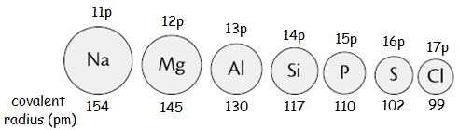

Down a group the number of filled electron shells increases. So even though there are more protons and an increased nuclear charge, the shielding effect of the inner electron shells prevents outer electrons being strongly attracted to the nucleus.

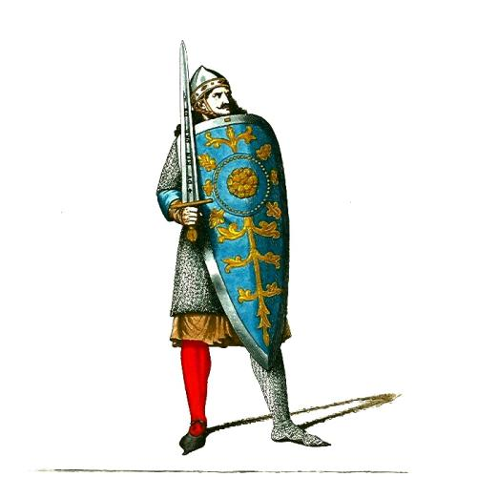
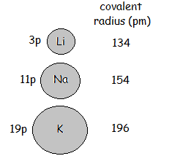

- Draw a graph of atomic size vs atomic number for elements 3 to 20
- Draw dotted lines between atomic number 9 and 11 then between 17 and 19
- Draw lines to ‘join the remaining dots’
- Add a page number and file your graph here!
- Use your graph to answer the following questions stating the trend and the explanation.

How does the atomic size of lithium compare with that of fluorine? Explain.
__________________________________________________________________________________________________________________________________________
__________________________________________________________________________________________________________________________________________

How does the atomic size of lithium compare with that of caesium? Explain
__________________________________________________________________________________________________________________________________________
__________________________________________________________________________________________________________________________________________

Atomic size is a periodic property, ie. a pattern is repeated across each period with elements in the same groups occurring at the same positions on the ‘waves’.

Electronegativity

Electronegativity is a measure of an atom’s nuclear attraction for the electrons in a covalent bond. Electronegativity values (Pauling Scale) are found in the data book.

Trend
Across a period electronegativity values ___________________.
Down a group electronegativity values ___________________.

Explanations
Across a period the number of protons ________________ which increases _______________ charge. Increased nuclear charge attracts/pulls bonding electrons closer to the nucleus.

Down a group the number of filled electron shells increases. So even though there are more protons and an increased nuclear charge, the shielding effect of the inner electron shells prevents bonding electrons being strongly attracted to the nucleus.

- Draw a graph of electronegativity values against atomic number for the first twenty elements
- Use a dotted line between the noble gases and the elements in Group 1
- ‘Join dots’ for elements in same period
- Add a page number and file your graph here
- Use your graph to complete the following statements

Electronegativity can be described as a periodic property because ___________________
__________________________________________________________________________________________________________________________________________
_____________________________________________________________________

There are no electronegativity values for the noble gases because ____________________
__________________________________________________________________________________________________________________________________________
_____________________________________________________________________

Ionisation energy
The first ionisation energy of an element is the energy required to remove one electron from each atom in one mole of gaseous atoms of the element. Energy is needed for this process so It is an _______thermic process:

K (g) → K⁺ (g) + e⁻ ΔH = + 425kJ mol⁻¹

Trend
Across a period first ionisation energy values ___________________.
Down a group first ionisation energy values ___________________.

Explanations
Across a period the number of protons ________________ which increases _______________ charge. Increased nuclear charge attracts outer electrons closer to the nucleus so more energy is needed to remove an outer electron.

Down a group the number of filled electron shells increases. So even though there are more protons and an increased nuclear charge, the shielding effect of the inner electron shells prevents strong attraction of outer electrons so less energy is needed to remove an outer electron.

2nd, 3rd and 4th Ionisation energies
More than one electron can be removed from an atom. The 2nd ionisation energy of an element is the energy required to remove one electron from each ion in one mole of gaseous ions of the element. It is also an endothermic process.

The calculation below shows the total energy input required to convert one mole of Magnesium atoms into one mole of Magnesium Mg²⁺ ions:

Calculate the energy required to convert one mole of Al atoms into one mole of Al³⁺ ions:

Why is the 2nd ionisation energy of sodium so much bigger than the first ionisation energy?
_______________________________________________________________________________________________________________________________________________________________________________________________________________

- Draw a graph of first ionisation energy against atomic number for the first twenty elements
- Use a dotted line between the noble gases and the elements in Group 1
- ‘Join dots’ for elements in same period
- Add a page number and file your graph here
- Use your graph to complete the following statements

The first ionisation energy can be described as a periodic property because _________
__________________________________________________________________________________________________________________________________________

The first ionisation energy of chlorine is _________________ than that of sodium because _______________________________________________________________________________________________________________________________________________________________________________________________________________

The first ionisation energy of fluorine is _________________ than that of iodine because _______________________________________________________________________________________________________________________________________________________________________________________________________________

The trends, and reasons for the trends, for covalent radius, electronegativity values and ionisation energies are very similar.

(3)Bonding in Compounds

Ionic Compounds

Compounds formed between metals and non-metals are usually, but not always ionic. Ionic compounds are formed if metal and non-metal atoms have large differences in electronegativity values. All ionic compounds are solid at room temperature so must have high melting points. If not, the compounds are covalent. Melting and boiling point information needs to be examined to determine the type of bonding.

Metals react with non-metals to form ionic compounds. A transfer of electrons from one atom to another results in metal atoms ____________ electrons to form an ion with a ____________________ charge. Non – metal atoms ____________ electrons to form an ion with a ____________________ charge. These ions have the stable electron arrangement of a noble gas. Oppositely charged ions ________________ each other. This electrostatic attraction is known as an ______________ bond.

All ionic compounds have ________ melting points therefore are all _________ at room temperature. All conduct electricity when _____________ or in _________________ because ions are _________________. They do not conduct in the ______________ state.

Ionic bonds are very strong: up to 600 kJmol⁻¹.This means that up to 600kJ of energy is needed to break 1 mol of ionic bonds. The strength of ionic bonds depends on the charge on each ion; the higher the charge, the stronger the bond.

In a crystal lattice eg. NaCl (or Na⁺Cl⁻), the formula tells us the ratio of ions present in the lattice.

The formula does not tell us the actual number of ions present.

Covalent Bonds - revision
Non – metal atoms join together by covalent bonds. A covalent bond is a ______________ _________ ___ ______________. Each atom has the stable electron arrangement of a ______________ gas.

Draw diagrams of methane and ammonia molecules on the next page to show:

- Overlapping electron clouds
- Shape of the molecules

Methane overlapping clouds Ammonia overlapping clouds

Methane shape Ammonia shape

Discrete Molecules
Discrete molecules have very strong internal covalent bonds but only weak intermolecular bonds. Use mp and bp information from the data book to complete the table.

Name of | Formula | Structure | State at Room Temperature
Carbon dioxide
Ammonia

Hydrogen oxide

Hydrogen chloride

Hexane

Discrete covalent molecular compounds are either _____________ or ___________.

Solid Covalent Network Compounds
Silicon dioxide (_________) commonly known as sand contains only _________________ bonds in its network so has a very high ________ and a structure similar to diamond:
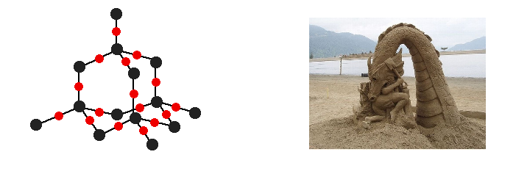
Silicon carbide (________) commonly known as carborundum contains only _______________ bonds in its network so has a very high ________ .

Both silicon dioxide and silicon carbide are very hard. Silicon carbide is used as an abrasive for cutting and grinding the surfaces of tools.

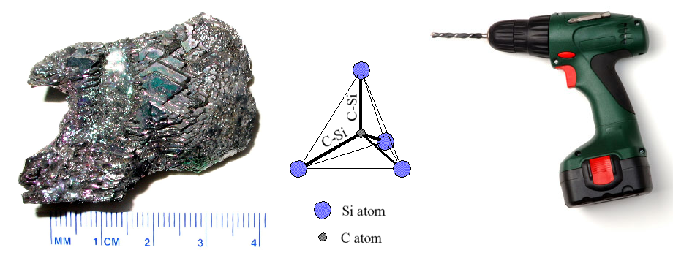

Summary table for covalent structures

Type of Bonding and Structure | Properties
Covalent network solids | _________________ melting points  _______________ of electricity (carbon in the form of ________________ is the exception)
Covalent molecular solids | _________________ melting points  _______________ of electricity
Covalent molecular gases and liquids | _________________ melting points  _______________ of electricity
Types of Covalent Bonds

Covalent bonds are very strong: up to 600kJmol⁻¹. This means that up to 600kJ of energy is needed to break 1 mol of covalent bonds. Electrons in the covalent bonds are held in place by the force of attraction of positive nuclei. Show these attractions in the diagram below:
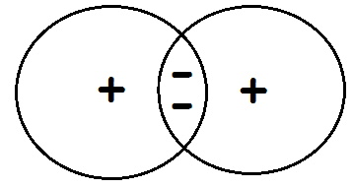

Electronegativity values tell us which nucleus has a greater attraction for bonding electrons. If there are 2 atoms of the same element, electronegativity values are equal. In a molecule of hydrogen, each atom has an electronegativity value of ______ so each nucleus has an equal attraction for the bonding electrons. This means electrons are more likely to be found in the centre of the bond. This is a pure covalent bond. All diatomic elements have pure covalent bonds.
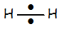
Electrons are constantly moving (wobbling) so they could be found nearer the nucleus of one of the atoms than the other. This means that one end of the molecule could become negatively charged while the other end becomes positive. This is known as a dipole.
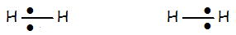
Electrons return to the centre to become pure covalent again before moving to the opposite end of the molecule so the polarity changes again. All diatomic elements contain pure covalent bonds which exhibit temporary dipoles. This is shown using the Greek symbol delta which means very small ________.

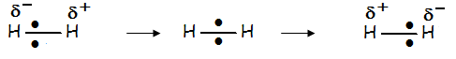
Show the changes in polarity for the elements chlorine and iodine the spaces below:

Comparing the electronegativity values of atoms in diatomic molecules made up of different elements, produces a different outcome. For example Hydrogen Iodide:

electronegativity values: hydrogen = ______ iodine = _______

The nucleus of ______________ has a greater attraction for bonding electrons than ________________. Electrons will always be nearer ______________. This results in a polar covalent bond because each end (pole) has a different charge. The molecule has a permanent dipole:

Now repeat the process for Hydrogen Chloride and then Hydrogen Fluoride:

Which of the 3 molecules above has the most polar covalent bond? ___________________
Why? ________________________________________________________________

Summary so Far
Pure covalent bonds occur in diatomic elements because the atoms have identical electronegativity values. Each nucleus has the same attraction for bonding electrons. Temporary dipoles occur. Polar covalent bonds occur in diatomic molecules because the atoms have different electronegativity values. One nucleus has a greater attraction for bonding electrons. Permanent dipoles occur due to unequal distribution of internal charges.

The Bonding Continuum
Pure covalent bonding and ionic bonding are two extremes of polar bonding. Atoms with identical electronegativity values (pure covalent bonds) are found at one end of the spectrum. Further along polar bonds with increasing differences in electronegativity values are found. Ions are formed if the difference in electronegativity is such that the atom with the greatest attraction for bonding electrons completely pulls electron(s) away from the other atom. Ionic bonding appears at the furthest point in the continuum.

The bonding continuum:

Polar and Non-Polar Molecules
Molecules can contain bonds with permanent dipoles (polar covalent bonds) but overall the molecule can be non-polar.

It is the symmetry of the charge distribution which determines the overall polarity of the molecule.

Methane and Butane
Each bond in the methane molecule is ___________ because the electronegativity values are _____________________.

The bonds are all arranged so that the charge is symmetrical around the carbon atom. The outside of the molecule is uniformly ⁻ in all directions so overall the molecule is non-polar.

Hydrocarbon molecules, like butane, are usually non-polar because the spatial arrangement of charge is distributed symmetrically.

Build a molecule of butane to see this for yourself.

C
H
H
H
H

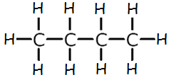

By substituting just one atom in each of these molecules, we immediately affect the distribution of charge around the carbon atom.

The carbon – halogen bond is very polar because of the difference in electronegativity values.

Each molecule has lost its symmetry of charge so the molecule is polar.

Show the charges using the delta symbol to see how each molecule is affected and build the molecule too!

C
H
F
H
H

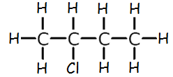

- Look at the molecules below and put the correct charge beside each delta symbol.

- Decide whether each molecule is polar or non-polar by looking at the symmetry of charge.

- Build the molecules to help you ‘see’ this.

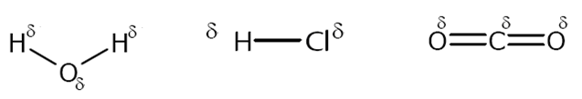

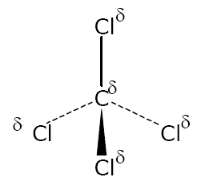
_________________ ________________ _________________

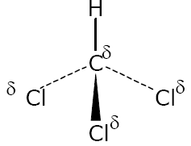
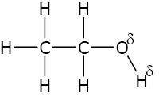

__________________ __________________ _________________

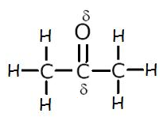

_____________________

Experiment – Polarity of Molecules

The polar nature of some molecules can be ‘seen’ in an electric field by holding a ‘charged’ plastic rod close to a stream of the test liquid.

Aim: To predict the polarity of molecules

Method:
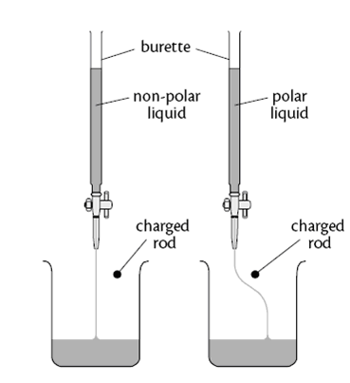

Results:

Name of Liquid | Polarity prediction | Actual Polarity
Water
Hexane
ethanol
propanone

- Draw the structures of the molecules to explain their polarity

Conclusion : Deflection will occur only if the molecules in the liquid are ______________.

Make sure you could reproduce the diagram in an exam and explain it.

Intermolecular Forces
Theoretically every element can exist in 3 states: solid, liquid and gas. When cooled sufficiently elements such as the noble gases, diatomic chlorine gas and liquid bromine can become liquid and/or solid.

What holds these atoms or molecules together in the liquid and solid states?

Intermolecular forces between atoms or molecules are known as van der Waals forces of attraction. There are different types of van der Waals forces depending on the electronegativity values of atoms being attracted but they all occur in exactly the same way.

London dispersion forces
Noble gases are m________________. When cooled atoms lose energy and move closer together. All electrons are constantly moving so atoms can exhibit temporary dipoles.

Add partial charge delta symbols to the noble gas atoms below to show this:

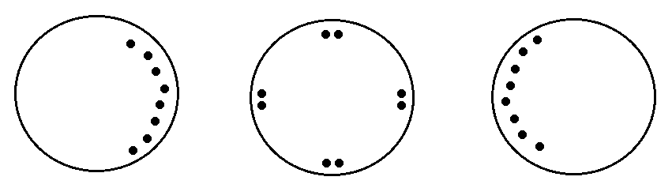

Only the outer electrons are shown to illustrate temporary dipoles but all electrons can move to contribute to the strength of the partial charge. The more electrons in the atom the stronger the partial charge.

Opposite charges attract to form van der Waals forces called London dispersion forces, which hold the atoms together in the liquid or solid state:

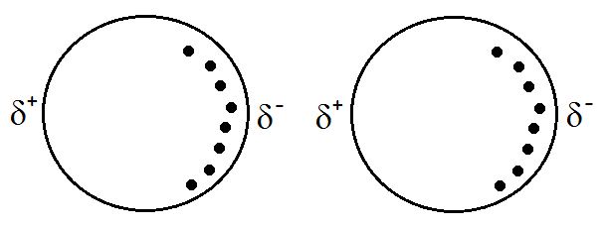
Since electrons are constantly moving the London dispersion forces will continually break and reform as poles change charge.

animations - Welcome to the NQ Higher Sciences website

London dispersion forces are extremely weak and easy to break but their strength varies depending on the number of electrons in the atom. The more electrons in the atom the stronger the partial charge – so the London dispersion forces will be stronger.

Melting and boiling point information confirms this. In general, the melting and boiling points of noble gases are ________________________ so the London dispersion forces holding the atoms together are very __________ and __________ to break.

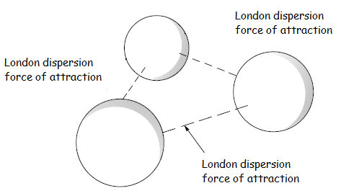

London dispersions forces
The simplest are the diatomic elements, hydrogen, nitrogen, oxygen and the halogens. Each molecule contains only 2 atoms with the same electronegativity value resulting in __________________ dipoles within the molecules (intramolecular). Weak London dispersion forces hold molecules together in the liquid and solid states when cooled sufficiently.

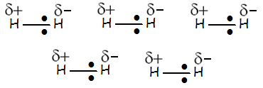
Draw dotted lines to show all possible London dispersion forces between molecules forces

Hydrogen, nitrogen, oxygen, fluorine and chlorine are gases at RT but bromine is a liquid and iodine is a solid.

Why does the state change as we move down the halogens? (Open ended question?)
_____________________________________________________________________________________________________________________________________________________________________________________________________________________________________________________________________________________________________________________________________________________________________________________________________________________________
Which molecular element should have the highest melting point sulphur or phosphorus and why?______________________________________________________________________________________________________________________________________________________________________________________________________________________________________________________________________________________________________________________________________________________

London dispersion forces are extremely weak and easy to break but their strength depends on the number of electrons in the molecule. The more electrons in the molecule the stronger the partial charges – so the stronger the London dispersion forces and harder to break.

Permanent dipole/permanent dipole interactions
Additional van der Waals forces occur along with the London dispersion forces when molecules are polar. Permanent dipoles occur when atoms have different electronegativity values – the bigger the difference the stronger the partial charges.

The additional intermolecular forces which occur are known as permanent dipole/permanent dipole interactions. These are stronger than London dispersion forces. animations - Welcome to the NQ Higher Sciences website
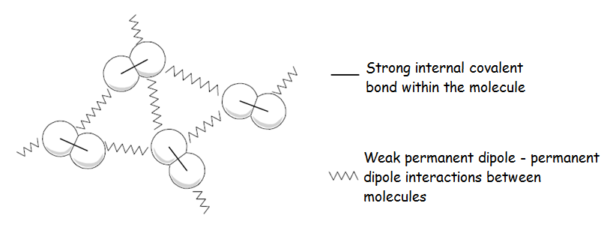
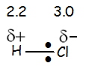

The permanent dipoles in hydrogen chloride can be shown as follows:

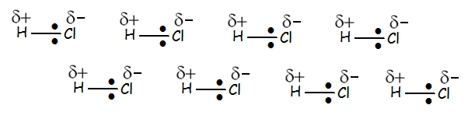

Draw dotted lines to show all possible permanent dipole/permanent dipole intermolecular forces

The permanent dipoles in hydrogen iodide can be shown as follows:

Draw dotted lines to show all possible permanent dipole/permanent dipole intermolecular forces in HI

Which compound has the higher melting point, HCl or HI ? _________________________

Why? _________________________________________________________________
_____________________________________________________________________

Hydrogen bonding
Hydrogen bonding is the strongest of all the van der Waals forces. They also co-exist with London dispersion forces. Hydrogen bonding is stronger example of permanent dipole/permanent dipole interactions. Hydrogen bonds only occur when a hydrogen atom in the molecule is covalently joined to one of the three most electronegative elements: nitrogen, oxygen or fluorine. animations - Welcome to the NQ Higher Sciences website

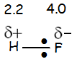

The permanent dipoles in hydrogen fluoride can be shown as follows:

Draw dotted lines to show all possible hydrogen bonds HF.
More Examples
The permanent dipoles in nitrogen hydride can be shown as follows:

Draw dotted lines to show all possible hydrogen bonds NH₃.

The permanent dipoles in hydrogen oxide can be shown as follows:

Draw dotted lines to show all possible hydrogen bonds H₂O.

Melting and boiling point information confirms the difference in strength between permanent dipole-permanent dipole intermolecular forces and hydrogen bonds.

Hydrogen chloride and hydrogen iodide have __________________ mps and bps than hydrogen fluoride, nitrogen hydride and hydrogen oxide so hydrogen bonds are ________________ than _________________________________________________.

Chemical Analysis Problem Solving Question
In the liquid state Hydrogen Fluoride can form long hydrogen bonded chains:
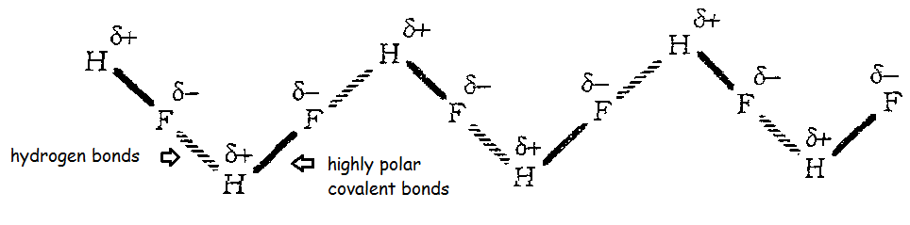

The large electronegativity difference between these atoms make hydrogen bonds much stronger than other intermolecular forces (hydrogen bond energy is up to about 50 kJmol⁻¹)
Hydrogen bonding can lead to some unusual results when analysing substances:

Mass spectrometer information on hydrogen fluoride produces 3 different masses, 20, 40 and 60 for this substance. Explain this!! (Open ended question?)

_________________________________________________________________________________________________________________________________________________________________________________________________________________________________________________________________________________________________________________________________________________________

Summary of Bonding

Substance | Type of Bonding | Bond Strength/kJmol⁻¹
Noble gases | London dispersion forces (temporary) | Very weak/up to 20
Molecular elements | London dispersion forces (temporary | Very weak/up to 20
Molecular compounds | Permanent dipole-permanent dipole | Weak/up to 30
Molecular compound containing hydrogen + NOF element | Hydrogen bonds | Quite weak/up to 50
Covalent network | Covalent | Very strong/up to 600
Crystal lattice | Ionic | Very strong/ up to 600
Metal | Metallic | Very strong/ up to 600
The Importance of Electronegativity Values and the Bonding Continuum
The larger the difference in electronegativity values the more ionic character but melting and boiling point data must also be examined.

The smaller the difference in electronegativity values the more likely a substance is polar covalent (less ionic character).

If electronegativity values are the same the substance is considered to be pure covalent (least/no ionic character).

Boiling Point of Polar and Non-polar compounds.
Now complete the table below for compounds and answer the questions which follow:

Substance | Molecular Mass | No of electrons | bp ºC | Polar/non-polar
Butane
( )
Methanal
(HCOH)
Ethane
( )
Propanone
(CH₃COCH₃)

Notice that compounds with similar masses have similar number of electrons so the strength of L_______________________________ should be similar.

How does the melting and boiling points of polar substances compare with the melting and boiling points of non-polar substances?
_____________________________________________________________________
_____________________________________________________________________

Why is it important to compare only the melting and boiling points of substances with similar numbers of electrons?
_____________________________________________________________________
_____________________________________________________________________

Boiling Points in Hydrides
Study the graph below. Label each line with the appropriate group number then answer the questions which follow:

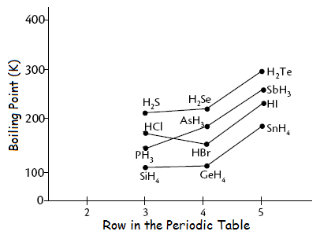

What is the General trend in boiling points for the groups in the graph?
_____________________________________________________________________
Explain this trend.

_____________________________________________________________________
_____________________________________________________________________
- Now add the boiling points for the Row 2 hydrides using the information below and your data book.
Convert boiling points in ^{O}C to the Kelvin scale by adding 273.

NH₃: bp = -33 ^{O}C

HF: bp = 19.5 ^{O}C

- Which hydride has no effect on the general trend? ______________________________

- Explain why the Row 2 hydrides alter the general trend in boiling points but the hydride you identified above does not.
_____________________________________________________________________
_____________________________________________________________________

The Most Important Hydride in the World ever!!!!!

Water is a liquid (at STP). This is only possible because of hydrogen bonding between water molecules. Hydrogen bonds are responsible for the unusually high boiling point of water.

If there were no hydrogen bonds between molecules water would exist only as a gas!!!! Think about this!!!! Oceans and rivers would never exist and it would never rain!!!!

Humans, and other living organisms, would not exist if water was a gas because chemical reactions in our body could not take place – an aqueous environment is needed for reactions!

When gases and liquids cool down, their atoms/molecules lose energy and move closer together ie. density increases. This is also true for water molecules then something weird happens when the temperature decreases to 4ºC.

Density increases as the temperature falls to 4ºC.

Molecules move closer together.

Between 4ºC and 0ºC the molecules start moving apart again – water expands when it becomes ice!! This is because hydrogen bonds move to achieve a perfect regular crystal structure (ice crystals). www.youtube.com/watch?v=lkl5cbfqFRM

Between 4ºC and 0ºC water molecules move apart to achieve a perfect regular open crystal structure.

Because ice is less dense than water (lighter) ponds and rivers freeze from the surface downwards. This creates a layer of insulation which prevents ice forming underneath. If ice was denser than water (heavier), ice would form from the bottom upwards so ponds, rivers etc. would freeze completely, killing all fish and aquatic plants!!

Viscosity
Intermolecular bonds between molecules in liquids are continually being broken and reformed so molecules move past each other easily. Hydrogen bonds are the strongest of the intermolecular forces so water molecules do not move past each other as easily. Water is more viscous.

The viscosity of different liquids can be compared by timing how long it takes a ball bearing to fall through the liquid or a bubble to move up. The more hydrogen bonds between molecules the more viscous the liquid.

*The Bubble/ Ball Bearing Experiment (Exam question)*

Aim: To investigate viscosity of substances

Method:

Results:

Name of  molecule | Structure | Number of H Bonds | Time for bubble to rise (s) or ball bearing to fall (s)

Conclusion
The greater the number of H bonds, the _____________ the ball bearing (or bubble) moves through the liquid, the _________ viscous the liquid

Miscibility/ Solubility
Small polar molecules like ethanol are soluble (miscible) in water because their polar O–H functional groups can form hydrogen bonds with the water molecules. Larger molecules, like butanol, are relatively insoluble (immiscible) even though they have the same polar group, because the larger non-polar hydrocarbon chain is the dominant influence.

Ethanoic acid has a formula mass of 60. Mass spectrometer information sometimes produces a formula mass of 120 because in solution hydrogen bonds form with water molecules and also hold the molecules together in pairs (intramolecular forces):

Small molecules like hydrogen chloride, HCl (g), and hydrogen iodide, HI (g), are highly ___________ because of their different _____________________ values, ie.

H---Cl H---I

These molecules are so soluble in water that when new ‘bonds’ are formed between the negative poles of the H-I molecules and the positive poles of the water molecules enough energy is released to break the bonds between the hydrogen and iodine atoms.

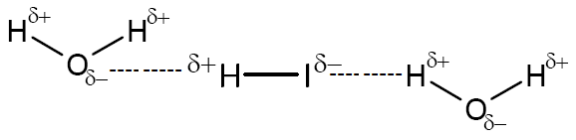

Hydrogen iodide molecules completely ionise in water to form an ______________ solution:

H⁺(aq) + I⁻(aq)

Similarly other _______________ covalent substances eg the other hydrogen halides HF(g), HCl(g), HBr(g), and pure concentrated sulphuric acid H₂SO₄(l), oleic acid, all completely ionise in water to form acidic solutions.

Non-polar Molecules

Polar compounds do not usually dissolve in non-polar solvents, like benzene or tetrachloromethane. Benzene molecules are held together by weak London dispersion forces between molecules in the liquid. This is also true for tetrachloromethane.

If these interactions were broken they would not release enough energy to break the stronger permanent dipole-permanent dipole interactions between polar molecules like water.

Non polar iodine is soluble in tetrachloromethane because sufficient energy is released when iodine molecules make new London dispersion forces with tetrachloromethane molecules to break the existing London dispersion forces between tetrachloromethane molecules.

Solubility of Ionic Compounds
Some ionic compounds dissolve in water. The slightly negative ends of water molecules are attracted to the __________________ ions in the crystal lattice while the positive ends are attracted to the __________________ ions in the crystal lattice.

Formation of new electrostatic attractions between ions and water molecules releases enough energy to overcome ionic bonds in the crystal lattice as shown in the diagram below:

Polar water molecules

Ionic crystal lattice Hydrated Ions

Non-polar substances are the best solvents for other non-polar substances.

Polar substances are the best solvents for other polar substances and for ionic compounds.

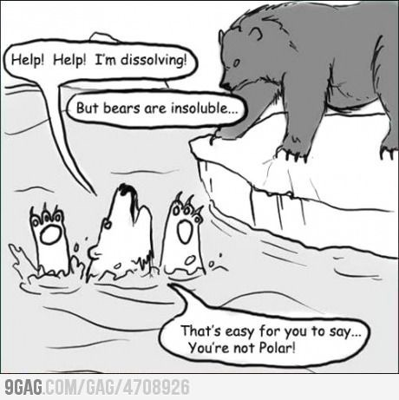
Substances containing O-H groups are best dissolved in water or solvents which also contain O-H groups.

In summary like dissolves like.

(P.s It is not enough to say ‘like dissolves like’ in the exam – you should be able to explain why!)

(5) Oxidising and Reducing Agents

Oxidation and Reduction – Revision

Oxidation is ________________________ Reduction is __________________________

Use your data book to write the following ion-electron equation oxidation reactions:

1. Aluminium atoms ______________________________________________
2. Iodide ions in solution ______________________________________________
3. Sulphite ions in solution ______________________________________________

Now do the same for the following reduction reactions:

4. Magnesium ions in solution _________________________________________
5. Liquid bromine _________________________________________
6. Permanganate ions in solution _________________________________________

There are further organic oxidation and reduction reactions in the Nature’s Chemistry unit in which:

Oxidation is ____________________________________________________________
Reduction is ____________________________________________________________

Oxidation and reduction reactions from the data book can be combined, when the number of electrons in each have been balanced, to form redox reactions. Data book equations can also be combined with organic equations.

Carry out the following experiments one at a time completing all equations as you go along. Your teacher may give you some examples to try.

These are test tube reactions: use 2cm³ of each solution and a small piece of solid and observe carefully:

1. The reaction of Zinc in 2cm³ Copper Sulphate solution. A __________________ reaction.

Oxidation: →

Reduction: →
_____________________________________________
Redox:
_____________________________________________

2. The reaction of Potassium Permanganate solution and Potassium Iodide solution.

Oxidation: →

Reduction: →

Oxidation: →

Reduction:
→ .

Redox: _____________________________________________

Now try these redox reactions without doing the experiments:

3. The reaction of Magnesium with dilute Sulphuric Acid (aka a _______________ reaction)

Oxidation: Mg(s) → Mg²⁺(aq) + 2e⁻

Reduction: 2H⁺(aq) + 2e⁻ → H₂(g) .

_____________________________________________

4. The reaction of Aluminium and dilute Hydrochloric Acid

Oxidation: Al(s) → Al³⁺(aq) + 3e⁻

Reduction: 2H⁺(aq) + 2e⁻ → H₂(g)

Oxidation: →

Reduction: → .

_____________________________________________

5. The reaction of Acidified Potassium Permanganate in solution with Iron(III) Sulphate and dilute Hydrochloric Acid.

Oxidation: Fe²⁺(aq) → Fe³⁺(aq) + e⁻

Reduction: MnO₄⁻(aq) +8H⁺ + 5e⁻ → Mn²⁺(aq) + 4H₂O(l)

Oxidation: →

Reduction: → .

_____________________________________________

Oxidising and Reducing Agents

An oxidising agent is a substance which promotes the oxidation of another substance by accepting electrons from it. Therefore the oxidising agent itself is reduced.

A reducing agent is a substance which promotes the reduction of another substance by donating electrons to it. Therefore the reducing agent itself is oxidised.

Identify the oxidising and reducing agents in the 6 equations you have just completed.

1. The oxidising agent is _________. The reducing agent is __________.

2. The oxidising agent is _________. The reducing agent is __________.

3. The oxidising agent is _________. The reducing agent is __________.

4. The oxidising agent is _________. The reducing agent is __________.

5. The oxidising agent is _________. The reducing agent is __________.

Your teacher may give you some more examples to try.

Everyday Uses of Oxidising Agents
- Hydrogen Peroxide: bleaching hair and clothes; teeth whitening; antiseptic*
- Potassium permanganate: antiseptic* used in fish ponds and aquaria
- Sulfur dioxide: bleaching

*Antiseptic kills bacteria, fungi and inactivates viruses (viruses are non-living packages of DNA or RNA so cannot be ‘killed’)

In summary:

ADD THIS TO YOUR DATA BOOKLET

Further Oxidation and Reduction Reactions

Some oxidation and reduction reactions contain additional steps to achieve the final equation.
These steps are:

1. Write the formula for the reactant and the product:

Cr₂O₇²⁻(aq) → Cr³⁺ (aq)

2. Balance the chromium

Cr₂O₇²⁻(aq) → 2Cr³⁺ (aq)

3. Balance the oxygen by introducing the extra oxygen needed in the form of water molecules

Cr₂O₇²⁻(aq) → 2Cr³⁺ (aq) + 7H₂O(l)

4. Balance the hydrogen by introducing the extra hydrogen in the form of hydrogen ions

Cr₂O₇²⁻(aq) + 14H+(aq) → 2Cr³⁺ (aq) + 7H₂O(l)

5. The electrical charge on each side of the equation must be balanced.

The nett charge on the LHS of the equation is 12+ ie. [(-2) + (+14)].

The nett charge on the RHS of the equation is 6+ ie. [2 x (+3)].

Balance the charge by adding 6 mol electrons to the LHS of the equation.

Cr₂O₇²⁻(aq) + 14H⁺(aq) + 6e⁻ → 2Cr³⁺ (aq) + 7H₂O(l)

Redox reactions of this kind only take place in acidic solutions – the H⁺(aq) ions are needed as a reactant.

Your teacher may give you some more examples to try.

Volumetric and Redox Titrations
The volume of an acid needed to neutralise a fixed volume of an alkali (a soluble base) can be found using a suitable indicator to determine the end-point of the reaction.

Note that the volume of an alkali needed to neutralise an acid can also be determined using this technique.

Balanced chemical equations can be used to calculate the concentration or volume of a solution following a titration.

Example 1

What volume of Sodium Hydroxide solution, concentration 2moll⁻¹, is needed to neutralise 50cm³ of Nitric Acid solution, concentration 1moll⁻¹?

Your teacher may give you some more examples to try.

Redox Titrations
Like volumetric titrations, Redox Titrations can be used to calculate the concentration of a reactant, or mass etc.

You have already successfully carried out a redox titration in your Vitamin C investigation.

Example:

A 25cm³ solution of Vitamin C was prepared and titrated against 0.031moll⁻¹ iodine solution using starch indicator. The average titre of iodine was 17.6 cm³

Calculate the concentration of Vitamin C

Balanced redox equation:

C₆H₈O₆ + I₂ C₆H₆O₆ + 2H⁺
^{(Vitamin C)}

1. Calculate the number of moles of iodine:

2. From the redox equation, calculate the number of moles of Vitamin C:

3. Calculate the concentration of Vitamin C

Self-Indicating Reactions

Certain titrations do not require the use of an indicator. This is because they are self –indicating.

i.e The Redox Titration between potassium permanganate and iron (II) sulphate.

The purple colour of permanganate appears once all the iron (II) ions have reacted.

