Airdrie Academy
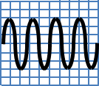
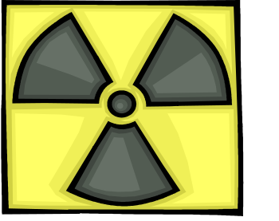
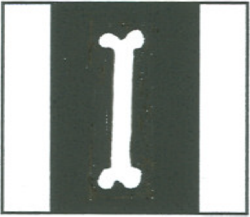
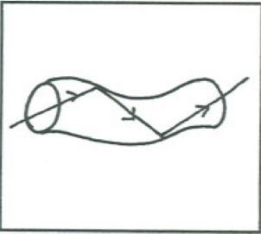
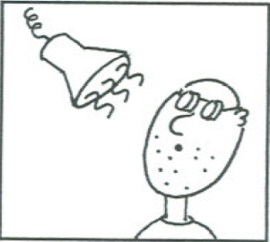
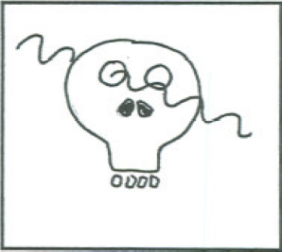

f
v
λ
f
N
t
v
d
t

N4 Physics

Waves & Radiation
Homework
Homework 1 - Sound

1 What do waves transmit? __________________ (1)

2. (a) What is sound produced by? ___________________ (1)

(b) What do we call the number of vibrations per second? ______________ (1)

3. A teacher puts a bell inside a large jar, and switches it on. His
pupils can hear the bell clearly. The teacher then pumps the air
out of the jar using a vacuum pump.
(a) What would happen to the sound? _____________________ (1)

(b) Why would this happen? ____________________________ (1)

4. In each of the following situations, state whether the sound is travelling through solid, liquid or gas.
(a) Native Americans could hear horses a long way off by putting

their ear to the ground. _____________ (1)

(b) Dolphins use high-pitched sounds to locate fish for food. ______________ (1)

(c) A teacher shouts at you for not attempting your homework! ____________ (1)

5. In the Star Wars films (and similar), there are many loud explosions as
spaceships blow up. In reality, you wouldn't hear the explosions at all.

Why not? ______________________________________________________ (2)

Total 10 marks
Homework 2 - The Speed of Sound

1. A pupil reads about an experiment that can be carried out to measure the speed of sound in air. When the hammer hits the metal block a sound wave is produced. The computer is used to measure the time it takes for the sound wave to travel from one microphone to the other. The computer will display the time taken for the sound to travel this distance or it can be used to calculate the speed of sound directly.



interface
computer
2.00 m
second microphone

first microphone
hammer

The pupil carried out the experiment, and the time measured was 0.0059 seconds.

(a) Find the speed of sound using the pupil's results.

(2)

(b) How could the accuracy of the result be improved? ______________________

_____________________________________________________________________ (1)

(c) The pupil found that the speed was not calculated properly when the experiment

was done close to a wall. Suggest a reason for this. ______________________ (1)

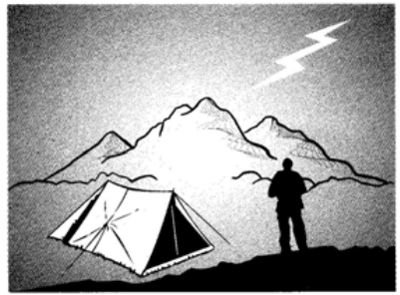
2. A camper sees a flash of lightning, and then hears the thunder 4 seconds later.
(a) Why is there a delay between the camper seeing the lightning and hearing the thunder?

__________________________________________ (1)

__________________________________________ (1)

(b) Find the distance between the camper and the lightning?

(PTO)
(2)
3. A person at the mouth of a cave shouts, and hears an echo from the back wall of
the cave. Using a stopwatch, she times 1.2 second between shouting and hearing
the echo. Calculate how far away the back wall of the cave is. Take the speed of
sound to be 340 m/s. (3)

Total 10 marks

Homework 3 - Types of Wave

1. For The waves below state which is a longitudinal and which is a transverse wave and how the energy travels in each. (4)
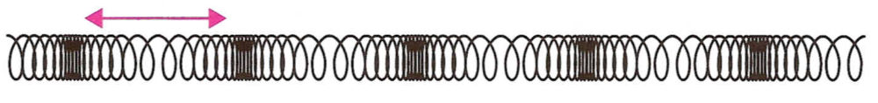

A(i) _________________(ii) _________________________________

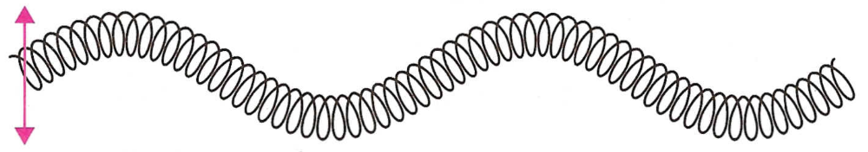

B (i)___________________(ii) _________________________________

2. State whether the following waves are transverse or longitudinal waves. (4)

(a) Light waves _______________ (b)Sound waves _____________________

(c) Water waves ______________ (d) Radio waves _____________________

3. Look at the diagram below
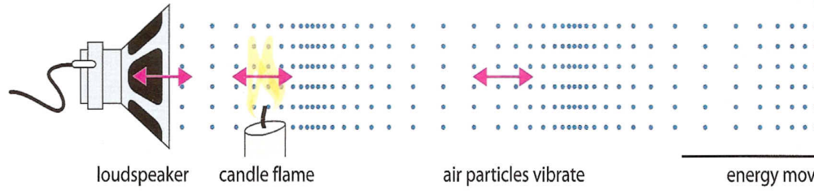

(a) In what direction do the air particles vibrate (horizontal or vertical)? ____________

(b) In what direction does the energy move along? _________________________

_____________________________________________________________________ (2)

Total 10 marks
Homework 4 - Wave Words

1. The questions below refer to this diagram.
8 m
3 m

(a) Calculate the wavelength of the waves shown.

(2)

(b) What is the amplitude of these waves? _____________ (1)

2. 24 water waves pass a point in 6 seconds. What is the frequency of the waves? (2)

3. If a sound wave has a frequency of 20Hz. What does this tell you about the number

of waves produced each second? ______________________________________ (1)

4. Complete the table below by filling in the symbol, unit and definition for the terms. (4)
Wave Term |  | Symbol | Unit | Definition
frequency
wavelength
speed
amplitude
Total 10 marks

Total 10 marks

Homework 5 – Waves

1. A wave of wavelength 2 m travels 60 m in 12 seconds.
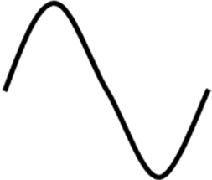
60 m
2 m

(a) What is the speed of the wave? (2)

(b) How many waves would be produced in 12 seconds? (1)

(c) What is the frequency of the wave? (1)

2. Complete this sentence:

The higher the pitch of a sound the ____________________ the frequency. (1)

3. Look at these oscilloscope traces for signals A and B:

A B

(a) Which signal would produce the loudest sound? __________ (1)

(b) Which signal would have the highest frequency? __________ (1)

(PTO)

4. Look at this diagram of a sound signal pattern displayed on an oscilloscope.
Describe what would happen to its frequency and amplitude in each of the following situations:

(a) The volume of the sound is increased. (1)

Frequency ___________________ and amplitude _________________________________ .
(b) The pitch is increased, but the volume is not changed. (1)

Frequency ___________________ and amplitude _________________________________ .

(c) The pitch is decreased and the volume is decreased. (1)
Frequency ___________________ and amplitude _________________________________ .

Total 10 marks

Homework 6 - Sound Level

1. What unit are sound levels measured in? _____________________ (1)

2 Coplete the following table using the figures below to show the typical
sound level of each sound:
30 dB, 60 dB, 70 dB, 90 dB, 120 dB
Typical Sound | Sound Level (db)
Busy street
Inside a boiler factory
Heavy truck passing by
Whisper
Normal conversation at 1 metre

(5)

3. Give two examples of noise pollution. ______________________________ and

________________________________________________________________ (2)

4. (a) In what way could a noisy factory cause harm to its workers? ____________

_____________________________________________________________________ (1)

(b) How could the workers avoid this harm? (without quitting their jobs!) (1)

_______________________________________________________ Total 10 marks

Homework 7 - Sonar and Ultrasound

- State the lowest and the highest frequency that humans can hear.
(2)
Lowest _____________________ and highest ________________________

- What do we call frequencies above the limits of human hearing? (1)
__________________________________-

- 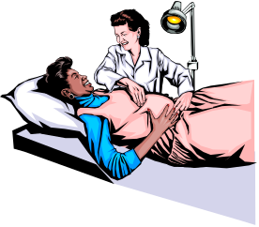Describe how ultrasound can be used to examine a foetus in its mother’s womb. (3)
__________________________________________________

__________________________________________________

__________________________________________________

___________________________________________________

- State one other use of ultrasound in medicine. ___________________________ (1)

___________________________________________________________________

- Describe how SONAR is used by fishermen at sea. (3)
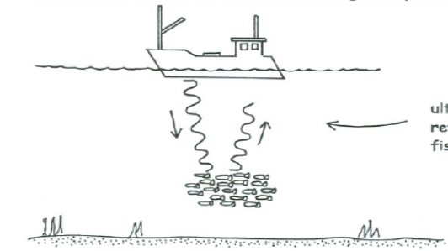


______________________________________________________________________

______________________________________________________________________

______________________________________________________________________

_________________________________________________________ Total 10 marks

Homework 8 - Speed, Frequency and Wavelength

1. The questions below refer to this diagram.
12 m

(a) Calculate the wavelength of the waves shown. (1)

(b) If the waves took 5 seconds to travel this distance, what is their frequency? (1)

(c) Use the wave equation to calculate the speed of the waves. (2)

2. A wave of frequency 8 Hz has a speed of 24 m/s. What is its wavelength? (2)

3. Find the velocity of a wave in a ripple tank if its frequency is 12 Hz and its wavelength 3 cm. (2)

4. The speed of a wave is 1.5 m/s and its wavelength is 0.25m. What is its frequency? (2)

Total 10 marks

Homework 9 - Infrared and Ultraviolet

1. State the other name for infrared radiation. __________________ (1)

2. Give two uses of infrared radiation in medicine.

_____________________________________________________________________

_____________________________________________________________________ (2)

3. Give one non-medical use of infrared radiation. ____________________

___________________________________________________________________ (1)

4. Give one use of ultraviolet radiation in medicine. _________________________

____________________________________________________________________ (1)

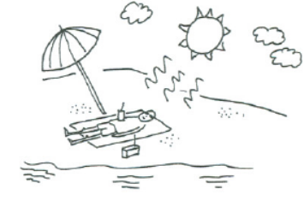
5. What happens to some chemicals when they absorb ultraviolet radiation? (1)
____________________________________________

6. What is the main danger of overexposure to ultraviolet radiation? (1)
_______________________________________________
7. Write down two things you know about light from a laser. (2)

________________________________________________________________________

_______________________________________________________________________
8. Describe one use of a laser in hospitals. (1)
______________________________________________________________________

_________________________________________________________ Total 10 marks
Homework 10 - X rays and Gamma Rays
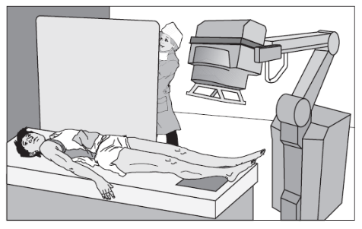
1. X rays cannot be detected by the naked eye.
What detects X rays? (1)
____________________________________
2. Describe one use of X rays in medicine. (1)
____________________________________

______________________________________________________________________

3. X rays are very useful to us but they can also be very dangerous, why? (1)

__________________________________________________________________

__________________________________________________________________
4. Gamma radiation can pass through most materials. Which material can it not pass through? (1)
_________________________________________
5. What happens to the activity of gamma source over time? (1)

____________________________________________________________________
6. Give two uses of gamma radiation in industry. (2)

_____________________________________________________________________

_____________________________________________________________________
7. List two safety precautions needed when dealing with a source of gamma radiation. (2)

______________________________________________________________________

______________________________________________________________________
8. Gamma radiation is present in our surroundings, what do we call this radiation? (1)

___________________________________________________ Total 10 marks
Homework 11 - Lens Action on Light
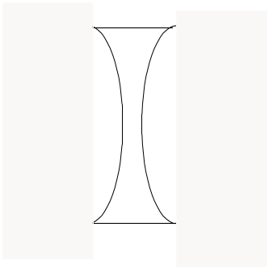
1. Complete these two ray diagrams:

Lens 1 Lens 2 (2)
2. Name the two lenses shown in question 1. Lens 1 _______________________

Lens 2 ____________________________________ (2)

3. A girl wants to find the focal length of a convex lens she has found in the classroom.
She uses light from the window in her experiment.
(a) What other equipment will she need to do her experiment? (1)

_________________________________________________________________

_________________________________________________________________
(b) What measurement should she make?

_______________________________________________________________

_______________________________________________________________(1)

(c) Why does she use light from the window rather than from the classroom
lights? (1)

___________________________________________________________________

___________________________________________________________________

4. Complete the table below by filling in the blanks to give information about short
and long sight: (3)
Eye Defect | Description | Lens Used
Short sight
Long sight

Total 10 marks
Homework 12 - Atomic Structure and Uses of Nuclear Energy

1. (a) Describe a medical use of radiation that is based on the fact that it can kill
cells. (1)

__________________________________________________________________
(b) Describe a medical use of radiation that is based on the fact that it is easily detected. (1)

___________________________________________________________________

2. Draw a diagram of a model of the atom. Carefully label the nucleus, and a proton, a neutron, and an electron. (4)

(4)
3. Nuclear power stations can produce electricity as cheaply as coal fired power stations and they do not give out carbon dioxide or acid gases. Why are so many people opposed to them? (1)

_______________________________________________________________
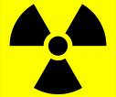
4. Name one man-made source of nuclear radiation. (1)

_____________________________________________________
5. Why should staff working with radioactive sources wear a film badge? (1)

_____________________________________________________
6. How are hospital staff protected from radiation and x-rays when they work with these resources (1)

_________________________________________________________________

_________________________________________________________________

Total 10 marks

