Airdrie Academy

Exam Questions

CfE Higher Chemistry

Unit 2 Nature’s Chemistry

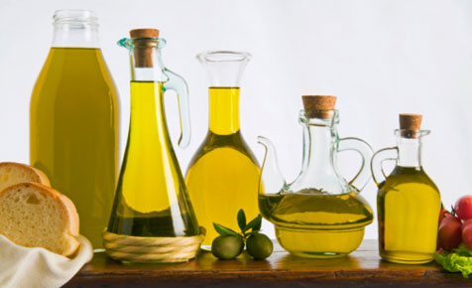

**2.1 Esters, Fats and Oils**

1. What is the structural formula for glycerol?

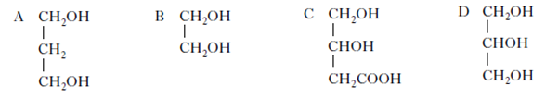

2. An ester has the following structural formula CH3CH2CH2COOCH2CH3

The name of this ester is

A propyl propanoate

B ethyl butanoate

C butyl ethanoate

D ethyl propanoate.

3. Esters are formed by the reaction between which two functional groups?

A A hydroxyl group and a carboxyl group

B A hydroxyl group and a carbonyl group

C A hydroxide group and a carboxyl group

D A hydroxide group and a carbonyl group

4. Rum flavouring is based on the compound with the formula shown.



It can be made from

A ethanol and butanoic acid

B propanol and ethanoic acid

C butanol and methanoic acid

D propanol and propanoic acid

5. Hydrolysis of an ester gave an alcohol and a carboxylic acid both of which had the same

molecular mass of 60. The structure of the ester was

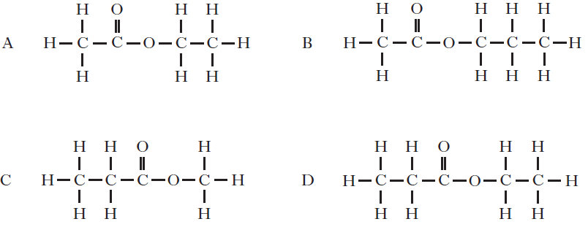

6. Fats have higher melting points than oils because comparing fats and oils

A fats have more hydrogen bonds

B fat molecules are more saturated

C fat molecules are more loosely packed

D fats have more cross-links between molecules

7. Which of the following reactions takes place during the ‘hardening’ of vegetable oil?

A Addition

B Hydrolysis

C Dehydration

D Oxidation

8. Fats are formed by the condensation reaction between glycerol molecules and fatty acid

molecules. In this reaction the mole ratio of glycerol molecules to fatty acid molecules is

A 1 : 1

B 1 : 2

C 1 : 3

D 3 : 1

9. Oils are generally

A solid at room temperature and contain a high proportion of unsaturated molecules

B solid at room temperature and contain a high proportion of saturated molecules

C liquid at room temperature and contain a high proportion of unsaturated molecules

D liquid at room temperature and contain a high proportion of saturated molecules.

10. Which of the following fatty acids is unsaturated?

A C19H39COOH

B C21H43COOH

C C17H31COOH

D C13H27COOH

11. Which of the following alcohols is likely to be obtained on hydrolysis of butter?

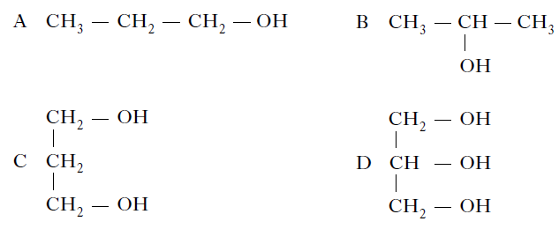

12. One of the chemicals released in a bee sting is an ester that has the structure shown.

This ester can be produced by the reaction of an alcohol with an alkanoic acid.

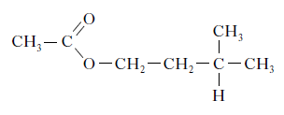

(a) Name this acid. (1)

(b) The ester can be prepared in the lab by heating a mixture of the reactants with a catalyst.

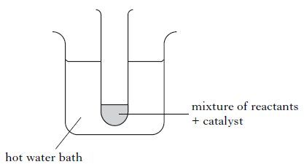

(i) Name the catalyst used in the reaction. (1)

(ii) What improvement could be made to the experimental set-up shown in the diagram? (1)

13. Propan-1-ol and propanoic acid react to form an ester.

The mixture of excess reactants and ester product is poured onto sodium hydrogencarbonate solution.

(a) What evidence would show that an ester is formed? (1)

(b) Draw a structural formula for this ester. (1)

14. The ester methyl stearate is also a useful vehicle fuel. A student prepared this ester from methanol and stearic acid during the Prescribed Practical Activity, “Making Esters”.

Describe how this ester was prepared. (2)

15. Foodstuffs have labels that list ingredients and provide nutritional information. The label on a tub of margarine lists hydrogenated vegetable oils as one of the ingredients. Why have some of the vegetable oils in this product been hydrogenated? (1)

16. A typical triglyceride found in olive oil is shown below.

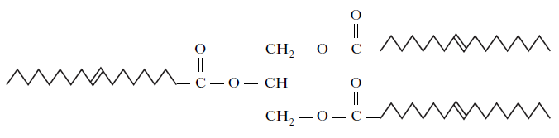

(a) To which family of organic compounds do triglycerides belong? (1)

(b) Olive oil can be hardened for use in margarines.

What happens to the triglyceride molecules during the hardening of olive oil? (1)

(c) Give one reason why oils can be a useful part of a balanced diet. (1)

17. When vegetable oils are hydrolysed, mixtures of fatty acids are obtained. The fatty acids can be classified by their degree of unsaturation. The table below shows the composition of each of the mixtures of fatty acids obtained when palm oil and olive oil were hydrolysed.

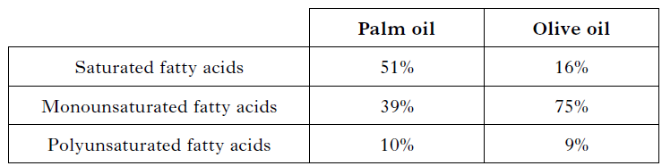

(a) Why does palm oil have a higher melting point than olive oil? (1)

(b) One of the fatty acids produced by the hydrolysis of palm oil is linoleic acid, C17H31COOH. To which class (saturated, monounsaturated or polyunsaturated) does this fatty acid belong? (1)

(c) When a mixture of palm oil and olive oil is hydrolysed using a solution of sodium hydroxide, a mixture of the sodium salts of the fatty acids is obtained. State a use for these fatty acid salts. (1) 11 9

**2.2 Proteins**

1. When a protein is denatured

A its overall shape is distorted

B its amide links are hydrolysed

C it is broken into separate peptide fragments

D it decomposes into amino acids

2. Which of the following compounds can be classified as proteins?

A Fats

B Oils

C Enzymes

D Amino acids

3. The monomer units used to construct enzyme molecules are

A alcohols

B esters

C amino acids

D fatty acids.

4. Amino acids are converted into proteins by

A hydration

B hydrolysis

C hydrogenation

D condensation

5. The arrangement of amino acids in a peptide is

Z-X-W-V-Y

where the letters V, W, X, Y and Z represent amino acids.

On partial hydrolysis of the peptide, which of the following sets of dipeptides is possible?

A V-Y, Z-X, W-Y, X-W

B Z-X, V-Y, W-V, X-W

C Z-X, X-V, W-V, V-Y

D X-W, X-Z, Z-W, Y-V

6. Which of the following is an amine?

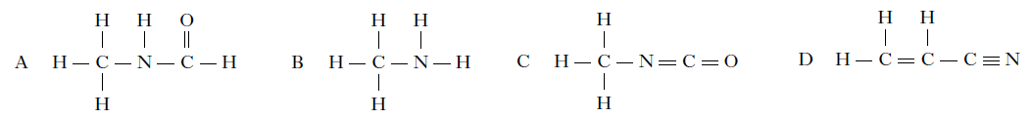

7. Which of the following arrangements of atoms shows a peptide link?

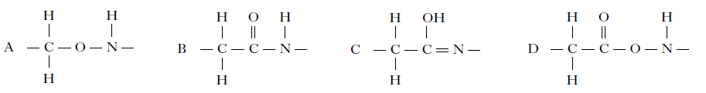

8. The following molecules are found in herbicides.

Which of the following contains an amide link?

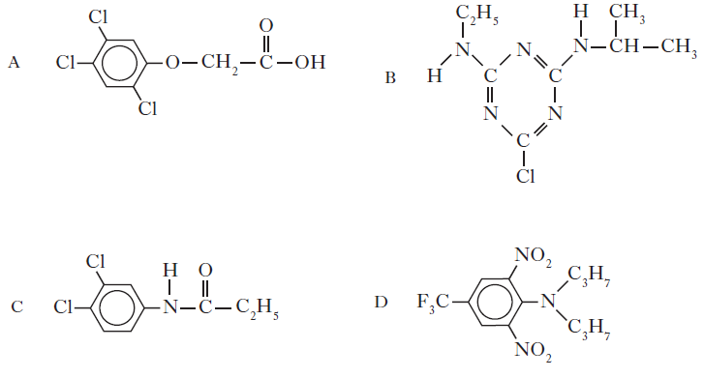

9. In α-amino acids the amino group is on the carbon atom adjacent to the acid group.

Which of the following is an α-amino acid?

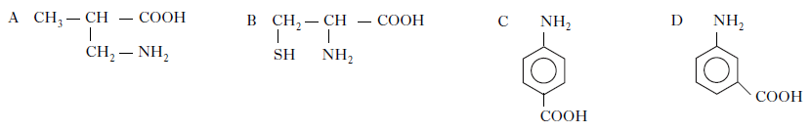

10. A tripeptide X has the structure

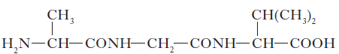

Partial hydrolysis of X yields a mixture of dipeptides.

Which of the following dipeptides could be produced on hydrolysing X?

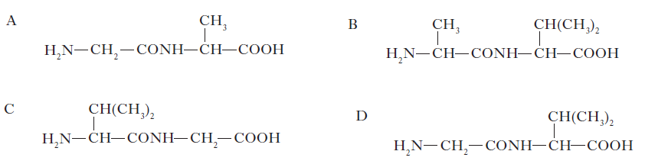

11. The rate of hydrolysis of protein, using an enzyme, was studied at different temperatures. Which of the following graphs would be obtained?

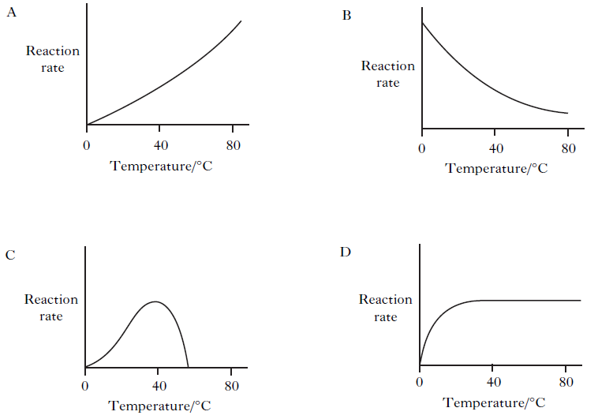

12. Polymers can be classified as natural or synthetic.

(a) Keratin, a natural polymer, is a protein found in hair.

The hydrolysis of keratin produces different monomers of the type shown.

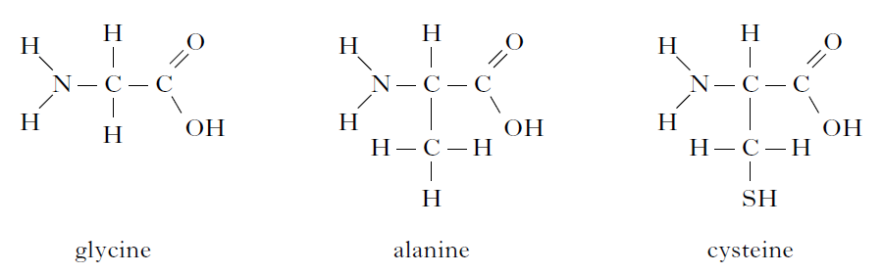

(i) What name is given to monomers like glycine, alanine and cysteine? (1)

(ii) What is meant by a hydrolysis reaction? (1)

(b) Dacron, a synthetic polymer, is used in heart surgery. A section of the polymer is shown.

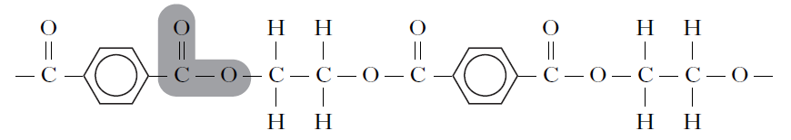

What name is given to the link made by the shaded group of atoms in this section of the polymer? (1)

13. Chemists have developed cheeses specifically for use in cheeseburgers.

(a) When ordinary cheddar cheese is grilled the shapes of the protein molecules change and the proteins and fats separate leaving a chewy solid and an oily liquid.

What name is given to the change in protein structure which occurs when ordinary cheddar is grilled? (1)

(b) To make cheese for burgers, grated cheddar cheese, soluble milk proteins and some water are mixed and heated to no more than 82 °C. As the cheese begins to melt an emulsifying agent is added and the mixture is stirred.

(i) Why would a water bath be used to heat the mixture? (1)

(ii) A section of the structure of a soluble milk protein is shown below.

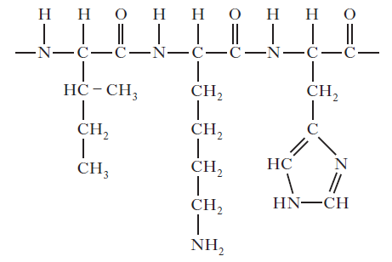

Draw a structural formula for any one of the amino acids formed when this section of

protein is hydrolysed. (1)

(iii) The emulsifier used is trisodium citrate, a salt formed when citric acid is neutralised using sodium hydroxide. Complete the equation below showing a structural formula for the trisodium citrate formed. (1) sp 8

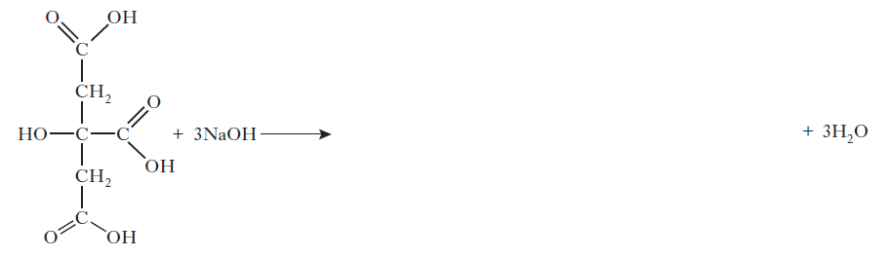

14. Phenylalanine and alanine are both amino acids.

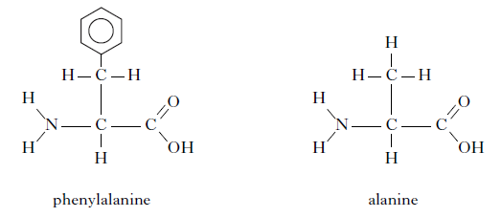

(a) Phenylalanine is an essential amino acid.

(i) What is meant by an essential amino acid? (1)

(ii) How many hydrogen atoms are present in a molecule of phenylalanine? (1)

(b) Phenylalanine and alanine can react to form the dipeptide shown.

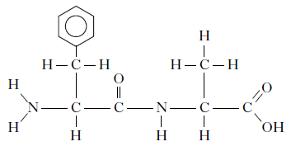

Circle the peptide link in this molecule. (1)

(c) Draw a structural formula for the other dipeptide that can be formed from phenylalanine and alanine. (1) 7 9

**2.3 The Chemistry of Cooking**

1. Vanillin and zingerone are flavour molecules.

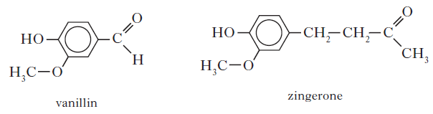

Which line in the table correctly compares the properties of vanillin and zingerone?

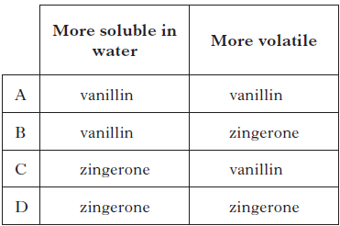

2. Erythrose can be used in the production of a chewing gum that helps prevent tooth decay.

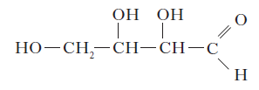

Which of the following compounds will be the best solvent for erythrose?

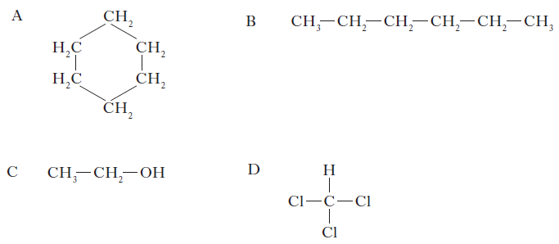

3. Cooking involves many chemical reactions. Proteins, fats, oils and esters are some examples of compounds found in food. A chemist suggested that cooking food could change compounds from being fat-soluble to water-soluble. Use your knowledge of chemistry to comment on the accuracy of this statement.(3)

**2.4 The Oxidation of Food**

1. Apples and bananas turn brown when cut or bruised. The first step of the reaction causing

the browning is shown below.

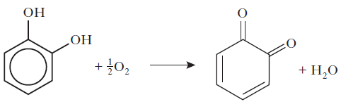

Which of the following terms correctly describes this reaction?

A Reduction

B Oxidation

C Dehydration

D Condensation

2. Which of the following reactions can be classified as reduction?

A CH3CH2OH → CH3COOH

B CH3 CH(OH)CH3 → CH3COCH3

C CH3CH2COCH3 → CH3CH2CH(OH)CH3

D CH3CH2CHO → CH3CH2COOH

3. The dehydration of butan-2-ol can produce two isomeric alkenes, but-1-ene and

but-2-ene. Which of the following alkanols can similarly produce, on dehydration, a pair of isomeric alkenes?

A Propan-2-ol

B Pentan-3-ol

C Hexan-3-ol

D Heptan-4-ol

4. Which of the following compounds is an alkanone?

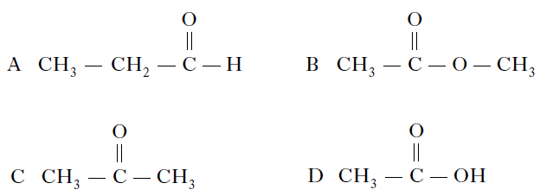

5. Which of the following is an aldehyde?

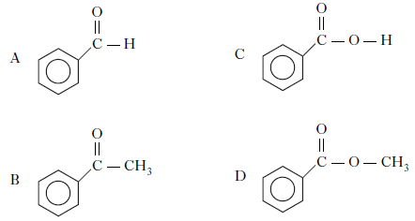

6. Which of the following compounds would react with sodium hydroxide solution to form

a salt?

A CH3CHO

B CH3COOH

C CH3COCH3

D CH3CH2OH

7. Which line in the table shows the correct functional group for each homologous series?

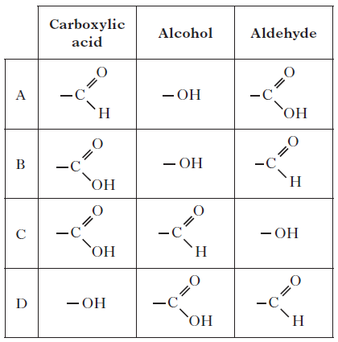

8. Which of the following organic compounds is an isomer of hexanal?

A 2-Methylbutanal

B 3-Methylpentan-2-one

C 2,2-Dimethylbutan-1-ol

D 3-Ethylpentanal

9. The name of this compound is

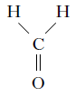

A methanol

B methanal

C methanoic acid

D methanone

10. Which alcohol could be oxidised to a carboxylic acid?

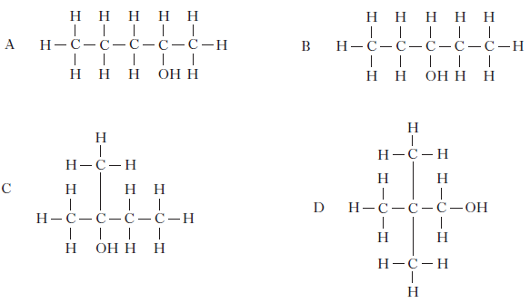

11. Which of the following structural formulae represents a tertiary alcohol?

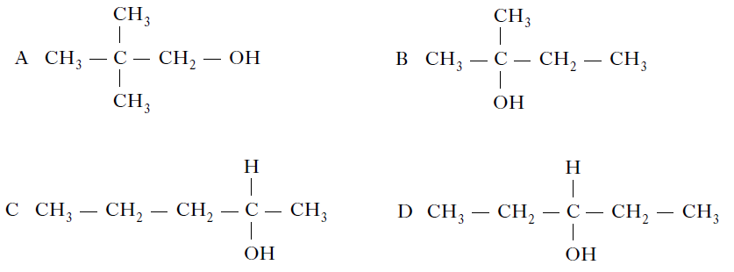

12. Compound X reacted with hot copper(II) oxide and the organic product did not give a

colour change when heated with Fehling’s solution. Compound X could be

A butan-1-ol

B butan-2-ol

C butanone

D butanoic acid

13. Which two isomers would each produce an acid when warmed with acidified potassium

dichromate solution?

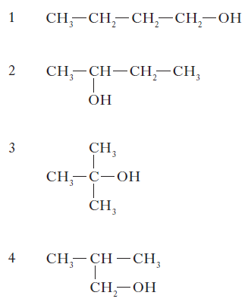

A 1 and 2

B 2 and 3

C 1 and 4

D 3 and 4

14. After heating for several minutes, as shown in the diagram, the pH indicator solution turned red.

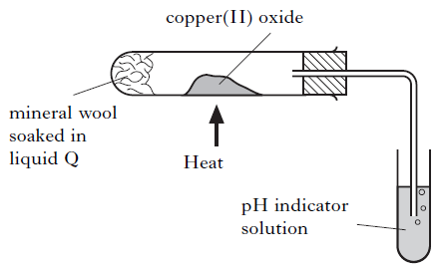

Liquid Q could be

A propanone

B paraffin

C propan-1-ol

D propan-2-ol

15. The structure of a molecule found in olive oil can be represented as shown.

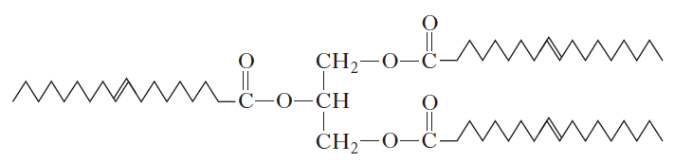

(a) Olive oil can be hydrolysed using sodium hydroxide solution to produce sodium salts of fatty acids. Name the other product of this reaction. (1)

(b) In what way does the structure of a fat molecule differ from that of an oil molecule? (1)

(c) Over time, open containers of olive oil develop a rancid flavour. What substance is reacting with the oil to cause these unwanted changes to take place? (1)

16. A student writes the following statement. It is incorrect. Explain the mistake in the student’s reasoning. (1)

Alcohols are alkaline because of their OH groups.

17. Carbon compounds take part in a wide variety of chemical reactions.

(a)

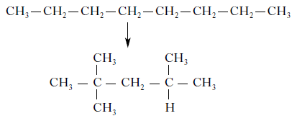

Name this type of chemical reaction. (1)

(b)



Draw a structural formula for C3H6O. (1)

18. Alkanols can be oxidised to alkanoic acids.

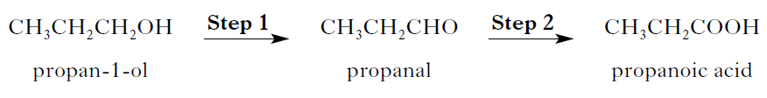

(a) Why can Step 1 be described as an oxidation reaction? (1)

(b) Acidified potassium dichromate solution can be used to oxidise propanal in

Step 2. What colour change would be observed in this reaction? (1)

19. Amines can be produced by reacting ammonia with an aldehyde or a ketone. This reaction, an example of reductive amination, occurs in two stages.

Stage 1 Amination

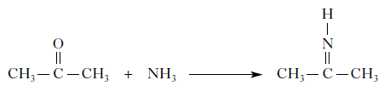

Stage 2 Reduction

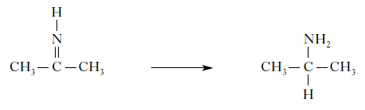

(a) Give another name for the type of reaction taking place in Stage 2.

(b) Draw the structural formula for the amine produced when butanal undergoes reductive amination with ammonia.

20. Using a cobalt catalyst, alkenes react with a mixture of hydrogen and carbon monoxide.

The products are two isomeric aldehydes. Propene reacts with the mixture as shown.

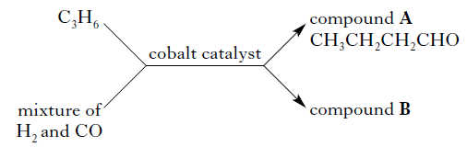

(a) What name is given to a mixture of hydrogen and carbon monoxide? (1)

(b) Draw a structural formula for compound B. (1)

(c) (i) What would be observed if compound A was gently heated with Tollens’ reagent? (1)

(ii) How would the reaction mixture be heated? (1)

(d) Aldehydes can also be formed by the reaction of some alcohols with copper(II) oxide.

Name the type of alcohol that would react with copper(II) oxide to form an aldehyde. (1)

21. Aldehydes and ketones can take part in a reaction sometimes known as an aldol condensation. The simplest aldol reaction involves two molecules of ethanal.

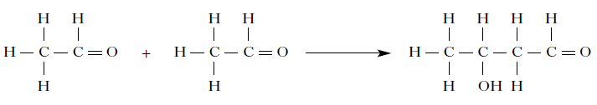

In the reaction, the carbon atom next to the carbonyl functional group of one molecule forms a bond with the carbonyl carbon atom of the second molecule.

(a) Draw a structural formula for the product formed when propanone is used instead of ethanal in this type of reaction. (1)

(b) Name an aldehyde that would not take part in an aldol condensation. (1)

(c) Apart from the structure of the reactants, suggest what is unusual about applying the term “condensation” to this particular type of reaction. (1)

22. Primary, secondary and tertiary alkanols can be prepared by the reaction of carbonyl compounds with Grignard reagents.

Step 1

The Grignard reagent reacts with the carbonyl compound.

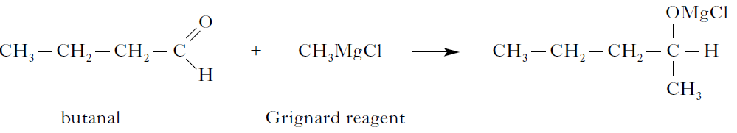

Step 2

The reaction of the product of Step 1 with dilute acid produces the alkanol.

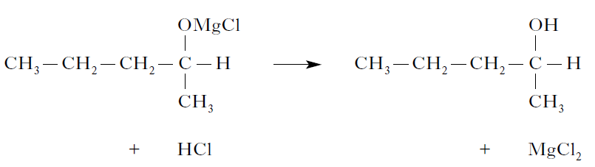

(a) Describe the difference between a primary, a secondary and a tertiary alkanol.

You may wish to include labelled structures in your answer. (1)

(b) Suggest a name for the type of reaction that takes place in Step 1. (1)

(c) The same Grignard reagent can be used to produce the alkanol below.

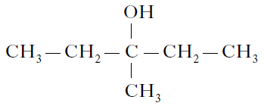

Name the carbonyl compound used in this reaction. (1)

23. Hairspray is a mixture of chemicals.

(a) A primary alcohol, 2-methylpropan-1-ol, is added to hairspray to help it dry quickly on the hair.

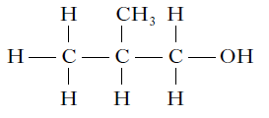

Draw a structural formula for a secondary alcohol that is an isomer of

2-methylpropan-1-ol. (1)

(b) Triethanol amine and triisopropyl amine are bases used to neutralise acidic compounds in the hairspray to prevent damage to the hair.

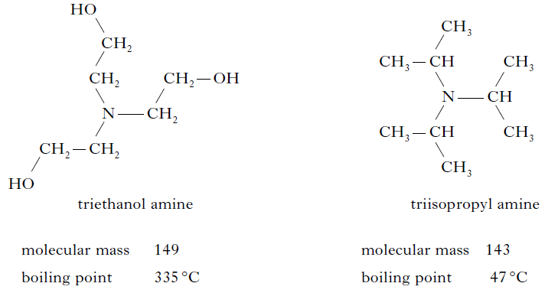

In terms of the intermolecular bonding present, explain clearly why triethanol amine has a much higher boiling point than triisopropyl amine. (2)

24. Chocolate contains various compounds.

(a) Many of the flavour and aroma molecules found in chocolate are aldehydes and

ketones. Two examples are shown below.

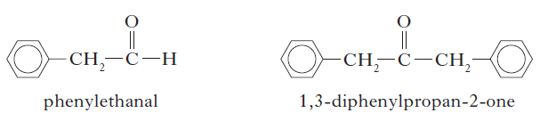

Phenylethanal can be easily oxidised but 1,3-diphenylpropan-2-one cannot.

(i) Name a chemical that could be used to distinguish between these two compounds. (1)

(ii) Name the type of organic compound formed when phenylethanal is oxidised. (1)

(b) Glycerol monostearate is an emulsifier used in chocolate.

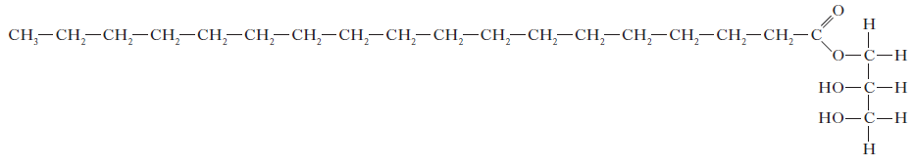

(i) Why is glycerol monostearate added to chocolate? (1)

(ii) Draw a structural formula for glycerol. (1)

(c) Theobromine, a compound present in chocolate, can cause illness in dogs and cats. To decide if treatment is necessary, vets must calculate the mass of theobromine consumed. 1·0 g of chocolate contains 1·4 mg of theobromine. Calculate the mass, in mg, of theobromine in a 17 g biscuit of which 28% is chocolate. Show your working clearly. (2)

(d) The flavour and texture of chocolate comes from a blend of compounds.

Using your knowledge of chemistry, describe how you could show that there are ionic compounds and covalent compounds present in chocolate. (3)

25. Ethanol has many uses.

(a) Ethanol is found at relatively low concentrations in wine.

(i) Name the chemical reaction that produces ethanol in wine. (1)

(ii) Standard ethanol solutions were used to produce a graph of density against

concentration of ethanol, given as a percentage of alcohol by volume (% abv).

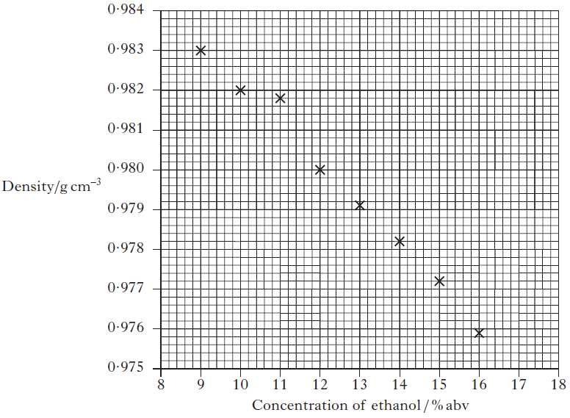

What is the concentration of ethanol, in units of % abv, in a solution of density

0·9818 g cm−3? (1)

(b) Whisky contains a higher concentration of ethanol.

(i) Before 1980, the concentration of alcohol in drinks was measured in terms of degrees proof. The concentration of alcohol in two drinks is shown in the table below, both as % abv and degrees proof.

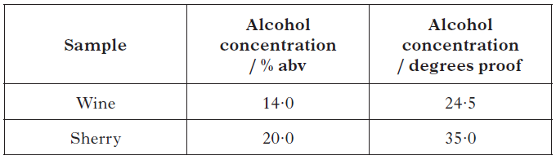

A cask strength whisky has an alcohol concentration of 65% abv. Calculate the alcohol concentration of this whisky in degrees proof. (1)

(ii) A barrel containing 195 litres of cask strength whisky costs £1300. The cask strength whisky is diluted with water to reduce the concentration of alcohol from 65% abv to 46% abv before it is bottled. Calculate the cost of the cask strength whisky needed to produce a 0·70 litre bottle. Show your working clearly. (2)

(iii) 5-Butyl-4-methyltetrahydrofuran-2-ol is a flavour compound found in whisky

stored in oak barrels.

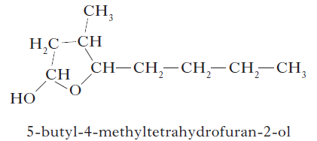

Write the systematic name for the compound shown below. (1) 13 11



**2.5 Soaps, Detergents and Emulsions**

1. Soaps are produced by the following reaction.

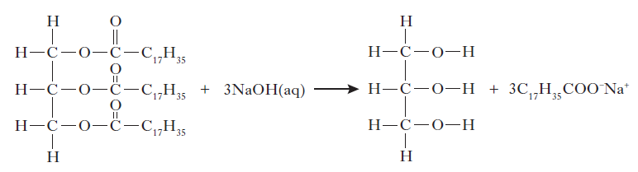

This reaction is an example of

A condensation

B esterification

C hydrolysis

D oxidation

2. A fatty acid is a long chain carboxylic acid. Examples of fatty acids are shown in the table below.

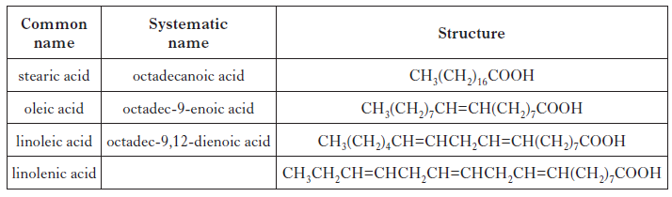

(a) What is the systematic name for linolenic acid? (1)

(b) Stearic acid reacts with sodium hydroxide solution to form sodium stearate.

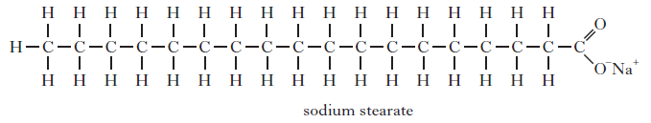

(i) Name the type of reaction taking place when stearic acid reacts with sodium hydroxide. (1)

(ii) **Explain fully** how sodium stearate acts to keep grease and non-polar substances suspended in water during cleaning. (3)

3. Small children can find it difficult to swallow tablets or pills so ibuprofen is supplied as an “infant formula” emulsion.

(a) The emulsifier used is polysorbate 80. Its structure is shown below.

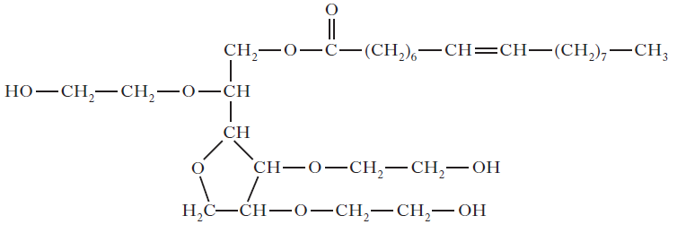

Explain why this molecule acts as an emulsifier. (2)

(b) The emulsion contains 2 g of ibuprofen in every 100 cm3 of emulsion. The recommended dose for treating a 6 month old baby is 0·050 g. Calculate the volume, in cm3, of “infant formula” needed to treat a 6 month old baby. (1)

**2.6 Fragrances**

1. Myrcene is a simple terpene.

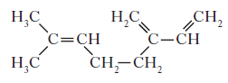

Terpenes contain at least one isoprene unit. Which of the following shows a correctly highlighted isoprene unit?

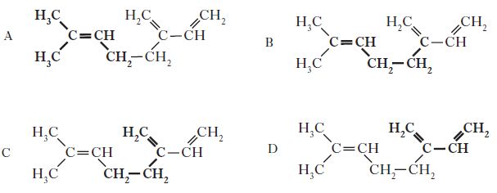

2. Limonene is one of the terpene molecules responsible for the flavour of lemons.

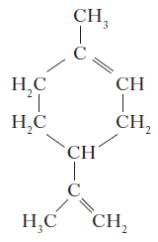

How many isoprene units are used in the production of one limonene molecule?

A 1

B 2

C 3

D 4

3. The structure of caryophyllene, which can be extracted from clove oil, is

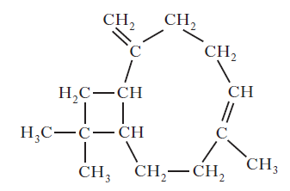

Which of the following would be the best solvent for extracting caryophyllene?

A Hexane

B Hexanal

C Hexanol

D Hexanone

4. Two typical compounds that are present in many perfumes are shown.

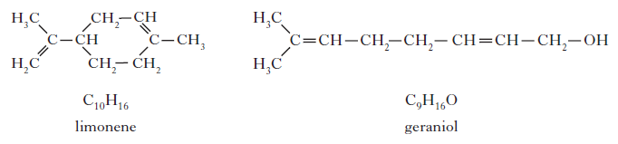

(a) Why does geraniol evaporate more slowly than limonene? (1)

(b) The structure of one of the first synthetic scents used in perfume is shown below.

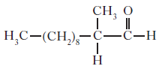

(i) Name the family of carbonyl compounds to which this synthetic scent belongs. (1)

(ii) Complete the structure below to show the product formed when this scent is

oxidised. (1)

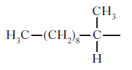

(c) Traces of a liquid were discovered in a bottle believed to contain perfume belonging to Queen Hatshepsut, ruler of Egypt over 3500 years ago. Perfumes were made by dissolving plant extracts containing pleasant smelling terpenes and esters in an edible oil. A little ethanol and water may also have been added.

Using your knowledge of chemistry, comment on the possible smell(s) when such a bottle is opened after being stored for thousands of years. (3)

5. A team of chemists are developing a fragrance for use in a shower gel for men.

(a) To give the gel a fruity smell the chemists are considering adding an ester. They synthesise six isomeric esters. Volunteers smell each ester and give it a rating out of one hundred depending on how fruity the smell is.

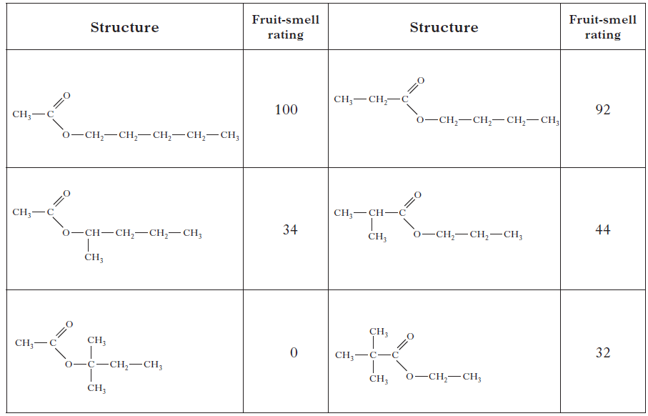

(i) Name the ester with the fruit-smell rating of 92. (1)

(ii) Shown below are the structures of three more isomers.

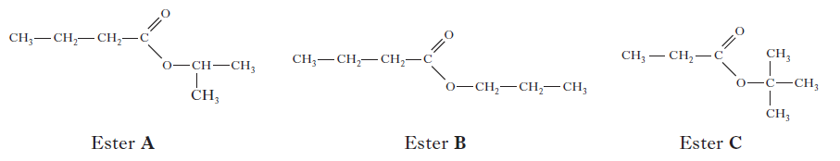

Arrange these esters in order of decreasing fruit-smell rating. (1)

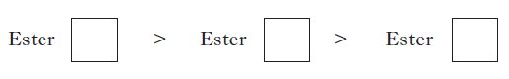

(b) To create a fragrance for men, the compound civetone is added.

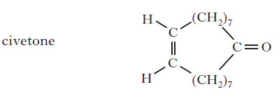

Draw a structural formula for the alcohol that can be oxidised to form civetone. (1)

(c) To make the shower gel produce a cold, tingling sensation when applied to the

skin, menthol is added.

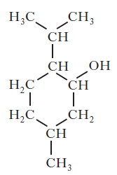

Like terpenes, menthol is formed from isoprene (2-methylbuta-1,3-diene).

Circle an isoprene unit on the menthol structure above. (1)

**2.7 Skin Care**

1. Fluorine reacts with methane via a free radical chain reaction. Some steps in the chain reaction are shown in the table below.

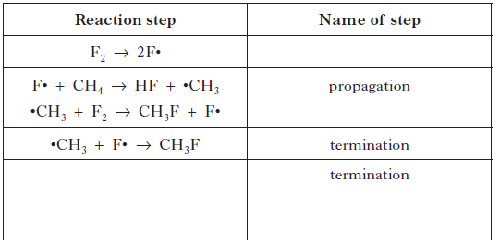

Complete the table by:

(a) inserting the missing name for the first step; (1)

(b) showing another possible termination reaction in the final row of the table. (1)

2. Suncreams contain antioxidants.

The antioxidant, compound A, can prevent damage to skin by reacting with free radicals

such as NO2•.

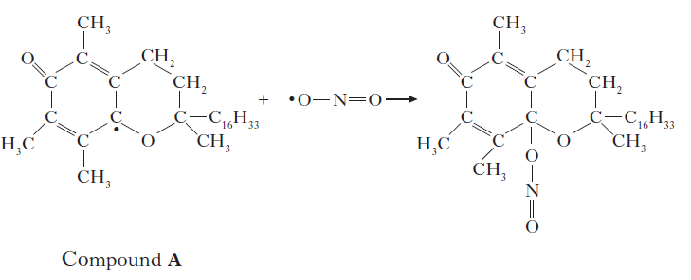

Why can compound A be described as a free radical scavenger in the reaction shown above?

3. Hydrogen and chlorine gases are used in an experiment to demonstrate a free radical reaction. A plastic bottle is wrapped with black tape leaving a “window” on one side.

The bottle is filled with a mixture of hydrogen and chlorine. When bright light shines on the bottle there is an explosion.

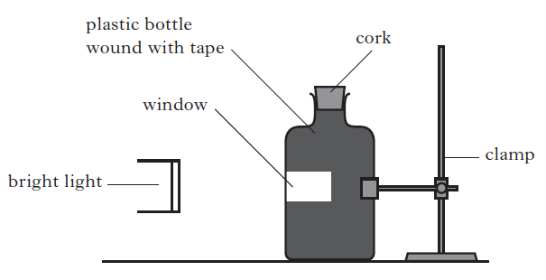

A free radical chain reaction is initiated when light energy causes chlorine radicals to form as shown below.



(a) Complete the equations below showing possible propagation and termination steps. (2)

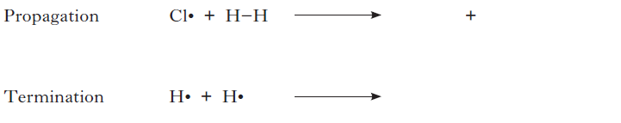

(b) Why is the plastic bottle used in the experiment wrapped in black tape? (1)

**General Questions**

1. A mixture of carbon monoxide and hydrogen can be converted into water and a mixture of hydrocarbons.

nCO + (2n + 1)H2 → nH2O + hydrocarbons

What is the general formula for the hydrocarbons produced?

A CnH2n–2

B CnH2n

C CnH2n+1

D CnH2n+2

2. Butadiene is the first member of a homologous series of hydrocarbons called dienes.

What is the general formula for this series?

A CnHn+2

B CnHn+3

C CnH2n

D CnH2n–2 8

3. Which of the following statements about methanol is false?

A It can be made from synthesis gas.

B It can be dehydrated to form an alkene.

C It can be oxidised to give a carboxylic acid.

D It reacts with acidified potassium dichromate solution.

4.

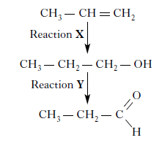

Which line in the table correctly describes reactions X and Y?

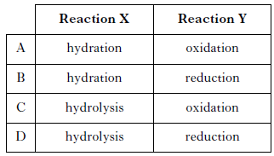

5.

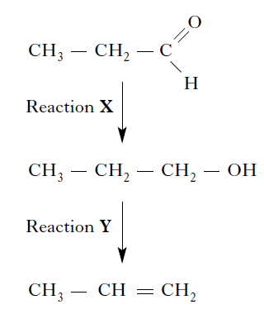

Which line in the table correctly describes reactions X and Y?

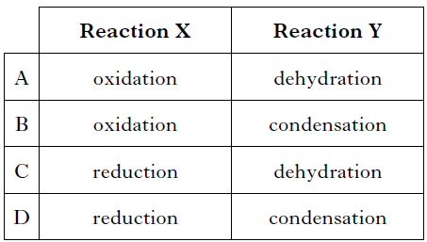

6. Which of the following fuels when burned would make no contribution to global

warming?

A Hydrogen

B Natural gas

C Petrol

D Coal

7. Which of the following hydrocarbons always gives the same product when one of its

hydrogen atoms is replaced by a chlorine atom?

A Hexane

B Hex-1-ene

C Cyclohexane

D Cyclohexene

8. Which of the following compounds does not have isomeric structures?

A C2HCl3

B C2H4Cl2

C Propene

D Propan-1-ol

9. What organic compound is produced by the dehydration of ethanol?

A Ethane

B Ethene

C Ethanal

D Ethanoic acid

10.

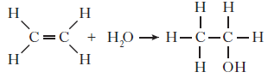

The above equation represents

A hydration

B hydrogenation

C condensation

D hydrolysis

11.

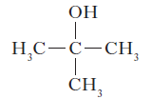

Which of the following compounds is an isomer of the structure shown above?

A Butanal

B Butanone

C Butan-1-ol

D Butanoic acid

12. A compound with molecular formula C6H12O2, could be

A hexanal

B hexan-2-ol

C hexan-2-one

D hexanoic acid.

13. Propan-2-ol can be prepared from propane as follows.

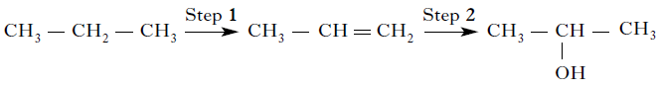

Which line in the table correctly describes the types of reaction taking place at Steps 1 and 2?

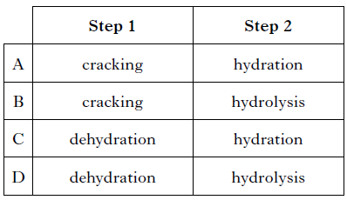

14. Ethyne is the first member of the homologous series called the alkynes.

Ethyne can undergo addition reactions as shown in the flow diagram.

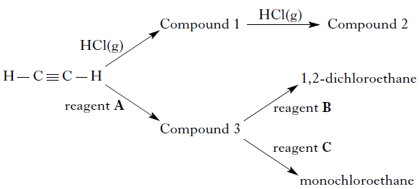

(a) Compound 2 is an isomer of 1,2-dichloroethane.

Draw a structural formula for compound 2. (1)

(b) Reagents A, B and C are three different diatomic gases.

Using information in the flow diagram, identify reagents A, B and C. (1)

|  |  |
| --- | --- |
| Reagent | Gas |
| A |  |
| B |  |
| C |  |

15. In 1865, the German chemist Kekulé proposed a ring structure for benzene. This structure was based on alternating single and double bonds.

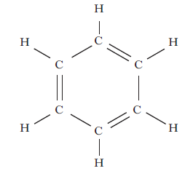

(a) (i) Describe a chemical test that would indicate that the above chemical structure for benzene is incorrect. (1)

(ii) Briefly describe the correct structure for benzene. (1)

(b) Benzene can be formed from cyclohexane.

C6H12 → C6H6 + 3H2

What name is given to this type of reaction? (1)

16. Infra-red spectroscopy is a technique that can be used to identify the bonds that are

present in a molecule. Different bonds absorb infra-red radiation of different wavenumbers. This is due to differences in the bond ‘stretch’. These absorptions are recorded in a spectrum.

A spectrum for propan-1-ol is shown.

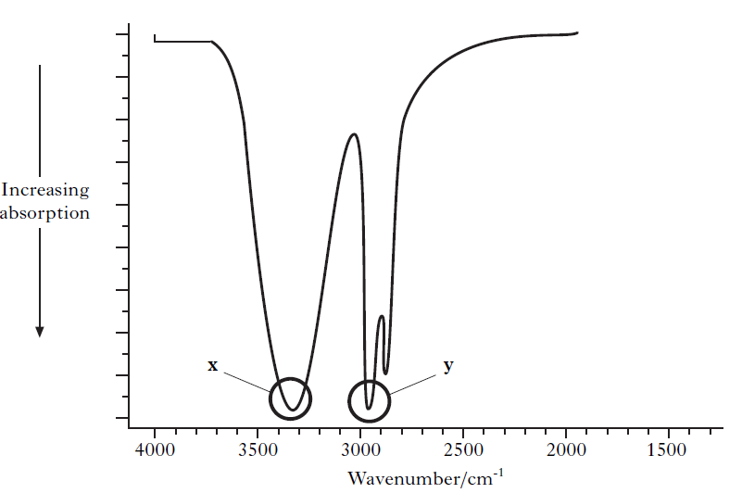

The correlation table on page 13 of the data booklet shows the wavenumber ranges for the absorptions due to different bonds.

(a) Use the correlation table to identify the bonds responsible for the two absorptions, x and y, that are circled in the propan-1-ol spectrum. (1)

(b) Propan-1-ol reacts with ethanoic acid.

(i) What name is given to this type of reaction? (1)

(ii) Draw a spectrum that could be obtained for the organic product of this reaction. (1)

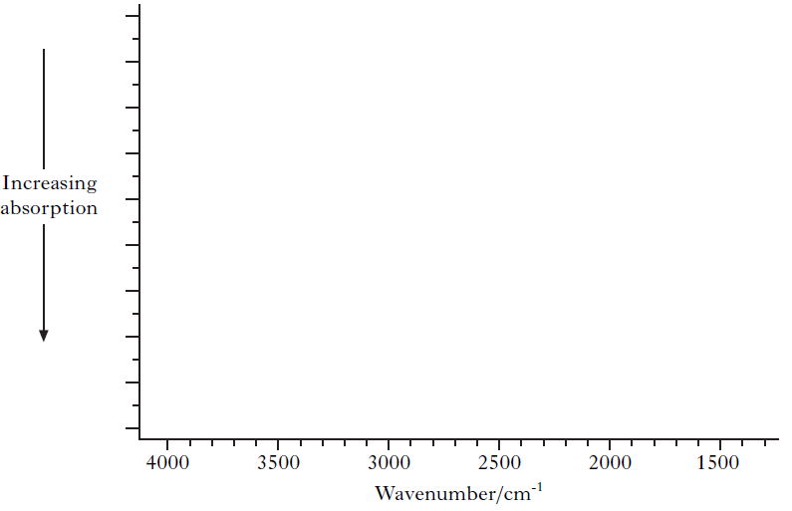

17. Paracetamol is a widely used painkiller.

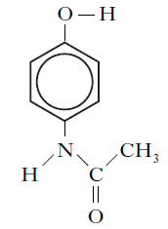

(a) Write the molecular formula for paracetamol. (1)

(b) One antidote for paracetamol overdose is methionine.

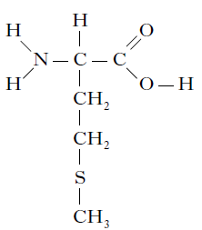

To what family of organic compounds does methionine belong? (1)

(c) The concentration of paracetamol in a solution can be determined by measuring how much UV radiation it absorbs.

The graph shows how the absorbance of a sample containing 0·040 g l –1 paracetamol varies with wavelength.

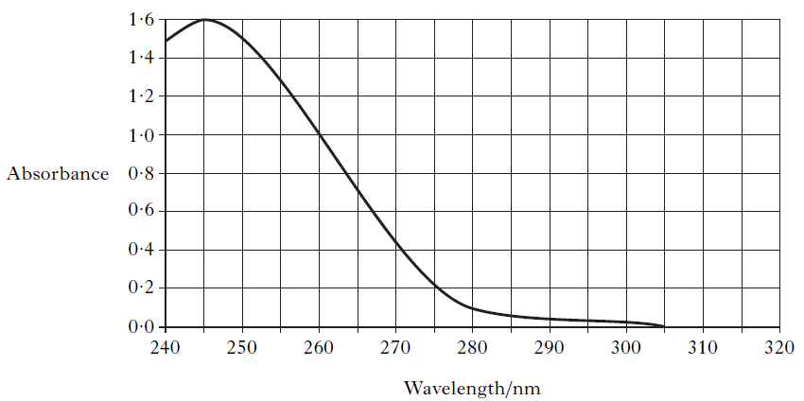

The quantity of UV radiation of wavelength 245 nm absorbed is directly proportional to the concentration of paracetamol.

The absorbance of a second sample of paracetamol solution measured at 245 nm was 0·90. What is the concentration, in g l –1, of this second paracetamol solution? (1)

18. Many carbon compounds containing oxygen are very flammable.

The table shows information about two families of isomers.

The lowest temperature at which a compound will ignite is called its flash point.

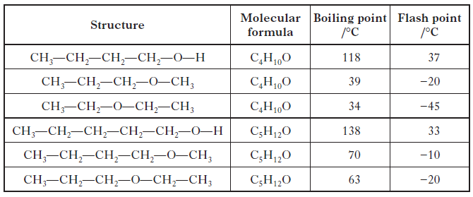

(a) A compound with the molecular formula C6H14O has a boiling point of 158 °C.

Draw a structural formula for this compound. (1)

(b) For a family of isomers in the table, write a general statement linking the flash points of the compounds to their structures. (1)

19. Hydrogels are used in disposable nappies. They are fine powders that can absorb up to 500 times their own weight in water.

A hydrogel is a very long molecule with carboxyl groups at regular intervals along its length. A short section of a hydrogel molecule is shown below.

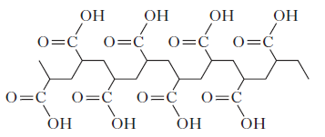

Hydrogels are extremely good at soaking up water because the water molecules are strongly attracted to them.

Using your knowledge of chemistry, comment on how suitable hydrogels would be for absorbing liquids or solutions spilled in a chemistry lab. (1)

20. Dental anaesthetics are substances used to reduce discomfort during treatment.

(a) Lidocaine is a dental anaesthetic.



Lidocaine causes numbness when applied to the gums. This effect wears off as the lidocaine is hydrolysed.

One of the products of the hydrolysis of lidocaine is compound C.



(i) Name the functional group circled above. (1)

(ii) Draw a structural formula for the other compound produced when lidocaine is hydrolysed. (1)

(iii) Draw a structural formula for the organic compound formed when compound C reacts with NaOH(aq). (1)

(b) The table below shows the duration of numbness for common anaesthetics.

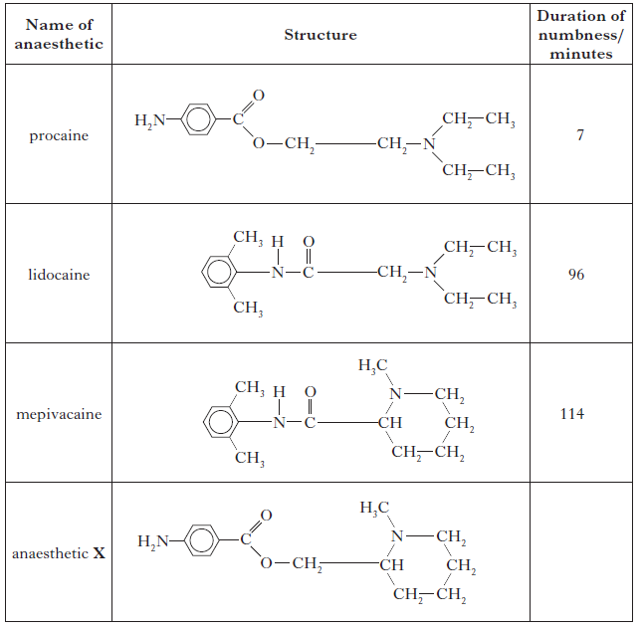

Estimate the duration of numbness, in minutes, for anaesthetic X. (1)

(c) The maximum safe dose of lidocaine for an adult is 4·5 mg of lidocaine per kg

of body mass. 1·0 cm3 of lidocaine solution contains 10 mg of lidocaine. Calculate the maximum volume of lidocaine solution that could be given to a 70 kg adult. Show your working clearly. (3)

21. Soft drinks contain many ingredients. Aspartame is added to many soft drinks as a sweetener. Its structure is shown below.

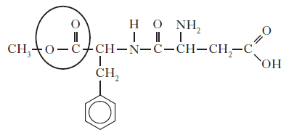

(a) Name the functional group circled. (1)

(b) In the stomach, aspartame is hydrolysed by acid to produce methanol and two amino acids, phenylalanine and aspartic acid.

Two of the products of the hydrolysis of aspartame are shown below.

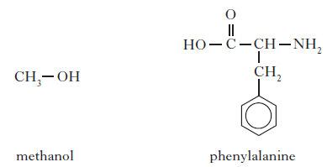

Draw a structural formula for aspartic acid. (1)

(c) The body cannot make all the amino acids it requires and is dependent on protein in the diet for the supply of certain amino acids.

What term is used to describe the amino acids the body cannot make? (1)

22. Cycloalkanes are found in nature. A representation of cyclohexane is shown below.

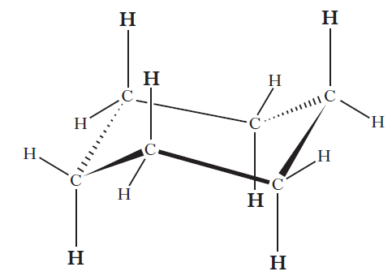

The six hydrogen atoms marked in bold are said to be in axial positions. In the molecule of 1,2-dimethylcyclohexane shown below, two methyl groups are in axial positions.

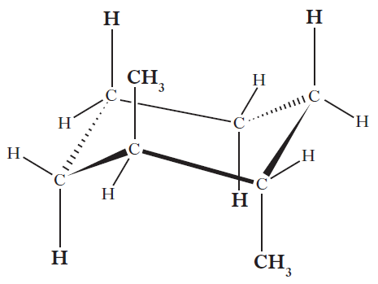

(a) Complete the structure shown below to show a molecule of 1,3-dimethylcyclohexane in which both the methyl groups are in axial positions. (1)

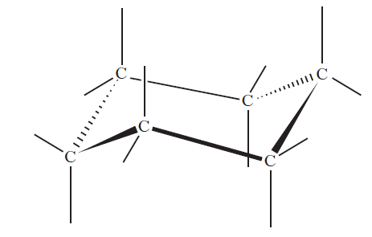

(b) Axial groups on the same side of a cyclohexane ring can repel each other.

The strength of the repulsion is known as the “steric strain”.

The table below shows values which allow the steric strain to be calculated.

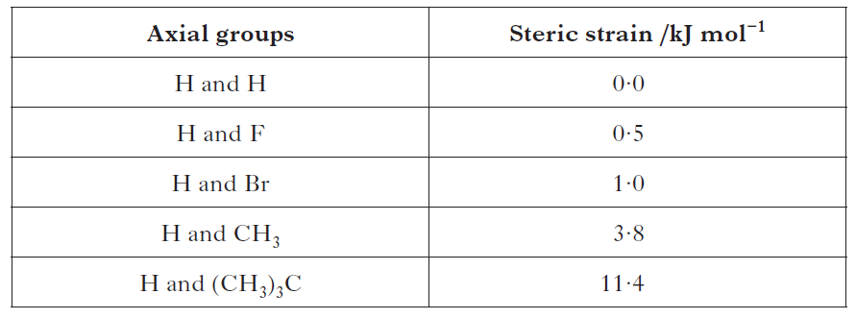

For example:

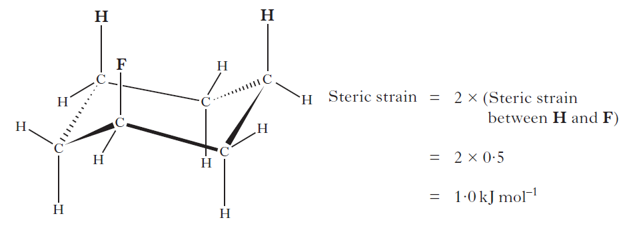

(i) Write a general statement, linking the size of the steric strain to the type of axial group present. (1)

(ii) Calculate, in kJ mol−1, the steric strain for the molecule shown below. (1)

