Airdrie Academy

Higher Chemistry

Nature’s Chemistry

Functional Group Questions

1. In which of the following liquids does hydrogen bonding occur
A Ethanol
B Ethyl ethanoate
C Hexane
D Pent-1-ene

2. Which line in the table shows the correct functional group for each homologous series?
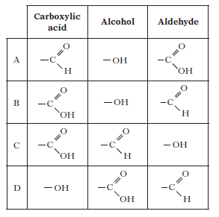

3. Aspartame is added to many soft drinks as a sweetener. Its structure is shown below.

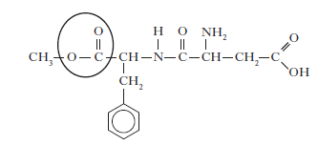
Name the functional group circled.

4. Shown below is the structure of asprin.
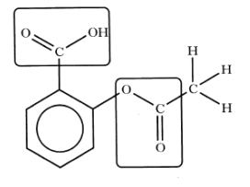
What two functional groups are highlighted?
A Carbonyl and ester
B Hydroxyl and carbonyl
C Hydroxyl and Carboxyl
D Ester and carbonyl

5. Vanillin and zingerone are flavour molecules.

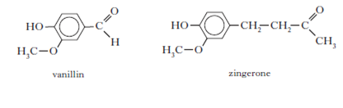
Which line in the table correctly compares the properties of vanillin and zingerone?

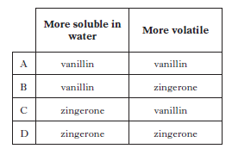

6. Erythrose can be used in the production of a chewing gum that helps prevent tooth decay.

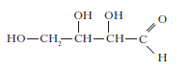
Which of the following compounds will be the best solvent for erythrose?

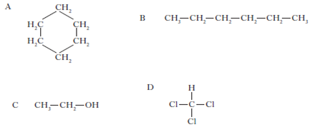

7. Dental anaesthetics are substances used to reduce discomfort during treatment. Lidocaine is a dental anaesthetic.

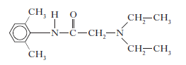
Lidocaine causes numbness when applied to the gums. This effect wears off as
the lidocaine is hydrolysed.
One of the products of the hydrolysis of lidocaine is compound C.
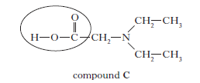
a) Name the functional group circled above.
b) Draw a structural formula for the other compound produced when lidocaine is hydrolysed.

c) The table below shows the duration of numbness for common anaesthetics.

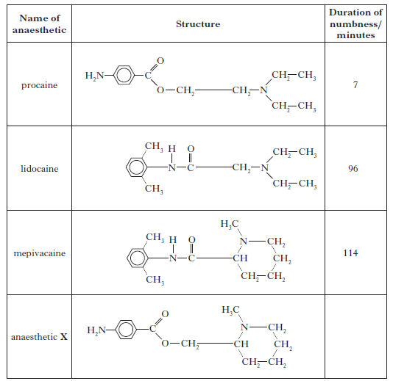
Estimate the duration of numbness, in minutes, for anaesthetic X.
(d) i) When forensic scientists analyse illegal drugs, anaesthetics such as lidocaine are sometimes found to be present.
The gas chromatogram below is from an illegal drug.

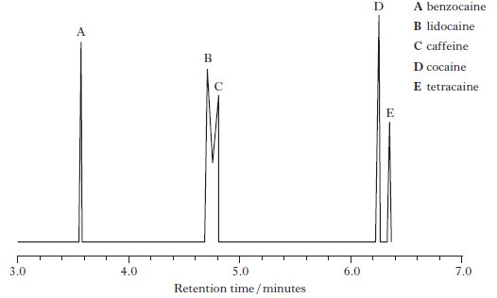
The structures of benzocaine and tetracaine are shown below.
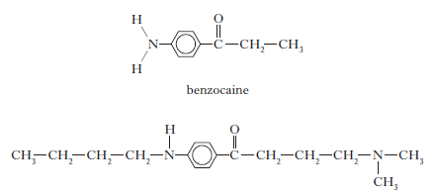
Suggest why benzocaine has a shorter retention time than tetracaine.

ii) Why is it difficult to obtain accurate values for the amount of lidocaine
present in a sample containing large amounts of caffeine?

8. Noradrenaline and phenylephrine cause increases in the blood pressure because the part of each of these molecules that they have in common has the correct shape to allow them to bind to a certain human protein.

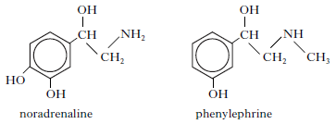

The part of these molecules which is the correct shape to bind to the protein is

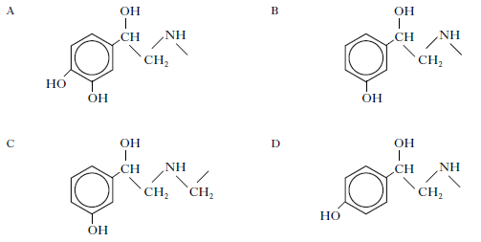

9. Triethanol amine and triisopropyl amine are bases used to neutralise acidic
compounds in the hairspray to prevent damage to the hair.

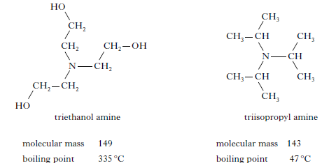

In terms of the intermolecular bonding present, explain clearly why triethanol amine has a much higher boiling point than triisopropyl amine.

10. Aspirin and oil of wintergreen are used in medicine. Their structures are shown below.
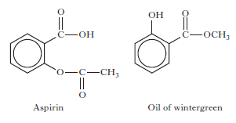
Identify the term which can be applied to aspirin but not to oil of wintergreen.

A Aldehyde
B Ketone
C Ester
D Carboxylic acid

11. Paracetamol is one of the most widely used pain relievers. It has the structure:

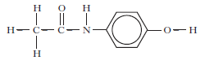

Which functional groups are present in a paracetamol molecule?

A Aldehyde, amine and hydroxyl
B Ketone, amine and hydroxyl
C Amide link and hydroxyl
D Amino acid and hydroxyl
12. The structure of caryophyllene, which can be extracted from clove oil, is
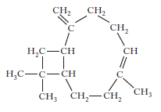

Which of the following would be the best solvent for extracting caryophyllene?

A Hexane
B Hexanal
C Hexanol
D Hexanone
13. Ibuprofen is one of the best selling pain killers in the UK.
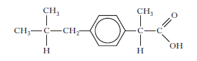

Ibuprofen tablets should not be taken by people who suffer from acid indigestion. Name the functional group present in ibuprofen that makes this drug unsuitable for these patients?

