Airdrie Academy

Higher Chemistry

Nature’s Chemistry
Homework

Skin Care

Homework 1

1. Why are antioxidants added to foods?

2. What is meant by a free radical?

3. Give the names of 3 natural antioxidants and state which foods they are found in.

4. Describe how orange juice can stop apples from going brown after they have been cut.

5. Apples and bananas turn brown when cut or bruised. The first step of the reaction causing the browning is shown below.
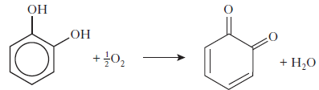

What type of reaction is this?

Homework 2

1. What are the three steps for the reaction between alkanes and halogens?

2. Write out each of the three steps for the reaction between chlorine gas and ethane under the action of UV light.

3. What is meant by a free-radical scavenger?

4. Suncreams contain antioxidants.
a) The antioxidant, compound A, can prevent damage to skin by reacting with free radicals such as NO2•.
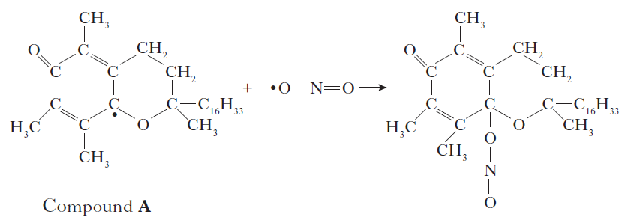

Why can compound A be described as a free radical scavenger in the reaction shown above?
b) Another antioxidant used in skin care products is vitamin C, C₆H₈O₆.

Copy and complete the ion-electron equation for the oxidation of vitamin C.

5. Fluorine reacts with methane via a free radical chain reaction.
Some steps in the chain reaction are shown in the table below.
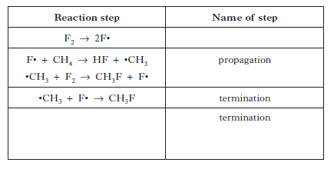
Copy and complete the table by:
a) inserting the missing name for the first step;
b) showing another possible termination reaction in the final row of the
table.

