CfE Higher Physics - Unit 1 Our Dynamic Universe - Part 2

SPECIAL RELATIVITY

- Introduction to special relativity.
- Relativity introduced through Galilean Invariance, Newtonian Relativity and the concept of absolute space.
- Experimental and theoretical considerations (details not required) lead to the conclusion that the speed of light is the same for all observers.
- The constancy of the speed of light led Einstein to postulate that space and time for a moving object are changed relative to a stationary observer.
- Length contraction and time dilation.

THE EXPANDING UNIVERSE

- The Doppler Effect and redshift in galaxies
- The Doppler Effect is observed in sound and light.
- For sound, the apparent change in frequency as a source moves towards or away from a stationary observer should be investigated.
- The Doppler Effect causes similar shifts in wavelengths of light. The light from objects moving away from us is shifted to longer wavelengths - redshift.
- The redshift of a galaxy is the change in wavelength divided by the emitted wavelength.
- For galaxies moving at non-relativistic speeds, redshift is the ratio of the velocity of the galaxy to the velocity of light.
- (Note that the Doppler Effect equations used for sound cannot be used with light from fast moving galaxies because relativistic effects need to be taken into account.)

Hubble's Law

- Hubble‘s Law shows the relationship between the recession velocity of a galaxy and its distance from us.
- Hubble‘s Law leads to an estimate of the age of the Universe.
- Evidence for the expanding Universe
- Measurements of the velocities of galaxies and their distance from us lead to the theory of the expanding Universe.
- Gravity is the force which slows down the expansion.
- The eventual fate of the Universe depends on its mass.
- The orbital speed of the Sun and other stars gives a way of determining the mass of our galaxy.
- The Sun‘s orbital speed is determined almost entirely by the gravitational pull of matter inside its orbit.
- Measurements of the mass of our galaxy and others lead to the conclusion that there is significant mass which cannot be detected — dark matter.
- Measurements of the expansion rate of the Universe lead to the conclusion that it is increasing, suggesting that there is something that overcomes the force of gravity — dark energy.

BIG BANG THEORY

- The temperature of stellar objects
- Stellar objects emit radiation over a wide range of wavelengths.
- Although the distribution of energy is spread over a wide range of wavelengths, each object emitting radiation has a peak wavelength which depends on its temperature.
- The peak wavelength is shorter for hotter objects than for cooler objects.
- Also, hotter objects emit more radiation per unit surface area at all wavelengths than cooler objects.
- Thermal emission peaks allow the temperature of stellar objects to be measured.
- Evidence for the Big bang
- The Universe cools down as it expands.
- The peak wavelength of cosmic microwave background allows the present temperature of the Universe to be determined.
- This temperature corresponds to that predicted after the Big Bang, taking into
- account the subsequent expansion and cooling of the Universe.

INTRODUCTION TO RELATIVITY

Background definitions

Galilean Invariance

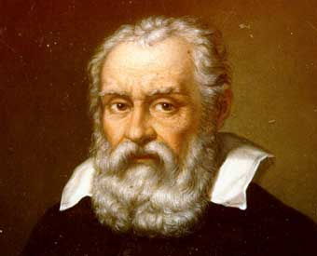

Galileo was one of the first scientists to consider the idea of relativity.

He stated that the laws of Physics should be the same in all inertial frames of reference.

He first described this principle in 1632 using the example of a ship, travelling at constant velocity, without rocking, on a smooth sea; any observer doing experiments below the deck would not be able to tell whether the ship was moving or stationary.

In other words, the laws of Physics are the same whether moving at constant speed or when at rest.

Newtonian Relativity

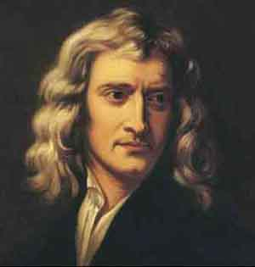Newton followed this up by expanding on Galileo’s ideas.

He introduced the idea of absolute, or universal space time.

He believed that it was the same time at all points in the universe as it was on Earth, not an unreasonable assumption.

According to Newton, absolute time exists independently of any perceiver and progresses at a consistent rate throughout the universe. Absolute space, in its own nature, without regard to anything external, remains always similar and immovable.

Useful Definitions and ideas

inertial reference frames: Simply two places that are moving at constant speeds relative to one another

absolute reference frame: A unique, universal frame of reference from which everything could be defined or measured. Einstein’s theories prove no such reference frame exists.

the ether: Early theories suggested that electromagnetic waves (light) required a medium (a space-filling substance or field) to travel through. This ether was believed to be an absolute reference frame. Modern theories have no requirement for this idea, and indeed the Michelson–Morley experiment performed in 1887 provided no evidence for such a field.

Example on relativity (at slow speeds)

You are standing in the back of a jeep moving at 30 mph directly toward a monkey in a tree, and you fire an arrow from a bow, which leaves the bow at a speed of 60 mph.

Relative to the monkey, what speed is the arrow traveling?

Relative speed of arrow = 60 + 30

= 90 mph

Einstein’s Special Relativity
In 1905, Albert Einstein published the theory of special relativity. This explains how to interpret motion between different inertial frames of reference.

Einstein did not appeal to the ether as an absolute frame of reference.
Instead, he explained observations in terms of the relative motion between two objects.

In essence, say for example, you and another astronaut, Amber, are moving in different spaceships and want to compare observations, all that matters is how fast you and Amber are moving with respect to each other.

Why SPECIAL relativity?
It is only special because this is a special case, where the motion between observers is uniform.
UNIFORM MOTION - Traveling in a straight line at a constant speed

The postulates on which Einstein based his theory of Special Relativity are:
- When two observers are moving at constant speeds relative to one another, they will observe the same laws of physics.
You cannot do any experiment to tell if you are in a stationary frame of reference or one moving at constant speed.
- The speed of light (in a vacuum) is the same for all observers, regardless of their motion relative to the light source.
Speed of light depends on the medium in which it is travelling, but cannot exceed 3 x 10⁸ ms⁻¹, the speed of light in a vacuum.

This means that if you were:
- at rest then speed of light is 3 x 10⁸ ms⁻¹
- in a moving frame of reference then the speed of light remains at 3 x 10⁸ ms⁻¹ when viewed by the person in that frame of reference
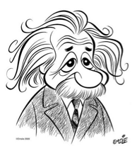No particular frame of reference is any more ‘stationary’ than any other.
As a consequence of Einstein’s theories, measured time and length will change for a moving system depending who is observing the system. c cannot change so from s = vt the time and the distances must change.

Understanding time dilation

Einstein’s theory of Special Relativity created a fundamental link between space and time.

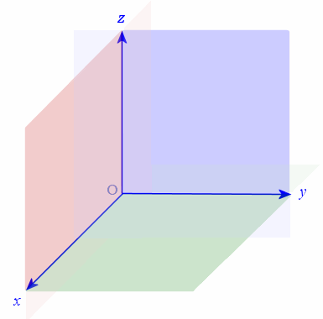The universe can be viewed as having:

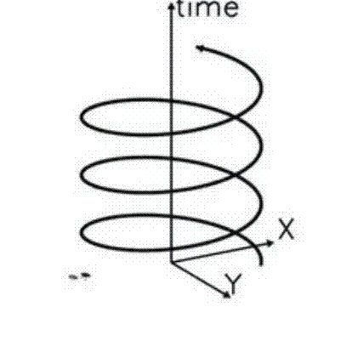Three space dimensions One time dimension
- Up/down
- left/right
- forward/backward

If you move fast enough through space, the observations you make about space and time differ somewhat from the observations of other people, who are moving at different speeds.

Einstein’s Thought Experiment

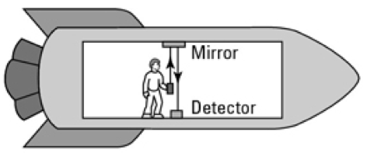Imagine that you’re on a spaceship and holding a laser so it shoots a beam of light directly up, striking a mirror you’ve placed on the ceiling. The light beam then comes back down and strikes a detector. We shall call this an event.

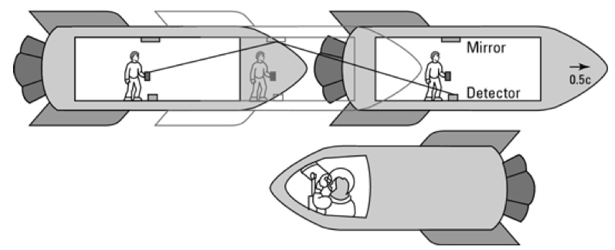However, the spaceship is traveling at a constant speed of half the speed of light, 0.5c.

According to Einstein, this makes no difference to you — you can’t even tell that you’re moving. However, if astronaut Amber were spying on you, it would be a different story.

Amber would see your beam of light travel upward along a diagonal path, strike the mirror, and then travel downward along a diagonal path before striking the detector. In other words, you and Amber would see different paths for the light and, more importantly, those paths aren’t even the same length.

Since Einstein’s 2nd postulate states that the speed of light is the same for all observers, because the beam Amber observes travels a greater distance, it must have happened in a longer time (if the speed of light is constant).

In other words, in Amber’s case, more time has passed for the event to happen, and the time on a ship moving very quickly appears to pass slower. Moving clocks run slow!

This phenomenon is known as time dilation.

Evidence for time dilation - Muons

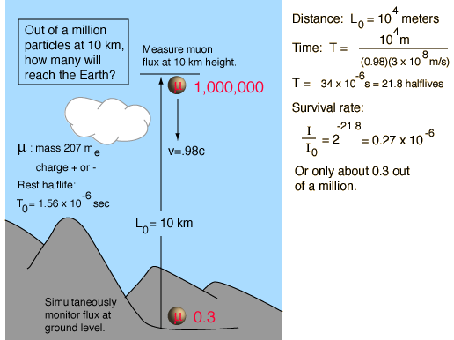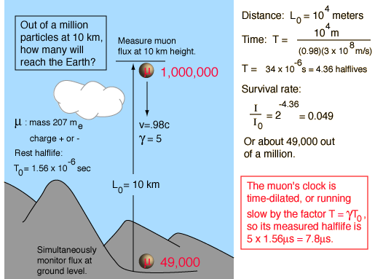There is experimental evidence to support Einstein’s theory. A particle known as a muon (see Particles and Waves unit) is created in the upper atmosphere. It only exists for a short time, having a half-life of 1.56 x 10⁻⁶ s. This means that for every million muons created at a height of 10 km, only 0.3 should reach the surface of the Earth.

However, around 50 000 are detected. This is because the muon is traveling very fast toward Earth, and so its clock runs slowly compared to an observer on Earth, and so the muon reaches the ground!

The time dilation formula

Moving objects run slower clocks as observed by a stationary observer. GPS satellites have to adjust their clocks to match the ones on Earth.

The key to using the time dilation formula is understanding the terms proper time (t) and dilated time (t’).

Proper time t: The time measured in the frame in which the clock is at rest relative
to the event is called the "proper time". The time will always be shorter in the rest frame.

Dilated time t’: If you are watching from somewhere else and you look at the clock on the moving object you will measure t’, the dilated time. The clock will be seen to be running slow.

The equation linking these two times is given as

v = speed object is moving at
c = speed of light
t = time measured by the observer at rest with respect to the event
t‘ = time measure by another observer moving relative to the event

Examples
1. The lifetime of a muon is 2.2μs. Muons travel at 99% the speed of light. How long do muons last for here on Earth?

2. A rocket is traveling at a constant 2.7 × 10⁸ ms^{–1} compared to an observer on Earth. The pilot measures the journey as taking 240 minutes. How long did the journey take when measured from Earth?

We do not notice this time difference in every day life because for speeds of 0.1c or smaller the Lorentz factor is approximately equal to 1.

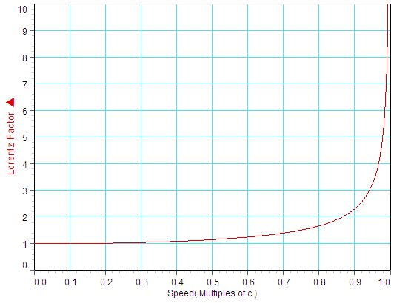The Lorentz Factor (γ) is part of the time dilation equation. It takes into account the speed of the object.

We can see that for small speeds (i.e. less than 0.1 times the speed of light) the Lorentz factor is approximately 1 and relativistic effects are negligibly small.
The Twin Paradox

The Twin Paradox helps us to understand the limitations of Special Relativity.

In this thought experiment, one of a pair of twins leaves on a high speed space journey during which he travels at a large fraction of the speed of light (let's say 0.995c) while the other remains on the Earth (stationary, relatively speaking). Because of time dilation, time is running more slowly in the spacecraft as seen by the earthbound twin and the traveling twin will find that the earthbound twin will be older upon return from the journey, let's say 1 year, from the travelers point of view.

Is this real?

The basic question about whether time dilation is real is settled by the muon experiment.

Would one twin really be younger?

The clear implication is that the traveling twin would indeed be younger, but the scenario is complicated by the fact that the traveling twin must be accelerated up to traveling speed, turned around, and decelerated again upon return to Earth.

Accelerations are outside the realm of special relativity and require general relativity.

Despite the experimental difficulties, an experiment on a commercial airline confirms the existence of a time difference between ground observers and a reference frame moving with respect to them.

Stationary Twin Travelling Twin

t' = time measured by observer t = time measured by traveller

traveller experiences 1 year
observer experiences 10 years

Length Contraction

Another implication of Einstein’s theory is the observed decrease in length of an object which is moving at high speeds. This is called length contraction, or more formally Lorentz contraction, and is only noticeable at a substantial fraction of the speed of light, and only in the direction parallel to the direction in which the observed body is travelling.
v = speed object is moving at
c = speed of light
= length measured by the observer at rest with respect to the moving object
' = contracted length of object as measured by another observer

Example
A rocket has a length of 10m when at rest on the Earth. An observer on Earth watches the rockets passing at a constant speed of 1.5 x 10⁸ ms⁻¹. Calculate the length of the rocket as measured by the observer.

Why an observer measures the length of a fast moving object as being contracted is related to the idea that the length of any object is found by knowing where the two ends of the object are, and determining the distance between them.
In relative motion, the position of both ends of the object cannot be determined simultaneously, which results in a contracted length measurement.

The Ladder paradox

The ladder paradox helps to explain how simultaneity relates to length contraction.

The problem starts with a ladder and an accompanying garage that is too small to contain the ladder.

Through the relativistic effect of length contraction, the ladder can be made to fit into the garage by running it into the garage at a high enough speed.

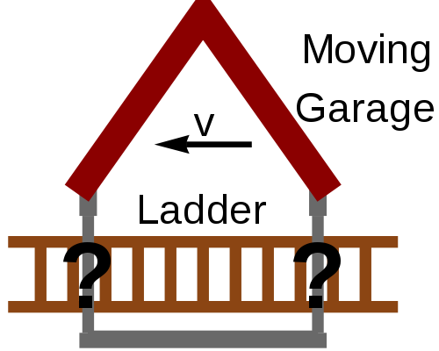Conversely, through symmetry, from the reference frame of the ladder it is the garage that is moving with a relative velocity and so it is the garage that undergoes a length contraction. From this perspective, the garage is made even smaller and it is impossible to fit the ladder into the garage.
Ladder paradox - solution

Both the ladder and garage occupy their own inertial reference frames, and thus both frames are equally valid frames from which to view the problem.

The solution to the apparent paradox lies in the fact that what one observer (e.g. the garage) considers as simultaneous does not correspond to what the other observer (e.g. the ladder) considers as simultaneous.

A clear way of seeing this is to consider a garage with two doors that swing shut to contain the ladder and then open again to let the ladder out the other side.

Garage reference frame Ladder reference frame
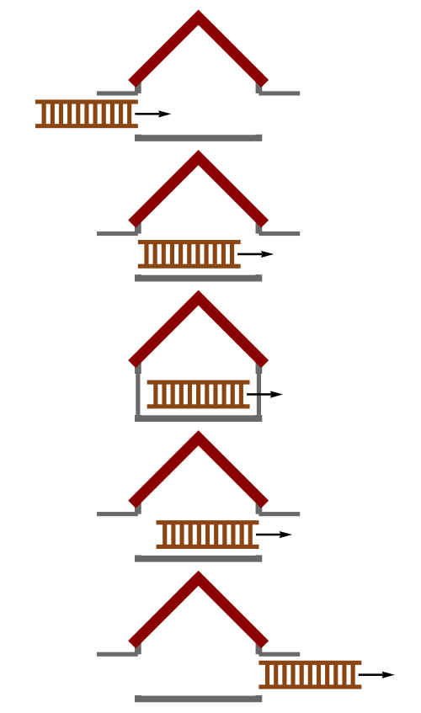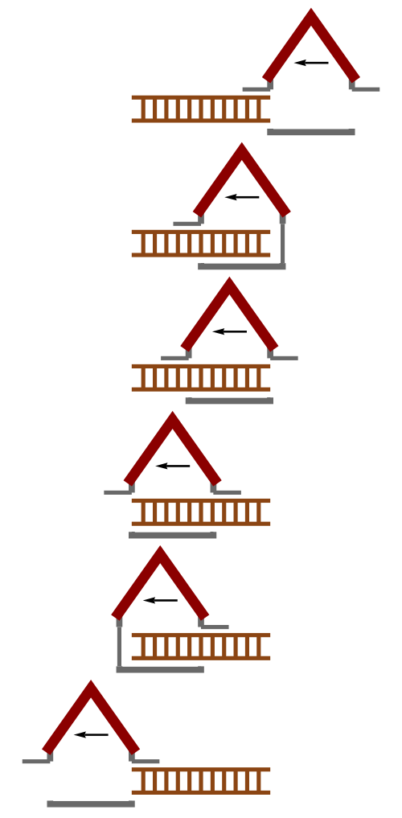

THE EXPANDING UNIVERSE

http://en.wikipedia.org/wiki/Length_contraction

From the perspective of the garage, the length-contracted ladder is short enough to fit entirely inside. The instant the ladder is fully inside the garage, the front and back doors close simultaneously. Then, since the ladder is still moving at considerable speed, the front and back doors simultaneously open again to allow the ladder to exit.

From the perspective of the ladder, the back door (right) closes and opens, then after the garage passes over the ladder, the front door (left) closes and opens.

The Doppler effect and redshift of galaxies.
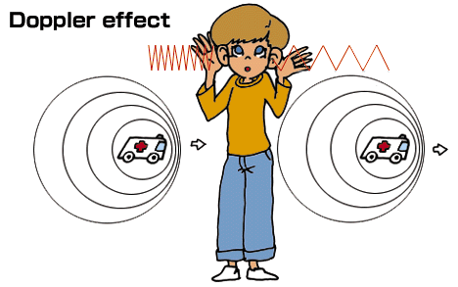
The Doppler effect is the change in frequency observed when a source of sound waves is moving relative to an observer.

A good example of this is an ambulance’s siren as it drives past.

In general more sound waves are received per second when the source of sound waves is moving towards the observer and so the frequency heard by the observer is increased. Similarly fewer sound waves are received per second when the source of sound waves is moving away from the observer and so the frequency heard by the observer is decreased.

If the source is moving towards the observer the frequency heard by the observer (f_{o}) is greater than the frequency of the source (f_{s}).

Hence if the source is moving away from the observer the frequency heard by the observer (f_{o}) is less than the frequency of the source (f_{s}).

The equation linking these two frequencies is:

f_{o} is the frequency heard by the observer (Hz)
f_{s} is the frequency of the source of the sound (Hz)
v is the velocity of the sound waves (ms⁻¹)
v_{s} is the velocity of the source (ms⁻¹)

If the source comes towards the observer, the frequency increases, use -ve
If the source goes away from the observer, the frequency decreases, use +ve

1. If a source of sound waves of frequency 10 Hz, is travelling towards an observer at 40 ms⁻¹ then the frequency heard by the observer will be…

2. If a source of sound waves of frequency 50 Hz, is travelling away from an observer at 10 ms⁻¹ then the frequency heard by the observer will be…

Applications of doppler effect

Ultrasound in Medicine

When a beam of ultra sound is sent into the body, any motion within the body causes a Doppler shift in the reflected ultrasound. This can be used to check the heat beat or blood flow of an unborn baby or find a deep vein thrombosis. Continuous, rather than pulse, ultrasound is used. Any differences between the ingoing and returning frequencies is heard as a tone or displayed on a screen

http://news.bbc.co.uk/local/southwestwales/hi/people_and_places/newsid_8556000/8556489.stm

Answering questions

Re-read your answers and make sure that the examiner can understand what you mean.

When frequency increases, wavelength decreases and vice-versa. So writing...

‘The Doppler effect is the change of wavelength and frequency when a source moves. If he source moves towards the observer it increases.’

...is not clear enough; the first sentence is OK, but the second could refer to the frequency or the wavelength so will gain no marks.

When you describe beams of travelling waves, some words can be used for distance or for time. Words such as ‘longer’ and ‘shorter’ may be unclear.

The Doppler effect for light

In the late 19th and early 20th centuries, astronomers observed that light from distant stars showed similar characteristics to the Doppler effect for sound.

When observing distant nebulae, astronomers observed that the wavelength appeared to increase. This suggested that the light was coming from a source, which was moving away from the earth. This is known as Red Shift.

Why?
When a source is moving away from an observer, the frequency observed by the observer is decreased because

So if f_{o} is less than the source frequency, then the observed wavelength will be greater than the wavelength of the source.

Spectral lines observed from stars are shifted towards longer wavelengths – the red end.

This meant if a source of light was travelling towards an observer, then the wavelength appeared to decrease. This is known as Blue Shift.

Why?
When a source is moving towards an observer, the frequency observed by the observer is increased because

So if f_{o} is greater than the source frequency, then the observed wavelength will be less than the wavelength of the source.

Spectral lines observed from stars are shifted towards shorter wavelengths – the blue end.

Observations show that the light from almost all other galaxies is red shifted and as such they are all moving away from us. This is why astronomers are able to put forward the idea that we are part of an expanding universe.

Red shift
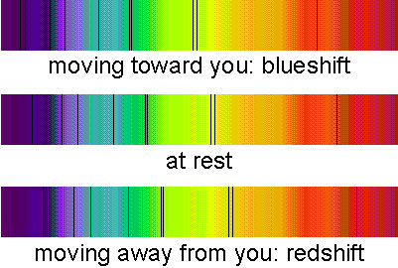

http://cosmology.net/images/redshift111.jpg

violet red
Information about a star’s temperature, composition and motion can be found by analysing its spectrum. Star motion can be fast enough to cause a detectable Doppler shift in light waves. If a star is moving away from the Earth, its spectral lines are shifted towards the red end of the spectrum. This also works for galaxies.
z = red shift (no units)
Δλ = λ_{observed} - λ_{rest}
λ_{observed} = wavelength measured by observer
λ_{rest} = wavelength measured at source
v = velocity of source
c = speed of light

(Note that the Doppler effect equations used for sound cannot be used with light from fast moving galaxies because relativistic effects need to be taken into account.)

Hubble's Law

The astronomer Edwin Hubble noticed in the 1920’s that the light from some distant galaxies was redshifted.
distance
recession velocity
Hubble discovered:
v = recession velocity
H₀ = Hubble Constant
d = distance to galaxy
(gradient of
graph = H₀)

For each element, the spectral lines were all shifted by the same amount for each galaxy. This shift was due to the galaxy moving away from Earth at speed.

Over a few years, he examined the redshift of galaxies at varying distances from Earth. The further away a galaxy was, the faster it was travelling.

This relationship between distance and speed of galaxy is known as Hubble’s Law.

Age of the Universe

If galaxies are travelling away from us, in the past they must have been closer (ie, matter must once have been packed in a small volume). By working back in time it is possible to calculate a time where all the galaxies were in fact at the same point in space. This allows for the age of the universe to be calculated. Currently, NASA have a value of 13.7 billion years as the age of the universe from this method.
Hubble’s constant H₀ as approximated by SQA = 2.4 x 10⁻¹⁸ s⁻¹

Therefore, age of universe is approximately 4.2 x 10¹⁷ s, equating to 13.2 billion years.

How do we know the distance to stars and galaxies?

If we know the luminosity of a star (how quickly it produces energy), the distance to the star is measured by how bright it appears to us.

Distance to stars: Parallax
distant 'fixed' stars
Earth in June
Earth in December
Sun
'nearby' star
parallax angle

As Earth orbits Sun, stars appear to move against the background of other distant stars

By measuring the parallax angle, distance can be calculated using trigonometry.

Distance to galaxies: inverse square law

The distance to a star or galaxy is worked out by comparing apparent brightness (how bright an object appears) and absolute brightness (how much light is actually produced).

Note: We still need to know the luminosity of ‘standard candles’ eg. cepheid variable stars (whose brightness varies regularly with a period)

Evidence fot the expanding Universe

Deductions from Hubble’s Law

Hubble’s Law suggests that galaxies farther from us are moving away faster than galaxies closer to us, which in turn leads us to conclude that the universe is expanding. The fate of the universe (whether the expansion will continue for ever or slow and then start to contract) depends on how much matter is in the universe. Matter causes gravity - enough gravity could slow the rate of expansion or stop it entirely.

So is there enough matter in the Universe to slow expansion?

Problem one: What's (Where’s) the matter - a local case study

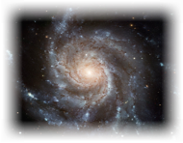

our Sun

In the same way that Earth orbits the Sun, our Sun orbits around our galaxy (with a period of approx. 240 million yrs).

With some simple Physics (see rotational motion in Advanced Higher Physics!) it can be determined that:

The speed of rotation of any object is determined by the size of the force maintaining its rotation. For the sun, this central force is due to gravity, which is determined by the amount of matter inside the Sun’s orbital path. If we know the rotational speed of the Sun we can calculate how much force is required to keep it in orbit, and hence the amount of matter in our galaxy!

Dark Matter The stuff we can‘t see!

PROBLEM: Calculations of the amount of matter in the galaxy suggest there is more than astronomers can detect.

Problem two: What's (How's) the matter not having an effect?

There is normal matter and Dark matter - all contributing to gravity. Why doesn’t it slow the expansion rate of the universe?

Gravity is an attractive force. All the matter in the universe is acting to slow the rate of expansion. However, measurements of the expansion rate of the Universe lead to the conclusion that the rate of expansion is actually increasing!

Dark Energy

It’s what’s driving all the expansion

PROBLEM: Something is overcoming the force of gravity to cause the universe to expand at an ever greater rate

The temperature of stellar objects

What’s stellar temperature got to do with Big Bang theory?

The Big Bang theory states that the universe started with a sudden appearance of energy at a singular point, which consequently (and very quickly) became matter, and then expanded and cooled rapidly. The theory therefore predicts that the universe should now, 13.7 billion years later, have a very cool temperature. If we can measure this temperature we can see if it accords with Big Bang theory.

If we can understand stellar temperatures, it can help us know how to find the average temperature of the universe.

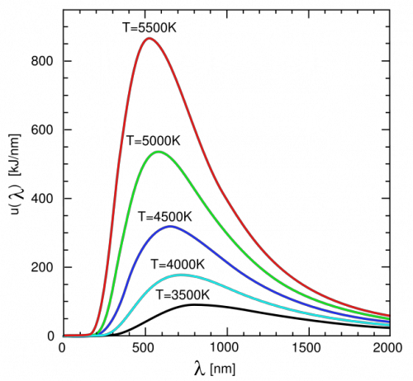Thermal emission peak

Stars emit radiation over a wide range of wavelengths.

The graph to the right is called a thermal emission peak which shows how the intensity of radiation produced (y-axis) from stars of different temperatures (the different lines on the graph) is related to the wavelength of light emitted from the star.

Essentially thermal emission peaks allow the temperature of stellar objects to be determined.

Three details emerge from studying these peaks:
- Stellar objects emit radiation over the complete electromagnetic spectrum.
- Each stellar object has a peak wavelength that depends on its temperature.
- As the temperature of the star increases:
  - There is more energy (intensity of radiation) at each wavelength
  - The peak wavelength shifts to shorter wavelengths

(Hotter stars emit bluer wavelengths)
Evidence for the Big Bang

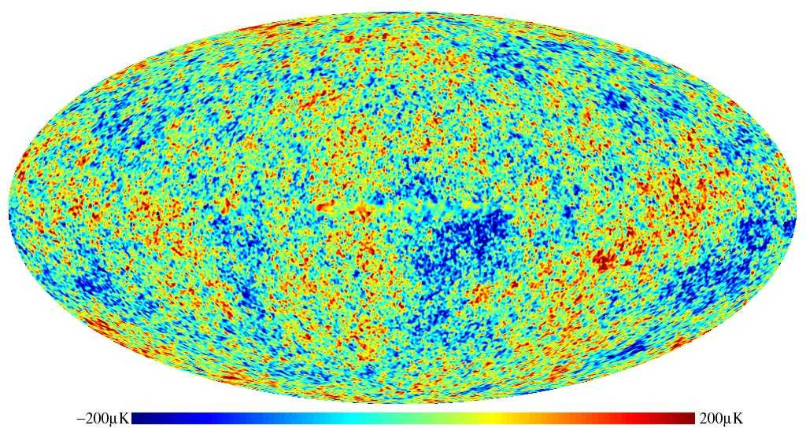When The Universe was very young, matter was at such a high temperature that it existed in a plasma state, where electrons were delocalised from their associated protons. In this state light (EM radiation) is not able to propagate, since it will interact with any electron or proton it encounters. As the Universe expanded the plasma cooled down enough (after about 380,000 years) for the recombination of electrons with protons and electromagnetic radiation was able to travel. This initial EM radiation has been travelling ever since, however, due to the expansion of the universe its energy has decreased and its wavelength increased into the microwave region of the spectrum. Fluctuations in this Cosmic Microwave Background are caused by variations in the density of the plasma at the time of release, since its distribution was not uniform. These greater densities may well be responsible for the later formation of galaxies. In fact, the first stars did not start to shine until 100 million years after the Big Bang.
Cosmic Microwave Background
http://www.sns.ias.edu/~dgrin/Research.htm

The CMB is a strong piece of evidence to support the Big Bang Theory and no other model is able to explain the presence of the CMB.

Finally, however, while the expansion is evident from observation (redshift) and the “image” taken 380,000 years after some Big Bang supports this, there is no direct evidence of the “Bang” itself. Big Bang suggests that everything started from nothing with an explosion and immediate appearance of matter which was not there before. Along with this theory it is suggested that time itself also began at the Big Bang. The initial conditions of the Universe are not clearly defined. Really we are looking at the Big Expansion Theory, since we have no definitive idea of what happened at the “start”. There is still a lot to discover.

The average temperature of the universe predicted by the Big Bang is around 2.73 Kelvin (K)

Astronomers have used a telescope called COBE (Cosmic Background Explorer) to detect radiation in the microwave region. The data collected fits the predicted thermal emission peak perfectly, confirming the average temperature measured is as predicted by the Big Bang theory.

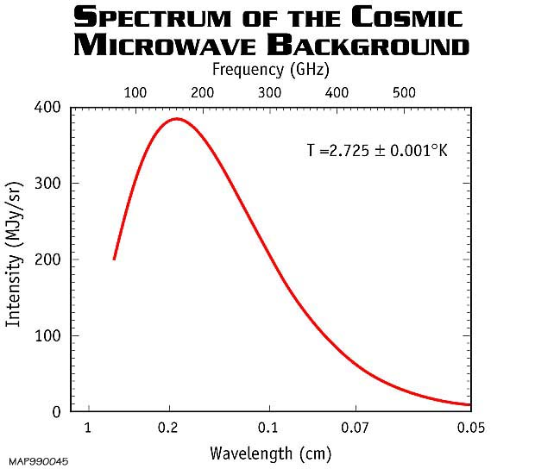

Remember, low temperatures have longer wavelengths

Coldest will be in microwave region of e-m spectrum

Note:

0°C = 273K

0K = -273°C

