Airdrie Academy

Higher Chemistry

Topic 1

Chemical Changes and Structure Homework
Section 3 – Structure and Bonding

Complete questions in homework jotter.
Do NOT write on the sheets.

Homework 1

1. Here are the shapes of some common molecules.
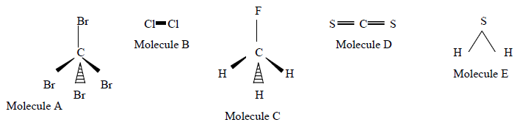

- What word is used to describe the shape of molecules A and C?

- Which molecule has the same shape as a molecule of water?

- Which molecule(s) have polar covalent bonds and consist of polar molecules?

- Which molecule(s) have polar covalent bonds but are non-polar molecules?

- Which TWO molecules contain bonds which are considered to be pure covalent?

2. The shapes of some common molecules are shown. Each molecule contains at least one polar covalent bond. Which of the following molecules is non-polar?
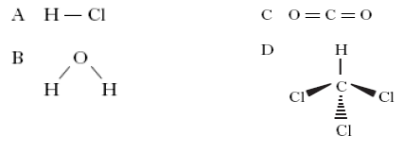

3. At room temperature, a solid substance was shown to have a lattice consisting of positively charged ions and delocalised outer electrons.
The substance could be

A graphite
B sodium
C mercury
D phosphorus.

Homework 2

1. When two atoms form a non-polar covalent bond, the two atoms must have

A the same atomic size
B the same electronegativity
C the same ionisation energy
D the same number

2. a) There are three types of structures that are found in elements:
1) metallic lattice,
2) covalent network and
3) covalent molecular.

Use the elements in period 2 (elements 3 to 10) to give one example of each type of structure. (3)

b) Look at the substances listed below and decide whether each would conduct electricity. You must explain your answer.

i) solid rubidium chloride
ii) liquid gallium
iii) liquid nitrogen

3. Use the table below to answer the following questions.
Compound | Formula | Formula Mass (g) | Boiling Point (0C)
Ethane | CH3 CH3 | 30 | - 89
Methanol | CH3OH | 32 | 64
Hydrazine | NH2 NH2 | 32 | 113
Silane | SiH4 | 32 | -112

- Which of the above compounds will have hydrogen bonding?

- Explain why the boiling point of Hydrazine is much higher than silane.

c) Why is the boiling point of Hydrazine higher than that of methanol?

Homework 3

- The elements from sodium to argon make up the third period of the Periodic Table.

- On crossing the third period from left to right there is a general increase in the first ionisation energy of the elements.
Why does the first ionisation energy increase across the period?

- The electronegativities of elements in the third period are listed on page 10 of the databook. Why is no value provided for the noble gas, argon?

2. Which of these is true for a covalent network?

A molecules are linked by London’s forces
B covalent bonds extend throughout the structure
C covalent bonds exist within molecules
D covalent bonds link ions into one network

3. Hydrogen will form a non-polar covalent bond with an element which has an electronegativity value of

A 0·9
B 1·5
C 2·2
D 2·5.

4. Which property of a chloride would prove that it contained ionic bonding?
A It conducts electricity when molten.
B It is soluble in a polar solvent.
C It is a solid at room temperature.
D It has a high boiling point.

5. In a covalent molecular substance…..

A all molecules are joined to each other by covalent bonds
B London’s forces link atoms within each molecule
C covalent bonds only exist within distinct molecules
D all the atoms are linked to form a lattice

Homework 4

1. London dispersion forces…………

A are so weak as to be unimportant
B determine the melting point
C weaken the covalent bonds
D make the atoms larger

2. Non-polar solvents tend to dissolve.

A metallic substances
B ionic substances
C polar substances
D non-polar substances

3. Ionic compounds have high melting points because……

A the forces between the ions are strong
B the atoms share more than one electron
C they have stable electron arrangements
D there are an equal number of positive and negative ions

4. Ions are held together in a lattice by
A shared electrons
B electrostatic forces
C covalent bonds
D exchanging protons

5. Solid metals are able to conduct electricity because……

A their outer electrons are free to move
B their inner electrons are free to move
C their ions can move in the lattice
D the atoms can move in the lattice

Homework 5

1. Which of the following atoms has the least attraction for bonding electrons?
A Carbon
B Nitrogen
C Phosphorus
D Silicon

2. Which of the following reactions refers to the third ionisation energy of aluminium?

A Al(s) → Al³⁺(g) + 3e–
B Al(g) → Al³⁺(g) + 3e–
C Al²⁺(g) → Al³⁺(g) + e–
D Al³⁺(g) → Al⁴⁺(g) + e–

3. At room temperature, a solid substance was shown to have a lattice consisting of positively charged ions and delocalised outer electrons.

A graphite
B sodium
C mercury
D phosphorus

4. Noble gases are described as monatomic because they all

A form molecules in which every atom is the same
B exist as single uncombined atoms
C have very stable electron arrangements
D belong to the same group in the periodic table

5. Element X was found to have the following properties.
(i) It does not conduct electricity when solid.
(ii) It forms a gaseous oxide.
(iii) It is a solid at room temperature.

Element X could be

A magnesium
B silicon
C nitrogen
D sulphur.

6. Which of the following shows the types of bonding in decreasing order of strength?
A Covalent : hydrogen : London’s forces
B Covalent : London’s forces : hydrogen
C Hydrogen : covalent : London’s forces
D London’s forces : hydrogen : covalent

7. There are many types of attractive force, some are weak and some are strong.

A positively charged ions and negatively charged ions
temporary dipole and induced dipole
C positively charged nuclei and delocalised electrons
D permanent dipole and permanent dipole
E positively charged nucleii and shared electrons

Identify the statement(s) referring to
- van der Waals’ forces

- the forces between oxygen and hydrogen atoms in water

- the intemolecular forces in HCl gas.

d) ionic bonds

Homework 6
1. Which of the following substances is a non-conductor but becomes a good conductor on melting?

A Solid potassium fluoride
B Solid argon
C Solid potassium
D Solid tetrachloromethane

2. Particles with the same electron arrangement are said to be isoelectronic. Which of the following compounds contains ions which are isoelectronic?

A Na₂S
B MgCl₂
C KBr
D CaCl₂

- The covalent bond in hydrogen chloride gas is polar and the molecule is polar. The covalent bonds in silicon tetrachloride are also polar. Explain why the silicon tetrachloride molecule is non-polar.

4. What type of bond is broken when ice is melted?
A Covalent
B Polar covalent
C London’s forces
D Hydrogen bonds

5. Which of the following has a covalent molecular structure?
A Argon
B Fullerne
C Calcium chloride
D Silicon dioxide

6. There are many types of bonding force between atoms and molecules.
A  permanent dipole to permanent dipole interactions | B  non-polar covalent bonds | C  hydrogen bonds
D  ionic bonds | E  metallic bonds | F  London dispersion forces

- Identify the three forces present in hydrogen fluoride.

- Identify the force(s) present in

- methane
- sodium chloride
- hydrogen bromide
- Neon
- Oxygen

- Identify the bond(s) and/or force(s) of attraction

i) responsible for the low boiling point of argon.
ii) that can exist between molecules.
iii) that allow electrons a lot of free movement.

7. Which of the compounds below have:
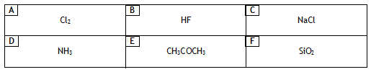

Identify the substance(s) where the intermolecular forces are
a) van der Waals’ forces only.
b) hydrogen bonds
Homework 7

1. a) What is meant by “the electronegativity” of an element?
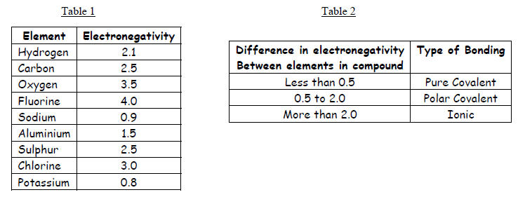
- Look at the information in tables 1 and 2, then use the information to predict the type of bonding in the compounds named below

i)hydrogen sulphide
ii) sodium fluoride
iii) potassium oxide
iv) aluminium chloride
v) ethane
vi) water

2. Elements and compounds show a variety of structures.
A  Cl₂ | B  Na | C  NaCl
D  SiO₂ | E  NH₃ | F  C(diamond)

Identify the substance(s)

a) with a tetrahedral arrangement of bonds in a covalent network.
b) which can conduct electricity because of delocalised electrons.
c) with discrete covalent molecules

3. Many of the properties of water arise from the presence of polar O - H bonds which make the water molecules polar.
Carbon dioxide contains polar C = O bonds but its molecules are non-polar.

- Explain this difference with the aid of diagrams of each molecule, showing polarities.

b) Water is unusual in that in the solid form (ice) is less dense than the liquid form.
Explain why water behaves in this way.

Homework 8

1. Both bonded and non-bonded pairs of electrons repel each other and this determines the shape of the molecule.
The following procedure is used to find the total number of pairs of electrons around a central atom.
(i) Note the number of electrons in the outer energy level (shell) of the central atom.
(ii) Note the number of other atoms present --- each atom provides one electron for bonding.
(iii) Add (i) and (ii) to give the total number of electrons.
(iv) Divide this number by two to give the number of electron pairs - both bonded and non- bonded pairs.
Example:- with ammonia, NH₃, N is the central atom.
(i) 2,5 = 5 electrons
(ii) 3H 3 x 1 = 3 electrons
(iii) Total = 8 electrons
(iv) 8 electrons gives four pairs.
Since NH₃ only has 3 bonds there is one non-bonded pair. The 4 pairs of electrons repel each other, giving the pyramid shape of the ammonia molecule as shown in the first row of the table.

Copy and complete the table.
Formula | Outer electrons in central atom | Total number of electrons | Bonded pairs | Non-bonded pairs | Molecular shape
NH₃ | 5 | 8 | 3 | 1
CCl₄ | 4 |  | 4 | 0
BeCl₂ | 2 | 4 | 2
PF₅ |  | 10 | 5

Homework 9

1.a) Predict the type of bonding (non-polar covalent, polar covalent or ionic) between the following elements.

i) magnesium and sulphur
ii) oxygen and phosphorus
iii) nitrogen and nitrogen
iv) fluorine and oxygen

- Justify, by reference to electronegativity values, your answers to i) and iv).

2. The boiling points of compounds depend on the intermolecular forces.

Name | Formula | Molecular mass | Boiling point (⁰C)
butane | CH₃CH₂CH₂CH₃ |  | - 0.5
propanone | CH₃COCH₃ |  | 56

a) Copy the table and calculate the molecular mass for each compound.
b) Explain why the boiling points are different.

3. The Group 5 hydrides are covalent compounds.
Compound | Enthalpy of formation/kJ mol⁻¹ | Boiling point/K
NH₃  PH₃  AsH₃ | -46  +6  +172 | 240  185  218

- What is the trend in stability of the group 5 hydrides?

b) Explain why the boiling point of NH₃ is higher than the boiling point of PH₃ and AsH_{3.}

4.The table below shows the boiling point, molecular mass and structure of the simplest alkanol, methanol, the simplest alkanoic acid, methanoic acid and the ester methyl methanoate which forms when the acid and the alkanol react together in a condensation reaction.

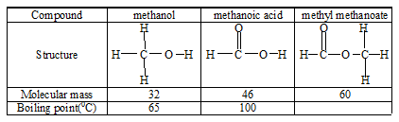

- Using molecular mass as the only criterion, use the boiling points of methanol and methanoic acid to predict the boiling point of methyl methanoate and put it in the table.

- The boiling point of the ester is in fact 32⁰C. Explain in terms of the intermolecular forces why this value is so different from your prediction.

Homework 10

1. The bar chart shows the melting points of chlorides of elements 3 to 20 (with no bars for 10, 15 and 18).
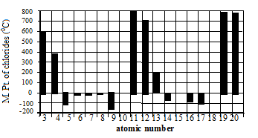

a) Copy and complete this statement describing the pattern for these melting points related to the Group number.
In general as the Group number increases the melting point of the chloride ................

b) Explain why no values are given for elements 10 and 18.
c) From the bar chart, state which of the chlorides has the weakest forces between the molecules.

d) Predict a value for the melting point of the chloride of element 15.

2. Consider the substances: potassium, bromine and potassium bromide.
a) Construct a table to show the type of bonding, the structure, the solubility or reaction with water, the state at room temperature and the electrical conductivity of the three substances.

b) Explain the solubility of potassium bromide in water in terms of its bonding.

- Explain in terms of its structure and bonding why silicon carbide can be used to make stones for sharpening chisels and knives.

- Lithium iodide is quite soluble in non-polar solvents e.g. white spirit (a mixture of hydrocarbons).

- What does this statement suggest about the type of bonding in lithium iodide?

b) State, with an explanation, whether you would expect lithium fluoride to be more or less soluble than lithium iodide in non-polar solvents.

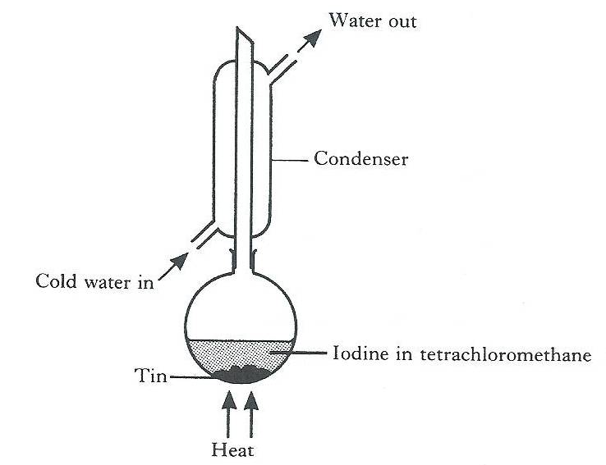
5. Tin iodide can be prepared directly from its elements.
Excess tin is heated for about an hour with iodine dissolved in tetrachloromethane.
Tetrachloromethane, which has a boiling point of 77 ºC, acts as a solvent for both the iodine and the tin iodide that is formed.
When the reaction is complete, the excess tin is removed. On cooling the remaining solutions, orange crystals of tin iodide appear.
The crystals have a melting point of 144 ºC.
(a) Why is a condenser used when heating the reaction mixture?

- Give two pieces of evidence from the method of preparation which suggest that tin iodide is a discrete molecular covalent compound.

(c) What type of bonds would be broken when tin iodide melts?

