Airdrie Academy

Higher Chemistry

Unit 1

Chemical Changes and Structure Homework

Section 2 – Periodicity

Complete questions in homework jotter.

Do NOT write on the sheets

**Homework 1**

1. Copy and complete the following statements.

a) i) Electronegativity is a measure of the ............................... an atom in a covalent bond has for the ...................... electrons of the bond.

ii) In the Periodic table electronegativity .............................. across a period and.............................. down a group.

b) In each of the following pairs identify the element with the greater electronegativity.

i) phosphorus or carbon ii) silicon or nitrogen

2. All types of bonding involve electrostatic attraction between positively charged particles and negatively charged particles.

Copy and complete the table showing the three types of **strong** bonding force.

|  |  |  |
| --- | --- | --- |
| **Type of bonding** | **Positively charged particles** | **Negatively charged particles** |
|  |  | shared electrons |
| ionic |  |  |
|  | positive nucleus |  |

3. a) Graph 1 shows the boiling points of the Group 7 elements. Why do the boiling points increase down Group 7?

b) Graph 2 shows the melting points of elements from lithium to neon across the second period. Give reasons for the high melting points of boron and carbon.

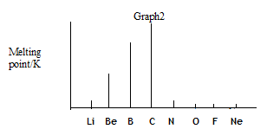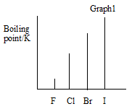

**Homework 2**

1. The Periodic Table below has been divided into four sections - **A, B, C** and **D.**

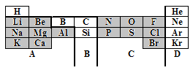

1. State the type of structure in each of the four sections A, B, C and D.

b) In which section(s) will van der Waals’ forces between the particles be significant.

c) Using elements in the above table as examples, explain briefly the difference between a covalent molecular substance and a covalent network substance

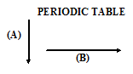.

2. a) Which arrow (A) or (B) indicates correctly a decrease in atomic size?

b) Explain why atomic size decreases in this way.

3. a) Define the **first ionization energy** of an element**.**

1. Which arrow (A) or (B) indicates correctly a decrease in the first ionisation energy of elements?

c) Give two reasons why the ionisation energy decreases in this way.

**Homework 3**

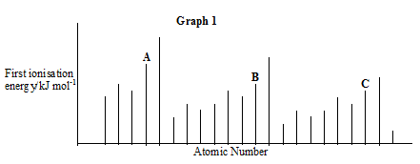1. The graph below shows the first ionisation energies of successive elements with increasing atomic number.

Elements A, B and C belong to the same group of the Periodic Table. Identify the group

2. Explain why the third ionisation energy of magnesium (7750 kJ mol-1) is so much greater than the third ionisation of aluminium (2760 kJ mol-1).

3. Ionisation energies can be found by applying an increasing voltage across test samples of gases until the gases ionise.

The results below were obtained from experiments using hydrogen atoms and then helium atoms.

|  |  |  |
| --- | --- | --- |
| Element | Voltage at which an atom  of gas ionises/V | |
| hydrogen | 13.6 | no further change |
| helium | 24.6 | 54.5 |

1. Why are there two results for helium but only one for hydrogen?
2. (i) Write an equation which would represent the first ionisation energy of helium gas.
3. (ii) Why is the first ionisation of helium higher than that of hydrogen?

c) The ionisation energy, I.E. , can be found from:

I.E. = voltage x 1.6 x 10-19 J

Calculate a value for the first ionisation energy of helium. (see table on previous page)

**Homework 4**

1. Use this table to answer the following questions.

|  |  |  |  |  |
| --- | --- | --- | --- | --- |
| **Ionisation Energy (kJ mol –l)** | **1st** | **2nd** | **3rd** | **4th** |
| Lithium | 526 | 7310 | 11800 | - |
| Sodium | 502 | 4560 | 6920 | 9540 |
| Magnesium | 744 | 1460 | 7750 | 10500 |

1. Explain why no value is given for the fourth ionisation energy of Lithium.

b) Explain why the first ionisation energy of Sodium is less that the first ionisation

energy of Magnesium.

c) Explain why the first ionisation energy of Sodium is less than the first ionisation

energy of Lithium.

d) Explain why the second ionisation energy of Sodium is far larger than the second

ionisation energy of Magnesium.

2. An ionic radius is the distance from the nucleus to the outermost energy level in an ion.

|  |  |  |  |  |  |  |  |  |
| --- | --- | --- | --- | --- | --- | --- | --- | --- |
| **Ion** | Li+ | Be2+ | B3+ | C4+ | N3- | O2- | F- | Ne |
| **Radius (pm)** | 68 | 35 | 23 | 16 | 171 | 132 | 133 | - |

1. Why do values decrease from Lithium to Carbon?
2. Why is there a large increase from Carbon to Nitrogen?

c) Why is there no value for Neon?

**Homework 5**

1. The graph shows the melting points of successive elements across a period in the periodic table

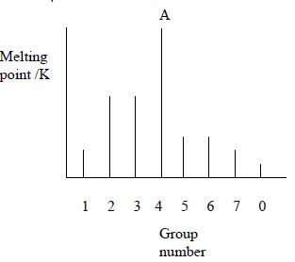

1. Use a data booklet to help you decide which period of the Periodic Table is covered by this graph.
2. Which type of element has the lowest melting point?

c) What type of bonding is present in element A?

2. The spike graph shows the variation in the first ionisation energy with atomic number for sixteen consecutive elements in the periodic table. The elements at which the spike

graph starts are not specified.

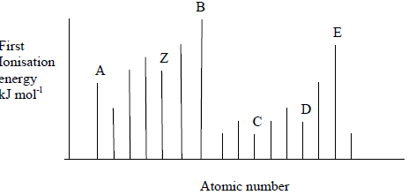

1. State the meaning of “first ionisation energy”.
2. Explain why the graph supports the idea that the properties of the elements are “periodic” in character.
3. One of the lettered elements belongs to the same group as Z. Which one?

d) Which letters represent elements that are noble gases?