Name:

Airdrie Academy

Higher Chemistry

Topic 1

Chemical Changes and Structure Homework

Subsection 1 - Rates

Complete questions in homework jotter.

Do NOT write on the sheets.

**Homework 1**

1. A pupil made the following observations on dripping taps.

45cm3 of water was collected from Tap A in 3 minutes.

340 cm3 of water was collected from Tap B in 20 minutes.

By calculating the average rate of loss of water from each tap, find out which tap was dripping faster.

2. A farmer records the weight of his pigs every Monday. Here is part of the record for one of the pigs.

|  |  |  |  |
| --- | --- | --- | --- |
| Date | Weight (kg) | Date | Weight (kg) |
| Jan 1 | 75.85 | Jan 22 | 83.70 |
| Jan 8 | 76.50 | Jan 29 | 86.90 |
| Jan 15 | 79.10 | Feb 5 | 92.10 |

Calculate the average rate of weight gain per week:-

1. during the first week
2. during the first three weeks
3. over the five week period
4. A pupil was attempting to measure the rate of a chemical reaction which produced a gas.

After six seconds 8cm3 of gas had been collected.

After ten seconds the total volume of gas collected was 14cm3.

Calculate the average rate of the reaction during this time interval (from six to ten seconds)

**Homework 2**

1. 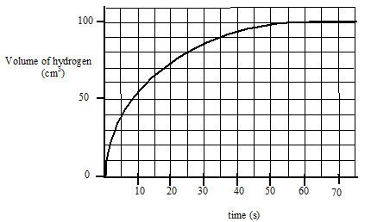The graph below shows the volume of hydrogen gas released when a 10cm strip of magnesium (mass = 0.1g) was added to 30cm3 of 1 mol l-1 hydrochloric acid.

(a) Calculate the average rate of reaction

i) over the first 15 seconds

ii) between 20 and 30 seconds

(b) How long did it take for the reaction to stop?

(c) The graph shows that the rate of reaction changes as the reaction proceeds. Explain why it changes in this way.

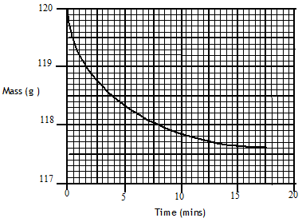2. Marble chips (calcium carbonate), reacted with excess dilute hydrochloric acid.

The rate of reaction was followed by recording the mass of the container and the reaction mixture over a period of time. The results of the experiment are shown in the following graph.

(a)Write a balanced equation for the reaction.

(b) Give a reason for the loss of mass of the container.

(c) Calculate the average rate of reaction over the first five minutes.

**Homework 3**

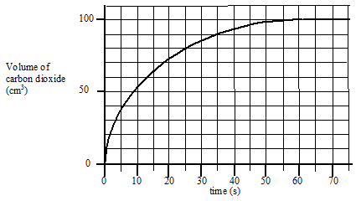1. The results shown below were obtained when 0.42 g of powdered chalk was added to cm3 hydrochloric acid, concentration 2 mol l-1 (an excess of the acid).

1. Sketch the graph and add a **solid** line to the graph to show what would happen if 0.42g of chalk lumps was used instead of powdered chips.

(b) Add a **dotted** line to the graph to show what would happen if 20 cm3 of 3 mol l-1 hydrochloric acid was used instead of 2 mol l-1 hydrochloric acid.

2. 1.0 g of zinc was placed in 20 cm3 of 2 mol l-1 hydrochloric acid.

After 20 seconds the zinc was removed, washed, dried and re-weighed.

The remaining zinc weighed 0.35 g.

(a) Write a balanced chemical equation for the reaction.

(b) Calculate the average rate of the reaction.

(c) Calculate the number of moles of hydrochloric acid used up in the 20 seconds.

**Homework 4**

1. A pupil was investigating the effect of temperature on the rate of a chemical reaction and obtained the following data.

|  |  |  |  |  |  |
| --- | --- | --- | --- | --- | --- |
| Temperature (oC) | 15 | 25 | 33 | 37 | 44 |
| Time for reaction to finish (s) | 154 | 66.7 | 40 | 30.3 | 22.2 |
| Relative rate ( .......... ) |  |  |  |  |  |

(a) Copy the table and calculate the relative rate of reaction at each temperature and add them to the table, putting the correct units in the brackets.

(b) Plot a graph of relative rate against temperature.

(c) Predict what the **relative rate** of the reaction will be at 50 0C.

(d) Use the graph to estimate the **time** for the reaction to finish at 40 0C.

2. (a) Explain:

i) Why decreasing the particle size increases the rate of a chemical reaction.

ii) Why increasing the concentration speeds up a chemical reaction.

(b) Give an everyday example of a reaction speeded up by

i) decreasing the particle size

ii) increasing the concentration

**Homework 5**

1. When hydrochloric acid is added to a solution of sodium thiosulphate the following reaction takes place.

2HCl(aq) + Na2S2O3(aq) 🡪2NaCl(aq) + SO2(g +S(s)+ H20(l)

Solid sulphur forms in the solution.

In one set of experiments the effect of varying the concentration of sodium thiosulphate was studied. Some of the volumes of solutions used are shown.

|  |  |  |  |
| --- | --- | --- | --- |
| Volume of 0.05 mol l-1  Na2S2O3(aq)/ cm3 | Volume of water/ cm3 | Volume of 0.1 mol l-1  HCl(aq)/ cm3 | Reaction time /s |
| 200 | 0 | 5 | 20 |
| 160 |  |  | 25 |
| 120 |  |  | 33 |
| 80 |  |  | 50 |
| 40 |  |  | 100 |

(a) Copy and then complete the table to show the volumes of water and acid that would have been used.

(b) Describe how the reaction time could have been measured.

(c) Describe how the relative rate of reaction would be obtained from each of the results.

2. Hydrogen peroxide can be used to clean contact lenses. In this process, the enzyme catalase is added to break down hydrogen peroxide. The equation for the reaction is:

2H2O2  **🡪** 2H2O + O2

The rate of oxygen production was measured in three laboratory experiments using the same volume of hydrogen peroxide at the same temperature.

|  |  |  |
| --- | --- | --- |
| Experiment | Concentration of H2O2/ mol l-1 | Catalyst used |
| **A** | 0.2 | yes |
| **B** | 0.4 | yes |
| **C** | 0.2 | no |

The curve obtained for experiment **A** is shown.

(a) Calculate the average rate of the reaction over the first 40 seconds.

(b) Copy the graph and add curves to the graph to show the results of experiments B and C. Label each curve clearly.

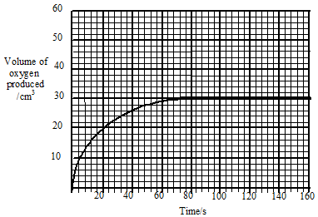

**Homework 6**

1. The graph shows the concentrations of reactant and product as equilibrium is established in a reaction.

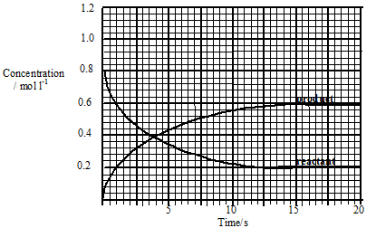

(a) Calculate the average rate of reaction over the first 10 s.

(b) The equilibrium constant for a reaction is given the symbol ***K***

In this reaction ***K*** is given by:

***K*** = equilibrium concentration of product

equilibrium concentration of reactant

Calculate the value of ***K*** for the reaction.

(c) The reaction is repeated using a homogeneous catalyst.

(i) What is meant by a homogeneous catalyst?

(ii) What effect would the introduction of the catalyst have on the value of ***K***?

2. Excess zinc was added to 100 cm3 of hydrochloric acid, concentration 1 mol l–1. Graph I refers to this reaction.

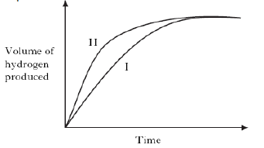

Graph II could be for…………….

A excess zinc reacting with 100cm3 of hydrochloric acid, concentration 2mol l–1

B. excess zinc reacting with 100cm3 of sulphuric acid, concentration 1 mol l–1

C. excess zinc reacting with 100cm3 of ethanoic acid, concentration 1 mol l–1

D. excess magnesium reacting with 100cm3 of hydrochloric acid, concentration 1 mol l–1.

3. The graph shows how the rate of a reaction varies with the concentration of one of the reactants.

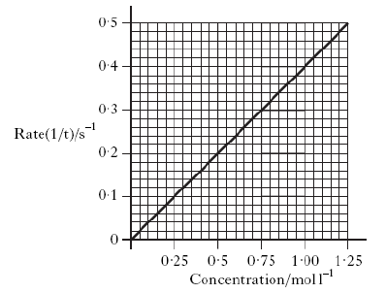

What was the reaction time, in seconds, when the concentration of the reactant was 0.50 mol l–1?

A 0.2

B 0.5

C 2.0

D 5.0

**Homework 7**

1. The potential energy diagram below refers to the reversible reaction involving reactants **R** and products **P**.

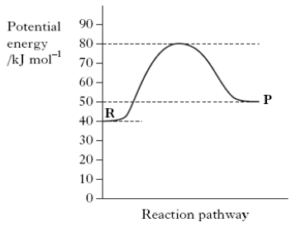

What is the enthalpy change, in kJ mol–1, for the reverse reaction **P → R**?

A + 30

B + 10

C –10

D –40

2. The following potential diagram is for a reaction carried out with and without a catalyst.

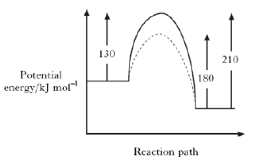

The activation energy for the catalysed reaction is

A 30 kJ mol–1

B 80 kJ mol–1

C 100 kJ mol–1

D 130 kJ mol–1.

3. A potential energy diagram can be used to show the activation energy (EA) and the enthalpy change (ΔH) for a reaction. Which of the following combinations of EA and ΔH could **never** be obtained for a reaction?

A EA = 50 kJ mol–1 and ΔH = –100 kJ mol–1

B EA = 50 kJ mol–1 and ΔH = +100 kJ mol–1

C EA = 100 kJ mol–1 and ΔH = +50 kJ mol–1

D EA = 100 kJ mol–1 and ΔH = –50 kJ mol–1

4. For any chemical, its temperature is a measure of

A the average kinetic energy of the particles that react

B the average kinetic energy of all the particles

C the activation energy

D the minimum kinetic energy required before reaction occurs.

5. When a catalyst is used, the activation energy of the forward reaction is reduced to 35 kJ mol–1.

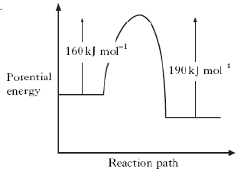

What is the activation energy of the catalysed reverse reaction?

A 30 kJ mol–1

B 35 kJ mol–1

C 65 kJ mol–1

D 190 kJ mol–1

**Homework 8**

1. A reaction was carried out with and without a catalyst as shown in the energy diagram.

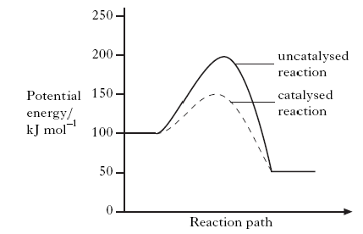

What is the enthalpy change, in kJ mol–1 for the catalysed reaction?

A –100

B –50

C +50

D +100

2. Which of the following is **not** a correct statement about the effect of a catalyst?

The catalyst

A provides an alternative route to the products

B lowers the energy that molecules need for successful collisions

C provides energy so that more molecules have successful collisions

D forms bonds with reacting molecules.

3.a) Copy the diagrams below and mark with an arrow:-

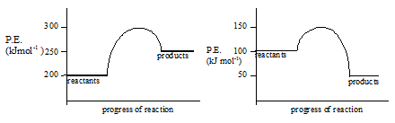

i) the activation energy EA.

ii) the enthalpy change Δ

b) State whether each reaction is endothermic or exothermic.

c) Calculate the value of ΔH and EA for each reaction

4. Copy the axes below and sketch potential energy diagrams for the following reactions, labelling the axes.

a) ΔH = -15 kJ mol-1  EA = 20 kJ mol-1

b) ΔH = +20 kJ mol-1  EA = 35 kJ mol-1

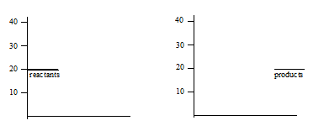

**Homework 9**

1. Two chemicals A and B react in solution to form C. The reaction has an activation energy of 150 kJ mol-1. If hydrogen ions are used as a catalyst the activation energy is 50 kJ mol-1. The enthalpy change for the reaction is -125 kJ mol-1.

Present this information as a potential energy diagram using the template below.

(Use a solid line for the uncatalysed reaction and a dotted line for the catalysed reaction.)

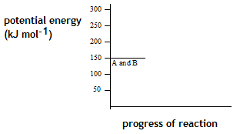

1. The graph shows the potential energy diagram for a urease catalysis of urea.

(a) What is the enthalpy change for the reaction?

(b) Acid is a less effective catalyst than urease for this reaction.

Sketch the diagram and add a curve to the potential energy diagram to show the hydrolysis when acid is used as the catalyst.

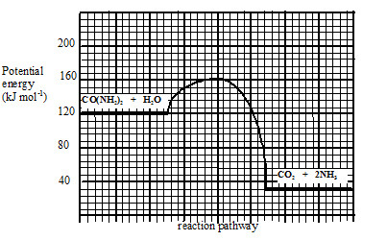

**Homework 10**

1. (a) Graph 1 shows the distribution of kinetic energies of molecules in a gas at300C.

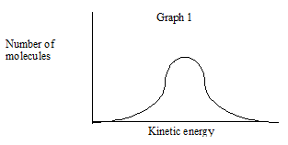

Copy the graph and add a dotted line to show the distribution of kinetic energies at 200C.

(b) In Graph 2, the shaded area represents the number of molecules with the required energy of activation, EA, for reaction to occur.

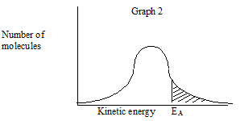

Copy the graph and draw a line to show how a catalyst affects the energy of activation.

(c) A collision involving molecules with the required energy of activation may **not** result in reaction.

State a reason for this.

2. What is meant by the term “activation energy”?

**Homework 11**

1. The decomposition of an aqueous solution of hydrogen peroxide into oxygen and water can be catalysed by iodide ions, I-(aq), or by solid manganese (IV) oxide, MnO2(s).

For each of these catalysts state, with a reason, whether the catalysis is homogeneous or heterogeneous.

2. An advice leaflet given to motorists when catalytic converters were first used states: “Cars fitted with catalytic converters must be run on unleaded petrol only.”

(a) Outline the reasons for fitting catalytic converters, naming the substances reacting and what happens to them.

(b) Describe in terms of adsorption how catalysts work, and state the effect this has on the activation energy for the reaction.

(c) Describe how a substance poisons a catalyst.

(d) Explain the reason for the advice given at the start of the question.

**Homework 12**

1.



2. In area **X**

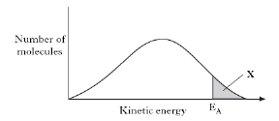

A molecules always form an activated complex

B no molecules have the energy to form an activated complex

C collisions between molecules are always successful in forming products

D all molecules have the energy to form an activated complex.

3. The reaction of oxalic acid with an acidified solution of potassium permanganate was studied to determine the effect of temperature changes on reaction rate.



The reaction was carried out at several temperatures between 40 °C and 60 °C. The end of the reaction was indicated by a colour change from purple to colourless.

(a) (i) State **two** factors that should be kept the same in these experiments.

(ii) Why is it difficult to measure an accurate value for the reaction time when the reaction is carried out at room temperature?

(b) Sketch a graph to show how the rate varied with increasing temperature.

4. As a rough guide, the rate of a reaction tends to double for every 10 °C rise in temperature.

Why does a small increase in temperature produce a large increase in reaction rate?

**Homework 13**

1. Enzymes are biological catalysts. They catalyse the chemical reactions which take place in the living cells of plants and animals. For example, the enzyme invertase catalyses the reaction of sucrose and water to give glucose and fructose. Enzymes are used in the manufacture of cheese, yoghurt, bread, wine, beer, lager, whisky and biological detergents. There are, therefore, many everyday examples of enzymes and they are used in many industrial processes.

1. Explain the meaning of the word catalyst.
2. Distinguish between the terms homogeneous and heterogeneous catalyst.

c) Rhodium, platinum and palladium are present as catalysts in the catalytic converters found in motor car exhaust systems. To what type of catalysts do they belong?

Explain your answer.

d) The enzyme catalase dissolves in water and the solution catalyses the decomposition of a solution of hydrogen peroxide in water. What type of catalysis is taking place?

2. Use the collision theory to explain why

a) increasing the concentration of a reactant increases reaction rate.

b) decreasing the particle size of a solid reactant increases reaction rate.

c) increasing the temperature increases the rate of reactions.

3. Many transition metals can act as catalysts. Which of the following is a

transition metal?

A Barium

B Gallium

C Vanadium

D Antimony

4.Kurt intended to study the effect of change in acid concentration on the reaction between nitric acid and limestone to produce carbon dioxide gas. He decided to monitor the mass of the flask as the reaction proceeded. Which of the following need not be kept constant?

A the temperature of the acid

B the shape of the flask

C the particle size of the limestone

D the mass of the limestone