Airdrie Academy

**NATIONAL 5 CHEMISTRY**

Unit 2

Nature’s Chemistry

[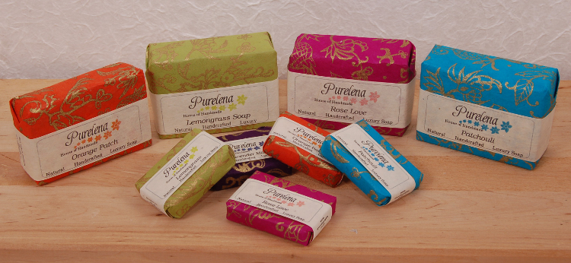](http://www.google.co.uk/url?sa=i&rct=j&q=&esrc=s&frm=1&source=images&cd=&cad=rja&uact=8&docid=1uF9D_rcCRFZIM&tbnid=bkVdmMLw1FUkeM:&ved=0CAUQjRw&url=http://blog.greenheartgifts.co.uk/2012/02/handmade-mini-soaps-from-dorset/&ei=dAc9U7HHNezb7AaH6YFo&psig=AFQjCNHAHlmzy0rNCAW3knzAG5w7vAIVcg&ust=1396594905041737)

Exam Questions

**Homologous series**

2006 I2 13MC

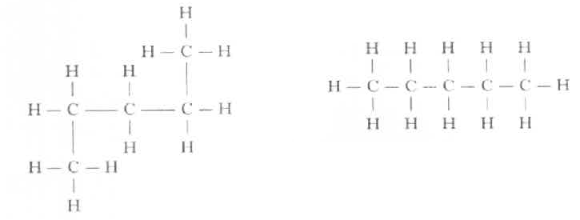1.

The above structural formulae represent

A the same hydrocarbon

B Different hydrocarbons

C Isomers

D Isotopes 1

2006 I2 14MC

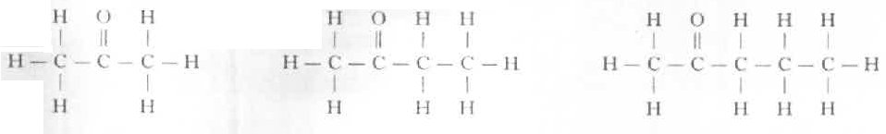2. The first three members of the alkanone series are:

What is the general formula for this homologous series?

A CnH2n-2O

B CnH2nO

C CnH2n-1O

D CnH2n+2O 1

2006 I2 16MC

3. The structural formula for hydrocarbon X is

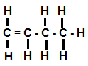

Which of the following statements about hydrocarbon X is true?

A X is named but-2-ene

B X is a saturated hydrocarbon

C X rapidly decolorises bromine solution

D X belongs to a group of hydrocarbons with the general formula CnH2n+2 1

2008 I2 13MC

4. Which of the following compounds fits the general formula, CnH2n, and will rapidly

decolourise bromine solution?

A Cyclopentane

B Cyclopentene

C Pentane

D Pentene

2008 I2 12MC

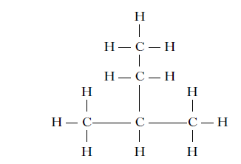5.

The name of the above compound is

A 1, 1–dimethylpropane

B 2-ethylpropane

C 2-methylbutane

D 3-methylbutane. 1

2007 I2 10 MC

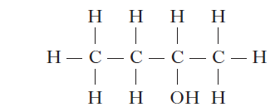6.

Which of the following compounds is an isomer of the one above? 1

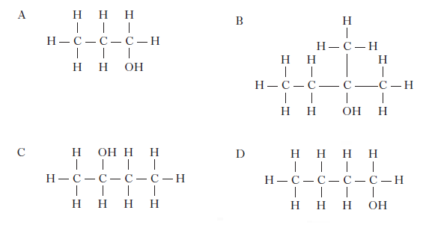

2008 I2 14MC

7. Three members of the cycloalkane homologous series are:

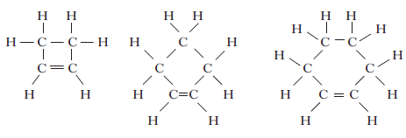

The general formula for this homologous series is

A CnH2n+2

B CnH2n

C CnH2n–2

D CnH2n–4 . 1

2008 I2 15MC

8. Which of the following molecules is an isomer of heptane?

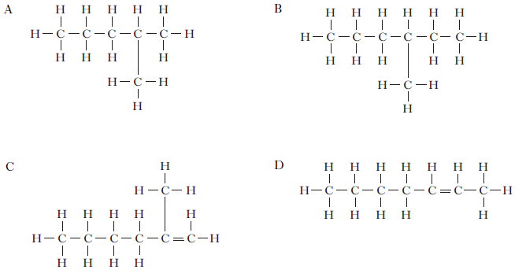

2009 I2 15MC

9. Which of the following could be the molecular formula of a cycloalkane?

A C7H10

B C7H12

C C7H14

D C7H16 1

2010 I2 10MC

10. 1 mole of a hydrocarbon burns completely in oxygen to produce 2 moles of carbon dioxide

and 2 moles of water.

The formula for the hydrocarbon is

A C2H4

B C2H6

C C4H8

D C4H10. 1

2009 I2 16MC

11. The shortened structural formula for an organic compound is

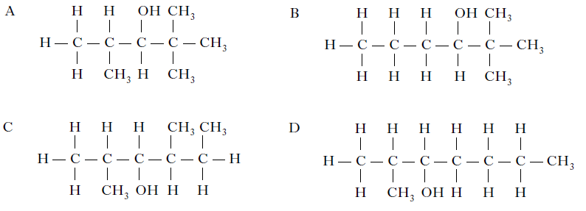 CH3CH(CH3)CH(OH)C(CH3)3.

Which of the following is another way of representing this structure? 1

2009 I2 12MC

12. Which of the following hydrocarbons does not belong to the same homologous series as the others?

A CH4

B C3H8

C C4H10

D C6H12 1

2006 CRED 4

13. The structural formulae for some hydrocarbons are shown below.

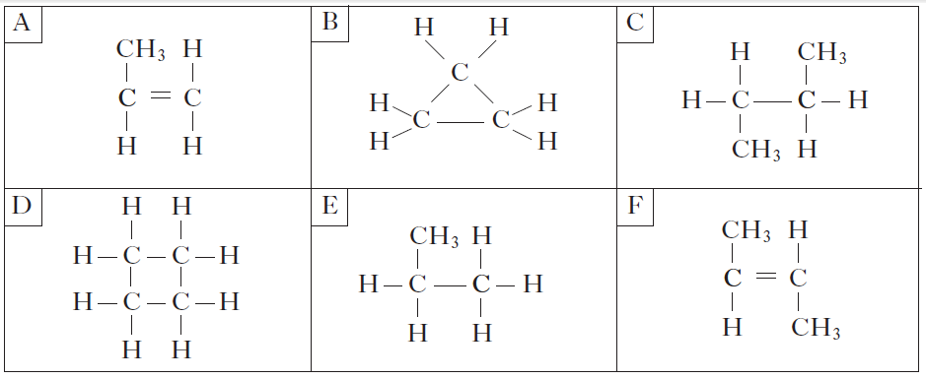

(a) Identify the hydrocarbon which could be used to make poly(butene). 1

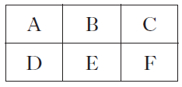

(b) Identify the **two** hydrocarbons with the general formula CnH2n which do **not**

react quickly with hydrogen. 1



2011 I2 8

14. Many different gases are found in car exhaust fumes. Some of these gases are produced by the combustion of petrol in car engines.

The pie chart shows the gases present in the exhaust fumes of a car.



What evidence in the pie chart shows that incomplete combustion of petrol has

taken place? 1

2013 I2 8

15. Crude oil is a mixture of hydrocarbons which can be separated into fractions by fractional distillation.

Petrol contains the following molecule.

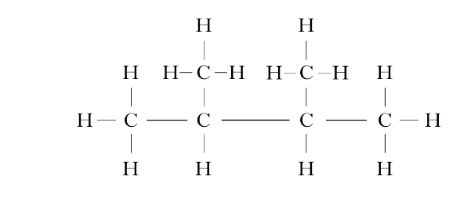

Name this molecule. 1

2011 C 16

16. Heptane can be cracked as shown.

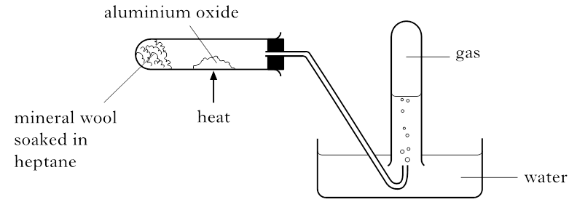

One of the reactions which takes place is:



The product C3H6 decolourises bromine solution quickly.

Draw a structural formula for an isomer of C3H6, which would not decolourise

bromine solution quickly. 1

2012 C 20

17. The monomer in superglue has the following structure.

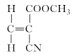

Bromine reacts with the monomer to produce a saturated compound. Draw the

structural formula for this compound. 1

 2011 C 22

|  |  |  |
| --- | --- | --- |
| 18.(a) | Ethylthioethane belongs to a homologous series of compounds called thioethers. |  |
|  | What is meant by a homologous series? | 1 |
| (b) | Ethylthioethane is formed when ethylthiol reacts with bromoethane as shown.    Draw the full structural formula for the thioether produced in the following reaction. | 1 |
| (c) | Ethylthioethane can also be formed by the reaction of ethylthiol with ethene.    Suggest a name for the type of chemical reaction taking place. | 1 |
|  |  |  |
|  |  |  |
|  |  |  |

2007 I2 5

19. Thiols are organic compounds containing sulphur. Some thiols are listed in the table.

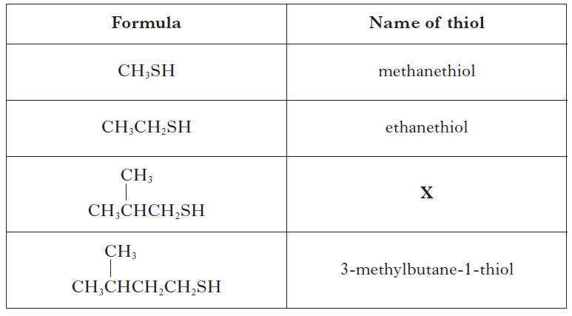

(*a*) Ethanethiol is added to natural gas to give it a smell.

Draw the full structural formula for ethanethiol. 1

(*b*) Suggest the name for thiol X. 1

(*c*) Thiols undergo complete combustion.

thiols + oxygen → carbon dioxide + water + ………………………………

Complete the word equation for this reaction. 1

2007 I2 6

20. A student carried out an experiment to test different hydrocarbons for saturation.

Her results are shown in the table.

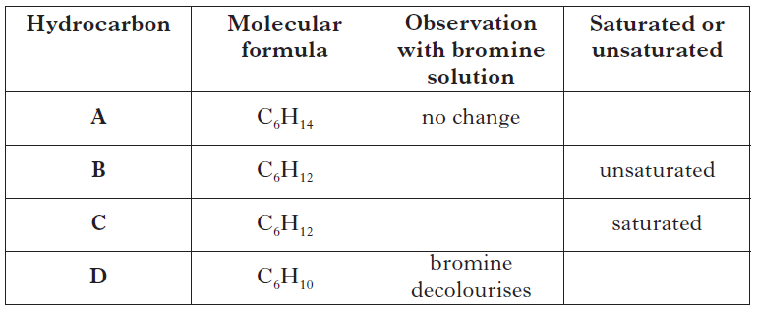

(a) Complete the table. 2

(b) Care had to be taken when using bromine solution. Give a safety precaution,

**other** than eye protection, which should be taken when completing this test. 1

(c) Suggest a possible name for hydrocarbon **B**. 1

2008 I2 5

21. Chlorofluorocarbons (CFCs) are a family of compounds which are highly effective as

refrigerants and aerosol propellants. However, they are now known to damage the ozone layer.

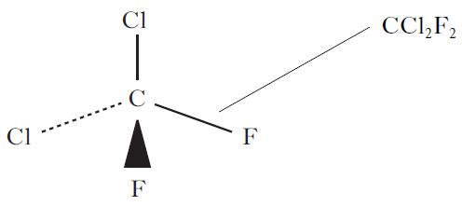 One example of a CFC molecule is shown.

(a) What term is used to describe the shape of this molecule? 1

(b) Scientists have developed compounds to replace CFCs. The table shows

information about the ratio of atoms in CCl2F2 and compounds used to replace it.

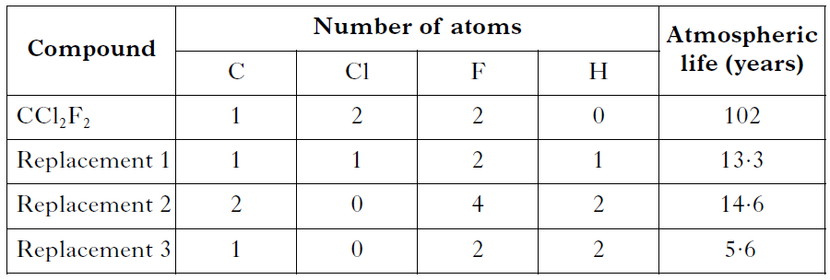

(i) Draw a possible structure for Replacement 2. 1

(ii) Compared with CCl2F2, the replacement compounds contain less of which

element? 1

(iii) From the table, what is the advantage of using the replacement molecules as

refrigerants and aerosol propellants? 1

2008 I2 7

22. Scientists have replaced oils in gloss paints with synthetic polyesters.

This has improved the drying quality of the paint.

The first step in the production of the synthetic polyester is shown.

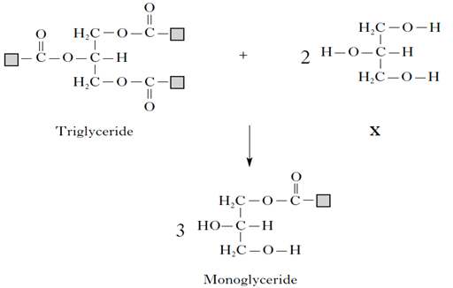

(a) What does the term synthetic mean? 1

(b) Copy out the triglyceride and circle an ester link. 1

(c) Name **X**. 1

2009 I2 6

23. The octane number of petrol is a measure of how efficiently it burns as a fuel. The higher the octane number, the more efficient the fuel.

(a) What is a fuel? 1

(b) The octane numbers for some hydrocarbons are shown.

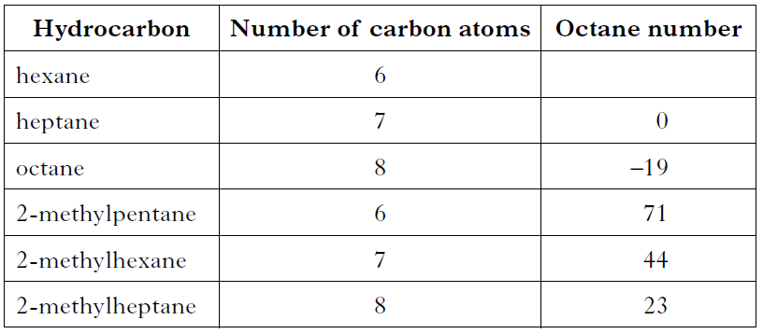

(i) Predict the octane number for hexane. 1

(ii) State a relationship between the structure of the hydrocarbon and their

efficiency as fuels. 1

2009 I2 8

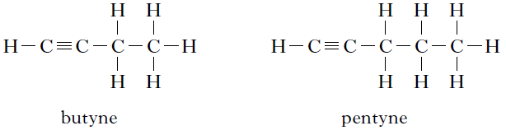24. Alkynes are a homologous series of hydrocarbons which contain carbon to carbon triple bonds. Two members of this series are shown.

(a) Name the first member of this series. 1

(b) Alkynes can be prepared by reacting a dibromoalkane with potassium hydroxide

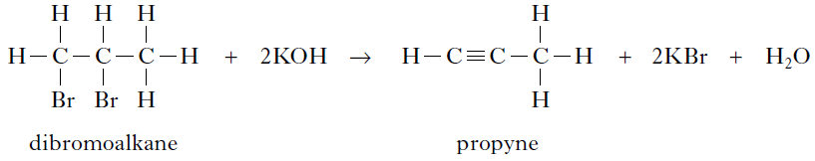 solution.

(i) Draw a structural formula for the alkyne formed when the dibromoalkane shown

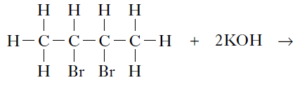 below reacts with potassium hydroxide solution. 1

(ii) Suggest a reason why the dibromoalkane shown below does not form an alkyne

when it is added to potassium hydroxide solution. 1

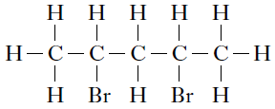

2010 I2 5

25. The diagram below shows the apparatus used to ‘crack’ a hydrocarbon.

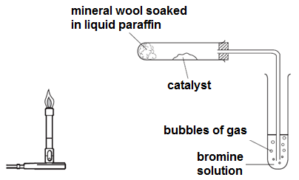

(*a*) Describe how the bunsen burner is used to heat the apparatus. 1

(*b*) Explain why the delivery tube must be removed from the bromine solution before

heating is stopped. 1

(*c*) (i) Name the catalyst that is used in this cracking reaction. 1

(ii) Catalysts speed up the rate of a reaction without being used up.

State another reason for using a catalyst. 1

(*d*) One of the reactions taking place is:

CH2CHCH3 + Br2 🡪 CH2BrCHBrCH3

What name is given to this type of chemical reaction? 1

2010 I2 6

26. Chemicals in food provide flavour and smell. Ketones are responsible for the flavour in blue cheese. Two examples of ketones are shown below.

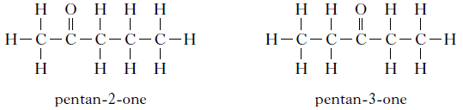

(a) Draw a structure for hexan-3-one. 1

(b) Suggest a name for the ketone shown below. 1

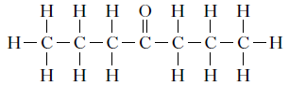

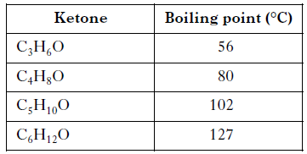 (c) Information about the boiling points of four ketones is shown in the table.

Predict the boiling point of C7H14O. 1

**Everyday Consumer Products**

2006 I2 15MC

1. Which of the following is the structural formula for propyl ethanoate? 1

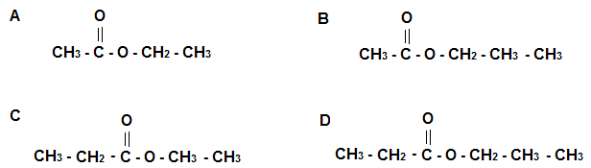

2006 I2 18MC

2. The method used to increase the ethanol concentration of fermentation products is

A cracking

B dehydration

C distillation

D hydrolysis 1

2007 I2 11MC

3. Which of the following represents an ester? 1

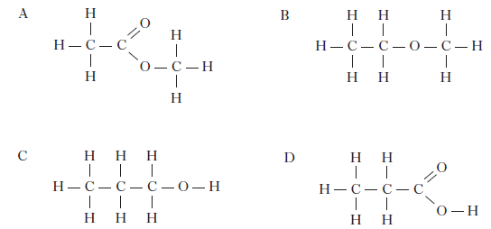

2008 I2 16MC

4. Fermentation of glucose to ethanol and carbon dioxide by yeast stops when the ethanol

concentration reaches about 13%.

This is because

A the ethanol has destroyed the yeast

B all the glucose has been used up

C carbon dioxide is harmful to yeast

D the mixture is now saturated with ethanol. 1

2008 I2 17MC

5. methanol + ethanoic acid 🡪 methyl ethanoate + water

This reaction is an example of

A addition

B dehydration

C condensation

D neutralisation. 1

2009 I2 17MC

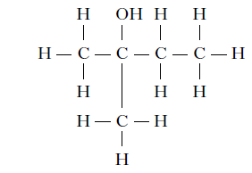6.

The above compound could be formed by adding water to 1

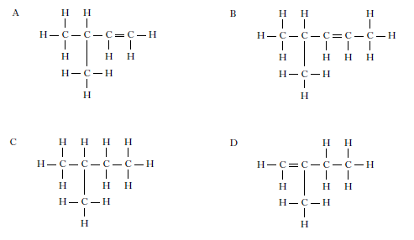

2010 I2 13MC

7. Which type of reaction is shown by the following equation?

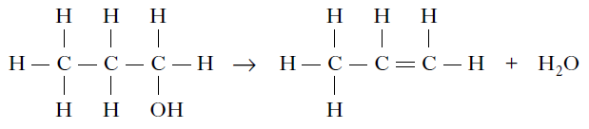

A Condensation

B Dehydration

C Hydration

D Hydrolysis 1

2011 I2 14MC

8. When propene undergoes an addition reaction with hydrogen bromide, two products are formed.

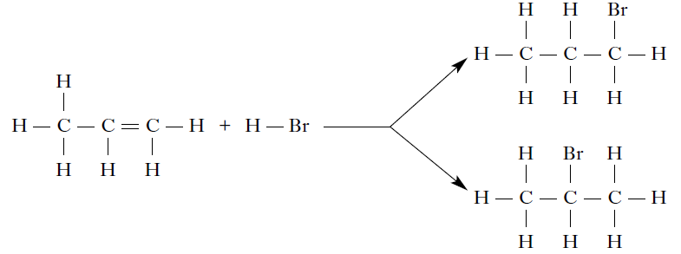

Which of the following alkenes will also produce **two** products when it undergoes an addition reaction with hydrogen bromide?

A Ethene

B But-1-ene

C But-2-ene

D Hex-3-ene 1

2011 I2 15MC

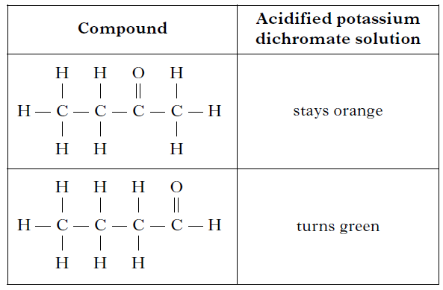9. The table shows the result of heating two compounds with acidified potassium dichromate solution.

Which of the following compounds will **not** turn acidified potassium dichromate

solution green? 1

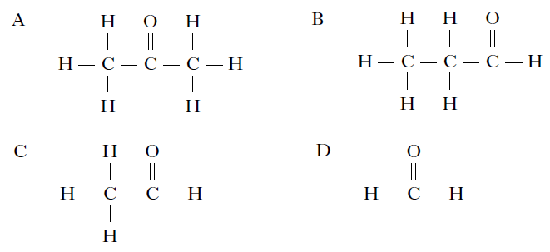

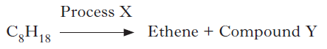2012 I2 15MC

10.

Which line in the table correctly identifies Process X and Compound Y? 1

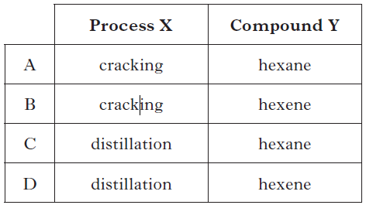

2013 I2 13MC

11. Ethanol can be produced from sugar cane by

A oxidation

B fermentation

C polymerisation

D catalytic hydration. 1

2013 I2 14MC

12. Propan-1-ol can be dehydrated.

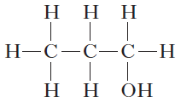

Which of the following compounds is a product of the reaction?

A Propanoic acid

B Propyl propanoate

C Propene

D Propane 1

2011 I2 9

|  |  |  |
| --- | --- | --- |
| 13. |  |  |
|  | The alcohol produced is ethanol.  Draw the **shortened structural formula** for ethanol. | 1 |
|  |  |  |

2012 I2 7

|  |  |  |
| --- | --- | --- |
| 14. | Ethanol is a member of the alkanol family of compounds. |  |
| (a) | Ethanol can be manufactured from ethene as shown in the following addition reaction.    What other name can be given to this type of addition reaction? | 1 |
| (b) | Butan-2-ol is another member of the alkanol family.    Draw the full structural formula for an isomer of butan-2-ol. | 1 |
|  |  |  |

2013 I2 9

|  |  |  |
| --- | --- | --- |
| 15. | Alkenes can undergo different reactions. |  |
|  | Potassium permanganate can be used to convert alkenes into two molecules.  The conversion of pent-1-ene is shown. |  |
|  | Name molecule X. | 1 |
|  |  |  |

2013 I2 13

|  |  |  |
| --- | --- | --- |
| 16. |  |  |
| (a) | Suggest a pH value for hipposudoric acid. | 1 |
| (b) | Hipposudoric acid contains a hydroxyl group.  Circle the hydroxyl group in the structure of hipposudoric acid. | 1 |
|  |  |  |

2009 I2 7

17. The diagram shows how paraffin, C12H26, can be cracked.

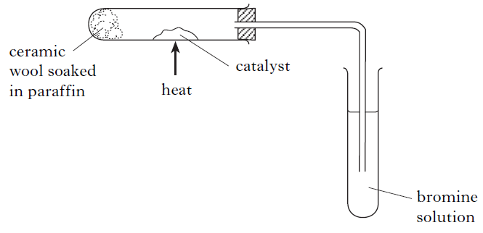

(a) Name the catalyst used in cracking. 1

(b) One of the reactions taking place when paraffin is cracked is

C12H26 🡪 C8H18 + X

(i) Identify molecule X. 1

(ii) Describe what would be seen when X is added to bromine solution. 1

2013 C 15

|  |  |  |
| --- | --- | --- |
| 18. | An antibacterial hand gel contains two alkanols, ethanol and propan-2-ol. |  |
| (a) | When alkanols are oxidised alkanoic acids are produced.    Draw the full structural formula for the alkanoic acid produced when butanol is oxidised. | 1 |
| (b) | Esters are produced when alkanols react with alkanoic acids.  The table gives information on esters.    Suggest a name for X. | 1 |

2009 I2 10

19. The flow chart shows some of the stages in the manufacture of ethanoic acid.

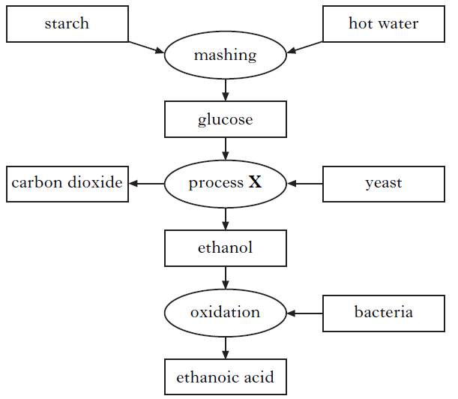

(a) In the mashing process, some of the starch is broken down into glucose.

Using the flow chart, write the word equation for the reaction taking place in

the mashing process. 1

(b) Name process X. 1

(c) Draw the full structural formula for ethanoic acid. 1

d) Ethanoic acid can be reacted with methanol to form an ester, which is used as a

solvent in nail varnish remover. Name this ester. 1

2010 I2 7

20. A recipe for making blackcurrant wine is shown.

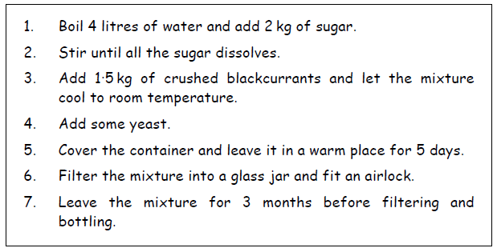

(a) Yeast is used to convert sugar into ethanol.

(i) What name is given to this process? 1

(ii) What type of substance, found in yeast, acts as a catalyst? 1

(b) Why was the mixture cooled at step 3, before the yeast was added to it? 1

(c) When blackcurrant brandy is made from blackcurrant wine, the ethanol

concentration is increased.

How could this be done? 1

2010 I2 8

21. Sweets, such as pineapple cubes, contain the artificial flavouring methyl butanoate.

(a) To which family of compounds does methyl butanoate belong? 1

(b) Methyl butanoate can be broken down to form an alkanol and an alkanoic acid.

(i) Name this type of chemical reaction. 1

(ii) Draw the full structural formula for the alkanoic acid formed from the

breakdown of methyl butanoate. 1

**Energy from Fuels**

2012 I2 5

|  |  |  |
| --- | --- | --- |
| 1. | The alkanals are a homologous series of compounds that all contain the elements carbon, hydrogen and oxygen. |  |
|  | The combustion of alkanals releases heat energy. |  |
| (a) | Make a general statement linking the amount of heat energy released and the number of carbon atoms in the alkanal molecules. | 1 |
| (b) | Predict the amount of heat energy released, in kJ, when 1 mole of pentanal burns. | 1 |

2007 I2 15c

2. The diagram shows the chemical energies of the reactants and products when magnesium reacts with dilute acid.

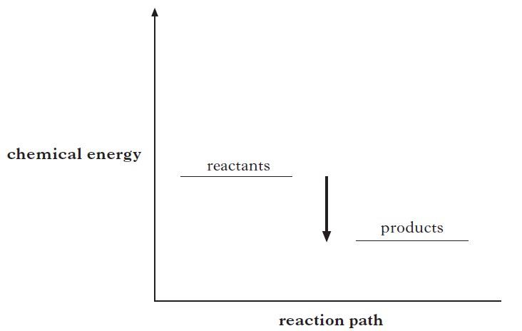

In what way does the energy diagram show that the reaction is exothermic? 1

2007 H 5

3. The energy changes taking place during chemical reactions have many everyday uses.

(a) Some portable cold packs make use of the temperature drop that takes place when the chemicals in the pack dissolve in water.

Name the type of reaction that results in a fall in temperature. 1

(b) Flameless heaters are used by mountain climbers to heat food and drinks. The

chemical reaction in a flameless heater releases 45 kJ of energy.

If 200 g of water is heated using this heater, calculate the rise in temperature of

the water, in °C. 1

2011 H 14

4. The enthalpies of combustion of some alcohols are shown in the table.

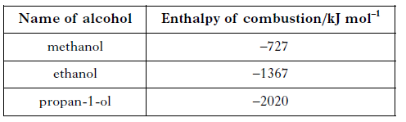

(a) Using this data, predict the enthalpy of combustion of butan-1-ol, in kJ mol–1. 1

(b) The following apparatus was used to measure how much heat was produced

when butan-2-ol, C4H9OH, was burned.

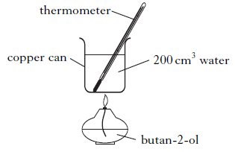

Mass of butan-2-ol burned = 1·0 g

Initial temperature of water = 18 °C

Final temperature of water = 38 °C

Use these results to calculate the heat released when 1g of butan-2-ol was burned. 1

2012 RH 3

5. Different fuels are used for different purposes.

(a) Ethanol, C2H5OH, can be used as a fuel in some camping stoves.

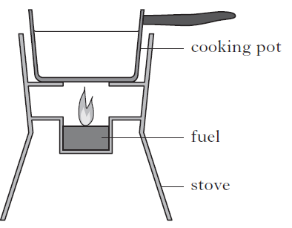

Theoretically, the amount of heat energy that should be released when one mole (46g)

of ethanol burns is 1367 kJ.

Suggest two reasons why less energy is obtained from burning ethanol in the camping stove than is predicted. 2

(b) Petrol is a fuel used in cars.

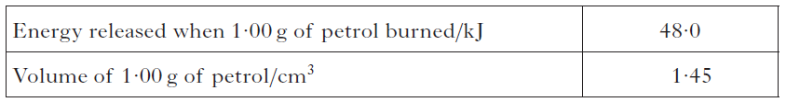

A car has a 50·0 litre petrol tank.

Calculate the energy, in kJ, released by the complete combustion of one tank of

petrol. 2