Higher Italian Name…………………………………….……..

Directed Writing

Using the phrases you have already been given to help, translate the following:

- = use dictionary

When you went
- last autumn …………………………………………………………………
- last spring …………………………………………………………………
- during the summer holidays …………………………………………………………………
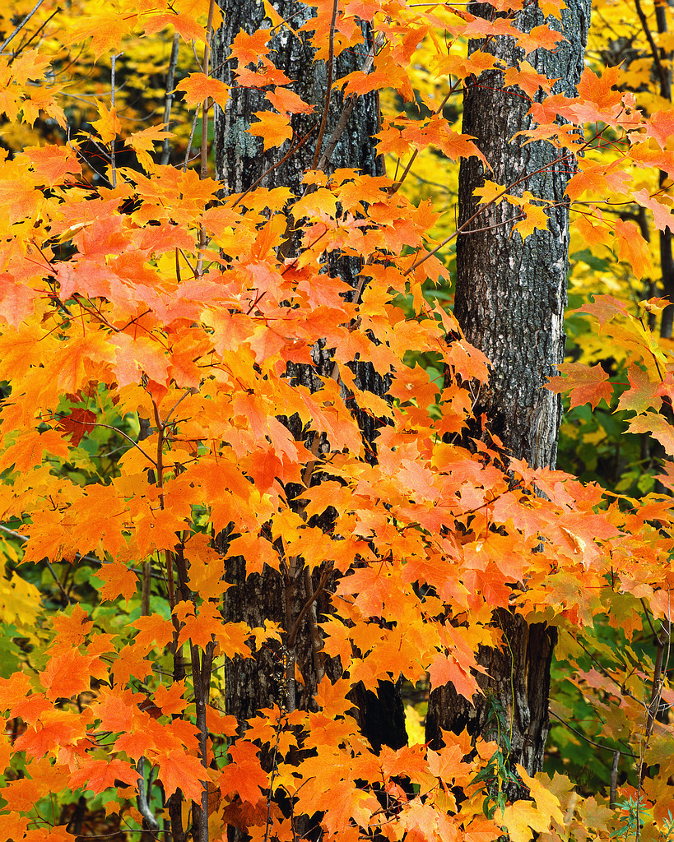
- 3 years ago …………………………………………………………………
- last December …………………………………………………………………
- 6 weeks ago …………………………………………………………………
Where you went and with whom
- I went to Switzerland …………………………………………………………………

- we went to Italy
………………………………
- we went to Rome
………………………………
- I went to Montreal …………………………………………………………………
- I stayed in a big town …………………………………………………………………
- 8 young people went to Italy on an exchange trip
......................................................................
……………………………………………………………………..
- I went away with my friends
…………………………………………………………………
- I went away with my parents…………………………………………………………………
- There were 10 people in the group …………………………………………………………………
- We rented a chalet in Italy
……………………………………………………………………
- We went skiing in the Alps…………………………………………………………………
- A boy stayed with me …………………………………………………………………

Expressing how you travelled
- We travelled by car …………………………………………………………………
- We took the train from Rome to Naples
- I took the train and the ferry
…………………………………………………………………
- We took the plane from Glasgow to Rome
…………………………………………………………………….

What you did during the journey
- I talked to my friends …………………………………………………………………
- I chatted *to my friends …………………………………………………………………
- I spent my time listening to music…………………………………………………………………
- During the journey I read a book…………………………………………………………………
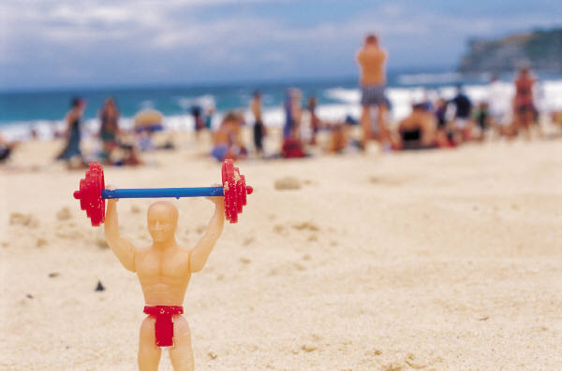
- I fell asleep …………………………………………………………………

How long you stayed
- I spent a fortnight in Bari
………………………………………………………
- We spent a week in the Alps
…………………………………………………………………
- I stayed a week with my pen friend
…………………………………………………………………
- I worked for four weeks in Switzerland
………………………………………………
- I stayed 5 days with my aunt
…………………………………………………………………

Where you stayed
- We stayed in a 5 star hotel ……………………………………………………………
- I stayed in a youth hostel …………………………………………………………………
- I stayed with an Italian family
……………………………………………………………………..
- The hotel was in a seaside resort*…………………………………………………………………
- We stayed in a caravan …………………………………………………………………
- There were 6 people in the family…………………………………………………………………
- There were 10 people in the group…………………………………………………………………
Describing your accommodation
- He lived in a small house …………………………………………………………………
- She lived in a pretty cottage* …………………………………………………………………
- The hotel was beautiful …………………………………………………………………
- The youth hostel was modern …………………………………………………………………
- The house was tiny …………………………………………………………………
- I shared a room with my pen friend…………………………………………………………………
Expressing how you got on with people
- I didn’t get on very well with my boss………………………………………………………………
- I got on really well with my pen friend……………………………………………………………
- my boss was very strict …………………………………………………………………
- I didn’t get on very well with the family…………………………………………………………
- I didn’t make friends …………………………………………………………………

