**La Vie Saine**

 [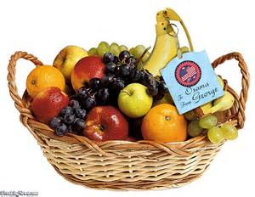](http://www.bing.com/images/search?q=fruit+baskey&view=detailv2&&id=5162B1A38DF9E142160D225C0491A4A528F515D3&selectedIndex=6&ccid=gKQPBtBz&simid=608011402876095116&thid=OIP.M80a40f06d07338c4eab7dfd6fb00d84fo0) 

|  |  |
| --- | --- |
| **Le français** | **L’anglais** |
| 1 Je dir**ais** qu’il faut manger  au moins trois repas par jour. |  |
| 2 Je dir**ais** qu’il faut faire du sport trois fois par semaine. |  |
| 3 Il faut que je dise qu’il faut faire attention à sa santé. |  |
| 4 Il faut que je dise qu’il ne faut pas boire trop de boissons gazeuses car c’est mauvais pour la santé. |  |
| 5 Je dois dire que je mène une vie saine, cependant, ma petite sœur ne mène pas une vie saine. |  |
| 6 Je dois dire qu’il faut éviter de manger les sucreries.  7 Je dois dire qu’il faut manger de la nourriture fraiche. |  |
| 8 Je dois dire qu’il faut manger cinq portions de fruits par jour. |  |
| 9 Je dois dire qu’il faut manger  beaucoup de légumes. |  |
| 10 Je dois dire qu’il faut boire trois litres d’eau par jour. |  |
|  |  |
| 11 | I would say that I don’t want to put on weight. |
| 12 | I would say that I want to lead a healthy life. |
| 13 | I have to say that I do lots of exercise every week. |
| 14 | I have to say that I take care of my health. |
| 15 | I have to admit that I try to control stress. |
| 16 | I have to admit that I try to sleep eight hours per night. |
| 17 | I have to admit that I try to follow a healthy diet. |
| 18 | I have to admit that I try to avoid fatty foods. |
| 19 | I have to admit that I try to follow a balanced diet. |
| 20 | I have to admit that I try to control stress |
| 21 | I think that we must avoid fatty foods. |
| 22 | I think that we must avoid fizzy drinks. |
| 23 | I think that we must do lots of sport every week. |
| 24 | I think that we must I think that we must lead an active life. |
| 25 | I think that we must take care of our health. |
|  |  |