AIRDRIE ACADEMY - ICT FACULTY
WORKING FROM HOME MATERIALS – S3 ICT (Computing Science)
Khan Academy

If you are in the position of being unable to attend school you can use the materials on the website https://www.khanacademy.org/coach/dashboard
Follow the instructions below –
- Sign Up to Khan Academy https://www.khanacademy.org/signup?continue=%2F
- Enter your Date of Birth
- Click on the Enter class code link
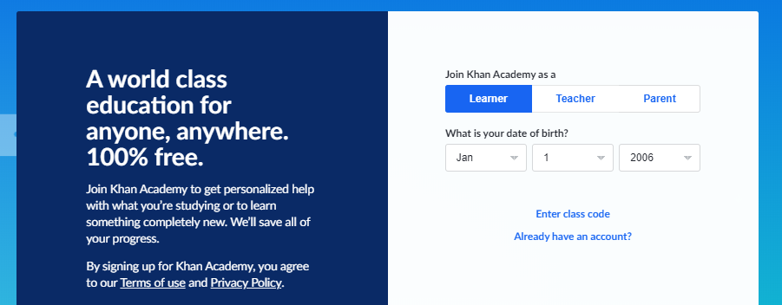
- Enter the class code EG992JPW

- The Mr Allen – Airdrie Academy class should appear as shown below
- Choose Create a new account
- Re-enter your Date of Birth (when prompted)
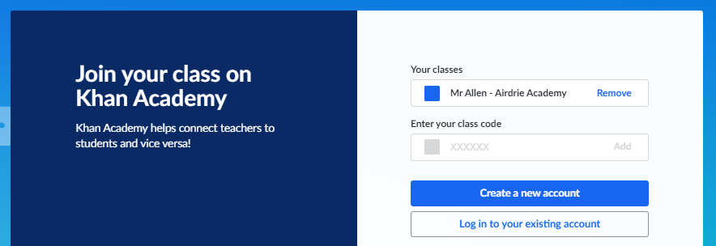

- Enter your email address (use your Glow email gw09surnamefirstname@glow.sch.uk)
- Enter your Firstname and Lastname
- Create a password (use school login password with # at the beginning e.g. #Passwd12)

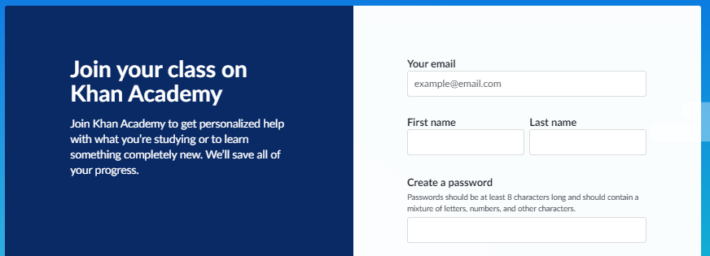

You are now ready to complete the following activities:
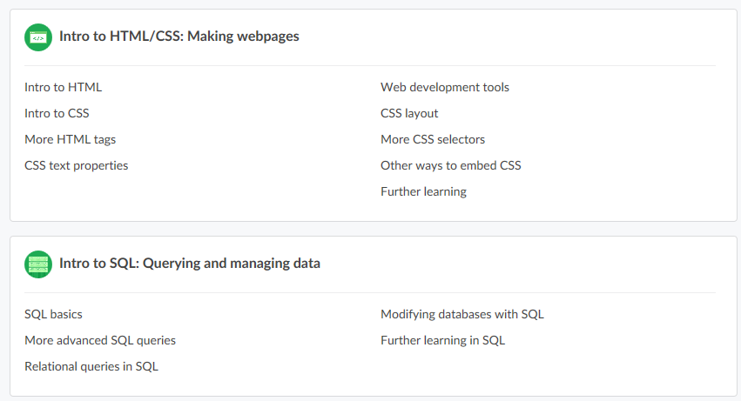

I am able to monitor your progress.
There are video tutorials as well as practical tasks to complete.

Mr Allen
Faculty Head ICT and Business

