AIRDRIE ACADEMY - ICT FACULTY – WORKING FROM HOME MATERIALS – S1 BUSINESS AND S1 ICT

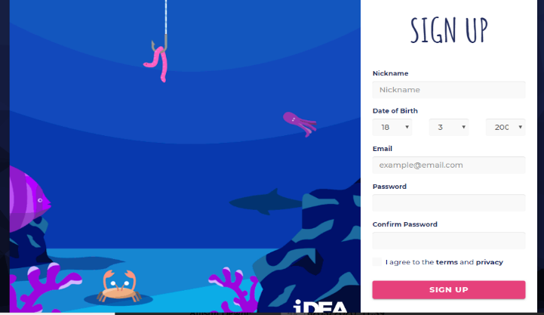
If you are in the position of being unable to attend school you can use the materials on the website www.idea.org.uk
Follow the instructions below –
- Access www.idea.org.uk
- If you don’t have an account click on Sign Up
- Enter a Nickname (Username)
- Enter your Date of Birth
- Enter your Email Address – you can use your Glow email address if you wish (i.e. gw09surnamefirstname@glow.sch.uk)
- Create a Password
- Click agree to terms and privacy
- Click Sign Up
You are now ready to login

At the top of the screen click on Badges – the level should be set to Bronze to start with.
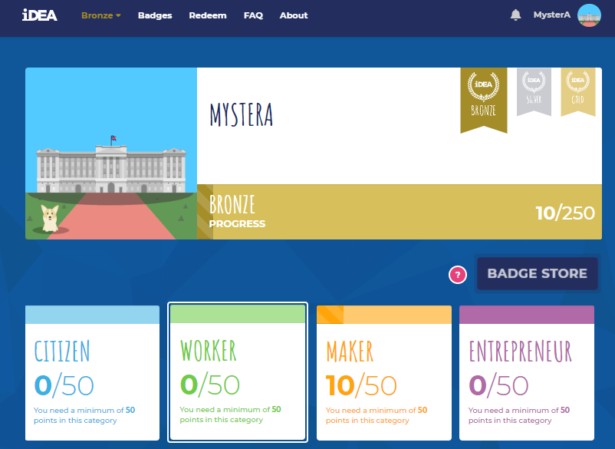
- For S1 Business – work on Citizen and Entrepreneur Badges
- For S1 ICT – work on Gamer and Maker Badges

Select a badge from one of the above choices and click start. Most badges provide information about the topic onscreen or video clips followed by some basic questions.

