National 5 Computing Science Revision Pack

Section 1 Basic Knowledge Questions

N5 SDD Revision
Name and describe the 5 programming data types.
Name and describe the 3 types of programming error.
Name and describe the 1 data structure we need to know.
Name and describe 4 ways of making code readable.
Name and describe the 2 types of loop.
Name and describe the 3 design notations.
Explain what is meant by concatenation.
What is meant by assignment?
State the 5 arithmetic operators.
State the 3 logical operators.
Describe the 5 conditional operators: <, >, <=, >=, <>.
What is meant by iteration?
What is meant by selection?
What does it mean if a program is fit-for-purpose?
What does it mean if a program is robust?
What does it mean if a program is efficient?
Describe the 3 categories of test data.
Name and describe the 3 pre-defined functions.
Name and describe the purpose of the 3 standard algorithms.
Write pseudocode versions of the 3 standard algorithms.

N5 DBDD Revision
What is an entity/table?
What is an attribute/field?
What is a record?
What is a query?
Name the 5 data types used for database entities.
Describe the 4 validation checks used in databases.
What is a primary key?
What is a foreign key?
Why should we use linked tables rather than a flat-file database?
What is the general structure of a SELECT query?
What is the general structure of an INSERT query?
What is the general structure of a UPDATE query?
What is the general structure of a DELETE query?
What is an SQL join query?
What is referential integrity?
How can results of a query be sorted?
Which kind of relationship should exist between a primary and foreign key?
What are the 6 principles of the GDPR?
What is an end-user requirement in database analysis?
What is a functional requirement in database analysis?

WDD Revision Questions
What is an end-user requirement in website analysis?
What is a functional requirement in website analysis?
What is a navigational structure for a website?
What is a wireframe design and why do we create them?
What is a low fidelity prototype and why would we create one?
What is the purpose of the Copyright, Designs and Patents Act?
What is the difference between a WAV and an MP3?
What is meant by sampling rate?
What are the properties of a GIF?
What are the properties of a JPEG?
What are the properties of a PNG?
What is meant by colour depth?
What is meant by resolution?
Why is compression important for photo, sound and video files?
What are classes and IDs as used in web design?
Write CSS rules to change the font, size, colour, alignment and background colour of text.
What is the general structure of an HTML page?
What is the purpose of a DIV tag?
Write HTML code to insert an image, a sound and a video file.
Write HTML code to create a numbered and a bullet point list.
Write HTML code to create a link and an anchor (link in the same page).
Write HTML code to create a heading and a paragraph.
Describe the difference between an internal and an external link.
Describe the difference between absolute and relative addressing.
What mouse events can trigger Javascript code?
What effects can be created using Javascript?
Describe 4 ways of testing a website.

Computer Systems
Convert the number 185 to 8-bit binary.
Convert the number 672 to 16-bit binary.
With the decimal number 123 x 10⁴⁵, identify the mantissa and the exponent.
With the binary number 1101010 x 2¹⁰¹⁰, identify the mantissa and the exponent.
Which part of a floating point number controls the accuracy?
Which part of a floating point number controls the range?
How many bits does extended ASCII use to represent a single character?
How many characters can be represented by extended ASCII?
Identify 4 shapes that can be stored in an SVG file.
Identify properties of a vector graphic by referring to the the shapes below.
Describe the bitmapped method of graphics representation by referring to the image below.
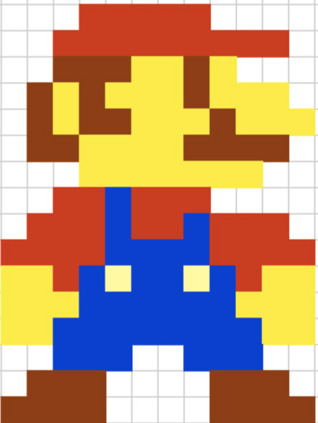

Describe the function of the three parts of a processor.
Describe how memory is organised in a computer system.
Describe the purpose of the two buses connecting memory and processor.
Describe the purpose of a translator program.
Describe the difference between an interpreter and a compiler.
Describe 3 ways of reducing the energy use of a computer system.
Explain why a firewall is described as a two-way filter.
State the purpose of encryption.
Describe how encryption is used when transmitting confidential data.

Section 2 Exam-Style Questions
- An array called Purchases holds numbers.
Purchases
3.99
1.50
6.25
5.99
6.00
7.85

- Write programming code to declare this array.
- Write programming code to ask for, and store, six values in this array.
- Write programming code to total all values in this array.

- A program asks a user to enter their year group 1 – 6. Write programming code to check that only valid values are entered.

- A cinema ticketing program asks for number of adults and children and whether or not they are a Cinema Club member. One adult costs £11. One child costs £8.
If there are more than 2 children and two adults then there is a £5 family discount. Cinema club members get a £2 discount on every ticket. Design a solution, using a methodology of your choice, to work out the cost of tickets.

- Look at the code below, designed to calculate the length of the hypotenuse in a right-angled triangle.

Dim A As Integer = InputBox(“Enter Side 1”)
Dim B As Integer = InputBox(“Enter Side 1”)
Dim C as Decimal
C = sqrt((A+B) * (A+B))
MsgBox(“Hypotenuse = “ & C)

Line 4 is highlighted as an error and is corrected to be:
C = math.sqrt((A+B) * (A+B))

- Identify the type of error that has occurred.
- When entering 3 and 4 as the 2 sides, the expected hypotenuse is 5 but the program returns the value 7. Identify the type of error that has occurred and describe how to fix it.
- When entering 3 and $ as the 2 sides, the program crashes. Identify the type of error that has occurred.

- . Look at this HTML code.
<ul class="links1">
<li><a href="/cookie_policy.html">Cookie Policy</a></li>
<li><a href="/terms_and_conditions.html">Terms & Conditions</a></li>
<li><a href="/accessibility.html">Accessibility Help</a></li>
<li><a href="/privacy_policy.html">Privacy Policy</a></li>
<li><a href="/sitemap">Sitemap</a></li>
</ul>
<ul class="links2">
<li><a href="/school-life/contacts.html">Contacts</a></li>
<li><a href="http://elearning.school.info/">E-Learning</a></li>
<li ><a href="/school-life/vacancies.html">Vacancies</a></li>
<li><a href="http://www.sqa.org.uk">SQA</a></li>
</ul>
- Identify an internal link, an external link, an absolute address and a relative address.
- Write a CSS rule to make all links in the links2 section green, centred and size 14 Calibri font.
- Write code to embed a file called school.mpg underneath the links.
More code from the page is shown below:
<img src="../images/badge1.jpg" onmouseover="this.src ='../images/badge2.jpg'" onmouseout="this.src ='../images/badge1.jpg'">
- Which language is shown in this code?
- The image shown changes in response to user interaction. What would cause the image to switch between two different images?
A JPEG has been used in this page.
- Give advantages and disadvantages of using a PNG instead of a JPEG for this webpage.
- Give advantages and disadvantages of using a GIF instead of a JPEG for this webpage.

- A guitar shop sells effects pedals from different manufacturers in a relational database. Pedals can be a looper, reverb, distortion, tuner, chorus or delay and can cost between £40 and £300. Details of the linked tables are shown below.

Manufacturer |  | Pedal
manID  manuName  manuContact |  | pedalID  manID  pedalName  pedalCost  pedalType

- Identify the primary keys and foreign key in these tables.
- Describe the relationship between these two tables.
Example data from both tables is shown below.
Manufacturer
manID | manuName | manuContact
EHX | Electro Harmonix | uksales@ehx.com
BOSS | Boss | info@boss.co.uk
TC | TC Electronic | brian@tcfx.com

Pedal
pedalID | manID | pedalName | pedalCost | pedalType
tcditto | TC | Ditto looper | 69 | Looper
tchof | TC | Hall of Fame | 99 | Reverb
tcfb | TC | Flashback | 99 | Delay
Bosstu | BOSS | TU3 | 63 | Tuner
Bossds | BOSS | DS1 | 50 | Distortion
Bossrv | BOSS | RV6 | 139 | Reverb
exhhg | EHX | Holy Grail | 115 | Reverb
ehxo11 | EHX | Ocean’s 11 | 136 | Reverb

- A data dictionary for the pedal table is shown below. Identify suitable values for entries 1 to 9.
Pedal
Attribute | Key | Type | Size | Required | Validation
pedalID | 1 | Text | 10 | 5
manID | 2 | Text | 10 | 6 | 7
pedalName |  | Text | 30 | Y
pedalCost |  | 3 |  | Y | 8
pedalType |  | 4 | 10 | Y | 9

- Write SQL code to insert a delay pedal, costing £85, from Boss, called the CH-2 with a unique ID of bossch2.
- The TC Flashback has been discontinued. Write SQL code to delete this pedal from the Pedal table.
- Write SQL code to produce a list with the name and cost of all reverb pedals, sorted from most expensive to least expensive.
- Write SQL code to produce a list with the manufacturer name, pedal name and contact name for all distortion pedals.
- An SQL query produces the following output.
manuName | pedalName | pedalCost
TC Electronic | Ditto Looper | 69
TC Electronic | Flashback | 99
TC Electronic | Hall of Fame | 99
Write the SQL code that would produce this table.

- A dog that is 5 years old is equivalent to a 42 year old human. A program to calculate the human equivalent age of a dog is analysed below.

Input – the age of a dog in years
Process – if the age is 2 or less, multiply dog age by 12, if age is more than 2, the human equivalent age is 24 for first 2 years then 6 for every additional year
Output – Human equivalent age of dog
Using a design technique of your choice, design an efficient solution to this problem.

- A database with two, linked tables is to be created using the details in the data dictionary below.

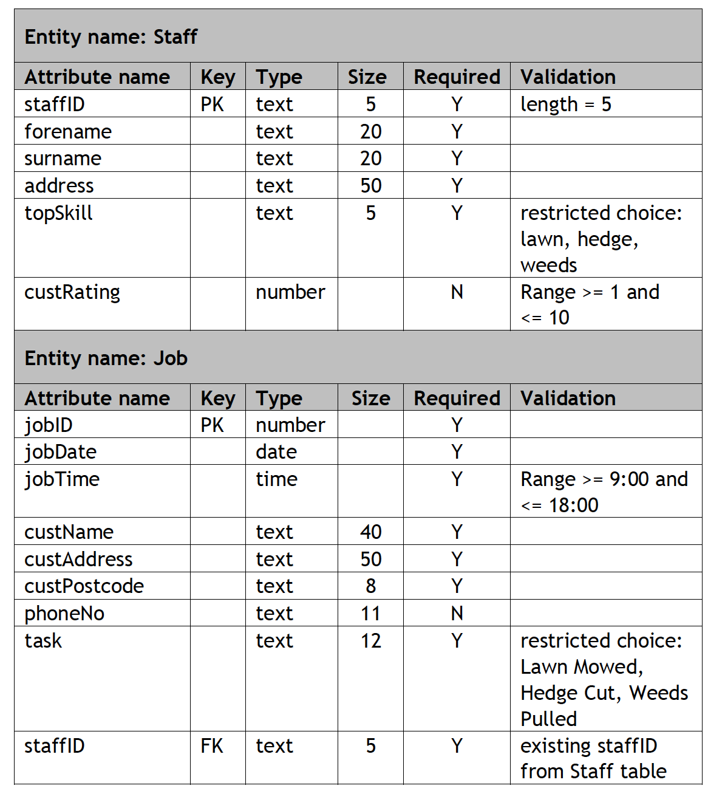

- Explain why database designers create a data dictionary.
- Using this data dictionary, describe the nature of the relationship between these two tables.
- How is a presence check indicated in the table above?
- Describe one use of a restricted choice in the table above.
- Describe the use of a range check in this database.
- Look at the validation used in the staffID field of the Job table.
- Describe the validation that should always be used for a foreign key.
- Explain how this validation ensures referential integrity.
- Why are fields Sizes implemented?
- Staff member DS021 has moved house recently. Write an SQL statement that will change the address of this member of staff to: 99 Willow Way, Falkirk, FA87 6FE.
- Staff member DS023 has left the company. Write an SQL statement that will remove the record of this member of staff.
- Write an SQL query to find the name, address and postcode of all customers who have a job scheduled for 27th January 2019.
- Describe how you can evaluate the accuracy of the code written in questions (h), (i) and (j)?

- When building a new website, a wireframe is created.

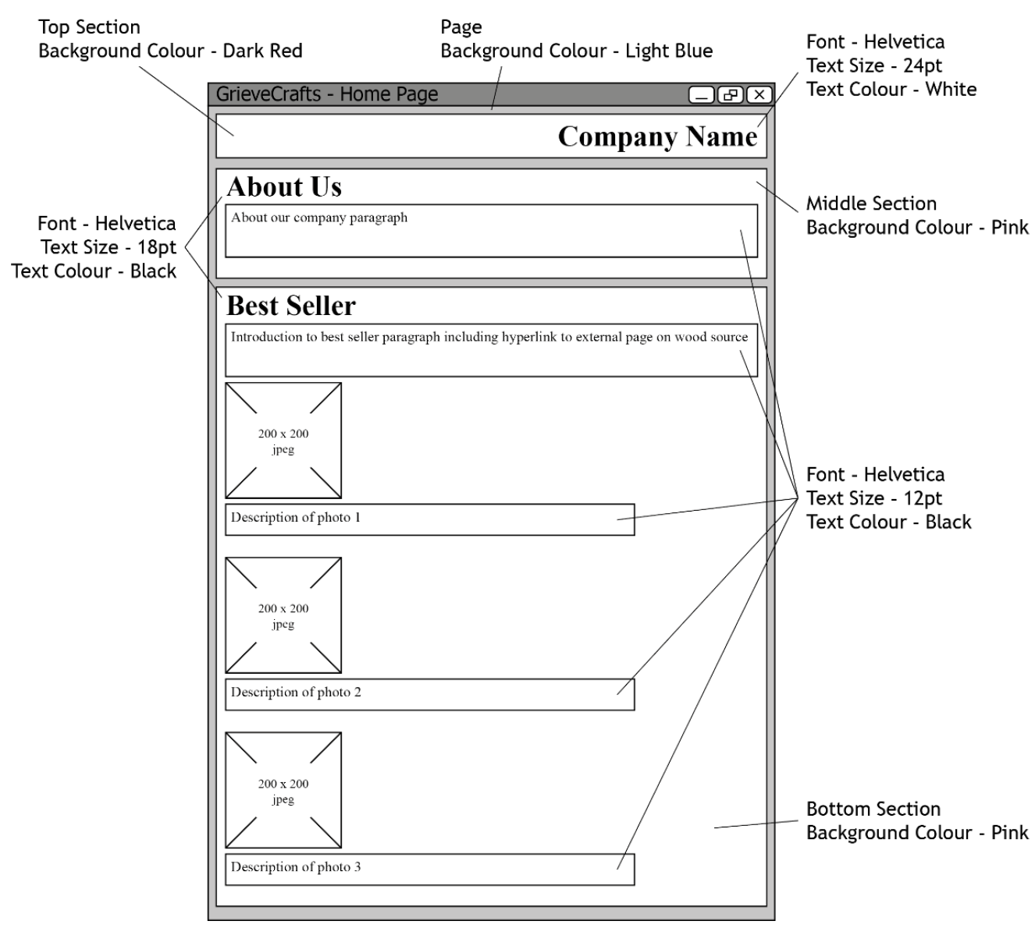

- At which stage of the development process is a wireframe created?
- Why is a wireframe created?
- Identify 2 elements of this webpage that will be coded in HTML.
- Identify 2 elements of this webpage that will be coded in CSS.
- From this wireframe, how many sections should be created using the <DIV> tag?
- Identify a style that is common between 2 or more sections of the webpage.
- What would be the effect of the following code?
<H2> Best Seller </H2>
- What would be the effect of the following code?
H2 {font-family:Helvetica; font-size:18pt}
- Explain how an external CSS file would be used in developing this webpage.

As well as a wireframe, a low fidelity prototype is created.
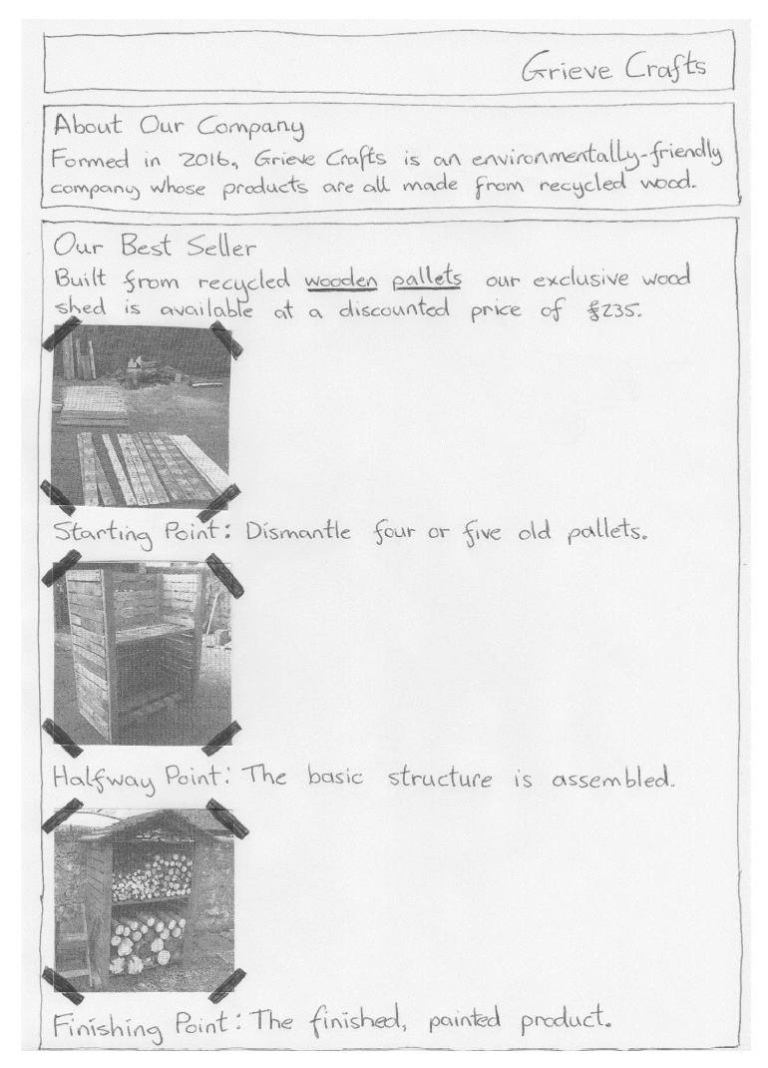

- Describe why a low fidelity prototype is needed as well as a wireframe?
- Identify the text that will become a hyperlink.
- Write code to create this hyperlink, linking to the website www.pallets.com
- How would the wireframe and lo-fi prototype be used at the testing stage?
- Describe 2 additional tests that could be undertaken.

- A program is to be created to monitor mobile phone signal strength. The design for the software is shown below.

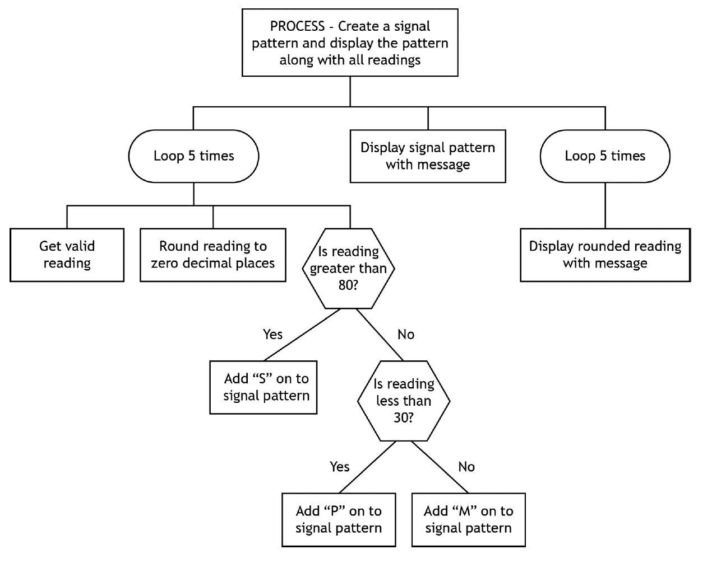

- Name the design notation shown above.
- Why do programmers create a design like this rather than starting to code a solution directly?
- Identify the pre-defined function used in this program.
- State the number of conditional loops used in this program.
- State the number of unconditional loops used in this program.
- Which shape indicates selection in this design?
- Which standard algorithm is used in this design?
- Describe one way in which this design is efficient.
- Describe one way in which this design is inefficient.
- Look at this following section of code. Does this code match the design? Explain your answer.

If reading > 80 Then
signalPattern = signalPattern & “S”
End If
If reading < 30 Then
signalPattern = signalPattern & “P”
End If
If reading >=30 And reading <= 80 Then
signalPattern = signalPattern & “M”
End If

- Identify the logical operator used in the code in question(j).
- How could you evaluate the robustness of this program?
- Whitestar Amps design and build amplifiers for electric guitars. Below is a description of the information currently recorded for each employee and the amplifiers the employees build.

When a new employee starts working at Whitestar Amps, their first name, surname, address, contact telephone number and if they have a driving licence is recorded.
Employees build three different models of amplifier (Jazz8, Rock100 and Blues55). After each amplifier has been built and tested it is given a unique serial number which the employee enters onto a paper form. They also include the date, time of day completed, if the amplifier passed testing and their own unique employee number assigned when they were first employed.

- Complete the missing information from the analysis of inputs below.

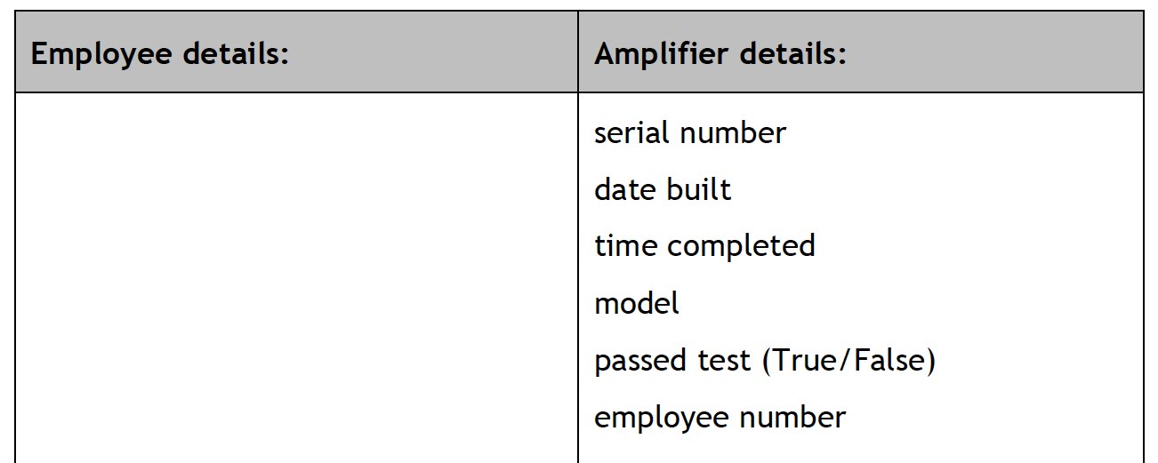

- Complete the data dictionary for the Amplifier entity.

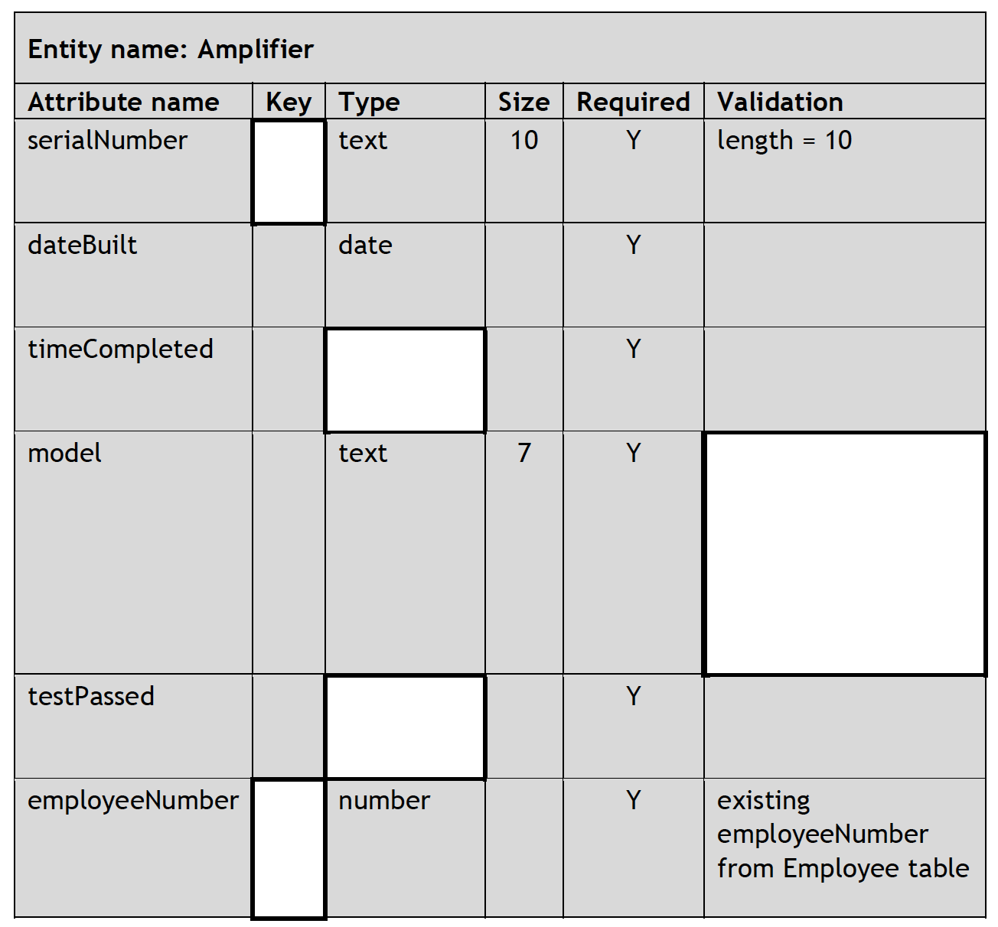

The completed data dictionary is shown below.
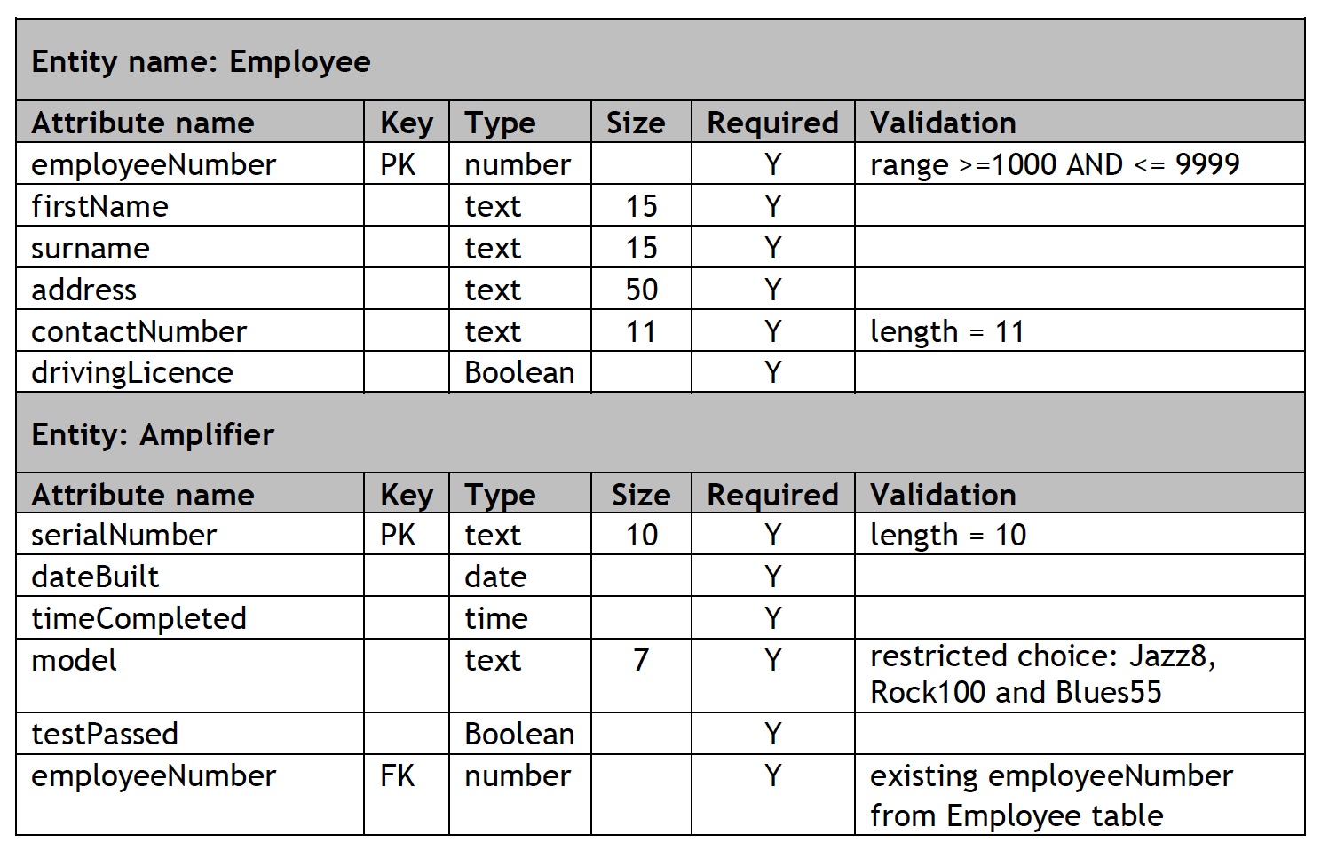

- The personal details of a new employee are listed below.

Employee number: 1599 Name: Jeremy May Address: 67 Red Lane
Driving licence: True Contact telephone number: 07923782534

Write the SQL statement that will add this new record to the correct table.

- Write the SQL statement to find the full name of all employees with a driving licence.

- Write the SQL statetment that will find the full name of all employees who have built a Rock100 amplifier and the date that they built it.

- In the board game ‘Capturing Olympus’, six players work as a team to earn points. One point is earned if the six players score a combined total of more than 50 hits. An additional point is earned if the average number of hits is greater than or equal to 10. Read the following analysis and design carefully.

Program analysis
A program is required to determine the number of points earned by the team. The program will ask the user to enter the number of hits scored by each of the six players and store these values. When all six players’ hits have been entered, the program will calculate the total and average number of hits. A message indicating the points earned is then displayed to the user.

Inputs
♦ a valid number of hits scored by each of the six players

Processes
♦ calculate the total hits achieved by all six players
♦ calculate an average number of hits (total/6)
♦ determine if the six players have earned points

Outputs
♦ a message is displayed if one point has been earned
♦ a message is displayed if the additional point has been earned
♦ a message is displayed if no points have been earned

Assumptions
♦ the number of hits a single player can achieve is greater than or equal to 0 and less than or equal to 30
♦ the average should be displayed to two decimal places
♦ one point is earned if the total number of hits is greater than 50. An additional point is earned if the average number of hits is greater than or equal to 10

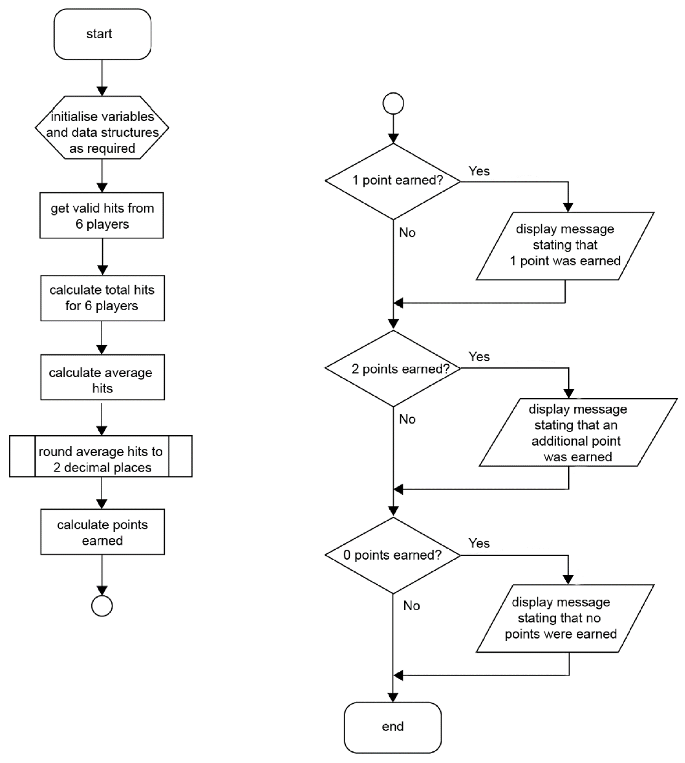

- Name the design methodology shown here.
- How many decisions are taken in this code?
- Which standard algorithm(s) are used in this program?
- Which pre-defined function(s) is used in this program?
- Which data structure is used in this program?
- How can you make code readable?
- Explain why this design is inefficient.
- Write an efficient program to perform this task.
- This program could be interpreted or compiled. Describe the differences between a compiler and an interpreter.

- A program is to be written to record and total all the points scored by a basketball player during a game. Players can score baskets worth 2 or 3 points and free throws worth 1 or 2 points. An example array is shown below.

Points | 3 | 2 | 3 | 2 | 2 | 1 | 2 | 1 | 1

- A player scores 15 times in a match. Write code to declare an array to store his scores.
- The program to store the points uses the algorithm below.

- Set total_points to zero
- Loop 15 times
- Get valid number of points
- Add points to total_points
- End loop
- Display total_points

Using a design methodology of your choice, refine step 3.
- Using a programming language with which you are familiar, write code to implement step 4.
- The player above scored 17 points. Show how this would be stored in a computer system as an 8-bit binary number.
- Which part of the processor calculates the total score?
- The array would be held in RAM. Describe the purpose of the two buses connecting to the processor when calculating the total score.
- Another statistic is calculated to work our average points per play. This variable is declares as a Real number. Describe how this value would be stored in a computer system.
- When programmed, the expected average score from above is 17/9 = 1.88888888889. Write code to calculate this value and round the result to 2 decimal places
- These statistics are stored along with a player’s name. Identify a suitable data type for storing the player name.
- One player’s name is Bob Nastanovich. Describe how this data is represented in a computer system.
- The program must be readable. Describe two techniques to produce readable code.
- During the game here are breaks between the 4 quarters of the match and during time outs. During these breaks, describe what the user of the program could do on their laptop computer to reduce energy use and maximise battery life.
- The complete program must be translated. Explain why it is necessary to translate the program code.
- The program will be used for every player in every match of a season. Explain why a compiled version of the software would be better than an interpreted version of the code.
- Woodline Academy holds a ‘pupil of the month’ competition. They wish to add a new page to their school website each month with the following content:

- The school name
- the month of the competition
- the name of the winning pupil
- a photo of the winning pupil
- a sound recording of an interview with the winning pupil

- Describe two end-user requirements for this website. Start your answer with the words “A user must be able to…”

- Describe two functional requirements for this website. Start your answer with the words “The website must have…”

- A sound file called interview.mp3 is to be embedded in the page. Write HTML code to add this sound file.

- The MP3 file format is chosen because it has a small file size so loads quickly. Describe how the MP3 format reduces the size of a sound file.

- The body of the webpage should have a blue background, white text and all text in Tahoma font. Write a CSS rule for the body.

- The pupil image has the HTML code below.

<img id=”winner” src=”octoberwinner.jpg>

Write a CSS rule to resize this image to be 200 pixels wide by 250 pixels high.

- Give two reasons why the JPG file format is a suitable file format for this image.

- The external style sheet is called styles.css and is stored in the same folder as the HTML page.
    - Write code to link the HTML and CSS pages together.
    - Where in the HTML page should this link be placed?

- A new cryptocurrency and digital currency website is to be launched.

A homepage will link to separate pages for BitCoin, Ethereum and LiteCoin currencies. An additional page will link to www.coinmarketcap.com which tracks cryptocurrency prices.

- Draw a website structure diagram for this site.
A logo for the site has been designed and is shown below. Vector and bitmapped versions of the logo are available.
- Describe how bitmapped graphics are stored in a computer system.
- Explain why GIF would be a suitable file format for the bitmapped logo.
- In the vector version of the logo, describe 3 properties of the blue circle in the logo.
- An introductory video about cryptocurrency is to be embedded in the homepage. Write HTML code to embed the intro.mp4 file.
- At the top of each page, an H1 header will have the page title. Each title should be in Courier font, size 44px, centre aligned, white text on a blue background. Write a CSS rule for the headings.
- Explain how the use of these CSS rules produces a consistent design of webpage.
- The code below is added to the homepage to create a rollover, that is the image switches between one picture and another.

<img class="rollover" src="../images/crypto1.jpg" onmouseover="this.src ='../images/crypto2.jpg'" onmouseout="this.src ='../images/crypto1.jpg'">

When would the crypto2 image appear on screen?
- All transmissions between the site and visitors must be secure. Describe how encryption is used to secure data transmissions.
- All computers in the CryptoExperts network are protected by a firewall. Describe how a firewall protects devices on a network.
- The web developers find images for the site online. Explain why they cannot simply reuse any images found online.
- Describe three ways of testing the completed website.
- All registered users of the site will submit contact and bank details. Describe the legal implications for CryptoExperts when collecting and storing this data.

