Second Level Literacy Home Activities
Listen or logon to the news. Listen to/read two news items. Note the main points in your jotter and use them to retell the items to a member of your family. | Select a chapter from a book. Having read it carefully, create five questions about it which you could give to one of your friends.  You should include different types of questions e.g. literal and inferential. | Select a book of your choice. Having read a chapter or a few chapters begin to create a visualiser, continue to develop this as you read on. | Select an historical figure.  He/she is writing his/her autobiography.  - Create a title for the book  - Illustrate the front cover  - Write an introduction  - Write a ‘blurb’ for the back cover  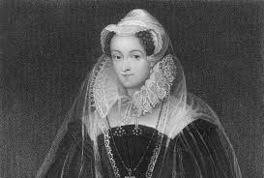
Think of an environmental issue which interests you – e.g. plastic pollution; recycling etc.  Do some research and make a three-minute documentary where you are the presenter. Record yourself (and family member you might interview) and keep it for use in school at a later date. | Log on to Sumdog Reading & Spelling. How many questions can you answer correctly? | Write a rhyming, acrostic poem about any subject of your choice.  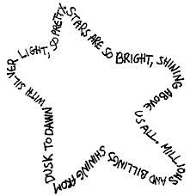 | Select a few stories from the news. Design the front page of your own newspaper. Remember to include:  - Title  - Price  - Date  - Pictures  - Headlines  - Adverts
Keep a diary for your days at home, detailing events and activities you are doing.  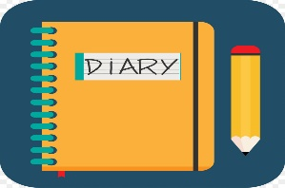 | Write a letter to a friend or relative  Giving details of what you have been doing and find out what they have been doing by asking relevant questions.  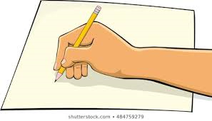 | Select words from books/newspapers/magazines and select appropriate spelling strategies such as syllabification, phonological knowledge, word patterns, mnemonics, spelling rules etc to ensure correct spelling. | Create a text, select a genre, audience and purpose of your choice. You could even word process this and save to share at a later date.

