AIRDRIE ACADEMY

Senior Phase Options

SESSION 2026-27



Information for
Students moving to Senior Phase
S5 & S6

Read this to help with you to finalise your choices.

The completed option form should be returned to your Depute Head Teacher before Monday 23rd March 2026.

Senior Phase Options 2026 – 2027

- This booklet gives general information on senior phase school courses

- Read about the courses you are considering and discuss your choices at home.

- Your finalised Option Form should be handed in to your Depute Head no later than Monday 23rd March 2026. Your options recorded at your interview will be used for your timetable if the final form is returned late.

- Note that some subjects listed may not run.

- Check that your selected courses are at the correct level.

S5 Options for 2026 – 2027

Guidelines for pupils - What you need to think about!

- Leaving school or staying on?

If your decision is to stay on at school think about whether you are likely to stay on for 1 year or for 2 years. This may influence what subjects you study in S5. Take into consideration what would be essential to you in going on to a college, or a university, or into employment. As well as essential subjects there may be other subjects which you enjoy. Also consider that colleges, universities, and employers prefer to take people who have a range of skills, not just qualifications covering a narrow area.

If your 16th birthday is on or before 30 September 2026 you may leave after 30 May 2026. If your 16th birthday is between 1 October 2026 and 28 February 2027, the earliest you can leave school is December 2026. Some pupils who want to leave school at Christmas may be able to start at College in August instead of school. You can only do this with the school’s permission, and it will depend on what kind of course you want to do, and if you are accepted on the course. Your pupil support teacher can help you with more information about this, and by arranging a Careers interview.

- How many subjects?

All pupils in S5 will follow 5 courses, each subject is studied in greater depth over a longer period of time, so pupils are timetabled for only 5 courses. Where combinations of subjects are not be possible, the house DHT will look at subjects offered in the local consortium schools to find the best progression route for each pupil. Please note that this would mean moving between schools and potentially disrupting your other courses. Any pupil undertaking a subject at another school must be committed to completing this subject online. Transport will not be provided by the local authority to facilitate the delivery of consortium courses unless for practical elements of the course.

- What subjects should I choose?

It is expected that all pupils study a Maths and English qualification. If you are considering an alternative to Maths, check on your career choice or intended college or university course. Many college and university courses, and apprenticeships or jobs require a particular level for Maths. Also check if Applications of Maths is accepted for what you are thinking on moving on to when leaving school.

This leaves 3 other subjects. When choosing these take the above points into consideration and also think about increasing your ‘employability.’ For instance:

Are your IT skills at level high enough?

What about being able to work with others?

Creativity is another desirable quality for many different careers.

Some subjects will develop leadership skills.

Consider all the possibilities on the Option Form. Don’t dismiss any subject as being ‘no use to me.’ Succeeding in a subject and gaining a qualification at a particular level shows you have worked consistently throughout the session. It shows you have a capacity for learning. It shows you can work with other people in different ways. Whatever the subject the qualification has equal status with any other subject at the same level.

Try using www.myworldofwork.co.uk to find out information about careers and subject choices. Additionally, most College and University websites have good information to guide your subject choice.

- Do I understand what all the subjects are?

Most of the subjects listed on the Option Form will be familiar to you, but some are new in the senior school. A list of subjects is included. Alongside the subject is the name of the Principal Teacher or the teacher responsible for the subject. This is who you should ask for more information about the subject. There is plenty of information on the internet. Look at www.ceg.org.uk/nq (National Qualifications website) for details of every subject at every level. This site also has links to SQA, careers sites and other useful ones.

5. What level of course do I choose?

Senior school courses are generally at Higher (SCQF level 6) or National 5 (SCQF level 5).
Foundation Apprenticeships are mostly one-year courses starting in S5 (SCQF level 6) and will be part of your timetabled classes. There is a possibility that you may have to travel to another school or college for delivery of the theory part but again this will be timetabled in columns D&E.

The different levels of course are:-

- National 5 (SCQF Level 5)

This level is a progression for pupils who have succeeded at National 4. Success at National 5 will usually allow you to move on to Higher the following year.

- Higher (SCQF Level 6)

To tackle a Higher course in S5, you should have a pass at National 5. In some instances Grade C will not be enough to move directly into a one year Higher.

- Foundation Apprenticeship (SCQF Level 6)

Applications are required to be admitted onto the FA courses and requirements for each of the Foundation Apprenticeships can be found in the booklet given out with your options information or at the following website: apprenticeships.scot/foundation

- HNC (SCQF Level 7)

Pupils who choose these HNC subjects should be aware that they are studying at degree level and are only available in their S6 choices. They are undertaking the first year of a degree programme and, if successful, have a guaranteed place on a Higher National Degree (HND) course at SCQF Level 8 at New College Lanarkshire, which is the equivalent to the second year of a degree programme.

The information above is intended as a guide. Different subjects have different requirements. Please read the options information for each subject you are interested in.
Principal Teachers decide which level you can work at in the subject. If you have any doubts, you can ask the Principal Teacher for that subject.

As well as your grades for S4 subjects, you should think about your overall workload. Five Higher courses is a realistic choice if you have Grade A/B in all your National 5 exams. Most pupils will have a mix of levels in their courses.

6. How much homework can I expect?

Courses at Higher and Advanced Higher levels need serious commitment for success. You should expect at least 1 hour of homework per week for each subject at this level. Homework is not always spread evenly over the session, so it may be more than 1 hour per subject at times.
National 4/5 courses may have less homework, depending on which course and level is studied, but a commitment to spend extra time on study and revision is essential at all levels.

Staff Contacts

English, Media Studies, Literature & Communication Mr Douglas

Maths , Applications of Maths Mr Smith/Mr Lofnes

Modern Studies, History, Geography Mrs Fraser
Scottish Studies, Business Studies & Classics

Engineering Science, Graphic Communication,
Metalwork & Furniture Making Mr Di-Nardo

Biology, Human Biology, Chemistry, Physics &
Laboratory Studies, Health Sector. Mr Paterson
ICT, Health & Food, Practical Cookery Mr Allen

Physical Education, SFA Refereeing Mr.Ferguson/Ms Gilmour

Art & Design, Photography, Music & Drama Mrs Douglas

French, Spanish, Religious Moral and
Philosophical Studies (RMPS) Mr Bauld

Subject Name | ENGLISH
Level(s) | Higher (SCQF L6)
Entry qualifications | A – B award in National 5 English
Course Assessment | The course is assessed in the following ways:  - Component 1 - question paper: reading – 70 marks  - Component 2 - portfolio: writing – 30 marks  - Component 3 – spoken language – pass/fail
Notes about levels | All pupils will commence the English Course at an appropriate level. During the course presentation level may change, depending on the pupil’s performance in unit tests, prelim, and other work.
Unit test arrangements | Assessment of candidates work will be ongoing throughout the session.
General Notes | The Higher English Course provides learners with the opportunity to develop the skills of listening, talking, reading and writing in order to understand and use language. Building on literacy skills, learners develop understanding of the complexities of language, including through the study of a wide range of texts, and develop high levels of analytical thinking and understanding of the impact of language.

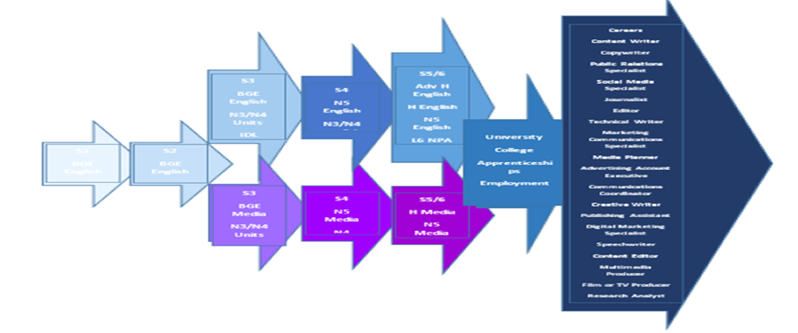

Subject Name | ENGLISH
Level(s) | National 5 (SCQF L5)
Entry qualifications | National 4 English/ No Award in National 5 English
Course Assessment | Communication  - 1 Reading Assessment  - 1 Broadly Discursive Writing Assessment  - 1 Listening Assessment  - 1 Speaking Assessment  Introduction to Literature  - 2 Critical Essays on texts taught in class  - 1 Unseen Textual Analysis
Notes about levels
Unit test arrangements | Assessment of candidates work will be ongoing throughout the session. Assessments are usually open book and not under timed conditions.
General Notes | Communication provides opportunities to develop skills in reading, writing, talking and listening. It is particularly appropriate for learners who need to interpret, evaluate and use detailed written and spoken communication for learning, life and work.  Introduction to Literature introduces learners to the study of literature and encourages them to read and develop a critical appreciation of a range of literary texts. Learners develop analytical and evaluative skills through the study of detailed texts from different genres. Successful completion of this course would provide candidates with an excellent preparatory year for Level 6 Communication and Literature in S6.

Subject Name | Media
Level(s) | Higher (SCQF L6)/ National 5 (SCQF L5)
Entry qualifications | A pass in English at National 5 / Higher level.  A pass in National 4 / National 5 Media
Course Assessment | There are 2 parts to the final assessment:  - Final Exam – 50% or 60 marks  - Production Assignment – 50% or 60 marks
Notes about levels | All pupils will commence the Media Course at an appropriate level. During the course presentation level may change, depending on the pupil’s performance in unit tests, prelim, and other work.
Unit assessment arrangements | There is an integrated approach to this course and assessment is ongoing throughout the session.
General Notes | The Higher and National 5 Media Courses enable learners to analyse and create media content. Learners understand and develop their media literacy skills and appreciate the opportunities and challenges that occur within the media industry, while developing both theoretical knowledge of the media and the ability to create media content.

Legal Studies – SCQF Level 6 (Higher)
SCQF Level: 6
Qualification Type: Higher
Assessment: Combination of question paper (exam) and assignment
This course is suitable for pupils who are interested in law or who plan to study a legal subject in the future. It covers two main outcomes. Introduction to Scots Law provides an overview of the civil and criminal justice system in Scotland, including key legal personnel and the appeals process. Crime in Society explores the main principles involved in prosecuting crime and considers the impact of crime on communities. The course is assessed internally and has no final exam.

Recommended Entry Requirements
- Pupils must have achieved National 5 English at grade C or above to take this course.
- Strong literacy, analytical and essay-writing skills

🎯 Skills Developed
- Legal reasoning
- Critical analysis
- Application of legal principles
- Research skills
- Essay writing
- Evaluation of sources
- Understanding of the Scottish legal system

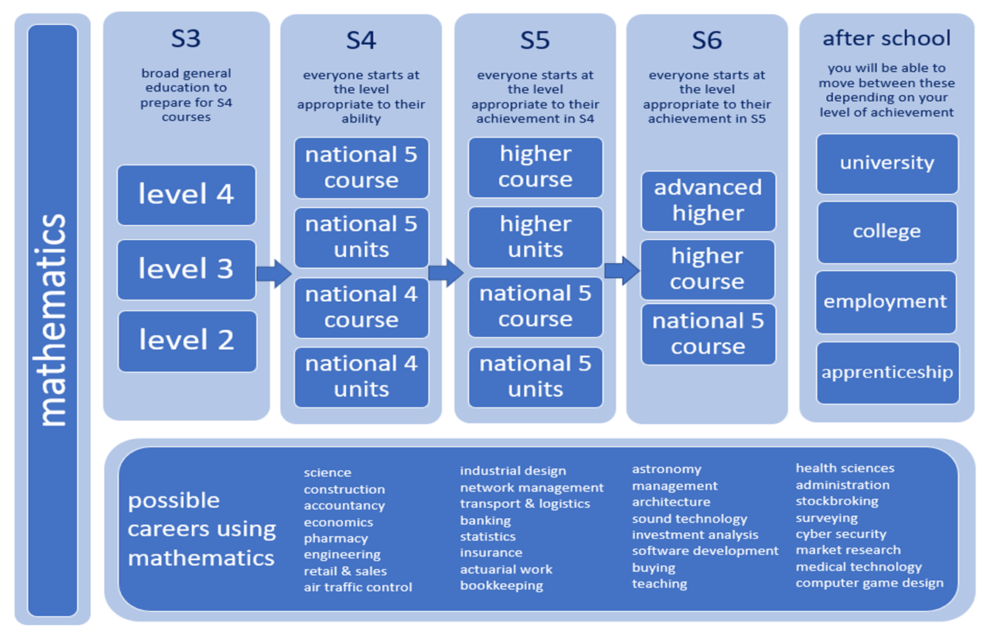
Mathematics

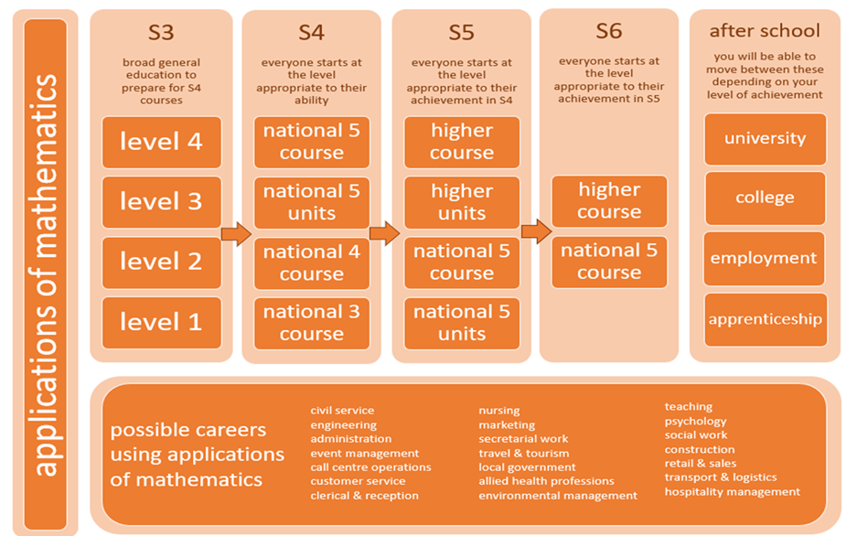

Subject Name | Mathematics
Level(s) | CFE Higher (SCQF L6)
Entry qualifications | National 5 Mathematics pass at A or B
Units | There are 3 units in this course  - Expressions and Functions  - Relationships and Calculus  - Applications
Intended Audience | S5/6
Unit test arrangements | None
Exam at end of course | Paper 1 - 1 hour 30 minutes - 70 marks (non-calculator)  Paper 2 - 1 hour 45 minutes - 80 marks
Expectations for homework | Informal and formal homework given regularly. Formal homework issued on completion of a topic.
General Notes | The Higher Mathematics Course enables learners to select and apply mathematical techniques in a variety of mathematical situations. Learners interpret, communicate and manage information in mathematical form. Learners will experience in-depth study of the ways in which mathematics describes our world, and become skilled in interpreting, analysing, communicating and managing information in mathematical form.  On successful completion of this Course, the learner could progress to:  - Advanced Higher Mathematics  Mathematics has applications in many other subject areas, and skills developed in this Course can support progression in other curriculum areas and employment.

Subject Name | Mathematics
Level(s) | CFE National 5 (SCQF L5)
Entry qualifications | National 4 Mathematics or level 4 of the Broad General Education
Units | There are 3 units in this course  - Expressions and Formulae  - Relationships  - Applications
Intended Audience | S4/5/6
Unit test arrangements | None
Exam at end of course | Paper 1 - 1 hour 15 minutes - 50 marks (non-calculator)  Paper 2 - 1 hour 50 minutes - 60 marks
Expectations for homework | Informal and formal homework given regularly. Formal homework issued on completion of a topic.
General Notes | The National 5 Mathematics Course enables learners to select and apply mathematical techniques in a variety of mathematical and real-life situations. Learners interpret, communicate and manage information in mathematical form.  On successful completion of this Course, the learner could progress to:  - Higher Mathematics  Mathematics has applications in many other subject areas, and skills developed in this Course can support progression in other curriculum areas and employment.

Subject Name | Applications of Mathematics
Level(s) | CFE Higher (SCQF L6)
Entry qualifications | National 5 Mathematics pass at A or B or  National 5 Applications of Maths pass at A or B
Intended Audience | S5/6
Unit test arrangements | None
Exam at end of course  Project Report | Component 1 – Question Paper:2hr 30mins - 80marks  Component 2 - Project - 30 marks
Expectations for homework | Informal homework given regularly. Formal homework issued on completion of a topic.
General Notes | The Higher Applications of Mathematics Course aims to:  - equip learners with the mathematical and statistical literacy skills they need for life, work and further study in a wide range of curricular areas  - develop learners’ financial literacy in real-life contexts  - show learners how they can use appropriate digital technology to manipulate and model mathematical, statistical and financial information  - develop learners’ mathematical reasoning skills so that they can generalise, build arguments, draw logical conclusions, assess risk, and make informed decisions in familiar and unfamiliar situations  - develop learners’ range of mathematical skills so that they can analyse, interpret and present data and numerical information  - provide learners with the skills to appraise quantitative information critically, considering modelling or statistical assumptions.

Subject Name | Applications of Mathematics
Level(s) | CFE National 5 (SCQF L5)
Entry qualifications | National 4 Applications of Mathematics or level 4 of the Broad General Education
Units | There are 3 units in this course  - Numeracy  - Geometry and Measure  - Finance and Statistics
Intended Audience | S4/5/6
Unit test arrangements | None
Exam at end of course | Paper 1 - 1 hour 5 minutes - 45 marks (non-calculator)  Paper 2 - 2 hours - 65 marks
Expectations for homework | Informal and formal homework given regularly. Formal homework issued on completion of a topic.
General Notes | The National 5 Applications of Mathematics Course enables learners to apply mathematical ideas and strategies to managing finance, statistics, geometry and measurement in real-life contexts.  On successful completion of this Course, the learner could progress to:  Application of Mathematics has links to many other subject areas, and skills developed in this Course can support progression in other curriculum areas and employment.
  - related areas, eg Skills for Work courses
  - further study, employment or training

Subject Name | Applications of Mathematics/Personal Finance
Level(s) | CFE National 4 (SCQF L4)
Entry qualifications | National 3 Applications of Mathematics or level 3 of the Broad General Education
Units | There are 4 units in this course:  - Numeracy  - Geometry and Measure  - Finance and Statistics  - Added Value
Intended Audience | S4/5/6
Unit test arrangements | Unit tests are taken during the session on completion of each unit. Pupils are required to pass each unit in order to achieve a full qualification at this level.
Exam at end of course | None
Expectations for homework | Informal and formal homework given regularly.
General Notes | The National 4 Applications of Mathematics Course enables learners to apply mathematical ideas and strategies to managing finance, statistics, geometry and measurement in straightforward real-life contexts  On successful completion of this Course, the learner could progress to:  Application of Mathematics has links to many other subject areas, and skills developed in this Course can support progression in other curriculum areas and employment.
  - National 5 Applications of Mathematics

Social Subjects

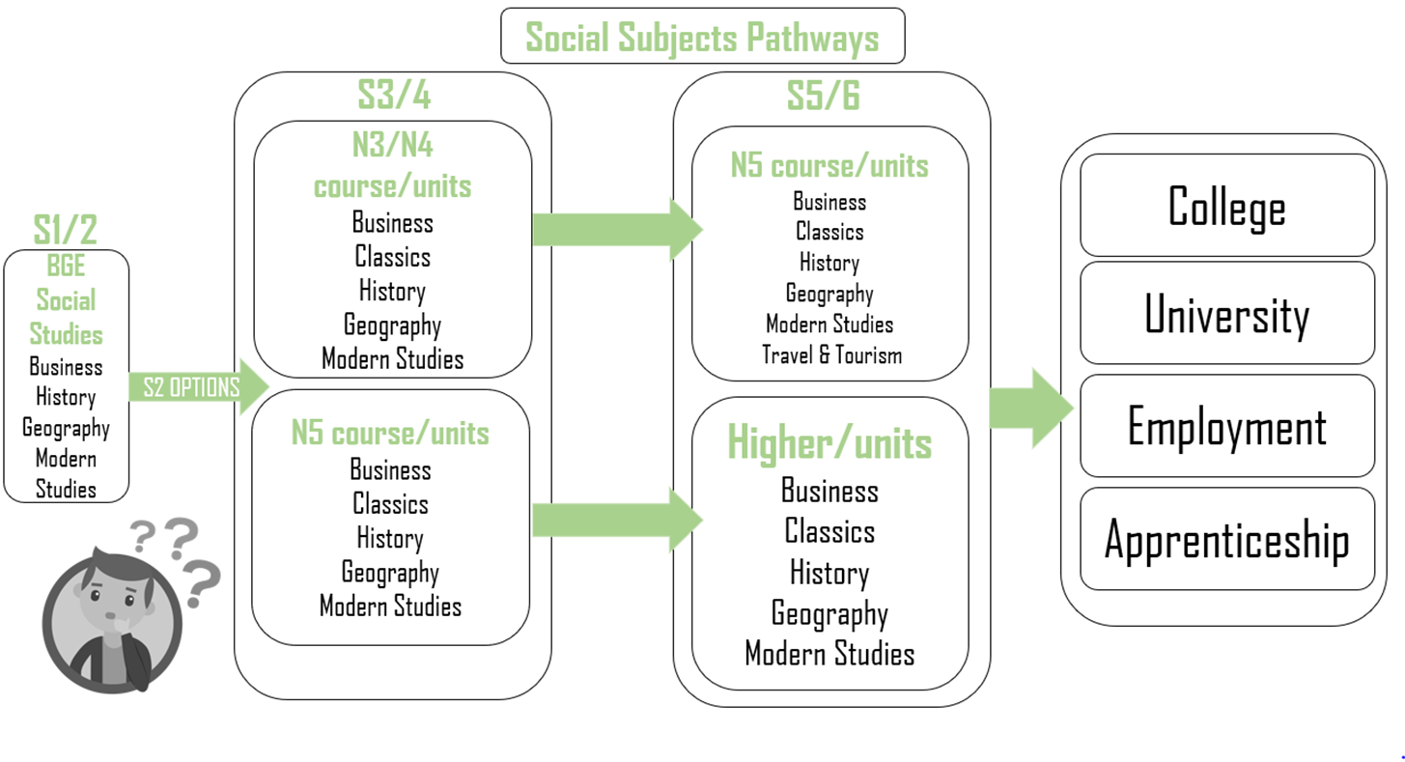

Subject Name | Modern Studies
Level(s) | Higher (SCQF L6)
Entry qualifications | Course award at National 5
Units | 3
Intended Audience | S5 /6
Added Value Unit | Higher Assignment
Exam at end of  course | YES - Paper 1: 1 Hour 45 Minutes  Paper 2: 1 Hour 15 Minutes
Expectations for Homework: | Regular homework and study for Prelim assessment.
General Notes | Candidates will study a variety of social, political and international issues happening across Scotland, Britain and the wider world including immigration, crime in the USA and health inequalities in the U.K. Pupils will be assessed on knowledge and understand and on evaluating skills.  Candidates will also develop their ability to carry out independent research and to present their findings when completing the Higher Assignment.
Any other information about the course or units or the type of work that will be covered? | Units:  Unit 1: Democracy in the United Kingdom  Unit 2: Social Issues in the United Kingdom – Social  Inequality  Unit 3: International Issues – The USA  To be presented for a Higher course award, pupils must pass the Prelim and submit an Assignment.

Subject Name | History
Level(s) | Higher (SCQF L6)
Entry qualifications | Course award at National 5
Units | 3
Intended Audience | S5/6
Added Value Unit | Higher Assignment
Exam at end of course | YES – Paper 1 : 1 Hour 30 Minutes  Paper 2 : 1 Hour 30 Minutes
Expectations for Homework: | Regular homework and study for Prelim assessment.
General Notes | Candidates will study a variety of Historical contexts across Scotland, Britain and the wider world including the struggle for racial equality in the USA and the impact of immigrant groups on Scotland. Pupils will be assessed on knowledge and understand and on analysis of Historical sources.  Candidates will also develop their ability to carry out independent research and to present their findings when completing the Higher Assignment.
Any other information about the course or units or the type of work that will be covered? | Units:  Scotland: Migration and Empire  Britain: The Making of Modern Britain  European & World: Free at Last  To be presented for a Higher course award, pupils must pass the Prelim and submit an Assignment.

Subject Name | Classics
Level(s) | Higher (SCQF L6)
Entry qualifications | In S5/6, a course award at National 5 in Classical Studies or another Social Subject is required for entry at Higher level.
Units | 3
Intended Audience | S5/6
Added Value Unit | N/A
Exam at end of course | YES – 2 Papers – 3 Hours
Expectations for Homework: | Regular homework and study for Learning Outcomes and/or Prelim assessments.
General Notes | Candidates study the religious, political, social, moral and cultural values and practices of classical Greek and Roman societies. They become more aware of issues affecting their own society and globally, by comparing the classical world with the modern world.
Any other information about the course or units or the type of work that will be covered? | Units  Unit 1: Classical Literature  Unit 2: Life in Classical Greece  Unit 3: Life in the Roman World  To be presented for a Higher course award, pupils must pass the Prelim.

Subject Name | Geography
Level(s) | Higher (SCQF L6)
Entry qualifications | Course award at National 5
Units | 3
Intended Audience | S5/6
Added Value Unit | Higher Assignment
Exam at end of course | YES – Paper I: 1 Hour 50 Minutes  Paper 2: 1 Hour 10 Minutes
Expectations for Homework: | Regular homework and study for Prelim assessment.
General Notes | Candidates will study a variety of Physical and Human environments such as Atmosphere, Hyctrophec, population an urban as well as global issues including climate change and health.  Candidates will be expected to evaluate and explain geographical issues. Pupils will also develop their ability to carry out independent research and to present their findings when completing the Higher Assignment.
Any other information about the course or units or the type of work that will be covered? | Units:  Unit 1: Physical Environments  Unit 2: Human Environments  Unit 3: Global Issues  To be presented for a Higher course award, pupils must pass the Prelim and submit an Assignment.

Subject Name | Scottish Studies
Level(s) | Level 5 (SCQF L5)
Entry qualifications | In S5/6, a course award at National 4 or above is required for entry at level 5 Scottish Studies.
Units | 3 Units are studied to achieve the course award. Mandatory unit:  Scottish Studies: Scotland in Focus (SCQF level 5)
Intended Audience | S5/6
Added Value Unit
Exam at end of course | There is no formal exam in this subject and pupils will be assessed through continues assessment and project work.
Expectations for Homework: | Pupils are expected to undertake regular homework activities to support and consolidate learning in the classroom.
General Notes | The purpose of this Award is to allow learners to broaden their knowldege of Scotland whilst developing and applying the skills, knowledge and understanding relevant to their chosen subject areas. Learners will have a choice of Units, from a range of subject areas, which they can study in a Scottish context.  The main aims of the Award are to give learners the opportunity to:  ◻ develop and apply skills, knowledge and understanding in their chosen subject areas.  ◻ make connections across these areas by studying them in a Scottish context.  ◻ develop an understanding of the contribution that Scotland and its people, past and/or present, have made and continue to make in these areas.  ◻ reflect on the place of Scotland within the wider context of the United Kingdom, Europe and/or the rest of the world.  ◻ explore an aspect of Scottish Studies that is of particular interest to them.  ◻ develop the skills of planning, researching, selecting and using information, and skills of reflection.  ◻ develop, with minimum support, their abilities to become independent learners.
Any other information about the course or units or the type of work that will be covered?

Food & Nutrition

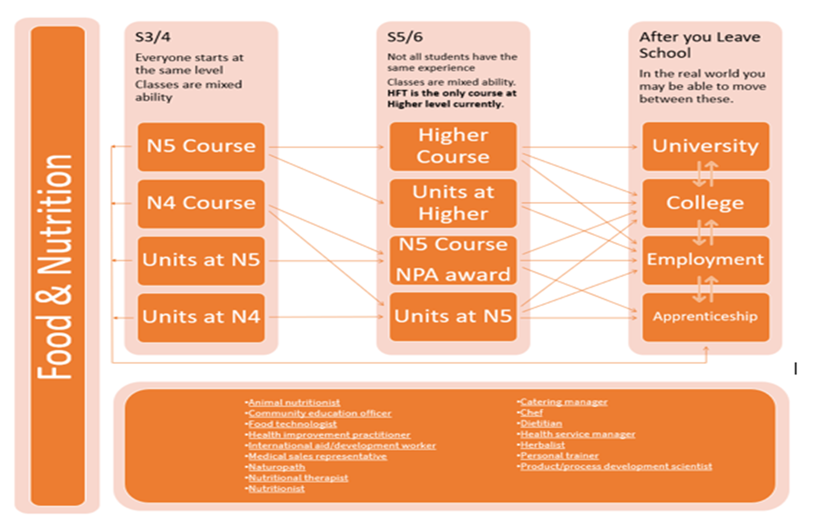

Subject Name | Health & Food Technology
Level(s) | Higher (SCQF L6) /National 5 (SCQF L5)
No entry qualifications but smaller number of appropriate qualifications should temp expectations. | Health & Food Technology Nationals 4/5
Units | Food product Development  Food for health  Contemporary Food issues
Notes about levels | This will run as a bi-level class
Unit test arrangements | Units are completed in class through open book practical tables. Unit assessments are only undertaken in the event of withdrawal from course certification
Course Assessment | At both levels  - An assignment conducted by staff at Airdrie Academy and marked by SQA.  - An exam paper  - At both levels the assignment and exam are worth 50% of the total.
General Notes | Candidates will gain:  - Knowledge and understanding of the relationships between health, food and nutrition.  - The ability to produce food products which meet individual needs in a range of contexts.  - A range of practical food preparation skills and techniques using appropriate tools and equipment.  - Knowledge and understanding of the functional properties of food.  - Knowledge and understanding of consumer food issues, choices and rights.  - Knowledge of technological developments in food.  - The ability to prepare food safely and hygienically.  - Organisational skills in planning, preparing and evaluating food products and processes.  - Problem-solving for a range of health, food, nutrition and consumer needs.

Technical
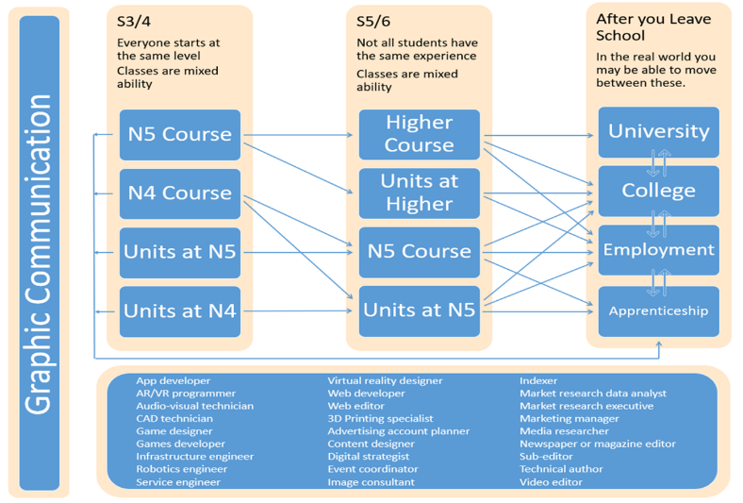
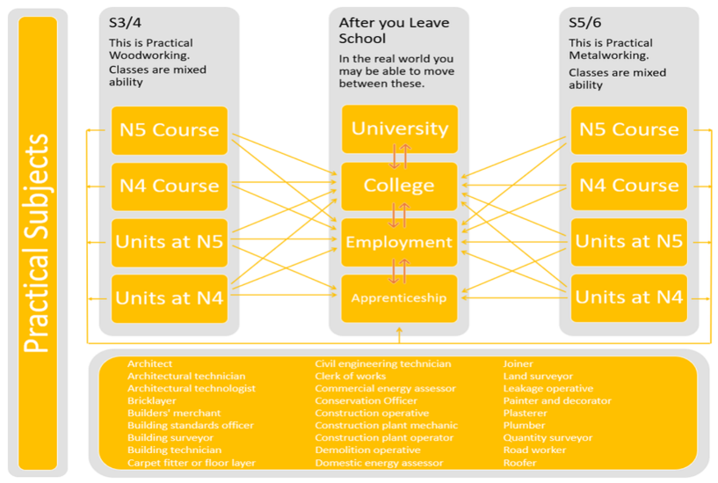
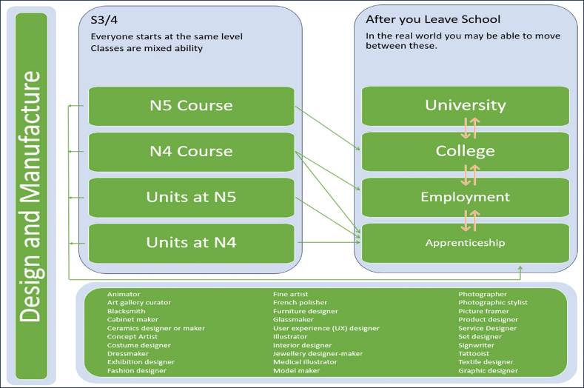
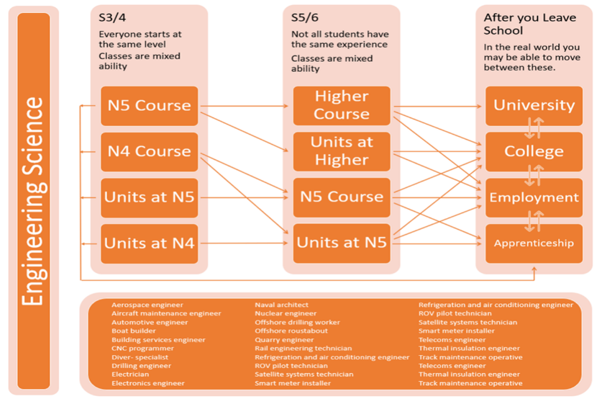

Subject Name | Furniture Making
Level(s) | Level 5 NPA (SCQF L5)
Entry qualifications | Qualification in another technical subject.
Units | H3LG 11 Furniture – Workshop Practice  H3LK 11 Furniture – Timber Frame  H3MC 11 Furniture – Carcase Making
Unit test arrangements | This National Progression Award (NPA) introduces learners to tools and techniques that are important in the furniture manufacturing sector.  It develops knowledge and understanding of planning and organising, workshop practice skills, woodworking joints, timber framing and carcase making, and provides bite-sized chunks of learning that are straightforward for centres to adopt and for learners to study.  There is no formal exam in this subject and pupils will be assessed through a combination of practical and knowledge assessments under closed- and open-book assessment conditions.

Subject Name | Engineering Science
Level(s) | Higher (SCQF L6) /National 5 (SCQF L5)
Entry qualifications | Engineering Science Nationals 4/5
Units | Electronics & Control  Mechanisms & Structure  Engineering Contexts & challenges
Notes about levels | This will run as a bi-level class.
Unit test arrangements | Units are completed in class through open book practical tables. Unit assessments are only undertaken in the event of withdrawal from course certification
General Notes  Course assessment | Candidates will gain;  - Knowledge and understanding of key engineering facts and ideas.  - Understanding the relationships between engineering, maths and science.  - An understanding of mechanical, structural, pneumatic and programmable electronic systems.  - The ability to apply analytical, design, construction and evaluation skills to a range of engineering problems.  - Knowledge of the workings of a range of engineered objects.  - The ability to communicate engineering concepts clearly.  - An understanding of the role and impact of engineering in society.  - Knowledge of the relevance of energy, sustainability and efficiency to engineering problems and solutions.  - Design and problem-solving skills.  An understanding of planning, organising and researching in a technological context.  Each level has 2 methods of assessment  An 8 hour assessment completed under exam condition. Normally completed in February in to March, attendance needs to be 100% during this period. The assignment is marked by the SQA and is worth 31% of the total grade.  The remaining 69% is made up from an external examination.

Subject Name | Graphic Communication
Level(s) | Higher (SCQF L6) /National 5 (SCQF L5)
Entry qualifications | Graphic Communication Nationals 4/5
Units | 2D  3D & Pictorial
Notes about levels | This will run as a bi-level class.
Unit test arrangements | This unit is passed after the completion of a small number of tasks which require both CAD and manual graphics work to be undertaken in most cases in response to a brief.
Course Assessment | - The assessment comes in two stages, a final exam and an internal 8 hour assignment (which requires 100% attendance) at Higher this is weighted 64% written and 36% assignment.  - At N5 this is 67% written and 33% assignment.

Subject Name | Practical Metalworking
Level(s) | National 4 (SCQF L4)/ National 5 (SCQF L5)
Entry qualifications | Practical Woodworking Nationals 4/5
Units for N4 | Bench Skills  Machine Processes  Joining Techniques & Thermal Joining.
Notes about levels | This subject is only offered at National 4/5
Assessment arrangements & N5 | This course work is assessed through the completion of 2 large projects over the year supported by a small number of test pieces for skill building. Nat 5 course is graded by assessment of a final module and a written exam the final model is worth 70% of the total.
Assessment arrangements & N4 | This course is awarded after the completion of 3 units and associated paperwork and a final module constituting the added value unit.
General Notes | Candidates will gain;  - A range of metalworking hand tool skills on tasks with some complex features.  - The ability to use a range of metalworking tools, equipment and materials.  - Skills in reading and interpreting drawings and diagrams in familiar and unfamiliar contexts.  - Skills in measuring and marking out metal sections and sheet materials.  - Cutting and forming skills.  - Creativity with familiar metalworking tasks with some complex features.  - Experience in using a problem-solving approach to metalworking tasks.  - Knowledge and understanding of safe working practices in a workshop.  - Knowledge of the properties and uses of a range of common metals and metalworking materials.  - Knowledge and understanding of sustainability issues in a practical metalworking context.

The Sciences

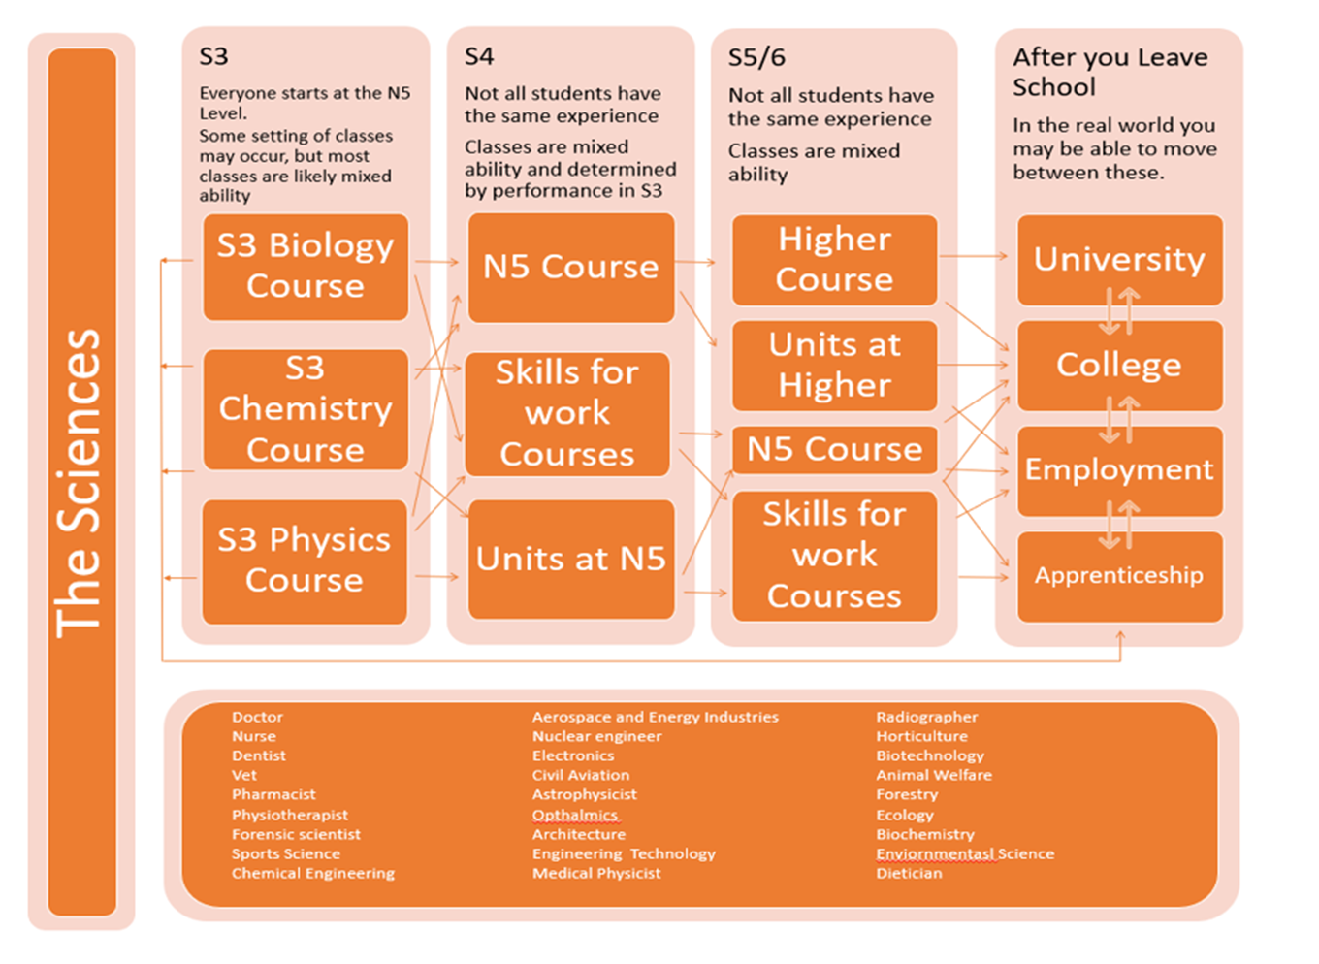

Subject Name | Human Biology
Level(s) | Higher (SCQF L6)
Entry qualifications | National 5 Biology
Units | 3
Intended Audience | S5/6
Exam at end of course | COMPONENT 1 – QUESTION PAPER  This will have two papers; titled ‘Objective Test’, titled ‘Paper 2’, together 80% of the final mark.  COMPONENT 2 – ASSIGNMENT  An experimental based assignment is to allow the learner to carry out an in-depth study of a biology topic.  The assignment will 20% of the final mark.
Expectations for Homework: | Regular homework will be provided throughout the year.
General Notes | The course allows learners to develop deeper understanding of the underlying themes specifically aspects of Human Physiology, Immunity and Biochemistry.
Any other information about the course or units or the type of work that will be covered? | UNITS  HUMAN CELLS  The study of cell division and differentiation. The structure and function of DNA and cell metabolism.  PHYSIOLOGY AND HEALTH  The study and reproduction including hormone control and treatment of infertility. The cardiovascular system and disease.  NEUROBIOLOGY and IMMUNOLOGY  The study of the nervous system communication and social behaviour.  The study of the immune system and response to disease.

Subject Name | Chemistry
Level(s) | Higher (SCQF L6)
Entry qualifications | National 5 Chemistry
Intended Audience | S5/6
Exam at end of course | COMPONENT 1 – QUESTION PAPER  This will have two papers;  1, titled ‘Objective Test’  2, titled ‘Paper 2’, 80% of the final weighting.  COMPONENT 2 – ASSIGNMENT  The purpose of the assignment is to allow the learner to carry out an in-depth study of a chemistry topic. They are all practical assignments.  The assignment will have 20 marks weighting to 20%.
Expectations for Homework: | One homework task per week – at least.
General Notes | This course develops scientific understanding issues relating to chemistry and uses the development of chemical theory to build an extensive set of skills for learners. Through application of a detailed knowledge and understanding of chemical concepts, in practical situations, learners develop an appreciation of the impact of chemistry on their everyday lives.
Any other information about the course or units or the type of work that will be covered? | UNITS  - CHEMICAL CHANGES AND STRUCTURE  This Unit covers the knowledge and understanding of controlling reaction rates and periodic trends.  - NATURES CHEMISTRY  This Unit covers the chemistry of carbon compounds found in food and drinks and skin care products. This Unit covers the knowledge and understanding of organic chemistry within the context of the chemistry of food and the chemistry of everyday consumer products, soaps, detergents, fragrances and skincare.  - CHEMISTRY IN SOCIETY  This unit covers the chemistry behind making new products which benefit society and the environment impact of global chemical industry.  - RESEARCHING  Learners will collect and synthesize information from different sources, plan and undertake a practical investigation, analyse results and communicate information related to their findings.

Subject Name | Physics
Level(s) | Higher (SCQF L6)
Entry qualifications | National 5 Physics
Intended Audience | S5/6
Exam at end of course | COMPONENT 1 – QUESTION PAPER  This will have two papers;  1, titled ‘Objective Test’.  2, titled ‘Paper 2’, will be 80% of the total mark.  COMPONENT 2 – ASSIGNMENT  The purpose of the assignment is to allow the learner to carry out an in-depth study of a Physics topic.  The assignment will have 20% marks.
Expectations for Homework: | One homework task per week – at least.
General Notes | This course will enable learners to develop a deeper understanding of Physics concepts and the ability to describe and interpret physical phenomena using mathematical skills. They will develop scientific methods of research in which issues in Physics are explored and conclusions drawn.
Any other information about the course or units or the type of work that will be covered? | UNITS  OUR DYNAMIC UNIVERSE  The Unit covers the key areas of kinematics, dynamics and space-time.  PARTICLES AND WAVES  The Unit covers the key areas of particles and waves.  ELECTRICITY  The Unit covers the key areas of electricity, and electrical storage and transfer.

Subject Name | Physics
Level(s) | Nat 4 (SCQF L4) / Nat 5 (SCQF L5)
Entry qualifications | National 3 or 4 Physics as appropriate.
Intended Audience | S4/S5/6
Exam at end of course  (Nat 5) | COMPONENT 1 – QUESTION PAPER  This will have two sections;  Section 1, titled ‘Objective Test’, will have 25 marks.  Section 2, titled ‘Paper 2’, will have 110 marks.  COMPONENT 2 – ASSIGNMENT  The purpose of the assignment is to allow the learner to carry out an in-depth study of a physics topic.  The assignment will have 20 marks (20% of the total marks).
Assessment of Course:  (Nat 4) | The National 4 course assessment is comprised of 3 end of unit assessments and other associated tasks. The course is internally assessed and externally verified. The course has an added value unit.
Expectations for Homework: | One homework task per week – at least.
Any other information about the course or units or the type of work that will be covered? | UNITS  ELECTRICITY AND ENERGY  The Unit covers the key areas of energy transfer, heat and the gas laws.  WAVES AND RADIATION  The Unit covers the key areas of waves and nuclear radiation.  DYNAMICS AND SPACE  The Unit covers the key areas of kinematics, forces and space.  Through each of the units above, learners will research issues, apply scientific skills and communicate information related to their findings, which will develop skills of scientific literacy.

Subject Name | Laboratory Science Skills
Level(s) | National 5 (SCQF L5)
Entry qualifications | This course is open to S5 and S6 pupils.  Candidates should have a National 4/5 pass in Chemistry, Physics or Biology.  Candidates should have a National 4/5 pass in Mathematics or passes in National 5 Mathematics Units. A pass in Applications of Mathematics at National 5 will also be acceptable.
Course Assessment | The course is internally assessed and externally moderated.  There is a strong focus on personal responsibility in the course in terms of organisation of workload to meet deadlines.
Units | 3 Units and an independent investigation is required to be completed.  Units:  Working in a lab  Practical Skills  Careers with Lab Science
General Notes | National 5 Skills for Work: Laboratory Science is an introductory qualification. The course provides a broad experiential introduction to laboratory science. Learners will explore a variety of industries and services, and career opportunities, in science laboratories locally, nationally, and globally.  They will develop the basic practical skills and knowledge needed for working in a laboratory: measuring, weighing and preparing compounds and solutions; and health and safety requirements. Practical skills in microbiology, measuring radioactivity, chemical handling and laboratory instrumentation will be developed.  Learners will work with others to produce a plan to undertake a practical investigation to test scientific hypotheses. This will also involve reporting of the results, conclusions and evaluations of the investigation.

ESPORTS (NPA – SCQF L5)
What is it?


The National Progression Award (NPA) in Esports at Levels 5 introduces pupils to the rapidly growing world of competitive gaming. This course explores the history and development of the esports industry, the technical aspects of gaming performance, and the skills required to plan and manage esports events.
What do you do in this subject during S5/S6?

Course Units:
1. Esports Industry - The History of Esports
· Examine the origins and evolution of competitive gaming.
· Understand the impact of technology, game development, and online streaming.
· Explore career opportunities and the global esports ecosystem.

2. Esports Gaming Performance - Technical Aspects of Performance
· Develop an understanding of gaming hardware, software, and network requirements.
· Learn about reaction time, strategy, and player psychology in high-level competition.
· Improve in-game mechanics, teamwork, and communication skills.

3. Esports Gaming Events - Planning an Esports Event
· Gain hands-on experience in organizing an esports tournament.
· Learn about event logistics, promotion, sponsorship, and audience engagement.
· Understand the roles of Shoutcasters, Analysts, Referees, and Event managers.

Is it for you?

This NPA is ideal for pupils who are passionate about Esports and want to develop skills relevant to careers in gaming, event management, content creation, and digital marketing. It provides a strong foundation for further study or entry into the Esports industry.

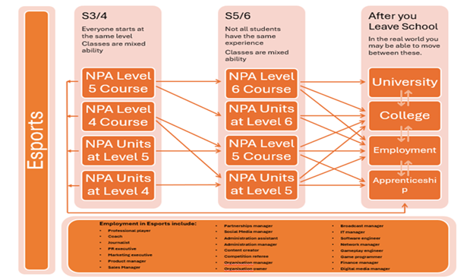

Subject Name | Computer Games Development NPA
Level(s) | Level 4, 5 & 6
Entry qualifications | The course is open to all levels of ability. It should be noted however, that level 6 and above have challenging aspects to the course. Students are expected to work their way through the different levels.
Units | The Units to be studied are Computer Games Design, Computer Games Media Assets and Computer Games Development. The Units involve practical tasks, which have to be completed to attain the Unit and / or the overall group award. There is no exam as such in this course.
Notes about levels | The games design course enables students to look at existing games and analyse their make-up. Students will have a choice of software to use to create their own games e.g. Blender, Kodu, Scratch Sauerbraten etc.
Unit test arrangements | Pupils will have the opportunity to complete at least one Unit by the end of December. Other Units will be completed by the end of May.
General Notes | This course will enable you to develop problem solving skills. Games will be designed from the initial idea through to working game, which will be programmed by the students.

Physical Education

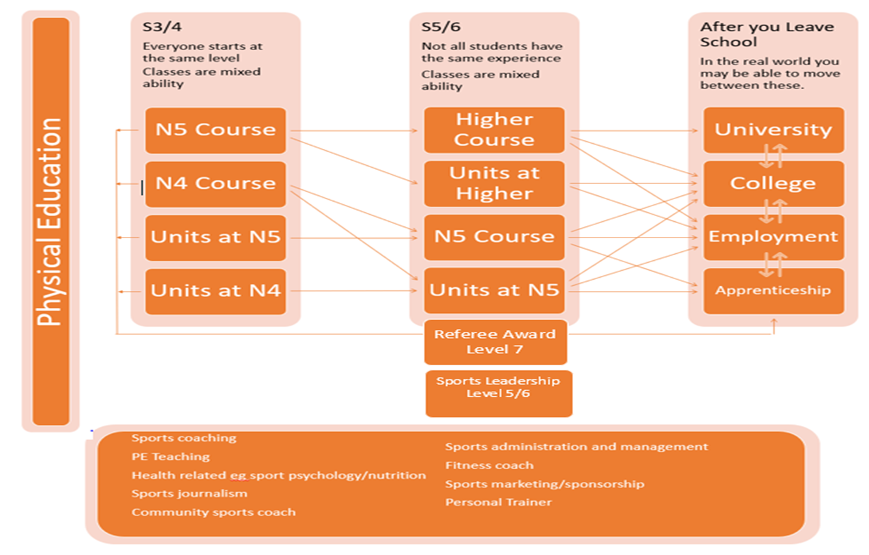

Subject Name | Physical Education
Level(s) | Higher (SCQF L6)
Entry qualifications | National 4 and 5 open to all.  An A or B for National 5 to do Higher.
Units | Performance Skills  Factors Impacting Performance  Added Value (National 4)
Notes about levels | National 4 and 5 would be taught together with level of presentation decided during the course of the year.  Candidates doing Higher will not be dropped down to National 5 if failing to meet the standard for higher.
Unit test arrangements | Performance is assessed at appropriate times during the session.  Factors Impacting performance theory is assessed at appropriate times throughout the year.
General Notes | Higher pupils would be expected to be at a level where they could pass the units at that level in order to be presented for that course award.  Higher pupils will do two one-off performances which will be worth 50% of their final grade.  Higher candidates will sit a 2.5 hour written exam at the end of the year which is worth 50% of the final grade.

Subject Name | Sports Leadership Award
Level(s) | (SCQF L5/L6)
Entry qualifications
General Notes | On completion of the course through the medium of sport candidates will have encountered a range of experiences that contribute to each and every learner achieving their own personal target set at the beginning of the course therefore each and every learner will experience success under the many forms this can be achieved.  Learners will develop knowledge of the different styles of leadership and qualities that are often used and apply these findings to allow them to develop their own style and help identify their own skills and qualities.  Candidates will be expected to complete a minimum of 10 hours demonstration of leadership skills in order to achieve the award.  This can be accumulated through a variety of sporting leadership experiences which can range from working with the associated primary schools delivering various activities to volunteer experiences within the department through lunch time or after school clubs.  To gain this award you must complete:  LEADERSHIP, AN INTRODUCTION: (20 hours)  This will involve individuals having the opportunity to research the different styles of leadership and discover the skills and qualities required to be an effective leader and produce a report based on your findings,  LEADERSHIP IN PRACTICE: (40 HOURS)  You will have the opportunity to take the leading role in many situations, each time having the chance to reflect on the experience and take forward the positive aspects and improve on any areas for development.  In order to complete the award you will carry out assessment activities such as:  Researching the skills, qualities and effectiveness of different leaders and produce a report based on your research.  Evaluate your own potential for leadership.  Take the leading role in carrying out an activity and produce a report based on this event.  Draw conclusions on your own effectiveness as a leader.

The Arts
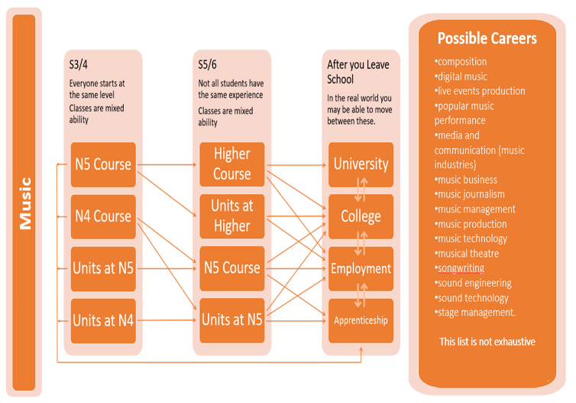
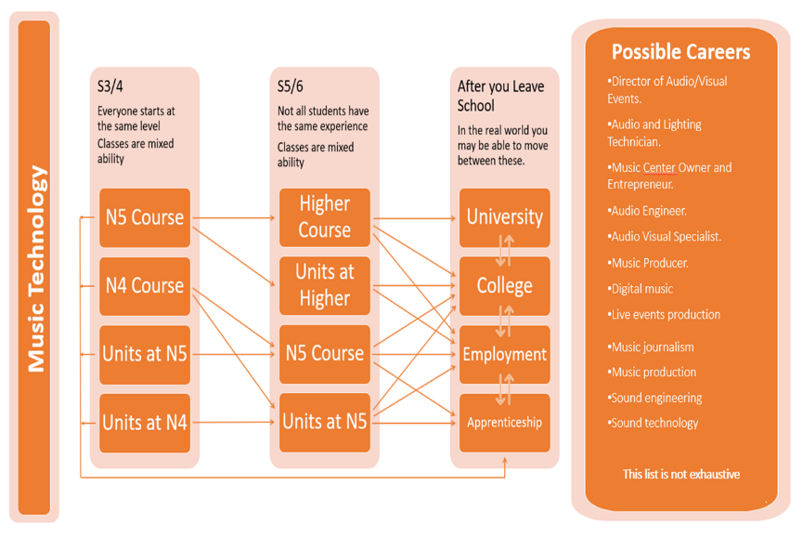

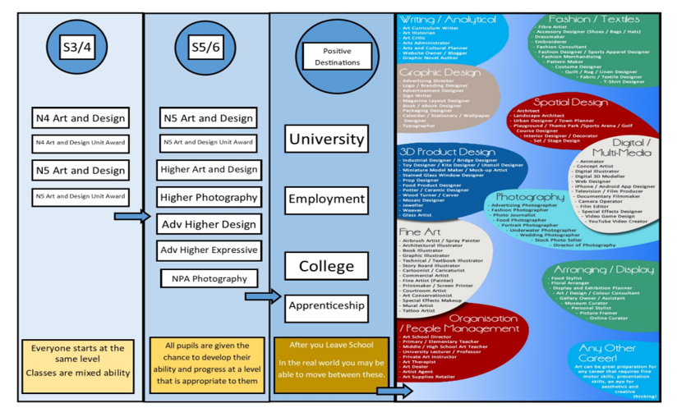
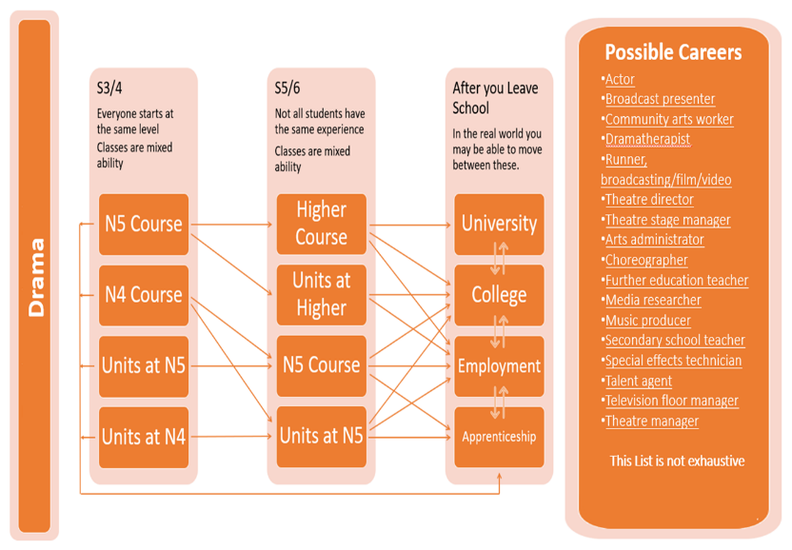

Subject Name | Art and Design
Level(s) | Higher (SCQF L6) / National 5 (SCQF L5)
Entry qualifications | National 5: Pass in National 4 Art & Design  Higher: Grade A/B at National 5 level.  (Pupils without a previous qualification in Art and Design who have a strong interest in the subject and good drawing skills may also be considered.)
Notes about levels | During the course of the year, pupils’ presentation level may change, depending on performance in the prelim and practical work.
General Notes | The course is assessed through a Design folio, an Expressive folio and a written question paper which are all marked externally by SQA.  Practical Portfolios: (Design and Expressive)  Pupils will have the opportunity to specialise in the areas of Art and Design that interest them most and create a portfolio that reflects their own personal interests.  Written Paper  Pupils will learn about the work of prominent artists and designers and their work. Pupils will be assessed on their ability to apply knowledge of these artists and designers and analyse unseen pieces of work.

Subject Name | Photography
Level(s) | Higher (SCQF L6)
Entry qualifications | Grade A/B in Nat 5 English
Notes about levels | This course is only available at Higher Level.
General Notes | Higher Photography provides pupils with the opportunity to learn more about the technical aspects of using a camera, as well as using their creativity to produce their own portfolio of images.  Pupils will learn about and utilise advanced photography techniques including the use of lighting, composition and digital imaging. Pupils will also learn to appreciate and evaluate the work of other photographers.  Higher Photography is assessed through a practical assignment and a written question paper which are both marked externally by SQA. Competency in written language is an important requirement for success in this course.  Pupils are responsible for developing and directing their own individual portfolios. If you are interested in this course you will be required to demonstrate initiative and must be willing to work on their projects out with school hours where necessary.

Subject Name | Music
Level(s) | National 5 (SCQF L5) / Higher (SCQF L6)
Entry qualifications | National 5 – Performing at National 4  Higher - Performing at Nat 5 minimum B
Units | - Music with Performing  Contain three units  - Performing skills  - Understanding Music  - Composing Skills
Notes about levels | The numbers of pupils in the class and differing ability levels will determine the levels being offered.
Unit test arrangements | Performing skills – Candidates perform a programme of pieces to a visiting examiner. End of Feb/ March  Understanding Music – Pupils develop knowledge and understanding of a wide variety of musical styles and are assessed through a written examination at the end of the course. May  Composing Skills – Pupils music create their own music in a variety of styles. N5 and Higher this is externally accessed – sent to SQA in April.
General Notes | Performing skills requirements:  Higher  Perform on two instruments at Grade 4 level.  Instrument 1 and 2 – 12 mins.  Nat 5  Perform on two instruments at Grade 3 level.  Instrument 1 and 2 – 8 mins.  N5 + Higher  Composing skills - Mandatory  One composition making use of music concepts and demonstrating development of these ideas.  Listening Unit  A listening test lasting 1 hour. (Higher only) 45 mins. (N5)  Homework expectations  Pupils will be expected to complete listening homework tasks and practice their instruments on a regular basis. If an instrument is not available at home then lunchtimes and after school should be used to practice.

Subject Name | Drama
Level(s) | Higher (SCQF L6)
Entry qualifications | National 5 Drama  National 5 English
Notes about levels | Written and practical coursework is completed throughout the year. This is to explore the chosen text in preparation for the final exam.
Unit test arrangements | There is an external acting exam in March. The candidates are asked to act in two contrasting pieces each lasting from 7-10 minutes and produce a written preparation for performance. Both of these elements are externally assessed. Candidates also complete a written exam during the May diet.  Acting and PFP = 60%  Written exam = 40%
General Notes | This course focuses on both the academic nature of theatre studies and practical investigation of play texts. The students explore all aspects of theatrical concepts and all must specialise in the study and techniques of acting and two production skills. The students also are introduced to aspects of performance analysis and are required to attend live theatre events in order to critically analyse different aspects of the performance both from an acting perspective and technical perspective.

Subject Name | Drama
Level(s) | Nat 5 (SCQF L5)
Entry qualifications | Nat 4 Drama  Nat 4 English
Units | There are 3 Units in this course: -All units are free standing and if appropriate can be completed separately.  - Drama Skills  - Production Skills  - Assessment Unit
Notes about levels | All students follow the Nat 5 course but will have the opportunity to change their presentation level.
Unit test arrangements | Unit tests comprise both practical and written exams at the end of each unit. Candidates are also expected to submit a folio of work, which reflects their chosen specialist production role.
General Notes | This course focuses on aspects of theatre production and practical investigation of drama including texts.  The students explore all aspects of theatrical concepts and all must specialise in the study and techniques of one of the following; acting, directing, set design, props, make-up and costume design, lighting and sound technology.  The final exam consists of a written paper and a practical exam, which is externally examined and a folio, which is sent to the SQA prior to the exam.

Modern Languages/RMPS
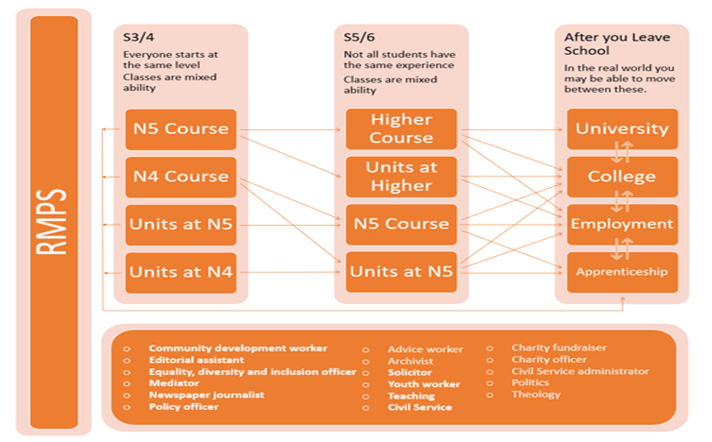
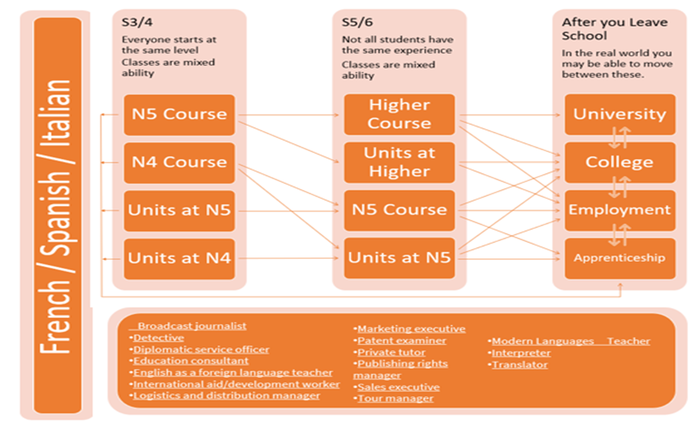

Subject Name | French
Level(s) | Higher (SCQF L6) /National 5 (SCQF L5)
Entry qualifications | Nat 5/Nat 4 pass
Units | There are 2 units in this course:  Unit 1 – Language  Unit 2 – Education and Work
Notes about levels | All pupils will follow the Higher Course. In the latter stages of the course presentation level may drop to Intermediate 2, depending on the pupil’s performance in unit tests, prelim, and other work.
Unit test arrangements | Unit tests are at the end of January, and the end of March
General Notes | This course will enable you to develop your ability to use the French language in useful and relevant contexts. The four skill areas are listening, speaking, reading and writing. In addition the course provides you with knowledge of France and the customs and way of life of the French people.

Subject Name | Spanish
Level(s) | Higher (SCQF L6) /National 5 (SCQF L5)
Entry qualifications | National 5 A-C Pass, National 4 course award
Notes about levels | Pupils will start the course at an appropriate level. In the latter stages of the course presentation level may change depending on the pupil’s performance in unit tests, prelim and other work.
General Notes | This course will enable you to develop your ability to use the Spanish language in useful and relevant contexts. The four skill areas are listening, talking, reading and writing. In addition the course provides you with knowledge of Spain and the customs and way of life of the Spanish people.

Subject Name | Religious, Moral and Philosophical Studies (RMPS)
Level(s) | Higher (SCQF L6)
Entry qualifications | For Higher learners are expected to have attained the skills, knowledge and understanding required by one of the following:  - RMPS National 5 course or relevant component units  - Other relevant courses (Social Subject) at National 5 or Higher level
Units | There are 3 units in all levels of the course  - Buddhism  - The origins of life  - Religion and Justice  An Added Value element runs through the course  - An extended response on a topic area from the course
Homework | Averaging 2 hours per week – including research and written presentations.
Unit test arrangements | To pass the course award candidates must pass the Unit assessments for each area as well as the course assessments
General Notes | The main aims of RMPS Higher are to enable learners to develop:  - the ability to critically analyse, reflect on and express reasoned views about religious, moral and philosophical questions and their impact  - a range of skills including investigating religious, moral and philosophical questions and responses, critical analysis, evaluation, and the ability to express detailed, reasoned and well-structured views  - in-depth factual and abstract knowledge and understanding of beliefs, practices and sources related to world religions  - in-depth factual and theoretical knowledge and understanding of religious, moral and philosophical questions and responses to them.

Subject Name | Religious, Moral and Philosophical Studies (RMPS)
Level(s) | National 5 (SCQF L5)
Entry qualifications | For National 5 learners are expected to have attained the skills, knowledge and understanding required by one of the following:  - RMPS National 4 course or relevant component units  - Other relevant courses (Social Subject) at National 4
Units | There are 3 units in all levels of the course  - Buddhism  - The origins of life  - Religion and Justice  An Added Value element runs through the course  - An extended response on a topic area from the course
Homework | Averaging 2 hours per week – including research and written presentations.
Unit test arrangements | To pass the course award candidates must pass the Unit assessments for each area as well as the course assessments
General Notes | The main aims of RMPS National 5 are to enable learners to develop:  - the ability to critically analyse, reflect on and express reasoned views about religious, moral and philosophical questions and their impact  - a range of skills including investigating religious, moral and philosophical questions and responses, critical analysis, evaluation, and the ability to express detailed, reasoned and well-structured views  - in-depth factual and abstract knowledge and understanding of beliefs, practices and sources related to world religions  - in-depth factual and theoretical knowledge and understanding of religious, moral and philosophical questions and responses to them.

