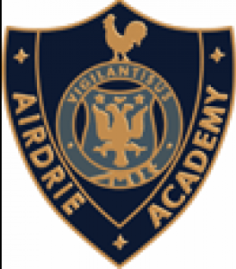
P7 Transition – Airdrie Academy Quiz
You probably have lots of questions about Airdrie Academy and we want to help you answer as many of these as possible before you join us in August. There are 15 questions below about our school and staff and we hope that answering these will prepare you for becoming an S1 pupil in Airdrie Academy.
Rather than simply giving you the answers, we want to test your research skills. All of the answers can be found in our school handbook: https://blogs.glowscotland.org.uk/nl/public/airdrieacademy/uploads/sites/26442/2019/12/18120239/newhandbook2020.pdf
The handbook can also be found via the school website in the ‘Policies and Documents’ tab.
We will post the answers later to allow you to correct your work.
- Give an example of any extra-curricular club?
- What is the Uniform in Airdrie Academy?
- Who are the Pupil Support teachers for Rochsoles House?
- What time does the school day start?
- Name any 1 of the 4 school values?
- Who are the Pupil Support teachers for Faskine House?
- Name 1 sports club that runs in Airdrie Academy?
- Name 1 non-sport club that runs in Airdrie Academy?
- Who are the Pupil Support teachers for Monklands House?
- What should pupils wear for PE?
- How long does each period last?
- Who are the Pupil Support teachers for Cleddans House?
- On which days does the school day finish early?
- Can you name all 4 houses?
- What are the House colours?

