Airdrie Academy

Self-Evaluation Report
Session 2015-2016

Contents Page
Introduction 3
Progress of 2015/16 SIP 4
S1-S3 Pupil Questionnaire Results 5
S4-S6 Pupil Questionnaire Results 6
Teaching Staff Questionnaire Results 7
Support Staff Questionnaire Results 8
Parent Questionnaire Results 9
Identified Strengths 10
Identified Declines 11
Summary 12
Self-Evaluation (HGIOS 3) 13
Literacy & Numeracy and Leaver Destinations 14
Leaver Attainment & Attainment v Deprivation 15
Action Plan 16

Introduction
Airdrie Academy is a non-denominational secondary school which serves the central north areas of Airdrie and surrounding villages. The roll is currently 1064, a slight decrease on last session. 246 pupils receive school transport, an increase on last session, and 16% of pupils are entitled to free school meals – a slight decreases on last session. 57% of our young people live in an SIMD 1 – 3 area. There are currently 75 FTE teaching staff in the school. This includes a Senior Management Team of 1 Headteacher and 4 Depute Headteachers and 19 Principal Teachers. Our aims are to provide an atmosphere that allows all pupils to benefit from challenge and enjoyment in their learning, experience success and achieve their full potential. We want to ensure that we prepare all of our young people for life in the 21st century.
Our school Values are:
“At Airdrie Academy, we will always aim to be Successful, be Respectful, be Responsible and be Ambitious.
These Values, shared by our whole school community, underpin everything we do at Airdrie Academy.”
Distinctive features of the school include:
- Young people’s leadership skills and their wide range of achievements.
- An improving trend of attainment across all measures.
- The school’s very positive ethos, which encourages and celebrates achievement and success.
- The impact of self-evaluation on school improvements, involving young people, staff and parents/carers.
- Staff are highly supportive and provide help to our young people.
- The impact of a wide range of partnerships on meeting learning needs and broadening
learning experiences.

The self-evaluation report presents the results of questionnaires used throughout the session to audit the views of the school’s stakeholders. Following this, a summary is provided of both the questionnaire results and school leavers’ attainment data. At the end of the report, a list of action points are identified with a view to making improvements next session.

2015/16 School Improvement Plan – Progress Report
A brief update on the progress of this session’s SIP is shown below.
 | Description | Progress
1 | Learning Rounds | Difficulties due to a very challenging year with staffing. In Plan for 2016 – 17
2 | Update L&T Section on Website | To be completed on new Website.
3 | Professional Learning | Professional Update implemented. Training ongoing.
4 | Active Literacy | Courses successfully implemented in English department. To be continued next session
5 | GIRFEC | New attendance procedures implemented. New letters to be implemented next session
6 | Pupil Voice | Implemented across all departments and Pupil Council
7 | Website | Completed. Website successfully updated and improved and transferred to new host.
8 | Review of BGE and Senior Phase | Year 1 completed successfully
9 | Developing Young Workforce | Implemented with lots of progress. Carried Forward to 2016 – 17

Pupil Questionnaires
Responses from pupils in the Broad General Education (S1-S3) and the Senior Phase (S4-S6) were measured separately. Please note that Q23 was not asked in session 2013-14. Numbers are percentages rounded to the nearest 1%.
 | S1 – S3 | % Agree |  |  | %Disagree
 |  | ‘16 | ‘15 | ‘14 | ‘16 | ‘15 | ‘14
Q1 | The school is helping me to become more confident. | 74, 64, 64 |  |  | 12, 23, 23
Q2 | I enjoy learning at school. | 79, 64, 65 |  |  | 15, 24, 23
Q3 | I am getting along well with my school work. | 90, 87, 86 |  |  | 6, 6, 6
Q4 | Staff encourage me to do the best I can. | 85, 72, 70 |  |  | 6, 21, 20
Q5 | Staff talk to me regularly about how to improve my learning. | 64, 52, 44 |  |  | 27, 40, 46
Q6 | I get help when I need it. | 82, 82, 81 |  |  | 12, 13, 15
Q7 | Staff listen to me and pay attention to what I say. | 75, 66, 72 |  |  | 18, 27, 20
Q8 | I have a say in making the way we learn in school better. | 44, 47, 43 |  |  | 39, 44, 41
Q9 | Staff expect me to take responsibility for my own work in class. | 91, 88, 90 |  |  | 7, 7, 4
Q10 | Staff and pupils treat me fairly with respect. | 68, 64, 69 |  |  | 21, 30, 23
Q11 | I feel safe and cared for in school. | 70, 61, 73 |  |  | 23, 26, 22
Q12 | I have adults in school I can speak to if I am upset or worried about something. | 83, 69, 72 |  |  | 10, 20, 20
Q13 | I find it easy to talk to staff and they set a good example. | 75, 62, 66 |  |  | 15, 28, 23
Q14 | Staff make sure that pupils behave well. | 74, 71, 74 |  |  | 17, 24, 15
Q15 | Staff are good at dealing with bullying behaviour. | 53, 45, 49 |  |  | 26, 33, 34
Q16 | The pupil council is good at getting improvements made in the school. | 45, 41, 42 |  |  | 28, 34, 33
Q17 | The school encourages me to make healthy food choices. | 50, 38, 39 |  |  | 39, 45, 46
Q18 | I take part in out-of-class activities and school clubs. | 49, 38, 46 |  |  | 44, 54, 45
Q19 | I know what out-of-school activities and youth groups are available in my local area. | 59, 45, 65 |  |  | 30, 42, 20
Q20 | I get enough help from school when I have subject choices to make | 76, 68, 56 |  |  | 12, 15, 23
Q21 | I get enough help form school about careers and options for when I leave school. | 65, 53, 50 |  |  | 20, 20, 25
Q22 | I get opportunities to go on trips out of school if I want. | 79, 67, 81 |  |  | 19, 22, 10
Q23 | Tutor Time activities help me in my learning. | 54, 45, - |  |  | 32, 45, -
Pupil Questionnaires
Responses from pupils in the Broad General Education (S1-S3) and the Senior Phase (S4-S6) were measured separately. Please note that Q23 was not asked in session 2013-14. Numbers are percentages rounded to the nearest 1%.
 | S4 – S6 | % Agree |  |  | %Disagree
 |  | ‘16 | ‘15 | ‘14 | ‘16 | ‘15 | ‘14
Q1 | The school is helping me to become more confident. | 73, 64, 57 |  |  | 21, 32, 37
Q2 | I enjoy learning at school. | 75, 76, 65 |  |  | 21, 14, 32
Q3 | I am getting along well with my school work. | 87, 88, 86 |  |  | 7, 9, 13
Q4 | Staff encourage me to do the best I can. | 85, 65, 77 |  |  | 12, 31, 23
Q5 | Staff talk to me regularly about how to improve my learning. | 59, 46, 51 |  |  | 33, 44, 44
Q6 | I get help when I need it. | 79, 79, 75 |  |  | 17, 21, 23
Q7 | Staff listen to me and pay attention to what I say. | 66, 56, 63 |  |  | 25, 42, 28
Q8 | I have a say in making the way we learn in school better. | 46, 26, 38 |  |  | 42, 60, 59
Q9 | Staff expect me to take responsibility for my own work in class. | 96, 94, 93 |  |  | 3, 4, 4
Q10 | Staff and pupils treat me fairly with respect. | 73, 68, 62 |  |  | 22, 27, 34
Q11 | I feel safe and cared for in school. | 65, 73, 74 |  |  | 19, 21, 22
Q12 | I have adults in school I can speak to if I am upset or worried about something. | 76, 62, 70 |  |  | 17, 27, 25
Q13 | I find it easy to talk to staff and they set a good example. | 76, 65, 58 |  |  | 19, 26, 34
Q14 | Staff make sure that pupils behave well. | 75, 63, 78 |  |  | 22, 27, 19
Q15 | Staff are good at dealing with bullying behaviour. | 47, 36, 52 |  |  | 31, 40, 32
Q16 | The pupil council is good at getting improvements made in the school. | 40, 40, 40 |  |  | 37, 50, 44
Q17 | The school encourages me to make healthy food choices. | 35, 29, 41 |  |  | 43, 62, 55
Q18 | I take part in out-of-class activities and school clubs. | 47, 35, 43 |  |  | 50, 62, 52
Q19 | I know what out-of-school activities and youth groups are available in my local area. | 60, 46, 54 |  |  | 31, 42, 38
Q20 | I get enough help from school when I have subject choices to make | 81, 60, 77 |  |  | 17, 32, 20
Q21 | I get enough help form school about careers and options for when I leave school. | 64, 54, 58 |  |  | 28, 35, 30
Q22 | I get opportunities to go on trips out of school if I want. | 77, 59, 68 |  |  | 21, 29, 30
Q23 | Tutor Time activities help me in my learning. | 45, 35, - |  |  | 43, 53, -
Teaching Staff Questionnaire Results
Numbers are percentages. Please note that Q21 was not asked in session 2013-14.

 |  | % Agree |  |  | %Disagree
 |  | ‘16 | ‘15 | ‘14 | ‘16 | ‘15 | ‘14
Q1 | Staff regularly discuss how to improve achievement for all pupils at both stage and whole school level. | 93, 100, 96 |  |  | 7, 0, 2
Q2 | All pupils are given activities which meet their learning needs. | 76, 79, 94 |  |  | 12, 18, 4
Q3 | Pupils are involved in setting learning targets. | 64, 74, 75 |  |  | 33, 21, 21
Q4 | Pupils are provided with regular feedback on what they need to do to improve. | 98, 98, 98 |  |  | 2, 2, 2
Q5 | Pupils are provided with opportunities to evaluate their own work and that of others. | 90, 97, 92 |  |  | 7, 3, 8
Q6 | Staff regularly ask for pupils' views on how their learning experiences could be improved. | 74, 76, 77 |  |  | 14, 21, 15
Q7 | Pupils take an active part in their learning. | 90, 86, 94 |  |  | 7, 10, 2
Q8 | Staff treat all pupils equally. | 62, 69, 60 |  |  | 38, 24, 39
Q9 | Staff and pupils respect each other. | 49, 61, 69 |  |  | 46, 33, 27
Q10 | The pupils are well behaved. | 56, 74, 74 |  |  | 41, 21, 21
Q11 | Support for pupils with additional support needs is effective. | 56, 64, 70 |  |  | 34, 28, 27
Q12 | Parents are fully involved in the school and their children's learning. | 48, 70, 67 |  |  | 24, 18, 20
Q13 | I have been actively involved in developing the school's vision and values. | 68, 66, 64 |  |  | 28, 33, 34
Q14 | I am actively involved in setting priorities to improve the school. | 63, 65, 62 |  |  | 32, 29, 30
Q15 | I have regular opportunities to help shape the curriculum by having staff discussions and working groups. | 76, 92, 89 |  |  | 22, 8, 8
Q16 | I am aware of the school's procedures for protecting children. | 95, 100, 98 |  |  | 5, 0, 2
Q17 | Leadership at all levels is effective. | 55, 72, 70 |  |  | 43, 21, 26
Q18 | Staff communicate effectively with each other. | 70, 69, 69 |  |  | 28, 23, 24
Q19 | I have good opportunities to take part in continuing professional development. | 69, 82, 79 |  |  | 24, 17, 20
Q20 | Staff across the school share good practice | 83, 83, 91 |  |  | 12, 11, 8
Q21 | Assessment for Learning strategies are embedded in my teaching practice. | 90, 92, - |  |  | 5, 8, -

Support Staff Questionnaire Results
Numbers are percentages.

Please note that there was a small sample size for this questionnaire which may question the statistical significance of the results.
 |  | % Agree |  |  | %Disagree
 |  | ‘16 | ‘15 | ‘14 | ‘16 | ‘15 | ‘14
Q1 | I have access to the information I need to carry out my work. | 80, 45, 100 |  |  | 20, 45, 0
Q2 | All staff and pupils respect each other. | 13, 0, 25 |  |  | 80, 100, 75
Q3 | Pupils are well behaved. | 33, 9, 100 |  |  | 60, 91, 0
Q4 | I am involved in staff discussions about how to achieve school priorities. | 13, 18, 50 |  |  | 67, 82, 50
Q5 | I have good opportunities to be involved in making decisions. | 13, 27, 67 |  |  | 53, 64, 33
Q6 | Staff communicate effectively with each other. | 27, 9, 40 |  |  | 67, 64, 60
Q7 | Staff treat all pupils equally. | 27, 0, 0 |  |  | 47, 82, 100
Q8 | Support for pupils with additional support needs is effective. | 60, 55, 100 |  |  | 27, 18, 0
Q9 | Parents are fully involved in the school and their children's learning. | 47, 9, 100 |  |  | 33, 9, 0
Q10 | I am aware of the school's procedures for protecting children. | 87, 100, 100 |  |  | 13, 0, 0
Q11 | Leadership at all levels is effective. | 27, 0, 75 |  |  | 60, 64, 0
Q12 | I have good opportunities to take part in training activities. | 40, 45, 100 |  |  | 53, 45, 0

Parent Questionnaire Results
Numbers are percentages.

 |  | % Agree |  |  | %Disagree
 |  | ‘16 | ‘15 | ‘14 | ‘16 | ‘15 | ‘14
Q1 | The school helps my child to be more confident. | 81, 80, 94 |  |  | 15, 15, 4
Q2 | My child enjoys learning at school. | 92, 89, 94 |  |  | 6, 11, 3
Q3 | My child’s learning is progressing well. | 97, 84, 98 |  |  | 2, 16, 2
Q4 | My child is encouraged and stretched to work to the best of their ability. | 95, 85, 97 |  |  | 4, 12, 2
Q5 | The school keeps me well informed about my child’s progress. | 91, 84, 92 |  |  | 8, 13, 8
Q6 | My child feels safe at school. | 91, 90, 93 |  |  | 8, 9, 5
Q7 | My child is treated fairly at school. | 97, 88, 96 |  |  | 2, 11, 4
Q8 | I feel staff really know my child as an individual and support them well. | 95, 81, 91 |  |  | 4, 15, 7
Q9 | My child benefits from school clubs and activities provided outside the classroom. | 73, 71, 74 |  |  | 16, 22, 14
Q10 | The school asks for my views. | 68, 70, 80 |  |  | 23, 23, 18
Q11 | The school takes my views into account. | 66, 76, 75 |  |  | 20, 21, 12
Q12 | The school is well led. | 95, 93, 88 |  |  | 3, 7, 1
Q13 | Overall, I am happy with the school. | 98, 92, 98 |  |  | 2, 7, 1

Identified Improvements
A comparison with last year’s survey results shows a number of improvements in the responses to the statements.
Pupil Views
- Approximately three-quarters of pupils feel that school helps them become more confident.
- 85% of pupils say that staff encouraged them to do their best.
- Over 60% of pupils say that staff regularly talk to them about how to improve their learning.
- More than 70% of pupils feel that staff listen to them and take account of their views.
- About 80% of pupils feel they have someone to talk to if they are upset or worried.
- Four in every five pupils feel they are given enough support in making subject choices.
- About 65% of pupils believe the school supports them well with future career choices.
- More than ¾ of pupils feel they have opportunities to go on school trips.
- Half of the pupils surveyed say that Tutor time activities help with their learning.

Staff Views
- 90% of staff feel that pupils take an active part in their own learning.
- 68% of staff feel that they have been actively involved in developing the school’s Vision & Values.
- 7 in every 10 teachers feel that staff communicate effectively with one another.

Parent Views
- 97% of parents surveyed feel that their children’s learning is progressing well.
- 95% of parents believe that their children are being encouraged and stretched to reach their full potential.
- Over 90% of parents feel well informed about their children’s progress.
- 97% of parents believe that their children are treated fairly at school.
- 19 in every 20 parents feel that staff know their children as individuals and support them well.
- 98% of parents are happy overall with the school.

Identified Declines
A comparison with last year’s survey results shows a decline in some of the responses.
Pupil Views
- Only 44% of pupils in S1-S3 feel that they have a say in making the way they learn better.
- 65% of S4-S6 pupils feel safe and cared for in school, this is a drop of 8% from last year.

Staff Views
- 64% of teachers feel that pupils are involved in setting their own learning targets. This is down 10% from last year.
- Only half of teachers feel that staff/pupils respect each other. This represents a 12% decline since last year.
- 56% of teachers believe that pupils are well behaved. This is an 18% drop from last year.
- The number of teachers who feel that parents are fully involved in their children’s learning is down by 22%.
- Just over ¾ of teachers feel that they have good opportunities to shape the curriculum. This represents a 16% decline.
- Only 55% of teachers believe leadership at all levels to be effective.
- About 70% of staff feel they are provided with good opportunities to take part in CPD activities. This is down 13% since last session.

Parent Views
- Less than 70% of parents feel that the school asks for their views. This is down slightly from last year but represents a 12% drop over two years.
- Only two thirds of parents feel that their views are taken into account – a 10% decline since last session.

Summary of Questionnaire Results
Strengths
The combined results of both pupil surveys appear to show an improvement in almost every area. Almost all pupils believe that staff expect them to take responsibility for their own work in class and that they are getting along well with their work. Staff are highly supportive and provide help to our young people. Staff regularly discuss ways to improve pupil achievement. Staff take part in curriculum development and school working groups. The large majority of staff believe that staff across the school share good practice. Almost all of our young people’s parents/carers are happy with the work of the school overall and believe the school is well led. In almost all areas there has been an improvement since last year.

Areas for Improvement
Although a significant number of pupils do take part in out of class activities, a significant minority do not. There has been an improvement in the view of the impact of the Pupil Council, although there are still a large minority of pupils who feel that it does not lead to improvements being made. Some staff feel that pupils are not well behaved and that support for pupils with additional support needs is not effective. A large minority of staff do not agree that leadership at all levels is always effective. A small minority of parents feel that their views are not asked for or taken into account.

Self-Evaluation (HGIOS 3)
Our levels in several quality indicators was audited throughout the session by departments and faculties.
Aggregate levels made up from departments/faculties across the school are shown below:

QI 1.1 Improvements in Performance 4
QI 2.1 Learners’ Experiences 4
QI 5.1 The Curriculum 4
QI 5.4 Assessment for Learning 4
QI 5.9 Improvement through Self-Evaluation 4

Improving Attainment in Literacy & Numeracy
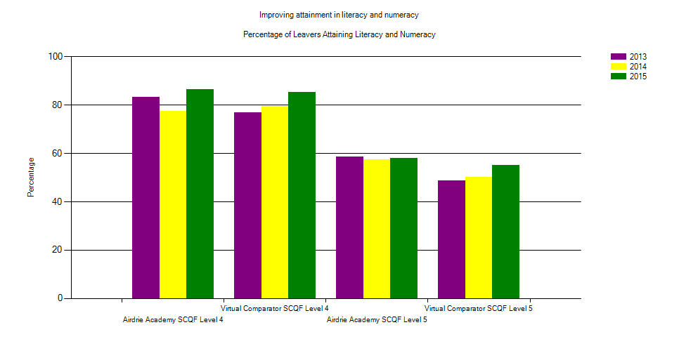
Overall, there is an increasing trend at Level 4 over the last 3 years. Airdrie Academy has outperformed the virtual comparator at Level 5 for the last 5 years.

Leaver Destinations
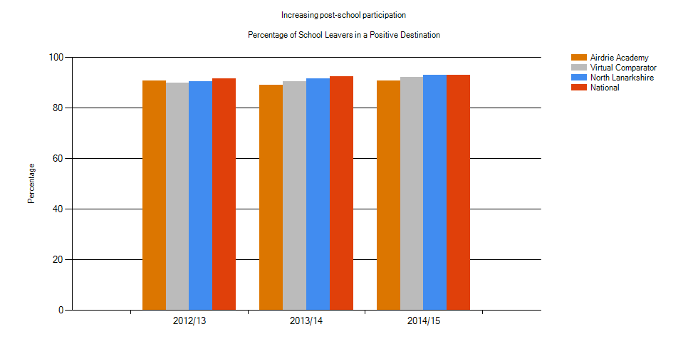

Leaver Attainment
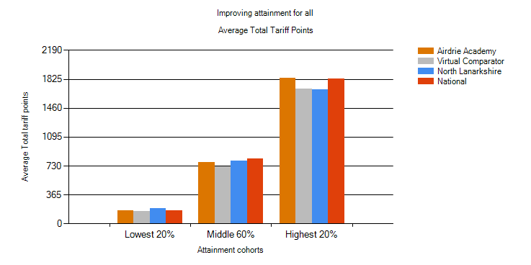
Our highest 20% and lowest 20% of leavers’ attainment was in line with the National average. We outperformed the virtual comparator across all three measures and particularly so in the highest 20% of leavers.

Attainment versus Deprivation
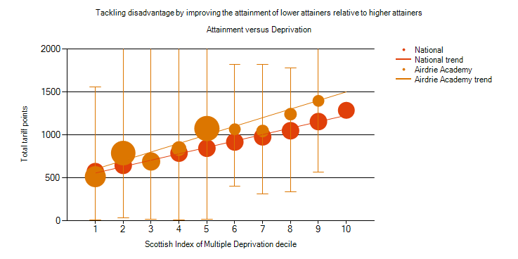
There is a gap in attainment which correlates to pupils’ SIMD deciles. However, our attainment in each decile outperforms the National average.

Action Plan
The following steps will be taken to improve the identified areas for improvement:
- Review the curriculum in both the BGE and Senior Phase to ensure that we are providing the best possible teaching and learning, leading to improvements in attainment, achievement and behaviour.
- Improve the commitment of staff to working groups etc in order to build capacity across the school.
- Continue to implement Pupil Conversations and Learning Teams to ensure that pupils have a say in the way the school progresses.
- Work with all staff to increase the effectiveness of leadership at all levels.
- Use a variety of methods including social media, website, questionnaires etc to engage with parents and carers.

