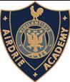
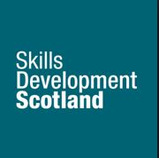
Airdrie Academy Transition Team
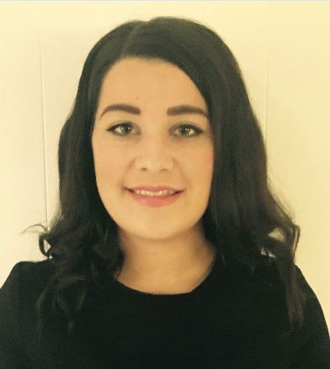
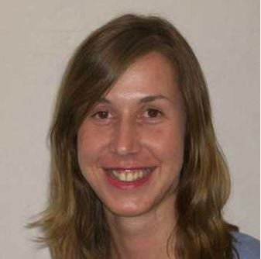
School Careers Adviser
Ruth Noble and Gillian Tannahill
We are based in school providing one to one guidance interviews for pupils 4th -6th year that are identified by school staff as requiring the support of the adviser. Pupils who are not in this category are also able to refer through themselves or through guidance teachers. We also as part of DYW are now involved in the broad general education phase and will provide one to one support to S2 or S3 (School decides) pupils at subject choice time to get them to think early on about planning and CMS. We also deliver group sessions to years 1-3 and also leavers groups to years 4-6.
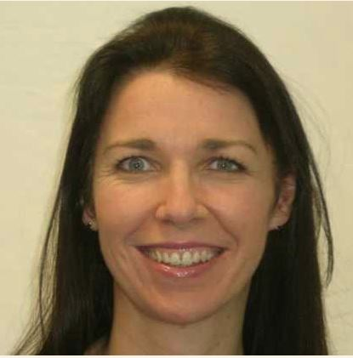
Post School Careers Adviser
Debbie Brown
Centre-based Advisers provide guidance to customers using the Career Management Skills model helping them to develop the skills they need to manage the different stages of their career. We work with all ages and support our customers to identify the personal circumstances which can affect their career planning. For those customers who require some extra help, our Advisers can refer them to one of our locally-based partners for training, information and advice.

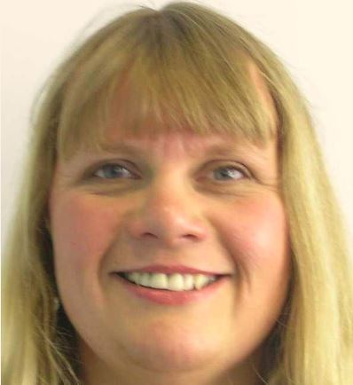
Personal Adviser
Cheryl Ballantine
As a Personal Adviser, I help customers with Employability Skills including CVs, job applications and interview techniques. We work with people of all ages to provide support and enhance their job searching skills. We are the main communication link for all Employability Fund providers across North Lanarkshire. We also work along side partner agencies to deliver employability services to ensure customers receive the appropriate service.

Work Coach
Navid Siddique
I am a Work Coach is based in the local community delivering mentoring support to individuals with multiple barriers to employment. Hard to reach clients will be invited to meet the work coach in a community setting that they feel comfortable attending. We sign post clients to appropriate external agencies and through multi agency work we help individuals develop their core, personal, social and employability skills on a one to one basis.

