Airdrie Academy

Drama Department

**Production Skills**

**DNA**



Name:

Class:

What will I learn?

I will be able to create and sustain aspects of voice to enhance characterisation. For example: pitch, pace, volume, tone, clarity, accent, articulation, register and intonation. *(EXA 4-13a)*

I will be able to create and sustain aspects of movement to enhance characterisation. For example: facial expression, body language, use of space, use of levels, gesture, posture, rhythm and timing. *(EXA 4-13a)*

I will be able to apply theatre arts technology and design resources effectively to an agreed concept to create and enhance mood and atmosphere. For example: through use of sound, lighting, costume, props, stage, make-up and hair. *(EXA 4-14b)*

I will be able to review and evaluate my progress through the creative process on and on-going basis and develop solutions to problems and they arise. *(EXA 4-15a)*

I will be able to analyse my own and others performances, including the work of peers and, where possible, professionals, making detailed comments, with appropriate justification, using appropriate drama vocabulary consistently. *(EXA 4-15a)*

Checklist

|  |  |  |  |
| --- | --- | --- | --- |
| Course Element | Date completed | Pupil Comment | Teacher Comment |
| Presentation of Research |  |  |  |
| Character Card |  |  |  |
| Set Design |  |  |  |
| Role on the Wall |  |  |  |
| Props |  |  |  |
| Make up design |  |  |  |
| Writing in Role |  |  |  |
| Costume design |  |  |  |
| Hot Seating |  |  |  |
| Lighting cue sheet |  |  |  |
| Sound cue sheet |  |  |  |
| Dress rehearsal |  |  |  |
| Final performance |  |  |  |

DNA

When a group of teenagers’ bullying of another student goes too far, they are left with an unplanned death [Adam] on their conscience. The mixed up group panic and decide to cover up their involvement in Adam's death. However, when they realize their deception has worked and actually brings peace to their confused lives, how do they move forwards? The teenagers split into two camps when they realize that their actions have framed an innocent man for their crime. But is this enough of an incentive to put right their wrong? And what happens when the presumed dead come back to life? Dennis Kelly’s twenty-first century play for young people calls society’s response to cruelty, bullying, peer pressure and pack mentality into question. Are these behaviours societal and learned, or are they inherent in us all?

DNA was developed ten years ago as a part of National Theatre’s Connections Scheme, which commissions playwrights to write plays for young performers aged fourteen to eighteen.

You should now research the play “DNA”. Find out as much information about the plot, characters, playwright as you can.

You will then present your findings back to the class.

Findings

Evaluation of Presentation

How effective was the content of your presentation? Explain your answer.

How did you make good use of voice when presenting? Use correct voice terminology.

How did you make good use of movement when presenting? Use correct movement terminology.

What would you change about your presentation to improve for next time?

Notes

Notes

Task 1 – Research

Rehearsal

You will now have a period of rehearsal. You will be given 10 minutes at the end of this period to complete your rehearsal log.

What did you achieve during this rehearsal?

How did you contribute you today’s rehearsal?

What did not go well during today’s rehearsal?

What is your target for the next rehearsal?

Character Card

You will now complete a rehearsal activity called a “Character Card”. Complete the page based on the character you are playing with as much detail as possible.

Name:

Age:

Occupation:

Appearance:

Personality:

Family Background:

Relationships:

Likes/Dislikes:

Set Design

You are going to create a ground plan for your scene. A ground plan is a birds eye view of you scene.

T

Key:

Taking into account the time is which the play is set and where it is, write a few sentences describing key aspects of your set and how you would like it to look.

………………………………………………………………………………………………………………………………………………………………………………………………………………………………………………………………………………………………………………………………………………………………………………………………………………………………………………………………………………………………………………………………………………………………………………………………………………………………………………………………………………………………………………………………………………………………………………………………………………………………………………………………………………………………………………………………………………………………………………………………………………………………………………………………….

Rehearsal

You will now have a period of rehearsal. You will be given 10 minutes at the end of this period to complete your rehearsal log.

What did you achieve during this rehearsal?

What did you contribute to today’s rehearsal?

What did not go well during today’s rehearsal?

What is your target for the next rehearsal?

Role on the Wall

You should now complete the “Role on the Wall” exercise about the character you are playing. The characters own thoughts, opinions, personality should go on the inside. Other characters thoughts and opinions about your character should go on the outside.

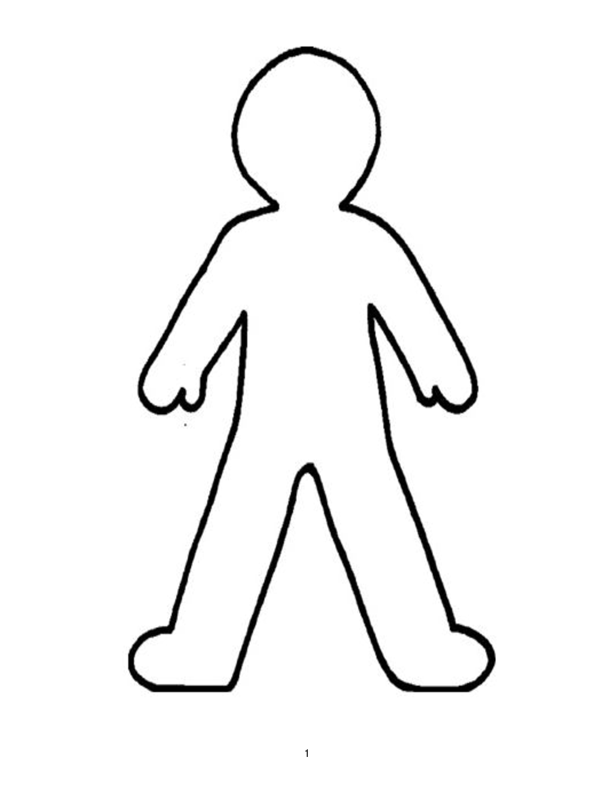

Props

You should now think about all props that are in your scene. You can get clues for props used both in the stage directions and dialogue between characters. Feel free to add in any props that you feel would enhance your performance.

|  |  |  |  |
| --- | --- | --- | --- |
| Prop | Personal | Hand Held | Pre Set |
|  |  |  |  |

Rehearsal

You will now have a period of rehearsal. You will be given 10 minutes at the end of this period to complete your rehearsal log.

What did you achieve during this rehearsal?

What did you contribute to today’s rehearsal?

What did not go well during today’s rehearsal?

What is your target for the next rehearsal?

Make-up

You should now create a make-up design for your character. You will need coloured pencils, do not use pen. The most important part of a make-up design is explaining you design. When you are finished make sure you have labelled and justified your decisions around the design.

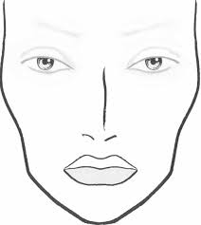

Writing in Role

You will now complete a diary entry as your character, you should write in the first person. Your character is reflecting on their day – therefore reflecting on what happened in you scene. You should write in as much detail as you can and include the characters thoughts, opinions, and feelings.

Dear Diary,

………………………………………………………………………………………………………………………………………………………………………………………………………………………………………………………………………………………………………………………………………………………………………………………………………………………………………………………………………………………………………………………………………………………………………………………………………………………………………………………………………………………………………………………………………………………………………………………………………………………………………………………………………………………………………………. ……………………………………………………………………………………………………………………………………………………………………………………………………………………………………………………………………………………………………………………………………………………………………………………………………………………………………………………………………………………………………………………………………………………………………………………………………………………………………………………………………………………………………………………………………………………………………………………………………………………………………………………………………………………………………………….……………………………………………………………………………………………………………………………………………………………………………………………………………………………………………………………………………………………………………………………………………………………………………………………………………………………………………………………………………………………………………………………………………………………………………………………………………………………………………………………………………………………………………………………………………………………………………………………………………………………………………………………………………………………………………….……………………………………………………………………………………………………………………………………………………………………………………………………………………………………………………………………………………………………………………………………………………………………………………………………………………………………………………………………………………………………………………………………………………………………………………………………………………………………………………………………………………………………………………………………………………………………………………………………………………………………………………………………………………………………………….

Signed…………………………………………………

Rehearsal

You will now have a period of rehearsal. You will be given 10 minutes at the end of this period to complete your rehearsal log.

What did you achieve during this rehearsal?

What did you contribute to today’s rehearsal?

What did not go well during today’s rehearsal?

What is your target for the next rehearsal?

Costume

You will now design a costume for your character. You just label and justify your decisions around your design.

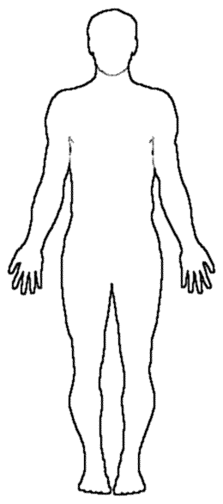

Hot Seating

Write down 10 questions that you will ask your partner in role. Your questions should be open ended questions.







10.

Rehearsal

You will now have a period of rehearsal. You will be given 10 minutes at the end of this period to complete your rehearsal log.

What did you achieve during this rehearsal?

What did you contribute to today’s rehearsal?

What did not go well during today’s rehearsal?

What is your target for the next rehearsal?

Lighting Cue Sheet

Example

|  |  |  |  |  |  |
| --- | --- | --- | --- | --- | --- |
| Cue Number | Scene | Cue Point | Lights | Intensity | Instructions |
| LX1 | Page 1 Scene 1 | Opening Scene | 1,3,5,9 | 90% | Warm wash of orange slowly fades up to 90% to indicate morning. |
| LX2 | Scene 1 Page 2 | “Stop it” | 4 | 100% | Snaps to red spotlight |

You should now create a Lighting cue sheet for your own scene. Lighting is a great tool to enhance our performance. It can separate different sections of the stage and also change the mood/atmosphere.

Lighting Cue Sheet

|  |  |  |  |  |  |
| --- | --- | --- | --- | --- | --- |
| Cue Number | Scene | Cue Point | Lights | Intensity | Instructions |
|  |  |  |  |  |  |
|  |  |  |  |  |  |
|  |  |  |  |  |  |
|  |  |  |  |  |  |
|  |  |  |  |  |  |
|  |  |  |  |  |  |

Sound Cue Sheet

Example

|  |  |  |  |  |  |
| --- | --- | --- | --- | --- | --- |
| Cue | Scene | Sound | Recorded/Live | Intensity | Instructions |
| SFX1 | Scene 1 Page 1 | Theme from Titanic | Recorded | 100% | Fade in Slowly over 10 seconds. |
| SFX2 | Scene 1 page 2 | Girls Scream | Live | 100% | Heard off stage when actors on stage sit down. |

Now you can create your own Sound Cue Sheet for your performance. Sound can be a great tool to enhance our drama. It can change the mood/atmosphere through atmospheric music or it could add a sense of realism to your performance for example, thunder and lightning to indicate the change in weather.

Sound Cue Sheet

|  |  |  |  |  |  |
| --- | --- | --- | --- | --- | --- |
| Cue | Scene | Sound | Recorded/Live | Intensity | Instructions |
|  |  |  |  |  |  |
|  |  |  |  |  |  |
|  |  |  |  |  |  |
|  |  |  |  |  |  |
|  |  |  |  |  |  |

Evaluation of Characterisation Techniques

By now you should have completed a number of characterisation techniques. Each techniques has a unique purpose which helps the actor build a believable character.

You should now evaluate how effective the following techniques were and what they helped enhance about your character.

Hot-Seating

Role on the wall

Writing in Role

Voice and Movement

As an actor you must be able to adapt your voice and movement to suit your character. You should be able to list 3 times in your performance where you changed your voice and movement to portray a believable character. You must use the correct vocabulary.

Movement

Voice

Dress Rehearsal

You will now have a period of rehearsal using a collection of the Production Areas. You will be given 10 minutes at the end of this period to complete your rehearsal log.

What did you achieve during this rehearsal?

What did you contribute to today’s rehearsal?

What did not go well during today’s rehearsal?

What is your target for the next rehearsal?

Performance Evaluation

Give a brief description about your performance.

Using the correct movement terms, describe 3 ways you changed your movement when acting?

Using the correct voice terms, describe 3 way you changed your voice when acting?

How did you contribute to the rehearsal process?

How did you effectively use sound?

How did you effectively use make up?

How did you effectively use lighting?

How did you effectively use costume?

How did you effectively use set design?

How did you effectively use props?

Evaluate your partner’s contribution.

Describe at least 2 challenges you faced during the rehearsal process and how you overcame these challenges.

What went well during your final performance?

What did not go well during your final performance? How would you prevent this from happening again>

Specialist Folio

Now that you have experimented with all Production Skills you will now choose one that you are most interested in and create a specialist folio. You can use the checklists below to assist in context of folio.

Everyone must have

|  |  |
| --- | --- |
| Item | Completed |
| Front Cover |  |
| Contents Page |  |
| Summary of Play |  |
| Social Context |  |
| Character Profiles |  |

Now you should only complete the checklist of your chosen Production Area.

Costume

|  |  |
| --- | --- |
| Item | Completed |
| Research & Findings |  |
| Initial ideas for costume |  |
| Costume design for 2 characters  (labelled, justified and in colour) |  |
| Photo evidence of costume |  |

Lighting

|  |  |
| --- | --- |
| Item | Completed |
| Research & Findings |  |
| Initial ideas for lighting including mood and atmosphere created |  |
| Lighting cue sheet |  |
| Justification of decisions |  |
| Photo evidence |  |

Sound

|  |  |
| --- | --- |
| Item | Completed |
| Research & Findings |  |
| Initial ideas for sound including mood and atmosphere created |  |
| Sound cue sheet |  |
| Justification of decisions |  |
| Photo evidence |  |

Make-Up

|  |  |
| --- | --- |
| Item | Completed |
| Research & Findings |  |
| Initial ideas for make-up |  |
| Make-up design for 2 characters (labelled, justified and in colour) |  |
| Photo evidence |  |

Set Design

|  |  |
| --- | --- |
| Item | Completed |
| Research & Findings |  |
| Initial ideas for set |  |
| Ground plan |  |
| Justification of decisions |  |
| Photo evidence |  |

