DRAMA

PRODUCTION SKILLS:
PROPS

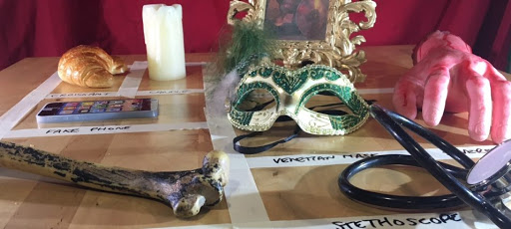

Name:

Class:
PROPS
Technically, a prop (or “theatrical property”) is any object that gives the scenery, actors, or performance space specific period, place, or character.

Props in a production originate from offstage unless they have been pre-set on the stage before the production begins.
Props are stored on a prop table backstage near the actor’s entrance during production then generally locked in a storage area between performances.
The person in charge of acquiring the props is generally called the “props master”.

Many props are ordinary objects. However, a prop must “read well” from the house or on-screen, meaning it must look real to the audience.

Many real objects are poorly adapted to the task of looking like themselves to an audience, due to their size, durability, or colour under bright lights, so some props are specially designed to look more like the actual item than the real object would look.
In some cases, a prop is designed to behave differently from how the real object would, often for the sake of safety.

Too many props can be difficult for the actor to use and they have to be brought onto and off the stage so can slow the action.

If you do use props in a performance, it’s important that actors work with them early on in the rehearsal process so that they can practise with them and identify any issues. Sometimes it’s perfectly acceptable to mime a prop, depending upon the style of theatre being created. Or you could be creative and choose a simple prop which can represent many things.
In the National Theatre production of The Curious Incident of the Dog in the Night-Time, the props play a crucial part. The white boxes on stage were multi-purpose and were used as set and seating. Some lit up to represent televisions, microwaves and fish tanks. One was a letter box and one was even lifted up to reveal a mock train toilet! 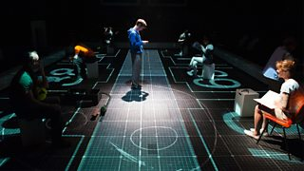

Ways Theatre Props Can Enhance Your Performance
Used correctly, props can add to your performance in a unique and profound way, with audience members thinking about your performance long after it’s finished. There are certain ways you can make use of props to ensure you get the most out of them.
Your props can be either real or symbolic
- Props can be used as either literal items, such as a characters putting their keys on a table, or they can be symbolic - metaphors used to indicate something else.
- Using literal props, and actions to go with them, create a visceral quality. This makes the plot spring to life, and can emphasise important movements.
- By using props symbolically, you can create powerful and profound images in the heads of your audience members. For example, if you wanted to demonstrate the separation of two people, a knife could be used to solemnly cut the air. You could also have a picture of the two characters torn apart.
Props can help to pace your story
- Props can be used to have a powerful impact on what characters are saying or doing, but these ‘silver-bullet’ props can only be used once to maintain their importance. You will have to think carefully about where to use important props that move the story forward or add a new level.
- Like a hook in music, props can be used to create a memorable drama sequence, engaging the audience and igniting the imagination. This helps to immerse the audience in the universe of your story, making even the most fantastical of settings come closer to being reality.
Selling your story with props
- If your performance involves an element of interacting with the audience, you can use props to sell your story to them, giving them a physical metaphor to really involve them in your vision. There is an example involving a marble, a baseball and a beach ball when talking about financial policies. Firstly, ask an audience member to keep a marble in their pocket, telling them how easy it would be to forget it. Next, you ask your audience member to keep a baseball in their pocket, remarking how much more difficult it is to forget it. Finally, the audience member is asked to put the beach ball in their pocket, which they can’t.
- This is where the metaphorical leap happens. By taking out the financial policy early, it would be like the marble, bought somewhat later, it would be like the baseball, noticeable but able to be carried. If left too late you wouldn’t be able to carry it. By involving the audience with symbolic prop use, the story becomes a lot more believable, and will stay with the audience for a long time.

Types of Props
A Set Prop is a prop that is integral to the set design of the production.
The set props are often the large movable items not built into the set. Generally this is furniture and would include things like chairs, tables, rugs, appliances, barrels, trunks, or large rocks. But it can also include large items like tents, a canoe, a car or even a wrestling ring.
The initial description of the setting is often communicated from the playwright at the top of the scene. It may be a sentence as simple as this one from Proof by David Auburn:
SETTING:
A back porch of a house in Chicago
This description gives little information about the props and the details are placed throughout the script itself in the action of the characters needing places to sit or picking up objects. The props master would need to read carefully to get an understanding of what set props might be required.
On the other hand, some playwrights give detailed, visual description with specific prop information, such as:
“A shabby living room. There is a worn brown leather sofa in the centre of the room near a ripped red and green tartan armchair in front of the small coal fireplace. A yellowing picture of a man, a woman and two children hangs on the back wall and is squinted.”
A Personal Prop is a prop that is specifically used by one or more actors that does not necessarily involve the set. For example, a mobile phone of a character being used on stage is the personal responsibility of the actor using it. E.g. money in a wallet, a handkerchief in a pocket.
The actor carries their personal prop/s to develop their character. Sometimes these are called for in the script, but often it is the actor who is requesting it. A pipe, a cane, or a fan can are also examples. Some actors are notorious for picking a prop or two at the very first rehearsal to play with.
A Pre-set prop is an item (or items) that is placed on the set prior to the performance and are usually there to help set the scene, time, location, etc. e.g. a lampshade, a picture, or a vase. These can be set and personal props too.

Handheld props are exactly that – props that will be held by a character. E.g. a hairbrush, a bunch of flowers, or a newspaper. These are usually personal props.

Costume props are usually items specific to a character and considered to be part of that character’s personality. E.g. a pair of spectacles, a pipe, or an inhaler. These are usually personal props.

Props Table
Below is an example of a props table. Note how every prop is clearly marked, identified and separate to allow for no confusion. They can be separated into order of use, actor using them or not, depending on table space.
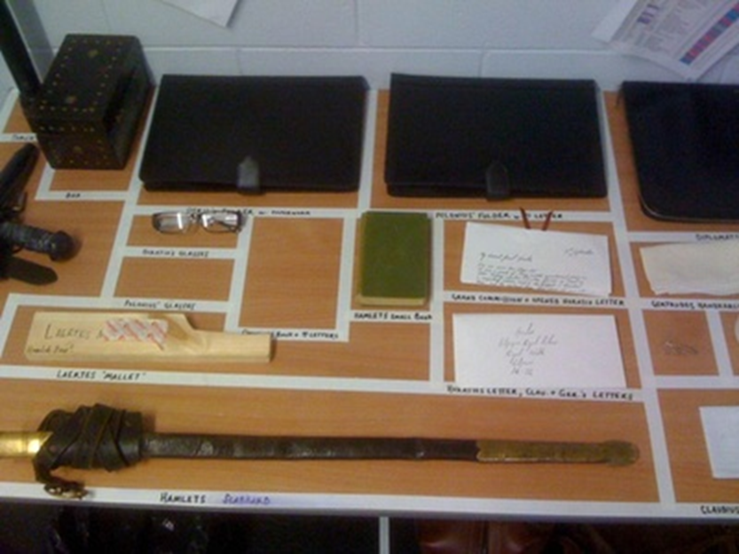

Though the props master is in charge of acquiring props for productions, it is usually the role of the Stage Manager (SM) or Assistant Stage Manager (ASM) to lay them out ready for actors to use and to ensure they are back on the table in the correct place at the end of the performances. Sometimes both roles of the Stage Manager and Props Master are taken on by one person, meaning they are responsible for both role-related aspects.

Task 1

The group you are working with are in the process of creating a drama.

Initial ideas and performance concepts should be thought of.

1. What is their drama about? Write down a brief paragraph to outline their story.

……………………………………………………………………………………………………………………

……………………………………………………………………………………………………………………

……………………………………………………………………………………………………………………

……………………………………………………………………………………………………………………

……………………………………………………………………………………………………………………

……………………………………………………………………………………………………………………

2. Detail the group’s initial thoughts about how the drama will be staged/produced.

……………………………………………………………………………………………………………………

……………………………………………………………………………………………………………………

……………………………………………………………………………………………………………………

……………………………………………………………………………………………………………………

3. In which period is the drama set? (E.g. present day, WW2, the future)

……………………………………………………………………………………………………………………

4. Does the group have any specific props demands?

……………………………………………………………………………………………………………………

……………………………………………………………………………………………………………………

……………………………………………………………………………………………………………………

5. What are your initial ideas about the drama in terms of props?

……………………………………………………………………………………………………………………

……………………………………………………………………………………………………………………

……………………………………………………………………………………………………………………

……………………………………………………………………………………………………………………

……………………………………………………………………………………………………………………

Task 2
What props are required for the drama?
Pre-set props to suggest the setting – time, season, place etc.:

Handheld props:

Costume props:

Task 3

Props List
Here is an example of a props list. This is what you follow when you are organising and managing the props.
Title of Production: A Game of Roulette
Item | Act / Scene | Pre-set / Handheld / Costume | Actor / Character | Notes
Pair of dice | Act 1 Sc 1 | Handheld | James Auld | James throws dice across the room. Collect and replace on props table at end of scene.
Pack of cards | Act 1 Sc 4 | Pre-set – on dinner table | Pamela Matthews | Pamela puts cards in her handbag. Replace on dinner table at end of act.
Lucky star keyring | Act 2 Sc 3 | Costume | James Auld | This will be placed in James’ jacket pocket for him to use throughout Act 2.
Large brown envelope | Act 2 Sc 5 | Handheld | Thomas Brown | Ripped up during scene – replace on props table for each performance.

All props should be ready and available by the dress rehearsal. The props list should detail all requirements for all props and should be clear and easy to follow. Create your production props list below:
Title of Production:
Item | Act / Scene | Pre-set / Handheld / Costume | Actor / Character | Notes
Checklist Example
A checklist is vital for the props master and performers.
Before the Performance Tech Dress Perf
Yes No Yes No Yes No
Are all the props in place?
Are all the props in working order?
Do you have your master props list next to you?
Can you read it in a blackout? Do you have a torch?
Do you have a back-up in case of emergencies?
Are your cues marked in your script?

Health and safety issues
Are all props safe to use?
Are the props well maintained?

During the performance
Follow through props list from beginning to end.
As one task is complete, prepare for the next.
After the performance
Were all props in the right place at the right time?
Have you replaced and stored all props?

Glossary of Props Words
Costume prop - items specific to a character and considered to be part of that character’s personality.
Dress rehearsal – final rehearsal of a drama with all of the theatre arts
Handheld prop – a prop that will be held by characters
Personal prop – a prop used by specific actors to enhance characterisation
Props – (short for theatrical properties) items used or carried by an actor, or items on the set
Props designer – the person designing any props for the production (this can be the same person who is props master or not)
Props list – a list of all props, who uses them, how and when
Props master – the person in charge of obtaining props
Props table – table backstage on which all props are placed for actors to collect as they enter and replace as they exit
Rehearsal prop – items that are used in rehearsal as soon as possible
Set Dressings – small items which enrich the setting e.g. cushions
Set prop – an item placed on the set, usually part of it, e.g. lamp, clock, picture
Stage Manager (or Assistant Stage Manager) – the person in charge of setting, organising and ensuring props are in the right place.
Theatre Production Arts – the collective name for lighting, sound, costume, props, make-up and set
Props Quiz

- What is the general meaning of a “prop”?
- Describe, in detail, one way in which props can enhance a performance. Make three points.
- Describe a set prop.
- Describe a personal prop.
- Describe a costume prop.
- Describe a handheld prop.
- Describe what a props table should be like.
- Why is a props list important?
- What does a props master need to know before organising props?
- You are a props master. Design and make your own props list for a made-up production with all relevant details. Have four props.

