Airdrie Academy
Drama Department

Production Skills
Blood Brothers
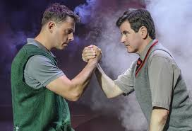

Name:

Class:

What will I learn?

I will be able to work collaboratively. When participating in group discussion I will be able to contribute by clarifying and expanding ideas. EXA 3-15a

I will demonstrate a use of characterisation techniques to improve and deepen the portrayal of character. EXA 3-12a

I will be able to reflect effectively on ideas, including ideas for using production skills in relation to, for example, lighting, sound, props, make-up, set design, costume. EXA 3-14a

I will be able to present a drama to an audience effectively portraying a character through a range of voice and movement techniques. EXA 3-12a

Blood Brothers
Blood Brothers is a powerful story set between the 1960s and 1980s and follows the twins who, where separated at birth. Unaware of each other’s identity they grow up in very different backgrounds but are friends and become blood brothers. Rivalry and social status drives them apart but they are fated both to die due to a curs cast on them by Mrs Lyons by one of the twins Eddie wealthy stepmother who has lied to her husband about the identity of their son and guards her secret venomously until she is driven mad by it and tragically is the cause of both boys sad end. The play is set in a backdrop of class divide caused by the 1980s Thatcher government where unemployment, poverty and hardship was rife but the rich were getting richer and the poor poorer.

Blood Brothers in a street 1962
Edward: Hello,

Mickey: (suspiciously) Hello,

Edward: I’ve seen you before.

Mickey: Where?

Edward: You were playing with some other boys near my house.

Mickey: Do you live up in the park?

Edward: Yes. Are you going to come and play up there again?

Mickey: No. I would but I’m not allowed.

Edward: Why?

Mickey: ‘Cos me mam says.

Edward: Well, my mummy doesn’t allow me to play down here actually.

Mickey: ‘Gis a sweet.

Edward: All right (He offers a bag from his pocket)

Mickey: (shocked) What?

Edward: Here.

Mickey: (trying to work out the catch. Suspiciously taking one) Can I have another one. For our Sammy?

Edward: Yes, of course. Take as many as you want.

Mickey: (taking a handful) Are you soft?

Edward: I don’t think so.

Mickey: Round here if y’ ask for a sweet, y’ have to ask about, about twenty million times. An’ y’ know what?

Edward: (sitting beside Mickey) What?

Mickey: They still don’t bleedin’ give y’ one. Sometimes our Sammy does but y’ have to be dead careful if our Sammy gives y’ a sweet.

Edward: Why?

Mickey: ‘Cos, if our Sammy gives y’ a sweet he’s usually weed on it first.

Edward: (exploding in giggles) Oh that sounds like super fun.

Mickey: It is, If y’ our Sammy.

Edward: Do you want to come and play?

Mickey: I might do. But I’m not playin’ now ‘cos I’m pissed off.

Edward: (awed) Pissed off. You say smashing things don’t you? Do you know any more words like that?

Mickey: Yeh, yeh, I know loads of words like that. Y’ know, like the ‘F’ word.

Edward: (clueless) Pardon?

Mickey:the ‘F’ word.

(Edward is still puzzled, Mickey looks around to check that he cannot be overheard, then
whispers the word to Edward. The two of them immediately wriggle and giggle with
glee.)

Edward: What does it mean?

Mickey: I don’t know. It sounds good though, doesn’t it?

Edward: Fantastic. When I get home I’ll look it up in the dictionary.

Mickey: In the what?

Edward: The dictionary. Don’t you know what a dictionary is?

Mickey: ‘Course I do …. It’s a, it’s a thingy innit?

Edward: A book which explains the meaning of words.

Mickey: The meaning of words, yeh. Our Sammy’ll be here soon. I hope he’s in a good mood. He’s dead mean sometimes.

Edward: Why?

Mickey: It’s ‘cos he’s got a plate in his head.

Edward: A plate. In his head?

Mickey: Yeh. When he was little, me Mam was at work an’ our Donna Marie was supposed to be lookin’ after him but he fell out the window an’ broke his head. So they took him to the hospital an’ put a plate in his head.

Edward: A plate. A dinner plate?

Mickey: I don’t think so, ‘cos our Sammy’s head’s not really that big. I think it must have been one of them little plates that you have your bread off.

Edward: A side plate?

Mickey: No, it’s on the top.

Edward: And …. and can you see the shape of it, in his head?

Mickey: I suppose, I suppose if y’ looked under his hair.

Edward: (after a reflective pause) You know the most smashing things. Will you be my best friend?

Mickey: Yeh, if y’ want.

Edward: What’s your name?

Mickey: Michael Johnstone. But everyone calls me Mickey. What’s yours?

Edward: Edward Lyons.

Mickey: D’ they call y’ Eddie?

Edward: No.

Mickey: Well, I will.

Edward: Will you?

Mickey: Yeh. How old are y’ Eddie?

Edward: Seven.

Mickey: I’m older than you. I’m nearly eight.

Edward: Well, I’m nearly eight, really.

Mickey: What’s your birthday?
Edward: July the nineteenth.

Mickey: So is mine.

Edward: Is it really?

Mickey: Ey, we were born on the same day …. That means we can be blood brothers. Do you wanna be my blood brother, Eddie?

Edward: Yes, please.

Mickey: (producing a pen knife) It hurts y’ know. (He puts a nick in his hand,) Now, give us yours.

(Mickey nicks Edward’s hand, then they clamp hands together)

Mickey: See this means that we’re blood brothers, an’ that we always have to stand by each other. Now you say after me, ‘I will always defend my brother’.

Edward: I will always defend my brother ….

Mickey: And stand by him.

Edward: And stand by him.

Mickey: An’ share all my sweets with him.

Edward: And share ….

The End

Research
With your partner you should now research the play ‘Blood Brothers’ Find out as much facts about the play and characters as you can. This can be anything from where it is set to the playwright.
You will then present your findings back to the class.

Findings

Findings

Evaluation of Presentation

How effective was the content of your presentation? Explain your answer.

How did you make good use of my voice when presenting? Use correct voice terms.

How did you make good use of my movement when presenting? Use correct movement terms.
What would you change about your presentation to improve for next time?

Rehearsal
You will now have a period of rehearsal. You will be given 10 minutes at the end of this period to complete your rehearsal log.
What did you achieve during this rehearsal?

What did you contribute to today’s rehearsal?

What did not go well during today’s rehearsal?

What is your target for the next rehearsal?

Character Card

You will now complete a rehearsal activity called a “Character Card”. Complete the page based on the character you are playing with as much detail as possible.

Name:
Age:
Occupation:
Appearance:

Personality:

Family Background:

Relationships:

Likes/Dislikes:

Set Design
You are going to create a ground plan for your scene. A ground plan is a birds eye view of you scene.

T
Key:

Taking into account the time is which the play is set and where it is, write a few sentences describing key aspects of your set and how you would like it to look.

………………………………………………………………………………………………………………………………………………………………………………………………………………………………………………………………………………………………………………………………………………………………………………………………………………………………………………………………………………………………………………………………………………………………………………………………………………………………………………………………………………………………………………………………………………………………………………………………………………………………………………………………………………………………………………………………………………………………………………………………………………………………………………………………….
Rehearsal
You will now have a period of rehearsal. You will be given 10 minutes at the end of this period to complete your rehearsal log.
What did you achieve during this rehearsal?

What did you contribute to today’s rehearsal?

What did not go well during today’s rehearsal?

What is your target for the next rehearsal?

Role on the Wall
You should now complete the “Role on the Wall” exercise about the character you are playing. The characters own thoughts, opinions, personality should go on the inside. Other characters thoughts and opinions about your character should go on the outside.
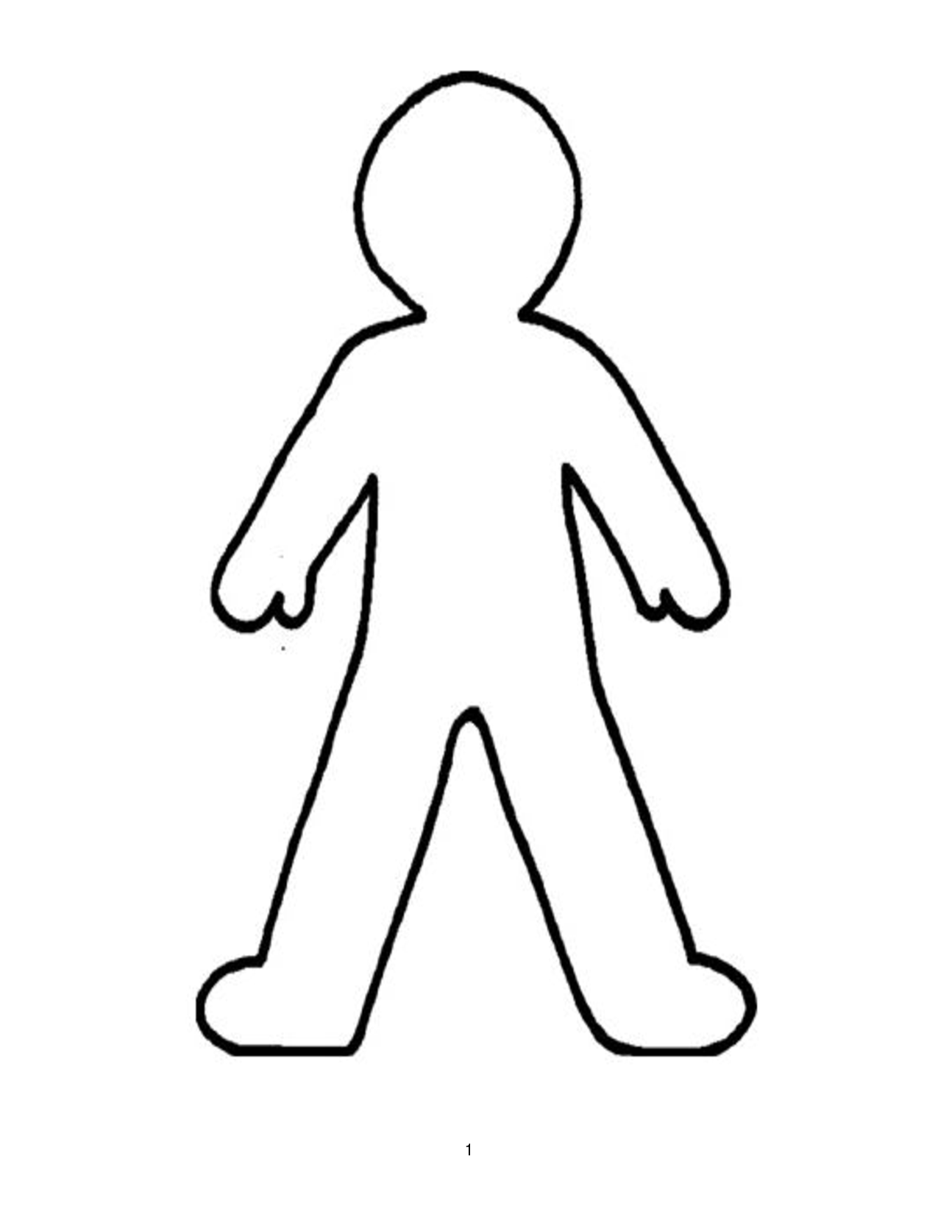
Props
You should now think about all props that are in your scene. You can get clues for props used both in the stage directions and dialogue between characters. Feel free to add in any props that you feel would enhance your performance.
Prop | Personal | Hand Held | Pre Set

Rehearsal
You will now have a period of rehearsal. You will be given 10 minutes at the end of this period to complete your rehearsal log.
What did you achieve during this rehearsal?

What did you contribute to today’s rehearsal?

What did not go well during today’s rehearsal?

What is your target for the next rehearsal?

Make-up
You should now create a make-up design for your character. You will need coloured pencils, do not use pen. The most important part of a make-up design is explaining you design. When you are finished make sure you have labelled and justified your decisions around the design.

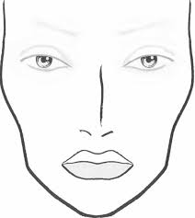

Writing in Role
You will now complete a diary entry as your character, you should write in the first person. Your character is reflecting on their day – therefore reflecting on what happened in you scene. You should write in as much detail as you can and include the characters thoughts, opinions, and feelings.
Dear Diary,
………………………………………………………………………………………………………………………………………………………………………………………………………………………………………………………………………………………………………………………………………………………………………………………………………………………………………………………………………………………………………………………………………………………………………………………………………………………………………………………………………………………………………………………………………………………………………………………………………………………………………………………………………………………………………………. ……………………………………………………………………………………………………………………………………………………………………………………………………………………………………………………………………………………………………………………………………………………………………………………………………………………………………………………………………………………………………………………………………………………………………………………………………………………………………………………………………………………………………………………………………………………………………………………………………………………………………………………………………………………………………………….……………………………………………………………………………………………………………………………………………………………………………………………………………………………………………………………………………………………………………………………………………………………………………………………………………………………………………………………………………………………………………………………………………………………………………………………………………………………………………………………………………………………………………………………………………………………………………………………………………………………………………………………………………………………………………….……………………………………………………………………………………………………………………………………………………………………………………………………………………………………………………………………………………………………………………………………………………………………………………………………………………………………………………………………………………………………………………………………………………………………………………………………………………………………………………………………………………………………………………………………………………………………………………………………………………………………………………………………………………………………………….

Signed…………………………………………………
Rehearsal
You will now have a period of rehearsal. You will be given 10 minutes at the end of this period to complete your rehearsal log.
What did you achieve during this rehearsal?

What did you contribute to today’s rehearsal?

What did not go well during today’s rehearsal?

What is your target for the next rehearsal?

Costume
You will now design a costume for your character. You just label and justify your decisions around your design.

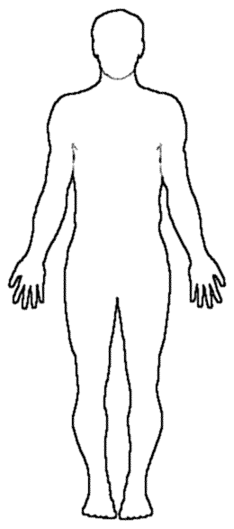

Hot Seating
Write down 10 questions that you will ask your partner in role. Your questions should be open ended questions.

10.

Rehearsal
You will now have a period of rehearsal. You will be given 10 minutes at the end of this period to complete your rehearsal log.
What did you achieve during this rehearsal?

What did you contribute to today’s rehearsal?

What did not go well during today’s rehearsal?

What is your target for the next rehearsal?

Lighting Cue Sheet

Example
Cue Number | Scene | Cue Point | Lights | Intensity | Instructions
LX1 | Page 1 Scene 1 | Opening Scene | 1,3,5,9 | 90% | Warm wash of orange slowly fades up to 90% to indicate morning.
LX2 | Scene 1 Page 2 | “Stop it” | 4 | 100% | Snaps to red spotlight

You should now create a Lighting cue sheet for your own scene. Lighting is a great tool to enhance our performance. It can separate different sections of the stage and also change the mood/atmosphere.

Lighting Cue Sheet

Cue Number | Scene | Cue Point | Lights | Intensity | Instructions

Sound Cue Sheet

Example

Cue | Scene | Sound | Recorded/Live | Intensity | Instructions
SFX1 | Scene 1 Page 1 | Theme from Titanic | Recorded | 100% | Fade in Slowly over 10 seconds.
SFX2 | Scene 1 page 2 | Girls Scream | Live | 100% | Heard off stage when actors on stage sit down.

Now you can create your own Sound Cue Sheet for your performance. Sound can be a great tool to enhance our drama. It can change the mood/atmosphere through atmospheric music or it could add a sense of realism to your performance for example, thunder and lightning to indicate the change in weather.

Sound Cue Sheet

Cue | Scene | Sound | Recorded/Live | Intensity | Instructions

Dress Rehearsal
You will now have a period of rehearsal using a collection of the Production Areas. You will be given 10 minutes at the end of this period to complete your rehearsal log.
What did you achieve during this rehearsal?

What did you contribute to today’s rehearsal?

What did not go well during today’s rehearsal?

What is your target for the next rehearsal?

Performance Evaluation

Give a brief description about your performance.

Using the correct movement terms, describe 3 ways you changed your movement when acting?

Using the correct voice terms, describe 3 way you changed your voice when acting?

How did you contribute to the rehearsal process?

How did you effectively use sound?

How did you effectively use make up?
How did you effectively use lighting?

How did you effectively use costume?

How did you effectively use set design?

How did you effectively use props?

Evaluate your partner’s contribution.

Describe at least 2 challenges you faced during the rehearsal process and how you overcame these challenges.

What went well during your final performance?

What did not go well during your final performance? How would you prevent this from happening again>

