Airdrie Academy

Drama Department

**Production Skills**

**Black Watch**

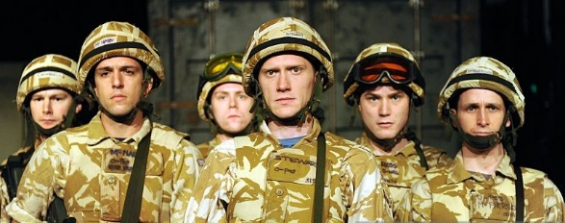

**Name:**

**Class:**

What will I learn?

I will be able to work collaboratively. When participating in group discussion I will be able to contribute by clarifying and expanding ideas**.** *EXA 3-15a*

I will demonstrate a use of characterisation techniques to improve and deepen the portrayal of character. *EXA 3-12a*

I will be able to reflect effectively on ideas, including ideas for using production skills in relation to, for example, lighting, sound, props, make-up, set design, costume. *EXA 3-14a*

I will be able to present a drama to an audience effectively portraying a character through a range of voice and movement techniques. *EXA 3-12a*

***Black Watch***

Is a play written by Greggory Burke and based on interviews with former soldiers in the Black Watch serving on operations TELIC in Iraq during 2004, prior to the amalgamation into the Royal Regiment of Scotland.

The Black Watch regiment is based in Fife and the Tayside region in Scotland, the army has been a part of their lives for generations. Their fathers, grandfathers, great grandfathers, have been soldiers in the regiment – a regiment that has been involved in virtually every major conflict since it was formed as the ‘Gallant Forty Twa’ in 1739.

*‘It’s in the blood. It’s part of who we are’*

In October 2004, the Black Watch was at the centre of political controversy after the USA requested British forces to be moved further north outside of the British-controlled Multi-National Division, to replace forces temporarily redeployed for the Second Battle of Fallujah. Based in an area later dubbed the ‘Triangle of Death’, the Black Watch came under sustained insurgent attack from mortars and rockets. On 4 November three soldiers and an interpreter were killed by a car bomb at a check point.

**Iraq 2004**

*The boys are on patrol sitting in the back of a warrior.*

*There is a large explosion outside the wagon*.

**Cammy**: Contact.

**Stewarty**: What?

**Cammy**: The other wagon’s been hit.

**Fraz**: What was it? Mortars?

**Cammy**: IED bud. Front tracks. They’re radioing ‘mobility kill’.

**Fraz**: Anyone hurt?

**Cammy**: They’re all fine.

**Granty**: Bumps and lumps and peppered tweed.

**Cammy**: Right. We’re going in tay pick them up.

**Kenzie**: Let’s feckin go come on.

**Fraz**: Zip it.

**Kenzie**: You zip it baw heed!

*There is a blast outside the wagon. The dismounts are thrown around in the back by the blast.*

**Cammy**: Traverse right!

**Granty**: Traverse right?

**Cammy**: Traverse right!

**Granty**: I am reversing right!

**Cammy**: Traverse! Traverse ya bampot! Watch the feckin ditch!!

*The wagon lurches round. There is another explosion. The dismounts are piled in the centre of the wagon in a heap. The wagon comes to a halt.*

**Cammy**: Is everyone alright?

**Stewarty**: Aye

**Fraz**: What in the name of the wee man is happening?

**Rosso**: Mortars.

**Granty**: I canny move it, Cammy. We’re feckin stuck.

**Fraz**: I told you to watch the feckin ditch!

**Kenzie**: Let’s just go!!!

**Stewarty**: Sit down ya baw bag. We’ve been hit. We’re going nowhere.

*While the boys are awaiting rescue they dream of their favourite Indian food when they get back.*

**Kenzie**: Cheese on toast.

**Stewarty**: Cheese on toast?

**Kenzie**: Aye.

**Fraz:** You canny hay cheese on feckin toast.

**Kenzie**: How no?

**Nabsy**: Cos ye canny.

**Kenzie**: How no?

**Fraz**: It’s no an Indian is it?

**Kenzie**: Aye but its food right?

**Macca**: It’s no an Indian ya daftie!

**Kenzie**: We’re talkin about food you want when we get home.

**Stewarty**: Aye but Indian food!

**Kenzie**: I just want cheese on toast!!!! Okay!!

**Fraz**: You cannae have cheese on toast!

**Kenzie**: Aye a feckin can!!

**Nabsy**: Ye cannae!

**Kenzie**: That’s the first thing I’m havin when I get back!

**Fraz**: Ya wee daftie!

**Stewarty**: Chinky?

**Fraz**: Black bean king prawn.

**Stewarty**: Lemon chicken.

**Fraz**: Sweet and sour chicken.

**Stewarty**: Shut it you’ve already had a go!!

**Fraz**: I like chinkys. Crispy beef.

**Stewarty**: I said shut it ya bampot one go each! Nabsy.

**Nabsy**: Vegetarian sweet and sour.

**Fraz**: Are you a vegetarian like?

**Nabsy**: Are you sure?

**Kenzie**: You need to eat some meat.

**Stewarty**: Okay, Macca.

Macca: Deep fried king prawn roll. Sesame prawn toast. Pickled ginger duck chow mein. Fried rice. Chips. Sweet & sour sauce. Dim sum dipper. Prawn crackers.

*beat*

Two prawn crackers.

**Stewarty**: Christ! Kenzie.

**Kenzie**: Cheese on toast.

*Fraz hits Kenzie on the head. Nabsy laughs.*

**Kenzie**: (to Nabsy) What are you laughin at?

**Nabsy**: Shut yer face! Ya wee daftie.

**Kenzie**: Come on then ya wee bampot!

**Nabsy**: Right you come on then!

**Kenzie**: Think I’m scared of you ya wee weasel?

*There is a brief scuffle. Fraz pulls them apart.*

**Fraz:** Quit it ya pair of wee dafties!!

**Sergeant**: Have we got a problem here gentlemen?

**Fraz**: No we haven’t.

**Sergeant**: You pair,

*beat*

Ten seconds.

*They all get out the wagon and Nabsy and Kenzie square up to eachother.*

**Sergeant**: Fraz.

**Fraz:** Ten, nine, eight, seven, six, five, four

**Sergeant:** three, two, one.

*Kenzie and Nabsy are pulled apart.*

**Sergeant:** What are ya doin?

Fraz: That wasn’t a bad fight.

**Sergeant**: Naw that was a crap fight. Get up and shake hands that’s the end of it. Okay? Next time you’ll be fighting me and ya dinnay want tay be daying that!!

**Cammy**: So whats happening?

**Sergeant**: The other wagon is trashed. We’re gonnae hat tay wait until they get transport down here to pick us up.

**Cammy**: We’re sitting ducks out here! That road is a…

**Sergeant**: I ken about the road! Tell me something that I dinnay ken!

Right. Get a perimeter set up Cammy. Fraz, Kennzie come way me. We’re going to get a translator. Stop and search some of this traffic. You never ken what might turn up. They’ve had plenty of time tay get organised. We might as well be some use tay someone while we’re stuck here.

Right let’s go!

**End**

Research

With your partner you should now research the playBlack Watch. Find out as much facts about the play and characters as you can. This can be anything from where it is set to the playwright.

You will then present your findings back to the class.

Findings

Findings

Evaluation of Presentation

How effective was the content of your presentation? Explain your answer.

How did you make good use of my voice when presenting? Use correct voice terms.

How did you make good use of my movement when presenting? Use correct movement terms.

What would you change about your presentation to improve for next time?

Rehearsal

You will now have a period of rehearsal. You will be given 10 minutes at the end of this period to complete your rehearsal log.

What did you achieve during this rehearsal?

What did you contribute to today’s rehearsal?

What did not go well during today’s rehearsal?

What is your target for the next rehearsal?

Character Card

You will now complete a rehearsal activity called a “Character Card”. Complete the page based on the character you are playing with as much detail as possible.

Name:

Age:

Occupation:

Appearance:

Personality:

Family Background:

Relationships:

Likes/Dislikes:

Set Design

You are going to create a ground plan for your scene. A ground plan is a birds eye view of you scene.

T

Key:

Taking into account the time is which the play is set and where it is, write a few sentences describing key aspects of your set and how you would like it to look.

……………………………………………………………………………………………………………………………………………………………………………………………………………………………………………………………………………………………………………………………………………………………………………………………………………………………………………………………………………………………………………………………………………………………………………………………………………………………………………………………………………………………………………………………………………………………

Rehearsal

You will now have a period of rehearsal. You will be given 10 minutes at the end of this period to complete your rehearsal log.

What did you achieve during this rehearsal?

What did you contribute to today’s rehearsal?

What did not go well during today’s rehearsal?

What is your target for the next rehearsal?

Role on the Wall

You should now complete the “Role on the Wall” exercise about the character you are playing. The characters own thoughts, opinions, personality should go on the inside. Other characters thoughts and opinions about your character should go on the outside.

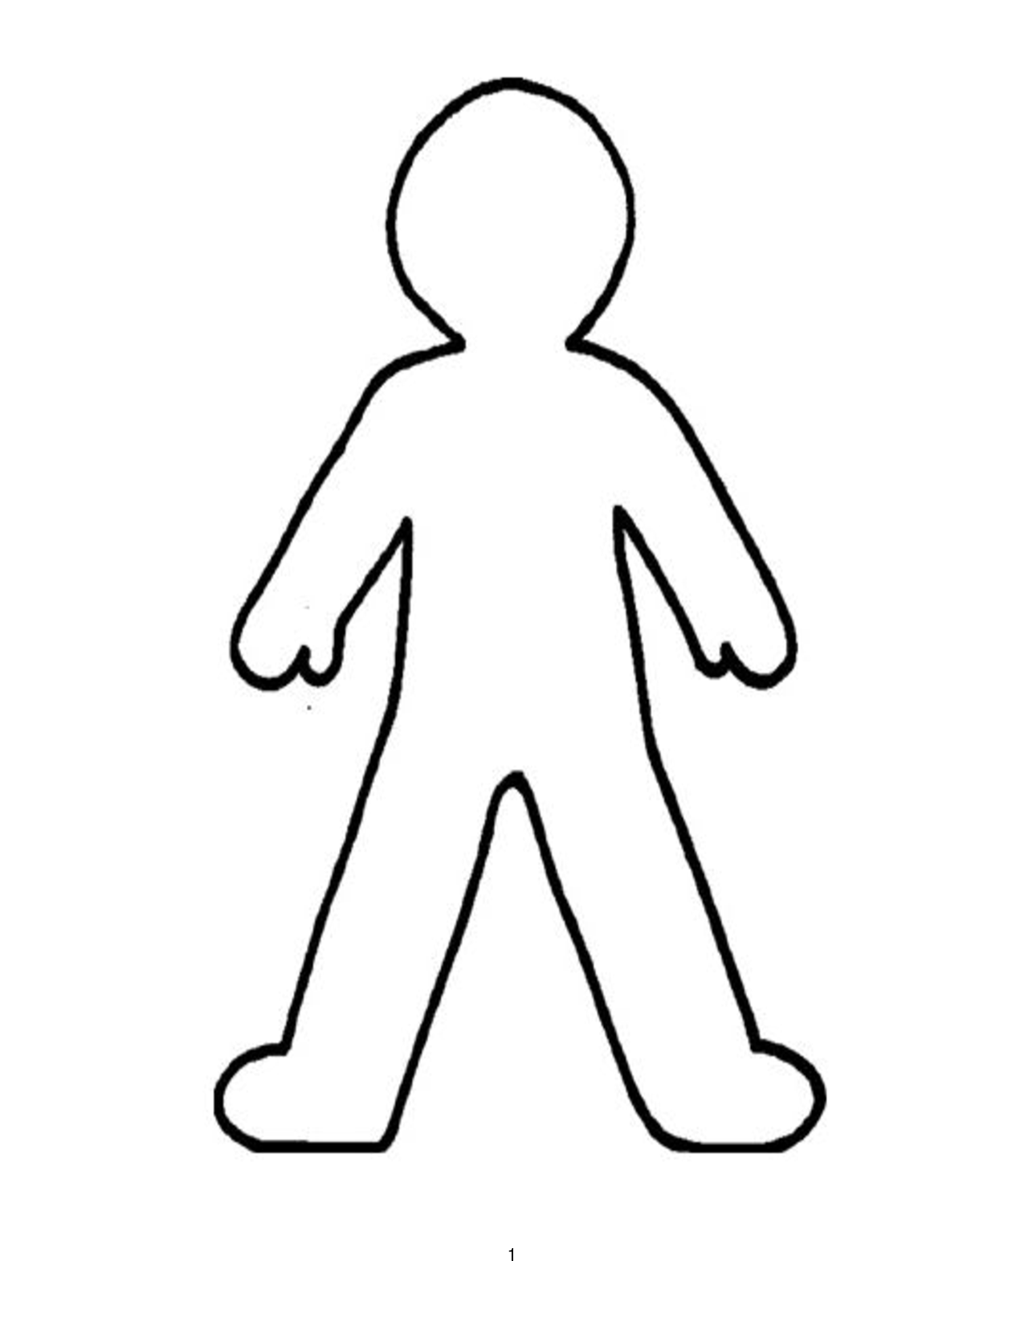

Props

You should now think about all props that are in your scene. You can get clues for props used both in the stage directions and dialogue between characters. Feel free to add in any props that you feel would enhance your performance.

|  |  |  |  |
| --- | --- | --- | --- |
| Prop | Personal | Hand Held | Pre Set |
|  |  |  |  |

Rehearsal

You will now have a period of rehearsal. You will be given 10 minutes at the end of this period to complete your rehearsal log.

What did you achieve during this rehearsal?

What did you contribute to today’s rehearsal?

What did not go well during today’s rehearsal?

What is your target for the next rehearsal?

Make-up

You should now create a make-up design for your character. You will need coloured pencils, do not use pen. The most important part of a make-up design is explaining you design. When you are finished make sure you have labelled and justified your decisions around the design.

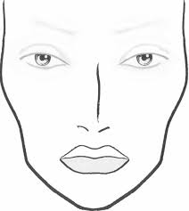

Writing in Role

You will now complete a diary entry as your character, you should write in the first person. Your character is reflecting on their day – therefore reflecting on what happened in you scene. You should write in as much detail as you can and include the characters thoughts, opinions, and feelings.

Dear Diary,

………………………………………………………………………………………………………………………………………………………………………………………………………………………………………………………………………………………………………………………………………………………………………………………………………………………………………………………………………………………………………………………………………………………………………………………………………………………………………………………………………………………………………………………………………………………………………………………………………………………………………………………………………………………………………………. ……………………………………………………………………………………………………………………………………………………………………………………………………………………………………………………………………………………………………………………………………………………………………………………………………………………………………………………………………………………………………………………………………………………………………………………………………………………………………………………………………………………………………………………………………………………………………………………………………………………………………………………………………………………………………………….……………………………………………………………………………………………………………………………………………………………………………………………………………………………………………………………………………………………………………………………………………………………………………………………………………………………………………………………………………………………………………………………………………………………………………………………………………………………………………………………………………………………………………………………………………………………………………………………………………………………………………………………………………………………………………….……………………………………………………………………………………………………………………………………………………………………………………………………………………………………………………………………………………………………………………………………………………………………………………………………………………………………………………………………………………………………………………………………………………………………………………………………………………………………………………………………………………………………………………………………………………………………………………………………………………………………………………………………………………………………………….

Signed…………………………………………………

Rehearsal

You will now have a period of rehearsal. You will be given 10 minutes at the end of this period to complete your rehearsal log.

What did you achieve during this rehearsal?

What did you contribute to today’s rehearsal?

What did not go well during today’s rehearsal?

What is your target for the next rehearsal?

Costume

You will now design a costume for your character. You just label and justify your decisions around your design.

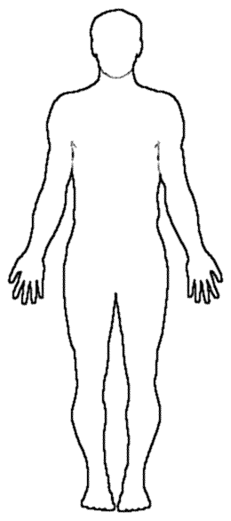

Hot Seating

Write down 10 questions that you will ask your partner in role. Your questions should be open ended questions.







10.

Rehearsal

You will now have a period of rehearsal. You will be given 10 minutes at the end of this period to complete your rehearsal log.

What did you achieve during this rehearsal?

What did you contribute to today’s rehearsal?

What did not go well during today’s rehearsal?

What is your target for the next rehearsal?

Lighting Cue Sheet

Example

|  |  |  |  |  |  |
| --- | --- | --- | --- | --- | --- |
| Cue Number | Scene | Cue Point | Lights | Intensity | Instructions |
| LX1 | Page 1 Scene 1 | Opening Scene | 1,3,5,9 | 90% | Warm wash of orange slowly fades up to 90% to indicate morning. |
| LX2 | Scene 1 Page 2 | “Stop it” | 4 | 100% | Snaps to red spotlight |

You should now create a Lighting cue sheet for your own scene. Lighting is a great tool to enhance our performance. It can separate different sections of the stage and also change the mood/atmosphere.

Lighting Cue Sheet

|  |  |  |  |  |  |
| --- | --- | --- | --- | --- | --- |
| Cue Number | Scene | Cue Point | Lights | Intensity | Instructions |
|  |  |  |  |  |  |
|  |  |  |  |  |  |
|  |  |  |  |  |  |
|  |  |  |  |  |  |
|  |  |  |  |  |  |
|  |  |  |  |  |  |

Sound Cue Sheet

Example

|  |  |  |  |  |  |
| --- | --- | --- | --- | --- | --- |
| Cue | Scene | Sound | Recorded/Live | Intensity | Instructions |
| SFX1 | Scene 1 Page 1 | Theme from Titanic | Recorded | 100% | Fade in Slowly over 10 seconds. |
| SFX2 | Scene 1 page 2 | Girls Scream | Live | 100% | Heard off stage when actors on stage sit down. |

Now you can create your own Sound Cue Sheet for your performance. Sound can be a great tool to enhance our drama. It can change the mood/atmosphere through atmospheric music or it could add a sense of realism to your performance for example, thunder and lightning to indicate the change in weather.

Sound Cue Sheet

|  |  |  |  |  |  |
| --- | --- | --- | --- | --- | --- |
| Cue | Scene | Sound | Recorded/Live | Intensity | Instructions |
|  |  |  |  |  |  |
|  |  |  |  |  |  |
|  |  |  |  |  |  |
|  |  |  |  |  |  |
|  |  |  |  |  |  |

Dress Rehearsal

You will now have a period of rehearsal using a collection of the Production Areas. You will be given 10 minutes at the end of this period to complete your rehearsal log.

What did you achieve during this rehearsal?

What did you contribute to today’s rehearsal?

What did not go well during today’s rehearsal?

What is your target for the next rehearsal?

Performance Evaluation

Give a brief description about your performance.

Using the correct movement terms, describe 3 ways you changed your movement when acting?

Using the correct voice terms, describe 3 way you changed your voice when acting?

How did you contribute to the rehearsal process?

How did you effectively use sound?

How did you effectively use make up?

How did you effectively use lighting?

How did you effectively use costume?

How did you effectively use set design?

How did you effectively use props?

Evaluate your partner’s contribution.

Describe at least 2 challenges you faced during the rehearsal process and how you overcame these challenges.

What went well during your final performance?

What did not go well during your final performance? How would you prevent this from happening again>