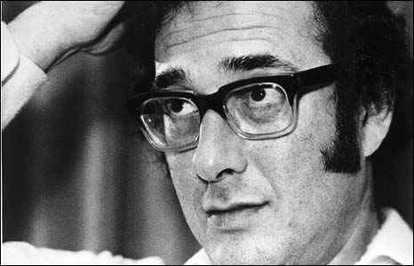

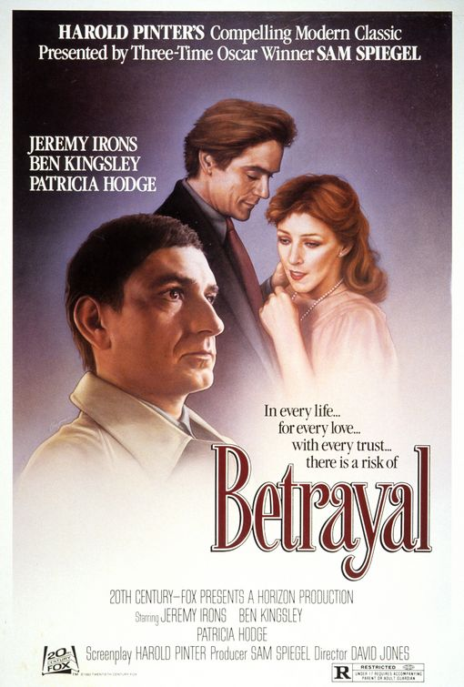
Nobel laureate, Playwright, Director, Poet, screenwriter, Actor, left wing political activist and cricket enthusiast bought up in Hackney.
In Pinter’s play Betrayal he outlines an extra-marital affair in reverse order, starting with the break up of the marriage and ending with the beginning of the affair that caused the break up.
Pinter has often refused to define his work, he once stated that it was about the’weasel under the cocktail cabinet.’ which he later regretted.
His early work has been related to Absurdist Theatre and his later work became more overtly political.

Pinteresque Describing a moment that is like one of his plays
Pinter Pause He is famous for writing pauses into his stage directions. There are 140 pauses in Betrayal
Challenges audience expectations by presenting events Non Chronologically
Create your own drama sequence. Make sure it has clear stages to it in terms of time scale and separate scenes.
Run it in a linear sequence (normal time order)
Then explore different ways of re-ordering the scenes of events

