Welcome to
Abronhill Primary School and Nursery Class


What Matters To Me!
“I am an individual”

Home to Nursery Transition

My name is ………………………………………………

I was born on…………………………………………
Here is a photo/drawing of me and family.
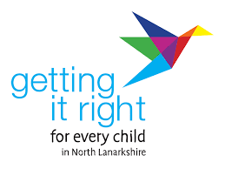
Getting it Right for Every Child (GIRFEC)
In Abronhill Primary School and Nursery Class we are committed to ‘Getting it Right for Every Child’ (GIRFEC), which is Scotland’s national approach to supporting the wellbeing of all children and young people.
GIRFEC is based on the United Nations Convention on the Rights of the Child (UNCRC). This is a global agreement to protect children.
GIRFEC is the Scottish Government’s promise to give all children, young people and families the right support at the right time.
GIRFEC has key principles, and these are central to everything that we do:
- Your child and family are at the centre of all work and decisions that affect you.

- We work together with our families.

- We understand that wellbeing is about all areas of life, including family.

- We value difference and treat everyone fairly.

- We tackle inequality.

- We will give support to your child and family.

- We will work with a range of agencies and specialists to make things better for your child and family, when required.
We use the SHANARRI Indicators to guide how we support children. These indicators are:
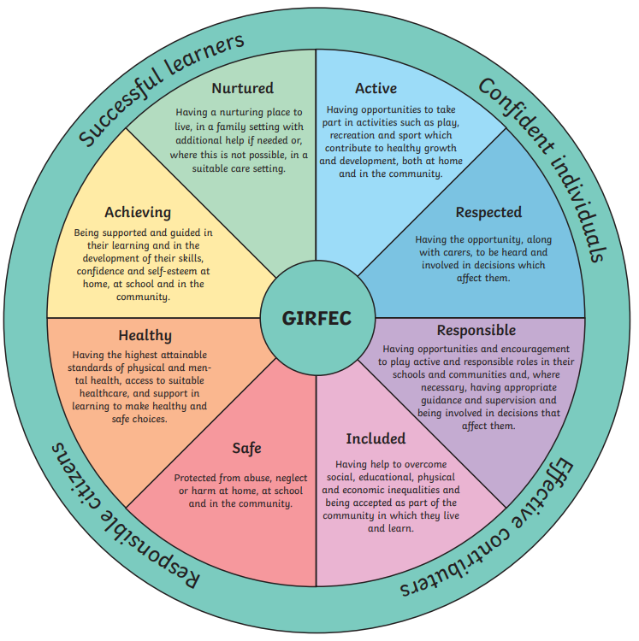
- SAFE
- HEALTHY
- ACHIEVING
- NURTURED
- ACTIVE
- RESPECTED
- RESPONSIBLE
- INCLUDED

SAFE

UNCRC Article 19: I have the right to feel safe and protected at home,
in nursery, and in the community.

People who help look after me:
Parents’ Names:
Doctor’s Name:
Health Visitor’s Name:
Any other services who work with me, e.g. social work, speech & language, occupational therapist etc.

People who will drop me off and collect me from nursery:
Name | Relation

I also go to another nursery or childminder. (Complete if relevant)
Nursery Attended: |  | Childminder’s Name:
Keyworker Name: |  | Days & Times:
Days & Times: |  | Contact Details:
Contact Details:

Keeping Myself Safe:
When I am out in public, I know how to keep safe | Yes | No
I mostly follow requests from the people looking after me | Yes | No
I enjoy risky play and challenging myself to practise new skills | Yes | No
I am confident in asking the adults around me for help | Yes | No

Is there anything else you would like to tell us about being SAFE?
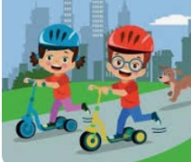

HEALTHY

UNCRC Article 24: I have the right to be as healthy as I can be,
with help to grow strong in body and mind.

About My Health:
I was born full term |  | Yes | No
I was born premature at _____ weeks
I wear glasses |  | Yes | No
I need support with my hearing |  | Yes | No
I need support with my speech and language |  | Yes | No
I need support with my physical mobility |  | Yes | No
I have a diagnosed medical condition/conditions |  | Yes | No
I have this medical condition
I need this medication/support to help me
I have this medical condition
I need this medication/support to help me
Further information about my medical condition/conditions:

Allergies:
I have an allergy/allergies |  |  | Yes |  | No
I am allergic to | 1. | 2. |  | 3.
I need medication for my allergy/allergies |  |  | Yes |  | No
Allergy medication I need | 1. | 2. |  | 3.
Further information about my allergy/allergies:

Nutrition:
Things I like to eat and drink | Things I do not like to eat and drink
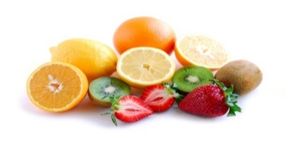

ACHIEVING

UNCRC Articles 28 & 29: I have the right to learn and develop my skills
through play and new experiences.

(Please tick the relevant boxes)
I can
 | separate from my parent/carer | put my own shoes on | put my jacket on | follow simple instructions/routines
by myself
with some support
with a lot of support

(Tick or colour the statements that describe you best)
I am learning every day
Talking  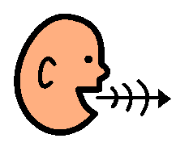 | I like to talk to lots of people | I can speak in short sentences | I can talk about people and places I know
 | I only like to talk to people I know well | I need some help when speaking | I can talk about things I like to do
 | I need support to talk to people | I use visuals and/or signing to help me talk | I can ask questions about my world
Listening  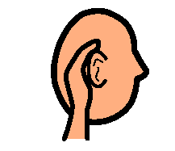 | I can listen for a short time | I can understand simple instructions (now & next) | I can listen to make a choice or learn new things
 | I need some help to listen | I can listen and respond in a short conversation | I can listen to a short story
 | I need a lot of help to listen | I can take turns when listening and talking | I am interested in what other people are saying
  Writing | I like to use my right hand | I like to switch hands  (I use right and left) | I like to write (making marks with pencils, crayons, chalk, paint etc.)
 | I like to use my left hand | I like to draw | I can talk about my drawings and writing
Maths & Numeracy  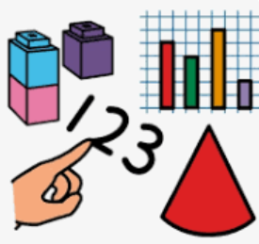 | I know some numbers | I like some songs that include numbers (e.g. 5 Little Speckled Frogs) | I can spot simple patterns  (e.g. blue-red-blue-red, big-small-big-small)
 | I can count to 5 or more | I can match number words to small sets (e.g. ‘three’ means three things) | I can recognise some shapes (e.g. circle, square, triangle)
 | I know that numbers mean an amount (e.g. give me 2 apples) | I can sort objects by colour, size or type | I can use measurement words (e.g. big, small, full, empty, long, short)

I sometimes need the following support with communication (tick or colour any relevant boxes)
touch me gently when speaking to me | say my name first before you speak to me | speak to me in a soft tone | do not use too many words
use gestures and/or signing | give me extra time to think before I respond | check if I am ready to respond | Other (please state)

These are some interests I have that help me to achieve
I enjoy playing with:

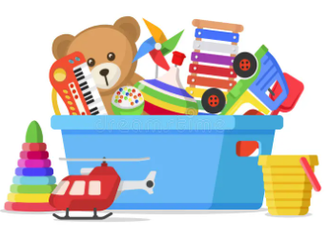
The songs or nursery rhymes I like to sing are:

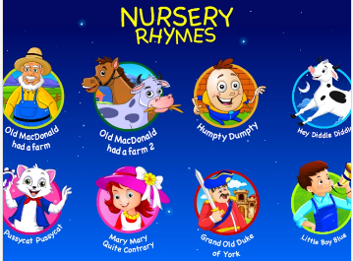
My favourite TV or film characters are:

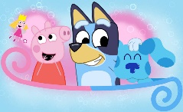

My favourite books are:

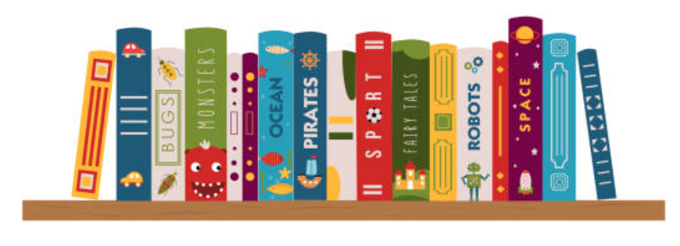
I have a special interest in (for example, animals, dinosaurs, pirates or princesses)

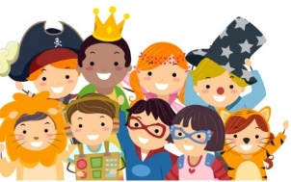

NURTURED

UNCRC Articles 6 & 27: I have the right to feel safe, cared for and valued,
with support to grow and thrive.

(Please tick the relevant boxes. If there is further information, please add this too.)
Routines/Experiences | Yes | Not Yet | Further Info
I have a good sleep pattern and go to bed at the same time most nights
I have a varied diet and like to try new foods
I am toilet trained
I can separate from my parent/carer without becoming upset
I have lots of experience playing with other children
I have a comfort item (e.g. toy, blanket)

Things that might upset me: | Things that make me happy:
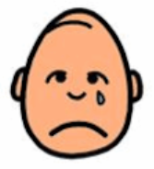 | 
Things I may need to comfort and reassure me:

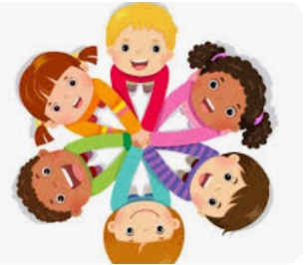

ACTIVE

UNCRC Article 31: I have the right to play, explore and be active every day.

(Please tick or colour the relevant boxes)
Active Play
I am very active | I am more reserved | I like to run and climb | I like bikes and scooters
I like to dance | I enjoy playing outside | I like to play outside in all weathers | I prefer to play indoors
I like quiet activities | I need some support to explore new types of play | I need some support with balance or  co-ordination | I have a medical condition that can affect my activities
There are some activities I need to avoid | There are some activities I can only do for a short amount of time | I need a rest during the day or I become tired | After active play, I am quite tired

Information to support my play and interests
Any further relevant information on the choices selected above:

These are activities I particularly enjoy:

I attend these groups, clubs or classes:

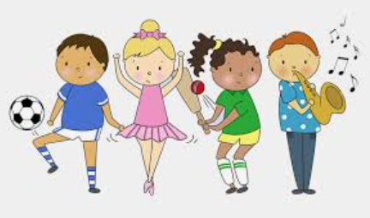

RESPECTED

UNCRC Article 12: I have the right to be listened to, and for my thoughts and feelings to matter.

This is how I like to communicate
I express my needs, wants and feelings by (e.g. using words, gestures, signs)
I use these key words or phrases for familiar things
I am confident in speaking about my needs, wants and feelings and show this by
My cultural and family values
These are the languages spoken in my home

These are some key words I would like you to know

I would like nursery to respect these important routines, celebrations or beliefs

These are foods and drinks I cannot have for religious or cultural reasons

These are some stories, music and cultural items that could be included in nursery

Celebrating individuality
I would like to be called

I would like these opportunities to make choices that matter to me (e.g. snack, activities, where to play)
During toileting or dressing, I would like

I like my achievements to be celebrated in these ways (e.g. stickers, sharing my news with others, photos etc.)
Other Information
This is some other information about how I would like to be respected

RESPONSIBLE

UNCRC Article 29: I have the right to learn how to make good choices
and take care of myself and others.

(Please tick the relevant boxes. If there is further information, please add this too.)
I am learning to be responsible | Yes | No | Sometimes | Further Info
I like to be given responsibility
I can follow rules and routines
I can follow instructions
I can help with small tasks (e.g. tidying, helping with dressing)
I can show care for others
I can look after belongings
I can take turns and share with others
I can recognise when I have done something wrong
I respond well to praise, encouragement or gentle correction

Is there anything else you would like to tell us about being RESPONSIBLE?

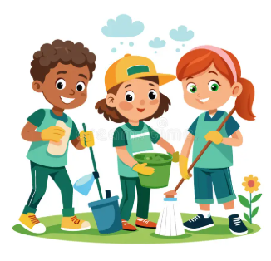
INCLUDED

Articles 2 & 23: I have the right to be accepted and involved,
whoever I am and wherever I come from.

Important information to help me feel included
My parents live in different houses, so I have two homes. These are the days I spend in my homes:
(Include any other relevant information you feel staff need to know)

When I am at nursery my parents/carers are: (e.g., at home, looking after my siblings, at college, working as…)

I have brothers and/or sisters (include names, ages and schools attended):

I have grandparents or other special people in my life called:

I have spent time away from my parents/carers mixing with other children (e.g., at nursery, parent and toddler group, with relatives):

I have a pet/pets (type and name):
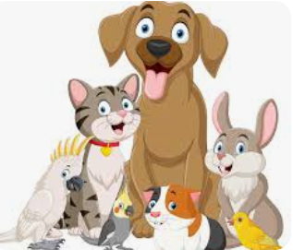

Is there anything else you would like to tell us about being INCLUDED?

Additional information from my parents/carers
Events during pregnancy and during their earliest years, can have an effect on your child’s progress or development. It can be useful to have knowledge of this information in nursery so that we can work in partnership to best support your child and family.

If you are comfortable sharing this information in this booklet, please do so below.
If you would rather speak with a member of management or staff about any information, please let us know and we can arrange this.

Please tell us what matters to you as a parent/carer when your child is at nursery.
Starting nursery might be the first time your child has had significant time away from you which can be an anxious and exciting time.
All information shared is important and valued.

Here are some examples of things you might like to include, opportunities to be part of a group, build relationships, take part in risky play, develop self-help skills, they need a comfort item to settle etc.

Thank you for taking the time to tell us about what matters to you. We are looking forward to learning lots, trying new things and having so much fun with you in Abronhill Primary School and Nursery Class.

