How to Join a Class Team Meeting

A Guide for Pupils

How to Join a Class Team Meeting

- Your teacher will schedule a class team meeting once a week. This will either appear in the calendar like this:

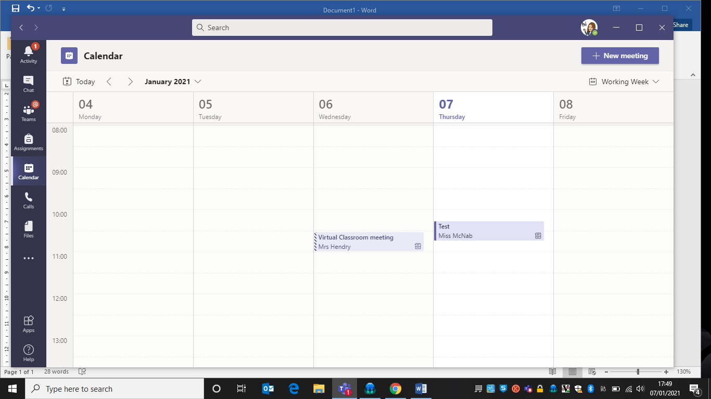

or in the ‘posts’ section of your class team, like this:

- If you meeting has been posted to the calendar, click on meeting title, then you should have an option to ‘join’ (this is usually in a purple rectangle)

If you are joining from the link in the ‘posts’ section, click on the three dots at the end of the purple banner.

Then select ‘view meeting details’. You should then have an option to ‘join’ (this is usually in a purple rectangle).

- Once you have joined the meeting, you have the following options.

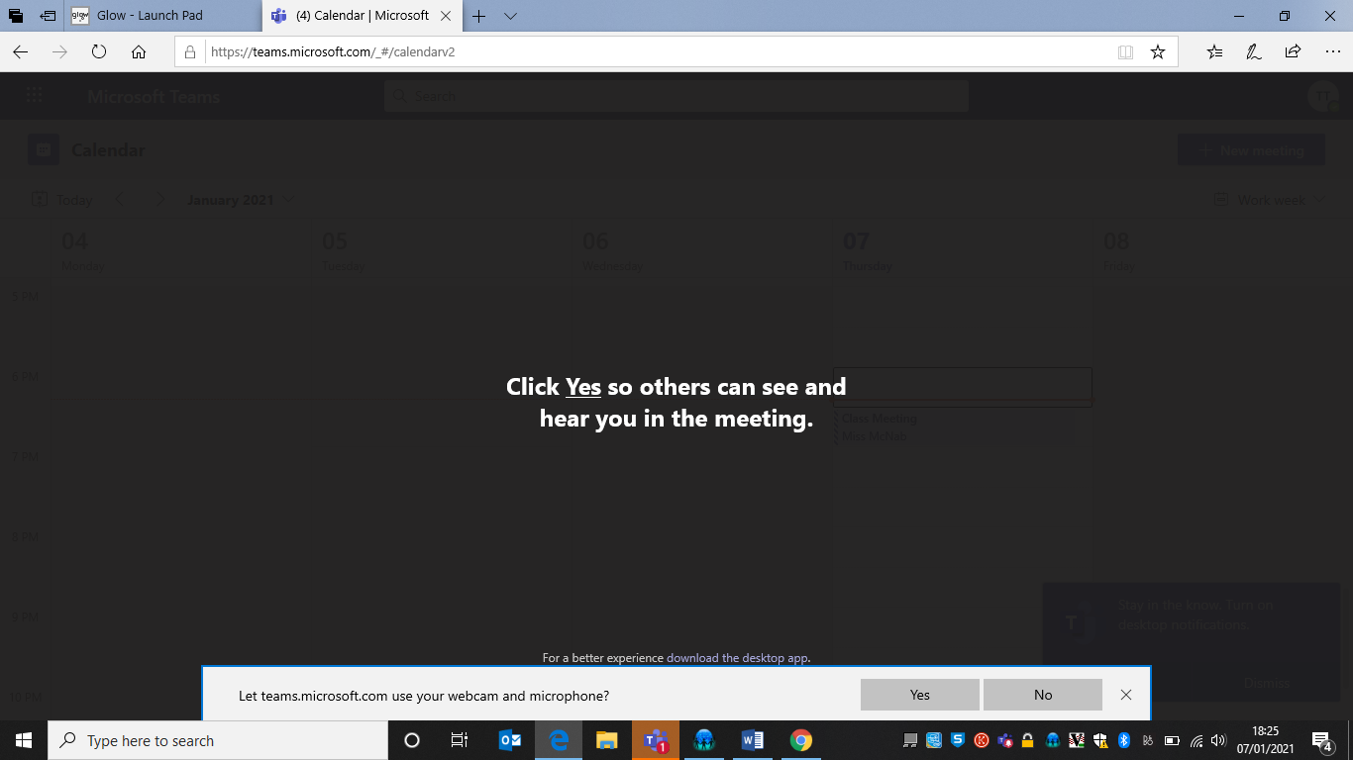

Select ‘yes’ to both options. This will allow your teacher to both hear and see you during your team meeting.

- You will then see this screen:

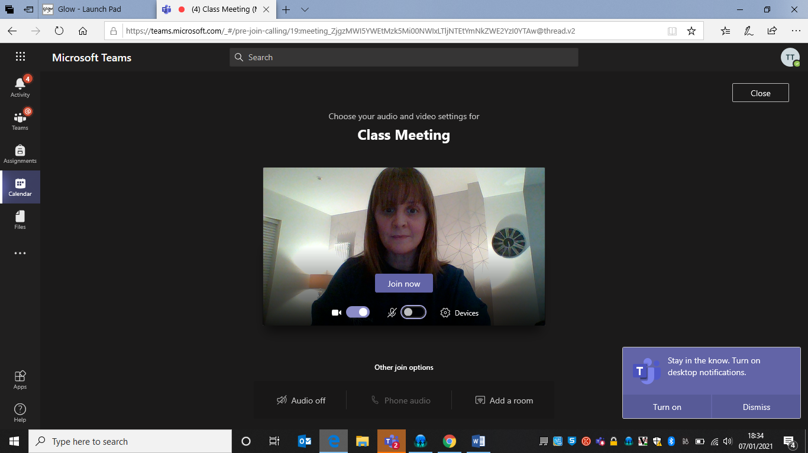
Join the meeting with your sound off. This will ensure that there is not lots of interference. You will be asked to turn your microphone on if you wish to speak.
Make sure your camera is turned on. If not, slide it on. It should look purple as in the picture. You will then be able to see yourself.

- Then select ‘join now’.

- You will then see this screen.

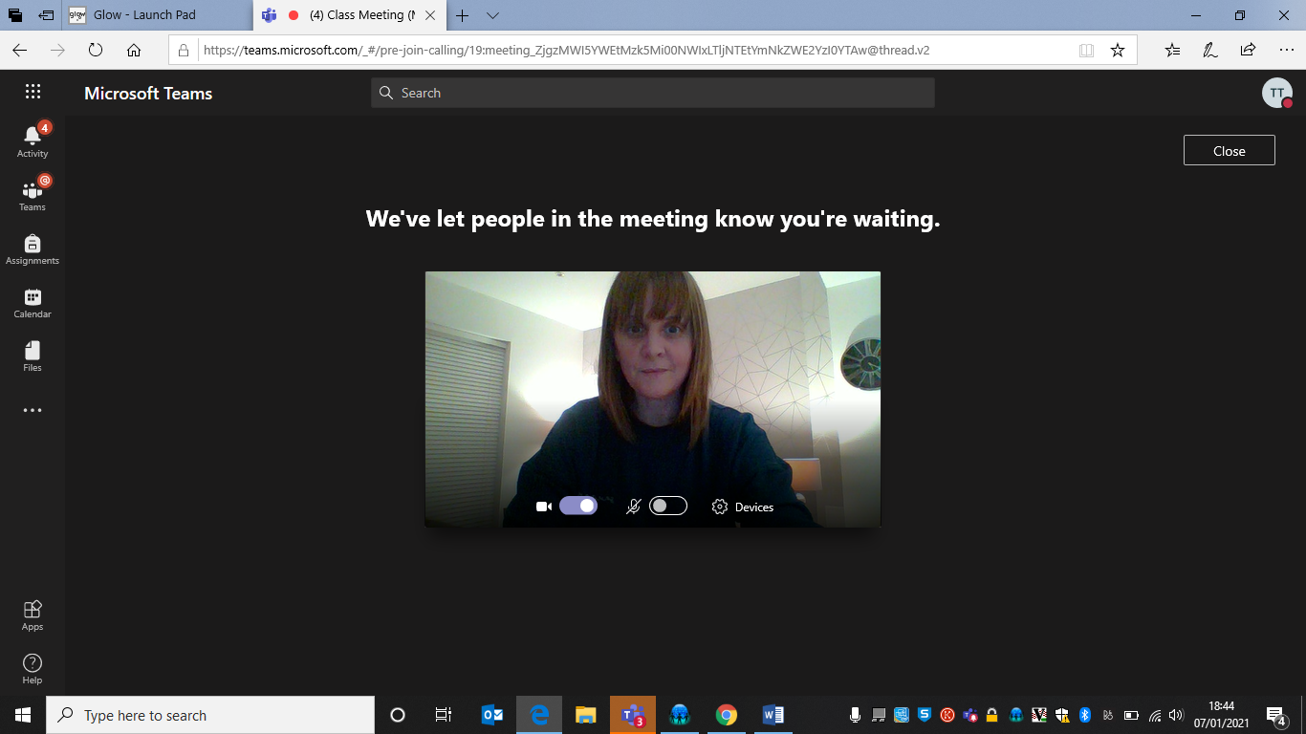

The meeting will not start until your teacher ‘allows you to enter’ the meeting.

- Once you are in the meeting, you should see your teacher and the other children who are in the meeting too.

- In the picture below, there are some descriptions about the tools and functions available within the meeting.

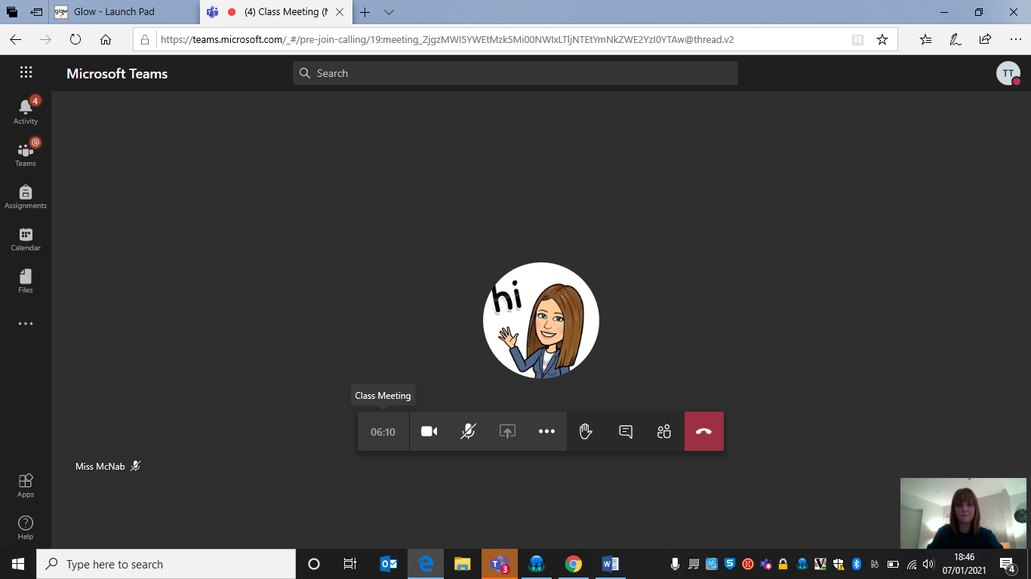
Chat function. This will allow you to type in a question or give an answer.
Raise your hand. This will let your teacher know you would like to talk. When it is your turn, remember to unmute your sound.
Your sound. Clicking on this will turn it off/turn it on.
Your camera. Clicking on this will turn it off/turn it on.

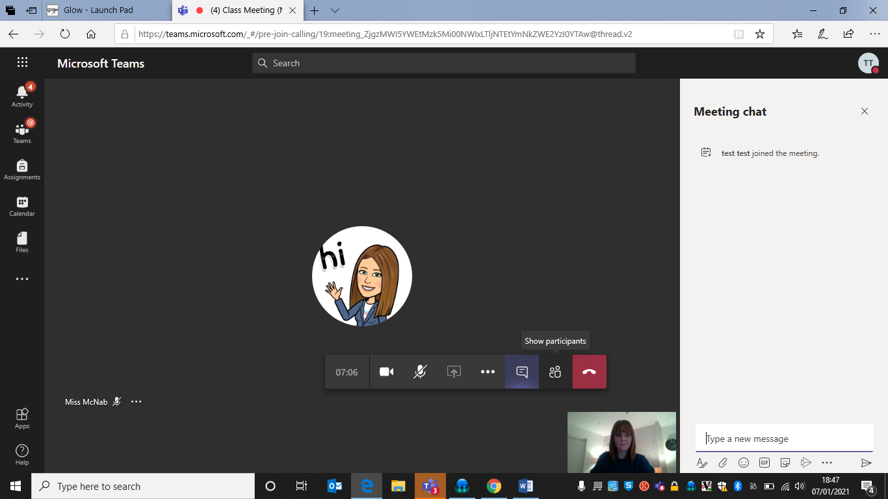
At the end of the meeting, use this button to leave.
Chat function. A chat bar will open up in your screen and you can type your message here.

