 Locating Teaching and Learning Grids in Teams

2.Groups- These are the same as your normal class working groups for literacy and maths. This is where you will find files to complete any work set for your group from the learning grid.

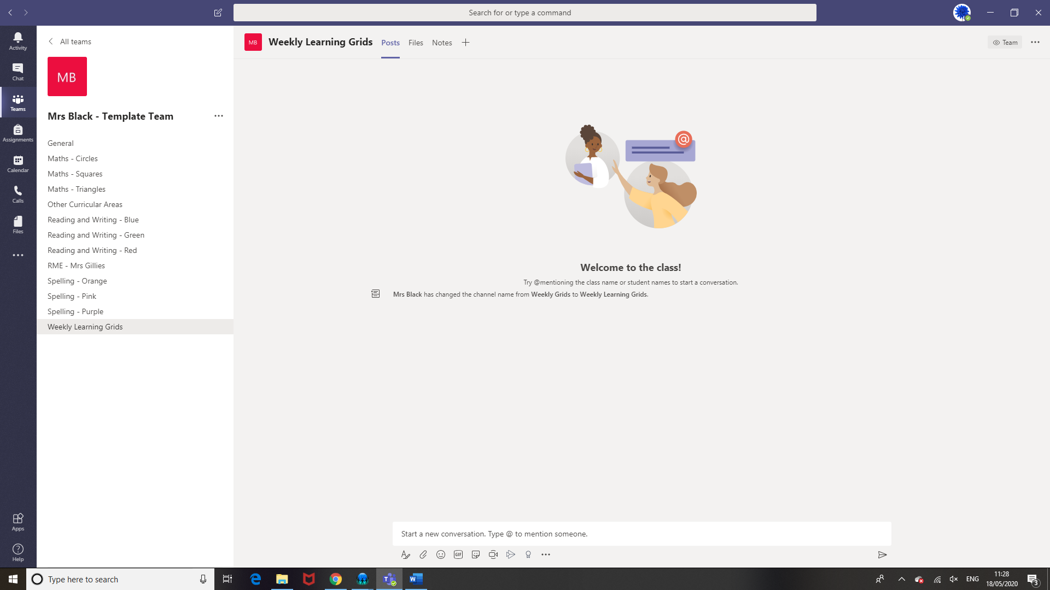

3.Posts – In this section your child can interact with their class teacher.

1.Weekly learning grids will be posted in this section. Each grid will be dated for the week.