Accessing Microsoft Teams
- Go to https://sts.platform.rmunify.com/account/signin/glow or google glow log in and enter your glow details.

- Click the house icon on the left-hand side of the screen.

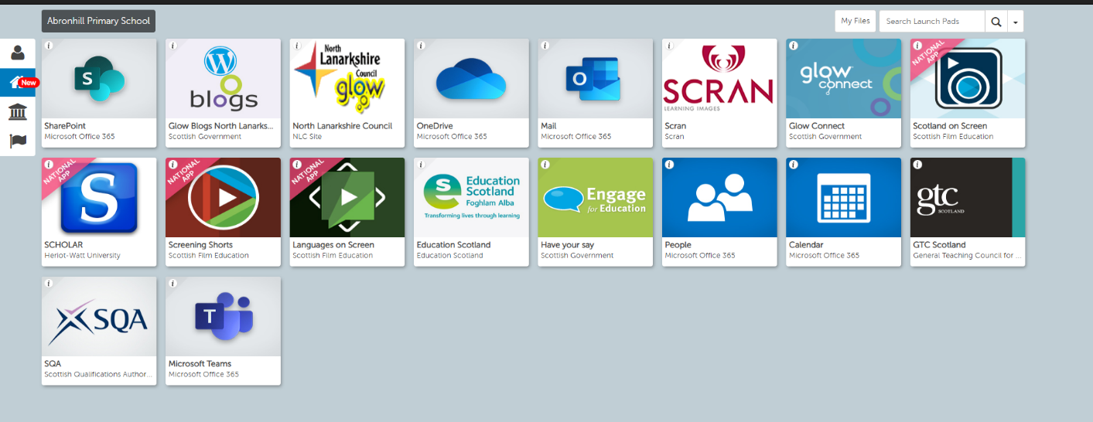

- Click on the icon ‘Microsoft Teams’

- At this point, you may be required to input your full glow email address (ensure you include @glow.sch.uk at the end of your username) and password.

- Click on your class.

- You are now successfully in Teams.

