:

Our Ref: JS/AM
Your Ref:
Contact:
Tel: 01236 794870
Date: 13th December 2018
Head Teacher
Jane Stocks
Abronhill Primary School and Nursery Class
Medlar Road
Abronhill
G67 3AJ
Dear Parent/guardian

PRIMARY 5 – PRACTICAL COOKING

Primary 5 pupils will be taking part in practical cooking for 3 Thursday’s commencing on Thursday 10th January 2019. I would ask that pupils bring £3.00 towards the cost of ingredients and also a container to take their food home in.

Yours sincerely
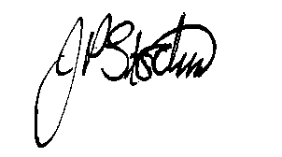
JANE STOCKS
Head Teacher

