:

Our Ref: JS/AM
Your Ref:
Contact:
Tel: 01236 794870
Date: 5th November 2018

Head Teacher
Jane Stocks
Abronhill Primary School and Nursery Class
Medlar Road
Abronhill
G67 3AJ
Dear Parent/Guardian

CHRISTMAS FAYRE

The Parent Council will be holding a Christmas Fayre on Friday 7th December. Below is a note of the time that your child’s class will be attending. All parents/guardians are welcome to come along.

Nursery (AM & PM) 10.00am till 11am

P4, P5, P6 and P7 11am till 12am

P1, P2 and P3 1.00pm till 2.00pm

Yours sincerely
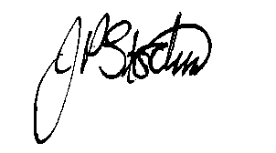
JANE STOCKS
Head Teacher

