:

Our Ref: JS/AM
Your Ref:
Contact:
Tel: 01236 794870
Date: 21st November 2018

Head Teacher
Jane Stocks
Abronhill Primary School and Nursery Class
Medlar Road
Abronhill
G67 3AJ
Dear Parent/Guardian

AFTERSCHOOL SCOTTISH COUNTRY DANCING PRIMARY 5 TO PRIMARY 7

Mrs Burns will be running an after school Scottish Country Dancing Club starting on Monday 26th November for 3 weeks.

If you are agreeable to your child taking part in this after school activity, please complete and return the tear-off slip below and return to the school office by Monday 12th November. You will be advised if your child has secured a place.

Yours sincerely
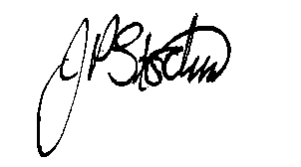
JANE STOCKS
Head Teacher
-----------------------------------------------------------------

TO: ABRONHILL PRIMARY SCHOOL – AFTERSCHOOL SCOTTISH COUNTRY DANCING

I give my child ____________________ class _____________permission to attend the above club.

I will collect my child from school at 4.00pm. / My child will walk home from school at 4.00pm.
(Please delete as appropriate).

Signed ………………………………………………………………Dated …………………..…….
(Parent/Guardian)

